
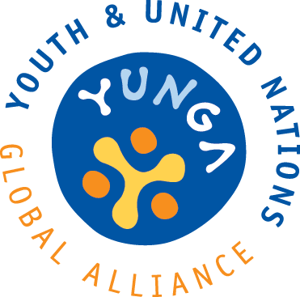
With the support from

YUNGA

International Drawing Competition: Protecting our fisheries - inheriting a healthier world

2013

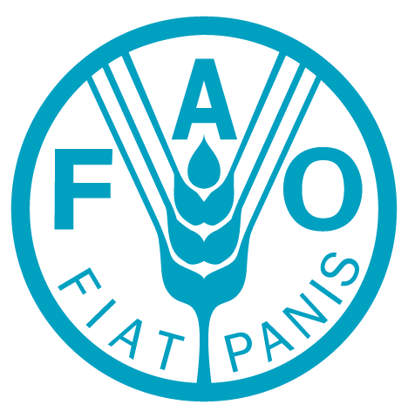
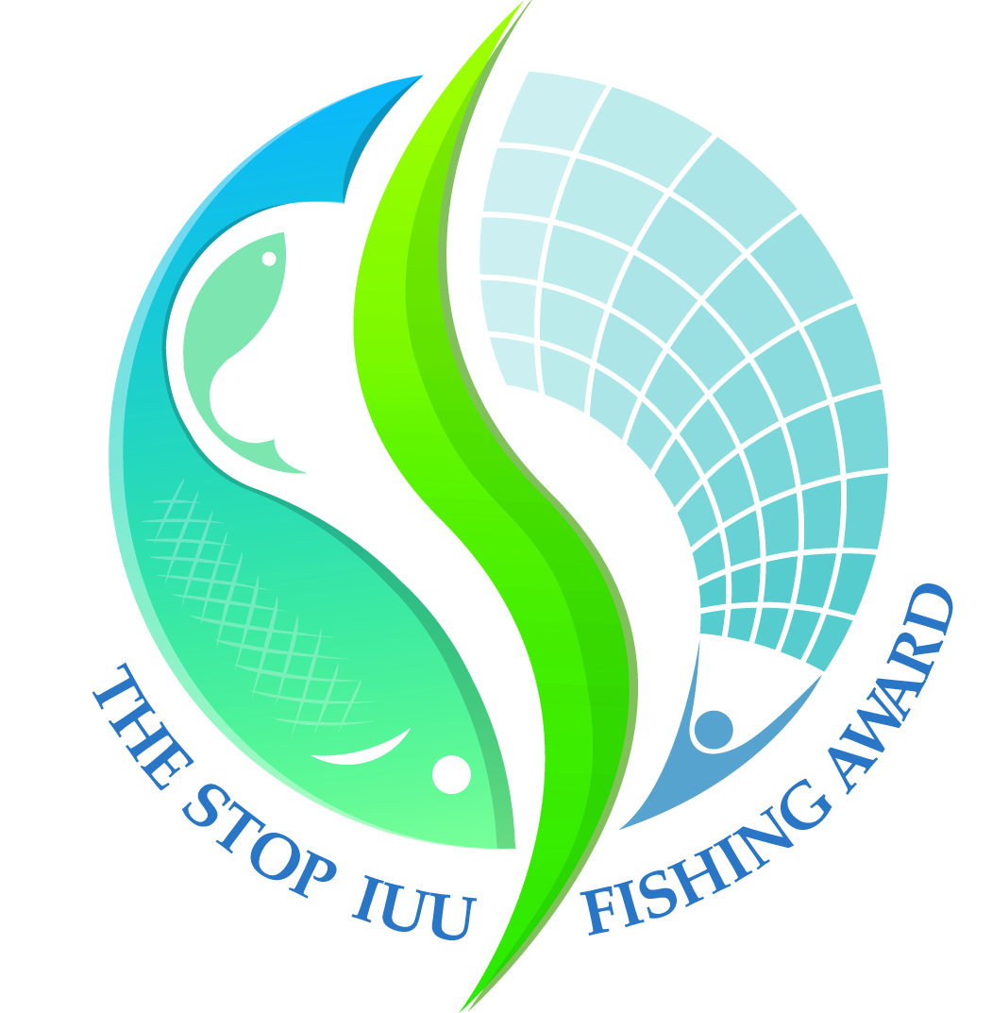

YUNGA International Drawing Competition: Protecting our fisheries - inheriting a healthier world

Organizers:
The Food and Agriculture Organization of the United Nations (FAO)
The International Monitoring, Control and Surveillance Network (MCS)

BACKGROUND

The International Drawing Competition: Protecting our fisheries - inheriting a healthier world is held as a part of a youth education initiative intended to enhance awareness of the importance of responsible fisheries among children and young people and to provide them with the knowledge that can help them to become responsible adults and active agents of change in our society. Relevant information about the challenges that our environment is facing today is an essential tool for enabling children and young people to take responsible action in their communities and, therefore, strengthen their participation in the protection, preservation and improvement of our natural resources. The project is developing a series of educational materials and activities for children and young people, teachers and youth leaders. The International Drawing Competition, linked to The Stop IUU Fishing Award/2013 (stopiuufishingaward@imcsnet.org), allows children and youth to express through their artwork and drawings, why protecting our fisheries is important to inheriting a healthier world. The winning artworks will be used in logos, posters, publications, T shirts and activity badges.

- PARTICIPANTS

The International Drawing Competition is open to ALL children and young people from 6 to 20 years of age.

- COMPETITION RULES

- The drawing should reflect issues concerning the importance of fishing responsibly. Learn more about some ideas to get started by reading the “Time to think and act” section (pages 6-8). You can plan and develop some cool activities to raise your group’s awareness about fisheries before they start drawing.
- Drawings should be on white A4-size or letter-size paper in the round or square frames provided in the annexed templates. The diameter of the round frame and length of the square should be 18 cm.
- Remind your group that the drawing could be used for making small badges and large posters! Encourage them to use bright, bold colours. Participants may use drawing materials of any type: pens, pencils, paints, with the exception of crayons as they do not reproduce well. They are also allowed to use computer graphic programmes.
- The drawings must be the child’s or youth’s original creation. Most importantly they should use their imagination and have lots of fun!

DEADLINE AND SUBMISSION OF ENTRIES

The deadline for submitting your drawings is 15 April 2013. The postmark date will be regarded as the date of delivery.

Send your drawing by e-mail to: children-youth@fao.org or by post it (preferably in a water-proof envelope) to:
Reuben Sessa

FAO, NRC
Viale delle Terme di Caracalla
00153 Rome, Italy

Please note that if your submission is sent electronically you should keep the original drawing in a safe place as we may require the original in case your drawing is selected.

- ADJUDICATION AND PRIZES

Adjudication will be conducted by a Panel formed from FAO staff and The International Monitoring, Control and Surveillance Network (MCS) representatives and graphic designers.
The winners will be awarded with:
- Monetary prizes: The following monetary prizes will be awarded to the first three winners of each age group:
 | 6-10 years | 11 -15 years | 16 -20 years
WINNER | 500 USD | 500 USD | 500 USD
RUNNER UP | 200 USD | 200 USD | 200 USD
THIRD ONE | 100 USD | 100 USD | 100 USD

- The schools/associations of the winning artworks will receive a gift.
- The winning artworks will be used in logos, posters, FAO publications (distributed worldwide), T shirts and activity badges.

HANDLING OF ENTRIES AND INTELLECTUAL PROPERTY

All entries will be handled by the organizers and will not be returned. The intellectual property of the entries is owned by the participants. The organizers, however, have the right to publish, exhibit, print or distribute the entries through any media.

Nothing contained in or related to this contest shall be deemed a waiver, express or implied, of the privileges and immunities of the Food and Agriculture Organization of the United Nations (FAO).

CERTIFICATES

Electronic blank certificates can be send for completion. These can be requested on submission of the drawings.

- ENQUIRIES
For further information and enquiries, please email: children-youth@fao.org

“Protecting our fisheries - inheriting a healthier world”

Children-Youth action for a global difference

PARTICIPANT’S name and surname................................................................................

PARTICIPANT’S name and surname................................................................................
DATE OF BIRTH (DD/MM/YYYY).................................... COUNTRY......................................
ADDRESS...............................................................................................................................
TEL........................................... E-MAIL.................................................................................
SCHOOL/ASSOCIATION........................................................................................................
TEACHER’S/LEADER’S NAME AND CONTACTS…………..…………………………........................

“Protecting our fisheries - inheriting a healthier world”

Children - Youth action for a global difference

PARTICIPANT’S name and surname................................................................................
DATE OF BIRTH (DD/MM/YYYY).................................... COUNTRY......................................
ADDRESS...............................................................................................................................
TEL........................................... E-MAIL.................................................................................
SCHOOL/ASSOCIATION........................................................................................................
TEACHER’S/LEADER’S NAME AND CONTACTS…………..…………………………........................

TIME TO THINK AND ACT!

Plan and organize activities you can do with your group before they start drawing. Encourage them to learn more and reflect about fish, eating fish and fishing activity - small and large scale - and the numerous livelihoods and cultural and biological diversity associated to these activities. Discuss what fisheries mean to people and how fisheries can be harvested from our oceans, seas, lakes, rivers. Discuss how fisheries fit into our cultures, our learning, our histories. For instance, find out (i) how fish can be harvested from our oceans, seas, lakes, rivers; (ii) how to fish without ruining our ecosystems and our society; (iii) what does pirate fishing mean and (iv) why combating pirate fishing is crucial to food security, poverty alleviation, resource sustainability and cultural diversity. Reflect why fishing responsibly and protecting our fisheries will make us live in a healthier world! Discuss what children and young people can do to protect our fisheries and to promote responsible fishing. You may use the facts and the ideas below to organize activities that work best for your group: games, songs, quizzes, drama, group discussions, among others. Remember, your commitment is essential to make us live in a healthier world.

Before you get to work, did you know that...

- From ancient times, fishing has been a major source of food for humanity and a provider of employment and economic benefits for millions of people. The wealth of aquatic resources was assumed to be an unlimited gift of nature. However, as vast as the world’s oceans may seem, their resources are limited and their ecosystems fragile. Aquatic resources, although renewable, are not infinite and need to be properly managed, if their contribution to the nutritional, economic and social well-being of the growing world's population is to be sustained.

- Eating fish is a healthy nutritional part of a balanced diet but making sure fish can continue to be available to all long into the future takes informed choices by all of us. How many days per week do you eat fish?

- Fishery is an important activity for maintaining the livelihoods of millions of people around the world. The activity varies from small-scale to large-scale and there are many people that work in fisheries processing plants and activities after the fish and fish products are caught, such as smoking or filleting among others. Taking family members and other dependents into account, almost 540 million people, or nearly 8 percent of the world population, rely on the sector for their livelihoods.

- In 1995, member countries of the Food and Agriculture Organization of the United Nations (FAO) adopted the Code of Conduct for Responsible Fisheries (http://www.fao.org/docrep/005/v9878e/v9878e00.HTM) to help to achieve more responsible fisheries worldwide.

- Illegal – or pirate - fishing causes economic losses (in the range of 10-23 billion USD annually) and brings unquantified, indirect negative consequences for fishing communities, the conditions of the resources and food security. Illegal fishing causes the unsustainable harvest of fish and other aquatic wildlife, destruction of aquatic habitats, loss of fish for present and future generations, loss of nutrition, and loss of income and employment for legitimate fishers. Illegal fishing can also push fish stocks to the point where they become commercially unviable or extinct.

Change starts with you!

Some 53 percent of the world’s marine fishery resources are fully fished, or fished to the maximum sustainable level. Another 32 percent is overfished, depleted, or recovering from depletion. Fish contributes to food security in many regions of the world. Numerous developing countries rely on fish as a major source of protein; in 28 of them, fish is responsible for over 40 percent of animal protein intake. Illegal - or pirate – fishing continue to be a major problem to achieve responsible and sustainable fisheries.
Here are some ideas you can use in your community to make people understand, but you can also think up of new ideas as well and use them with friends. (We would love to know of your ideas that you have found worked in your community). The more people you can involve the more the impact.

- Learn. Learn about the fish and fish products, fisheries, fishermen and fisherwomen, their livelihoods and their importance within your area. How do they affect your health and well-being?

- Be aware. When we eat fish it can come from irresponsible fishing that could harm our environment and our society. Discuss available options on how irresponsible fishing could be stopped.

- Act. Once you better understand fisheries issues, it is time to take action. For example, avoid eating baby fish and ask your seller if she/he knows the fish they are selling comes from responsible fisheries.

- Share. Encourage your family and friends to help you promote responsible fisheries. Or, join an environmental, community-based initiative or youth group that works on fisheries-related issues.

Take part in the challenge badges which have already been developed for:
a. Biodiversity: www.fao.org/climatechange/youth/68784/en/
b. Climate change: www.fao.org/climatechange/youth/63380/en/
c. Forest: http://www.fao.org/climatechange/youth/68804/en/

Information Sources

Here are some websites to get you started. You can also talk with fishers – young and elders – to learn from their traditions and wisdom.

Food and Agriculture Organization of the United Nations (FAO)
http://www.fao.org/fishery/en
http://www.fao.org/fishery/ssf/guidelines/en

The International Monitoring, Control and Surveillance Network (MCS)
http://www.imcsnet.org/

International Year of Cooperatives 2012
http://social.un.org/coopsyear/

Small-scale fisheries
https://sites.google.com/site/smallscalefisheries/

International Collective in Support of Fishworkers
http://www.icsf.net/

