http://www.booksopen.net/education-in-africa/
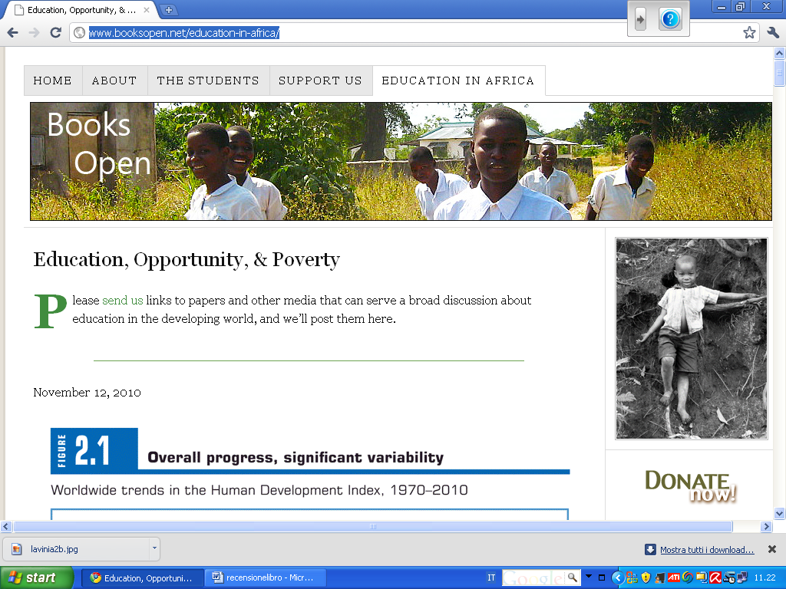
_______________________________________________
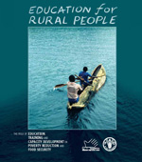
EDUCATION for RURAL PEOPLE: The role of EDUCATION, TRAINING and CAPACITY DEVELOPMENT in POVERTY REDUCTION and FOOD SECURITY
From the Abstract: “The broad background is that studies leading to the formulation of the Millennium Development Goals in 2000 have shown the potential that poor people have to make their living if the right conditions are created. The challenge for the international community is to identify barriers and to create conditions for rural people to change and improve their situation. In this perspective, the way to reach food security is to strengthen the capacity of poor people. The concept of capacity is closely associated with notions such as empowerment. It is generally agreed that education in all its forms is one important pillar in such a strategy. The role of education is not only to impart knowledge and skills but also to contribute to the empowerment of people by improving their self-confi dence, widen their frame of reference and give them the tools to participate in wider processes of social and economic change.”

