http://www.libreriauniversitaria.it/education-for-rural-people-role/book/9789251062371

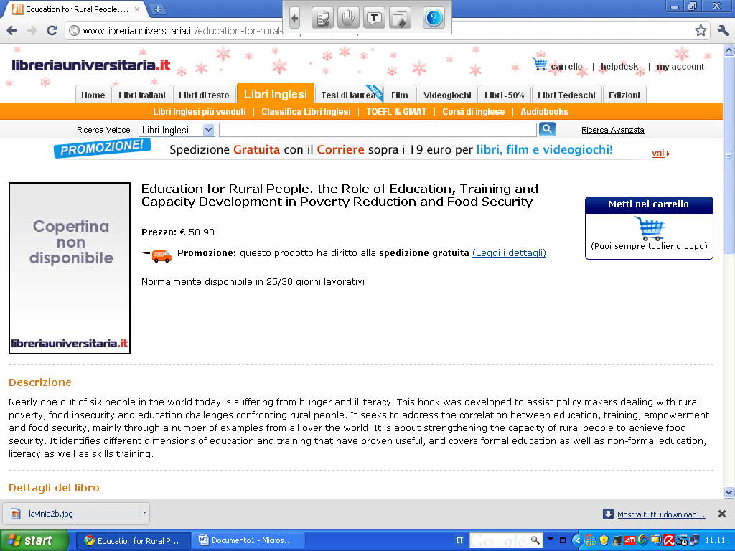

Dettagli del libro
- Titolo: Education for Rural People. the Role of Education, Training and Capacity Development in Poverty Reduction and Food Security
- Altri: Food and Agriculture Organization (Fao)
- Editore: Food & Agriculture Organization of the UN (FA
- Data di Pubblicazione: June 2009
- ISBN: 9251062374
- ISBN-13: 9789251062371
- Pagine: 00152
- Reparto: Reference - General

