http://www.ag.iastate.edu/stories/2010/11/acker-agriculture-is-powerful-tool-vs-poverty/
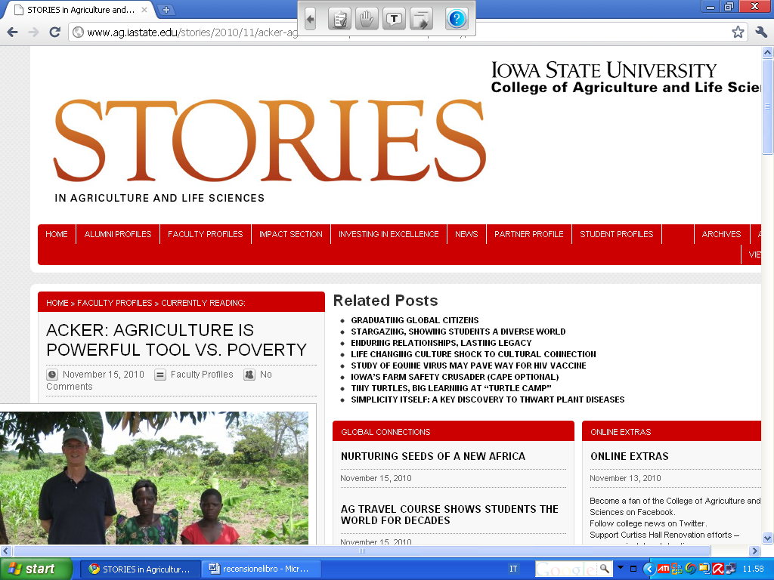
Pen to paper: Acker and Lavinia Gasperini wrote Education for Rural People: The role of education, training and capacity development in poverty reduction and food security in 2009, published by the Food and Agriculture Organization of the United Nations, available in English, French, Spanish and Italian.http://www.abbeys.com.au/book/education-for-rural-people-the-role-of-education-training-and-capacity-development-in-poverty-reduction-and-food-security.do

