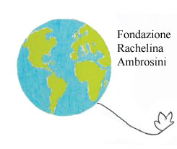The Rachelina Ambrosini Foundation
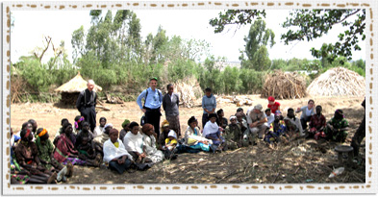
For years the Rachelina Ambrosini Foundation has been dealing with several humanitarian-charity projects in Italy and worldwide, working closely with associations, seriously committed over the surrounding area. The foundation works mainly with young people, not only with the more disadvantaged ones, but also helps those who are more fortunate, those who potentially have the tools to help themselves. it is for this reason that the organization involves students in initiatives to raise awareness and understanding in social situations, bringing them closer to the world of voluntary work and involving them in events such as “ The Days of Solidarity” and “The Days of Globalism”, together with a school contest that this year moves into its eleventh year (application forms available at www.fondazionerachelinambrosini.it).
All commitments throughout the world: Africa, Philippines, Honduras.
In order to mark the presence of the Ambrosini Foundation in the world, we could imagine a sort of comforting embrace around its most fragile part. It is currently operating in Ethiopia, The Philippines and Honduras, which are amongst the poorest and less industrialized countries in the world, which are also penalized in some cases by political situations and cultural restrictive beliefs existing on a still difficult ground, some examples of these are indigence, complicated and ineffective street systems and a lack of main services such as hospitals and schools. In these places the Foundation responds in a simple but decisive way to the urgent needs of these populations; guaranteeing at least one meal a day to 500 children of Santa Cruz on the isle of Marinduque in the Philippines; the support of the delicate process of education and alimentary self-sustainment thanks to the activation of a school vegetable garden in the communities of Las Flores and El Paraiso in Honduras and the cooperation with the Italian Association of Doctors with ‘Africa Cuamm’ in order to guarantee free access to maternity and postnatal care for both mother and child in the hospital of Wolisso in Ethiopia and in 15 other African hospitals. The Foundation has also been working in partnership with the WFO (The World Famine Association) since June 2011.
The humanitarian projects: Horn of Africa – Ethiopia. “Parto……con Te”.
In Africa the Ambrosini Foundation supports the cause of dedicated doctors. These doctors together with Africa Cuamm, they have been working with the objective of creating an effective local health service system since 1950. “My brother is African” is the In 2010 this group promoted their mission with an important event called “My Brother is African”, at the heart of this event was the driving force behind the mission of the Ambrosini Foundation. This mission started in 2011 when the President of the foundation, Tommaso Maria Ferri and the co-founding father, Don Luigi Mazzucato, alongside a group of voluntary professionals made up of doctors, engineers, university teachers and operators of development and cooperation went to Ethiopia. The missionary pilgrimage left from the catholic hospital of St. Luke of Wolisso, the Ambrosini Foundation dedicated The Dove of Peace to the medical staff there. It then carried on through the streets of Lalibela, Axum, Gondar, Addis Abeba, settling in the district of Goro, on the borderline with Southern Sudan, here they launched their humanitarian project “Parto…con te”. Here the Foundation is creating a free health service system to guarantee better maternity and postnatal care for mother and child. It is also installing a solar powered plumbing system and offering training programs for 50 HEWs (Health Extension Workers) to assign to the kebelè of Goro. This health system will offere assistance to those in need with no discrimination and will consequently promote intercultural relations as there are numerous different ethnic groups here, including refugees from Darfur, and for this reason integration is particularly important.. The nearest well to the village is seven kilometers away and e the Gumus are not always allowed to take water from it, but where there’s no water water there’s no life.
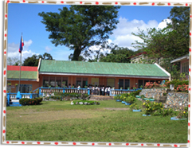 Philippines – Isle of Marinduque. “Un Sor...riso al cioccolato”.
In the archipelago of Philippines , Isle of Marinduque, there is a small town called Santa Cruz. The landscape and untouched nature is breathtaking. However looking closer into certain elements of the island, such as the Hupi Elementary school, where 500 of the inhabitants children study, we can see cracks in this idyllic appearance and the contrast between the overall beauty and extreme poverty is shocking. The hard life of this area is clear in the quality of life of children. They are malnourished and in many cases orphans. To get to school they wake up very early, they live in faraway villages and often walk for miles to be at school by 7 o’clock, when lessons start. They don’t have breakfast, and after a few hours they are so tired that they fall asleep at their desks. To pick them up teachers cook rice mixed with cocoa and milk in huge pots so that the children will have at least one meal a day. In order to take care of them, The Rachelina Ambrosini Foundation along with the nuns of Congregation of Saint Theresa of Baby Jesus in the Philippines started the humaniatarian mission called “Un Sor...riso al cioccolato” on the 1st of September . The project, joined by other associations, was able to guarantee these 500 children not only one complete and varied meal a day but also the right to receive an adequate education and above all better health assistance. The school is now equipped with computers, and on the land next to it school vegetable gardens have been created in addition to this, recently some small workshops of sewing and carpentry have been launched, and factories built to work local resources in order to support work and local families.

Honduras – Las Flores. “ Vivi con la gioia del cuore”.
“ Vivi con la gioia del cuore” is a solidarity project which was started up in 2004 in Honduras by the Ambrosini Foundation and by the Consulate of Honduras in Salerno, in cooperation with Father Ferdinando Castriotti, a missionary in some villages of Central America. The cooperation is based on intervention sharing in favour to the youth and the needy communities and it is basically inspired by the life style of Rachelina Ambrosini to express the spirit of brotherhood and full respect of human dignity. This enabled the Foundation to intervene and help the children of the Las Flores community (Central Honduras, Francisco Morazàn district). Thanks to the help of the Italian Consulate in San Pedro of Sula, the humanitarian aid firstly distributed clothes, shoes and didactic materials, then supplied Hygienic and sanitary tools for the pupils of the infant and primary school of the small town. It purchased these goods locally, in order to provide an real contribution to the local factories. After that the aim was to adapt the school structure to meet safety regulations and to protect the pupils. Since 2011 the Foundation has been involved in the creation of small indoors school vegetable gardens in many villages. In this way it wanted to invest in the environmental sustainability and food self-sufficiency, and transmit to the small children of Honduras the value and hope to enjoy the products of their own land.
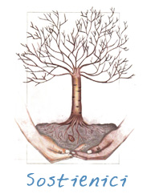
BANCA PROSSIMA – GRUPPO BANCA INTESA SAN PAOLO
IBAN IT04 N033 5901 6001 0000 0010 633
Fondazione Rachelina Ambrosini corso Luigi Cadorna, n.7 – 83030 Venticano (Avellino) – Italy tel. +39 0825 965201 infoline: cell. +39 339 4465559 www.fondazionerachelinambrosini.it – e mail: fondazioneambrosini@alice.it

