Food for the Cities - Des Aliments pour les Villes
Alimentos para las Ciudades - 为城市供应食物

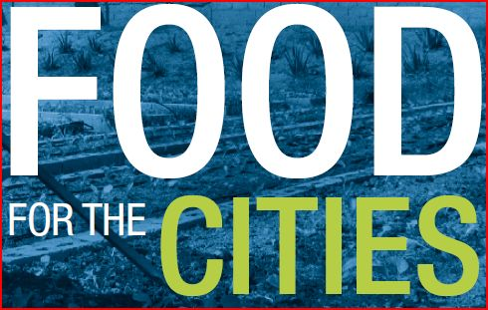

www.fao.org/fcit

The FAO Food for Cities multi-disciplinary initiative
is aimed at enhancing FAO support for implementing city-region food systems to enable local authorities to ensure governance of a dynamic and sustainable food system with strong urban-rural linkages and enabling the involvement of all key local stakeholders, with particular attention to local authorities. It is built upon FAO expertise and capacities in the different technical domains of agriculture and food.

For any further information, please contact:
Julien Custot Julien.Custot@fao.org – facilitator

You are invited to join the “Food for Cities” global network
http://dgroups.org/fao/food-for-cities

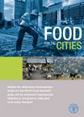  Brochure  In English  ftp://ftp.fao.org/docrep/fao/012/ak824e/ak824e00.pdf  Available also in:  Arabic, Chinese, Español, Français, Portuguese | 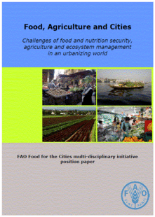  Food, Agriculture and Cities.  Position paper - FAO, Rome (2011)  In English: http://www.fao.org/index.php?id=28645
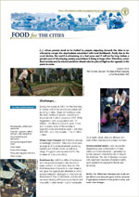  Factsheets  In English  http://www.fao.org/docrep/011/ak003e/ak003e00.htm  Available also in:  Chinese, Español, Français | 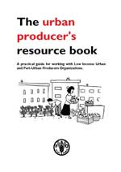  The urban producer’s resource book  In English  http://www.fao.org/docrep/010/a1177e/a1177e00.htm  Available also in:  Español, Français
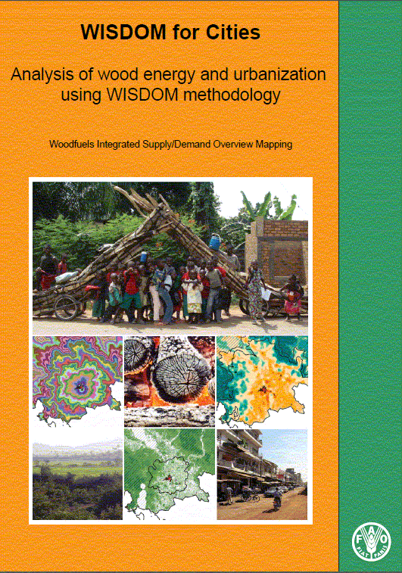  WISDOM for cities: Analysis of wood energy and urbanization aspects using WISDOM methodology - Woodfuels Integrated Supply/Demand Overview Mapping - FAO, Rome (2008)  In English:  ftp://ftp.fao.org/docrep/fao/010/i0152e/i0152e00.pdf Available also in: Français | 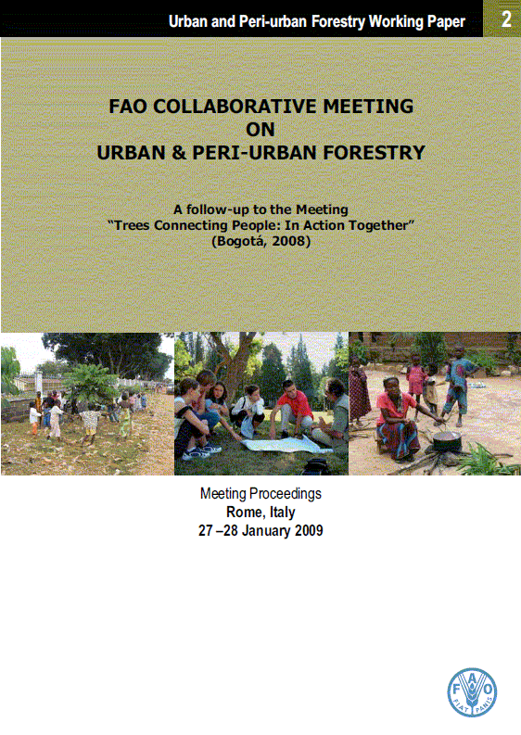  FAO collaborative meeting on urban and peri-urban forestry: A follow up of the Meeting “Trees Connecting People. In Action Together” (Bogota, 2008) – Meeting Proceedings  Urban and Peri-Urban Forestry Working Paper No. 2  FAO, Rome (2009)  In English: http://www.fao.org/docrep/012/i1352e/i1352e00.pdf
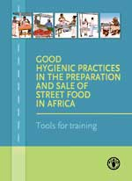  GOOD HYGIENIC PRACTICES IN THE PREPARATION AND SALE OF STREET FOOD IN AFRICA Tools for training  FAO, Rome (2009)  In English: ftp://ftp.fao.org/docrep/fao/010/i0152e/i0152e00.pdf | 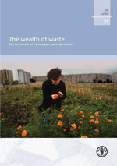  THE WEALTH OF WASTE  The economics of wastewater use in agriculture  FAO, Rome (2010)  In English:  http://www.fao.org/docrep/012/i1629e/i1629e00.htm
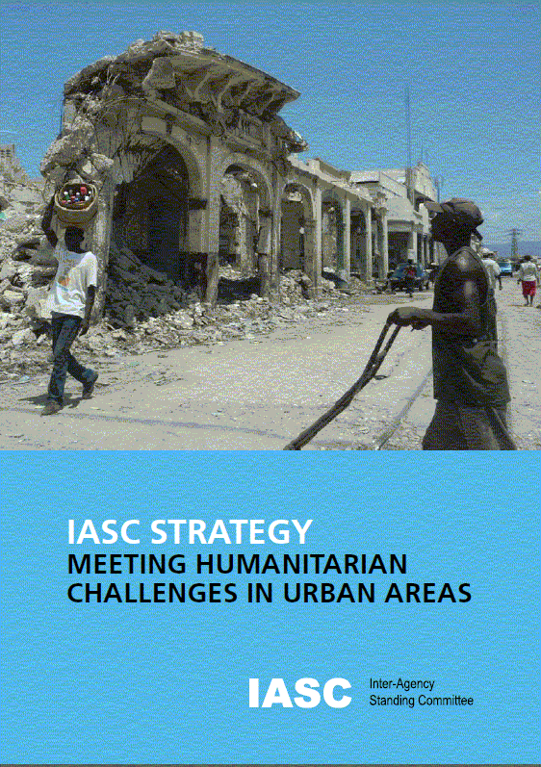  IASC STRATEGY MEETING HUMANITARIAN CHALLENGES IN URBAN AREAS IASC, 2010  In English: http://www.fao.org/fileadmin/templates/FCIT/PDF/IASC_Urban_Humanitarian_Strategy.pdf | 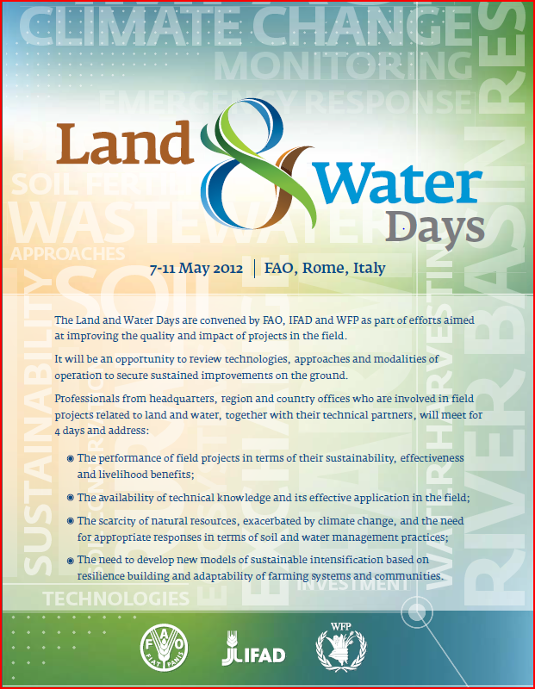  FAO Land and Water days, land and water for UPA, May 2012  http://www.fao.org/fileadmin/templates/FCIT/PDF/Report_LW_for_UPA_Session_FINAL.pdf  http://www.fao.org/nr/water/docs/FAO_recycling_society_web.pdf  http://www.fao.org/nr/water/docs/fao_urban_agri_factsheet.pdf
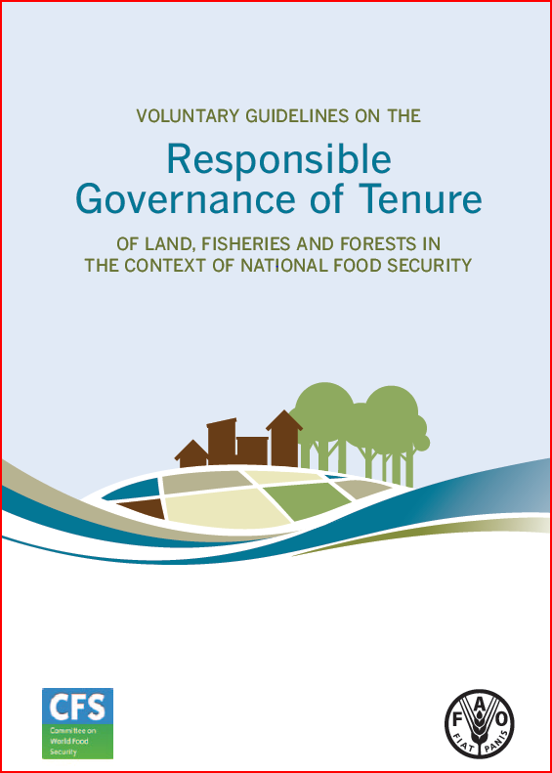  Voluntary Guidelines on the Responsible Governance of Tenure  http://www.fao.org/docrep/016/i2801e/i2801e.pdf | 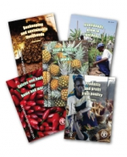  Diversification booklet series  No.2 Livelihoods grow in gardens (2nd Edition)  http://www.fao.org/docrep/015/i2463e/i2463e00.pdf  No.5 Processing for prosperity (2nd Edition)  http://www.fao.org/docrep/015/i2468e/i2468e00.pdf
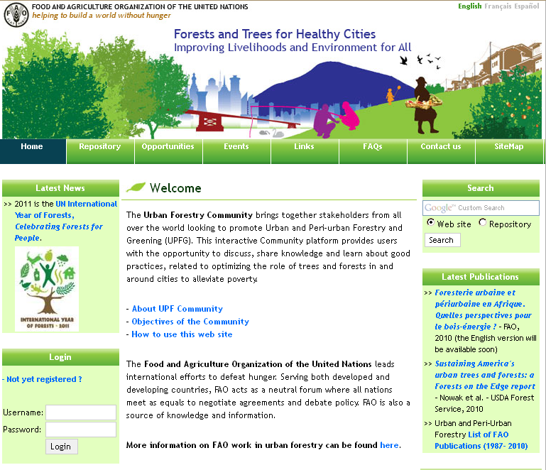  Forest and Trees for healthy Cities on-line community  http://km.fao.org/urbanforestry/  Available also in:  French and Spanish | 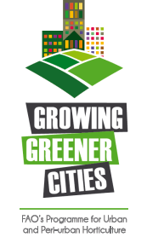  FAO’s programme for Urban and Peri-Urban Horticulture  http://www.fao.org/ag/agp/greenercities/index_en.html  Available also in:  French, Spanish and Portuguese

