**ESS/ALSLAC/09/2**

**E**

November 2009

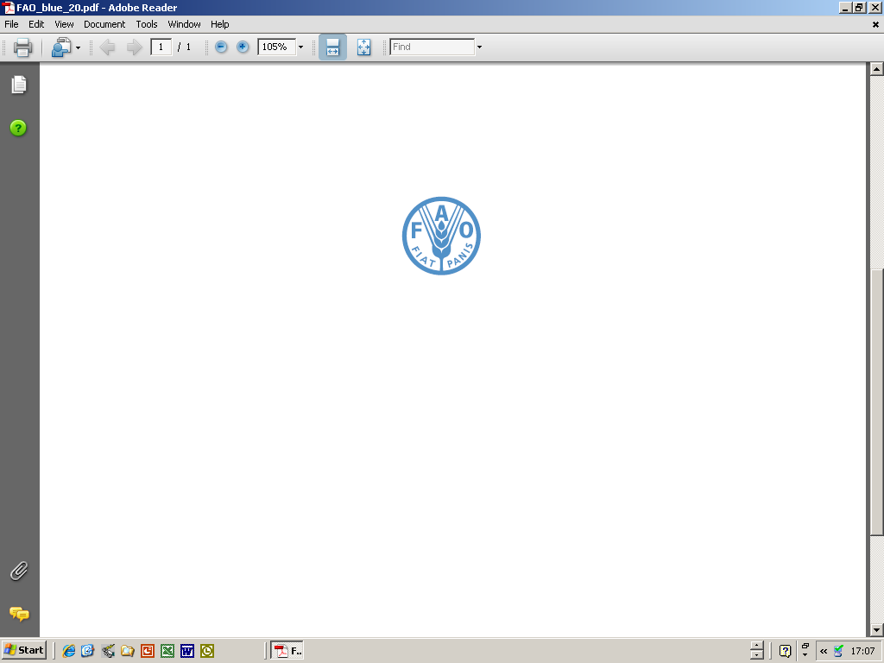  

FAO-OEA/CIE-IICA WORKING GROUP ON AGRICULTURAL AND LIVESTOCK STATISTICS FOR LATIN AMERICA AND THE CARIBBEAN

Twenty-fifth Session

Rio de Janeiro, Brazil, 10-12 November 2009

PROVISIONAL TIMETABLE

## **Tuesday, 10 November 2009**

**09:00 - 09:30 Registration of the participants.**

09:30 - 10: 00 Agenda Item 1 - Opening of the Session

* Address by the FAO Representative
* Address by the Representative of IICA
* Address by the Representative of the Government of Brazil

10:00 to 10:30 Break

10:30 to 11:00

* Introduction of the participants and resource persons
* Organization and operation of the meeting

Agenda Item 2 - Election of Chair, Rapporteur and Drafting Committee

Agenda Item 3 - Approval of the Agenda

11:00 to 11:20 Agenda Item 4 - FAO Activities in Food and Agricultural Statistics in the Latin America and Caribbean Region during 2008-09

* FAO Activities in Food and Agricultural Statistics in the Latin America and Caribbean Region during 2008-09 (R. Sibrian, FAO)

11:20 to 12:30 Agenda item 5 - Global Strategy to Improve Agricultural Statistics

* Global Strategy for Agricultural Statistics (E. Nuñes, IBGE and H.Som, FAO)
* Integration of Agricultural Statistics into National Statistics System in Brazil (F. Bolliger, IBGE)
* Statistics Capacity Building in Costa Rica (Didier Hernández)
* General discussion

12:30 to 14:00 Lunch

14:00 to 15:00 Agenda Item 6 - Tracking Results in less-than-ideal Situation: Sourcebook on indicators for monitoring and evaluation of agricultural and rural development

* Tracking Results in less-than-ideal Situation: Sourcebook on indicators for monitoring and evaluation of agricultural and rural development (H.Som)
* General discussion

15:00 to 15.30 Break

15:30 to 17:30 Agenda Item 8 - World Census of Agricultura 2010: Progress in Latin America and the Caribbean

* New features of the World Programme for the Census of Agriculture 2010 (H. Som)
* Selected country experiences in agricultural census:
  + Chile (Diana Trujillo, INE)
  + Brazil (Antonio Carlos Simões Florido and Octavio Costa de Oliveira, IBGE)
  + Haiti (Rideler PHILIUS)
  + Panama (Victor Villalobos)
* General discussion

**Wednesday, 11 November, 2009**

09:00 to 10:30 Agenda Item 7 - Food Security Statistics

* The food balance sheets for monitoring food security in Panama (Villalobos)
* Food Insecurity Assessment from Continuous Household Survey 2003-04: Bolivia Experience (Walter Portillo)
* Food Insecurity Assessment from National Household Survey 2003-04: Peru Experience
* Food insecurity assessment based on household surveys in Brazil (Marcia Maria Melo Quintslr/ Andre Luiz Martins Costa, IBGE)

10:30 to 11.00 Break

11:00 to 12.30 Agenda item 9 - Special Presentations by the Countries and Invited Institutions

* Data Users Needs and Capacity Building (L. Sivers, NASS, USDA)
* Objective Methods of Estimating Areas and Yields in Mexico (Miramontes)

12:30 to 14.00 Lunch.

14:00 to 14:45 Agenda Item 11 - Statistical capacity building: an FAO Strategy and Programme

* Approaches and Programmes for Statistical Capacity Building: *FAO Strategy and Programme (H. Som)*

14:45 to 17:30 Visit to IBGE

*Thursday, 12 November, 2009*

09:00 to 09:45 Agenda Item 10 - Collecting and compiling agricultural prices

* Collecting and Compiling Food and Agricultural Prices in Latin America: Current Status and Future Directions (R. Sibrian)
* General Discussion

**09:45 to 10:30 Agenda item 12 -** Upgrading Human Resources skills for agricultural statistics in 21st Century

* Upgrading Human Resources skills for agricultural statistics in 21st Century (H. Som)

10:30 to 11:00 Break

11:00 to 12:30 Agenda Item 9 (continued) - Special Presentations by the Countries and Invited Institutions

* Compilation of sale and rent prices of agricultural land in Uruguay: An example of the use of administrative records for statistical purposes (Alfredo Hernández)
* Dominican Republic (Francisco Caceres)
* Paraguay

12:30 to 14:00 Lunch

14:00 to 15:30 Agenda Item 13 - Discussions on proposals for working group recommendations

15:30 to 16:00 Break

16:00 to 1700 Agenda 14 - Draft Recommendations of the Meeting (discussion)

17:00 to 17:30 Agenda Item 15 and Agenda Item 16

* Adoption of the Recommendations of the Working Group
* Closing Session