**ESS/ALSLAC/09/INF 1**

**E**

November 2009

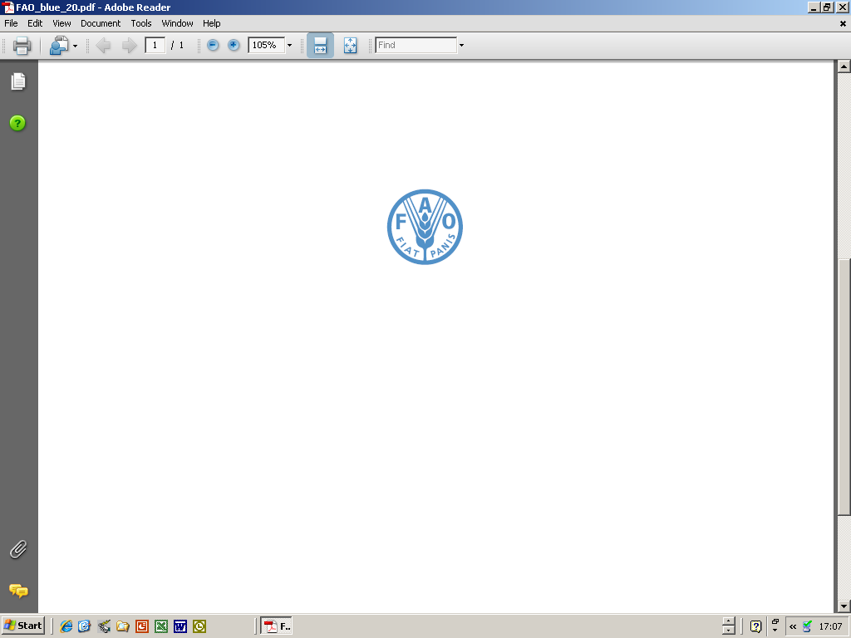  

##### FAO-OEA/CIE-IICA Working Group on Agricultural and Livestock Statistics for Latin America and the Caribbean (25th Session)

**Rio de Janeiro, Brazil,10-12 November 2009**

##### INFORMATION NOTE

**I. Seminar information**

## Venue

The 25th session of the FAO-OEA/CIE-IICA Working Group on Agricultural and Livestock Statistics for Latin America and the Caribbean, sponsored by the Food and Agriculture Organization of the United Nations – FAO, the Interamerican Institute of Cooperation for the Agriculture – IICA and the Brazilian Institute of Geography and Statistics – IBGE, will take place at the IBGE, in Teixeira de Freitas Auditorium located at 706 General Canabarro Street, district of Maracanã, Rio de Janeiro, Brazil on November 10-12, 2009.

## Registration

The opening session will start at 9:00 AM on Tuesday, November 10th, 2009. Registered participants may take their material at the reception desk at the lobby of the Teixeira de Freitas Auditorium from 8:30 AM.

## Languages

During the meeting, there will be simultaneous interpretation services to/from English and Spanish.

## Internet and e-mail services

There will be free access to the Internet on computers located at the lobby of the Teixeira de Freitas Auditorium.

## Food

Coffee breaks and lunch will be offered during all the days of the Working Group session.

## Contact persons

Please contact the following persons for any information on the event:

In Brazil

**Ms. Renata Dias Corrêa Guimarães**

IBGE – Instituto Brasileiro de Geografia e Estatística

International Relations

Av. Franklin Roosevelt, 166 – sala 201

Castelo - Rio de Janeiro – RJ - Brasil

Tel: +55 21 2142-0993

Fax: +55 21 2142-8730

E-mail: renata.guimaraes[@ibge.gov.br](mailto:wanda.coelho@ibge.gov.br)

**Mr. Renato Bastos**

IBGE – Instituto Brasileiro de Geografia e Estatística

Centre of Documentation and Dissemination of Information

Marketing Coordination

Rua General Canabarro, 706

Maracanã, Rio de Janeiro - RJ - Brasil

Tel: +55 21 2142-0123 extension number 3601

Fax: +55 21 2142-0257

E-mail: [renato.bastos@ibge.gov.br](mailto:j.tenorio@ibge.gov.br)

At FAO for technical matters:

**Mr Hiek Som**

Deputy Director, Statistics Division

FAO

Via delle Terme di Caracalla

00153 Rome, Italy

Tel: +39-06 5705 5070

Fax: +39-06 5705 5615

E-mail: Hiek.Som@fao.org

**II. Travel**

## Visa requirements

Foreign participants should check the need for visa to enter Brazil. If required, visa should be obtained from Brazilian embassies or consulates before entering the country.

Vaccination

Vaccination against yellow fever is required when coming to Brazil. Foreign participants should carry with them their vaccination certificate.

## Accommodation

The participants are responsible for their own hotel reservation.

The organizers of the event recommend the following hotels:

**Sofitel Rio Hotel**

Avenida Atlântica, 4240

Copacabana

Tel: +55 21 2525-1232 / 2525 - 1200

E-mail: [reservas.sofitelrio@sofitel.com](mailto:reservas.sofitelrio@sofitel.com) / paulo.cesar@sofitel.com

Fare: Single = R$ 440.00 + 14%(taxes)

Breakfast is included

[http://www.sofitel.com/gb/hotel-1988-sofitel-rio-de-janeiro-copacabana/index.shtml](http://www.pestana.com/)

**Olinda Othon Classic**

Avenida Atlântica, 2230

Copacabana

Tel: +55 21 2159 9000 / Fax: +55 21 2159 9001

E-mail: [reservas.olinda@othon.com.br](mailto:reservas@othon.com.br) / monica.amorim@othon.com.br

Fare: Single or double (Deluxe Front View) = R$ 265.00 + 15%(taxes)

Breakfast is included

http://www.hoteis-othon.com.br/html/hotel/olinda-othon-classic/o_hotel.aspx

**South American Copacabana Hotel**

Rua Francisco Sá, 90

Copacabana

Tel: +55 21 2227-9161 / Fax: 55 21 2267-0748

E-mail: reservas@southamericanhotel.com.br

Fare: Single = R$ 185.00

Double = R$ 203.00

There is no tax.

Breakfast is included

http://www.southamericanhotel.com.br

Transportation

For transportation between the airport and the hotel, we suggest to use the service of special taxis. Tickets may be purchased at the taxi counters just outside customs in the Rio de Janeiro International Airport or at the arrival area in the Santos Dumont Airport.

IBGE will offer shuttle service from the recommended hotels to the venue and back. However, it is necessary that each participant informs to Ms. Renata Guimarães the name of the hotel in which the reservation was made. Therefore, the shuttle bus will pick up the passengers at 8:00 AM sharp in the reception of each hotel.

## Side/Social Events

The organization of the Working Group session will provide the following agenda of side events:

* Cocktail on Tuesday, Nov 10 after the last session of the day;
* Free transportation to a tourist attraction on Wednesday, Nov 11 afternoon (participants will be responsible for their own expenses);
* Free transportation to a typical restaurant on Thursday, Nov 12 after the closing of the Working Group session (participants will be responsible for their own dinner expenses).

**III. Other information**

Weather

The weather in Rio de Janeiro in November is generally mild, with temperatures around 30ºC. The venue is air-conditioned at approximately 22ºC.

Money exchange

The participants may bring foreign currency or traveler checks, that may be exchanged into local currency, the Real. International credit cards are generally accepted. Currency exchange is available at the airports and in some hotels. The exchange rate is approximately R$ 1.75 for US$ 1.00.

Electric system

Standard voltage in Rio de Janeiro is 110V.