16th World School Milk Day
30 September 2015

The 1st World School Milk Day was celebrated in September 2000 and has since become an annual event held in many countries throughout the world. The proposal to hold the celebration was originally made in an e-mail discussion forum moderated by FAO (Dairy Outlook) and it has since been promoted each year by FAO.

In 2015, World School Milk Day was celebrated in approximately 20 countries. Activities centred on school-based events and included the distribution of milk, seminars, essay and art competitions, media reports and promotional events. Here is a selection of events from a range of countries.
Country | Description
Bosnia and Herzegovina | School-based activities | 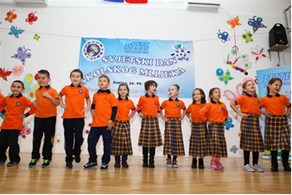
Croatia | Distribution of dairy products and dairy exhibition held | 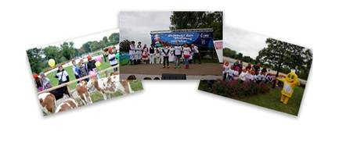
Ethiopia | Milk information day held | 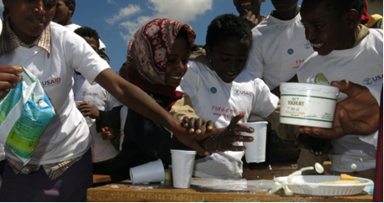
Dominican Republic | Milk distribution in schools and a press release | 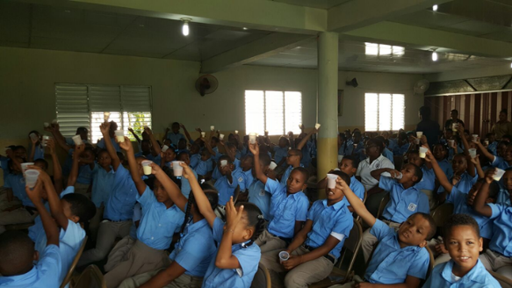
Germany | School-based events and exhibitions organized | 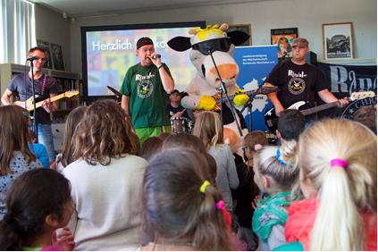
Finland | Promotional material and a press release | 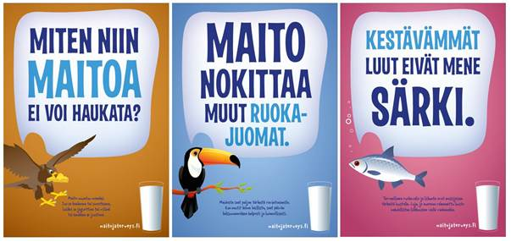
India | Dairy factory visit and drawing competition | 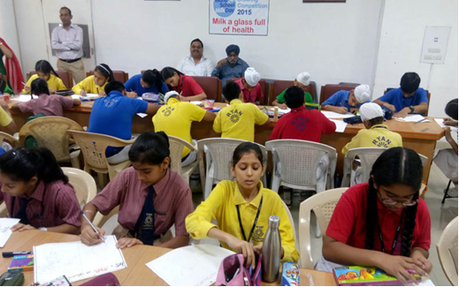
Jamaica | Milk information day held | 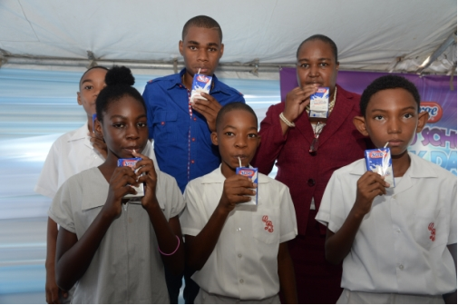
Luxembourg | Information day
Myanmar | Distribution of dairy products and an exhibition | 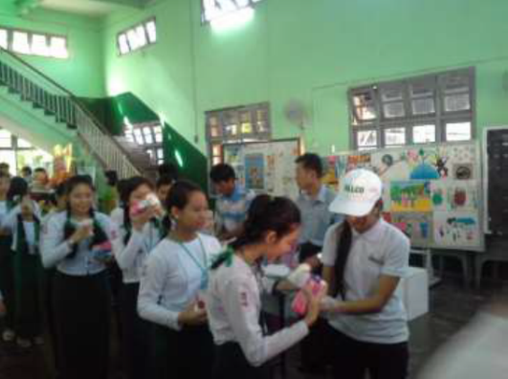
New Zealand | School-based activities  Thank you letter to Fonterra Farmers | 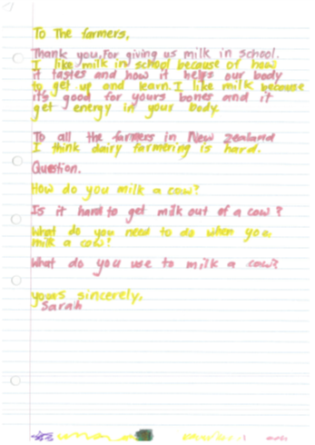
Peru | Web promotion of the event | 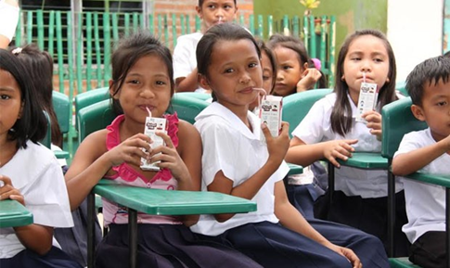  More info
Poland | Information day and election of the Milk Queen | 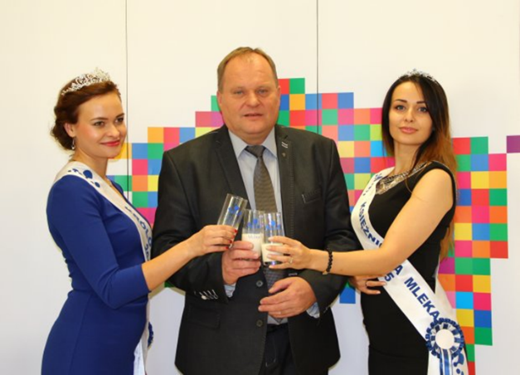
 |  | More info
UK | Nutritional promotions | 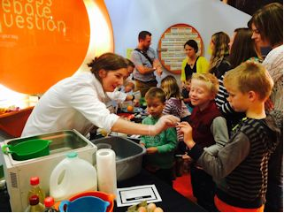  More info
Russian Fed. | Quiz and dance contest in schools | 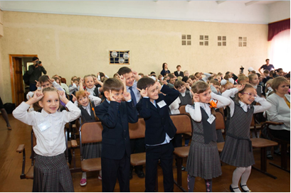
Spain | Promotion of recipes based on dairy products | 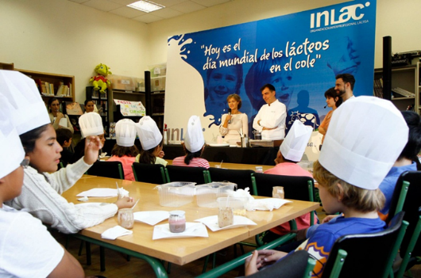
Thailand | Activities in schools | 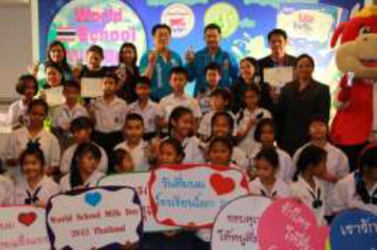
United States | Distribution of promotional kits and school-based events | 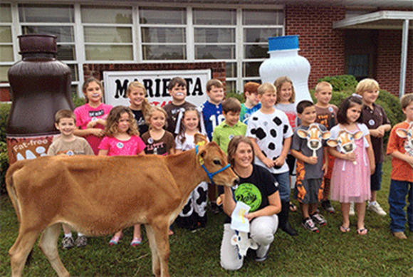  More info

Source: Information derived mainly from the Dairy-Outlook e-mail discussion forum, plus internet.

WORLD SCHOOL MILK DAY – last Wednesday in September
How did it start? Following discussion on FAO's email discussion lists regarding selecting a particular day on which school milk could be celebrated internationally, consensus was reach amongst members that World School Milk Day would be celebrated on the last Wednesday in September. This date was chosen because schools were open all the countries surveyed during this month. The end of the month was selected to allow countries in the western hemisphere sufficient time to prepare for this day, as in most of these countries the school year starts in early September. Wednesday was chosen as it was a school day in all countries surveyed.
The 1st World School Milk Day was held in 2000 and it has since become an annual event. Every last Wednesday in September, over 30 countries - regardless of whether they are large or small, rich or poor - celebrate World School Milk Day, demonstrating that the interest in school milk is universal.
The goal of World School Milk Day is to provide a particular day when attention is focused on this issue and thereby promote such programmes. Importance is lent to the event by the fact that other countries are doing the same thing, on the same day, and that FAO is supporting the activity.
FAO's role is to co-ordinate celebrations by informing people through the Dairy-Outlook and School-Milk lists about the Day and collating information from list members regarding preparations for celebrating this Day and inspire others to join in. From our end here, we can only remind, encourage and promote, but the real ideas and organizing work happens at the national or local level in the various countries.
How is World Milk Day celebrated? World School Milk Day is an "open" day - people are free to celebrate how they wish. Celebrations can be at any level - from national or regional events to individual schools. Some countries have started in a small way and have organized bigger celebrations with each passing year. Big or small, all have a common goal: to draw attention to school milk and thereby promote its consumption.
In celebrating the Day, FAO's involvement can be freely mentioned; however, this does not extend to FAO endorsing a particular branded product. At the same time, a key facet of FAO's work on school milk has been the duel promotion of dairy industry development and good child nutrition. Therefore, branded products and promotions, which are a way of promoting the dairy industry, can be used during celebrations.
Celebrations of past years showed how creative people are in celebrating WSMD. In almost all countries celebrating the Day, free milk is distributed to children in schools. Other activities include sporting events, distribution of educational and promotional material and celebrity visits to schools; also drawing and art competitions are very popular. Often dairy companies act as sponsors of the Day and provide not only free milk but also promotional material such as t-shirts, caps, pens, posters, etc. for the children.
Let us know how you celebrate the 17th WORLD SCHOOL MILK DAY, 28 Sept, 2016
Send messages to: fao-dairy-outlook@fao.org

