Committee on Commodity Problems

INTERGOVERNMENTAL GROUP ON TEA

Twenty-second Session

Naivasha, Kenya, 25-27 May 2016

REPORT OF THE WORKING GROUP ON CLIMATE CHANGE

**INDIA**

**Action area 1: Database collection and analysis**

Data collection and analysis of meteorological parameters has been further updated and carried out for all the seven locations in East India, on yearly, weekly and daily basis. The data in Figure 1 represent South bank region of Assam and the 96 years of data which although continues to shows an overall decline of nearly 200 mm but it also shows that when compared to previous years rainfall (2014) the year 2015 has shown a rise in total rainfall of around 280 mm with respect to 2014. A closer look at the data of these two years (2014 and 2015) when analysed in weekly basis gives an answer to the rise in total rainfall in the year 2015. The data presented in Figure 2 represent the weekly data of the South bank region of Assam for the year 2014 and 2015. The figure shows that in the year 2014 there was almost no rain after the month of June whereas in 2015 rainfall continued till end of October. Such trends of high and low rainfall variability from year to year basis bring about too much (flood) and too less (drought) water availability in tea gardens.

Assam tea is known for its second flush variety i.e. the leaves harvested in the month of May-June. It is during the second flush that the bush produces the finest quality of leaves and buds rich in natural chemicals that result in strong cups and the rich aroma for which Assam tea is famous. The second flush comes for a period of 15 to 20 days. The leaves at this time is a resultant of the climate prevailed during its prior months because tea being a rain-fed perennial crop, the physiology of tea plants is closely linked to external environmental and climatic factors – elevation, precipitation, temperature, soil moisture, fertility, light duration and intensity, humidity, shelter, shade and carbon dioxide concentration and so any change in these conditions can significantly impact yield. Daily rainfall for the year 2016 has been analysed and compared with the long term normal (Figure 3). Results show that rainfall in this period in the current year i.e. 2016 has significantly increased. This increase in rainfall will lead to cooler temperature than required and consequently lesser growth and ultimately impacting the overall yield.

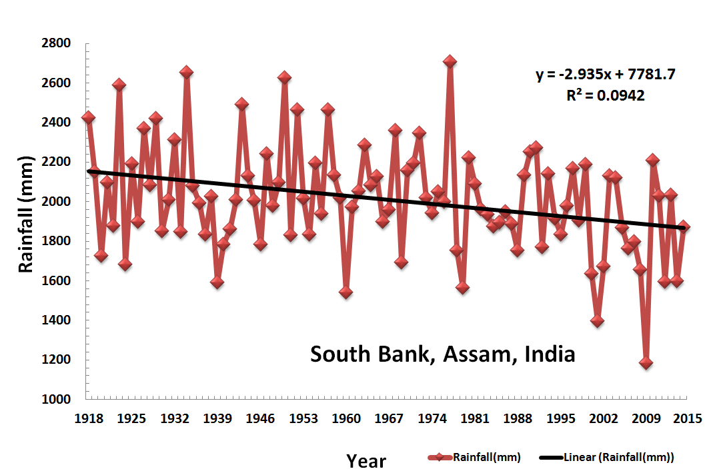

**Fig.1: Annual total Rainfall, 1918-2015 (South Bank, Assam, India)**

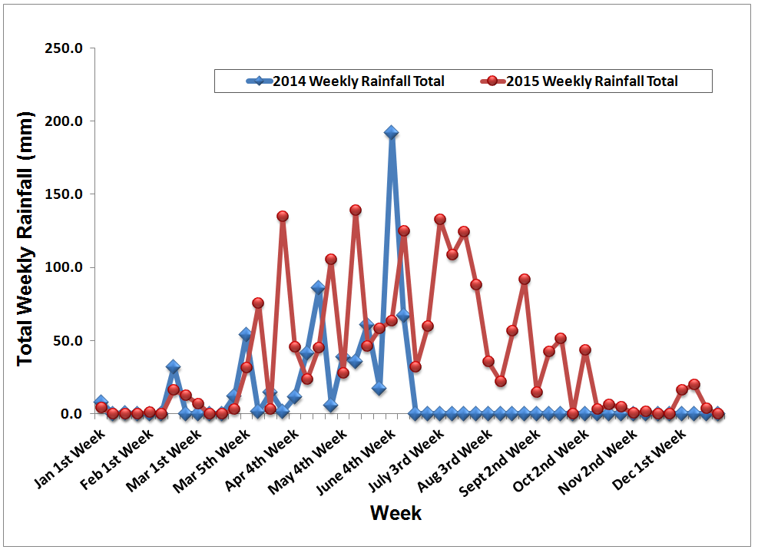

**Fig.2: Comparison of Weekly total Rainfall in last two consecutive year’s 2014 and 2015 (South Bank, Assam, India)**

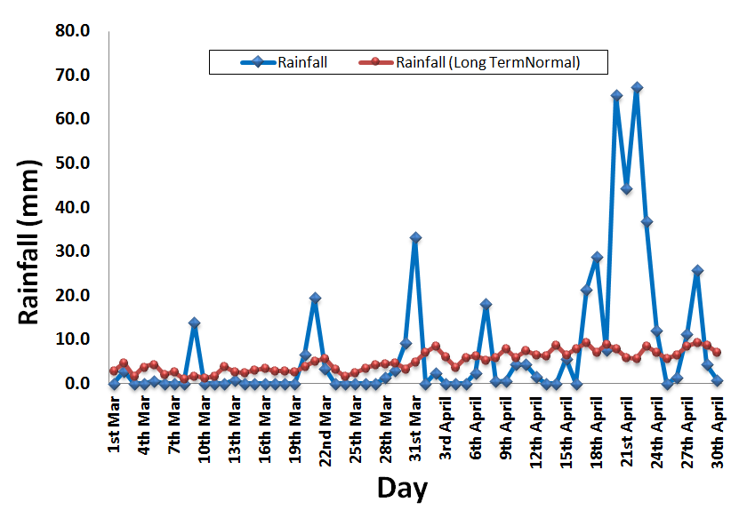

**Fig.3: Daily rainfall during the period March and April 2016 (South Bank, Assam, India)**

**Work out interaction between Genotype (G) x Environment (E) x Management (M) which is the prime driver of productivity**

The third phase of the OTC experiment started in the year 2014 was completed. In the first phase the carbon dioxide level was 450 ppm and enrichment was done for five hours per day up to 400 hours. In the second phase, the level of carbon dioxide increased to 500 ppm for 400 hundred hours and the third phase the level increased to 550 ppm for 200 hours. Sensor data of daily temperature, humidity, carbon dioxide level of both the OTC and temperature of ambient condition were monitored. Morphological and biochemical parameters of the plants were measured at regular interval to find out the impact of climate on the clones. Data collected after third phase of the experiment are given below.

Morphological observation showed, the impact of growing environment on increase of plant height was significant (P=0.001). Out of fifteen clones, seven clones showed maximum increase in height when they were placed in the chamber with elevated carbon dioxide and the temperature, three clones showed maximum increase when they were placed in the chamber where temperature is more than ambient with ambient carbon dioxide level. Other three clones showed maximum increase in both the elevated condition. Most of the cultivars except few showed minimum height increase when placed in ambient condition (Figure 4).

Results of biochemical analyses showed that the impact of growing environment on Chlorophyll-a, Chlorophyll-b, Chlorophyll a+b was found to be significant (P=0.001). Maximum content was found in plants either when they are placed in chamber with elevated temperature or in ambient condition. In some clones the chlorophyll content was minimum when they were placed in the chamber with elevated carbon dioxide and the temperature. Chlorophyll a/b ratio also showed significant impact of environment (P=0.001).Ratio was found to be more in some clones when they were exposed to elevated temperature and carbon dioxide (Figure 5).

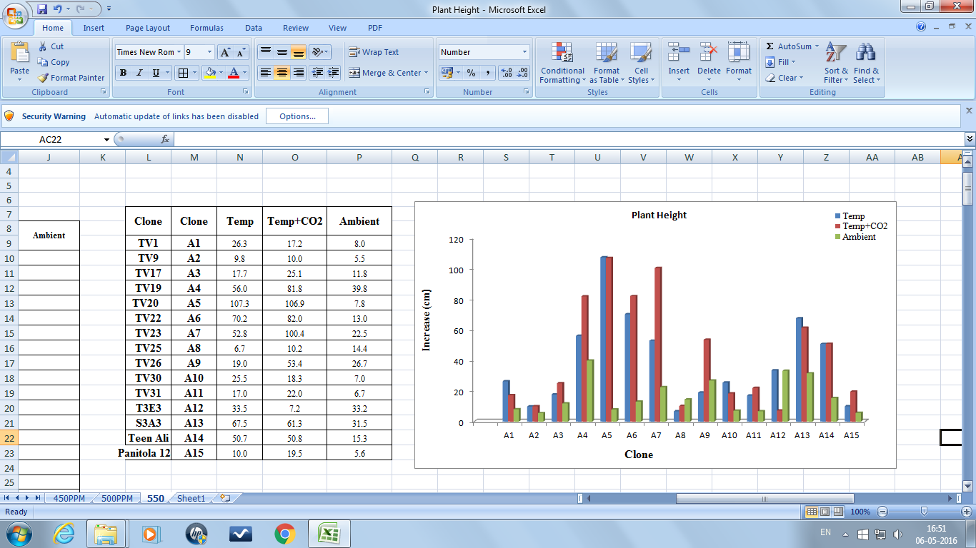

**Figure 4 Impact of environment on increase of plant height**

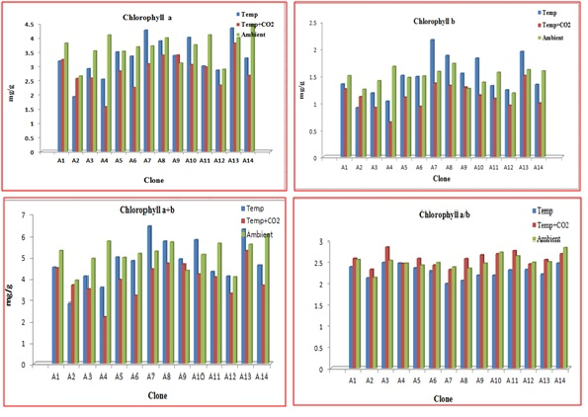

**Figure 5 Impact of environment on Chlorophyll content**

**Action area 2: Analysis of vulnerability / suitability with IPCC AR5 scenarios**

Spatial analysis was carried out to understand the impact of predicted future climate change in the four tea production regions of Assam: Upper Assam, South Bank, North Bank, and Cachar using existing baseline data and combining this with the most recent IPCC, AR5 predictions to create likely scenarios of future suitability for tea growth in the four regions by 2050.

The modelling was carried out using current climate data as baseline data and future climate data generated through several Global Circulation Models (GCMs). Variables included are monthly total precipitation, and monthly mean, minimum and maximum temperature, and 19 derived bioclimatic variables. The current climate grid was based on interpolation of observed meteorological data for a period of 50 years (1950–2000) from various sources including Global Historical Climatology Network (GHCN), FAO, WMO, International Centre for Tropical Agriculture (CIAT), R-Hydronet. The future climate was derived from WorldClim data which is a set of global climate layers (climate grids) with a spatial resolution of about 1 km2. The data layers were generated through interpolation of average monthly climate data from weather stations on a 1 km2 resolution grid. Out of the 19 GCMs, five models were selected for this study based on preliminary literature review about suitability of those models in the Indian subcontinent. The future climate grids of 2050 of the selected five models are climate projections obtained from GCMs for two representative concentration pathways (RCPs) 2.6 and 4.5. These are the most recent GCM climate projections that are used in the 5th Assessment IPCC report.

The GCM output was downscaled and calibrated using WorldClim as baseline ‘current’ climate. Suitability of tea in the current climate grid as well as future RCP’s in 2050 were modelled using MaxEnt (Maximum Entropy species distribution model) where the location of current areas of tea plantation was taken as reference. The sensitivity of the model in predicting the future suitability of tea growing region was carried out. Trends of change in precipitation and other climatic parameters were statistically derived. Statistical analysis was done to identify the most influential variables deciding on the future suitability of tea in Assam.

The results from one of the five models HadGEM2-ES for two RCP scenarios (2.6 & 4.5) of 2050 are presented here showing the present suitability of tea in the four tea major growing regions of Assam (Figure 6), the future suitability of tea in the year 2050 under the RCP 2.6 (Figure 7) and RCP 4.5 (Figure 8) scenarios of IPCC. The current suitability shows that South Bank region, parts of Upper Assam and Cachar are the suitable regions (very good and excellent suitability) whereas North Bank region are comparatively less suitable (good suitability). However, the predicted probability distribution of tea in future shows that 35 years from hence the suitability of these regions will reduce drastically across entire tea growing regions and shifting of tea is observed in comparatively higher altitude areas of Karbi Anglong, DimaHasao and Tinsukia districts under RCP 2.6 scenario where CO2 level are likely to reach 490 ppm by 2100. While considering RCP 4.5 where CO2 levels are likely to increase further up to 650 ppm the suitability reduces further with maximum reduction in Upper Assam region w.r.t. RCP 2.6 scenario. The drastic change in suitability is due to the change in seasonality of precipitation which has the maximum influence on future suitability in the modelled scenarios. Statistical analysis of change in precipitation shows a negative trend in the winter season as well as during the pre-monsoon season while positive trend of change during the monsoon season or more precisely during the months of June, July, and August as seen in Figure 9. The seasonal temperature was also observed to increase across all major tea growing regions under RCP 2.6 scenario (Figure 9 & Figure 10). While increase in temperature in the growing season may reduce the suitability, temperature increase in the dormant season may extend the growing season and increase suitability. This trade-off is needed to be studied further.

A test of confidence to find the variability with models and the coefficient of variation of maximum temperature predictions between models are 1.86% and coefficient of variation of minimum temperature predictions between models are 3.023% whereas the coefficient of variation of precipitation predictions between models is 8.06%. The model sensitivity analysis showed that all the 5 models have an AUC value between 0.862 – 0.867 (RCP 2.6) & 0.861 – 0.868 (RCP 4.5). Amongst the 19 bioclimatic variables seasonality of precipitation was found to have maximum influence on suitability of tea growing in Assam in 2050.

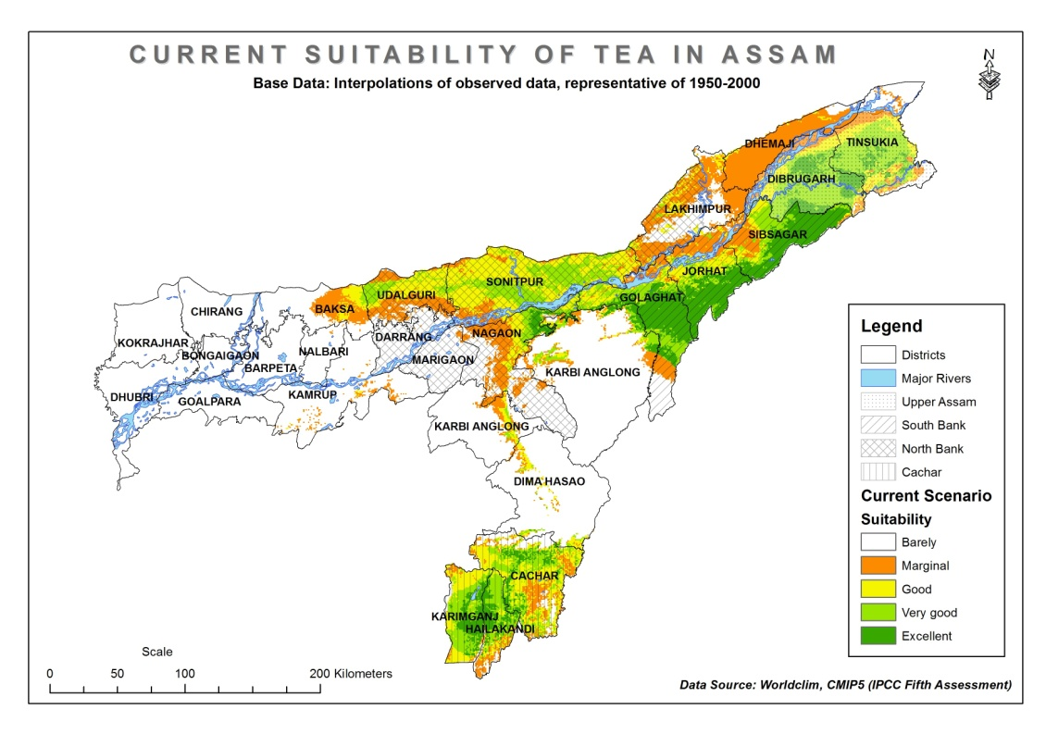

**Figure 6 Current suitability of tea in Assam based on *Maxent* model (*Source:* ETP-TRA Climate Project)**

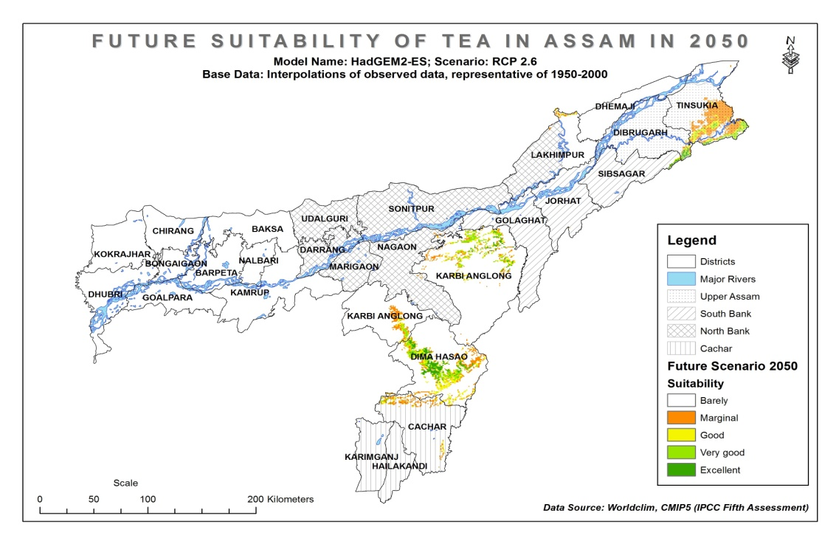

**Figure 7 Future suitability of tea in Assam by 2050 in RCP 2.6 IPCC Scenario (*Source:* ETP-TRA Climate Project)**

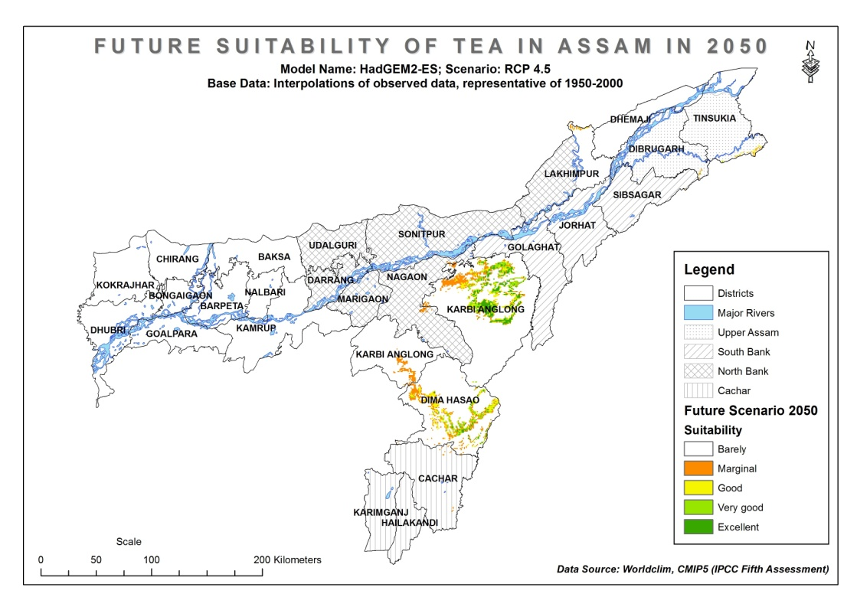

**Figure 8 Future suitability of tea in Assam by 2050 in RCP 4.5 IPCC Scenario (*Source:* ETP-TRA Climate Project)**

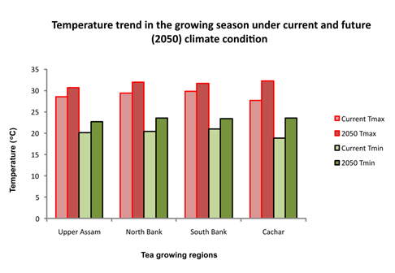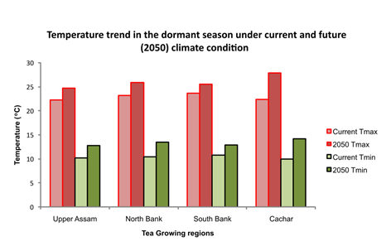

**Figure 9 Temperature trend in the growing and dormant season under current and future (2050) climate condition in four major tea growing regions of Assam (*Source:* ETP-TRA Climate Project)**

The results imply that likely decrease in precipitation during 1st and 2nd flush period, which may have an adverse effect on the production of the premium tea and increase in precipitation during the monsoon months June, July and August, may lead to waterlogging / flooding. The adaptation measures that are currently being implemented by the tea growers (which were not considered in the suitability modelling) may compensate the impacts of climate change to some extent, but are NOT sufficient. New adaptation techniques need to be explored which would be more contemporary with the future climate conditions.

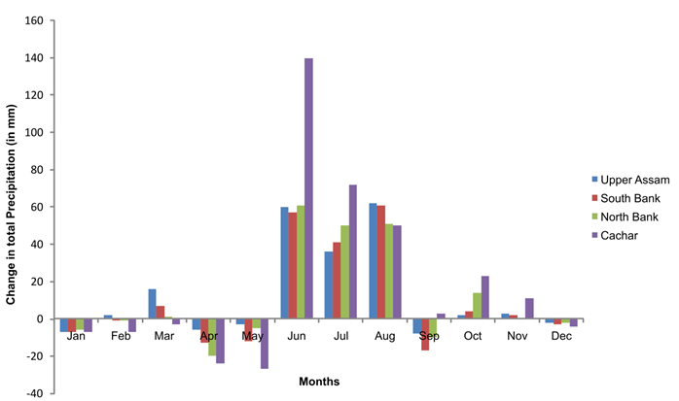

**Figure 10 Change in precipitation in 2050 in four major tea growing regions of Assam (*Source:* ETP-TRA Climate Project)**

**Action area 3: collate and combine adaptation strategies common to all WG countries along with country specific strategies**

The adaptation strategies common to all the WG countries have been collated in the booklet on Climate Change Adaptation in Tea and in available as recommendation to the industries in page 78-79.

**Action area 4: Publish a booklet on adaptation strategies common to all countries**

A booklet on Climate Change Adaptation in Tea has been prepared highlighting the technology and practices carried out currently in India to counter climate threats, along with other member countries of the WG. The booklet will be released during the FAO-IGG meeting in Kenya in May 2016.

**SRI LANKA**

**Action area 1: Database collection and analysis**

**Investigations on growth and yield of tea at high temperature regimes**

New investigations on clonal adaptability to high temperature regimes are in progress. Preliminary results of the field investigations with poly tunnels have shown that shoot growth and yield of tea at elevated temperatures, i.e. inside poly tunnel (35.9oC) in the low country region (warmer region) were less than that under ambient condition (34.0oC ). The time taken for bud break was extended and shoots population density reduced at elevated temperatures showing the possible adverse impacts of global warming on tea production in the low country region. These results agree with the previous findings.

**Action area 2: Analysis of vulnerability / suitability with IPCC AR5 scenarios**

**Data analysis and identification of vulnerable regions and adaptation strategies**

As detailed in the previous report, the Tea Research Institute of Sri Lanka has done a comprehensive analysis of data and consequently, tea growing regions vulnerable for climate change have already been identified. Most suitable adaptation measures to minimize adverse impacts were also identified.

Presently, the Tea Research Institute of Sri Lanka is in the process of disseminating these findings to the end users, i.e. tea small growers and corporate sector estates. Further investigations on same subject will be carried out once the Meteorology Department of Sri Lanka develop local climate scenarios as per IPCC AR 5.

Soil and soil moisture conservation in tea lands is one of the important adaptation strategies to minimize adverse impacts of climate change. The Sri Lanka government has given financial support to tea small growers for soil and soil moisture conservation in tea lands which help reducing climate change impacts.

The dry period with warm climatic conditions experienced in Sri Lanka during the first quarter of the year has reduced tea yields in all the regions largely affecting tea smallholders. The dry weather was more severe in March 2016. Consequently, the total tea production has reduced by around 11% during the first quarter of the year 2016 in comparison with the preceding year. Further, the loss of production in March 2016 was around 26% as compared with the same period in 2015 which shows the severity of dry weather and its potential impact on tea production.

**Action area 3: Collate and combine adaptation strategies common to all WG countries along with country specific strategies & Action area 4: Publish a booklet on adaptation strategies common to all countries**

A booklet depicting details of adaptation strategies suitable for different tea growing nations including Sri Lanka has been compiled. This will be translated into Sinhala & Tamil (local languages)once it is released at the next FAO-IGG sessions in Kenya.

**KENYA**

1. **Introduction**

Climate change will affect crop growth and consequently crop management. Climate change is very likely to affect future tea growth and crop management. Kenyan tea cultivations and production are likely to be faced with extreme conditions in future as a result of climate change. There are many climatic factors affecting agro-ecosystems and thereby influencing crop yield in different magnitudes. Climate change and variability threatens to increase the frequency and the intensity of these factors. The weather and seasonal ﬂuctuations in variables such as rainfall, temperature and humidity, and soil water deﬁcits inﬂuence annual yield distribution, and hence annual yields and black tea quality.

The variations in tea productivity and quality due to weather factors have been reported in many studies. In particular, tea yields vary with temperature, the saturation of water vapour pressure of air, rainfall and evapotranspiration which are affected by climate change. The components of tea yield (i.e. number of harvested shoots per unit area, rate of shoot growth and the average weight of shoots at harvest) are largely inﬂuenced by weather factors. Yields are usually low during the dry spells while low temperatures lead to slow growth resulting in low yields as a consequence of high proportion of dormant shoots, but high black tea quality. Provided soil moisture is adequate, warm temperatures lead to fast growth, resulting in high yields but low black tea quality. However, higher temperature will most likely affect photosynthesis negatively and thus obstructing biomass production.

Generally, rising atmospheric CO2 levels act like a natural carbon fertilization similar to current practice in glasshouse vegetable production, thereby enhancing crop growth. With both extreme rainfall and drought threatening Kenya under climate change, there are a number of significant impacts on the tea sector. Absence of rainfall will affect tea production because Kenya’s tea is production under rain fed system, thus dry spells causes decreased yields. Drought on the other hand is almost annual phenomena with tea yield losses of more than 20% for 2 to 3 consecutive months. The tea yield response to irrigation can be large during dry weather. Different tea genotypes differ in responses to irrigation even when they are grown at a single site under uniform management.

Frost bite, although a rare phenomenon in the past, is becoming a threat with tea yield losses of up to 30% for 3 consecutive months whenever it occurs. In Kericho, Sotik and Nandi Hills, net loss of tea green leaf due to hail is estimated at 2.7 million kilograms per year (reports from large scale farmers only). The combination of the named climatic factors may also not only act upon crop yield but also on crop quality, with the potential of affecting farm income more severely than just yield loss.

The adaptability of the plant to areas with large variations in geographical, climatic and environmental factors can cause changes in growth patterns in different genotypes leading to variations in yields and black tea quality. The adverse effects of drought can be partially mitigated by use of shade trees or irrigation. However, shade trees reduce tea yields in high altitude areas and nutrient availability but improve black tea quality. Developing countries are most at risk from impacts of climate change due to existing vulnerabilities and limited capacity to cope.

By generating site specific strategies for decision making, it is possible to shift from responding disasters to managing risks in a more cost-effective manner.

1. **Impact of dry weather on tea growth and yield**

The following issues have direct and indirect impacts:

* Leaf and bark desiccation
* Stem/collar canker wood rot
* Dormancy, poor bud break and bud scorch
* Plant casualties
* High evaporation
* Formation of a hard pan on ground surface
* Dry weather pests

**Impact of excessive rains**

* Poor bud break shoot development
* Heavy soil erosion/degradation
* Lowering soil depth
* Reduced water holding capacity
* Poor soil nutrients status
* Poor drainage in low lying areas
* Fast spread of fungal diseases
* Incidence of wet weather pests (nematodes)

Tea performance is near optimal in an environment with well-distributed rainfall ranging from 1500mm to 2500mm annually with long sunny intervals. Suitable air temperatures for tea growth range from minimum 180C to a maximum 300C with a mean of 240C. Timbilil Agro-meteorological Station was established in early 1950s to collect and monitor the climatic variables. Timbilil has experienced a generally increasing rainfall of about 1.2mm annually (Figure 1). The temperature trends show an annual increase of 0.020C, which may have an impact in tea production (Figure 2).

**Figure 1: Timbilil annual rainfall (1952-2015)**

Rainfall trend is rather different from temperature and radiation, depicting a quadratic relationship with time. Yield could be reduced by 30-90 kg /ha/month due to 100 mm drop in rainfall. Droughts restrict shoot extension i.e. causes slower shoot growth rate leading to high black tea quality. The yield variations in a single clone can range from about 18% during the rainy season.Rainy period leads to fast tea ﬂush (growth) which reduces black tea quality.

There is an increasing temperature trend of about 0.020Cy-1 (r2=0.375) from 1958 to 2015.Yield variability is directly related to base temperature for shoot extension and shoots population density, which affect management in terms of labour planning, transport requirements and factory capacity. Although, low temperatures restrict shoot extension, there are genotypic differences in the shoot base temperatures because some few clones can tolerate low temperatures while other cannot and only become dormant. Provided there is adequate moisture in the soil, high temperatures favour fast shoot growth thus increasing yield but lowering the black tea quality. On the contrary, low temperatures cause slow shoot growth rates leading to reduced yields with improved black tea quality.

**Figure 2: Timbilil mean air temperature (1958-2015)**

**Figure 3: Timbilil soil water deficit (2005-2015)**

Data on the annual variation of SWD from 2005 to 2015 suggest a decrease (Figure 3).

| **Table 1: Correlations of rainfall, temperature, crop yield and soil water deficit** | | | | | |
| --- | --- | --- | --- | --- | --- |
|  |  | Rainfall | Temperature | Cropyield | SWD |
| Rainfall | Pearson Correlation | 1 | .027 | .153 | .483 |
| Sig. (2-tailed) |  | .906 | .497 | .132 |
| N |  | 22 | 22 | 11 |
| Temperature | Pearson Correlation |  | 1 | .303 | -.164 |
| Sig. (2-tailed) |  |  | .170 | .630 |
| N |  |  | 22 | 11 |
| Cropyield | Pearson Correlation |  |  | 1 | .385 |
| Sig. (2-tailed) |  |  |  | .242 |
| N |  |  |  | 11 |

The analysis showed that there were significant positive correlation (R2=0.27 (Table 1), between rainfall and temperature which implied that any rainfall increase was accompanied by temperature increase. Thus, better quality and higher valuation are obtained from teas manufactured from shoots plucked during slow growth conditions in such months as July. Reduced rate of shoot extension is evident during period of water stress and low temperatures. High rate of shoot growth is recorded in warmer conditions at lower altitudes such as Sotik provided water and temperatures are not limiting. Such ﬂuctuation in harvestable yields due to seasonal variations affect the optimal efficiency of both tea growers and the processors.

1. **Future Projections**

In the future projections, mean rainfall could increase by about 11 percent by 2075. The distribution of rainfall and the rise in mean temperature beyond the threshold of 23.5oC will shift the current production areas, changing the distribution of suitable areas for growing tea in Kenya. The above scenario will decrease the distribution of suitable tea growing areas by 2050, but migration to upper altitudinal gradients will generally occur and will compensate for the predicted increase in temperature.

1. **Adaptations**

For the farmers to get prepared to adapt to climate change in tea production, adjustment of communities and ecosystems to cope with the adverse effect of climate change variability and change has been made.Appropriate measures that are adopted by stakeholders to minimize adverse impacts of climate change on tea and are clustered in either long term, medium term or short term:

**Long term drought adaptation strategies**

Increase uptake of improved quality tea clones

Use of drought tolerant cultivars

To avert the impacts of drought coupled with high temperature, planting of hardy/drought tolerant cultivars are recommended.

Selection of suitable areas for tea: expanding of tea to new areas that marginal where the weather conditionsare dry and soil conditions are poor is discouraged.

Farmers are encouraged to invest more on productive regions (Suitable/moderately suitable).

Farmers are encouraged to venture into other diversified agricultural enterprises as a risk precaution against climate change in tea enterprises.

Establishment of recommended shade trees (Grevillea robusta, Sesbaniasesbans and Mellicia dura)

Shade tree stand in tea plantations reduces ambient temperature/prevents sun scorch therefore reducing the plant mortality in the event of long drought. When tea is exposed to sun light and ambient temperature is 30-32oC the leaf temperature rises above 40oC. However, if shade trees are planted, leaf temperature limits only to >1-20C above the ambient temperature. Leaf litter acts as organic matter and while it covers the ground, it enriches the soil with N, P, K, and Carbon. Shade trees also have a major contribution to Carbon sequestration as well as improving net assimilation of tea leaf, reduced weed growth and minimize wind damage.

Rainwater harvesting for use during a dry spell

Water shed management

Establishment of forests covers on sloppy areas

**Medium term strategies to adapt to drought**

1) Proper land preparation/forking – to retain more water in soil

Cutting of lateral drains of ‘lock and spill’ type provided with silt pits / reverse slopes and de silting

2) Soil rehabilitation with a grass *e.g.* Vetiver. Soil rehabilitation helps to minimize the drought mortalities.

3) Rainwater harvesting is recommended in any of the tea estate infrastructure;

a) Factory roof /building roof/ house roof

b) With burying of pruned litter

4) Soil and moisture conservation through establishment of green manure crops

5) Dry weather pruning *e.g.* in the months of January to March

6) Minimal forking should be practiced during rainy period to retain more water within the plantation.

**Short term drought mitigation strategies:**

1. Follow all the soil moisture conservation measures
2. Irrigation: If a water source is available, micro irrigation can be practiced, mainly during new clearing, young tea stage. However, irrigation in tea in Kenya is expensive and considering that tea is grown in areas that receive the minimum rainfall of 1200 mm, then irrigation is localized to a few areas. Small micro-catchments is recommended in new plantations to ensure more water is available surrounding the young plants.
3. Weed Management prior to dry spell is recommended to reduce the competition for moisture.
4. Preparation for drought
   1. Fertilizer application of a minimum of 150 Kg N/ha ensures that plants don not succumb to drought. Application in excess of this rate increases plant mortality.
5. Skiffing - a light pruning to remove top most maintenance 2-3” of foliage assures reduced evapotranspiration area.
6. Cover crops such as oats, should also be cut back to ground level before on set of drought
7. Pests including mites often occurs in localized areas during dry weather. These pests could be controlled following using integrated methods; such as skiffing.
8. **Conclusion**

To guard against climate change in the tea industry, we need to enhanced adaptation progressively manage the risks through adapting the tolerant clones/varieties, judicious use of fertilizers, shade trees and reduce emissions of greenhouse gases in the agricultural systems.