INTERGOVERNMENTAL GROUP ON TEA
INTERSESSIONAL MEETING
Report of the Working Group on Climate Change

- Introduction
At the 22nd Session of the Intergovernmental Group on Tea (IGG/Tea) which took place on 25-27 May 2016 in Naivasha, Kenya, and as per the decisions taken at the intersessional meeting in October 2015, the WG presented a publication entitled: "Research Report of Adaptation to Climate Change". The book was presented to the Secretary of the IGG/Tea, Mr Kaison Chang, and was adopted by the IGG/Tea.
The Group commended the efforts of the WG in publishing the book and encouraged the other WGs to document their outputs in a similar manner, and the following action plan was proposed:
- The WG decided to work on vulnerability/suitability at micro scale for ease of implementation of adaptation strategies in different countries.
- The trend analysis would be further strengthened using different statistical models in order to determine the significance of climate trends and comparing them with the baseline.

- India
Assessment of vulnerability/suitability at micro scale for ease of implementation of adaptation strategies

Database collection and analysis
Data collection and analysis of meteorological parameters has been further updated and carried out till the year 2016. The data in Fig 1 represent South bank region of Assam and the 98 years of rainfall data shows that it continues to exhibit an overall decline of more than 220 mm in the region. For minimum temperature it has been observed that a steep increase of 1.3⁰C has been observed in South Bank, Assam (Fig. 2) which is a substantial increase and the trend is continuing.
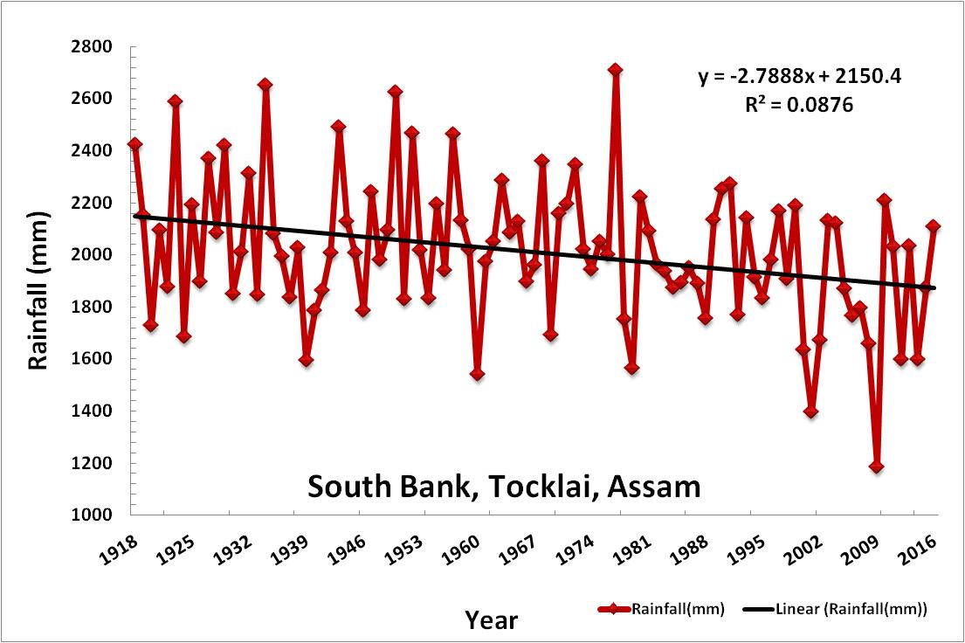
Fig 1. Annual total rainfall, 1918-2016 (South Bank, Assam, India)

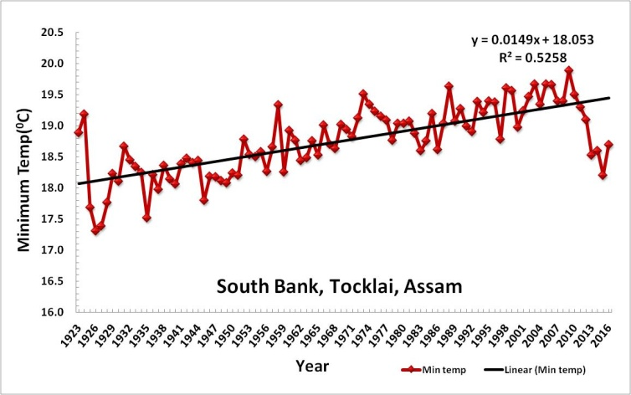
Fig 2. Annual average minimum temperature, 1923-2016 (South Bank, Assam, India)

Well distributed abundant rainfall is the essential factor for the commercial viability and sustainability of tea production. Apart from the substantial decrease of 220 mm rainfall more detailed analysis of the rainfall data reveals that there are yearly variations with occurrence of low and high rainfall which make some years wet and some droughty. Also the frequency of extreme rainfall events has increased in last about 30 years, which results in occurrence of more drought and flood period compared to past. The monthly total rainfall data of the last 30 years when compared with the long term normal during the growing season shows that each month has a deficit of rainfall which is detrimental for tea production in the long run (Fig. 3).

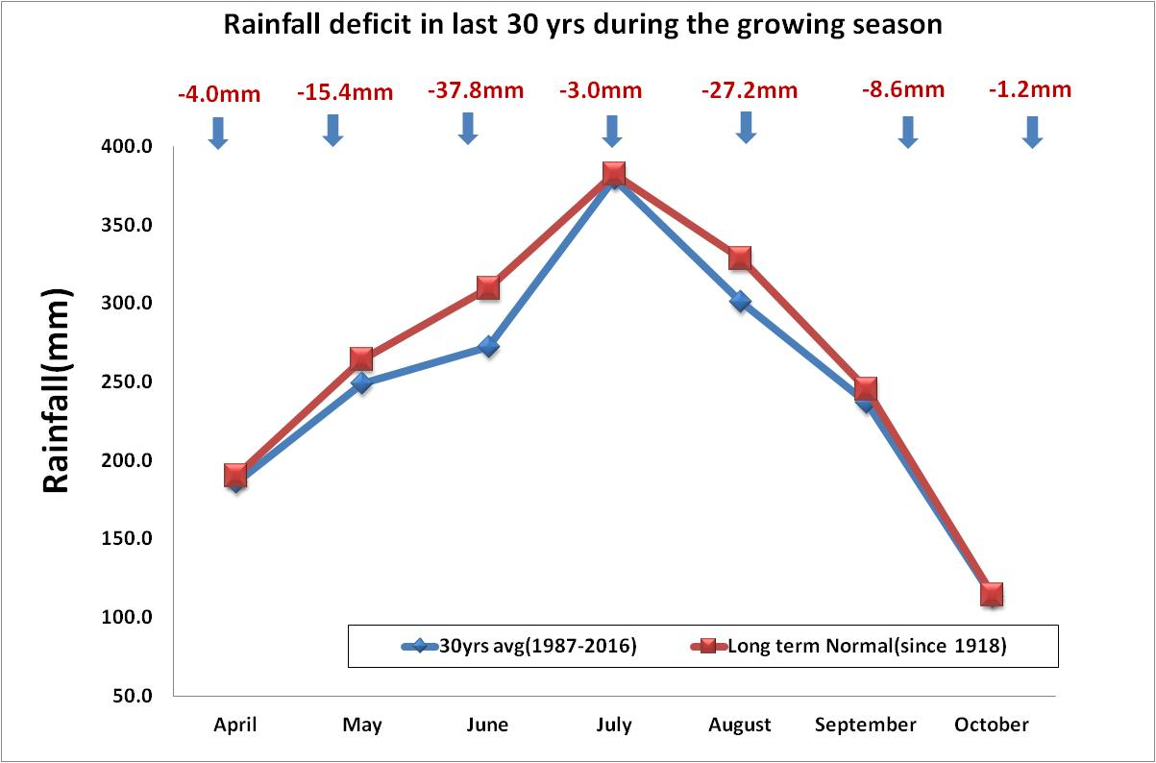
Fig 3. Rainfall deficit in last 30 years during the growing season (South Bank, Assam, India)

Adequate rainfall during winter and early spring is crucial for high yield. But when the rainfall pattern during this period was analyzed to see its deviation from the long term normal the result showed that there is a complete absence of winter rains in the recent past. The data presented in Fig. 4 represents the South Bank region of Assam where it can be seen that the last three years had almost no rain for the period October to March and the rainfall has concentrated mostly from June to September. Not only this but the early weather rainfall i.e. rainfall during March and April is also reduced currently. Data in Fig.5 shows the comparison of long term normal rainfall data with last three years data (2014, 2015 & 2016) for the period April to October, it is found that the year 2014 has a rainfall of 1489.8 mm which is 290.2 mm below normal. Whereas 2015 has 22.9 mm above the long term normal rainfall (1802.9 mm). The distribution was also uneven.

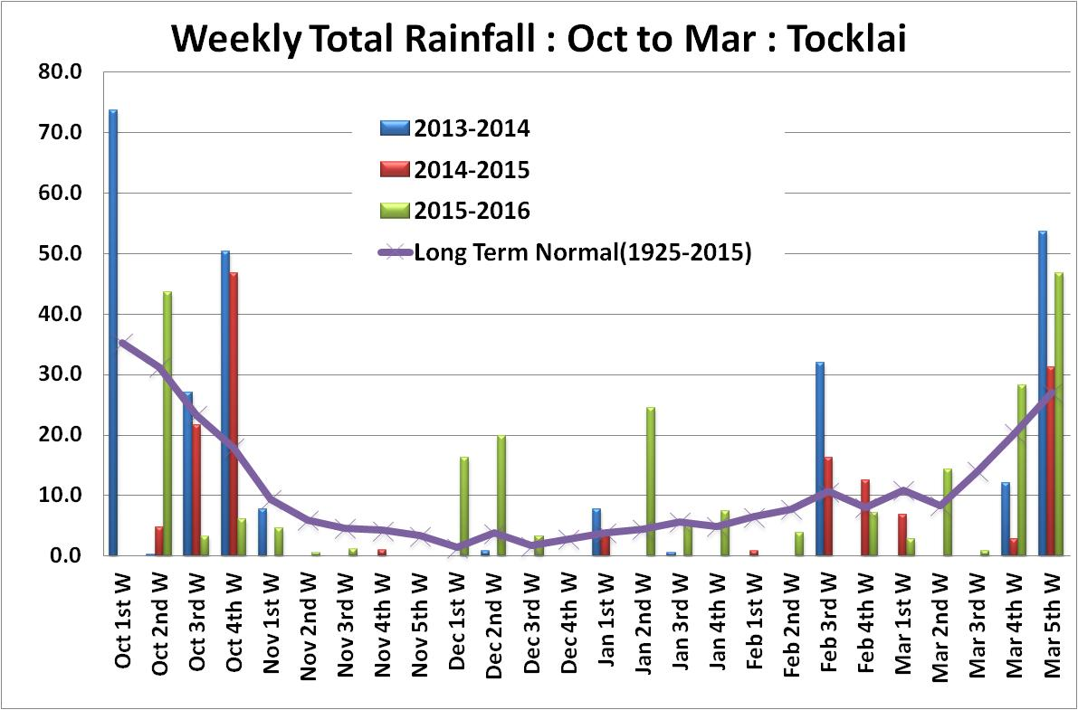
Fig 4. Rainfall, October to March, Long term normal vs. recent past years

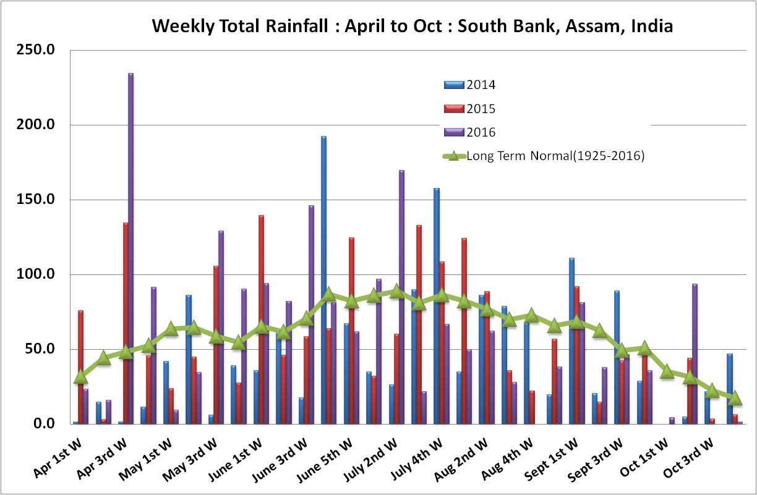
Fig 5. Comparison with long term normal for the period April to October, Tocklai

Work on interaction between Genotype (G) x Environment (E) x Management (M), the prime driver of productivity
An open top chamber (OTC) experiment was started in February, 2016 with a new batch of fifteen Tocklai released/recommended clones. The first and second phase of the experiment was completed and the third phase has been started. In the first phase the carbon dioxide level was 450 ppm and enrichment was done for five hours per day up to 200 hours. In the second phase, the level of carbon dioxide increased to 500 ppm and in the third phase the level increased to 550ppm. This phase will be completed after 200 hours of enrichment. Inside temperature of the chambers were 3-5⁰more than ambient Sensor data of daily temperature, humidity, carbon dioxide level of both the OTC and temperature of ambient condition were monitored. Morphological, physiological and biochemical parameters of the plants were measured at regular interval to find out the impact of climate on the clones. Morphological parameters were plant height, collar diameter, branch number and leaf number. Physiological parameters were photosynthesis, stomatal conductance and transpiration. Biochemical parameter was chlorophyll.

The impact of growing environment on increase of plant height was found to be significant (P=0.001) in the first phase of the experiment. Among the fifteen clones some of the clones showed significant increase in height when placed in the chambers with both temperature and carbon dioxide elevated and temperature elevated when compared to the increase in ambient condition. Some other clones showed significant increase of height when placed in chamber with temperature and carbon dioxide elevated as compared to ambient. Some clones showed significant increase when placed in temperature elevated chamber over ambient. One clone showed significant increase in temperature and carbon dioxide elevated condition compared to the other two conditions (Fig 6).

Fig 6. Impact of environment on increase of plant height

The impact of the three growing environment on increase of collar diameter was found to be significant (P=0.001) in the first phase of the experiment. In some of the clones maximum increase of collar diameter were found when they are placed in the chamber with elevated carbon dioxide and temperature followed by elevated temperature and minimum in ambient condition. In some clones increase was equal in both the elevated condition which was more than ambient (Fig 7).

Fig 7. Impact of environment on increase of collar diameter

The impact of growing environment on photosynthesis was found to be significant (P=0.001).Some clones showed significantly higher rate of photosynthesis compared to ambient when they are placed in chambers with temperature and carbon dioxide elevated and temperature elevated. Some other clones showed significantly higher rate when they are placed in both the chambers with elevated condition compared to ambient and difference of rate between the two elevated conditions is also significant. Some clones showed significantly higher rate in temperature and carbon dioxide over the rest of the two conditions (Fig. 8).

Fig 8. Impact of environment on rate of Photosynthesis

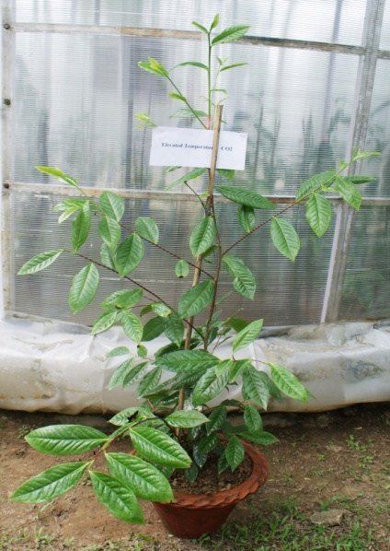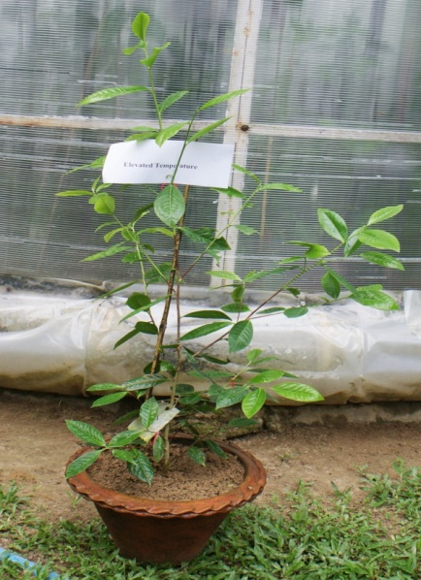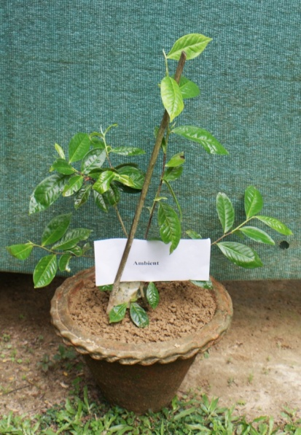
Elevated temperature+CO2 Elevated temperature Ambient
Plate1: Photo showing the growth of the plants in the three growing condition

Growth of a clone in the three growing condition was shown in the Plate1. Maximum growth was observed in the elevated temperature and carbon dioxide condition followed by temperature elevated and ambient respectively.

Analysis of vulnerability/suitability with IPCC AR5 scenarios
It has already been reported in the earlier report that spatial analysis was carried out to understand the impact of predicted future climate change over the entire Assam using existing baseline data and combining this with the most recent IPCC, AR5 predictions to create likely scenarios of future suitability for tea growth by 2050. This study has been taken further by carrying out the study in a micro scale with inclusion of the analysis of suitability of tea growth by 2070 along with 2050.

For this, preliminary analysis on a GIS platform has been carried out to figure out the climatically suitable/vulnerable tea areas in the South Bank Region of Assam, India based on the AR5 predictions of future scenarios. Firstly database of the locations of all the gardens that lie in the of the south bank region were collected and plotted on the map as shown in Fig 9. This map gives an idea about the distribution of tea gardens in the region and consequently when the future climate suitability/vulnerability is derived it helps in identifying the gardens which fall in either suitable or vulnerable areas. Depending upon the status of those gardens, appropriate adaptation strategies can be planned out which may help in combating the effects of climate change on tea.

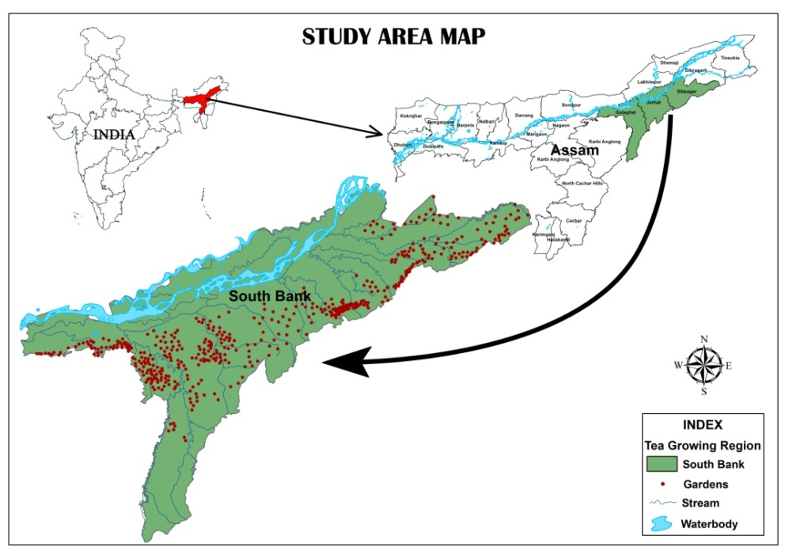
Fig 9.Study area map showing the distribution of tea gardens in the
South Bank region of Assam, India

The Suitability/ Vulnerability analysis of tea areas in 2050 and 2070 in terms of temperature and precipitation were based on the most recent GCM climate projections that are used in the Fifth Assessment IPCC report (AR5). In this study two scenarios RCP 2.6 and RCP 4.5 were considered where RCP 2.6 defines a scenario where CO2 level are likely to reach 490 ppm by 2100 and RCP 4.5 scenario where CO2 levels are likely to increase further up to 650 ppm.

Temperature Suitability/ Vulnerability

The future temperature data extracted from the GCM were downscaled to regional level i.e. extracted for the South Bank region of Assam using HADGEM-ES model. The temperature distribution over this region in the year 2050 and 2070 under RCP 2.6 and 4.5 are shown in Fig. 10.
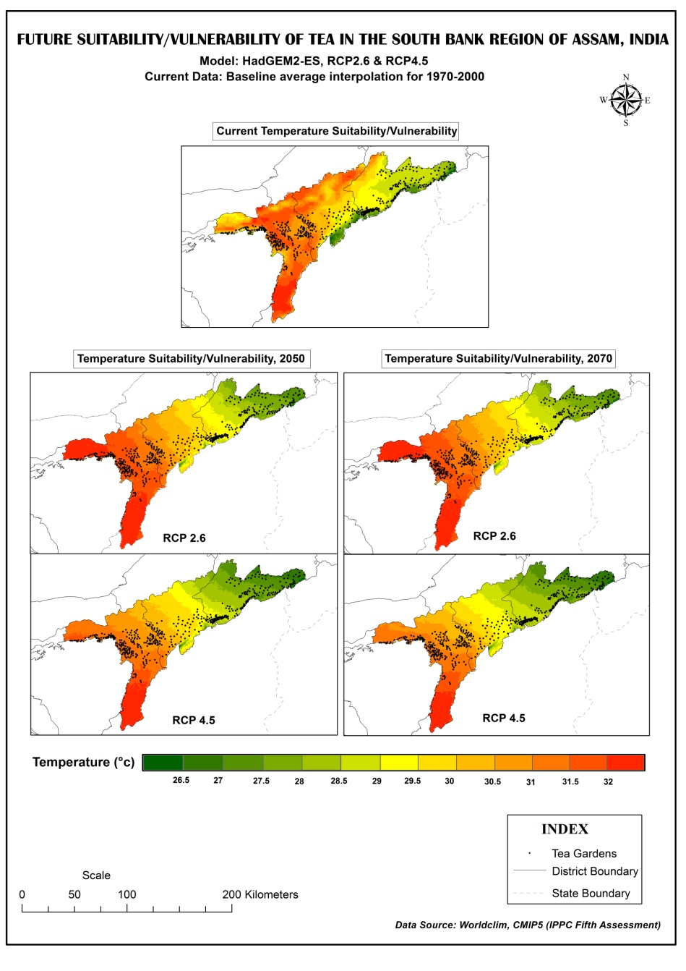
Fig. 10 Future suitability/vulnerability of tea in terms of temperature in the South bank region of Assam for 2050 and 2070 under RCP 2.6 and 4.5 scenario

The maps (Fig. 10) gives a clear understanding of the extent of the shift of temperature from current to future. So far as tea crop is concerned, it is already documented that the optimum leaf temperature for maximum productivity was found to be 25-30⁰C. The rate of photosynthesis declines fast above 37⁰C and there is no net photosynthesis at 42⁰C. Also the leaf temperature varies from 2-12⁰C more than ambient depending on the shade provided to the plant.

It can be seen in Fig. 10 that few gardens which had favourable temperature requirement for growth of tea has shifted to the higher temperature zones when compared to current scenario. Those gardens which appears to be vulnerable in the map needs to be identified and consequently proper adaptation strategies may be planned well in advance so as to lessen its impacts in the growth of tea.

Precipitation Suitability/ Vulnerability

The distribution of Precipitation over this region in the year 2050 and 2070 under RCP 2.6 and 4.5 are shown in Fig 11.

From Fig.11 it can be seen that the variability in precipitation in this region does not show much variation from current to future. Also the total rainfall requirement by tea crop is within range in the future years. However, more than the total amount, the distribution of rainfall matters a lot for sustained high yield of tea throughout the season. Therefore further study needs to be carried out in terms of the variation in monthly rainfall which will bring out the distribution pattern of rainfall.

Based on the outputs of this study it can be inferred that the extent of vulnerability in the South bank region can be very well mitigated if adequate adaptation strategies are practiced at appropriate time with proper planning.

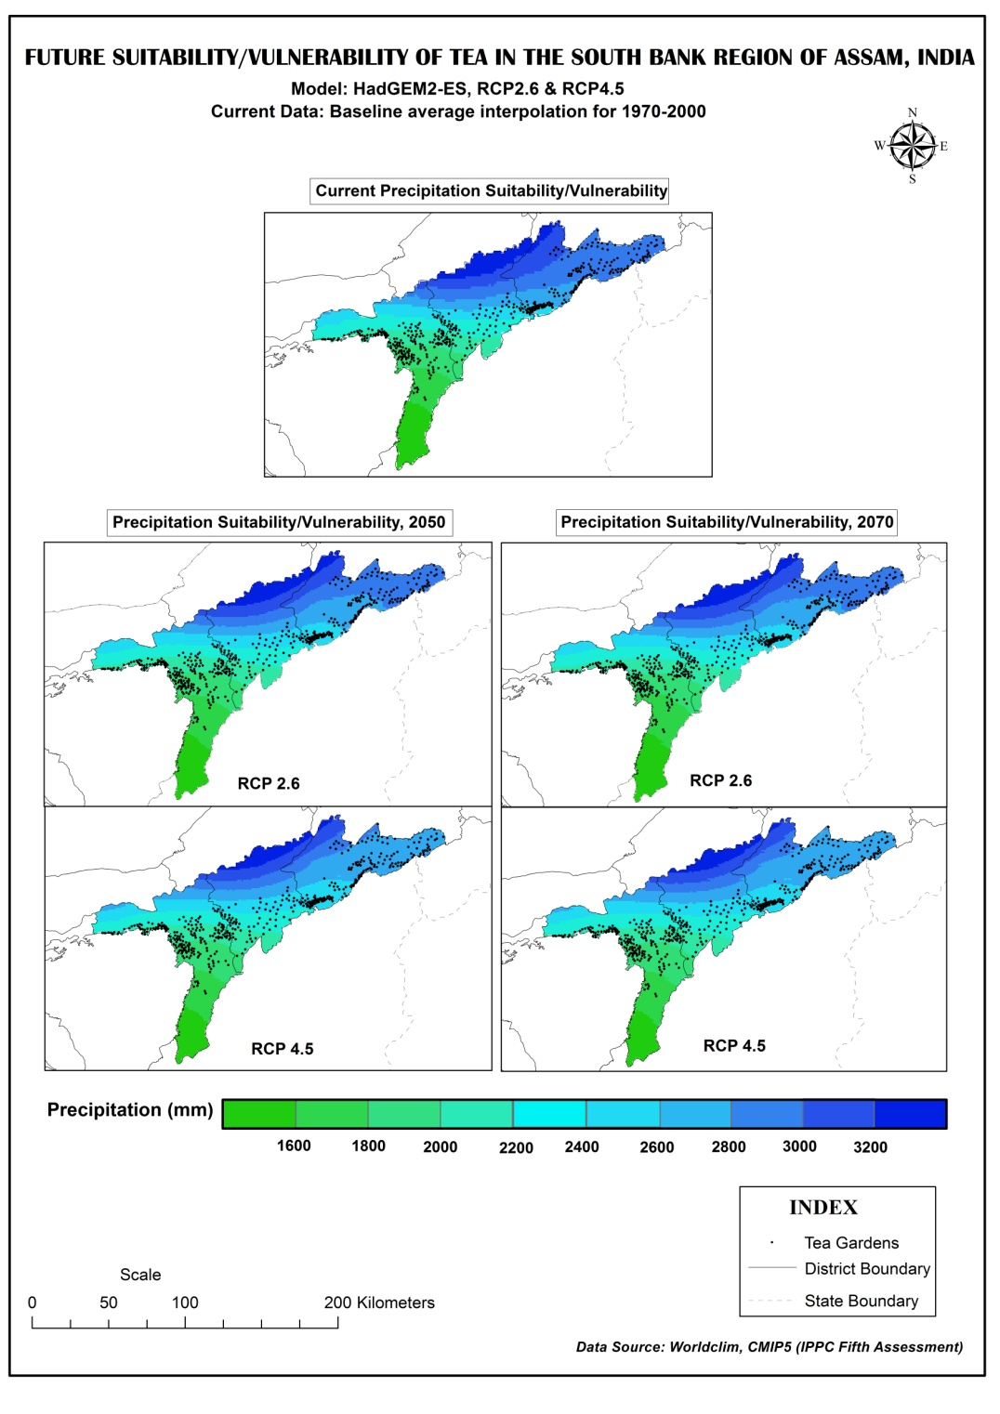
Fig. 11 Future suitability/vulnerability of tea in terms of precipitation in the
South bank region of Assam for 2050 and 2070 under RCP 2.6 and 4.5 scenario
- Sri Lanka
Assessment of vulnerability/suitability at micro scale for ease of implementation of adaptation strategies

The vulnerability map has already been developed for tea in Sri Lanka on the basis of agro-ecological region which is supposed to be the most relevant and micro scale region for implementing adaptation measures in Sri Lanka. These agro-ecological regions have been classified based on climatic and soil conditions. Further, the adaptation measures proposed are largely applicable to all tea growing regions in the country as discussed in the report of the working group on climate change released during the last FAO-IGG session.

Seasonal weather forecast

The seasonal weather forecasts (monsoons) for tea growing districts are being released to the stakeholders through the TRI website and other extension programmes organized by the TRI. Additionally, such information is planned to be sent to the growers/extension staff through SMS Gateway developed by the TRI. The latest forecast for July-September 2017 shows that below normal rainfall is expected in all tea growing regions.

Carbon balance of tea plantations in Sri Lanka

Carbon balance (carbon footprint) of tea plantations in different tea growing regions of Sri Lanka has been estimated by the Tea Research Institute of Sri Lanka in collaboration with the Faculty of Agriculture, University of Peradeniya. Results of the study showed that the Sri Lanka tea industry is a net carbon absorber, with an annual absorption of 7.837 million tonnes of CO₂, thus providing a strong foundation for marketing tea as an eco-friendly product. The annual carbon absorptions in up-, mid- and low-country regions in Sri Lanka were 0.874, 1.278 and 1.426 million tons respectively. The corresponding emissions were only 0.430, 0.334 and 0.677 million tonnes per year for the three respective regions. Accordingly, the net carbon balances of the three regions were 0.444, 0.944 and 0.750 million tonnes yr⁻¹, making-up the total carbon balance to be2.137 million t yr⁻¹.

Fig 12. Net carbon absorptions of different components of a tea plantation in different elevation zones

Fig 13. Carbon emissions from different processes of the tea industry in different elevation zones

Fig 14. Carbon balance of tea plantations in the different elevation zones

Effect of high temperatures on growth and yield of tea in the low country

Field investigations in the low country have shown that the increase in present ambient mean temperatures (28ºC) by around 2ºC (by erecting poly tunnels in the field) in the low country tea fields reduces population density and growth rate of tea shoots. Bud break is also extended and some axillary buds fail to produce new shoots under the elevated temperature condition. Consequently, the tea yield in the experimental plots was reduced by about 40%. The impacts can vary depending on the genetic constitution of the cultivar. Hence, new observations are planned to study the variation of cultivar response to rising temperatures.

Fig 15. Effect of high temperature on density and growth rate of shoots

Fig 16. Effect of high temperature on tea yield

Studies on physiological responses of tea to global climate change

The studies conducted to determine the biomass distribution and carbon sequestration potential of bi-clonal seedling tea have shown that significantly a higher biomass content of bi-clonal seedling tea was partitioned towards the roots and stems followed by the collar and it was the lowest towards the leaves where as in VP tea(TRI 2025), significantly a higher biomass content was partitioned towards the stems followed by collar, roots and it was the lowest towards the leaves. Carbon sequestration potential the bi-clonal seedling tea was higher than that of the TRI 2025. These results highlight the suitability of bi-clonal seedling tea under changing climates and also for climate change mitigation.

- Kenya
The Tea Research Institute of Kenya is involved in monitoring weather parameters and relating to tea crop cultivation. From the data gathered, there is fluctuation in annual rainfall; however, rain days are on decline resulting into soil water deficits. There are also increasing warming conditions which when coupled with increasing dry days reduces crop yields. Also, there are occasional hail and frost incidences resulting into crop losses in the West of Rift Valley. Some of the proposed mitigation and adaptation strategies include farm forestry, crop diversification, appropriate clonal selection and judicious application of fertilizers

Weather and tea yields

Tea (Camellia sinensis (L) O. Kuntze) is grown in Kenya under rain-fed conditions which are highly vulnerable to environmental instabilities. Tea Research has been observing weather parameters related to tea production such as rainfall, temperature, soil water deficits, hail incidences, frost incidences and associated crop losses in the tea production counties. It has agrometeorological stations at Timbilil (35⁰ 21´ E, 0⁰ 22´S 2180m a.m.s.l) and Kangaita(37⁰ 17.8´E; 0⁰ 19.8´S; 2030m a.m.s.l). Below is a summary of the trends:

Rainfall

Tea requires minimum annual rainfall of 1 270 mm which is supposed to be well distributed throughout the year. Rainfall distribution in the course of the year matters most for sustainable tea production. Fig. 17 shows the highest, lowest and rainfall trend at the institute.

Fig 17. Rainfall trend at Timbilil Agro-meteorological station

Even though there is no significant trend in annual rainfall, the rain days are indicating significantly decreasing trends as depicted in Fig.18. Up to 45.45% of the variation in rain days is attributed to change in time. Currently, we receive heavy rainfall within a short period of time hence equating with the previous totals which were rather well distributed throughout the year.

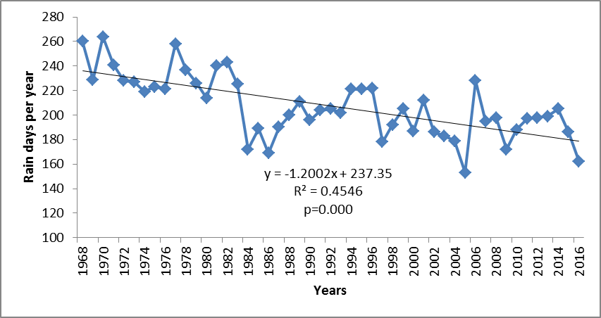
Fig 18. Annual rain days at Timbilil Agro-meteorological station
Temperatures
Tea requires temperature range of 13⁰C to 30⁰C provided moisture is not limiting with optimal temperature at 24⁰C. However, the long term data analysis of temperature indicated that high tea yields occur in environments of temperature of above 16.25⁰C. There is evidence of warming conditions in Kenya over time and this is evident from the long-term data which indicates an increase of 0.02⁰C. The year 2016 demonstrated the warmest year with mean annual temperature of 17.5⁰C (Fig.19). With such prevailing conditions coupled with minimal rainfall received in the same year (Fig.12), then there is a likely scenario that could suppress crop yields.

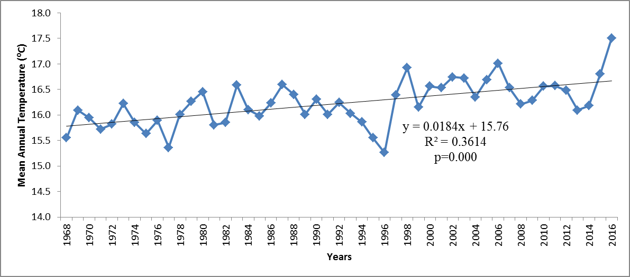
Fig 19. Annual mean air temperature at Timbilil Agro-meteorological station

Soil water deficits

This is an indicator of dryness of the soil. Deficiency of water in the soil may lead to water stress in the plant since water loss from the leaves will be higher than absorption rates hence thwarting various physiological. There has been increasing trend in the dryness of the soil with time though not statistically significant. With declining rain days (Fig.18) and increasing temperatures (Fig.19), the effects of increasing dryness of the soil (Fig.20) is likely to result into serious crop yield decline in the tea growing regions.

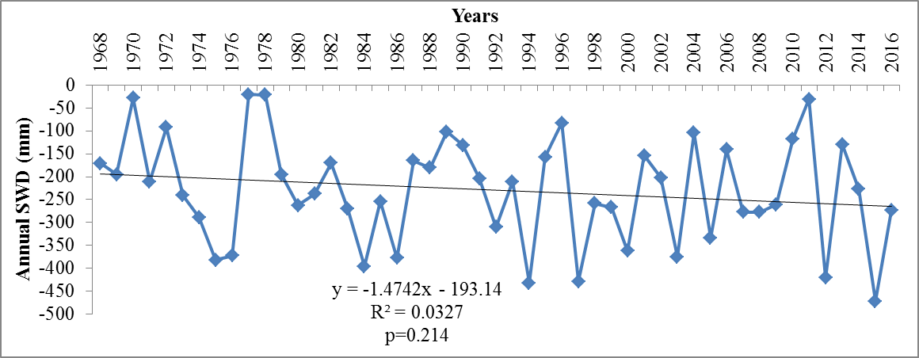
Fig 20. SWD (mm) at Timbilil Agro-meteorological station

Frost, hail incidences and crop losses

There have been irregular frost incidences in the Western part of Kenya, with Nandi County having the highest incidences of up to 84 while Kericho had 19. Crop loss as a result of frost in Kericho is slightly higher than Nandi with 780,627.50 Kg mt and 721,463.30 Kg mt lost, respectively (Fig.21). This differential in crop losses can be due to the higher area under tea in Kericho.

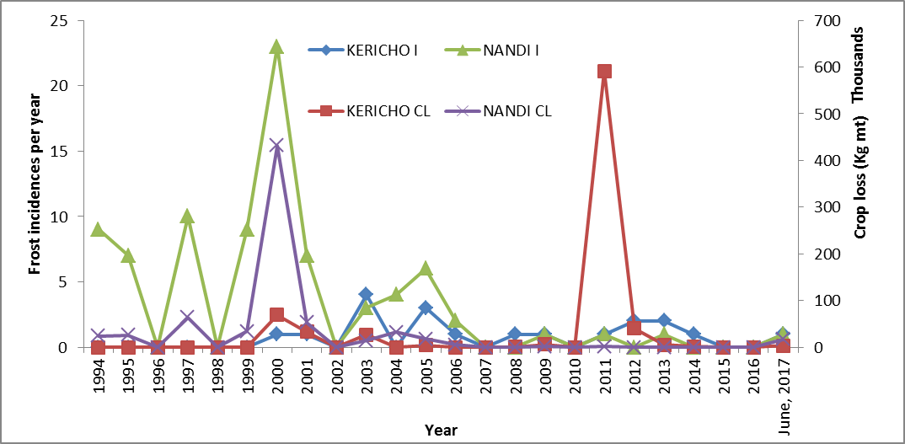
Fig 21. Frost incidences and associated crop loss in Western Kenya

Hail is another great challenge to tea cultivation in the western Kenya (Fig.22). However, both incidences and crop losses are on the decline. When compared with crop losses due to frost, hail results into ten times more crop loss. Nonetheless, by breaking the leaves and branches of the plant, hail acts as a light skiffing operation on the bushes and the following yields will be adequate to compensate for the missed plucking rounds as opposed to frost damage. The size of hail stones and duration of each incident also determines the crop loss. The tiny pellets of hail are more destructive to tea leaves than the large sized pieces.

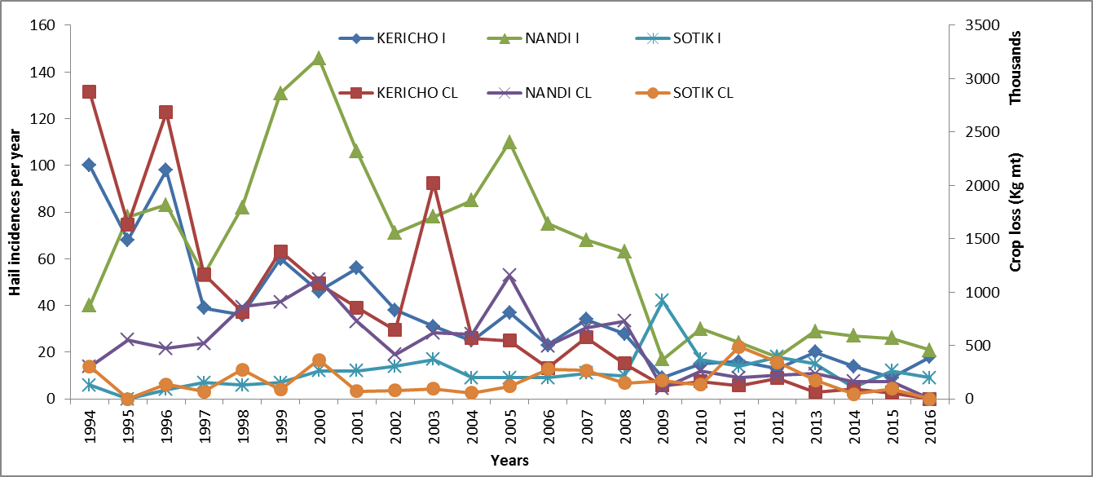
Fig 22. Hail damage and associated crop losses in the West of Rift Valley.

Mitigation and adaptation strategies

In order to assist tea farmers adapt to the changing trends in weather parameters within the tea producing regions, Tea Research Institute has been involved in various activities and programmes as outlined below:

Trainings: There have been trainings offered to farmers within and outside the institute on the best agronomic practices to engage in for sustainable tea production. Farm forestry with tea friendly trees and fertilizer application timing is emphasized. Water harvesting and nature conservation are also demonstrated.
County Agricultural officers have also been trained on the best practices to combat adverse effects of climate change and variability within the tea growing areas.

Crop Diversification: We have also encouraged tea farmers to engage in crop diversification in order to sustain livelihood in case of damage to the crop by occasional adverse effects of weather.

Drought tolerant clones: Tea Research Institute has also developed several tea cultivars that are capable of tolerating some of the extreme weather events especially drought and frost as well as emerging pests and diseases linked to climate variability. Some of the cultivars include TRFK 430/90 and TRFK 371/3 which are tolerant to drought and out-yields TRFK 31/8 which is TRI’s baseline clone by over 68%. TRFK 301/4 and 301/5 are also tolerant to drought, high yielding and in addition resistant to numerous biotic and abiotic stresses. TRFK 306/1 (Purple tea) is also preferred candidate for extreme weather events and has additional health benefits above green teas.
China

Estimation of the effect of climate change on tea production in China using a yield response model

In a recently published report Boehm et al. (2016) demonstrated the association between empirically estimated monsoon dynamics and other weather factors with tea yields in 15 tea producing provinces in China using a yield response model.

This study was carried to assess the effect of climate change on tea production in China by using historical weather and production data from 1980 to 2011 to construct a yield response model that estimates the partial effect of weather factors on tea yields in China, with a specific focus on East Asian Monsoon dynamics.

A yield response model uses Ordinary Least Squares (OLS) linear regression to model yield as a function of various exogenous weather factors. This analysis focused on quantifying the association between the East Asian Monsoon onset, duration, and retreat and tea yields. How other weather factors are associated with tea yields, including minimum temperatures, precipitation before, during and after the estimated monsoon period, and solar radiation was also examined in the study.

The timing of rains is important to tea productivity and management decisions. The authors hypothesized the monsoon period to be non-stationary over the study period and so the onset and retreat should be estimated empirically. To do this they ffound the break-points in the linear daily year-by-province cumulative precipitation function to arrive at approximate East Asian Monsoon onset and retreat dates for the study period in the tea growing provinces of China (Fig.23). This method provided new insights into how climate change affects tea yields through changes in the timing of seasonal rains.

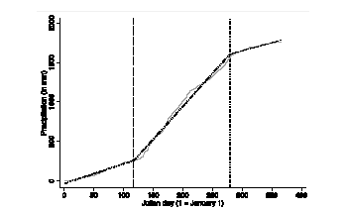

Fig. 23 This graph illustrates how the cumulative precipitation function is used to estimate the onset and retreat dates of the monsoon for each province in each year from 1980 to 2011. It shows the onset (dashed grey vertical line) and retreat (dotted grey vertical line) of the monsoon in Yunnan province in 1990. The slope of the cumulative precipitation function changes significantly at these two points. These two points mark the estimated onset and retreat of the East Asian monsoon in Yunnan province in the example year 1990. The dashed lines overlaid on top of the cumulative precipitation function show the slope of each section of the function as estimated by “Segmented”. [Taken from the Boehm et al. (2016)]

The yield response model used by the authors was based on the model used in Auffhammer et al. (2006) and Auffhammer et al. (2013) and is specified as follows:

ln py_{it}q “ p_{i} ` bX_{it} ` t ` #_{it}

where y_{it} is the yield in province i in year t in tons per hectare; and p _{i} is the province fixed-effects term to account for unobservable provincial factors affecting tea yield. This fixed-effect term is important because we do not account for non-weather factors that might explain the difference in yields across provinces. These factors include soil quality, labour, fertilizer, or pesticide use. X_{it} is a vector of weather variables including monsoon characteristics such as onset, retreat, and duration; bare parameter estimates for each weather variable; t is the time trend to account for a linear change over time in yield due to technological advances; and #_{it} is the error term. Both the fixed-effects and time trend terms are standard econometric methods for accounting for unobservable factors that may influence the estimates of each b. X_{it} also contains one-year lags for each weather variable. Lagged weather variables account for the fact that tea is a perennial crop and harvests in the current year may be impacted by weather in the previous year. All variables are transformed with the logarithmic function so that they can be interpreted as elasticities and because the functional form of these variables is inherently logarithmic in nature. The panel is strongly balanced and fifteen tea-producing provinces are included in the analysis. These provinces include Guangxi, Jiangsu, Shandong, Shaanxi, Guizhou, Fujian, Yunnan, Sichuan, Anhui, Hubei, Henan, Hunan, Zheijiang, Jiangxi, and Guandong. The construction of weather variables contained in X_{it} is described in Table 1.

Table 1. Description of weather variables*
Variable | Description of Construction
Monsoon  duration (days) | 1.Averaged daily gridded precipitation data (0.5˝ ˆ 0.66˝) across grid cells within the tea-growing region of each province
 | 2.Input the daily cumulative precipitation function into R’s “Segmented” package.
3. “Segmented” requires a starting point from which to approximate the monsoon onset and retreat

dates. The average historical monsoon onset and retreat dates across China’s major tea producing regions are used for this purpose. 1 May is the 121st day of the year representing the monsoon onset and 31 August is the 234th day of year representing the end of the monsoon

(Zhai et al. 2005)
 | 4. “Segmented” approximates the unknown breakpoints in the slope of the cumulative precipitation function, providing an approximate start and end date of the monsoon, which is then used to calculate the duration of the monsoon by province and year.
Monsoon  onset/retreat date  (Julian day) | Estimated date upon which the monsoon onset/retreat occurs.
* Adapted from the Boehm et al. (2016).

Table 1. Description of weather variables (cont’d)
Pre-monsoon  rainfall (mm) | Averaged daily gridded precipitation data across grid cells within the tea-growing region of each province. Then the average total daily rainfall during the approximated pre-monsoon period (1 January: monsoon onset date) was obtained.
Monsoon  rainfall (mm) | Averaged daily gridded precipitation data across grid cells within the tea-growing region of each province. Then average total daily rainfall during the approximated monsoon period (monsoon onset date/monsoon retreat date) was obtained.
Post-monsoon  rainfall (mm) | Averaged daily gridded precipitation data across grid cells within the tea-growing region of a province. Then average total daily rainfall occurring during the approximated post-monsoon period (monsoon retreat date: 31 December) was obtained.
Pre-monsoon minimum temperature (˝C) | - Averaged daily gridded minimum temperature data across grid cells within the tea-growing region of each province.  - Averaged daily minimum temperature from 1 January to the monsoon onset date for each province in each year.
Monsoon minimum temperature (˝C) | - Averaged daily gridded minimum temperature data across grid cells within the tea-growing region of each province.  - Averaged daily minimum temperature over the approximated monsoon period for each province in each year.
Pre-monsoon  surface radiation (W/m²) | - Averaged daily gridded radiation data across grid cells within the tea-growing region of each province.  - Averaged daily solar surface radiation over the approximated pre-monsoon period for each province in each year.
Monsoon surface  radiation (W/m²) | - Averaged daily gridded radiation data across grid cells within the tea-growing region of each province.  - Averaged daily solar surface radiation over the monsoon period for each province in each year.

The precipitation and temperature variables were constructed using the three seasons based on the empirically derived monsoon period described earlier. These three seasons include the pre-monsoon, monsoon, and post-monsoon period. Because climate change has been reported to alter the timing of the East Asian Monsoon, this alternative approach to defining seasons may have more predictive power than using historical onset and retreat dates. Average daily pre-monsoon or spring temperatures are important for tea bud breaking, so a variable representing the pre-monsoon average daily minimum temperature was included in this model. Another variable included is the average daily minimum temperature during the monsoon period since minimum temperatures during this period have an interactive effect with precipitation on tea plant growth. The minimum instead of maximum temperatures across all the models were used because the authors wanted to assess the relationship of surface radiation in their analysis. Average daily surface radiation (W/m²) and average daily maximum temperatures are more highly correlated than solar radiation and average daily minimum temperatures. Thus, surface radiation was used as measure of daily sunlight and heat exposure rather than average daily maximum temperatures. A variable representing average daily precipitation during all three estimated seasons was also included in the analysis since rainfall is such an important driver of tea yields. No variables representing extreme weather events (i.e., high heat days, extreme rain days, etc.) were used in the models because of the spatial resolution of the analysis over relatively large geographic areas (i.e., the province), the frequency of weather anomalies would be extremely small and not affect the results of the analysis.

Results

Results showed that tea yields in China are impacted by daily precipitation and temperatures, as well as by seasonality as determined by the empirically estimated onset and retreat of the East Asian Monsoon. There was a consistent negative association between tea yields and the monsoon retreat date in all model specifications used.A1% increase in the monsoon retreat date was associated with 0.481%–0.535% reduction in tea yield. A 1% increase in average daily precipitation occurring during the monsoon period was associated with a 0.184%–0.262% reduction in tea yields. In addition, the models show that 1% increase in the average daily monsoon precipitation from the previous growing season was associated with 0.258%–0.327% decline in yields.

Table 2. Five-year mean and standard deviation values for monsoon onset, retreat and duration.*
 | 1980 | 1985 | 1990 | 1995 | 2000 | 2005 | 2010
Mean monsoon onset | 114.3 | 124.5 | 123.8 | 126.6 | 132.1 | 142.9 | 136.9
SD monsoon onset | 34.8 | 35.3 | 24.5 | 33.5 | 24.7 | 30.4 | 30.9
Mean monsoon retreat | 261.2 | 270.3 | 248.5 | 254.4 | 262.9 | 258.4 | 260.0
SD monsoon retreat | 15.5 | 14.4 | 26.3 | 16.2 | 14.7 | 16.3 | 12.3
Mean monsoon duration | 146.8 | 145.8 | 124.8 | 127.8 | 130.8 | 115.6 | 123.2
SD monsoon duration | 38.1 | 37.9 | 38.6 | 30.6 | 27.5 | 30.6 | 35.5
*Taken from the Boehm et al. (2016).

The average length of the monsoon for 2011 was approximately 23 days shorter (Table 2) than it was in 1980 and a statistically significant (p < 0.05) negative trend over the time period for average monsoon duration (p = 0.004) (see Fig. 24),which means that the average duration of the monsoon across the tea producing provinces in China is getting shorter.
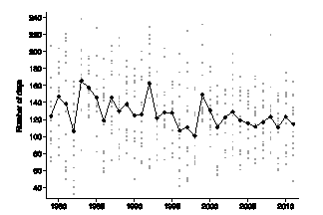

Fig.24 Yearly average monsoon duration is noted by the black connected line. Each grey dot on the graph shows the monsoon duration for each province in each year in the sample, upon which the yearly average was calculated (taken from the Boehm et al. [2016]).

The study also showed that a 1% decrease in solar radiation in the previous growing season was associated with 0.554%-0.864% decrease in tea yields. These findings suggest the need for adaptive management and harvesting strategies given climate change projections and the known negative association between excess rainfall and delayed monsoon retreat on tea quality and yield.

New planting and soil management practices may need to be developed to help Chinese tea farmers cope with changes in precipitation and monsoon dynamics. The management strategies are likely to be of increasing importance in light of the fact that the frequency of extreme rain events is expected to increase as a result of future effects of climate change. Farmers in Yunnan province report some other strategies to address changes in precipitation patterns. These include planting tea from seed instead of using clonal propugules which have less dense and deep root systems; mixed cropping of tea gardens in forests; and enhancing the drainage of tea gardens.

Effects of elevated CO₂ on endogenous caffeine and jasmonic acid (JA) content, and Colletotrichum gloeosporioides virulence on tea

In another study carried out by Li et al (2016) two-year-old tea seedlings of Longjing 43 (Camellia sisnensis L.) were exposed to either ambient CO₂ (380 μmolmol–1)or elevatedCO₂ (800 μmolmol–1) for 2 weeks in a controlled environment growth chambers (Conviron, Winnipeg, Canada). The growth conditions were as follows: the photosynthetic photo flux density (PPFD) 600 μmol m–2 s–1, photoperiod 14/10 h (day/night), day/night air temperature 26/22°C, and relative humidity 85%. After 2 weeks of acclimation, plants exposed to both ambient and elevated CO₂ were subjected to inoculation with C. Gloeosporioides (causing brown blight in tea). Plants were also mock inoculated following the same inoculation procedure. The pot placement within each CO₂ condition was randomized every two days. In the experiments employing a combined treatment of C. gloeosporioides and exogenous treatment of caffeine (0.1, 1, and 10 mM) or MeJA (0.02, 0.2, and 1 mM), caffeine or MeJA solution was applied to the tea seedlings 6 h prior to C. gloeosporioides inoculation; distilledwater (ddH2O)was sprayed as control.

Results of the current study showed that elevated CO2 decreased caffeine and JA contents in tea leaves but increased susceptibility of tea to C. gloeosporioides. However, caffeine stimulated a specific branch of the LOX pathway that synthesizes JA to induce tea defense against C. gloeosporioides under elevated CO2. These findings lead to an assumption that climate change will likely trigger diseases caused by C. gloeosporioides, and that application of caffeine could be a potential solution for efficient disease control. As fungicide resistance and its residual toxicity are growing concerns in the tea industry, caffeine could serve as a probable alternative to synthetic fungicides for controlling foliar disease in tea plantations.

References:

Rebecca Boehm, Sean B. Cash, Bruce T. Anderson, Selena Ahmed, Timothy S. Griffin, Albert Robbat Jr., John Richard Stepp, Wenyan Han, Matt Hazel and Colin M. Orians. Association between Empirically Estimated Monsoon Dynamics and Other Weather Factors and Historical Tea Yields in China: Results from a Yield Response Model. (2016). Climate 4, 20; doi:10.3390 /cli4020020 www.mdpi.com/journal/climate].

Auffhammer, M.; Ramanathan, V.; Vincent, J.R. Integrated model shows that atmospheric brown clouds and greenhouse gases have reduced rice harvests in India. Proc. Natl. Acad. Sci. USA 2006, 103, 19668–19672.

Auffhammer, M.; Hsiang, S.M.; Schlenker, W.; Sobel, A. Using Weather Data and Climate Model Output in Economic Analyses of Climate Change. Rev. Environ. Econ. Policy 2013, 7, 181–198.

Li Xin, Ahammed Golam Jalal, Li Zhixin, Tang Meijun, Yan Peng, and Han Wenyan (2016). Decreased Biosynthesis of Jasmonic Acid via Lipoxygenase Pathway Compromised Caffeine-Induced Resistance to Colletotrichumgloeosporioides Under Elevated CO2 in Tea Seedlings. Biochemistry & Cell Biology,106:1-7.

Submitted by India; contributions from China, India, Kenya and Sri Lanka.

