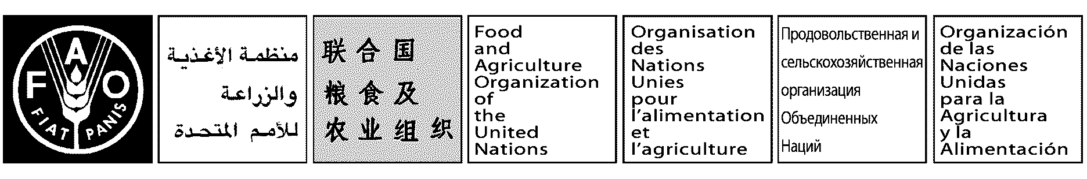

OPENING REMARKS

by

Hiroyuki Konuma
Assistant Director-General and
FAO Regional Representative for Asia and the Pacific

delivered at the

EU Learning Training Workshop

FAO RAP, Bangkok
25 July 2012

Good morning, ladies and gentlemen,

First of all, on behalf of FAO Regional Office for Asia and the Pacific I would like to welcome all participants from the country offices of the region and the participants form the RAP office. I also give my warm welcome to the trainers from Rome.

Given that Asia is home accommodating around 62% of the world undernourished population (578 million). Representing 57% of total world population, Asia has prevalence of 28% stunting among children under five (100 million) and about one in three children is underweight. This region is facing challenges of the growing population and the limited natural resources while we are fighting for food insecurity for the region through improved agricultural technologies and policies. To fulfill FAO’s mandate and to achieve world food security, we have to mobilize more resources with our partners in the world to achieve our goals.

FAO’s field programme delivery for long-term projects in Asia and the Pacific has been tripled over several years for USD 40 million per year in 2004 to nearly USD 130 million in 2012. If we include the emergency project delivery, the annual delivery reached USD 250 million in 2011. This correspond to increased demands and expectations to FAO’s assistance and services in countries in the Region.

European Union (EU) is currently the No. 1 donor for FAO TF programmes in terms of volume (USD 25 million in 2011) and its funding in this region is increasing recent years. It is foreseeable that we will have more opportunity to formulate or implement EU funded projects in the years to come.

Currently we have 14 ongoing projects in the region mainly in the countries of Afghanistan, Bangladesh, Cambodia, China, DPR Korea, Mongolia, Sri Lanka, Timor Lester plus two regional projects. The total project funding amounts nearly USD 112 million. It is expected that more EU funded projects will come in the coming years. You may know that the GCP/INT/130/EC – “Improved Global Governance for Hunger Reduction 2012-2015” is just approved by the donor, and the overall budget of the Programme is 47 million Euros. The project is to provide support to ASEAN Integrated Food Security Framework in our region. Also the country offices of Afghanistan, DPRK, Laos and Sri Lanka are preparing new proposals for EU funding in the coming months. Today, we received a message from HQs informing that new European Union funding opportunities from the Cooperation Programme for Research and Technological Development (FP7) in coming. Among which there are two themes in the Cooperation Programme that are directly relevant to the work of FAO:

(1) Food, Agriculture and Fisheries, and Biotechnology. Budget of EUR 341 350 000
(2) Information and Communication Technologies: Nanosciences, Nanotechnologies, Materials and New Production Technologies (NMP). Budget of EUR 230 000 000

The FP7 Cooperation Programme is very relevant to our decentralized offices. I hope through this training our decentralized offices will be better equipped to meet the challenges and will be able to submit your good application timely.

This training workshop is well designed by inviting well combined trainers for this training workshop, i.e. one EU specialist from EU PuntoSud Mr. Federico Bastia and two TCSR officers Mr. Bart van Ommen Senior Programme Officer and Ms. Carolina Pirri, Programme Officer. The EU specialist will explain to us the overall EU funding policy and the angles for formulating an EU project. The two experienced TCSR experts working for EU programme for years will help us build up a good bridge to link both the EU and FAO rules, and at the same time, will also show us know how to operate EU project through tiny administrative and operational methods. I am sure you will benefit a lot from this training.

It is also a good opportunity for all officers in Rome, Bangkok and each country officers to know each other and to establish good links for future cooperation, especially for field offices to get timely backstopping from Rome in order to manage the EC funded project more efficiently and effectively.

Finally I wish you have successful training and pleasant stay in Bangkok.

Thank you.

