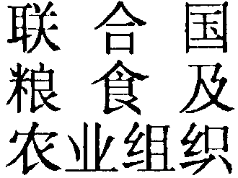
FOOD AND
AGRICULTURE
ORGANIZATION
OF THE
UNITED NATIONS
ORGANISATION
DES NATIONS
UNIES POUR
L’ALIMENTATION
ET L’AGRICULTURE
ORGANIZACION
DE LAS NACIONES
UNIDAS PARA
LA AGRICULTURA
Y LA ALIMENTACION
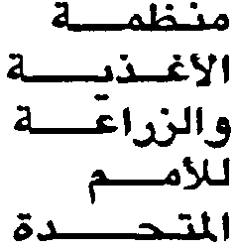

Third World Climate Conference WCC-3
Climate Prediction and Information for Decision-making

Expert segment: Vision for the Conference

Address delivered by Mr Manzoor Ahmad
Director, FAO Liaison Office in Geneva

CICG, Geneva, 31 August 2009

Mr/Mrs Chairperson
Excellencies,
Dear Colleagues
Ladies and Gentlemen,

A little more than a year ago, FAO organized the High-Level Conference on World Food Security: the Challenges of Climate Change and Bioenergy; it was at a time when we had just witnessed the impacts of soaring food prices and growing social unrest.

And just when the supply situation started to relax and food prices began to recede, the global economic crisis set in, worsening the situation and pushing even more people into poverty and hunger. Currently, eighteen per cent of the world’s population go hungry; a situation that poses a serious risk for world peace and security.

No doubt, many factors have contributed to the current situation; and, on the face of it, few seem to relate directly to agriculture. They include higher energy prices, the growing use of agricultural resources for biofuels, the vagaries of weather and, more recently, the massive global economic downturn.

But still the neglect of agriculture played an important role in creating the problems initially and in making matters worse now. Decade-long underinvestment in agriculture made the sector more vulnerable ecologically and less responsive to new opportunities economically.

Droughts and floods first slashed output and a lack of investment and working capital now slows the speed of recovery; and makes it now harder to deal with impacts of the economic downturn. This lack of investment has been particularly pronounced for the reduction of foreign public investment in agriculture, i.e. ODA. Aid to agriculture fell from 8 billion dollars (2004 basis) in 1984 to 3.4 billion dollars in 2004, representing a reduction in real terms of 58%. This has had a particularly severe impact on 70% of the world’s poor whose principal livelihood is dependant on agriculture.

Ladies and gentleman,

We all know that the exact impact of climate and weather on food production and food security are difficult to gauge as too many factors play a role. We also know that the impact on a global scale is seldom visible in practice as benefits in the often rich higher latitude areas outweigh the suffering in poorer lower latitude regions.

Only the most severe and widespread droughts, such as those witnessed between the 1960s and the mid-1980s in the Sahel are directly visible in our agricultural statistics. But from all we know from past experience and climate change predictions, these marginal environments will become even more marginal; and we also know that their ability to adapt to climate change and more variable weather will be compromised if investments in agriculture fail to resume.

The fact that climate change is likely to come along with more severe and more frequent weather extremes; thus particularly exposing the poor and hungry to more hardship, UN agencies have a crucial role to play in helping developing countries adapt to climate change, making investments in mitigation efforts more transparent and ultimately more economic. This will require new forms of technology and strengthening seasonal forecasts.

But we also have to be aware of the fact that communication in agriculture is a complex process. It implies interactions between producers of forecasts, agricultural service providers and the media with users of forecasts. At all levels, from research to the assessment of the effectiveness of the advice, it requires strengthened collaboration between the meteorological community and the world of agricultural producers.

Ladies and gentlemen,

The direct involvement of FAO in this important meeting is one important sign of the commitment of the Organization to the ideas that climate is an essential variable in agriculture, that the technical capacity of national climate services and decision capacity of users must be strengthened to better serve those responsible for food security, at all levels, and that the limits to financial and other resources can only be overcome through collaboration between the climate and agricultural communities, at all levels.

