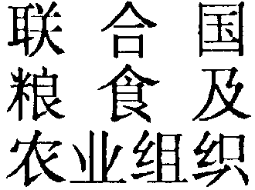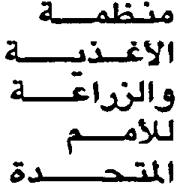
FOOD AND
AGRICULTURE
ORGANIZATION
OF THE
UNITED NATIONS
ORGANISATION
DES NATIONS
UNIES POUR
L’ALIMENTATION
ET L’AGRICULTURE
ORGANIZACION
DE LAS NACIONES
UNIDAS PARA
LA AGRICULTURA
Y LA ALIMENTACION

WORLD HEALTH ORGANIZATION
126th Session of the Executive Board
Geneva, 18-23 January 2010

Comments on Food Safety
by
Dr. Manzoor Ahmad
Director, FAO Liaison Office in Geneva

Thursday, 21 January 2010
Mr. Chairman,

On behalf of FAO, I would like to thank you for giving me this opportunity to make this intervention.

At the outset I would like to say that we fully concur and support the various points relating to food safety made in Doc. EB126/11. Nevertheless, I would like to make the following specific remarks:

First, we are very satisfied with the current FAO-WHO collaboration on food safety matters and fully support the continuation of high-level management meetings between the two organizations. This ensures the smooth co-ordination of our joint activities, increases synergies and avoids duplication at all levels.

Second, with regard to INFOSAN [International Food Safety Authorities Network], FAO is fully engaged with WHO in the INFOSAN joint programme which complements the recently established FAO EMPRES-Food Safety as part of the EMPRES [Emergency Prevention System] -Food Chain initiative.

Third, FAO’s food safety programme strongly builds on the food chain approach and enjoys the support of various Technical Divisions engaged in work that covers different stages of the food chain from primary production to consumption. FAO is well positioned in implementing the food chain approach to food safety, given its capacity to intervene at various stages of the food chain to address possible threats at the different stages of the supply chain. Collaboration between the health and agriculture sectors should further enhance the effectiveness of food control systems and improve consumer protection.

Fourth, FAO fully supports the ongoing work of the Foodborne Disease Burden Epidemiological Reference Group (FERG) and compliments WHO for this initiative. It provides an important input to policy decisions concerning prioritization of food safety work, as well as convincing arguments for the allocation of additional resources to food safety work.

Fifth, FAO is pleased with the ongoing collaboration with WHO on the provision of scientific advice to Codex and to Member States on all aspects related to food safety assessment and decision making. This is an area of increasing importance for FAO and we would wish to see it expanding in terms of technical coverage and resources to meet the increasing needs in this field. Moreover, we want to ensure that all decisions concerning food safety continue to be based on scientific evidence, as required by the WTO Agreement on Sanitary and Phytosanitary Measures. Recent efforts made by FAO and WHO to establish a trust fund to attract extra-budgetary resources to support the work on scientific advice has not received the necessary attention and support from the donor community. FAO would like to reiterate its call for a substantial mobilization of resources to enable this joint programme to meet the expectation of world consumers for a safer and better quality food supply.

Sixth, FAO fully supports the collaboration with WHO throughout the GLEWS [Global Early Warning and Response System for Major Animal Diseases] initiative. The H5N1 highly pathogenic avian influenza and the pandemic influenza A/H1N1 2009 provide a tangible and real example of interlinking and collaboration of FAO and WHO on cross-cutting issues that has the effect of improved integration of communication between public health and animal health systems for prevention, early warning and rapid intervention.

Finally, FAO supports the proposed Resolution and invites the Executive Board to adopt it so as to provide the means for the food safety programme in WHO to play its pivotal role in promoting a safer food supply at the global level. FAO also draws the attention of the Executive Board to the need to ensure adequate and sustainable funding for the joint FAO/WHO normative work on food safety, including Codex, and the provision of scientific advice.

Thank you, Mr. Chairman.

