**Chapter 3. Trends affecting Forest genetic resources**

1. **Introduction**

Over the years sustainable forest management has been of primary concern due to its potential impact on biological diversity and its importance in maintaining the global ecological functions while enabling an adequate uses of the products derived from forest. In spite of its high importance, the natural tropical rainforest has continued to diminish rapidly at a globally scale. Many major drivers of change in forestry are external to the forestry sector. Demographic, economic, technological and climate changes all shape forest development.

Beside wood production, forest and forest ecosystems play essential socioeconomic and environmental functions, which are increasingly acknowledge although their value in many countries are often underestimated or ignored. FAO reported in the “Global Forest Assessment 2010” that the proportion of the global forest with the main objective as production is 30%, protection of soil and water 8%, conservation of biodiversity 12%, social services 4%, multiple use and others 24% (Figure 3.1).

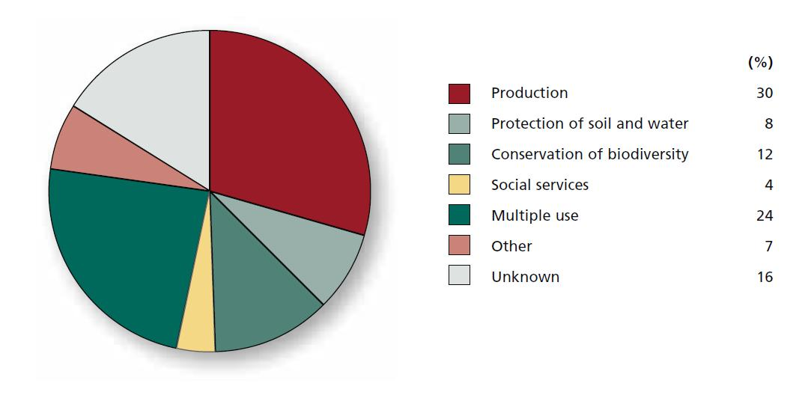

Fig 1.1 Designated functions of forests reported in the Global Forest Resources Assessment (FAO, 2010).

In fulfilling these functions forest ecosystems and trees provide goods and services, which are vital not only to human beings but also to all living being on earth including livestock, wild animals, fish and invertebrates . Important forest products include wood (mostly industrial wood), valued at just over US$ 100 billion annually and Non-Wood Forest Products amounting up to US$ 18.5 billion annually. The later value is likely to be underestimated as information is still missing from many countries where NWFP are highly important (FAO, 2010).

Given the important role of forest products and forest ecosystems services and the challenges arising with population growth, such increased need for food, the changing world consumption habits and its consequence on climate change and on forest resources, it becomes important to identify and analyse the major trends affecting Forest and its genetic resources.

When discussing the trends affecting FGR management, we should keep in mind that FGR are managed within a diversity of forest and trees management systems, which include naturally regenerated forest, planted forest, trees outside forest and agroforestry systems.

On a global average, more than one-third of all forest is **primary forest**. Primary forest is defined as “forest of native species where there are no clearly visible indications of human activities and the ecological processes have not been significantly disturbed” (FAO, 2010). Primary forests, in particular tropical moist forests, include the most species-rich, diverse terrestrial ecosystems. It is also considered as the most suitable conditions for the conservation of forest biodiversity including genetic resources. However primary forests are unfortunately increasingly threaten, even if the area of forest designated for conservation of biodiversity is in progress as a result of the ongoing global efforts (e.g. the Aichi Targets) to conserve biological diversity. In 2010, 12 percent of the world’s forest area is designated for conservation. Furthermore l**egally established protected areas cover an estimated 13 percent of the world’s forests. These protected areas include** national parks, game reserves, wilderness areas and others. The primary function of these forests usually includes the conservation of biological diversity, the protection of soil and water resources, or the conservation of cultural heritage.

The area of **planted forest** has increased over time amounting to a total of 264 million ha in 2010 compared with 178 million ha in 1990 (FAO, 2010). Planted forests currently represent 7 percent of the total forest area (Fig 1.2) and provide and essential contribution to the supply in industrial wood, wood energy, non-wood forest products as well as environment services including soil and water protection. A relatively wide number of tree species are used in planted forest. This number is estimated to be less than 400 and the growing stock of the ten most planted species represents more than 90 percent of the total growing stock in many countries, in the temperate and boreal zone, it represents less than 20 percent of total growing stock in tropical countries with high species diversity (FRA, 2010).

Figure 1.2. Characteristics of the world forests in 2010 (FAO, 2010)

The conversion of forest lands to agriculture is one of the major threats to forest genetic resources. Together croplands and pastures have become one of the terrestrial biomes on the planet, rivalling forest cover in extent and occupying about 40% of the land surface. Up to 40% of the global croplands may also be experiencing some degree of soil erosion, reduced fertility, or overgrazing (Wood et al. 2000).

1. **Facts and changes in Forest and Forest Ecosystems**

* 1. ***Forest and forest ecosystems degradation***

Forest and forest ecosystems are the best refuge of biodiversity where forest genetic resources conservation and processes are better enhanced and sustainably managed. The essential role of forest ecosystems in the conservation of the world biodiversity and in the provision of goods and services to the world population has gained increasing recognition over years in response to the challenges induced by climate change, population growth, and the inter-related increasing demand for food, wood, and energy. Worldwide changes to forests, farmlands, expansion of urban centres, development of the road networks, and building of artificial lacs are being driven by the need to provide food, wood, fiber, water, and shelter to the 7.2 billion world population.

Human activities are considered as the main drivers of changes in forest and forest ecosystems. The impact of disturbances may vary not only due to their intensities but also due to the nature of the forests or forest ecosystems. Depending on the management practices and intensity, different categories of trees based ecosystem or management systems can be distinguished: 1) Naturally regenerated forest, 2) planted forests and 3) trees outside forest and agroforestry systems.

Primary forests, in particular tropical moist forests, play an essential role in biodiversity conservation (Gibson et al. 2011). They contain 50 percent or more of all terrestrial biodiversity. Furthermore, the food security, livelihoods and cultural and spiritual identity of many indigenous people is often linked to primary forest (CBD Secretariat, 2009). Beside the fact that there is no substitute for primary forest to maintain tropical biodiversity, the right to pursue development can jeopardise its conservation in countries where primary forest constitute a large portion of the forest cover (e.g. 95 percent of the total forest cover in Surinam, 92 percent in Brazil, 91 percent in Papua New Guinea, 89 percent in Peru and 65 percent in Gabon) and where forest production, in particular timber provides an important contribution to the country economy. The combined effect of the right to pursue development and to expend farm lands explains the overall loss of 0.37% of the primary forest area from year 2000 to year 2010 (table 2.1)

* 1. **Land use changes**

Each year, 13 million ha of forests are being lost, mainly through conversion to other land uses. Land use changes usually leads to conversion of forest into agricultural land or into management systems, which mainly target production of timber, wood energy or other commodities.

Land use activities primary for agricultural expansion, and timber extraction, have caused a net loss of about 7 to 11 million km2 of forest in the past 300 years (Foley et al. 2005). In spite of the important effort undertaken in forest restoration and afforestation activities, with 5.7 million ha restored or planted annually, to reverse the forest degradation trend, 13 million ha of forest are still being lost every year, the earth is still losing some 200km2 of forest each day. Change in land use can therefore represent a serious threat to forest ecosystems, habitats, species and genetic diversity.

Table 2.1. Area of primary forest change over time, 1990-2010

|  |  |  |  |  |  |  |  |
| --- | --- | --- | --- | --- | --- | --- | --- |
| Region | Area of primary forest (x1000ha) | | | Annual change (x1000ha) | | Annual change (%) | |
|  | 1990 | 2000 | 2010 | 1990-2000 | 2000-2010 | 1990-2000 | 2000-2010 |
| East and Southern Africa | 7594 | 7024 | 6430 | -57 | -59 | -0.78 | -0.88 |
| North Africa | 15276 | 14098 | 13990 | -118 | -11 | -0.80 | -0.08 |
| West and Central Africa | 37737 | 32540 | 27527 | -520 | -501 | -1.47 | -1.66 |
| East Asia | 28179 | 26456 | 25268 | -172 | -119 | -0.63 | -0.46 |
| South and Southeast Asia | 87062 | 83587 | 81235 | -348 | -235 | -0.41 | 0.29 |
| Western and Central Asia | 2924 | 3083 | 3201 | -16 | 12 | 0.53 | 0.38 |
| Europe | 5183 | 5360 | 5438 | 18 | 8 | 0.34 | 0.14 |
| Caribbean | 207 | 206 | 205 | n.s. | n.s. | -0.07 | -0.02 |
| Central America | 5766 | 5226 | 4482 | -54 | -74 | -0.98 | -1.52 |
| North America | 274920 | 273795 | 275035 | -113 | 124 | -0.04 | 0.05 |
| Oceania | 41416 | 39191 | 35493 | -222 | -370 | -0.55 | -0.99 |
| South America | 684654 | 653691 | 624077 | -3096 | -2961 | 0.46 | -0.46 |
| World | 1190919 | 1144258 | 1102382 | -4666 | -4188 | -040 | -0.37 |

Source: FAO (2010). Global forest resources assessment 2010. FAO forestry paper 163. FAO, Rome, Italy

Important drivers of forest ecosystems degradation include large scale plantations for timber or paper pulp, and oil-palm (Foley et al 2005, Kongsager and Reenberg, 2012) which have replaced many natural forests and cover 1.9 million km2 worldwide.

Many land-use practices and extraction of forest and trees products (e.g., fuel-wood, non-wood forest products, forest grazing and roads) can result in degradation of forest ecosystems in particular with regard to their productivity, biomass, stand structure, species composition, and genetic diversity, even without changing forest area (Foley et al. 2005, Todd and Hoffman, 1999).

It is impossible to accurately estimate genetic loss that is resulting from deforestation and forest degradation given our general poor knowledge of forest genetic resources, in particular for tropical forest.

**2.3. Opportunities and assets for future action in conservation of FGR**

**Improve conservation of FGR**

*In situ* conservation is the most sustainable method for conserving forest genetic resources. However in the context of the climate change and the new trend with natural disasters, bush forest fires and illegal harvesting, *ex situ* conservation is regarded as an essential complementary conservation tool.

Because of the high cost involved in *ex situ* conservation, priority should be given to populations of endangered species or Taxa that are likely to become extinct.

Example of the Millennium Seed Bank (MSB) project

Together with their [partners](http://www.kew.org/science-conservation/save-seed-prosper/millennium-seed-bank/projects-partners/index.htm) in 80 countries worldwide, the Millennium Seed Bank project has already successfully saved seeds from over 11% of the world's wild plant species. By 2020, our aim is to secure the safe storage of seed from 25% of the world’s bankable plants. We target plants and regions most at risk from climate change and the ever-increasing impact of human activities. MSB also save the seeds of the world's plant life faced with the threat of extinction, and those that could be of most use in the future.

**Enhancing the role of protected areas for FGR in situ conservation**

A substantial proportion of wild and/or endemic plants occur only in primary forests and protected forest areas. Only in those forests ecosystems is the natural populations genetic structure conserved. Natural processes involved in the dynamics of FGR resources are better assessed and understood in protected natural forests, which remain the best laboratories for studying species’ ecology and biology. The contributions of primary forests and protected areas to the development of knowledge on plant species and to the conservation of FGR, therefore, need to be promoted.

1. **Information and Knowledge on FGR**

**3.1 knowledge on species and their genetic resources**

The availability of, and access to, quality and up-to-date information on FGR is reported to be poor in many countries. Most country reports highlight the need to promote awareness among decision-makers and the general public of the importance of FGR and their roles in meeting present and future development needs. Lack of information limits the capacity of countries and the international community to integrate FGR management into cross-cutting policies. In spite of the efforts made by plant taxonomists and geneticists in characterising and describing forest plants species and species populations, many key questions still needs to be answered.

*Filling the Knowledge gap on botany (How many tree species are there on earth?)*

Knowledge of species and their conservation status is still insufficient and inaccurate to adequately support conservation and sustainable management of forest genetic resources at global level. Estimates of number of plant species vary widely from 25000 to more than 400000 (Stebbins, 1974; Prance et al., 2000; Govaerts, 2001; Bramwell, 2002; Miller, 2011) and perhaps more than a quarter of all flowering plants still have not been named or discovered yet (Prance et al. 2000; Miller, 2011). Moreover, the answer to the question “how many trees species are there on earth?” remains so far very roughly answered. Figures vary enormously depending on authors, 50 000 according to the (National Research Council, 1991); between 80 000 and 100 000 species (Turok and Gebured 2000). These estimates become even more confusing when trying to refer to specific definition of tree. The state of the world forest genetic resources report include plant species identified by countries as part of their forest resources. In many cases country forest genetic resources reports include trees, shrubs, palms, bamboos, lianas, cycads, ferns and some herbaceous plants few cases (see annexe ....on Reference species list).

Status of botanical knowledge of plant species vary from country to country. Information on country forest plant species richness was not well reflected in most country reports although a remarkable effort was made to provide the information in the regional synthesis. A relatively small proportion of countries have a relatively accurate estimate of the number of their vascular plants; some of them completed their flora and very few have a detailed plant species checklist that includes species characteristics and life form, which could allow distinction between the type forests plants e.g. trees, shrubs, palms, bamboos, etc.

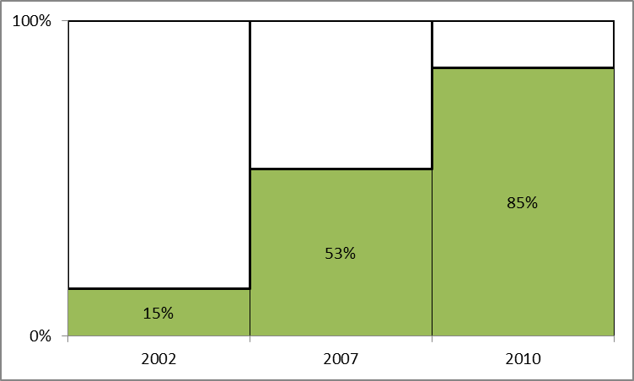

Figure 3.1 Proportion of plants in accessible working lists (Secretariat of the Convention on Biological Diversity (2009)

Major challenges to fill the gap of knowledge on plant species include frequent synonymy, the difficulty of discriminating certain species by morphology alone, and the fact that many undiscovered species are small in size, difficult to find, or have small geographical ranges (Scheffers et al. 2012).

**Major initiatives recently taken to fill the gap on knowledge on plants species include “The Global Taxonomy Initiative**” which enables the international community to acknowledge the existence of a "taxonomic impediment" to the sound management of biodiversity and to initiate a programme with the objective to remove or reduce the knowledge gaps in our taxonomic system.

In response to the Global Strategy for the Conservation of Biodiversity (GSCB) adopted in 2002 by the CBD, “the plant list” has been developed to provide a widely accessible working list of known plant species, which aims to be comprehensive in coverage at species level for all names of mosses and liverworts and their allies ([*Bryophytes*](http://www.theplantlist.org/1.1/about/#bryophytes)) and of [Vascular plants](http://www.theplantlist.org/1.1/about/#taxonomic-coverage) which include the flowering plants ([*Angiosperms*](http://www.theplantlist.org/1.1/about/#angiosperms)), conifers, cycads and their allies ([*Gymnosperms*](http://www.theplantlist.org/1.1/about/#gymnosperms)) and the ferns and their allies including horsetails and club mosses (*[Pteridophytes](http://www.theplantlist.org/1.1/about/" \l "pteridophytes)*). The last update (September 2013) include 1,064,035 species names, contains 642 plant families and 17,020 plant genera. Of these 350,699 are accepted species names, 470,624 synonyms and 242,712 unresolved (**The Plant List, 2013).**

Knowledge on species distribution remains inaccurate in the tropics and only few species have been subject to development of distribution maps. The status is however a bit different for temperate species. For example, in Europe 34 species distribution maps have been developed thanks to the European network on forest genetic resources (EUFORGEN: http://www.euforgen.org/distribution_maps.html). These distribution maps (figure .....) include information at population level, which are essential for monitoring the dynamic of the genetic resources of the related species.

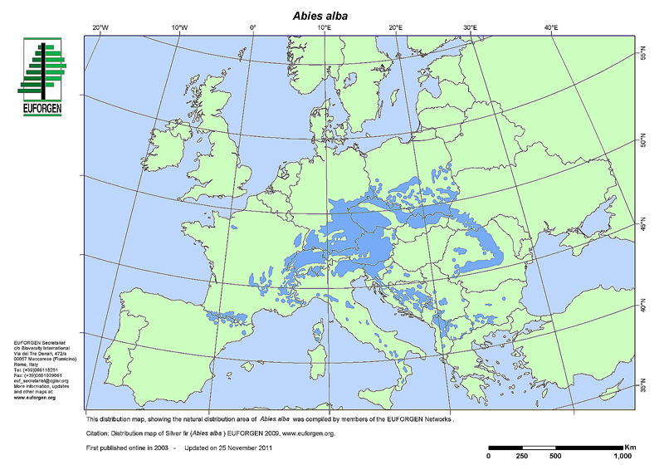

Figure 3.2. Example of species distribution map: case of *Abies alba* in Europ (source: EUFORGEN 2009. www.euforgen.org)

**3.2. Biotechnology in FGR management**

The development of new technologies e.g. biotechnology and there applications in tree breeding and genetic resources conservation, is expending although at a much more lower speed in developing countries and in the tropics in general. In general current uses of biotechnologies in forestry fall broadly into three categories: those based on molecular markers, those that enhance vegetative propagation eg micropropagation and genetic modification of forest trees. Tools used in biotechnology differ slightly between studies related to naturally regenerated forest and those related to planted forest.

For naturally regenerated forest, molecular markers and genomics are providing important knowledge on genetic variation within and between species populations. Biotechnology further provides important insights into the nature of the entire tropical forest ecosystems including the relationship between forest trees and the soil microbial communities with which they interact.

For planted forest and depending on the level of management intensity and genetic material used, the biotechnology tools used include tissue culture in vegetative propagation, to molecular markers, quantitative trait locus analyses, whole-genome sequencing, and genetic modification. These tools are currently applied for a range of purposes and involve a varied number of species. Assessment reported in FAO **(2004)** indicates that major forest biotechnology activities were reported for 142 genera in over 80 countries, with activities relatively evenly spread among major categories: genetic modification, 19 percent; characterizing genetic diversity, 26 percent; genomics, genetic maps and marker-assisted selection (MAS), 21 percent; and vegetative propagation or micropropagation, 34 percent. Of the over 700 tree species reported by countries as subject to tree improvement programme, 241 species are included in biotechnology research.

The development of large scale clonal plantations of some economically important species (e.g. Eucalyptus spp, Tectona grandis) using biotechnology has been reported by a number of countries including (Brazil, Chile, Congo Republic, India, South Africa, etc.).

Currently gene transfer is being tested in many forest species undergoing intensive breeding activities (Carnus et al. 2006). It is report that a total of 24 trees species are involved in GM experimental plantations around the world. Species frequently mentioned are Eucalyptus, Poplars, Radiata pine, Scots pine, Norway pruce.

The rapid development of tools (eg molecular markers) for analysing the genetic variability of forest trees has enable scientist to better characterise and assess gene fluxes between and within species populations, and to better understand the effects of silvicultural practices on the long-term evolution of genetic diversity of forest trees (Carnus 2006).

**3.3 Valuing Non Wood Forest Products demand**

A part from wood, forest provides a wide range of goods and services which are essential to the livelihood of the people and countries’ economy. However the reported value of non-wood forest products remains underestimated because of lack of information and relevant assessment tools at country level. Recent estimate made by FAO in 2010 indicates a value of the world NWFP of less than 17 billion US$ annually (Table 3.1.).

Table 3.1. Value of NWFP removals by category and regions

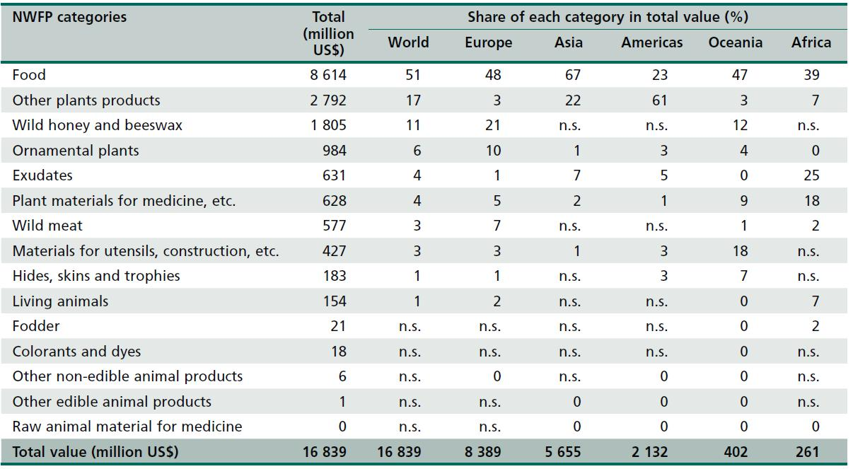

Source: FAO, 2010

Over 1000 tree species were identified as actively managed for NWFP in the country reports on the state of forest genetic resources. This number is probably far from the estimates usually found in publications. For example FAO (2011) indicates that 75% of the overall tropical tee species are being used for their NWFP value.

**3.4 Scientific needs related to current challenges**

## *Selection and breeding of trees to respond to climate change*

There is a need to modify traditional breeding programs. Breeding programs will need to consider plasticity and adaptation to increased drought, a substantial change from current practice, and add climate change-related traits into their selection criteria, which is still little done worldwide.

Provenance trials that have been established at multiple locations using germplasm sourced from a variety of ecological conditions, demonstrate that variation in adaptive traits is almost always present within tree species. Not only is genetic diversity in important adaptive traits expressed across regions and provenances, but it is also abundant within populations, reinforcing an optimistic view that climate change challenges may be met by standing genetic variation in such species (Hoffmann and Sgro 2011).

However, many provenance trials were established before the need to respond to large scale anthropogenic environmental change was considered an important research issue, and so the traits measured in trials have often not been the most important ones from an adaptation-to-climate-change perspective. Nevertheless, these old multi-locational trials provide insight into the performance of provenances from different climate regions and allow sources of locally adapted material to be identified. Survival and growth are considered good proxies to fitness (e.g., Ouedraogo et al. 2011). New trials specifically established to assess explicit responses to climate change are being established in a number of countries (details can be found at <http://treebreedex.eu/>).

### Some important traits needed for adaptation to different climatic conditions but are not often considered in breeding programs are: Pest resistance, Drought resistance, Fire resistance/tolerance, Cyclone resistance, salt tolerance, Phenotypic plasticity

### Countries developing national forestry action plans should be encouraged to specifically include genetic level responses to climate change in their plans.

***Other priority area for research***

In many ways, **understanding of genetic diversity in tropical tree species** is advancing rapidly, yet the scale of the task ahead remains enormous. In such high diversity systems, under extreme pressure from human exploitation, changing climate and shifting ecology, the need to improve the state of knowledge is acute. For most species, we even lack good basic data on what the standing resources are, and the dynamics and mechanisms that maintain them. Gathering these data and interpreting them to discover how contemporary genetic resources were formed and to predict how they may respond to changes in the future is a vast challenge. Here, we recommend a series of research priorities to begin to address this challenge; it is likely that these efforts would be most effective targeted at the lists of priority species identified by regional forest genetic resources networks, but other species should not be excluded.

1. **Improved taxonomic knowledge of tropical tree species.**
2. Improving the understanding of the genetic diversity of important or priority species and the processes that determine the structure of the genetic diversity within and between populations. Identifying and understanding the genetic traits which enhance adaptation of species, will particularly be useful in tackling many challenges related to climate change. It will further provide opportunities to boost the functions of trees and forest.
3. **Mapping tropical forest genetic resources.** Assess key priority species across complete range, i.e. map genetic variation, to provide context for FGR prioritisation. Map layers could include neutral genetic data, genomic data, and experimentally-assessed phenotypic variation. Existing initiatives provide a lead, i.e. MAPFORGEN <http://www.mapforgen.org/>
4. Promote meta-analysis on key aspects of forest genetic resources will be necessary to better understand the link between characteristics of diversity at species and genetic levels and the processes determining priority/important forest species genetic status processes.

**4. Drivers of changes in the forestry sector affecting FGR**

**4.1 Demand on forest products**

The world current population of 7.2 billion is projected to reach 9.6 billion by 2050. Whereas population in developed countries are expected to remain largely constant, growth is expected to be particularly dramatic in the least developed countries of the world, which are projected to double in size from 898 million inhabitants in 2013 to 1.8 billion in 2050 and to 2.9 billion in 2100 (UN, 2013). Along with population growth, production of energy, food and many other commodities is predicted to increase with some negative impact on the natural resources including forest genetic resources. Deforestation is driven by the need for land for more agricultural or agroforest production, human settlements, infrastructure and mining. For example, the demand for wood products for both industrial and domestic uses is expected to increase by 40% in the next 20 years (FAO, 2010). Expansion of small scale permanent agriculture justify 60% of forest conversion in Africa while large scale permanent agriculture involving commodities such as palm oil, soya beans represents the major cause of forest conversion in Latin America and Asia (FAO, 2001).

At present bio-energy including, firewood, charcoal represent a major portion of the domestic energy consumption in many developing countries. It is one of the main causes of forest degradation in many developing countries especially in Africa where fuel wood represents 90% of the total wood removals compared to 47% of overall world (FAO, 2010). Driven by population growth and the subsequent demand for more domestic energy supply, fuel wood consumption has increased by 4% from 2000 to 2010. Fuel wood removal is considered among the major cause of forest degradation in the so called dry land or semi-arid countries in Africa.

Bio-energy is expected to become an important component of future renewable energy systems, and policies are being developed to facilitate this process. The EU, long lacking a forest policy, is now promoting energy policies having potentially far-reaching implications for forests and forest use. The EU currently imports almost half the energy resources it consumes. Energy security is also becoming a central theme. At present, Europe imports liquid biofuels and wood pellets. Already in 2007, many European countries, such as Belgium, Finland, the Netherlands, Sweden and the U.K., imported significant amounts of biomass varying between 12% and 43% of their total utilization for energy purposes.

**4.2 Expansion of crop areas**

The growing global demand for land for the production of agricultural commodities has resulted in sometimes irreversible changes to the world’s forest cover. The development of small scale permanent agriculture in many developing countries, in particular in Africa and large scale permanent agriculture in Latin America and Asia are important factors of crop land expansion. Over the last decade (2000-2010), permanent crop area has globally increased by 15.7%, with 22% in the least developed countries (Table 4.1).

Figure 4.1. Changes in crop land area from 2000 to 2010 (source of data: FAOSTAT, 2013)

Heavy grazing in forest land can cause a shift from perennial to annual vegetation type. examples of studies showed up to 50% reduction of large woody shrubs cover in South Africa ( ). Other studies, mostly on grassland conditions suggest that species diversity can receive a positive impact, resulting in increased species richness although not always. The spatial concept of plant species richness as presented in Olff and Ritchie (1998) suggest that higher plant diversity should occur when local extinction rates of species are lower than local colonization rates. Forest reserves in some regions are the main source of fodder for cattle which graze freely during the dry season when animal feed become scarce. Typical example can be found in the sahelian and other semi-arid countries of West Africa where the cattle and small ruminant population is estimated to be as high as 60 million and 160 million respectively (SWAC-OECD/ECOWAS, 2008). In these cases, pressure of the growing livestock population on the genetic resources can be destructive and a serious threat to many woody forage species. Furthermore herders who practice pollarding of fodder trees to feed their animals can put particular tree species en danger.

In Latin America, cattle ranches are expanding rapidly (FAO 2007a) and accounts for a large portion of deforestation. In the Brazilian Amazon region, ranches cover an area of at least 8.4 million hectares in total (<http://www.unep.org/vitalforest/Report/VFG-06-Forests-under-threat-as-agricultural-commodities-take-over.pdf> ).

**4.3 Forest fire**

Fire may cause variable effects depending on the intensity and extent in space of the fire. Increased fire frequency may eliminate fire-sensitive species altogether from woodlands and parklands. In regions that have not regularly experienced wild fires in the past, fire may become the main driver of change, with a rapid transition from fire-sensitive to fire-resistant species.

Severe fire may have the same effect as clearing a forest especially where large patchy openings are created as a result of fire. The patterns and sizes of such openings versus the forest cover influences genetic diversity. The major impacts are heavy mortality on the burnt species thus reduced population sizes and this would increase genetic drift. For isolated populations this means the migration rates of seed and pollen exchange are affected. Sources of migration could even be cut off, thus reducing the effectiveness of pollinators.

Adverse fire may directly affect biotic dispersal agents and this may decrease migration of genes between populations. Migration may increase if the migration vectors are abiotic. A more devastating fire may affect traits that could have a direct bearing effect on fire resistant species and such action would have direct selection that indiscriminately remove all such genotypes (FAO, 2010).

**4.4 Climate change**

Global climate change projections depend on the rate of emissions of greenhouse gases, but expected temperature increase can occur following a low temperature increase scenario, which predict an increase range from 1.1oC to 2.9 by 2090-2099 (compared to 1980-1999), a medium scenario with an increase range from 1.7oC to 4.4oC and a high scenario with an increase range from 2.0oC to 5.4oC (Solomon et al. 2007). Among the reasons for greenhouse gas emissions, deforestation and forest degradation, through agricultural expansion, conversion to pastureland, infrastructure development, destructive logging, fires etc., account for nearly 20%.

***Impact of climate change and forest pest***

Changing weather patterns are altering the growing conditions for forest trees as well as the population dynamic of the pests and diseases that attack them. In Canada, cold winters used to prevent or reduce the spread of a bore beetle plague. The insect is now, with warmer winters, expanding into new areas and attacking pine trees that have no resistance, and therefore threatening the genetic diversity of forest populations. Useful insects (e.g. pollinators) and other plant associated organisms can be affected as well. Improving knowledge of forest genetic diversity, including on pest resistance, will be increasingly important in forest management, as this example illustrates.

***Impact of climate change on the dynamic of species populations****:*

High mortality due to extreme climatic events, in combination with regeneration failure, will result in local population extinction and the loss of FGR. This will be the case particularly at the receding edge of distributions.

Predictions regarding impacts on FGR in natural forests, forest plantations and on farms vary. Although some authors (e.g. Hamrick, 2004) consider that many trees have sufficient phenotypic plasticity and genetic diversity at the population level to significantly reduce the negative effects of climate change, others have taken a different viewpoint and predicted severe impacts (e.g. Mátyás 2007; Rehfeldt *et al*., 2001). Different positions relate partly to the types of species and environments being considered. Authors who make the more pessimistic forecasts often base their views on tropical trees (Dawson *et al*., 2011) or on marginal populations of temperate species (Mátyás *et al*., 2009), while more optimistic authors often consider temperate and boreal taxa (Lindner *et al*., 2010).

Climate change impacts are expected to be severe in dry, high-temperature regions where trees are at their adaptive limit (e.g. Lindner *et al*., 2010 for Europe) and in confined islands of moist forest that are surrounded by drier land (e.g. moist forests in Australia; Williams *et al*., 2003). Whereas the ranges of some tree species are expected to expand, others will diminish. In temperate regions, range reduction at the receding edge of distributions (low elevation and low latitude) is expected to be more rapid and of greater magnitude than expansion at the leading edge (high elevation and high latitude) because of a number of factors that limit the ability of tree species to migrate across landscapes. Thuiller *et al*. (2006) have also shown that tree species richness and functional diversity will be impacted more at low than at high latitudes in Europe. In other regions such as the tropics, changes in precipitation rather than temperature may be of key importance (Dawson *et al*., 2011).

***Climate change and invasive species***

Changing climates will result in new species invasions, altered patterns of gene flow and the hybridization of species and populations. Shifting ecological niches will increase the risk of invasion by more competitive tree species that are more precocious or can move more quickly. Invasions of new genes via pollen and seed dispersal may disrupt local evolutionary processes, but could also be a welcome source of new adaptive traits (Hoffmann and Sgro, 2011).

**4.5 Policy environment: *Ownership***

Ownership is a key variable which determines forest management options and sustainability. FAO reported that in 2005 that 80% of the world forest is public, 18 % private and 2% others. Privately owned forest encompasses 58% of individual forest, 19% of corporate or institutional forest and 23% of community or indigenous forest (FAO, 2010).

Public ownership remains the predominant ownership category in all regions. Decentralisation system in many countries has an important impact in forest management and may allow different states within the same country to apply different forest management regulations. Furthermore the role of local communities and indigenous people in forests and forest ecosystems management is increasingly acknowledged, leading to more integration of their rights in the forest management plan.

Further to the regulations adopted and applied at community, province or state levels forest management is guided by national and international legal instruments. Ensuring that regulations at the different levels are consistent when necessary remains an important challenge, especially when trying to combine the user rights of local and indigenous people and conservation of endangered species.

## 4.6 Opportunities and assets to cope with the changes

## *Assisted migration to accelerate adaptation to climate change*

Trees and tree populations are amenable to the “facilitated translocation” of germplasm, which involves movement (by people) of tree seeds and seedlings from existing ranges, to sites expected to experience analogous environmental conditions in future years (Guariguata et al. 2008; McLachlan et al. 2007). The movement could be latitudinal or altitudinal (Box 7). The purpose of this intentional movement of individuals, populations, or reproductive materials (seeds and vegetative parts), also called “assisted migration”, is to reduce climate change-related extinction risks (Heller and Zavaleta 2009; Marris 2009; Millar et al. 2007). Species or populations that are unable to migrate to new locations or adapt through natural selection can be intentionally moved to a region where stresses are less severe. Assisted migration could also take the form of translocation of germplasm over long distances (assisted long-distance migration), translocation just beyond the range limit (assisted range expansion), and translocation of genotypes within the existing range (assisted population migration) (Winder et al. 2011). Under certain interpretations, assisted migration would include the introduction of new species to maintain ecological services, such as wood production and carbon sequestration. In practice, a gradual form of assisted migration could consist of implementing guidelines that require that reforestation of harvested sites be done using seed from neighboring sources already adapted to expected future climates, e.g., (in the Northern hemisphere) by using seed from sources south (in the northern hemisphere) of the area to be planted (Box 8)

***Decentralisation and FGR management***

Many countries have developed over the years a decentralized country administration and natural resources management policy. The main objective for the establishment of Decentralised Natural Resources Management (DNRM) programmes being the improvement of equitable access to and sustainable management of natural resources by indigenous and local people, who rely on them for their livelihood.

In such countries, natural resources management, including FGR management issues are usually included in the decentralisation policies. ,

In some cases, regulation measures are decided at province or state level. In countries where this is the case, there is a need to provide appropriate technical support to decentralized administrations in order to enable them to review or develop policy tools that ensure sustainable use and management of FGR, including protection, preservation and sustainable use of FGR for maintaining customary use by indigenous and local communities.

In order to take advantage of the opportunities that decentralisation is offering, decentralised natural resource management programmes should be more aware of their political and ecological limitations, and more strategic in building sustainability based on the socio-cultural, economic and environmental context of the specific targeted area. Be it a state, a province, a district or a village. Participation of the people at local level and ownership of management proagrammes by the stakeholders are better enhanced through well planned decentralisation initiatives.

Furthermore it is commonly accepted that in situ conservation of FGR has better chances of success if local or indigenous communities living in the forests or in their vicinity are responsible of or strongly involved in the implementing the conservation programmes. In this regard decentralisation programmes represent a useful policy framework for in situ conservation of forest genetic resources in many countries.

***Multiple uses Forest Management (MFM)***

All the changes that affect the status and trends of forest genetic resources, call for better sustainability in forest management. The United Nations general assembly defines sustainable forest management (SFM) as a “**dynamic and evolving concept, which aims to maintain and enhance the economic, social and environmental values of all types of forest, for the benefit of present and future generations”.**

Naturally regenerated forest across the tropics provide a wide range of products, ecosystem services and social and economic opportunities and can potentially be managed to meet multiple objectives Sabogal et al. (2013).

Multiple use forest management (MFM) is the concept of forest management that combines two or more objectives, such as production of wood, proper environment conditions for wildlife, soil and water protection, recreation, and the supply of a range of NWFP (e.g. food, animal feed, medicines ect.). This approach is a way to enhance sustainable forest management by taking into consideration the concerns of the stakeholders.

Other important international initiatives such as the REDD+, goes beyond carbon storage to include conservation and sustainable management of forests as a way to encourage developing countries to contribute to climate change mitigation. REDD+ therefore represent an important asset for developing FRG conservation activities in countries where the programme is implemented.

### *Timber tracking technology: an innovative tool to prevent illegal timber trade*

Unsustainable and illegal logging is a driving force of deforestation worldwide. It is estimated that more than 50% of wood exported from the Amazon, Central Africa, South East Asia and Russia is illegally harvested resulting in annual losses in revenues and assets between US$ 10-15 billion. Timber-producing countries will continue to lose valuable resources and income until such unsustainable and illegal practices are stopped.

Examples of common practices associated with illegal logging are false declaration of: a) species if harvested wood is from an endangered species or a species excluded from legal harvest in a particular country or region; b) country of origin when harvest of a particular species is allowed in one country but not another; and c) timber that has been harvested outside of a concession or inside a protected area.

At present, there is a lack of practicable control mechanisms to identify the origin of timber and wood products. Furthermore timber companies need to be sure on the true botanical species since species name is part of the requested information of the EU timber regulation (<http://ec.europa.eu/environment/eutr2013/index_en.htm>) and the US Lacey Act ([www.ucsusa.org/illegallogging](http://www.ucsusa.org/illegallogging)). For species, which are difficult to distinguish by comparing their morphological traits, genetic differentiation remains the most efficient method for the species identification. A genetic inventory of high value trees before felling will not only be a first step of a Chain of Custody security system but also a way to avoid the felling of the wrong tree species.

Advances in science over the last decade have made possible the use of new technologies, based on DNA fingerprints and stable isotopes, provides timber companies and timber traders a high level of accuracy in identifying timber species and origin. DNA provides a scientific, truly independent and infallible platform to distinguish the species, validate the Chain-of-Custody documentation and eliminate fraud.

Thus the development of the DNA technology offers great opportunities for the forest genetic resources management, including:

* A better enforcement of forest laws and regulations by improved verification and monitoring procedures
* The development of genetic (and isotopic) reference database for traded timber species for the purpose of timber tracking..
* Improved tools to control the trade with CITES protected species and species that could be confounded with them
* A transfer of know-how and capacity building in timber producer and timber transit countries

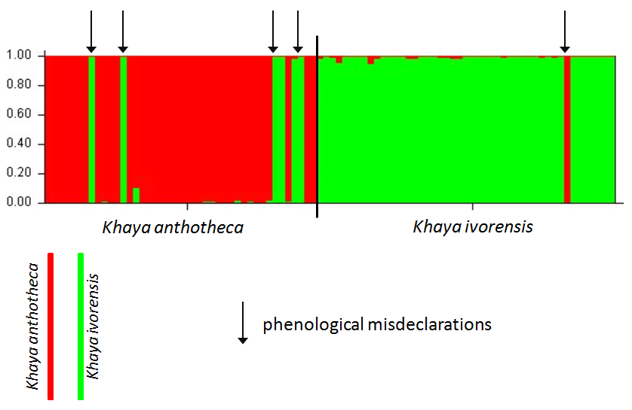

Figure 4.2 Genetic differentiation between *Khaya ivorensis* and *Khaya anthotheca* (Degen 2013, unpublished)

|  |  |
| --- | --- |
| Genetic reference map for mahogany (Swietenia macrophylla) in Latin America (Degen et al. 2013) | The distribution of 13 haplotypes in 32 populations of Neobalanocarpus heimii from 29 forest reserves of Peninsular Malaysia show populations differences (Lee Hong Tnah et al. 2009) |

Figure 4.3 genetic reference maps of species in Latin America and the Malaysian Peninsular (Source: Degen et al. 2013; Lee Hong Tnah et al. 2009)

As shown in by Höltken et al (2012), the barcoding of species helps to clearly identify the CITES protected timber species.

Several publications (e.g. Craft *et al.* 2007, Lee Hong Tnah *et al.* 2009, Degen *et al.*. 2013, Jolivet and Degen 2013) have demonstrated the efficiency of DNA technology to distinguish the genetic differentiation between trees from different part of the earth. The fig 4.3show some examples of genetic reference maps of some species.

***Integrate FGR in broader forest and NRM management policy framework***

Under the CBD, there are a number of international agreements which are progressively being implemented. The Cartagena Protocol on biosafety which is force, and The Nagoya Protocol on Access to Genetic Resources and the Fair and Equitable Sharing of Benefits Arising from their Utilization, now being ratified by member countries. Both protocols are useful international regulation framework, which should contribute to the conservation sustainable use and management of forest genetic resources at global as well as individual country level.

***Identifying appropriate indicators for FGR monitoring***

Genetic diversity is probably the element of biodiversity where the development of relevant indicators has lagged most behind. This has repeatedly been pointed out by the scientific community (*e.g.* Laikre *et al.* 2010). Recognised by SCBD (SCBD 2010, cf. also Walpole 2009), the Strategic Plan for Biodiversity 2011-2020 allow for improved coverage. Nevertheless it remains a major challenge to identify and operationalize indicators of genetic diversity, including tree genetic diversity (Graudal et al ......TS) .

The use of a hierarchical approach introducing the proportion of coverage as a measure of progress on selected indicators at different levels offers a possibility for general use within the S-P-B-R framework. In table ....below a first attempt is made to list indicators and their type (state, pressure, benefit, response) in a cross tabular format with the levels considered (global, regional/national and local).The table is not exhaustive, but contains a set of possible examples.

The difficulties in defining sound and realistic indicators arise from the fact that they should be policy relevant, scientifically sound, understandable, feasible to obtain and sensitive to changes over time. A separate document on indicators for sustainable FGR management is being prepared along with the State of the World Forest Genetic Resources to fill the gap.

**References**

Bawa KS, Dayanandan S (1998) Global climate change and tropical forest genetic resources. Climate Change 39:473–485

Bradley J, Glenn C, Howe T (2011). Strategies for conserving forest genetic resources in the face of climate change. Turkish Journal of Botany, 35 (2011) 403-409

Carnus J.M., Parotta J. Brockerhoff E., Arbez M., Jactel H. Kremer A, Lamb D., O’Hara K., and Walters B. 2006. Planted forests and biodiversity. *Journal of Forestry* 104, 65-77.

CBD Secretariat, 2009.

Craft KJ, Owens JD, Ashley MV (2007). Application of plant DNA markers in forensic botany: genetic comparison of Quercus evidence leaves to crime scene trees using microsatellites. Forensic Sci. Int. 165(1):64-70.

Degen B., Ward S.E., Lemes M.R., Navarro, C., Cavers S., Sebbenn A.M. (2013) Verifying the geographic origin of mahogany (*Swietenia macrophylla* King) with DNA-fingerprints. Forensic Sci Int Genet. 7 (1): 55-62

FAO 2004. Trends and current status of the contribution of the forestry sector to national economies. FAO Working paper: FSFM/ACC/07

FAO. 2004. *Preliminary review of biotechnology in forestry, including genetic modification.* Forest

FAO, 2010. Global Forest Resources Assessment 2010. FAO Forestry paper 163.

FAO 2011. Biotechnologies for agricultural development. Abdc10, FAO. 569 pages.

FAO, 2011. Forest for improved nutyrition and food security. <http://www.fao.org/docrep/014/i2011e/i2011e00.pdf> . Accessed on February 17, 2014.

[Gibson L](http://www.ncbi.nlm.nih.gov/pubmed?term=Gibson%20L%5BAuthor%5D&cauthor=true&cauthor_uid=21918513), [Lee TM](http://www.ncbi.nlm.nih.gov/pubmed?term=Lee%20TM%5BAuthor%5D&cauthor=true&cauthor_uid=21918513), [Koh LP](http://www.ncbi.nlm.nih.gov/pubmed?term=Koh%20LP%5BAuthor%5D&cauthor=true&cauthor_uid=21918513), [Brook BW](http://www.ncbi.nlm.nih.gov/pubmed?term=Brook%20BW%5BAuthor%5D&cauthor=true&cauthor_uid=21918513), [Gardner TA](http://www.ncbi.nlm.nih.gov/pubmed?term=Gardner%20TA%5BAuthor%5D&cauthor=true&cauthor_uid=21918513), [Barlow J](http://www.ncbi.nlm.nih.gov/pubmed?term=Barlow%20J%5BAuthor%5D&cauthor=true&cauthor_uid=21918513), [Peres CA](http://www.ncbi.nlm.nih.gov/pubmed?term=Peres%20CA%5BAuthor%5D&cauthor=true&cauthor_uid=21918513), [Bradshaw CJ](http://www.ncbi.nlm.nih.gov/pubmed?term=Bradshaw%20CJ%5BAuthor%5D&cauthor=true&cauthor_uid=21918513), [Laurance WF](http://www.ncbi.nlm.nih.gov/pubmed?term=Laurance%20WF%5BAuthor%5D&cauthor=true&cauthor_uid=21918513), [Lovejoy TE](http://www.ncbi.nlm.nih.gov/pubmed?term=Lovejoy%20TE%5BAuthor%5D&cauthor=true&cauthor_uid=21918513), [Sodhi NS](http://www.ncbi.nlm.nih.gov/pubmed?term=Sodhi%20NS%5BAuthor%5D&cauthor=true&cauthor_uid=21918513). 2011. Primary forests are irreplaceable for sustaining tropical biodiversity. Nature 478: 379-391.

Höltken A.M., Schröder H., Wischnewski N., Degen B., Magel E., Fladung M. (2012) Development of DNA-based methods to identify CITES-protected timber species : a case study in the Meliaceae family

Jonathan A. Foley, Ruth DeFries, Gregory P. Asner, Carol Barford, Gordon Bonan, Stephen R. Carpenter,F. Stuart Chapin, Michael T. Coe, Gretchen C. Daily, Holly K. Gibbs, Joseph H. Helkowski, Tracey Holloway, Erica A. Howard, Christopher J. Kucharik, Chad Monfreda, Jonathan A. Patz, I. Colin Prentice, Navin Ramankutty, Peter K. Snyder 2005. Global Consequences of Land Use. Science vol 309: 570-574. Global Consequences of Land Use. Science vol 309: 570-574.

Jolivet C., Degen B. (2013) Use of DNA fingerprints to control the origin of Sapelli timber (*Entandrophragma cylindricum*) at the forest concession level in Cameroon. Forensic Sci. Int. Genet 6 (4): 487-493.

Lee Hong Tnah, Soon Leong Lee, Kevin K.S. Ng, Naoki Tani, Subha Bhassu, Rofina Yasmin Othman (2009) Geographical traceability of an important tropical timber (Neobalanocarpus heimii) inferred from chloroplast DNA. Forest Ecology and Management 258 (9): 1918-1923

Lee Hong Tnah, Soon Leong Lee, Kevin Kit Siong Ng, Qamaruz-Zaman Faridah, Ibrahim Faridah-Hanum (2010). Forensic DNA profiling of tropical timber species in Peninsular Malaysia. Forest Ecology and Management 259 (8): 1436–1446

Loo Judy, Bruno Fady, Ian Dawson, Barbara Vinceti1and Giulia Baldinelli (2011) Climate change and forest genetic resources- State of knowledge, risks and opportunities. Prepared for the Thirteenth Regular Session of the Commission on Genetic Resources for Food and Agriculture, 18-22 July 2011, FAO Headquarters, Rome.

FAO, 2004. **Preliminary review of biotechnology in forestry, including genetic modification** Genetic Resources Working Paper FGR/59E. Forest Resources Development Service, Forest Resources Division. Rome, Italy.

<http://www.euforgen.org/distribution_maps.html> (Accessed on 18th February)

Kongsager, R. and Reenberg, A. (2012). Contemporary land-use transitions: The global oil palm expansion. GLP Report No. 4. GLP-IPO, Copenhagen.

Olff, H., and M. E. Ritchie. 1998. Effects of herbivores on grassland plant diversity. Trends in Ecology & Evolution 13:261–265.

Solomon, S; D Qin; M Manning; Z Chen; M Marquis; KB Averyt; M Tignor; and HL Miller. 2007. In *IPCC 2007: Climate Change 2007: The Physical Science Basis. Contribution of Working Group I to the Fourth Assessment Report of the Intergovernmental Panel on Climate Change*. Cambridge University Press, Cambridge, UK.

SWAC-OECD/ECOWAS, 2008. Livestock and regional market in the sahel and West Africa. Potentials and challenges.

The Plant List **(2013). Version 1.1. Published on the Internet; http://www.theplantlist.org/ (accessed 1st January).**

Secretariat of the Convention on Biological Diversity. (2009). Sustainable Forest Management, Biodiversity and Livelihoods: A Good Practice Guide. Montreal, 47 + iii pages.

Scheffers B. R., Joppa L. N., Pimm S. L., Laurance W. F. 2012. What we know and don’t know about Earth’s missing biodiversity. Trends in Ecology and Evolution. 27 ( 9), 501-510

S. W. Todd & M. T. Hoffman. 1999. A fence-line contrast reveals effects of heavy grazing on plant diversity and community composition in Namaqualand, South Africa. *Plant Ecology* 142: 169–178.

Sunderland and Pottinger A. J (2011). The international forest review: Special issue on Forests, Biodiversity and Food security. Common wealth Association

Thompson, I., Mackey, B., McNulty, S., Mosseler, A. (2009). Forest Resilience, Biodiversity, and Climate Change. A synthesis of the biodiversity/resilience/stability relationship in forest ecosystems. Secretariat of the Convention on Biological Diversity, Montreal. Technical Series no. 43, 67 pages.

United Nations, Department of Economic and Social Affairs, Population Division

(2013). *World Population Prospects: The 2012 Revision, Key Findings and*

*Advance Tables*. Working Paper No. ESA/P/WP.227.

Wood S., Sebastian K., Scherr S.J. (2000). Pilot analysis of Global Ecosystems: Agroecosystems. International Food Policy Research Institute and World Resources Institute, Washington, DC.