Transboundary Agro-Ecosystem Management Programme (TAMP) for the Kagera River Basin

Project Brief – December 2006

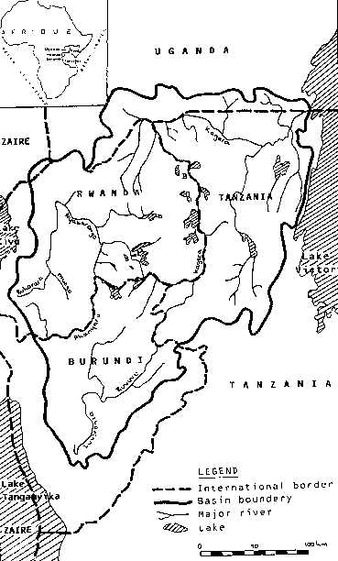
Background

The Kagera river basin covers an area of 59,700 km², distributed between Burundi, Rwanda, Uganda and Tanzania. It flows into Lake Victoria, the largest fresh water body in Africa.

The natural resources of the Kagera river basin support the livelihoods of some 16.5 million people, the majority rural and depending directly on farming, herding and fishing activities. These natural resources face increasing pressure as a result of population growth, intensification of agriculture and livestock activities and unsustainable land management practices. The basin’s land, freshwater and its associated biodiversity are threatened by declining productivity of cropland, rangeland and forests.

The Transboundary Agro-Ecosystem Management Programme (TAMP) for the Kagera River Basin aims to reverse land degradation in order to generate the local, regional and global environmental benefits resulting from a more productive and sustainable use of biodiversity and agricultural ecosystems. It responds to the need for concerted action among farmers, communities, districts and countries in the river basin to reverse the process of degradation and ensure the conservation and sustainable use of land, water and biological resources. Particular attention will be paid to the biodiversity and agro-ecosystem functions on which human livelihoods and food security depend.

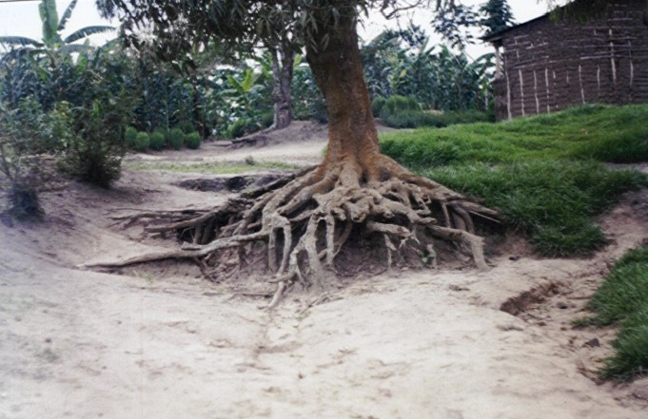The Kagera TAMP project is funded through the Global Environment Facility (GEF) in partnership and with co-funding from the governments, partner programmes and donors at country and regional levels. The project development phase was executed by the UN Food and Agriculture Organization (FAO) with support of the United Nations Environment Programme (GEF-UNEP), as implementing agency. The full project has been reviewed and included in the GEF work programme for approved funding of US$7 million in 2007 under the TerrAfrica Initiative for Sustainable Land Management in Sub-Saharan Africa.
The project is managed by both agriculture- and environment-sector agencies through national Technical Advisory Committees. Country-level coordination is the responsibility of:
- Ministry of Agriculture and Livestock (MINAGRI) in Burundi
- Ministry of Agriculture, Livestock and Forestry (MINAGRI) in Rwanda;
- Ministry of Agriculture, Animal Industry and Fisheries (MAAIF) in Uganda;
- Division of the Environment (DOE), Vice President’s Office, in coordination with the three agriculture-sector line ministries in Tanzania.

Stakeholders
The success of the Transboundary Agro-Ecosystem Management Programme (TAMP) for the Kagera River Basin rests on the active participation of a broad range of stakeholders:
- farmers, herders, their communities and the private sector;
- those providing extension and technical support at District (Prefecture) level, including service providers, projects and NGOs;
- researchers, from district and regional bodies and university staff
- decision-makers at national level in Burundi, Rwanda, Tanzania and Uganda; as well as,
- authorities of the Kagera - and more broadly of the Nile - water basin organizations.

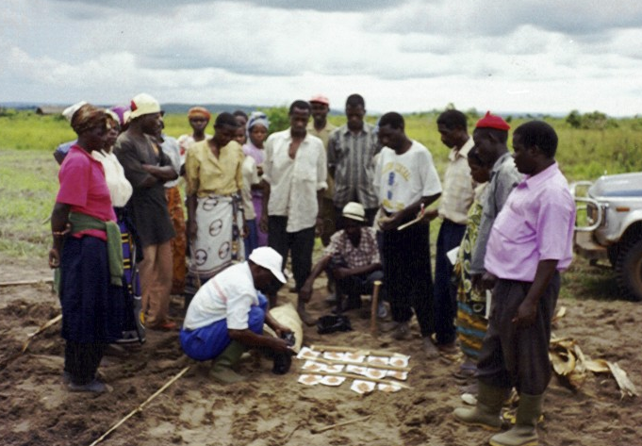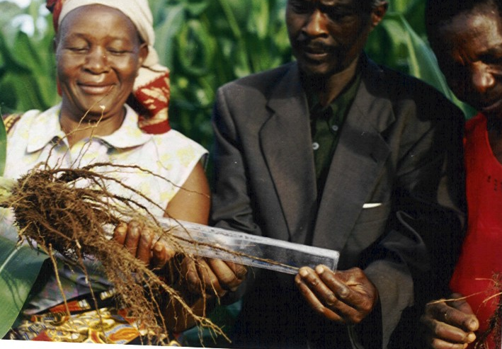

Project Development Process and Results

Beneficiary countries shared their views on the major issues and challenges affecting the Kagera watershed at an initial regional workshop held in Mbarara (Uganda) in May 2001, supported through a GEF Project Development Facility PDF-A grant. The workshop resulted in agreement between stakeholders on the direct and underlying causes of land degradation, and overall objectives to be pursued through the proposed transboundary initiative. This led to the GEF PDF-B proposal and grant (US$700,000 + co-funding) to support the full project formulation process during the period from April 2004 to March 2006 (EP/RAF/401/GEF). Burundi joined the Kagara TAMP with approval of the regional PSC in November 2005 allowing the project to target the whole Kagera river basin (it was not a full PDFB partner due to country insecurity).

The major outcomes of the project development phase for the TAMP are:
- Collaborative mechanisms for project development and implementation developed;
- Transboundary field-based diagnostic of land use and agricultural management conducted;
- Framework and action-oriented implementation strategy developed for the Transboundary Agro-Ecosystem Management Programme (TAMP) and project formulated.

Specific outputs from the PDF-B phase, which was led by the National Project Managers in Rwanda, Tanzania and Uganda, supplemented by consultations in Burundi, include:

- Multi-sectoral Technical Advisory Committees (TAC) established in Rwanda, Tanzania and Uganda;
- Regional Project Steering Committee (PSC) established to advise on regional collaboration and coordination and which invited Burundi to join the project late in 2005;
- Consolidated database with remote-sensing & GIS data from the four countries in the river basin (with a detailed atlas for 3 PDF-B countries plus basic data for Burundi);
- Field methodology developed, tested and used in representative sites across the basin to assess land degradation, agro-ecological and socio-economic status and trends using participatory techniques (transects and rural appraisals);
- Agricultural, environmental, policy and project implementation issues in the basin identified and fed into national/district level stakeholder consultations and workshops;
- Relevant experiences/lessons learned in the region reviewed with a view to strengthened community-level planning and integrated management of land resources;
- Full project formulated drawing in depth from the expertise, knowledge gained and lessons learned from the countries and region and reviewed at district and national levels;
- Partnerships and co-funding opportunities and commitments by governments, projects, donors and regional programmes identified, in particular LVEMP and NBI-NELSAP.

Kagera TAMP full project

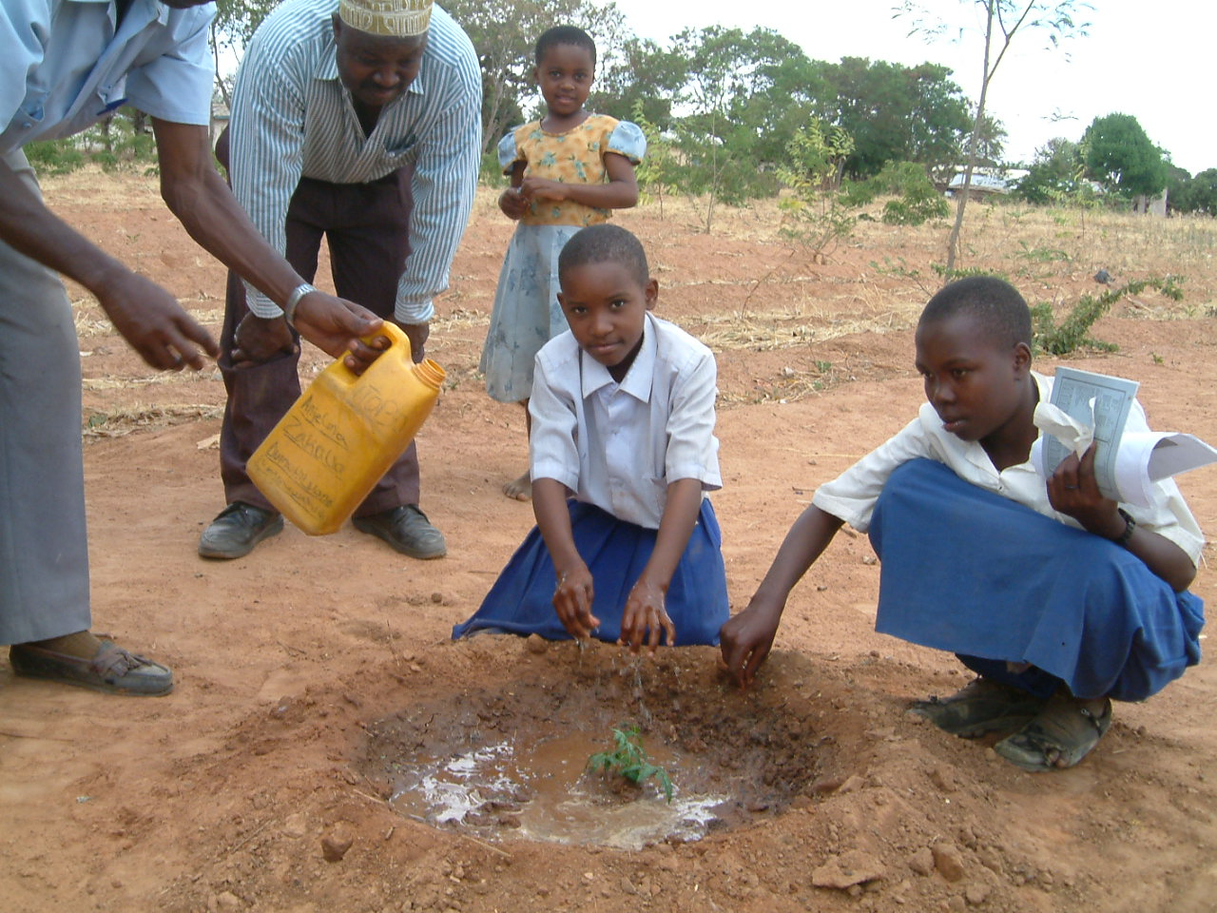
The Project Brief, Executive Summary and letters of endorsement from the four partner countries were submitted to the GEF Secretariat initially in March 2006 and subsequently for re-pipelining in the work programme in September 2006. Approval and funding of Kagera TAMP has again been deferred to the GEF Council meeting of 4 to 8 June 2007.
The project responds to GEF operational programme OP15 - Sustainable Land Management, with relevance to OP13 (biodiversity) and OP12 (integrated ecosystem management), and strategic objective “Demonstrate and up-scale successful SLM practices for control and prevention of desertification”.

The goal of the project is improved management of the natural resources of the Kagera river basin through the widespread promotion and adoption of productive and sustainable land management techniques to improve farmer’s livelihood and food security. TAMP has four components to be implemented on the basis of an integrated ecosystem approach:
- Enhanced regional collaboration, information sharing and monitoring;
- Enabling policy, planning and legislative conditions;
- Increased stakeholder capacity and knowledge at all levels for promoting integrated agro-ecosystems management; and
- Adoption of improved land use systems and management practices generating improved livelihoods and environmental services.

Expected Outcomes of the TAMP

- Raised awareness and sharing of information across the basin and among stakeholders on issues of biodiversity, natural resources management and ecosystem functions.
- Strengthened capacities of local communities and institutions in terms of sustainable resource management and livelihood strategies.
- Improved resource management practices and agro-ecosystems (agro-pastoral and intensive cropping), developed through on-farm participatory processes.
- Regional and national collaborative mechanisms established among partner countries.
- Appropriate mechanisms, tools and incentives at community, catchment, district and river-basin levels.

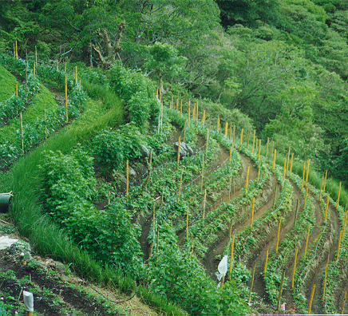
Global environmental benefits expected to accrue are:
- Conservation of globally significant agricultural biodiversity: characteristic and resilient agro-ecosystems and associated indigenous knowledge systems.
- Preservation of habitats and genetic resources (e.g. corridors for transhumant cattle, staging point for migratory birds): identification of hotspots (for risk alleviation and management) and bright spots (for replication of successful conservation, sustainable use and rehabilitation actions).
- Reversal of land degradation trends, through improved land use and management practices, including:
  - reducing erosion and sedimentation;
  - restoring soil productivity through nutrient cycling, moisture and cover management and other conservation measures;
  - restoring water quality and recharge;
  - protecting wetlands from agricultural encroachment.
- Reduction in greenhouse gas emissions and related climate change offsets through enhanced carbon sequestration.
- Protection of international waters through concerted transboundary priority setting, targeted actions and consensus for sustainable resources management.
Key Indicators: Sustainable land/agro-ecosystem management practices implemented on 43,700 ha. of land by year 3 and 100,000 ha. by year 5; 10% increase in NRM-based income for 120,000 farmers/herders; 20% increase in carbon stores on 30,500 ha.; 10% reduction in sediment load in 4 representative micro-catchments; 1,035,200 people benefiting from training in SLM; enabling environment for regional cooperation in SLM established.

Contacts
Sally Bunning sally.bunning@fao.org  Land conservation & management officer  Land & Water Development Division  FAO Headquarters, Rome, Italy  Tel: (+39) 0657054442  Mobile: (+39) 3480519095 | Anna Tengberg anna.tengberg@unep.org  Senior officer Land Degradation  GEF Coordination Division  UNEP Headquarters, Nairobi, Kenya  Tel: (+254) 20624147  Mobile: (+254) 0722913606

