Components of Income Aggregate:

“National Panel Survey- Uganda 2011-2012”

Prepared for the Rural Income Generating Activities (RIGA) Project

of the Agricultural Development Economics Division,

Food and Agriculture Organization

August, 2014

This document provides the survey-specific details associated with the income aggregate construction. For more information about the RIGA project, please refer to http://www.fao.org/es/esa/riga. For additional detail regarding the overall RIGA income aggregate construction approach, please refer to Carletto, et al (2007), “Rural Income Generating Activities Study: Methodological note on the construction of income aggregates” found on the RIGA website.

The Uganda National Panel Survey (UNPS) was carried out for twelve months from November 2011 to October 2012. The survey is the third wave of a panel for which the first wave of data collection took place in 2009/2010 and the second in 2010/2011. It collected data using Household, Agricultural and Community questionnaires and obtained information at the individual, household, plot, business and community levels.

The UNPS 2011/12 sample includes 2,850 households that were visited during the Uganda National Household Survey (UNHS) 2009-2010.

The UNHS 2011/12 has only one set of sampling weights. It is called mult and was renamed weight in RIGA. In the original datasets, the various household-level modules of the 2011/12 UNPS data can be linked by the variable HHID. Agricultural module datasets can be linked either with the HHID variable or by combining HHID with the unique plot identifier, PLOTID. The variable HHID is renamed “hh” in RIGA datasets.

In the original datasets, “urban” is the variable that identifies whether households are located in urban or rural areas. There are 2,266 rural households and 584 urban households in the dataset. In addition, the variable “AGhh” is a dummy equal to “1” if the household is in the agricultural sector and “0” otherwise.
Regarding income from different sources, revenues and costs were disaggregated when such information was available. The disaggregated sources for each income component are summarized in output variables column of Table 1. The net variables and the data files included in the final total income aggregate (Income.dta) are in bold. Unless otherwise noted, all variables included in the aggregate income variable are net of costs.

An average household size in Uganda is 5.3 persons. All money amounts are in Ugandan Schillings (UGX). In 2012, the official exchange rate was UGX 2,177= $1.0. The income aggregates are calculated at the household level and all aggregates are annualized.

Comments
- All calculations, data cleaning and data imputations are computed using Stata.
- In all sections, the raw data undergoes a transformation (it is annualized, aggregated, taken from person – household level, etc) before a check for outliers takes place.
- The industry codes used for classifying wage employment follow the United Nations International Standard Industrial Classification (ISIC) standards. Given the survey classification of each employed household member by industry, the employment sectors include: Agriculture and fishing, Mining, Manufacturing, Electricity and utilities, Construction, Commerce, Finance insurance and real state, Services and Unknown.
- The classification of non-farm enterprise activities into industries categories follows the same classification system as the employment section. Given these standards, the non-farm enterprise sectors include: (1) Agriculture, Livestock, Hunting and Fishing, (2) Mining, (3) Manufacturing, (4) Electricity and Utilities, (5) Construction, (6) Commerce, (7) Transportation, Storage and Communications, (8) Finance, Insurance and Real Estate, (9) Services and (10) Other Industries.
- For all sections, whenever information was available regarding the share of a business, enterprise, or any other income activity owned by the household, the income earned from that activity was weighted by the share owned by the household.
- A final outlier check is imposed at the end of the Aggregateincome.do file in which households with income shares from any given activity greater than or less than 3 (300%) are dropped from the final income aggregate.
- Participation and income share variables for all income components are included in the final income aggregate

Note on crop prices

Calculating crop prices from the agricultural module of the household survey required data transformation due to inexact reporting of quantities and total values of crops sold gathered during the field activities. Once the production prices were quantified in kilograms through the use of conversion factors, statistics resulted in unusually low mean and median values in round 2 compared to the unit price of round 1. Following consultations with the World Bank and the UBoS, we find that sales values reported during round 2 and used to compute round 1 unit prices were by mistake divided by 100. Unit prices from round 2 were therefore multiplied by 100 in order to get the correct unit price, and therefore correct value of crop income.

The programs that calculate each household’s income aggregate component are summarized in Table 1. Table 2 summarizes the results from the created income aggregate.
Table 1. Files and Variables generating the Rural Income Aggregate
Do file | Input data files  RAWHH= household questionnaire  RAWAG= agricultural questionnaire | Output data files | Main variables constructed | Notes/Decisions
Sample.do | RAWHH \GSEC1.dta  RAWHH \GSEC19.dta | Sample.dta
Prices.do | RAWHH \GSEC15B.dta  RAWAG \AGSEC5A.dta  RAWAG \AGSEC5B.dta | price_purch_ea.dta  price_purch_district.dta  price_purch_region.dta  price_purch_stratum.dta  price_purch_urban.dta  price_purch_itemcd.dta  price_prod_ea.dta  price_prod_district.dta  price_prod_stratum.dta  price_prod_region.dta  price_prod_urban.dta  price_prod_itemcd.dta  price_fg_ea.dta  price_fg_district.dta  price_fg_stratum.dta  price_fg_region.dta  price_fg_urban.dta  price_fg_itemcd.dta  price_mrkt_ea.dta  price_mrkt_dis.dta  price_mkt_stratum.dta  price_mrkt_region.dta  price_mrkt_urban.dta  price_mrkt_itemcd.dta  pricep_prod_ea.dta  pricep_prod_district.dta  pricep_prod_stratum.dta  pricep_prod_region.dta  pricep_prod_urban.dta  pricep_prod_itemcd.dta | price_purch_ea  price_purch_district  price_purch_region  price_purch_stratum  price_purch_urban  price_purch_itemcd  price_prod_ea  price_prod_district  price_prod_stratum  price_prod_region  price_prod_urban  price_prod_itemcd  price_fg_ea  price_fg_district  price_fg_stratum  price_fg_region  price_fg_urban  price_fg_itemcd  price_mrkt_ea  price_mrkt_district  price_mkt_stratum  price_mrkt_region  price_mrkt_urban  price_mrkt_itemcd  pricep_prod_ea  pricep_prod_district  pricep_prod_stratum  pricep_prod_region  pricep_prod_urban  pricep_prod_itemcd | Created median prices for each crop at different  administrative levels (enumeration area, districts,  stratum region, locality) using the reported  expenditures in the consumption module and  the reported sales from the agricultural module.
Food.do | RAWHH \GSEC15B.dta | Foodown.dta  Foodown_crop.dta  Foodown_livestock.dta | foodexp  foodexp_livst  foodexp_crop  foodpurch  foodgift  foodown | .
Other.do | RAWHH \GSEC11.dta  Rentagric.do | Other.dta (it includes other incomes as income from properties and royalities) | otherinc  other
Rentagric.do | RAWHH \AGSEC2A.dta  RAWHH \AGSEC2B.dta | Rentagric.dta | farmrnt
Cropincome.do | RAWAG \AGSEC3A.dta  RAWAG \AGSEC4A.dta  RAWAG \AGSEC3B.dta  RAWAG \AGSEC4B.dta  RAWAG \ AGSEC10.dta  RAWAG \ AGSEC9.dta | cropexp1.dta (inputs)  cropinc.dta (revenues, other exp)  machincost.dta  extensioncost.dta  Cropincome.dta | seedexp  fertexp  pestexp  laborexp  extensioncost  machincost  harvestv  soldcropv  transportexp  storedv  harlostv  anifeedv  foodprodv  ownconsv  cropincome1  cropincome2
Livestock.do | RAWAG \GAGSEC6AT1.dta  RAWAG \GAGSEC6BT1.dta  RAWAG \GAGSEC6CT1.dta  RAWAG \GAGSEC7T1.dta  RAWAG \GAGSEC8T1.dta | livstinc.dta  transfersliv.dta  livstexp.dta  livstexplab  livstexpfeed  livstexptreat  livstexpother  livstbyprod.dta  Livestock.dta | livstborn  livstsold  livstexplab  livstexpfeed  livstexptreat  livstexpother  livstexp  livstexp  livstlost  livstbyprodsold  livstinc
Selfemp.do | RAWAHH\GSEC12.dta | Selfemp.dta | selfimp1  selfimp2  selfimp3  selfimp4  selfimp5  selfimp6  selfimp7  selfimp8  selfimp9  selfimp10
Employment.do | RAWHH \GSEC8.dta | Employment.dta | wge1_1  wge2_1  wge3_1  wge4_1  wge5_1  wge6_1  wge7_1  wge8_1  wge9_1  wge10_1  wge1_2  wge2_2  wge3_2  wge4_2  wge5_2  wge6_2  wge7_2  wge8_2  wge9_2  wge10_2
Transfers.do | RAWHH \GSEC11.dta | Transfers.dta | transfersgross  pubtransimp  privtransimp
Aggregateincome.do | Sample.dta  Rentagric.dta  Cropincome.dta  Livestock.dta  Employment.dta  Other.dta  Selfemp.dta  Transfers.dta | Income.dta | agr_wge  nonagr_wge  crop1  crop2  livestock  other  selfemp  transfers  totincome1  totincome2

Table 2.
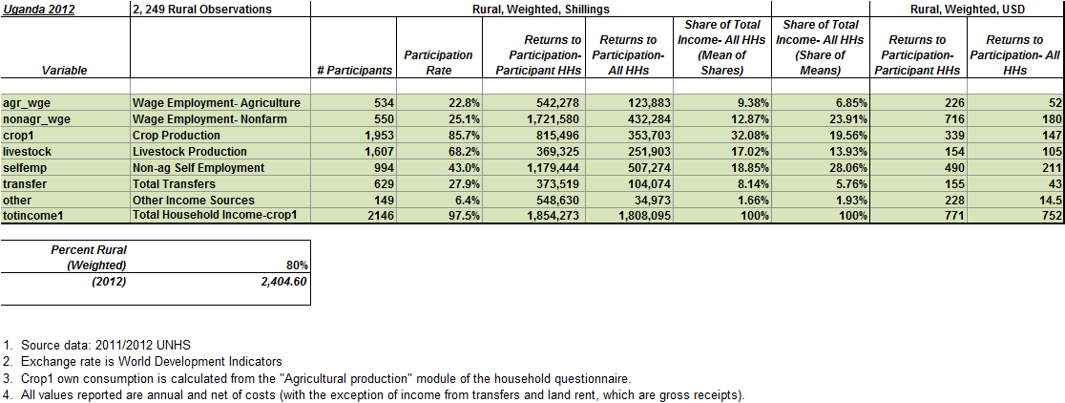

Table 3.
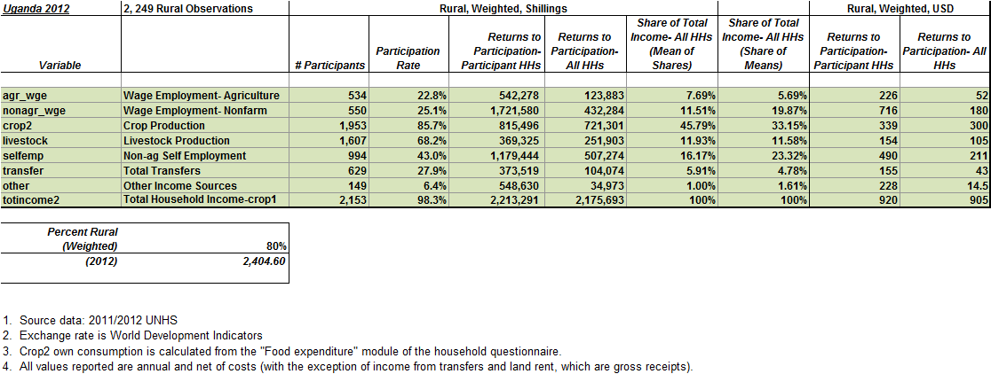

The RIGA Project is a collaboration between FAO, the World Bank and American University in Washington, D.C. Original data can be obtained from the World Bank’s Living Standards Measurement Study by visiting the LSMS website at: http://www.worldbank.org/lsms
The sample size grew in 2011/12 due to changes in household composition (e.g., panel individuals that recently split to form new households were included in the survey.)
RIGA project calculations.
Exchange rate used comes from the World Bank database, World Development Indicators 2013

