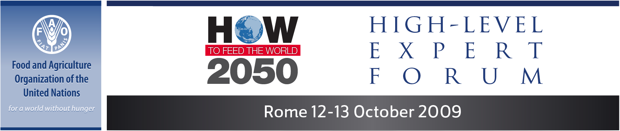

MEDIA ACCREDITATION FORM

Journalists and technical staff representing mass media outlets who wish to cover the Forum must fill in this form and submit it together with 1) a letter of assignment on official letterhead from the editor or bureau chief of a recognized media outlet and 2) a valid ID (passport or national identity card).

Materials (form, letter, scans of documents) should be submitted by email (preferred) to Sari.Gilbert@fao.org or regular post or courier to: FAO, Media Relations Branch (KCIM), Room A309,
Attn. Sari Gilbert, Viale delle Terme di Caracalla, 00153 Rome, Italy.

Early submission via email is strongly recommended. ID will have to be shown when collecting the passes. We regret not to be able to assist people coming from abroad with visas.

If using Microsoft Word, type in the grey fields, save the form, and send via email.
If filling in by hand and printing, please write in block letters. Questions? Call (+39) 06 570 53761.

PERSONAL DATA
Surname:
First name:
Place and date of birth:
Nationality:
Passport number/expiry date:
Office address:
Email:
Telephone:
Fax:
Working language(s):
DATA ON THE MEDIA REPRESENTED
Name of the media:
Headquarters address:
Website:
Contact person and title:
Telephone:
Email:
Type of medium (check as many as necessary): | Daily Newspaper | Television | Radio
Type of medium (check as many as necessary): | News agency | Periodical | Internet news
Type of medium (check as many as necessary): | Other | Photo/visual service
If you selected other,
please specify:

