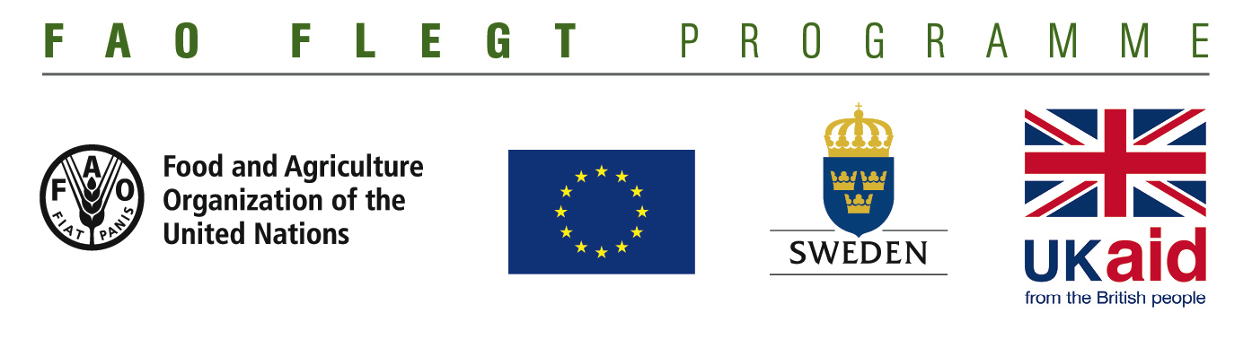

Government institutions, Non-State Actors and Private sector Organisations

**Supporting priority actions to participate in the implementation of the VPA process**

**CONCEPT NOTE FORM**

**Deadline for submission of Concept Notes:**

**15 September 2016, 16.00 GMT**

|  |  |  |  |
| --- | --- | --- | --- |
| **1. Applicant - General details** | Full Name | |  |
| Acronym | |  |
| Country**[1]** | |  |
| Legal Status | |  |
| Address | |  |
| Contact person | Name |  |
|  | Tel |  |
|  | E-mail |  |

|  |  |  |
| --- | --- | --- |
| **2. Applicant – Managerial Capacities** | Annual Turnover / Budget | **US$** |
| Governance structure  *Please briefly describe the structure of the organization, roles and responsibilities of the resource persons involved.* |  |

|  |  |  |  |
| --- | --- | --- | --- |
| **3. Lot addressed** |  | **Lot 1**: Private Sector | **Lot 2**: VPA Support |
| **4. Programme Output and Supported action(s)** | #1 | *[select one output]* | *[select one output]* |
| #2 | *[select a maximum of two Supported actions]* | *[select a maximum of two Supported actions]* |

|  |  |
| --- | --- |
| **5. Main targeted country** |  |

|  |  |  |
| --- | --- | --- |
| **6. Requested FAO Contribution** *(maximum 110 000 US$)* |  | **US$** |

|  |  |  |
| --- | --- | --- |
| **7. Duration** *(maximum 15 months)* |  | **Months** |

|  |
| --- |
| **8. Title, objective, expected results and main activities**  **- Title** |

**- Objective (50 words)**

*Describe what the project aims to achieve in terms of its topic and the changes that should take place as a result of the project.*

**- Expected results and activities (500 words)**

*Give sufficient information so that the results, preferably no more than 3, can be clearly understood. For each result, list suggested indicators of achievement, covering BOTH quantitative and qualitative progress.*

*Under each result, list the activities proposed with a brief explanation of each activity. There should be at least two activities per result and preferably no more than four or five. State the key deliverable(s) that each activity should achieve.*

**9. Relevance (500 words)**

*State which theme the proposal addresses and how it complements other ongoing work. Briefly describe the problem to be addressed, how the proposal will address this problem and why the strategy was selected. Indicate how the outcome at the end of the project will be sustained.*

**10. Gender and youth (300 words)**

*State briefly those aspects of the proposal design that focus on gender mainstreaming and/or youth inclusion. How is the proposal different as a result of the gender and youth focus? Has it be designed to meet specific gender or youth needs?*

*Remember that simple steps can make a huge difference, for example on Gender mainstreaming: building on existing initiatives from advocacy groups, analyzing the different roles of men and women in the sector, monitoring of gender related indicators, or integrating advocacy in your activities. Please refer to the “Annex 2: Gender-mainstreaming list of supported actions” in the Guidelines.*

1. Country in which the applicant is registered