Summary of HLC/08/INF/2: Summary of Climate Change Adaptation and Mitigation: Challenges and Opportunities for Food Security

Introduction:

Climate change will superimpose itself on these existing trends, significantly increasing production risk and rural vulnerability, particularly in regions that already suffer from chronic soil and water resource scarcity, high exposure to climatic extremes including droughts and flooding, poverty and hunger. Climate change pressures will be compounded by a pronounced lack of sufficient knowledge, infrastructure, organization and resources that local populations and national governments need to cope with and adapt to climate change. This will be especially true in many poor tropical arid and semi-arid regions, increasing the risk of large overall negative impacts on food security, natural resources and rural livelihoods in coming decades and further increasing the gap between developing and developed countries. (par 8)

Increased and New Vulnerabilities: The recent increases in food prices and their immediate negative impacts on food security demonstrate that the current system is already, unexpectedly, quite vulnerable. Most importantly, one of the main factors identified as the cause of the current commodity cost crisis – climate extremes that have reduced production in key exporting countries – is the very factor that is projected to increase in frequency and severity in coming decades. (par 10)

Smallholder and subsistence farmers, pastoralists and fisherfolk in developing countries may not be able to cope due to reduced adaptive capacity and higher climate vulnerability. Under such conditions, pressure to cultivate marginal land or to adopt unsustainable cultivation practices as yields drop is likely, and may increase land degradation, water scarcity and endanger biodiversity. This vicious dynamic may lead to large-scale migrations, as rural poor populations abandon regions that no longer can support livelihoods, food and fuel. (par 12)

There is a dangerous complacency based on the assumption that impacts and related crises will not become pronounced until the second half of this century. Adaptation and mitigation strategies to limit damage from climate change in developing countries must be consistent with, build upon and provide new direction for existing and future development plans focusing on rural poverty and agricultural development at all relevant scales, from national to international. (13-14)

Agriculture and Global Climate Change: Agriculture is not only a fundamental human activity at risk from climate change, it is a major driver of environmental and climate change itself. 16. In addition to land resources, agriculture is a major user of water. Over 200 million ha of arable land is under irrigation, utilizing 2500 billion m3 of water annually. (par 15-17)

Agriculture is a significant contributor to land degradation and, in particular, a major emitter of greenhouse gases. A number of mitigation strategies have been identified as useful in achieving the goal of stabilization of atmospheric concentrations between 450-550 ppm CO2. In the forestry sector, these include reduced deforestation and degradation of tropical forests (REDD), sustainable forest management (SFM) and forest restoration (FR), including afforestation and reforestation (A/R). In agriculture, they involve reduction of non-CO2 gases through improved crop and livestock management and agroforestry practices, enhanced soil carbon sequestration in agricultural soils via reduced tillage and soil biomass restoration. (par 19)

Table 2 indicates that technical mitigation potential achievable by a complex mix of actions in both the agriculture and forestry sector is significant. Most of the mitigation is achievable in the forestry sector, with important implications for climate policy options. Importantly, the total mitigation potentially achievable in the land-based sector is quite close to total emissions of the agriculture sector as a whole. If achieved, they would contribute to making this sector nearly carbon-neutral. (par 20)

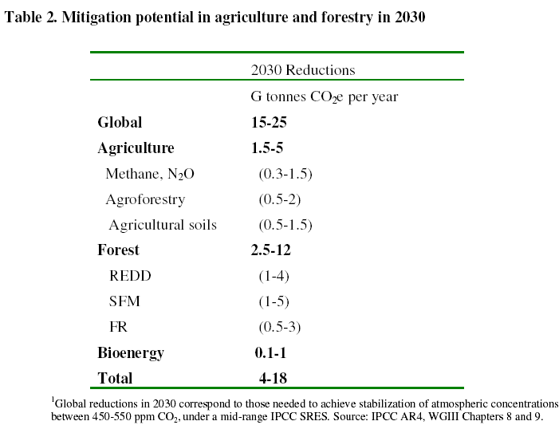

Adaptation and Mitigation Strategies: The overall challenge of climate policy will be to find the efficient mix of mitigation and adaptation solutions that limit the overall impacts of climate change. This includes recognizing that many mutually re-enforcing synergies exist between specific mitigation and adaptation solutions that can lead to more efficient allocation of “climate response” resources. Importantly, many of these synergies exist in the forestry and agriculture sectors. (par 22)

Global Challenges and Key Perspectives: Actions to limit damage from climate change need to be implemented now in order to be effective. Mitigation actions involve direct reduction of anthropogenic emissions or enhancement of carbon sinks, while adaptation is necessary to limit potential risks of the unavoidable residual climate change now and in coming decades. Importantly, there are significant differences in the policy nature underlying adaptation and mitigation actions. The benefits of adaptation choices will be realized almost immediately but will matter most under moderate climate change, perhaps up to about mid-century. By contrast, benefits of mitigation may only be realized only decades from now, becoming relevant only towards the end of the century. (par 24)

It follows that a significant challenge of climate policy is to identify and then develop instruments that allow for a portfolio of adaptation and mitigation strategies that are effective in time and space and focus on balancing actions across the most appropriate sectors, and within the chosen scope of specific climate response policies. One important example is related to bioenergy and biofuel production which, as a mitigation strategy, may have benefits for rural incomes and thus development. However, they need to be planned at the appropriate regional and local scales. Climate change adaptation strategies should aim at maintaining, or even increasing, food production in key exporting developed and developing regions, or in regions key to food security. (par 25-27)

Climate Responses and Food Security: A commitment to feeding the hungry and lifting increasing numbers of rural farmers in developing countries out of poverty for current and future generations must the focus of adaptation and mitigation planning. (par 29)

There are useful synergies for merging adaptation and mitigation in agriculture, especially those relevant to food security. They should form the core of climate policy planning and implementation. However, some mitigation responses may not be conducive to adaptation. For instance, bioenergy and some land conservation programmes may involve actions that introduce new competition for land and water resources otherwise necessary for enhancing system resilience and safeguarding food production under climate change. (par 30-32)

Linking Adaptation And Mitigation Within Climate Policy Mechanisms

There is a very large, and currently untapped, potential for mitigation in the land sector, related to project activities that are not currently allowed under the Clean Development Mechanism (CDM), such as avoided deforestation, enhanced forest management and agroforestry. To a much lesser extent, it could also include soil carbon sequestration in agricultural soils, which is extremely relevant to improving rural livelihoods and food security prospects. (par 34)

By including these categories of activities within a modified post-2012 mechanism, additional sequestration potential of up to 10-15 billion tonnes CO2e yr-1 could be generated by 2030, enough to counter emissions of greenhouse gases for the entire agricultural and forestry sectors combined, making them nearly carbon neutral. (par 35)

Importantly, mitigation strategies based on forestry and agroforestry activities would generate large revenue. Resources freed up from mitigation investments in less cost-effective areas could be used instead for implementing adaptation activities that are needed to safeguard food security and improve rural livelihoods in the face of climate change, without having to be bound at every step by mitigation constraints. (par 37)

Policy and Technology Requirements

Expanding the Role of Adaptation and Mitigation within Development Policy: Adaptation and mitigation under climate change will require dynamic policies to cope with the high level of uncertainty in the timing and magnitude of potential climate changes and the rapidly evolving knowledge. Furthermore, climate change adaptation policies will interact with sustainable development and natural resource management, such as those necessary to protect human and animal health, foster governance and political rights.

Data, Research and Operational Requirements: It is important to recognize the presence of resilience factors such as family labour, diversity of plant and animal species, patterns of diversification away from agriculture and possession of indigenous knowledge that may be useful in designing less vulnerable production systems. It is particularly important to align the scale (both spatial and temporal) and reliability of the information with the scale and nature of the decision. Bottom-up assessments of the potential technical effectiveness of farm-level adaptations in the face of long-term projections, including changes in climate variability, may be quite useful for input into policy and investment analyses. (par 41-44)

Importantly, planners need to avoid negative “lock-ins”, by making sure that adaptations now do not undermine the ability of systems to cope with potentially larger impacts later in the century. (par 45)

Changing the Decision Environment: Adaptation at the management unit level, based on current decision environments, may not be fully adequate for coping with climate change. Planning at local, regional, national and international levels will be needed in order to facilitate a broader range of responses. Many options for policy-based adaptation to climate change have been identified for agriculture, forests and fisheries. These can involve adaptation activities, such as developing infrastructure, capacity building in the broader user community and within institutions. However, there are many environmental, economic, informational, social, attitudinal and behavioral barriers to implementation of adaptation and mitigation Participatory approaches are needed to utilize appropriate scientific knowledge while retaining a focus on values important to stakeholders. See Boxes 4 and 5 in original document:
http://www.fao.org/fileadmin/user_upload/foodclimate/HLCdocs/HLC08-inf-2-E.pdf

Policy Options

Short-Term (Current to 2012): The objective of short-term recommendations is food security safeguards in multilateral and national policy instruments that focus on eradicating hunger at global, regional and local levels. (par 50)

International level: There is a need for support and active contribution to strategies on adaptation, mitigation, financing and technology transfer. This requires focused attention towards the post-2012 mechanisms at international level, including:

• Conference of the Parties of the UNFCCC in Copenhagen, in 2009;
• The Post-Kyoto new and enhanced financial mechanisms;
• GEF: exploring potential of GEF funds for land-based adaptation and mitigation;
• UN and international institutions: seeking effective coordination through partnerships for strong research and development and planning for adaptation and mitigation. (par 51)

Increasing visibility of food security issues is necessary within the broad climate change community itself, especially for efforts of high policy relevance such as:

• the development of an IPCC publication on Food security and climate change;
• enhanced CGIAR-system research programme on climate change and food security;
• creating a climate change focus within the Global Platform for Disaster Risk Reduction, as part of the Hyogo Framework for Action to reduce vulnerability to natural hazards. (par 52)

Such efforts must include a focus on international coordination between exporting and importing nations, within the context of food security. They should include a move to reduce or eliminate barriers to trade and agricultural subsidies, and set guidelines for non-food sectors competing with food production for land and water resources, such as bioenergy. (par 53)

National level: There is a need for strong support of policies and direct contribution of ideas from the national level. Food security targets need to be included in National Adaptation Programmes of Action. Specific climate-related targets need inclusion in National Programmes for Food Security, including improved adaptive management of natural resource use in order to increase resilience to shocks. There is a requirement for building community capacity of subsistence and smallholder farmers, pastoralists and fisherfolk, with a view to collect indigenous knowledge and enhance resilience through activities such as income diversification. (par 54)

Medium-Term to Short-Term (Current to 2020-2030) Whereas short-term focus must be on putting in place the necessary policy frameworks for action, the strategy for the medium term must focus on developing practical actions for combating climate change impacts locally and regionally, specifically for poor developing countries most at risk. This requires increased:

i) Coordination: local actions must be coordinated at national and international levels, in order to maximize resources while keeping response options open to avoid lock-in situations in later decades as climate change impacts progress.

ii) Monitoring: observation networks and data platforms are needed for monitoring both climate and food production systems. These need to be integrated with climate and impact projections, in order to provide policy-makers and stakeholders with information necessary for understanding adaptation options and needs at successive time horizons, as well as to identify risk thresholds and the steps needed to avoid them. These could take the form of simple climate impact and adaptation “indices” or “metrics”. In addition, enhanced monitoring of food supply and demand pressures, embedded in short-to-medium term projections based on socio-economic trends, should be used to evaluate costs and benefits of proposed adaptation and mitigation strategies. (par 55)

Longer Term (Current to 2050 and Beyond): There is a need for strategies that aim at conserving natural resources and limit carbon footprints in the face of large demand for food, water and other environmental services. In particular, it should be recognized that beyond 2050, land-based mitigation from avoided deforestation, agroforestry and soil carbon sequestration in agricultural soils, necessary to stabilize emissions in the short term, would have largely reached their potential. New green technologies and land management options will then be necessary to mitigate emissions of greenhouse gases while making agriculture carbon neutral. (par 57-58)

Open economic trade, reduced subsidies and income diversification, coupled with potential new income for rural populations from enhanced environmental services (including carbon and energy), likely represent important steps for sustaining successful adaptation and mitigation strategies. (par 60)

