EB 2010/101/R.2: IFAD's 2011 results-based programme of work and administrative and capital budgets, and the IFAD Office of Evaluation's results based work programme and budget for 2011
and indicative plan for 2012-2013

For: Approval

Under the Eighth Replenishment of IFAD’s resources, IFAD aims to: raise the level of its new commitments (by 50 per cent over the 2010-2012 period); increase the impact of the projects it finances and supports during implementation; strengthen its partnership and leadership role in the global effort to reduce rural poverty and food insecurity; raise the proportion of its workforce dedicated to country programme development and implementation; and improve its overall efficiency.

Under the Eighth Replenishment of IFAD’s resources, IFAD aims to: raise the level of its new commitments (by 50 per cent over the 2010-2012 period); increase the impact of the projects it finances and supports during implementation; strengthen its partnership and leadership role in the global effort to reduce rural poverty and food insecurity; raise the proportion of its workforce dedicated to country programme development and implementation; and improve its overall efficiency. To develop the capacity to deliver (and subsequently support the implementation of) this programme of new commitments, IFAD Management proposes a budget of US$141.95 million, a 7.5 per cent nominal increase over 2010.
The overall increase is focused on strengthening capacity in country programme development and implementation (cluster 1: Efective national policy, harmonization, programming, institutional investment frameworks for rural poverty reduction). Relative to the proposals discussed in September 2010, the higher allocation to cluster 1 is supported by proposed real reductions in the allocations to
cluster 3 (2.2 per cent) and cluster 4 (1.2 per cent).
IFAD Management also proposes under-the-line budgets of US$2 million to defray the costs of the Consultation on the Ninth Replenishment of IFAD’s Resources, and, on an exceptional basis, US$490,000 to compensate for the loss of the host country contribution to covering the cost of the thirty-fourth session of the Governing Council.
A capital budget of US$15.19 million is proposed for 2011, including US$12 million for the Loan and Grant System replacement project. The amortization of completed projects financed from the capital budget is charged to the administrative budget, and the administrative budget for 2011 includes US$972,000 for that purpose.

Part one – High-level preview of IFAD’s 2011 resultsbased programme of work and administrative and capital budgets

IFAD’s programmes of work for 2011
Under the Eighth Replenishment of IFAD’s Resources, the Member States gave IFAD the resources and the mandate to play a material and proactive role in accelerating global investment in smallholder development, including mobilization of new partnerships and resources. Within the framework of the Medium-term Plan 2010-2012, IFAD Management proposes an indicative work programme of US$1.5
billion (see table 2) for 2011, composed of a programme of work of US$1 billion from its regular resources and an additional US$0.5 billion in commitments entrusted to IFAD Management but mobilized from other sources (including the Global Agriculture and Food Security Programme, Spanish funds, the European Commission, the OPEC Fund for International Development and the Global Environment Facility). This will be by far the largest work programme in IFAD’s history. With planned traditional cofinancing and the additional resources directly managed by IFAD, it will involve a total mobilization of US$2.5 billion in new commitments to smallholder development in 2011 – and will be a key component of the accelerated effort to reach the Millennium Development Goals in rural areas by 2015. (Please see Table 2 in original document EB 2010/101/R.2).

The programme of loans and DSF grants
IFAD’s programme of work is delivered through its portfolio of loans/DSF grants and regular grants. IFAD is currently developing 62 projects, of which 51 projects/programmes and supplementary loans/DSF grants are being prepared for approval in 2011, with at least 40 per cent in sub-Saharan Africa. In line with the strategic objective of expanding the work programme with larger projects, and
within the framework of the performance-based allocation system, 12 of the new planned projects/programmes are over US$30 million (including those for Bangladesh, Ethiopia, Nepal, the Niger, Rwanda and Senegal) while only nine new programmes are below US$10.0 million (including those for Kiribati, Timor-Leste and Tonga).
The anticipated value distribution of the programme of loans and DSF grants in terms of the strategic thrusts articulated in the Strategic Framework 2007-2010 is shown in the chart below. In order of size, they are: agricultural technologies and effective production services (28.7 per cent); natural resources – land and water (20.2 per cent); financial services (17.4 per cent); competitive agricultural inputs
and produce markets (15.4 per cent); rural off-farm employment and enterprise development (11.3 per cent); and local and national policy and programming processes (7.1 per cent).

The regular grant programme
The estimated number of global/regional and country grants in 2011 is 84, for a total IFAD grant value of US$65 million. The principal thrusts of the planned regular grant programme are: innovative technologies and approaches in support of IFAD’s target group; awareness, advocacy and policy dialogue; strengthened capacity of partner institutions in support of poor rural people; and knowledge management and dissemination of information on issues related to rural poverty reduction.
Regional grants will be used to reinforce cross-cutting issues such as the integration of producer organizations into staple food markets and linkages with sustainable financial services, young people’s and women’s opportunities and participation, and development of natural resource management approaches related to climate change adaptation. As in lending operations, the thrust will be towards larger grants with well-performing partners – with clear strategic value-adding potential pursued under firm IFAD oversight.

IFAD’s administrative budget

Allocation policy, budget levels and budget utilization
Successive IFAD administrative budgets – and allocations to the Programme Development Financing Facility (PDFF), which was integrated into the administrative budget in 2010 – have reflected the absolute priority placed on achieving development impact through an expanded programme of work and project portfolio. Staff, consultants and other expenditures dedicated to directly supporting project development and implementation support (cluster 1 in the results and process matrix)1 have been increased in real terms each year, albeit at a lower rate than the increase in the nominal value of the programme of work. In all other areas, covering activities that make the work of cluster 1 and IFAD’s
governing bodies possible, the aggregate budgeted level of staffing and the real level of non-staff costs has been kept on a zero- or negative-growth basis, bringing significant improvements in the real cost: output ratio in the area of administration and corporate support systems. With the exception of cost adjustments, the truly administrative component of IFAD’s annual budget has experienced zero growth since 1995, except for 2006. The administrative budget finances annual recurrent expenditures; the PDFF was specifically created by the Governing Council to finance multi-year expenditures on project development and implementation. Reflecting the expansion of the programme of work and the multi-year commitments involved in developing it, the PDFF carry-forward into 2010 expanded to US$7.15 million (see table 5). Unlike the administrative budget, and reflecting the multi-year nature of the commitments it finances, the PDFF had no cap on carry-forwards from year to year. Within the integrated budget structure introduced in 2010, expenses previously financed from the PDFF are now financed from cluster 1 (country programme development and implementation), and to maintain an adequate level of carry-forward capacity for the multi-year commitments involved, it will be proposed that the Governing Council agree to establish an authorization for IFAD to carry forward 6 per cent of its annual budget for cluster 1 into the subsequent year’s budget.

Results from use of the administrative budget and the PDFF
Past real increases in the budget for country programme development and implementation (cluster 1), and the full utilization of that budget, have delivered a rapid expansion in new loan and grant commitments. The improvement has not only been quantitative. The 2010 edition of the RIDE (EB 2010/101/R.11) submitted to the 101st session of the Executive Board describes IFAD’s progress towards reaching and surpassing its qualitative and quantitative performance targets for 2012, including a major increase in the number of poor rural people supported by its ongoing projects (from 29.2 million to 36.6 million).
In addition to project development, IFAD is now supervising approximately 90 per cent of the projects in the portfolio, and plans to directly supervise about 85 per cent of new projects.

Overall parameters of the administrative budget for 2011

Rationale for proposed resource allocations across result clusters
Since 2010, and in accordance with Eighth Replenishment recommendations, the administrative budget has been structured within an integrated results-based budgeting system aligning all IFAD’s budget resources (combining the resources previously managed under the PDFF heading with the administrative budget) with its development results and key activity areas. These activity areas are: country programme development and implementation (cluster 1); high-level policy dialogue, resource mobilization and strategic communication (cluster 2); corporate management, reform and administration (cluster 3); and support to Members’ governance activities (cluster 4). The major objectives and indicative resource allocations for each of these clusters is presented below.

Cluster 1. Country programme development and implementation
The principal objectives of country programme development and implementation are designing the projects and grants that constitute the programme of work, and supporting the implementation of IFAD’s large and growing stock of already approved projects. Project development and approval are just the beginning of IFAD’s project engagement, triggering in relation to each project a partnership of
ongoing supervision, implementation support, disbursements and procurements that can last for a decade.
With the approval of the Executive Board, IFAD has established 29 IFAD country offices, of the 30 approved, as integral elements of its systems for country programming and harmonization, project development, and project implementation support and direct supervision. A progress report and activity plan for IFAD’s country presence has been submitted to the 101st session of the Executive Board (EB 2010/101/R.15).
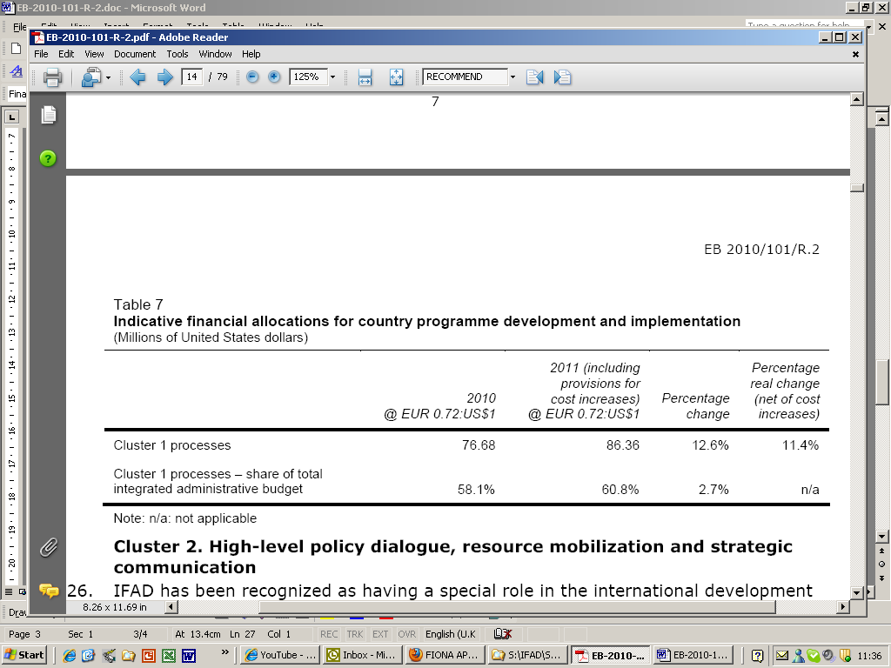

Cluster 2. High-level policy dialogue, resource mobilization and strategic communication
IFAD has been recognized as having a special role in the international development architecture – not only in directly managing investment in smallholder agricultural development, but also in strengthening the conceptual and analytical framework and dialogue for global and national policy processes that influence agricultural policy and investment. This effort will need to be aimed in two directions: towards external partners; and within IFAD itself, to better position IFAD’s programmes with regard to emerging issues arising from the development of the global system of agricultural trade and investment, and to better tap IFAD’s own country-level experience with these issues.
The Office of the Chief Development Strategist (CDS) was established on 1 January 2010 (and renamed the Office of Strategy and Knowledge Management, SKM, in October 2010) to provide IFAD with analytical and leadership capacity in the global dialogue on rural and smallholder development. The office was tasked with producing the flagship publications of the Fund, supporting the work of regional economists in the Programme Management Department (PMD), and championing knowledge management and innovation activities.
IFAD’s broader outreach in policy analysis and communications, spurred by recognition that its impact depends upon participating in and leveraging broader processes, should be mirrored by more systematic efforts in resource mobilization. The widening of the spectrum of investors and financiers in agricultural development in IFAD’s development partner countries, on the one hand; and the high cofinancing targets suggested for IFAD’s loans and grants in the Consultation on the Eighth Replenishment, require IFAD to diversify its approaches to resource mobilization. This, in turn, will require new expertise and a more direct relation between resource mobilization and the formulation of specific project or programme financing packages.
IFAD will be able to grasp this opportunity only by focusing and reorganizing resources at the level allocated in 2010, with a small real increment (US$300,000) to strengthen resource mobilization in the context of the thrust towards mobilizing new funding partnerships, an ongoing effort which will expand the commitment level managed by IFAD by US$0.5 billion in 2011 (see table 8).
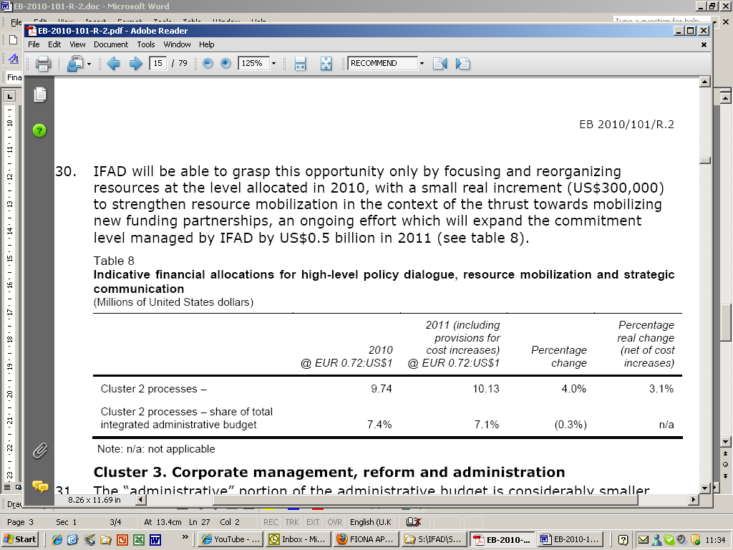

Cluster 3. Corporate management, reform and administration
The “administrative” portion of the administrative budget is considerably smaller than the operational portion. In real terms it has not grown at all since 2006, and it has increased only once since 1995, while the lending programme and portfolio it supports has expanded rapidly, structural shifts in activities have given rise to new demands, and industry standards for corporate oversight have evolved.
In addition to the overall challenge of funding timely and high quality services to support operational activities, IFAD must sustain a shift from country presence as a pilot and ad hoc phenomenon to a structured and permanent part of its organization. Critical areas to be covered include:
- Financial resource management and the improved relevance of IFAD’s financial assistance instruments.
- Human resource management.
- Information and communications technology.
- Risk management and oversight.
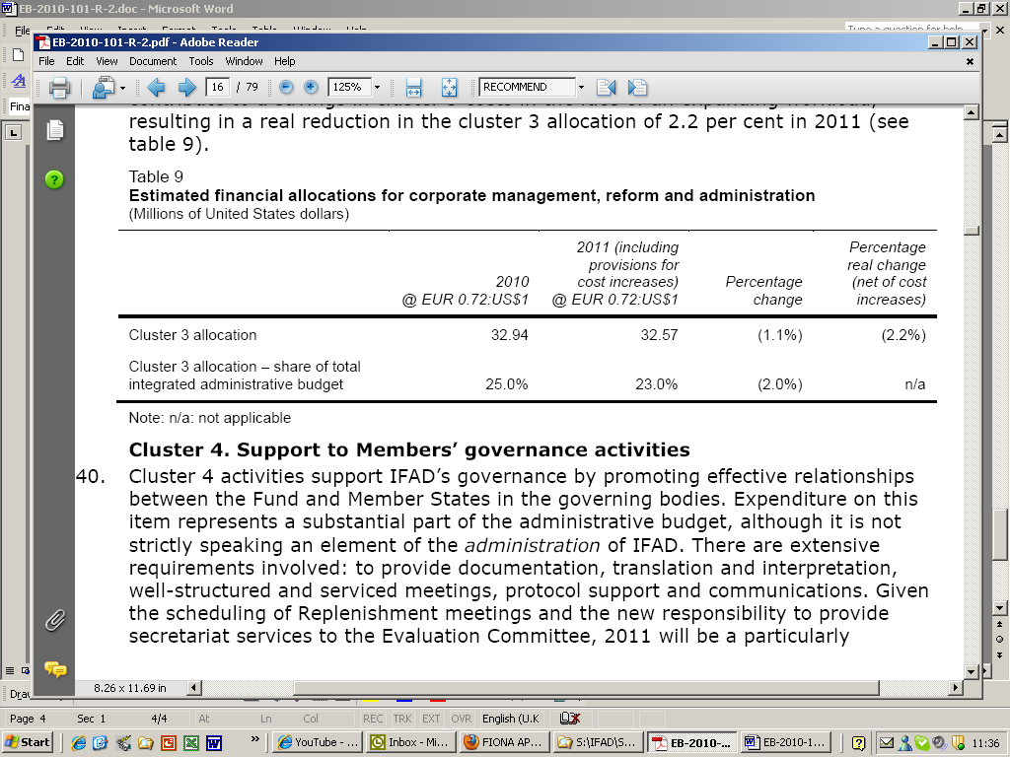
Cluster 4. Support to Members’ governance activities
Cluster 4 activities support IFAD’s governance by promoting effective relationships between the Fund and Member States in the governing bodies. There are extensive requirements involved: to provide documentation, translation and interpretation, well-structured and serviced meetings, protocol support and communications.
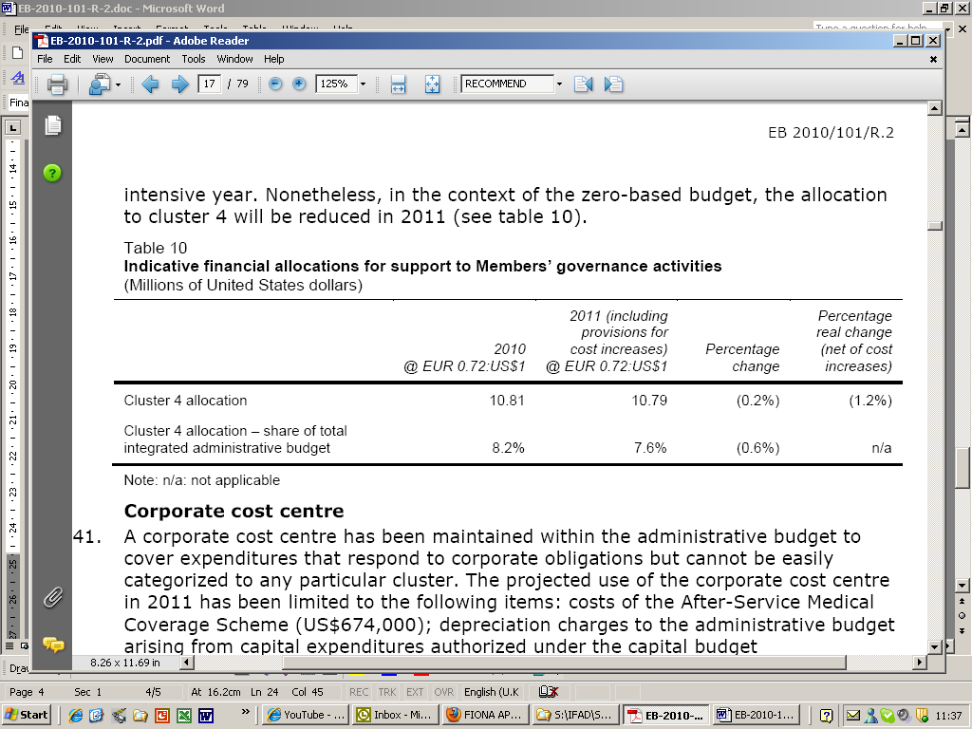

Aggregate estimated administrative budget allocations for 2011
The total proposed value of the administrative budget for 2011 is US$141.95 million, representing, as indicated in the high-level preview, a real increase of 6.4 per cent (see table 11). The increase is concentrated in the country programme development and implementation area, which is the absolute priority of both IFAD Management and the Executive Board.
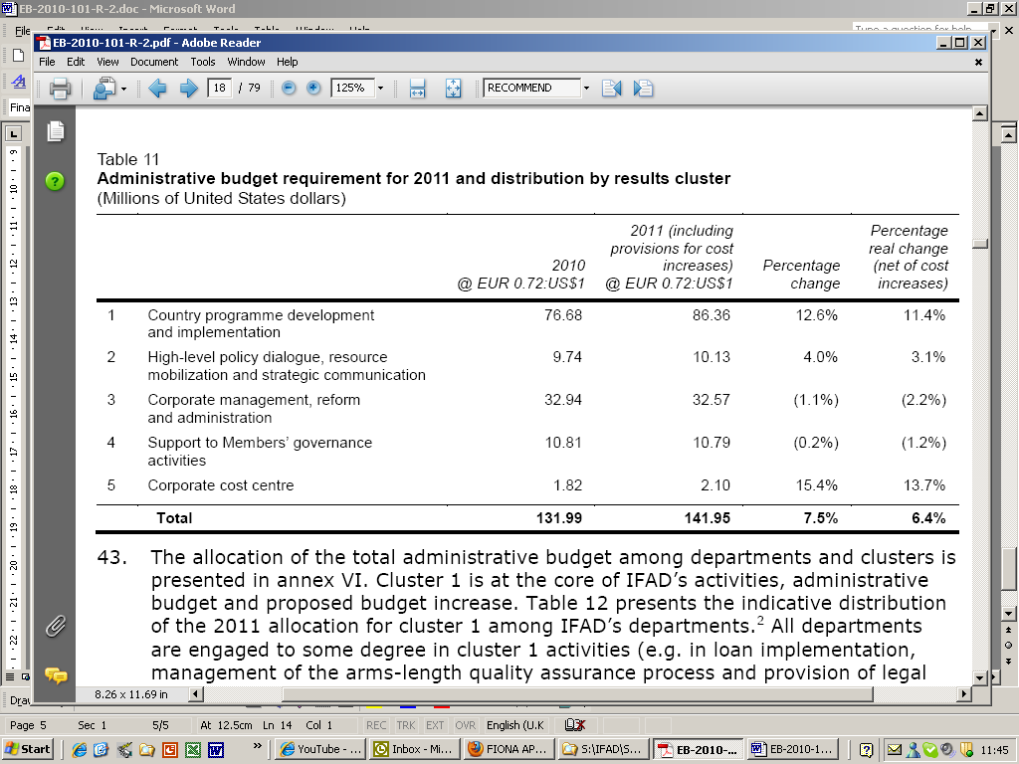

Capital budget

The capital budget was introduced in 2008 with the primary aim of implementing multi-year information and communications technology (ICT) projects focused on enhancing administrative efficiency and effectiveness.
The total capital budget proposed for 2011, at US$15.19 million (see table 18), is significantly higher than in the past, reflecting the maturation of ICT project preparation, urgent enhancements to the IFAD security infrastructure, and the need to accelerate ICT capital investment to eliminate business process bottlenecks.

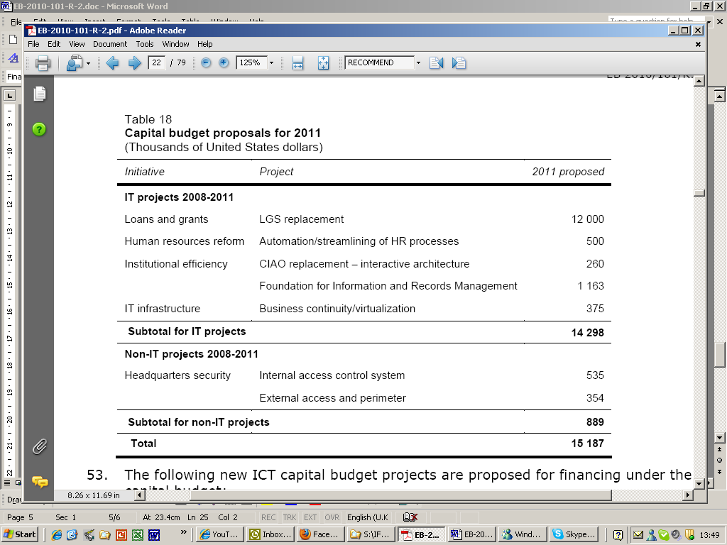

Governing Council costs for 2011

Elements of the cost of holding the annual IFAD Governing Council meeting are provided for in the administrative budget. The host country has covered other elements of Governing Council costs. It has been indicated that this support will not be available in 2011, and IFAD Management is requesting that the Executive Board endorse a proposal to the Governing Council authorizing an extraordinary budget for 2011 to cover the absence of the customary contribution from the host country.
The amount requested is US$490,000, equivalent to EUR 350,000.

Consultation on the Ninth Replenishment of IFAD’s Resources

The Consultation on the Ninth Replenishment of IFAD’s Resources (IFAD IX) will take place in 2011 and Management estimates it will cost up to US$2.0 million (see table 20). All costs falling under the direct control of Management are lower than the Eighth Replenishment budget request. There are, however, expenditures such as for the external chair and a possible external session that cannot be costed at this point. IFAD Management proposes that these costs be provided for within the total envelope of US$2 million. Given the uncertainty about actual costs, Management would provide a report to the 104th session of the Executive Board in December 2011 on the uncommitted balance and proposals for reversion of all or part of the same to IFAD’s general resources.
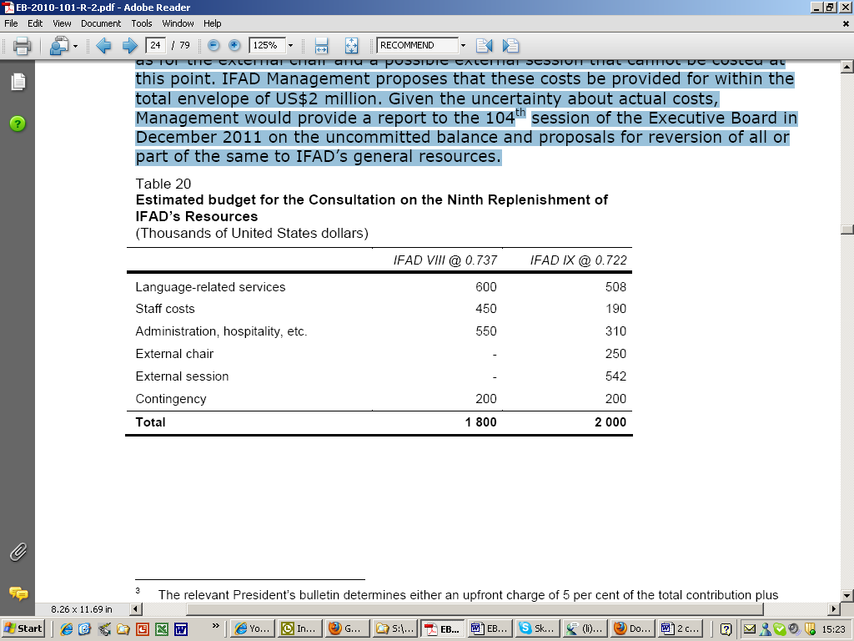

Part two – IFAD Office of Evaluation’s results-based work programme and budget for 2011 and indicative plan for 2012-2013

Introduction

As requested by the Executive Board, this is the third three-year rolling evaluation work programme prepared by the IFAD Office of Evaluation (IOE). The document contains a proposal for IOE’s work programme and budget for 2011 and indicative plan for 2012-2013.
This proposal comes at a crucial time of evolving development challenges, major corporate reforms in IFAD and internal changes within IOE resulting from the Peer Review of IFAD’s Office of Evaluation and Evaluation Function.4 This changing internal and external environment will require more than a "business as usual" approach by the division.
The preview of IOE’s results-based work programme and budget for 2011 and indicative plan for 2012-2013 was discussed during the Evaluation Committee’s sixty-third session in July 2010 and also at the Audit Committee meeting and Executive Board session held in September 2010. After further discussion with the Evaluation Committee at its October 2010 session, IOE’s proposed results-based
work programme and budget for 2011 and indicative plan for 2012-2013 was discussed by the Audit Committee in November 2010 and the Executive Board at its December 2010 session, together with IFAD’s administrative budget for 2011.

Summary

The Evaluation and Audit Committees and the Executive Board all broadly agreed with IOE’s proposed objectives, divisional management results (DMRs), work programme and budget.
In considering the preview document, the Evaluation and Audit Committees and the Board made a number of comments for IOE to bear in mind in preparing the final submission, specifically the need to (i) define indicators to track progress in achieving the DMRs; (ii) illustrate the methods and processes for undertaking the validation of project completion reports (PCRs) and project performance assessments (PPAs); (iii) identify more clearly the savings and efficiency gains generated by IOE; and (iv) include a comparison between the evolution of the administrative budget of IFAD and that of the IOE administrative budget.
In response to these comments, IOE has: (i) developed 16 indicators to monitor performance against the DMRs (see annex XIV, table 1 ); (ii) provided a summary of the methodology that the division has developed, with inputs from colleagues at the African Development Bank (AfDB), Asian Development Bank (AsDB) and World Bank for PCR validation and PPAs (see annex XVIII); (iii) underlined the savings and efficiency gains in section VIII; and (iv) added a historical comparison of its budget against IFAD’s annual administrative budget (see table 21).
The total budget now proposed by IOE for 2011 is around US$5.88 million – reflecting a further reduction in real terms with respect to the proposal contained in the preview document. This represents a decrease of 6.3 per cent in real terms against the 2010 budget. As shown in table 21 and figure 2, the proposed IOE budget is shrinking over time as a proportion of IFAD’s administrative budget and is well within the cap established by the Executive Board, which has also been decreasing consistently for the past four years.

An evolving environment

This results-based work programme has been developed after carefully considering key changes in the external context that have implications for IOE, the evolving strategic directions within IFAD and the implications of the Peer Review.
Changes in external environment. These include greater attention to joint evaluations as a result of the Paris Declaration on Aid Effectiveness and the Accra Agenda for Action; the consequences of climate change for the operations funded by IFAD; and the growing diversity among IFAD’s borrowing Member States (e.g. lower-middle-income, middle-income and upper-middle-income countries; and fragile states including countries affected by conflict and natural disasters and highly indebted countries). In response to these changes, IOE plans to undertake joint evaluation activities with the AfDB and the Food and Agriculture Organization of the United Nations (FAO) next year. It will work towards enhancing its methodology to better capture climate change and gender issues in project evaluations and country programme evaluations (CPEs). It will also conduct CPEs that cover a diverse set of country contexts, including fragile states and low-income countries.6 Details of the planned activities in these areas are provided in section VI.
Major internal corporate reform initiatives at IFAD. These entail the imminent introduction of a new corporate strategic framework for 2011-2015, the preparation of a medium-term plan for 2010-2012, human resources reform, zero-based budgeting, wider country presence, greater attention to knowledge management and scaling up, and more efforts devoted to self-evaluation. All these initiatives have implications for IOE.
A number of core issues are likely to receive attention during the Consultation on the Ninth Replenishment of IFAD’s Resources in 2011. These include results measurement, direct supervision and implementation support, country presence, scaling up, gender, engagement of the private sector and efficiency. IOE needs to take these issues into account in developing its work programme, as it may need to contribute to the debate on these or other topics during the Ninth Replenishment Consultation.
Peer Review of IFAD’s Office of Evaluation and Evaluation Function and the implications for IOE. The Peer Review made a number of recommendations with important implications for IOE, the Evaluation Committee and IFAD Management.
Key recommendations affecting IOE’s future evaluation work are: (i) change IOE’s product mix to devote proportionately more resources to higher-plane evaluations, which include corporate level-evaluations (CLEs) and country programme evaluations (CPEs); (ii) change the approach to project evaluation as previously conducted, by undertaking from 2011 onwards the validation of PCRs and
conducting PPAs on a selective basis; (iii) enhance knowledge management to strengthen the evaluation learning loop; and (iv) improve IOE efficiency by using more cost-efficient approaches, while enhancing quality and effectiveness, in carrying out the IOE work programme.
IOE’s overarching purpose is to contribute, through its evaluation work, to enhancing the Fund’s development effectiveness. Therefore, for 2011 and its indicative plan for 2012-2013, IOE proposes the following two strategic objectives:
- Strategic objective 1: Contribute to improving the performance of IFAD-funded policies and operations.
- Strategic objective 2: Promote effective knowledge management and learning.
In support of these objectives, IOE has identified the following operational objectives.
Operational objective 1: Enhanced IOE efficiency. More robust internal financial systems and administrative processes are critical to enhancing efficiency and delivering the annual work programme in a timely manner.
Operational objective 2: Methodology development. Expand further IOE’s methodology to address changes in the environment and contribute to strengthening IFAD’s self-evaluation systems to facilitate independent evaluations.

Highlights of 2010 work programme

Overall, by the end of 2010, IOE expects to have implemented all the activities planned in the 2010 work programme.
Conducting of selected corporate-level, country programme and project evaluations. IOE is working on six project evaluations – in Brazil, the Dominican Republic, Ghana, the Lao People’s Democratic Republic, Rwanda and the United Republic of Tanzania – which will be completed before the end of the year.
Specific evaluation work required by the IFAD Evaluation Policy and the Terms of Reference of the Evaluation Committee. The 2010 Annual Report on Results and Impact of IFAD Operations (ARRI) is under preparation, and will be discussed by the Evaluation Committee and the Executive Board before the end of 2010.
Evaluation outreach and partnerships. Representatives of IOE took part in the 2010 annual general meeting of the United Nations Evaluation Group (UNEG), and are involved in a number of UNEG task forces.9 IOE participated in the biannual meetings of the Evaluation Cooperation Group (ECG) of the multilateral development banks and the Network of Networks on Impact Evaluation (NONIE). The third phase of the partnership agreement between IOE and the Swiss Agency for Development and Cooperation (SDC) is under implementation.10 IOE staff participated in selected in-house committees and platforms, such as the Operational Strategy and Policy Guidance Committee (OSC) and country programme management teams (CPMTs), to ensure that lessons learned from evaluations are adequately internalized into new IFAD policies, strategies and projects.
Evaluation methodology and effectiveness of IOE. The division continues to undertake internal peer reviews for each evaluation and has made use of senior independent advisers on a selective basis to provide comments on key evaluation outputs. The final report of the Peer Review was completed at the beginning of 2010. The Peer Review process absorbed significantly more IOE staff time than initially anticipated.
Additional activities undertaken by IOE in 2010. IOE has already taken steps towards implementing the main Peer Review recommendations. These consist of:
- Transforming its approach to project evaluations.
- Measures to strengthen IOE’s financial systems, human resource management and administrative processes: allocating a 50 per cent share of an IOE Professional staff member’s time to financial and administrative functions in 2010.

The results-based work programme for 2011 and indicative plan for 2012-2013

This section charts the proposed activities to enable IOE to achieve its DMRs and strategic and operational objectives. Details of the proposed evaluations for 2011 and the indicative plan for 2012-2013 are provided in annex XII.
Strategic objective 1: Contribute to improving the performance of IFAD-funded policies and operations.
DMR 1: High-quality ARRIs and CLEs that provide building blocks for the development and implementation of better corporate policies and processes.
DMR 2: High-quality CPEs that serve as building blocks for better results-based country strategic opportunities programmes (COSOPs).
DMR 3: Project evaluations that contribute to better IFAD-supported operations.
Strategic objective 2: Promote effective knowledge management and learning
DMR 4: Production of evaluation syntheses and ARRI learning themes.
DMR 5: Systematic communication and outreach of IOE’s work.

Operational objective 1: Enhanced IOE efficiency
DMR 6: More efficient financial, human resource and administrative management.
Operational objective 2: Methodology development
DMR 7: Methodology development for independent evaluation work.
DMR 8: Support to the self-evaluation function of IFAD and its Member States.

One-time activities in 2011

Subject to the agreement of the Evaluation Committee at its sixty-fourth session in October 2010, there are two major “one-time” tasks that IOE will have to undertake as part of the action plan for the implementation of the Peer Review recommendations. These are: (i) preparation of the revised IFAD Evaluation Policy; and (ii) review and provision of comments on the enhanced Terms of Reference and Rules of Procedure of the Evaluation Committee to be prepared by IFAD Management. Both these documents will be considered by the Evaluation Committee and then presented for the Executive Board’s approval in May 2011.

2011 resource issues

A reduced 2011 budget
Savings. IOE’s concerted efforts to generate financial savings have made it possible to propose a reduced budget for 2011. In a number of areas, changes in past practices have resulted in savings.
Budget. Using the inflation factor of 1.4 per cent for non-staff costs, the standard position cost and the exchange rate US$/EUR = 0.72 suggested by the Strategic Planning and Budget Division and applied by the Fund in developing its 2011 annual administrative budget, IOE’s budget proposal for 2011 is US$5.88 million (see annex VI). This reflects a decrease of 6.3 per cent (US$390,000) in real terms or
5.4 per cent in nominal terms with respect to IOE’s 2010 budget.
The proposed IOE budget for 2011 is smaller than in 2009 and 2010. It is also well within the cap established by the Executive Board.18 Taking 2006 as the starting year, that cap has been decreasing consistently, although 2007 was an anomalous year in this respect.

Part three – Recommendations

In accordance with article 7, section 2(b) of the Agreement Establishing IFAD, it is recommended that the Executive Board:
· Approve the programme of work for 2011 at a level of SDR 640 million (US$1000 million), which comprises a lending programme of SDR 598 million (US$935 million) and a gross grant programme of US$65 million. It is proposed that this programme of work level be approved for planning purposes and that it be adjusted during 2011 in accordance with the level of resources available.

In accordance with article 6, section 10 of the Agreement Establishing IFAD and regulation VI of the Financial Regulations of IFAD, it is recommended that the Executive Board:
· Transmit to the thirty-fourth session of the Governing Council, first the administrative budget of IFAD for 2011 in the amount of US$141.95 million, second the capital budget of IFAD for 2011 in the amount of US$15.19 million, third the Ninth Replenishment budget in the amount of US$2 million, fourth, the extraordinary compensatory budget for the 2011 Governing Council in the amount of US$0.49 million and fifth, the administrative budget of IFAD’s Office of Evaluation for 2011 in the amount of US$5.88 million.

