Summary of WFP/EB.A/2008/13-B: Update on WFP Food Procurement

In 2007, WFP procured 2.1 million mt of food valued at US$767 million in 82 countries, of which 69 were developing countries. Of this, 80% was purchased in developing countries. 9% was bought with contributions restricted to purchase in the donor country; only 11% was procured in developing countries as the best option. (par 1-4)

Food Procurement Trends: In 2007, for the third year in a row, WFP purchased the most food in Africa, followed by Asia.7. In 2007 as in 2006, Uganda was the country in which WFP made the most food purchases: 210,000 mt valued at US$55 million.Table 2 lists the top 20 countries in which WFP procured food in 2007. (par 5-7)

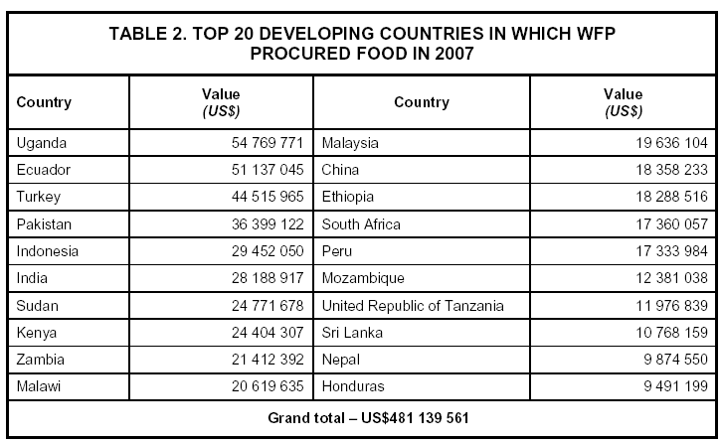

The Impact of Rising Food Costs: Procuring appropriate food in a cost-efficient and timely manner is becoming more and more of a challenge: food costs are rising while availability is decreasing, markets are very volatile and export controls have proliferated. WFP’s ability to procure food in a range of markets, including locally and regionally, has to some extent cushioned it against global price increases. WFP paid on average less than prevailing global market prices, with commensurate savings on transport costs. However, as fewer and fewer markets are insulated from international price increases, this cushioning will inevitably become less effective. (par 8)

Status of Procurement Capacity: At the end of 2007, WFP had 18 international professional food procurement officer posts, 7 in Headquarters and 11 in the field, 2 junior professional procurement officer posts funded by Belgium and Norway, and 8 national food procurement officer posts. Of the professional officer posts, 12 are financed from the Programme Support and Administrative (PSA) budget; the remaining 6 and the 8 national officer posts are financed from the direct support costs (DSC) of the operations in the countries where they are assigned. Food procurement is also carried out by procurement focal points, who often have other functions as well. (par 9-10)

Highlights of Food Procurement

Purchase for Progress: Pilot activities are being launched to further explore programming and procurement modalities. Food assistance programmes will be combined with innovations in local and regional procurement and marketing tools enhanced to promote agricultural development. The aim is to reduce the risks low-income farmers face and increase their incentives to invest in technologies and practices that improve production. This undertaking is also known as P4P. (par 11)

Belgian Support to Strengthening of Small-Holder Farmer’s Market Access and Participation in the Democratic of Congo: Funding has been provided by Belgium for a three-year programme to raise the incomes of small-scale farmers, enhance food security and contribute to poverty reduction by improving market access in selected areas. The programme will support strategies to reduce post-harvest losses and add value to agricultural commodities at the producer level through improved handling, packaging, storage and processing. (par 12)

Quality Assurance Initiatives: A review of WFP’s food specifications was undertaken to ensure that current quality standards are in accordance with international norms:

- A study was made with WFP’s nutrition experts and DSM, a micro-nutrient production company, to improve the micro-nutrient fortification of blended foods and develop an improved weaning food for children under 2.
- WFP and Kemin Industries, an international company providing nutritional ingredients for food manufacturers, have completed an analysis of the shelf life of WFP blended foods and biscuits.
- Agreements have been concluded with two independent superintendence companies to audit the processed food production facilities of companies selling to WFP, to ensure that Good Manufacturing Practices (GMP) are applied and Hazard Analysis of Critical Control Points (HACCP) standards are adhered to.

Food Procurement Capacity Assessments: More systematic mapping of food procurement opportunities has been initiated in some African and Latin American countries to enhance WFP’s knowledge of local markets, expand its supplier base and improve its emergency response capacity. (par 14)

The 2007 Food Procurement Map: This has been released showing which commodities were purchased in which countries and for which destinations, along with related information. The map continues to be colour-coded according to the DAC national income categories. This year it was produced on CD and an interactive version is available at www.wfp.org. (par 15)

Procurement on Behalf of Governments: WFP is assisting the governments of a number of countries, including India, Egypt and several in Latin America, to procure food for their own social welfare programmes. Funded by contributions from the governments, the mechanism is managed through trust funds. (par 16)

