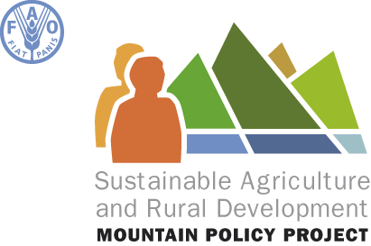

Sustainable Agricultural and Rural Development
in Mountain regions

Rome, 27 May 2009, 15.00-16.30 (Lebanon Room)

“Food security through additional income generation”

Provisional Agenda

- Opening statement: Alexander Müller, Assistant Director-General of the Natural Resources Department 5 min

- Presentation of FAO’s Mountain strategy : Thomas Hofer, FAO entry point for mountain, FAO 10 min

- The SARD-M originators priorities 15 min
  - France Ms. Mireille Guigaz, Permanent Representative
  - Switzerland Mr Hans Jörg Lehmann, Permanent Representative

- The Adelboden Group : a forum for reflection and action / Morocco and the SARD-M project: Mohamed Aït Kadi, member of the Adelboden Bureau / President of the General Council for Agricultural Development (Morocco) 15 min

- Presentation of the project, its findings and present proposal 2010- 2013: Jean Gault, project coordinator 15 min

- Discussion 25 min

- Conclusions: Mr Müller 5 min

Coffee Break

