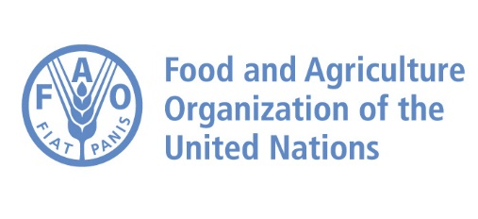 |  | 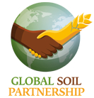

Report of the World Soil Day Celebration

2020 Application to the

King Bhumibol World Soil Day Award

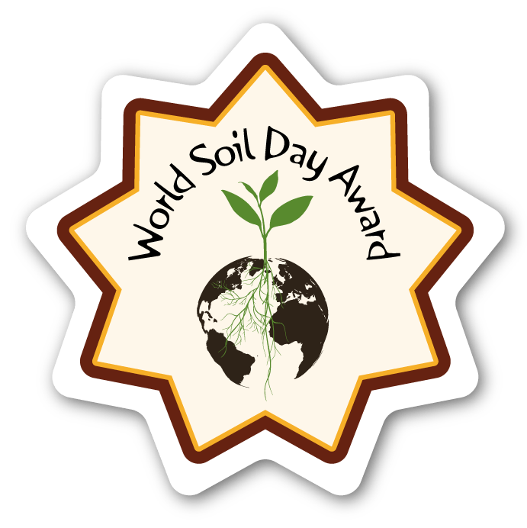

The completed form should be submitted by 30 September to:
GSP Secretariat
Viale delle terme di Caracalla
00153 Roma, Italy
Email: GSP-Secretariat@fao.org

Each candidate should complete the report below to be pre-screened by the GSP Secretariat, as per the criteria. Short-listed candidates will be assessed by the Selection Committee in order to designate a winner.

PART A | Details of the candidate

Description

Name of the candidate for the prize:
Click here to enter text.
Address
Click here to enter text.
Telephone
Click here to enter text.
Mobile
Click here to enter text.
Email
Click here to enter text.

PART B | Description of the project (achievement)

Description

Title of the event
Click here to enter text.
Select the categories of events (you may select more than one type of activities):
- Conference, workshop or symposium
- Soil judging contest
- Educational project
- Screening of a video or film on soil
- Rally
- Exhibition on soil
- Wikipedia Edit-a-thon
- Field work/celebration
- Soil painting
- Art exhibit/performance
- Day at a soil museum
- Guest lecture
- Activities with farmers
- Celebration in the field
- Photo contest on soil
- Soil quizzes and games
- Soil competition for students
- Field trip
- Others (Please specify)
Click here to enter text.

Short description of the event (max 500 words)
Click here to enter text.
Target audience:
Click here to enter text.
Objectives:
Click here to enter text.
Number of participants (if various categories of participants were involved, please specify and include the associated number of participants):
Click here to enter text.
Duration and exact dates of the event:
Click here to enter text.
Was the event promoted in the media? If yes, which media channels were used? Please describe and include the relevant links:
Click here to enter text.
Were any videos of the event published on a website and/or disseminated through social media channels? If yes, please explain and provide links.
Click here to enter text.
Was the event covered by the press or national media? If yes, please specify
Click here to enter text.

How was the event disseminated (through social media, direct mailing, web, press, etc.)?

Click here to enter text.

Was the event open to the general public?

Click here to enter text.
Did it include the participation of a national authority/government institution?

Click here to enter text.
Were any promotional material, publications, gadgets distributed at the event? If yes, please specify the type and quantities.

Click here to enter text.
Were official materials from World Soil Day printed out and used during the event? If yes, please specify how.

Click here to enter text.
How would you measure the impact of the event on the public (you may select more than one option)
- The degree to which debate and new thinking was stimulated
- Whether it aims at increasing knowledge
- Whether and how it influences the wider debate on the importance of soils
- How it contributes to raising awareness on soils
- The outreach of the message
- Whether it generates practical advice or feedback
Please explain briefly.

Click here to enter text.

PART C | Annexes

The candidate is encouraged to include relevant supporting materials such as communication material, publications, CD-ROMs, leaflets, photographs and/or links to audio segments or videos, press releases, web statistics that demonstrate and support the results and associated impacts of the WSD event. This additional material is not compulsory but can be annexed if it is deemed useful in strengthening the candidature of the nominee.

Proposed criteria to evaluate success:

Category | Criteria | Score: 1 to 5
Operational | - Creativity of the idea  - Quality of material used  - Overall work  - Result evaluation
Awareness | - Material produced  - Social media shares  - PR mentions  - Media channels
Overall participant satisfaction | - Public engagement (in number of people)  - Feedbacks
Outreach | - Liaison with press and media Networking opportunities
Digital awareness | - Web traffic  - Web story or blog/success story
Inter-institutional engagement | - Co-organization of the event by various institutions including the government.  - National observance of the World Soil Day

