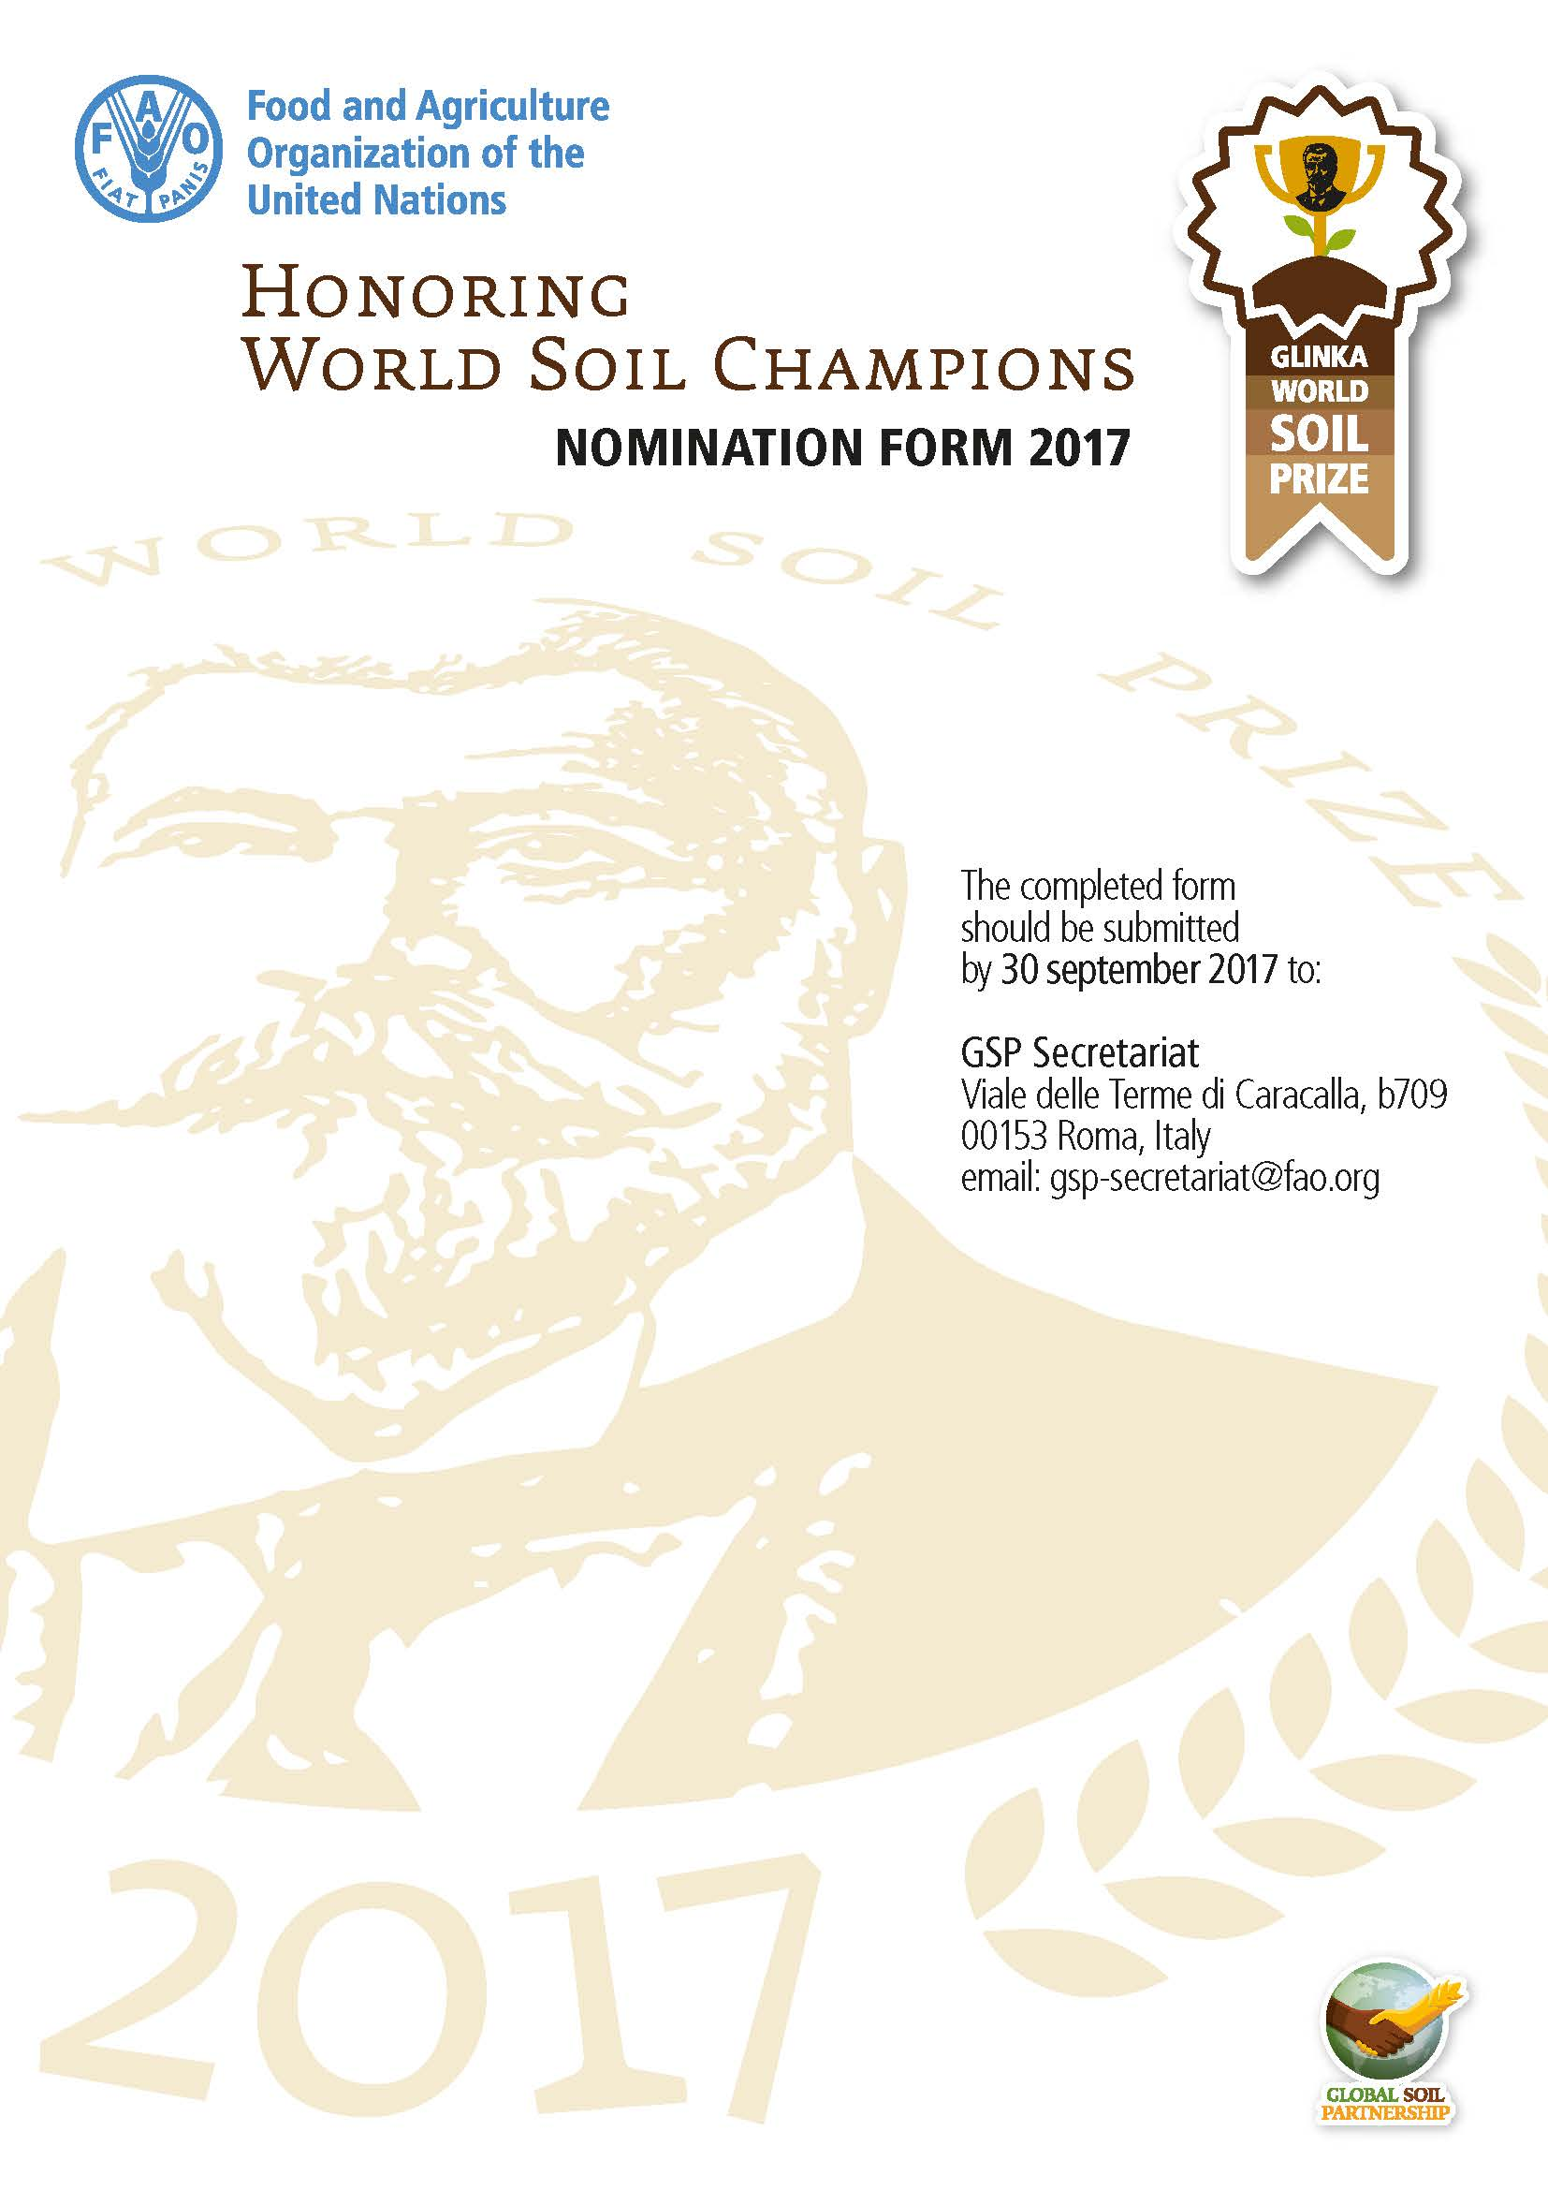

Name of the nominee/candidate for the prize:
Click here to enter text.

Date of nomination:
Click here to enter text.

PART A | Administrative information

Information about the nominating GSP partner
Name of the GSP partner proposing the current candidate
Click here to enter text.
Legal status
Click here to enter text.
Address
Click here to enter text.
Contact person Click here to enter text.
Telephone Click here to enter text.
Mobile Click here to enter text.
Email Click here to enter text.

Information about the nominee
Name of the candidate (or institution)
Click here to enter text.
Legal status
Click here to enter text.
Address
Click here to enter text.
Contact person (in case of an institution) Click here to enter text.
Telephone Click here to enter text.
Mobile Click here to enter text.
Email Click here to enter text.

PART B | Description of the project (achievement)

Description

Summarize the outstanding achievements of the nominee in promoting sustainable soil management (SSM) (max 1000 words)
Click here to enter text.

How are the achievements linked to the revised World Soil Charter? Elaborate (max 1000 words)
Click here to enter text.

Indicate which of the five GSP pillars the project/achievement is relates to (if more than one pillar is addressed by the project, please only consider the most relevant pillar of action)
☐ 1. Promote sustainable management of soil resources for soil protection, conservation and sustainable productivity
☐ 2. Encourage investment, technical cooperation, policy, education, awareness and extension in soil
☐ 3. Promote targeted soil research and development focusing on identified gaps and priorities and synergies with related productive, environmental and social development actions
☐ 4. Enhance the quantity and quality of soil data and information: data collection (generation), analysis, validation, reporting, monitoring and integration with other disciplines
☐ 5. Harmonization of methods, measurements and indicators for the sustainable management and protection of soil resources

Describe in which respects and to what degree the nominee contributed to SSM (max 500 words)
Click here to enter text.

Explain how the achievements of the nominee have contributed to food security, climate change adaptation and mitigation, and sustainable development (max 500 words)
Click here to enter text.

Elaborate on the impacts of the nominee’s activities in society (max 500 words)
Click here to enter text.

Any other remarks or specific features not mentioned above which you think can positively impact your nomination (max 1000 words)
Click here to enter text.

PART C | Annexes
Nominators are encouraged to include relevant supporting materials such as publications, CD-ROMs, leaflets, photographs and/or links to audio or videos that demonstrate and support the results and associated impacts made by the nominee. This additional material is not compulsory, but can be annexed if the nominator considers it useful to strengthen the candidature of the nominee.

