**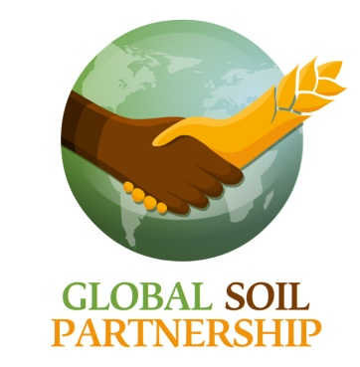**

**APPLICATION TO BECOME A PARTNER OF**

**THE GLOBAL SOIL PARTNERSHIP (GSP)**

*Please submit completed application form*

*to the GSP Secretariat (*[*GSP-Secretariat@fao.org*](mailto:GSP-Secretariat@fao.org)*) at FAO HQ in Rome, Italy*

We (**Name of the organization/institution**),  apply to become a Partner of the Global Soil Partnership.

**Type of institution\***:

Academia/Research institution  NGOs, Civil society  Private sector  Intergovernmental organizations

Other, please specify \_\_\_\_\_\_\_\_\_\_\_\_\_\_\_\_\_\_\_\_\_\_\_\_\_\_\_\_\_\_\_\_\_\_\_\_\_\_\_\_\_\_\_\_\_\_\_\_\_\_\_\_\_\_\_\_\_\_\_\_\_\_\_\_\_\_\_\_\_

The organization hereby:

agrees to abide by the World Soil Charter Principles;

pledges a willingness to actively participate in the GSP network;

acts in accordance with the Terms of Reference for the Global Soil Partnership;

confirms that the information submitted with the application is correct, and ensure that any changes in the information will be reported to GSP.

The institution nominates **Mr/Mrs** as Focal point to the Global Soil Partnership

**Email** :

**Postal address :**

**Website** :

tris_bar

**(GSP/FAO USE ONLY)**

***The Applicant is hereby accepted as a Partner of the Global Soil Partnership, with the benefits, rights***

***and obligations set out in the Global Soil Partnership’s Policy on Partners.***