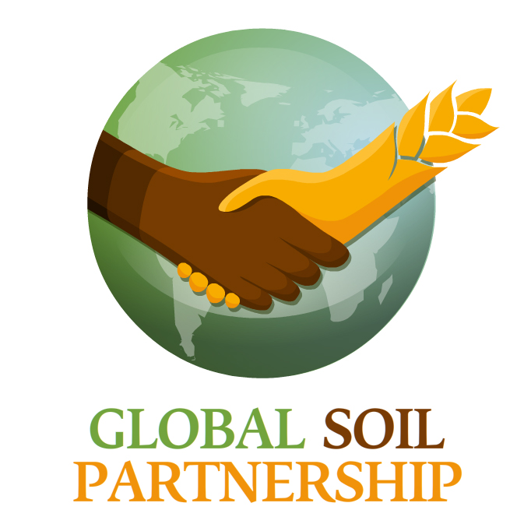

**First announcement**

The Food and Agriculture Organization of the United Nations - FAO - in the framework of the Global Soil Partnership, and

ISRIC – World Soil Information as coordinator of the EU-funded e-SOTER project are organizing a Global Soil Partnership workshop:

**"Towards Global Soil Information:**

**activities within the GEO Task Global Soil Data”**

**Dates:** 20-23 March 2012 (4 days)

**Venue:** FAO HQ, Rome, Italy

**Background**

FAO, with the support of the European Commission has launched the **Global Soil Partnership** in September 2011 to raise awareness of decision makers on the vital role of soil resources for achieving food security, adapt to and mitigate climate change and guarantee provision of environmental services. The improvement of soil information and its use in developing sound soil policies and improved decision making for soil protection and management are the main aims of the GSP. In that regard, the GSP will address five main pillars of action:

1. harmonization and establishment of guidelines and standards of methods, measurements and indicators;
2. strengthening of soil data and information;
3. promoting targeted soil research and development;
4. promoting sustainable management of soil resources; and
5. encouraging investment, policy and technical cooperation in soils.

In particular pillar 2 strengthening of soil data and information will be the subject of this workshop.

The **e-SOTER** project funded by the European Commission FP7 research program and coordinated by ISRIC – World Soil Information has developed in the past 3.5 years a *Regional pilot platform as EU contribution to a Global Soil Observing System.* The Group on Earth Observations plans a global Earth Observation System and, within this framework, the *e-SOTER* project addresses the felt need for a global soil and terrain database.

Technical barriers that had to be overcome included: quantitative mapping of landforms; soil parent material and soil attribute characterization and pattern recognition by remote sensing; standardization of methods and measures of soil attributes to convert legacy data. Two major research thrusts involved: 1) improvement of the current SOTER methodology at scale 1:1 million in four windows in Europe, China and Morocco. Moderate-resolution optical remote sensing was combined with existing parent material/geology and soil information, making use of advanced statistical procedures; 2) within 1:250 000-scale pilot areas, advanced remote sensing applications were developed - geomorphic landscape analysis, geological re-classified remote sensing, and remote sensing of soil attributes.

The **GEO Global Soil Data task** will support the development of a global soil information system building upon the work of on-going and completed projects. The system will incorporate data from global, regional and national soil data projects into a coherent system using a common dictionary – to support implementation of major multilateral environmental agreements (e.g. UNFCCC, UNCCD and CBD) and provide harmonized and policy-relevant information to users at the global, regional and national level. The system will deliver web-based services on soil information.

During the workshop, the status of global soil information will be discussed, in particular the contributions of e-SOTER, GSP and the GEOSS Global Soil Data task as well as from other projects and initiatives, as well as the necessary steps in the future.

**Objective**

The objective of the workshop will be to review the state of the art of tools and techniques for mapping soils at global and regional scales as an input for defining future activities under the implementation of the Global Soil Partnership.

**Target audience**

The target audience constitutes the global community engaged in production and use of soil information.

**Acceptance of Papers**

A limited amount of papers will be accepted after a review by a committee. The accepted papers should be relevant to the objective of the workshop.

**Workshop proceedings**

The accepted papers together with the outputs of the meeting will be subject to a publication under the FAO Soils Bulletins.

**Programme Structure:**

* Keynote speakers
* Contributed papers
* Plenary discussions
* General discussion session at the end regarding future activities

**Preliminary program:**

Tuesday 20 March: Status and Needs of Global Soil Information

* Introduction to GSP Soil Data and Information Pillar (GSP-Secretariat).
* Keynote: Status of global soil information (Dr. Neil McKenzie, CSIRO Australia)
* Global soil data: status and future (V. van Engelen, PoC GEO Global Soil Data task/ coordinator e-SOTER project).
* Keynote: Current and future demands of soil information for fertility management (tbc)
* Keynote: Education on soils, still an option? (tbc)
* Keynote: Is soil information needed for food security and development? (tbc)
* Keynote: Importance of soil information from a donors perspective (tbc)
* Keynote: Importance of soil information for applied research (tbc)
* Keynote: Importance of soil information for users in the field (tbc)
* GEO task Global Soil Data (area-class and soil property maps)  
  Presentations by task leaders: V. van Engelen, G. Zhang, L. Montanarella, J. Hempel (to be confirmed)

Wednesday 21 March: Tools for Soil Mapping (polygon based)

e-SOTER approach and products (Presentations by work package leaders)

* Endre Dobos: Development of a terrain and parent material platform at scale 1:1 million
* Erika Micheli: Integration of soil legacy data and remote sensing data: the creation of the soil component of the platform
* Thomas Mayer, Rainer Baritz, Joanna Zawadzka, Titia Mulder, Michael Bock: New methodologies for scale 1:250 000
* Gerard Heuvelink: Validation and uncertainty analysis
* Rudi Hessel, Simone Verzandvoort: Applications of e-SOTER
* Yusuf Yigini, Steve Hallett, Amir Pourabdollah, Hannes Reuter: e-SOTER web services; status and way ahead to a Global Soil Information Service

Thursday 22 March: Tools for Soil Mapping (point based and others)

Contribution to Global Soil Data by different ongoing initiatives

* Presentations by task contributors: R. Baritz
* FAO Regional Information Systems, R. Vargas
* JRC -LUCAS
* Globalsoilmap.net and AfSIS
* GS-Soil
* Cranfield University
* RAINFOR Project
* SoLIM, Wisconsin University
* Other projects, initiatives (accepted papers)

Friday 23 March: The way forward about global soil information (from ideas to actions)

* Presentation of a GSP Plan of action for Global Soil Data and Information
* Open session for discussing the future on soil data and information
* Consolidation and agreement of the future Plan of Action
* 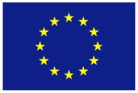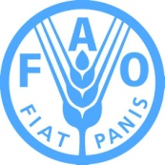The way forward, from plans to actions.