FAO private sector partnership mapping tool

Technical design and notes for a user manual v1

Context
These notes are part of the final deliverable for TPI input to the design of a private sector partnership mapping tool for FAO.
The context for the tool the is FAO’s Strategy for Private Sector Engagement (2021-2025) and Private Sector Partnerships Division (PSR) implementation of the Strategy organization-wide. The tool will provide a common methodology for regional and headquarters strategy and planning and is closely related to the implementation and use of the corporate Customer Relations Management System (CRM) for Private Sector engagement.
The design has been developed using inputs from workshops with PSR, Regional Partnership Officers and IDWG. It comes in the form of an excel prototype which includes graphical representation suggesting which PS actors to prioritize for engagement. These notes accompany the prototype and will form the basis of a user manual and recommendations for how it can be used.

Design of the tool

The design concept for the tool is
- A multi-step process:
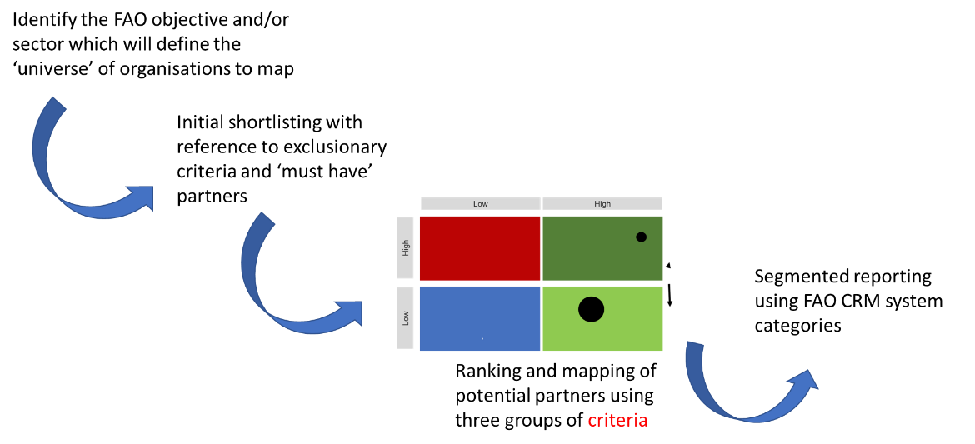

- This mapping uses rankings of potential partners from the shortlist using three sets of criteria:
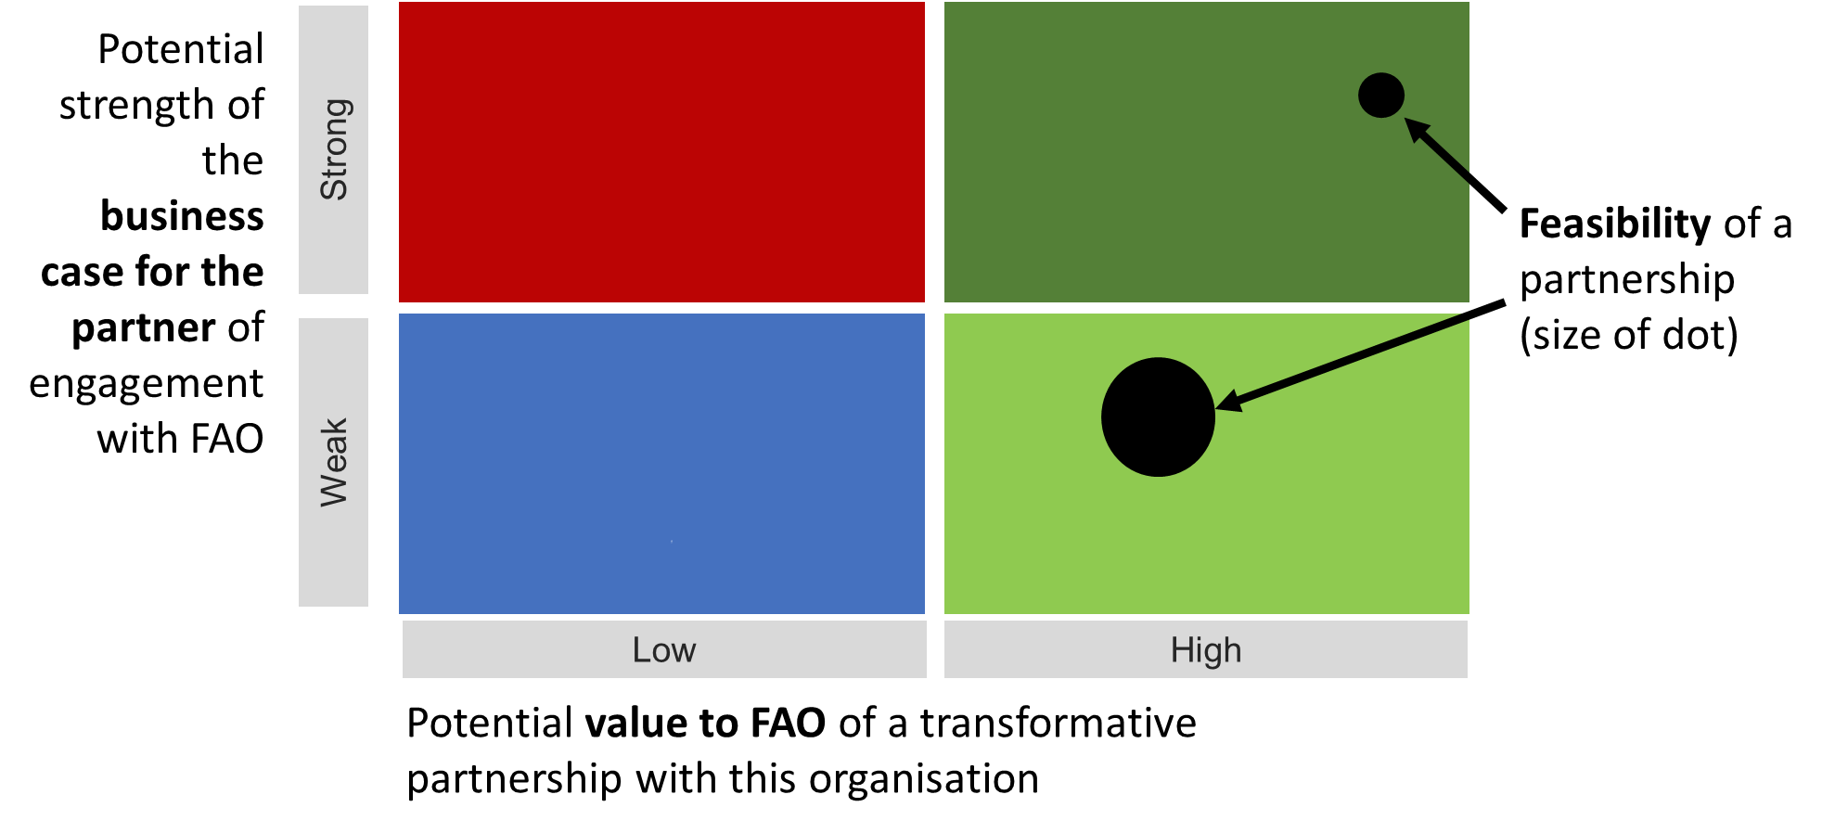
The ranking comprises 3 ‘scores’ for each entity. Each of these scores is the average for the data set arising from assessing a range of statements for each criteria. The user scores this evidence as to the extent that the entity has the potential to fulfil this element of the criteria.

Form of the criteria
The criteria are all drafted in the form of an extension of a basic statement, which is either
‘When considering the impact that FAO is seeking to achieve through a partnership in this area of FAO interest….’ (value to FAO)
or
‘When considering this entity as a potential significant partner to FAO…’ (in the case of the business case to the entity).

Examples of the ‘full’ questions in each case would be:
‘When considering the impact that FAO is seeking to achieve through a partnership in the areas of FAO interest, the activities and resources of this entity are highly complementary to FAO's own’

‘When considering this entity as a potential significant and enduring partner to FAO, The entity has committed to a strategy which has focus areas and goals that can be achieved through a partnership with FAO’

These are all drafted as the most positive expression of this in terms of the potential for a partnership.
The tool will then ask for a rating of the extent to which this ‘positive’ statement is actually fulfilled in practice, as indicated by the evidence available.
Users are guided to give a rating on a scale of 1-10:
- Evidence suggests this will not be the case, or only a to a small degree

- Evidence suggests this element of the criteria fulfilled in some part
6
7
8
9
10 Evidence suggests this element of the criteria can be fully met

or 0 for ‘Don't know’ removes this criteria from the rating
Only up to 25% of ‘don’t knows’ will be allowed in order to provide valid score for mapping.
The full set of criteria are included in an Annex to these notes but they are also included in the prototype (see below).

Guide to the prototype

General
The prototype is an Excel spreadsheet which accompanies these notes.
The protype only allows mapping of up to 12 entities but it establishes the process for the functionality that could be used for as many entities as required. It also enables use of the tool to be demonstrated.
This comprises 7 sheets with their content indicated in the tabs.
The cells are marked according to their content which follows the styles used in the Excel ‘cell styles’ sections as follows (not all styles are used):
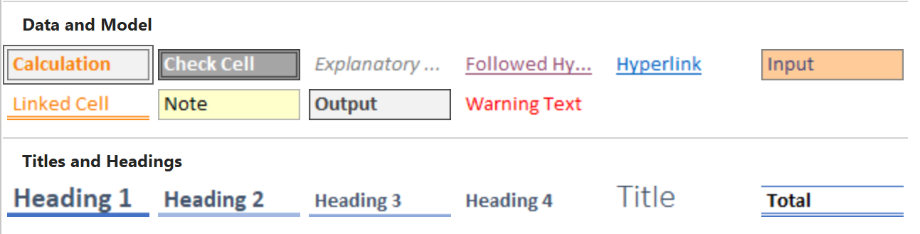

‘Entities to map’ sheet
It is assumed that a prior process beyond the scope of a mapping tool will have identified the FAO Objective and research undertaken to identify the universe of potential partners.
The purpose of the prototype is to test that the design and concept work for the mapping element of the process, and the segmented reporting. It does not provide any process or tool to support to the identification of the relevant FAO objectives and universe of potential partners, or shortlisting.
See more on setting up to do a mapping in the ‘Using the tool’ section below.
Prototype summary: The entities shortlisted are entered in the Input cells +on the ‘Entities to map’ sheet.

‘Settings’ sheet
This sheet has a number of panels with settings that can be adjusted. Many (or all?) of these may not be adjusted by the user in the final version, although it might be useful to provide access to them to someone with additional administrator training.
The panels are as follows:
- Minimum threshold of answers to make answer valid
This is the number of answers that need to be more than 0, which means that an evidenced-based rating has been provided rather than ‘don’t know’. It is set at 75% of answers.
This is used in the three criteria sheets, for example range W5 to W16 in the ‘Value to FAO data entry’ sheet. This is a formula that makes the ‘Viable average’ in range T5 to T16 ‘O’ if the percentage set of non-zero ratings isn’t met. These formulas are used again everywhere a new rating average is required.
Prototype summary: The percentage of valid answers required can be amended in cell C1, ‘Settings’ sheet
- Size and type of partner
This specifies the way that the results of the mapping will be segmented for different ‘views’ of the mapped data. At the moment the prototype only uses the ‘Size and type of entity’ list, but the ‘Use case (tbc)’ list could be refined and used in the same way.
The size settings are used in ‘Entities to map’ data entry sheet to provide a drop down menu of options in column D. These are then used in the criteria and chart sheets. For example, the data for the entities is then used in the ‘Value to FAO data entry’ sheet. It is linked through cells in the range C5 to C16. This is the picked up in the formulas that segment the data, for example in cell D19 and all the similar cells in range D19 to R30, which show only the scores only of the entities that have been identified as a Micro, Small or Medium-Sized Enterprise (MSME). The average rating for these organisations is then used in the ‘Chart working’ sheet to produce maps only of MSMEs in rows 21 to 38
Prototype summary: The way that rankings can be segmented in the final maps is set by the contents of cells in the range B4 to B10 in the ‘Settings’ sheet
- Value to FAO questions (and also Business case and Feasibility questions)
These three panels determine which questions are more relevant to certain sizes and types of entity for the most highly segmented mapping option. These questions are indicated against the options size and types of entity by indicating them with a ‘1’ in cells in the ranges G4 to U11, G15 to N22 and G26 to Q26. Questions not to be included in these reports are marked ‘0’.
These settings are used in the criteria sheets to specify which ranking data to include some of the mappings. For example in the ‘Value to FAO data entry’ sheet, cell Y19 (and all similar cells) takes each ranking relevant to a size/type of entity and then specifies whether to include this in the data to be used for the map. Note that the rule of 75% of questions having to be more than zero is adjusted to the correct number of statements that are valid in any particular range. This is done in this sheet in formula cells in column AQ and refers also to formulas in (for example) the Settings cells in the range W4 to W11.
The segmented data is then used in the ‘Chart working’ sheet to produce the charts marked ‘Selected questions’. These appear in columns P to AD
Prototype summary: The questions to use for the mostly highly segmented final maps is set by the contents of cells in the ranges G4 to U11, G15 to N22 and G26 to Q26 in the ‘Settings’ sheet

Criteria sheets: ‘Value to FAO data entry’, ‘Business case data entry’, ‘Feasibility data entry’
These sheets all have one panel for data entry and the rest of the cells are either linked cells, formulas, headings or explanatory material.
The data entry panels are:
- Value to FAO data entry: cells in the range D5 to R16
- Business case data entry: cells in the range D5 to K16
- Feasibility data entry: cells in the range D5 to N16
The data to be entered is a rating between 0 and 10 for each cell using a drop-down list. This rating is for the statement in the cell in the same column and row 2. Instructions are provided in a panel cell C3.
Prototype summary: The rating for each entity against each component of the criteria is to be entered in the data entry panels in the ‘Value to FAO data entry’, ‘Business case data entry’ and ‘Feasibility data entry’ sheets.

‘Chart working’ sheet
This sheet only has linked cells and charts derived from the data in these linked cells. There are three types of charts which are the outputs to the too:
- A mapping of all the entities that have viable results (i.e. where there are more that 75% of evidenced ratings): range F1 to N19
- Segmented mappings according to size and type, and with ratings from all questions included whether they are fully relevant or not to that size and type of entity: range F20 to N129
- Segmented mappings according to size and type, and with only ratings from questions included that are fully relevant to that size and type of entity: range U20 to AD129
Note that because the prototype is limited to 12 entities many of these segments only have data for one or tow entities so the charts with the dummy data are not insightful, but when the full tool is developed with the capacity to map many entities then the segmented mapping should be very useful.
Prototype summary: The ‘Chart working’ sheet includes only linked cells and charts. These charts are the mapping element of the tool and the tool’s main outputs.

Using the tool

FAO strategic priorities
Much of the value of using the tool will derive from how well the resultant partnerships contribute to achieving FAO’s strategic objectives. Users should therefore think carefully at the outset about what the strategic lens they are applying before they start to short list entities.
It is recommended that material developed by TPI on transformative partnering is cross referenced for guidance. This material is with the FAO Partnership and UN collaboration (PSU) team who commissioned the research in 2022. It is TPI’s understanding that this will be rolled out within FAO during 2023.
The use cases presented in Annex 2 may also be helpful in guiding users as to which strategic objectives will be most rewarding to use to produce a short list for the tool.

Research on entities
A lot of research on private sector entities will be need in order to use the tool. Users may already have a good working knowledge of some entities, but the aim of the tool is to reach new partners which suggests that they are may not be FAO’s radar yet. It is assumed that users are experts in the private sector so will know how to undertake this research, but some ideas provided by workshop attendees are include in Annex 3 ‘Useful sources of information when researching entities’
FAO exclusionary criteria should then be used before arriving at a short list to use in the mapping stage.

Iteration
Users may wish to use the tool more than once in the process of identifying new private sector partners. A first iteration may include more entities and be based on light-touch research that is sufficient to be able to rate more than 75% of each criteria but where the rating is based on minimal evidence for each. This can enable the most obviously promising entities to be placed on a reduced short list for further research.
A second iteration of the tool can then be run with more evidence that will produce a more accurate and insightful set of data and mapping. This can then be used for strategic decisions making on which entities to approach for discussions around a possible partnership. There could even then be further iterations once information is available from the entities themselves.

Guidance for the use of the charts

The following is an example of an output chart with dummy data for 12 entities.
There are four colour coded quadrants and the entities are mapped to one of the four. The colours reflect a traffic light system:
Green: move forward in the process - highly suitable to explore a partnership
Amber: pause and reflect – maybe suitable for partnership but needs further thought or research
Red: stop; not a suitable candidate for partnership
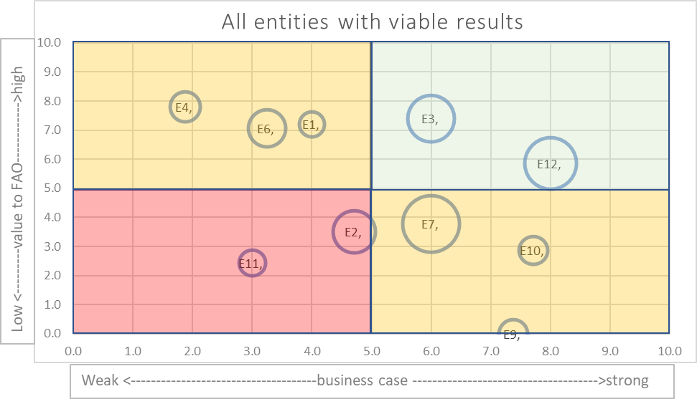
The positioning of an entity provide the following insights to the tool user, and suggests next step:

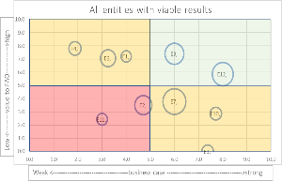
Top right quadrant
- The entities with highest potential to provide value to FAO in a partnership, and where there is likely to have the greatest interest from the potential partner, are those in the top right quadrant
- However, users should then review the ‘Feasibility’ score and be mindful that a low score may indicate that there is a risk that achieving a partnership may be very difficult, take a long time, and incur high transaction costs. They must then decide whether the potential value of such a partnership will outweigh these risks and costs. A partnership which delivers a little less value but is highly feasible may be a better strategic option.

Bottom left quadrant
- Entities with low potential for partnership are in the bottom left quadrant and should be discarded

Top left quadrant

- Entities in the top left quadrant have the potential to create value for FAO in a partnership but the indications are that the entity may not be a strong partner. Users of the tool can look at the subcomponents of the ‘Business case’ criteria in these cases and determine why this entity has returned a low score. If these issues can be mitigated or are not thought to be of much consequence for the type of partnership envisioned then FAO may chose to proceed, but with due caution and the risks of not achieving a strong partnership are higher in these instances.
- As with the top right, a review of ‘Feasibility’ may then reveal additional risk or cost which should also be taken into account when deciding whether to pursue a partnership

Bottom right quadrant

- Entities in the bottom right quadrant may be keen to partner with FAO but the value for FAO appear relatively low. The user may review the subcomponents of the ‘Value to FAO’ and determine that the entity is going to provide enough value to FAO in one or more areas to make a partnership worth while, but should proceed with die caution and be mindful that there is a risk that FAO incurs high transaction costs with little benefit.
- As with the top right, a review of ‘Feasibility’ may then reveal additional risk or cost which should also be taken into account when deciding whether to pursue a partnership

ANNEX 1: Criteria

Full list of potential criteria for potential value of the stakeholder’s resources in a transformative partnership with FAO
Short-form: Value to FAO (low to high)
When considering the impact that FAO is seeking to achieve through a partnership in this area of FAO interest:
1 | A partnership with this entity as high potential to impact on FAOs strategic objectives (or 4 Betters)
2 | The entity's activities, and array of resources, are highly relevant to, and aligned with, FAOs strategic objectives
3 | The entity has highly relevant influence that can support transformative change
4 | The activities and resources of this entity are highly complementary to FAO's own
5 | This entity has projects and programmes that have the potential to greatly improve FAOs work
6 | The entity has footprint that will enable FAO to have a greater reach (e.g. geographic, or within a supply chain)
7 | FAO has the capacity (people, skills, time) to make good use of a partnership opportunity Deleted because it repeats what is in feasibility
8 | This entity has financial resources that could be made available to support FAO's work
9 | This entity has the technical strengths that FAO needs
10 | The entity is large enough and has enough resources to be a useful partner for FAO This raised a question at workshop 3 as to whether it makes sense
11 | The entity brings complementary knowledge and information, for example about the local context and needs
12 | The entity has features that suggest that it will a potential to be able work with FAO to identify and implement new and innovative solutions that will support FAO’s work Amended after workshop 3
13 | The entity is a significant actor in the country [or region or global level, whichever is relevant] which can bring benefits to FAO (such as influence and advocacy)
14 | The entity has the ambition with FAO’s help to be able to introduce products/services that are highly relevant to FAO objectives. ‘With FAO’s help’ added after workshop 3 to differentiate from procurement
15 | There is an opportunity to create a greater scale of impact through partnership between FAO and this entity
16 | The impact of this entity's activities clearly benefit people in the sector that FAO is working in

General comment at workshop 3: ‘this section is quite long and it is difficult to grasp the different priorities’. Response: the guidance notes will explain that the segmented reports only use the mots relevant questions for that type of entity. I am also confident that on examination users will see the differences

Full list of the criteria for potential strength of potential partner’s internal business case for engagement with FAO
Short-form: Business case for partner (weak to strong)
1 | The entity's activities and resources which are relevant to FAO are part of the organisations core business and use their core skill-sets
2 | The customers, clients or other key stakeholders (such as a membership base if relevant) of the entity are also highly relevant to FAO and could benefit from a partnership between the entity and FAO
3 | The entity has committed to a strategy which has focus areas and goals that can be achieved through a partnership with FAO
4 | The entity has good reasons to commit long term investment of resources to a partnership with FAO
5 | It is realistic to assume that the entity can achieve its objectives better if it is able to benefit from FAO's expertise and/or other assets
6 | There is likely to be a widespread engagement in the entity in any collaboration with FAO - it is not just one individual or a small team
7 | The entity has a strong track record of working in areas and goals that can be strengthened through a partnership with FAO
8 | The entity has a strong commitment to the SDGs

General comment at workshop 3: surprising there is no mention of profit, risk, market access
Response: many of them can contribute commercially to a company but many entities FAO partners are not for-profit so it is better to keep at this level? Also, it raises as risk that FAO is offering to give one company an unfair advantage which might make the user nervous of partnership

Criteria for the feasibility of a partnership
Short-form: Feasibility (low to high)
Considering the practical aspects of potentially partnering with this entity:

1 | FAO and the entity know each other well and have a strong track record of effective collaboration
2 | They have already engaged extensively with other UN agencies
3 | We already know their policies and procedures and that they are not incompatible with FAO's instruments
4 | They make long term, reliable commitments to partners
5 | Compared to other entities FAO has worked with they are straightforward to work with
6 | They are keen to make a partnership with FAO work whatever the difficulties
7 | They are an organisation that will be able to contract with FAO (if a formal agreement is needed) This was questioned in workshop 3: are there any private sector organisations that FAO can’t legally partner with
8 | There are no regulatory or other public interest reasons why a partnership will not be feasible
9 | Having considered the likely time and resources needed, we believe we the right skills, time available and capacities in relevant teams to commit to the engagement process
10 | There are no insurmountable internal decision-making processes that will impede reaching agreement with this entity
11 | FAO decision making process and the time it takes to make decisions are not totally incompatible with those of the entity After workshop 3: changed from ‘are compatible with’ to ‘are not totally incompatible with’ as someone said that the former was too limiting

Several comments in workshop 3 were around risk and whether it should be addressed in the criteria but I think we agreed that risk is addressed thoroughly elsewhere in the partnering process?

ANNEX 2: Guidance material
TPI material to assist with training users on the criteria
Value to FAO criteria
The following can help a user to understand the concept of the value that a partnership can bring to support FAO to achieve its objectives:
Complementarity: Bringing together essential complementary resources
Standards: Creating collective legitimacy and knowledge
Innovation: Combining diverse resources, thinking, approaches
Shared learning: Creating a mechanism for collective learning and capability- building
Shared risk: Collectively sharing risk of major investments / implementation
Synergy: Aligning programmes / resources and cooperating to exploit synergies
Scale: Combining delivery capacity across geographies Taking successful programmes, products and approaches to scale to multiply the impact.
Business case for the private sector entity criteria
Partnership opportunities at the interface between business and development:
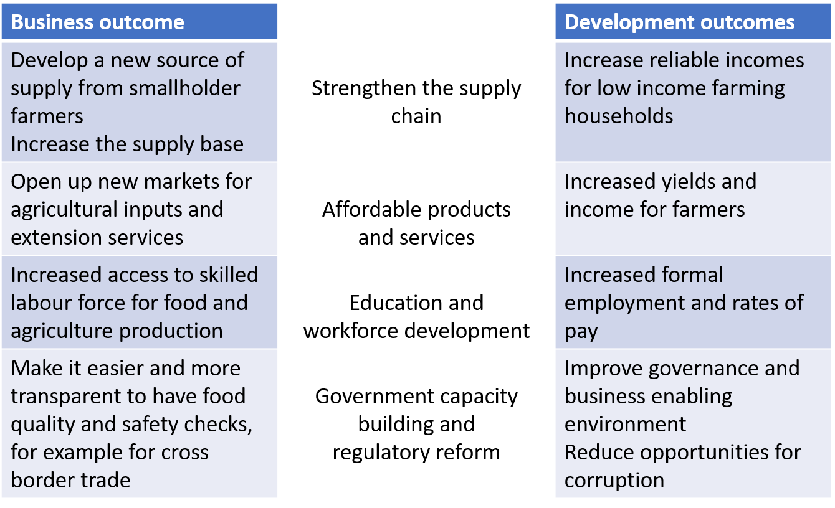

Further guidance on these topics can be found in The SDG Partnership Guidebook here.

Use cases (from Workshop 3)
General uses of the mapping tool
- Supporting a rationale for engaging with specific private sector entities
- Strategic involvement of the private sector in FAO activities
- Hint to potential types of modality engagement with mapped entities
- Improving transparency
Broad use case
- Identifying opportunities for innovation
- Corporate reporting
- Funding opportunities
- finding technological solutions
- Highlighting key areas for private sector partnerships
- Filling knowledge gaps
- Enhancing perfomance/impact of projects in the field through local PS inclusion
- Advocacy and Comms partnerships
- Stocktaking exercise (at country level)
- Investment match-making
- Mapping financiers to engage with
- using tool for specific ask from the PS
Specific use case
- HiH Initiative
- Strategic connection of PS work to UN Food Systems Summit
- CPF formulation
- medium term strategic planning for the PSE of the Offices
- Digital Village/OCOP Initiative partner identification
- Facilitate EPC discussion

Useful sources of information when researching entities (from Workshops 1 and 2)
Initial work prior to using the tool
Conduct needs assessment at the country and regional levels
Basic due diligence before short-listing
- UN exclusionary criteria Yes/No
- If entity operates in a high-risk sector for FAO
When researching an entity to rate the criteria, the following could be useful sources of information:
- Their business values, practices and operations -
- Countries of operation
- History of real commitment to common goals Vs "blue-washing”
- Reputation
- Experience working with UN - check if the entity has been already engaging with other UN agencies
- Where they operate, previous performance (due diligence audits) and its capacity to deliver
- History of engagement with FAO - If there is any engagement history
- Assurance results
- Market reports that provide a comparison with competitors
- Background on partner programmes, procedures, operations, management policies
- Expressed interest and expectations
- Commitment to SDGs and if they a part of SDG platforms.
- Company Annual/financial reports, audits.
- Their approach and commitment towards sustainability and inclusiveness
- Sustainability report
- ESG performance ratings
- CSR and philanthropy reports and plans

