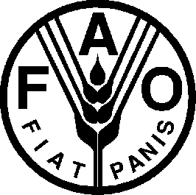

INTERNATIONAL TREATY ON PLANT GENETIC RESOURCES FOR FOOD AND AGRICULTURE

MODEL INSTRUMENT OF RATIFICATION/ACCEPTANCE/APPROVAL*

The Government of [ name of country ] has the honour to refer to the International Treaty on Plant Genetic Resources for Food and Agriculture, which was approved by the FAO Conference at its Thirty-first Session in November 2001, and to inform the Director-General of the Food and Agriculture Organization of the United Nations that [ name of country ] hereby [ ratifies ] [ accepts ] [ approves ]* the aforesaid Treaty pursuant to its Article 26 and undertakes to abide by its provisions.

[ Date ] [Signature by one of the following
national authorities]

- Head of State or
- Head of Government or
- Minister of Foreign Affairs or
- Minister of Department concerned
-

[ SEAL ]

*Only one of these need be chosen, depending on the term most commonly used by the States submitting the instrument. Ratification is the term most frequently used.

