Fishery value chain analysis in Cambodia
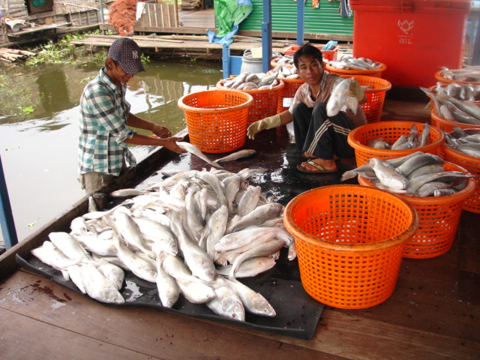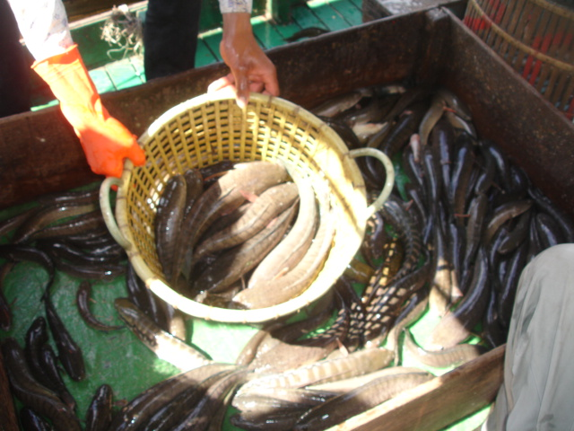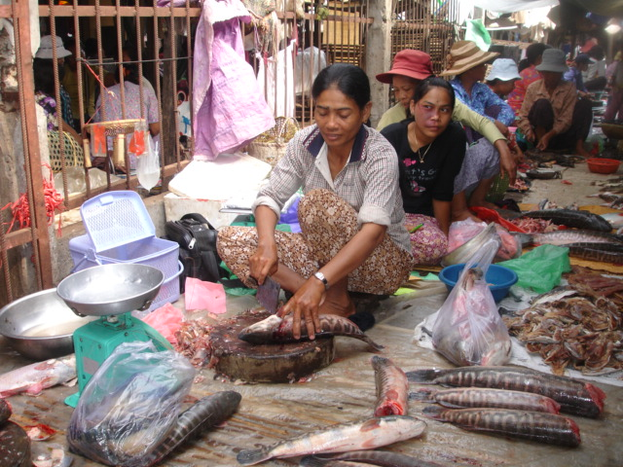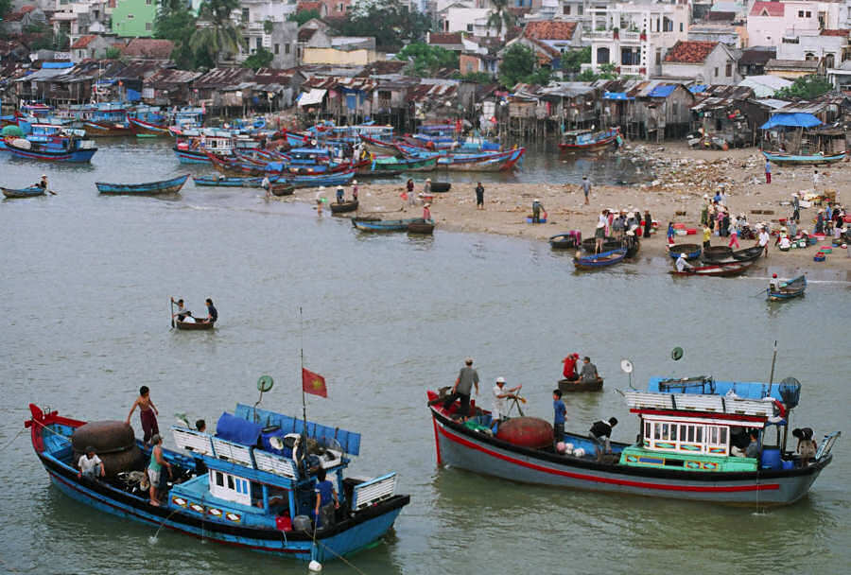

June, 2011
FAO, Rome
Table of contents
Page

Value chain analysis, Cambodia 2
1. Basic information of inland fisheries production 2
2. Fish export 7
3. Fish consumption 14
4. Aquaculture fisheries 19
4.1 Cage/Pen culture 19
4.2 Pond culture and rice-fish culture 20
5. Fish processing 21
5.1 Traditional processing 21
5.2 Modern or industrial fish processing 22
6. Final consumption: fish commodity and fish products 24
7. Transportation 25
8. Regulations and management of freshwater fisheries 26
9. The different agents in the Cambodian value chain 27
9.1 Fish marketing system in Cambodia 27
9.2 Stakeholders in the fisheries commodity and product chain 27
10. Data availability 32

Value chain analysis, Cambodia

A value chain analysis, providing both qualitative and quantitative background information, is to be undertaken for all case studies (products), which is included in the project before an econometric analysis is undertaken. Sources of information for this analysis may include secondary data, published or unpublished literature, surveys, focus groups discussion,​​​​​ key informant interview and rapid appraisal. The value chain analysis will include the following stages:

Basic information of inland fisheries production
The Cambodia’s fisheries sector, encompassing extensive freshwater fisheries within floodplains, river, lakes, marine fisheries, rice-field fisheries and some aquaculture, is managed by Fisheries Administration (FiA). Fish constitutes about 75 percent of the animal protein intake for the Cambodian households and most of it comes from freshwater fisheries. It is thought to be the most productive inland fisheries of the world, contributing about 60 percent of the country’s commercial fisheries production (Ahmed et al., 1998).
The Mekong river has created vast wetland and flooded forest, which has great species diversity and high fish productivity. Flooded forests, a kind of non-timber forest products, are of importance to aquatic and wildlife ecosystem and people livelihood. Flooded forests around the Great Lake Tonle Sap and on both sides of the Tonle Sap, mainstream Mekong-Bassac rivers, have an important ecological role and contribute significantly to fisheries by serving as nursery, breeding grounds, habitats for fish population and aquatic resources that consists of more than 200 species. They also serve as trapping sediment from the river and control water flow in the lakes/rivers. Floodplain ecosystem in the areas around Mekong and Tole Sap encompasses vast areas of flooded forests, which can be described as kind short tree and shrub species able to withstand inundation for 3–6 months (Zalinge et al., 2000). The monsoonal flooding inundates more than 600,000 hectares of existing flooded forests, 80 percent of which are located around the Great Lake Tonle Sap. Whereas, the remaining 20 percent are scattered in the Mekong delta, along the Tonle Sap, the Mekong-Bassac rivers and their floodplains have some kinds of flooded forests that produce fruits or leaves, which are important food ingredients for fish species. For these merits of flooded forests, Van Zalinge (1997) indicated that the flooded forests in their natural state are expected to be more productive and richer in fish species than when it is converted into rice fields for instance. Where huge flooded forests are present, it is normally categorized as potential Fishing Lots and Dai Fisheries.
The mainstream Mekong and Tonle Sap rivers meet in Phnom Penh and continue to flow as the Bassac-Mekong rivers into Vietnam. Other smaller rivers and streams run off the main drainage system and they are important for fishing, transportation and provision of alluvial soils through annual flooding (Ahmed et al., 1998). The Great Lake Tonle Sap, the biggest in South Asia and the lower tributary of the Mekong river system, have been providing livelihood opportunities to millions of people in Cambodia. Traditionally, the Great Lake Tonle Sap is the spawning ground for many fish species that migrate through Tonle Sap river when the Great Lake Tonle Sap expands with floodwater, usually by four to six times its dry season size.
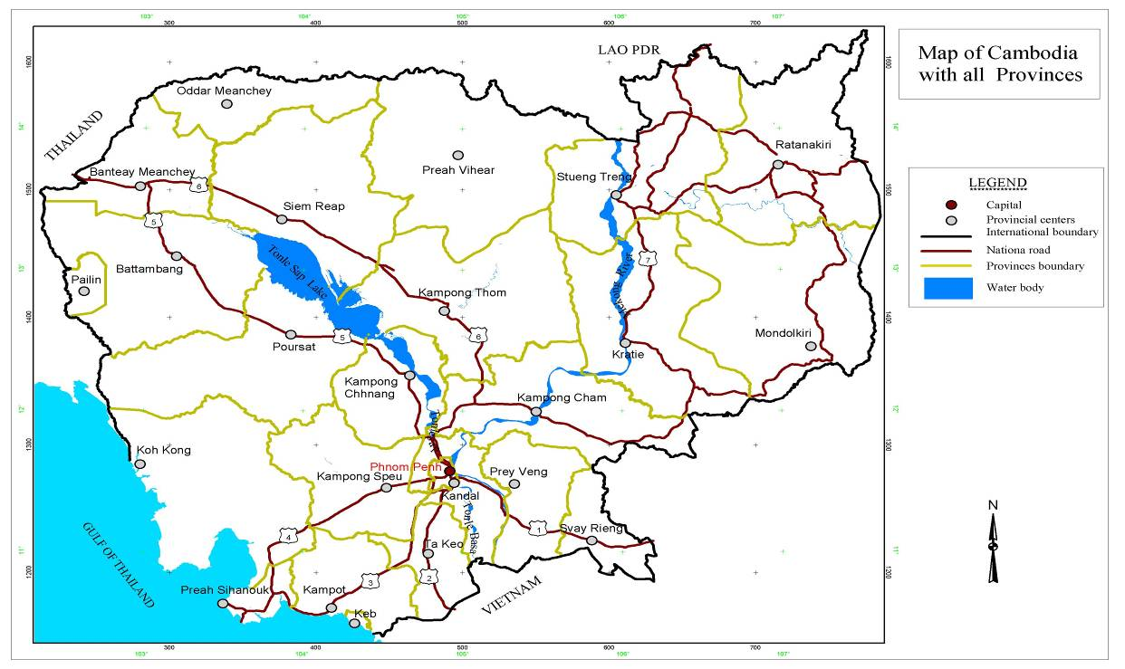
Figure 1: Map of Cambodia showing all provinces and water bodies.

In the last 10 years, catches from the rice-field fisheries and small-scale indigenous fisheries are almost ignored in the data collection efforts of the FiA. However, the official estimate of the FiA increased by 323 percent i.e. from 74,700 tonnes in 1991 to 231,000 tonnes in 1999. This increase is due to the inclusion of small-scale fish catch into the national annual production figure of inland fisheries. The estimates based on catch assessment and related studies by Zalinge et al. (2002) made a comprehensive effort for a reliable estimate by combining data from different sources. This estimate provides a range of total fish production/catch between 290,000 and 440,000 tonnes. Currently, this figure is widely used by the researchers and policymakers, although the estimate still remains indicative only. Much effort is still needed to reach to a conclusive figure, in order to assess sustainability of inland fisheries. If it is true that the current catch of fish is higher than the previous decades, this is likely to be due to increase in population dependent on fishing and increasing fishing effort in the form of destructive and illegal fishing activities. As shown in Table 1, the total fish catch of marine fisheries increased with the exception of year1995, whereas the catch of inland fisheries fluctuates during 1991–2009. In the case of fish aquaculture, it increased over the years, with the exception of year 2001. However; the capture of shrimp aquaculture fluctuates over the years.
Table 1: Total production of inland, marine and aquaculture including capture during 1991–2009 (unit: metric tonne)
Year | Capture (Inland and Marine) |  |  | Aquaculture
Year | Inland | Marine | Total | Fish | Shrimp
1991 | 74 700 | 36 400 | 111 100 | 6 700 | –
1995 | 72 500 | 30 500 | 103 000 | 8 779 | 731
2000 | 245 600 | 36 000 | 281 600 | 14 410 | 20
2001 | 385 000 | 42 000 | 427 000 | 13 857 | 143
2002 | 360 300 | 45 850 | 406 150 | 14 547 | 53
2003 | 308 750 | 54 750 | 363 500 | 18 410 | 90
2004 | 250 000 | 55 800 | 305 800 | 20 760 | 75
2005 | 324 000 | 60 000 | 384 000 | 25 915 | 110
2006 | 422 000 | 60 500 | 482 500 | 34 160 | 40
2007 | 395 000 | 63 500 | 458 500 | 35 190 | 70
2008 | 365 000 | 66 000 | 431 000 | 39 925 | 75
2009 | 390 000 | 75 000 | 465 000 | 49 925 | 75
Source: FiA, 2009
The areas of the various inland water systems created by the Mekong river are shown in Table 2. Ahmed et al. (1998) noted that besides an overall decline, there were significant changes in area under different types of land and water resources that support fisheries between 1985–1987 and 1992–1993. The changes in area under each type of resource can be attributed to loss of primary flooded forests and to the conduct of the survey at different periods. Although these data are pertained to the 1990s, they are still in use due to lack of recent data. However, at this time, the various inland water system areas may have smaller area compared to the 1990s.
Table 2: Various types of land and water resources areas that support inland fisheries in Cambodia
Land and water resource | Area (Ha)  (1985–1987) | Area (Ha)  (1992–1993)
Permanent water (river, lake, pond, etc.) | 567,100 | 411,100
Flooded forest | 795,400 | 370,700
Flooded secondary forest | 28,200 | 259,800
Flooded grassland | 80,800 | 84,900
Receding and floating rice fields | 17,500 | 29,300
Seasonally flooded crop fields | 366,800 | 529,900
Swamp | 12,200 | 1,400
Total | 1,868,000 | 1,687,100
Source: Ahmed et al. (1998)
According to recent land use data estimates, only 19,517 hectares of inundated forest or flooded forest remain around the Great Lake Tonle Sap (Gum, 2000).
At present, inland fishing activity is organized at three levels: (1) family (subsistence) fishing, (2) middle-scale (artisanal) fishing and (3) large-scale (industrial) fishing (Table 3). The fishing calendar is divided into two seasons: open (October–May) and closed (June–September).
Table 3: Characteristic features of fishing practices in inland/freshwater fisheries, Cambodia
Description | Types of fishing
Description | Family scale | Middle scale | Large scale
Fishing period | Round the year | October–May | October–May
Major gear technique | Harpoon/spear;  Cast net (<5 m);  small gillnet; single hooked lines and bamboo traps | Seine net; gillnet; cast net; hooked long line and bamboo traps | Bagnet; bamboo/wooden barrage and bamboo fence and traps
Fishing rights allocation | Free within areas outside fish reserves and fishing lots | Annual license fee according to gear type and size | Leasing of designated fishing grounds every two years through competitive bidding
Background of fishers/operators | Artisanal fishers;subsistence farmers and landless | Artisanal fishers from river and lake side communes | Financially and politically powerful people and agents
Source of fishing labour and terms of employment | Family members | Family members and co-villagers as partners &occasional hired workers; income sharing | Hired workers from non-fishing communes; fixed wages (cash and food) according to skills
Education | No education;  can read only; and  primary school | No education;  can read only;  primary school and  more experience | Can read only;  primary &secondary school, and  more experience
Income | Poor | Poor, and average | Rich, average and poor
Average size of crew | 1–3 | 3–6 | 50—80
Source: Hap (1999)
The FiA considers areas for inland fisheries in 13 provinces including Phnom Penh, which are important for commercial inland fish capture. Moreover, inland fisheries occupy two major ecosystems: first, the Great Lake Tonle Sap river zone and second, the Mekong–Bassac inundated zone. The provinces that are covered by the first zone are Kampong Chhnang, Pursat, Battambang, Banteay Meanchey, Siem Reap, Kampong Thom and part of Kandal to the North of Phnom Penh. The second zone covers part of Kandal to the South of Phnom Penh, Kampong Cham, Takeo, Prey Veng and Svay Rieng. A third ecosystem, consisting of the upper part of the Mekong and the rapids region of Cambodia, covers provinces such as Kratie and Stung Treng. This is considered less important for commercial fisheries but serves as an important ecological link for most migratory species and provides subsistence-fishing opportunities to nearby residents (Ahmed et al., 1998).
The results in Table 4 indicate that fifty two percent of the annual inland capture fisheries productions were shared by the family fisheries and rice-field fisheries. This implies that family-scale fishing and rice-field fisheries are considered as important as (or even more important than) the large-scale or commercial fisheries. In addition, they are believed to link directly to the daily supply of food/nutrition, employment opportunities and income generation to millions of poor farmers and fishers.
Table 4: Total annual fish catches and types of fisheries, including inland, marine and aquaculture in year 2009.
Types of fishery | Annual catch  (metric tonnes per year) | %
Inland fisheries
1. Middle- and large-scale fisheries | 120,000 | 23.30
2. Family-scale fisheries | 155,000 | 30.10
3. Rice-field fisheries | 115,000 | 22.33
Fish aquaculture | 49,925 | 9.70
Marine fisheries | 75,000 | 14.57
Total | 514,925 | 100.00
Source: FiA, 2009.
Some studies have found that there has been a high dependency of people on the fishery industry particularly in relation to the employment opportunities that the fisheries provide in order to support their livelihoods. Ahmed et al. (1998) reported that about 39 percent of households are involved in fishing activities. They also point out in their 1995–1996 survey that the Great Lake Tonle Sap’s inland fisheries secured employment to around 1.2 million Cambodian fishers. They mentioned that about 92 percent of the 5,117 surveyed households in the eight provinces about the Great Lake Tonle Sap and Kandal/Phnom Penh accessed common property resources, such as inundated forest, rivers, lakes, flooded rice fields, irrigation canals, stream and dikes.

Fish export
As fisheries products are the most valuable source of animal protein for daily food in Cambodia, as well as in the world, the domestic and international demand for fish commodity and fish products is high compared with other animal meat (Rab, et al 2006). In Cambodia, the most important fisheries products are derived from inland fisheries. Marketing and distribution networks are well developed for inland fisheries products. There are small- and middle-scale fish traders in the fisheries sector, whereas high-value species are usually sold in the international market. In general, a lack of complete and accurate data at the national level makes it difficult to quantify Cambodia’s fisheries export. On the other hand, total fish exported by a fishery company (KAMFIMEX) during 1995–2009 is reported in table 5. The report indicated an increase in the year 2000 and 2005 whereas, the export decreased during 2006–2007 and increased again in the two consecutive years.
Table 5: Statistics of fish export during 1992–2009 (unit = tonne)
Year | 1995 | 2000 | 2005 | 2006 | 2007 | 2008 | 2009
Inland | 15,628 | 26,972 | 23,660 | 19,500 | 10,550 | 12,450 | 11,500
Marine | 8,188 | 16,628 | 28,340 | 10,500 | 13,550 | 12,550 | 18,500
Total | 23,816 | 43,600 | 52,000 | 30,000 | 24,100 | 25,000 | 30,000
Source: FiA, 2009.
However, the actual exports are much higher than these figures as exporters commonly do not report all exports at land border points, and the main export destinations are Thailand and Vietnam. Besides, the inland fisheries products are exported to other Asian markets, namely Singapore, Malaysia, Hong Kong, China (live fish), Taiwan, Japan, as well as the United States – (big market for frozen fish, fish fillet, fish boil and salted dry fish) and Australia. Till now, Cambodia does not have the European Union (EU) Commission's approval to export fishery products to the EU markets, due to lack of quality control certification. Fish sauce has been exported to Thailand from Battambang, Siem Reap and Kampong Chhnang provinces, and to Vietnam from Kampong Cham, Kandal, Takeo, Phnom Penh and Prey Veng provinces.
According to the fisheries export company KAMFIMEX, in 2003 the most lucrative markets for Cambodia’s fisheries exports are: first United States and Australia, second China, Hong Kong, Singapore and Malaysia, and third Thailand and Vietnam.
Table 6 shows some trade statistics collected from importing countries. Besides the reported imports, a substantial quantity of marine fishery products, mainly high-value finfish, shrimp and cephalopods, leaves the border unreported. According to the provincial fisheries office in Sihanouk Ville, only 20 percent of the exports of marine fishery products take place officially, the remaining 80 percent are smuggled via sea to Thailand traders who supply fuel and ice to Cambodian fishermen.

Table 6: Imports of fishery products from Cambodia
Importing country | Year | Quantity (tonnes) | Value (USD)
Hong Kong | 1999 | 648 | 6,137,820
Malaysia | 1998 | 173 | 2,632,849
Thailand | 1999 | 3,342 | 1,224,989
United States | 1999 | 280 | 1,063,464
Singapore | 1999 | 108 | 1,000
China | 1998 | 15 | 24,761
Source: INFOFISH/National Statistics
There are three types of exports in inland fisheries products in Cambodia. These are first, export of chilled fish via land using big trucks, cars (to Thailand); second export of live freshwater species and catfish fingerlings via water-way using cages with big boats (to Vietnam); third export of high-value live fish and some fish products via air (to Asian countries).
Tables 7 and 8 indicate the top 20 important species for export, in terms of volume and price, from sample traders in Phnom Penh, Kampong Chhnang and Siem Reap provinces in the closed season. In terms of volume, the highest fish species was Chhpin (39 percent) and followed by Kanchos Thmor (9 percent), Slat (7 percent) and Chhlaing (6 percent). In terms of average export price the most important species were live Damrey (42 USD/kg, 2.4 percent of export volume), fresh Damrey (23 USD/kg, 1.4 percent of export volume), Promah and Khya (11 USD/kg) and Kanchos Thmor (7 USD/kg). For the rest, the average export price ranged from 1 to 4 USD/kg.

Table 7: Top 20 important species for export in terms of volume by sample traders in Phnom Penh, Kampong Chhnang and Siem Reap provinces in closed season 2003
Name of species |  | Quantity |  | Average buying price | Average export price
Khmer name | English name | (kg) | % | (USD/kg) | (USD/kg)
Chhpin | Goldfin tinfoil barb | 999.00 | 38.56 | 0.80 | 1.20
Kanchos Thmor | Asian bumblebee catfish | 222.00 | 8.57 | 5.83 | 7.13
Slat | Bronze featherback | 194.00 | 7.49 | 2.78 | 3.35
Chhlaing | NA | 158.00 | 6.10 | 2.05 | 2.55
Chhdaur | Giant snakehead | 144.00 | 5.56 | 2.65 | 2.92
Kanchak Sla | Smallscale archerfish | 123.00 | 4.75 | 2.35 | 2.87
Chhlaing | Yellow mystus | 82.00 | 3.16 | 2.00 | 2.48
Sanday | Great white sheatfish | 81.00 | 3.13 | 3.72 | 4.57
Kray | Royal featherback | 63.00 | 2.43 | 3.18 | 3.89
Damrey (live) | Marbled sleeper | 63.00 | 2.43 | 19.81 | 42.44
Kchoeung | Frecklefin eel | 55.00 | 2.12 | 3.70 | 4.52
Chhkok | Soldier river barb | 48.00 | 1.85 | 1.33 | 1.60
Krormorm | NA | 43.00 | 1.66 | 2.35 | 2.97
Kantrob | Kissing gourami | 38.00 | 1.47 | 1.08 | 1.28
Damrey (fresh) | Marbled sleeper | 37.00 | 1.43 | 7.00 | 23.20
Kanchrouk | Chameleon botia | 35.00 | 1.35 | 2.52 | 3.14
Khya | NA | 35.00 | 1.35 | 10.25 | 11.32
Chhlonh Chhnoht | Peacock eel | 35.00 | 1.35 | 2.61 | 3.28
Kaok | Armoured sea catfish | 30.00 | 1.16 | 4.20 | 4.66
Khmann | Transverse-bar-barb | 16.00 | 4.09 | 1.48 | 1.96
Other species |  | 90.00 | 0.58 | 2.19 | 2.63
Total |  | 2,591.00 | 100.00 | 3.44⁽¹⁾ | 4.49⁽¹⁾
Source: Rab, Hap et al. (2006), Note: ⁽¹⁾ average buying and exported price of fish in all species

Table 8: Important species for export in terms of price in Phnom Penh, Kampong Chhnang and Siem Reap provinces in closed season 2003
Source: Rab, Hap et al. (2006), Note: ⁽¹⁾ average buying and exported price of fish in all species
Name of species |  | Quantity |  | Average buying price | Average exported price
Khmer name | English name | (kg) | % | (USD/kg) | (USD/kg)
Damrey (live) | Marbled sleeper | 63.00 | 2.43 | 19.81 | 42.44
Damrey (fresh) | Marbled sleeper | 37.00 | 1.43 | 7.00 | 23.20
Promah | Small-scale croaker | 13.00 | 0.50 | 10.50 | 11.37
Khya | NA | 35.00 | 1.35 | 10.25 | 11.32
Kanchos Thmor | Asian bumblebee catfish | 222.00 | 8.57 | 5.83 | 7.13
Kaok | Armoured sea catfish | 30.00 | 1.16 | 4.20 | 4.66
Sanday | Great white sheatfish | 81.00 | 3.13 | 3.72 | 4.57
Kchoeung | Frecklefin eel | 55.00 | 2.12 | 3.70 | 4.52
Ruschek | Speckled horseface loach | 10.00 | 0.39 | 3.40 | 4.50
Klaing hay | Twisted jaw sheatfish | 2.00 | 0.08 | 4.00 | 4.50
Kray | Clown featherback | 5.00 | 0.19 | 3.72 | 4.34
Kray | Royal featherback | 63.00 | 2.43 | 3.18 | 3.89
Kaok | Sona sea catfish | 2.00 | 0.08 | 3.25 | 3.85
Kaok | Spotted sea catfish | 5.00 | 0.19 | 3.00 | 3.80
Slat | Bronze featherback | 194.00 | 7.49 | 2.78 | 3.35
Chhlonh Chhnoht | Peacock eel | 35.00 | 1.35 | 2.61 | 3.28
Kanchrouk | Chameleon botia | 35.00 | 1.35 | 2.52 | 3.14
Krormorm | NA | 43.00 | 1.66 | 2.35 | 2.97
Chhdaur | Giant snakehead | 144.00 | 5.56 | 2.65 | 2.92
Kanchak Sla | Small-scale archerfish | 123.00 | 4.75 | 2.35 | 2.87
Other species |  | 1 394.00 | 53.80 | 1.06 | 1.37
Total |  | 2 591.00 | 100.00 | 3.44⁽¹⁾ | 4.49⁽¹⁾

During the open season 2004, the important species for export in terms of volume and price from sample traders in Phnom Penh, Kampong Chhnang and Siem Reap provinces is reported in Tables 9 and 10. The fish species having the highest volume was Changwa Poht (27 percent) followed by Kray (20 percent), Raws (18 percent) and Chhdaur (8 percent). In terms of the average export price, the most important were live Damrey (35USD/kg) followed by fresh Damrey (23 USD/kg), Promah (13USD/kg), Khya (10USD/kg) and Kes (7USD/kg). For the remaining species, the average export price ranged from 1 to 6 USD/kg.
As these results show, the most important species varied in the open and closed seasons in terms of quantity, but not in terms of the exported price. However, the overall average export price was higher in the closed season.
Figure 2 indicates the export routes of freshwater fisheries by land and boat to neighbouring countries from Cambodia. As the map indicates, the most important landing sites for freshwater fish exports are Chong Khneas and Kampong Khleang in Siem Reap province and Kampong Chhnang for export to Thailand via Poipet and Vietnam via Phnom Penh, and Kratie for export to Lao PDR (and then to Thailand) via Stung Treng.
Table 9: Importance of species by quantity export from all sample traders
Name of species |  | Quantity |  |  | Average buying price | Average exported price
Khmer name | English name | (kg) |  | % | (USD/kg) | (USD/kg)
Changwa Poht | Scissortail rasbora | 40,000 | 26.72 |  | 0.70 | 1.00
Kray | Royal featherback | 30,450 | 20.34 |  | 3.50 | 3.83
Raws | Chevron snakehead | 26,475 | 17.68 |  | 2.85 | 3.34
Chhdaur | Giant snakehead | 11,225 | 7.50 |  | 3.30 | 3.53
Chhlonh Chhnoht | Peacock eel | 5,712 | 3.82 |  | 2.66 | 3.17
Chhlaing | Yellow mystus | 5,090 | 3.40 |  | 2.08 | 2.65
Kes | Common sheatfish | 4,570 | 3.05 |  | 7.04 | 7.92
Slat | Bronze featherback | 4,106 | 2.74 |  | 3.49 | 4.08
Sanday | Great white sheatfish | 4,080 | 2.73 |  | 4.97 | 5.72
Kanchrouk Chhnoht | Tiger botia | 3,000 | 2.00 |  | 1.50 | 2.50
Taaun | NA | 3,000 | 2.00 |  | 4.20 | 4.66
Ruschek | Speckled horseface loach | 2,600 | 1.74 |  | 4.25 | 5.25
Bandol Ampeou | Borneo river sprat | 2,500 | 1.67 |  | 0.45 | 1.00
Other species |  | 6,910 | 4.62 |  | 4.72 | 6.77
Total |  | 149,718 | 100.00 |  | 4.26⁽¹⁾ | 5.28⁽¹⁾
Source: Rab, Hap et al. (2006), Note: ⁽¹⁾ average buying and exported price of fish in all species

Table 10 : Importance of species by prices of export from all the sample traders
Name of species |  | Quantity |  | Average buying price | Average exported price
Khmer name | English name | (kg) | % | USD/kg | USD/kg
Damrey (live) | Marbled sleeper | 1,140 | 0.76 | 22.34 | 34.95
Damrey (fresh) | Marbled sleeper | 210 | 0.14 | 8.00 | 23.20
Promah | Small-scale croaker | 450 | 0.30 | 11.33 | 12.72
Khya | NA | 270 | 0.18 | 9.41 | 10.26
Kes | Common sheatfish | 4,570 | 3.05 | 7.04 | 7.92
Kchoeung | Frecklefin eel | 640 | 0.43 | 5.69 | 6.55
Sanday | Great white sheatfish | 4,080 | 2.73 | 4.97 | 5.72
Ta aun | Whisker sheatfish | 50 | 0.03 | 4.50 | 5.30
Ruschek | Speckled horseface loach | 2,600 | 1.74 | 4.25 | 5.25
Tanel | Truncated estuarine catfish | 200 | 0.13 | 4.00 | 5.00
Ta aun | NA | 3,000 | 2.00 | 4.20 | 4.66
Kray | Clown featherback | 60 | 0.04 | 3.63 | 4.33
Slat | Bronze featherback | 4,106 | 2.74 | 3.49 | 4.08
Krormorm | NA | 70 | 0.05 | 3.18 | 3.83
Kray | Royal featherback | 30,450 | 20.34 | 3.50 | 3.83
Chhdaur | Giant snakehead | 11,225 | 7.50 | 3.30 | 3.53
Raws | Chevron snakehead | 26,475 | 17.68 | 2.85 | 3.34
Chhlonh Chhnoht | Peacock eel | 5,712 | 3.82 | 2.66 | 3.17
Chhlaing | Yellow mystus | 5,090 | 3.40 | 2.08 | 2.65
Kanchrouk Chhnoht | Tiger botia | 3,000 | 2.00 | 1.50 | 2.50
Other |  | 46,320 | 30.94 | 1.28 | 1.63
Total |  | 149,718 | 100.00 | 4.26⁽¹⁾ | 5.28⁽¹⁾
Source: Rab, Hap et al. (2006), Note: ⁽¹⁾ average buying and exported price of all fish species

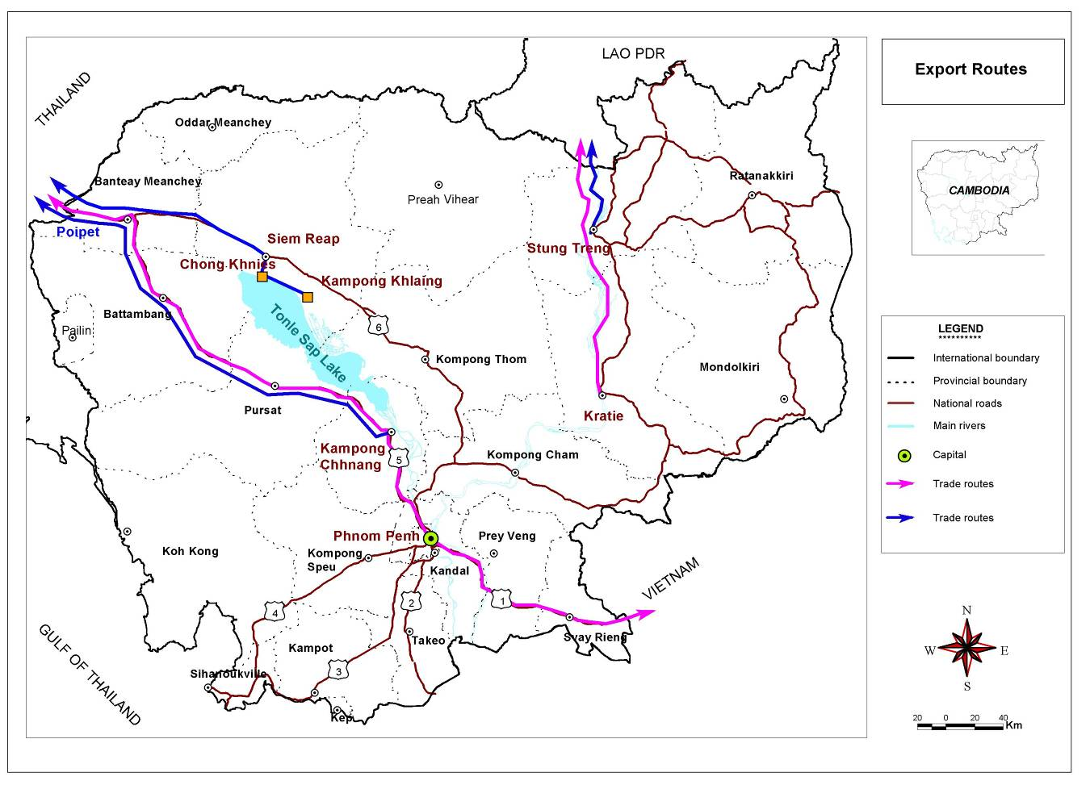
Figure 1 Map showing export routes by land road for inland fisheries products in Cambodia.

Fish consumption
In general, the rate of fish consumption at the household level in Cambodia is perhaps one of the highest in the country. Ahmed et al. (1998) reported a per capita annual consumption of 75 kg of fish in fresh and processed form for households that live near rivers, lakes and flooded areas within the major fishing provinces. Table 11 reported the key findings of the past studies on the rate of fish consumption pattern by region in Cambodia.

Table 11 : Rate of fish consumption pattern by region by different studies in Cambodia (per capita per annum)
Regions | Amount  (in kg) | Referred  study
National rate (average)  Svay Rieng province  South-eastern Cambodia  Southern Cambodia  South-western Cambodia  Tonle Sap region (floating village)  Tonle Sap (up-land area of Siem Reap)  Fishing households  Non-fishing households  Fishing dependent communes  (excluding fish sauce)  Fishing dependent communes  (including fish sauce) | 25–30  25  13.5  40  38  71  32  80  67  71  75.5 | MRC/DOF, 1998  Touch, 1993  Csavas, 1994  CIAP, unpublished  APHEDA, 1997  Hong, 1995  Hong, 1995  Ahmed et al., 1998  Ahmed et al., 1998  Ahmed et al.,1998  Ahmed et al., 1998
Source: Kim Sour et al. (2002)
Mogensen (2001) found that daily consumption of fish and Other Aquatic Animal (OAA) in Cambodian diet is about 79g per capita per day, or 492g per household per day (at the rate of 104 g per adult unit). With corresponding to a daily consumption of whole animals of fish and OAA, this comes to about 113g per capita per day (or 701g per household per day). The same study also illustrated that, of the consumption of edible parts of fish and OAA, big fish, small fish and OAA constitutes about 42, 47 and 11 percent, respectively.
Fish production and consumption by household and village type: fishing, fishing cum farming and farming village
On the basis of the results of the study on “Socio-economic and values of the resources in the great lake Tonle Sap and Mekong-Bassac Area, 2006’’, with a total sample of 405 households who live in different villages as in fishing, fishing cum farming and farming village type, in the three provinces of Siem Reap, Kampong Chhnang and Kandal, show that the average annual catch per household is higher in fishing villages compared with other village types. Of these three provinces, the highest average annual household catch was in Siem Reap province (15, 424kg), followed by Kampong Chhnang province (8,197kg). This implies that Siem Reap province may have better fishing areas compared to other provinces, it could also be due to the availability of greater areas of flooded forest. However, provinces in the Great Lake Tonle Sap river zone have higher fish catches than villages in the Mekong-Basac zone. In terms of fish utilization, overall 75 percent of the total fish catch was sold, and only 6 percent was used for the household consumption. The remainder was processed (8 percent) and (11 percent) used for fish feed (table 12).

Table 12: Average catch and utilization (kg) of fish per household by village type in each province, during the fishing year 2002–2003.
 | Average annual amount per household (kg)
Type of village | catch | consumption | sold | processed | fish feed
1. Kampong Chhnang
Fishing | 8,197 | 136 | 7,402 | 67 | 592
Fishing cum farming | 2,258 | 172 | 1,166 | 30 | 889
Farming | 557 | 150 | 347 | 16 | 44
Total | 3,638 | 153 | 2,940 | 38 | 508
2. Kandal
Fishing | 2,539 | 302 | 1,002 | 479 | 757
Fishing cum farming | 1,299 | 178 | 680 | 395 | 45
Farming | 290 | 79 | 188 | 10 | 12
Total | 1,444 | 193 | 646 | 306 | 299
3. Siem Reap
Fishing | 15 424 | 723 | 11 369 | 1 884 | 1 449
Fishing cum farming | 5 023 | 240 | 4 597 | 113 | 73
Farming | 255 | 128 | 121 | 4 | 1
Total | 6 901 | 364 | 5 362 | 667 | 508
Overall average | 3,990  (100%) | 236  (6%) | 2,982 (75%) | 333  (8%) | 439  (11%)

Tables 13 and 14 illustrate the relationship between average household catch, utilization and the value of gear owned for the fishing season 2002–2003. Households are divided into five groups, according to the value of gear owned: first, less than USD15; second USD15–100; third USD100–200; fourth USD200–300; and fifth over USD300. The results show a positive relationship between average catch and value of gear owned. Thus, households owning a high value of gear tend to have high annual catches (table 13), in both open and closed seasons (Table 14). Specifically for fishing lots, there was very high fish production compared with family-scale fishing and the majority of the catch sold. As Table 14 shows, 97 percent of the catch from fishing lots was sold, the rest was used for fish feed. A negligible quantity of the catch from fishing lots was consumed by fishing households or processed.

Table 13: Average catch and utilization (kg) of fish by gear value during fishing year 2002–2003.
Value of gear owned (USD) | Average quantity (kg)
Value of gear owned (USD) | catch | consumption | sold | processed | fish feed
Above 300 | 14,755 | 644 | 11,044 | 1,471 | 1,596
200–300 | 2,683 | 266 | 1,770 | 196 | 451
100–200 | 1,331 | 180 | 750 | 201 | 201
15–100 | 623 | 156 | 293 | 90 | 84
0–15 | 36 | 9 | 18 | 6 | 3
Fishing lot | 300,000 | 50 | 289,750 | 200 | 10,000
Average of all group | 3,990 | 236 | 2,982 | 333 | 439
Note: the average per household is based on all households owning gear in each category.
Table 14: Average catch and utilization (kg) of fish by value (USD) of gear owned for the open and closed fishing seasons in 2002–2003.
Value of gear  (USD) | Average annual quantity (kg)  Open season (2002) |  |  |  |  | Average annual quantity (kg)  Closed season (2003)
Value of gear  (USD) | catch | consum-ption | sold | proce-  ssed | fish  feed | catch | consum-ption | sold | proce-ssed | fish  feed
Above 300 | 13,214 | 543 | 9,708 | 1,470 | 1,493 | 1 541 | 101 | 1 336 | 0 | 103
200–300 | 2,091 | 199 | 1,376 | 188 | 328 | 592 | 67 | 394 | 8 | 123
100–200 | 1,045 | 117 | 570 | 190 | 168 | 287 | 63 | 180 | 11 | 33
15–100 | 395 | 71 | 179 | 90 | 55 | 227 | 85 | 113 | 0 | 29
0–15 | 15 | 5 | 5 | 5 | 0 | 22 | 5 | 13 | 1 | 3
Fishing lot | 300 000 | 50 | 289 750 | 200 | 10 000 | - | - | - | - | -
All | 3 501 | 174 | 2 621 | 327 | 379 | 489 | 62 | 361 | 6 | 60

As indicated in table 15, average household catches were higher in the open season (3,501 kg) than in the closed season (508kg) and a greater amount was consequently consumed, processed, used for fish feed and sold fresh. The average household catch was highest in fishing villages, followed by fishing cum farming and farming villages, for the open and closed seasons. In particular, the high catch amounts for fishing and fishing cum farming households in the open season reflect the lot fisheries, which are only operational during the open season. Utilization of catch also varied between different village types. Farming households consumed a greater portion of the catch at home (29–39 percent) compared with fishing households (11–25 percent), in both closed and open seasons. This probably reflects the fact that both fishing and farming households reserve a similar amount of the catch for household consumption and sell and/or process the rest.
Table 15: Average catch and utilization (kg) of fish per season and household by village type and fishing season
Catch/utilization for season | Open season (October-May 2002) |  |  |  |  | Closed season (June-September 2003)
Catch/utilization for season | Fishing | Fishing cum farming | Farming | All |  | Fishing | Fishing cum farming | Farming | All
Total catch | 7,612 | 2,441 | 244 | 3,501 |  | 885 | 433 | 128 | 488
Consumption | 304 | 141 | 70 | 174 |  | 78 | 56 | 50 | 61
Sold | 5,717 | 1,836 | 155 | 2,621 |  | 681 | 319 | 66 | 361
Processed | 787 | 163 | 9 | 327 |  | 6 | 11 | 1 | 6
Fish feed | 804 | 301 | 9 | 379 |  | 120 | 47 | 11 | 60

Similarly, weekly catch rates during the open season were high in fishing and the fishing cum farming village households (17 and 15 kg respectively), but fairly low in farming households (3 kg). With regard to sale of catch, the average price in farming villages was slightly higher than other village types (table 16).
Table 16: Average weekly fish catch, utilization and price of fish per household (closed season 2003)
Catch/utilization (kg) | Fishing  village | Fishing cum  farming village | Farming  village | All  villages
Catch | 16.88 | 15.10 | 3.03 | 12.60
Sold | 12.91 | 10.61 | 1.72 | 9.15
Consumption | 1.69 | 1.70 | 1.11 | 1.54
Processed | 0.07 | 0.26 | 0.01 | 0.12
Fish feed | 2.21 | 2.54 | 0.19 | 1.78
Average price (USD/kg) | 0.38 | 0.37 | 0.46 | 0.39
Source: Rab, Hap et al. (2006)
Note: Weekly amounts based on the week before interview in August 2003.

Aquaculture fisheries
Aquaculture contributes about 10 percent of the total inland fish catch in Cambodia. The aquaculture is considered to have the great potential for increasing fish production in Cambodia.
The natural fish is often used as the feed for the aquaculture as the cultured fish has higher market value. Therefore, cultured fish in the recent past may well be threatening the livelihoods and food security of poor, as the small fish capture fishes are diverted from the human food to feeding high-value cultural stock. Sociological aspects of the promotion of aquaculture therefore warrant a critical examination of the livelihoods and food access issues, as these small fishes are the traditional source of animal protein in the diet of poor Cambodian households and in general the people of Lower Mekong basin.

4.1 Cage/Pen culture
Fish culture in floating cages is believed to be an age old practice in Lower Mekong basin and it originated in and around the Great Lake Tonle Sap area of Cambodia. It might have evolved from the age old practice of holding surplus natural fish in the bamboo pens and cages, and was also used to transport live fish from the fishing grounds to the local market.
Cage culture is a unique system, in which fishes are cultured in cage during the dry season, when water levels are low and transferred to floating cages when the water level rises during the wet season. Cage culture is practiced mainly in floating villages in two provinces in the north western parts of the Great Lake. It is practiced in several places in the Mekong river system: in the Great Lake Tonle Sap, the Tonle Sap river, the Mekong river and Bassac river.
Cages are made either of split bamboo supported by a wooden frame or wood. Wooden cage cost more than the bamboo cage, but wooden frame lasts for a minimum of 4–5 years period compared with about 2 years for the bamboo frame. Most cages are constructed in the shape of a boat, elongated with a tapering bow and truncated stern. This is to permit the cage to be towed by a motorized boat to market. Moreover, cages used to culture snakehead species tend to be smaller than those used for other species, and they are rectangular or box shape.
Most cage culture involves the culture of indigenous species, the major groups of which by species are Carps and Catfish. In terms of production from aquaculture, the major species are Pangasius Catfish, in particular Pangasius Sutchi, and the Giant Snakehead Chana Micropeltes.

4.2 Pond culture and rice-fish culture
In Cambodia, the pond culture and rice-fish culture are practiced by large number of households for household consumption and income generation. There are two types of rice-fish culture, namely a rice fish with pond next to the rice field and a rice fish with a pond inside the field. The pond and rice-fish culture involves the construction of levee of the rice field, digging pond and canal, and lining the wall with lime.
The pond and rice-fish culture is in fact often overlooked by the rural development experts. Small aquatic animals such as fish, frogs, crabs, snakes as well as a number of plant species are the product from the rice fields, and there is a great potential for intensification of their production in Cambodia. Table 17 reported that the total production trend by product in all type of culture system across Cambodia, such as fish, shrimp, fingerling and crocodile. The results indicate a general increase, with the exception of few years, in the production of fish aquaculture, fingerling and crocodile. However, the production of shrimp fluctuated over the years. This implies that aquaculture in Cambodia has been developed.
Table 17: Aquaculture production trend including all type of products
Years | Fish  (metric ton) | Shrimp  (metric ton) | Fingerling  (thousand head) | Crocodile  (head)
1993 | 7,400 | 500 | 4,816 | 990
1995 | 8,779 | 731 | 14,691 | 5,096
2000 | 14,002 | 20 | 7,508 | 26,300
2001 | 13, 857 | 143 | 11,000 | 36,000
2002 | 14,547 | 53 | 13,420 | 50,850
2003 | 18,410 | 90 | 14,293 | 78,008
2004 | 20,760 | 75 | 15,793 | 74,820
2005 | 25,915 | 110 | 15,205 | 120,000
2006 | 34,160 | 40 | 6,810 | 137,642
2007 | 35,190 | 70 | 33,708 | 128,945
2008 | 39,925 | 75 | 37,193 | 156,500
2009 | 49,925 | 80 | 69,750 | 185,000

Fish processing
Recently, fisheries products from freshwater and marine capture fisheries had been produced by traditional and modern technology. The traditional processing can be classified into three forms, such as small, middle and large-scale form. Most of the products from traditional processing are supplied for domestic consumption, whereas the modern processing supplies both domestic and export market. According to FiA (2009), 44,500 tonnes of fish and fisheries products were processed in Cambodia and 18,140 tonnes (54 percent) was exported. The exported fisheries products were dry-salted fish; smoked fish; fish paste; fermented fish; fish with ice; fish, shrimp, crab, squid frozen, dried fish and etc.

5.1 Traditional processing
The fisheries commodity produced by this type of processing normally supply for Cambodian people including those within and outside the Cambodia..

5.1.1 Small-scale
Small scale processing is common practice for Cambodians, who are very fond of processed fishery products, such as fish paste, fish sauce, dried salted fish, smoked fish and etc. These traditional ways of processing fish are well adapted to irregularity of the seasonal fish catch. For example, to produce fish paste and fish sauce, salt is added immediately to the fish which makes it possible to stock the fishery products for the whole year. However, if the fish needs processing, then water and other ingredients are added and the fish is left to ferment, finally making fish sauce. Though the final product is of low value, it is a way of handling the amount of fish during peak period.
In general, small-scale fish processing is an activity of households that produce for family consumption. Those are people living near the river, fishing lots, lakes, and also people living in upland areas.

5.1.2 Middle-scale
Middle scale fish processing is usually owned by household, which operated by using family's labour, their relatives, and hired labourers during peak period. The location is near the fishing lots, fishing villages and landing places. Generally, they are involved in processing dry-salted fish, smoked fish, Pha-ork (fermented fish), marm etc. There is high demand for sun-dried fish processing for animal feed thus, its production increased in this few years and it is exported to Vietnam.

5.1.3 Large-scale
Large scale processing is generally operated by fisheries enterprise and fish source fagenty. They usually employ 40–60 labours, mostly ladies who are involved in the activities of transforming fishes into dry-salted fish products, ordinary fish pastes and boneless fish pastes (with high value), Pha-ork (fermented fish), and smoked fish (Tana, 1992). This processing form is normally occupied by private processors and fishermen themselves or their relatives. The large-scale processing firms are located in the fishing villages near by fishing lots, especially in the Great Lake Tonle Sap River, which are in Siem Reap, Battambang, Kampong Chhnang and Kampong Thom. These enterprises operate in open season, especially at peak period of fish (i.e. from January–February and May–June. Major of fish production are caught by large-scale and middle-scale fishing.

5.2 Modern or industrial fish processing
In general, the fisheries products produced by enterprise are exported to the international market. These enterprise and fagenty have been occupied by private companies and some by foreigner and it is operated under the supervision of the government, which are represented by fisheries company (KAMFIMEX). There are four freezing processing plants (enterprise) in Cambodia, and these plants hold export permits. One plant is located in Phnom Penh and the other three are based in the port city of Sihanouk Ville. Two of the facilities are owned by one Cambodian firm, Lian Heng Trading Company. There are some small freezing facilities that undertake contract processing mainly for traders, including KAMFIMEX, the state-owned trading company.

5.2.1 Lian Heng trading company, Phnom Penh
This company operates two processing plants: one in Phnom Penh has 100 percent Cambodian investment, whereas the latter has foreign investment from Hong Kong.

A. Processing plant (enterprise) in Phnom Penh
They produce freshwater products and export to the following international market:
- United States/Australia: frozen fish, shrimp and smoked fish
- Singapore : frozen freshwater fish
- Hong Kong: frozen shrimp
In 1999, the plant exported 300 tonnes of fishery products. They were not keen to reveal the value of these exports. The company is eager to expend its markets, but lacks the necessary knowledge and initiatives from the government sector to promote fisheries trade. The 10 percent export duty in one fishery product is one of the hurdles that the company is currently facing. The company is unable to export to the EU because Cambodia is not approved for fishery export to EU.

B. Processing plant (enterprise) in Sihanouk Ville
This enterprise has been leased out by the government to the company, the visit to the plant revealed domination of foreign investors (from Hong Kong and Taiwan) in processing and marketing of products. However, the existing processing facilities are extremely poor and unhygienic. There is no concept of a proper processing line. Products are processed under the supervision of Hong Kong counterparts who were tight-lipped.
In 1999, it exported 390 tonnes with a value of USD300, 000. All products were exported to Hong Kong and Taiwan, the products include frozen shrimp, frozen squid tubes and stuffed crab meat. According to the company representative, the producer prices are fixed by the importer in Hong Kong. The average price of the products was quoted at USD0.80/kg, which is extremely low for shrimp and squid.

C. SUN WAH Fisheries (in Sihanouk Ville)
The manager of SUN WAH reported that this enterprise was established in August 1996 with 100 percent foreign investment by the large Hong Kong-based conglomerate SUN WAH. It is a medium-scale operation with a daily capacity to process 10 tonnes of raw materials.
In 1999, it exported over 450 tonnes of processed products mainly to the mother company in Hong Kong. Some of the products were re-exported to other international market. SUN WAH is the head quarter in Hong Kong and is responsible for marketing its products. The main goods for exporting are shrimps, squids and some finfish. The company has had the privilege for 4 years of zero export duty, effective since mid-1996. SUN WAH is the highest quality seafood processing plant in Cambodia. This company has allowed from top government management to run the business successfully and has a long-term business interests in Cambodia, thus there is concern about the industry and its future prospects. However, Cambodia is not getting the full benefit out of total exports due to lack of control of the whole conditioning and marketing process.

Final consumption: fish commodity and fish products
The commodity of fishery is the cheapest source of animal protein in Cambodia as well as in the world. At present, the fishery resources have been under pressure due to the growing population and increasing demand in domestic and international market. This has been reflected on the consumption pattern of fish food in both developed and developing countries. For an economic reason, fishes have been classified into three groups, depending on the species, quality (freshness) and weighing/size in freshwater fish.
First and second grade refers to a group of species comprising in large size fishes, such as giant snakehead (chdour/deap), striped snakehead (ros), common sheetfish (kes), pangasius sp. (pra), greater bony lipped barb (krum), yellow mystus (chhlang), osteochilus hasselti (kros), etc. Normally, the fish size ranged from 1 kg and above for the first grade and less than 1 kg for second grade with exception of some preferable species. Third grade refers to a group of species comprising small fishes, such as jullien mud carp (riel), white lady carp (lingh), indian river barb (sroka kdam) and other species etc. The fish species in this group have been used for fish processing, particularly into fish paste, fish sauce, low-quality fermented fish and smoked fish (Jica Interim Report, 1997). Moreover, they are also used for making animal feed, such as sun-dried fish, especially during peak period (January–March).
According to the official statistics of FiA, fisheries resources, including inland and marine, are identified as fish commodity and fish products as follows:

- Inland fisheries commodity and fish products
Fisheries Administration (FiA) have been classified inland and marine fisheries commodities and fish products as reported in Table 18 and 19. The fish commodities and products in both freshwater and marine fisheries have been contributed incredibly in marketing activities. These products supply both domestic and international markets.
Table 18: Inland fisheries commodity and fish products (FiA classification)
Commodities | Fish products
First grade fish  Second grade fish  Third grade fish  Freshwater eel  Kampeus [giant freshwater prawn (Macrobrachium)]  Fingerling  Baby crocodile (this is included into fisheries commodity) | Fish paste  Fermented fish/steamed fish  Salted dry fish  Smoked fish  Fish sauce  Dried fish use as animal feed
- Marine fisheries commodity and fish products
Table 19: Marine fisheries commodity and fish products (FiA classification)
Commodities | Products
- Shrimp  - Lobster  - Crab  - Squid, octopus, cuttle fish  - Mollusc, shell  - First grade fish  - Second grade fish  - Third grade fish | - Salted dry fish  - Steamed fish  - Dry shrimp, squid and slingay  - Processing shrimp  - Crab meat  - Salted carp  - Trey bourb  - Dry black sea cucumber  - Ki and fish meal  - Fish source

Transportation
In general, fish and fisheries products transportation were undertaken through different means from one area to other, this include transportation through water, land and air. Transportation via water includes fish cages with large boats, tank boats and sculls; via land includes trucks, cars, motorbike, horse cars, oxcarts and bicycles; via air using airplanes.

Regulations and management of fresh water fisheries
There are many laws and regulations in the fisheries sector to improve fisheries management, conservation, development and sustainable fisheries resources utilization. Those regulations include law on fisheries, statement of the royal government of Cambodia on national fisheries sector policy, royal decree on community fisheries establishment, sub decree on releasing and abolishing fishing lots, sub decree on community fisheries management, proclamation on community fisheries guideline, proclamation on community fisheries registration, national fisheries management plan, community fisheries management guidance, five years strategic plan (2007–2011; community Fisheries Development office), and fisheries development action plan.
The FiA is a government authority, which is responsible for the management of fisheries resources that are based on the fisheries policies and fisheries law (KoC, 2007). FiA’s responsibilities involves licensing, enforcement of regulations, research and community fisheries management. It employs about 1,350 staff at national, provincial and district levels (Hortle, 2004).
In order to manage inland fisheries resources, fishing is organized at three levels: first, family (subsistence) fishing, second middle-scale (artisanal) fishing and third large-scale (industrial) fishing. The fishing calendar is divided into two seasons: open (October–May) and closed (June–September). The state recognizes the fishing rights of family scale for subsistence at all times of the year round, imposing restrictions mainly on the fishing efforts; for example, type of gear and mesh size. It has open access to fishing ground outside dimension of fishing lot and does not require a license. Middle-scale and large-scale fishing are allowed only in the open season. Middle-scale fishing requires licenses issued by the FiA. Medium-scale fishers can operate only in the open access areas of the fishing domains. Finally, large-scale or commercial-scale fisheries or fishing lots are based on “lots”. The rights to operate each fishing lot are given through a fishing lot auction system, and are resumed every two years through this auction system (see table 3).

The different agents in the Cambodian value chain

9.1 Fish marketing system in Cambodia
The fish marketing and distribution networks are relatively well developed in inland fisheries. There are small- and medium-scale fish traders in the fisheries sector. Normally, the smaller traders collect fish from fishermen and sell it to wholesalers who distribute it to different places. There is high domestic demand of fish and fish products, ranging from live to processed forms such as fish paste, fermented fish, dry-salted fish, steamed fish, smoked fish and fish sauce etc. High-value species are usually sold to the traders for marketing in Phnom Penh or exporting.
The main players of the fisheries marketing system comprise fishermen, collectors, wholesalers/middlemen and retailers. The fishermen play a role as workers, and is either part or full time involved in small-, medium- or large-scale fishing. The wholesalers/distributors are the main traders and providers of the capital to most of the fishermen in both medium- and large-scale fishing. The retailers are selling fishes directly to the consumers. The fishermen, fishing lot owners, dai fishing owner, local collectors and local fish processors operated without any organized information system regarding prices, market demand or annual catch volumes.
In inland areas, fishes are distributed in various ways. In many locations around the Great Lake Tonle Sap, Mekong River and along river systems, fish is sold to customers at the “farm gate”. This practice is more common among small/family scale or traditional producers who process for subsistence purposes and localized sales. In other cases, fish are transported by oxcarts, motorbikes and small trucks to urban markets. In addition, cages are towed to Phnom Penh from the Great Lake Tonle Sap and Mekong areas so that fish can be marketed alive. The market for marine products is relatively small, and marketing channels for marine products are not particularly well developed.

9.2 Stakeholders in the fisheries commodity and product chain
The most complicated component of the fish marketing system in Cambodia is the supply chain and distribution channels, in which numerous transactions take place before fish and fish products reach the consumer or export markets. There are many middlemen (or often “middle-women” for that matter) who, in all their guises, are essential for the fisheries trade. The trading system would not function without these entrepreneurial individuals and their enterprises.
Although there are different elements of the producer component – inland, marine, aquaculture and processing – they have similar supply chains. Fish harvested by all scales of fishers and fish farmers are immediately landed (i.e. at the landing site or harbour), and transferred to fish collectors and/or fish processors. Sometimes, harvested inland fishes are kept alive in pens or cages for sale during periods, when supply is scarce and prices are more satisfagenty. Before reaching the consumer, fish and fish products would have passed through a number of transactions – fisher, fish collector, landing site owner, fish processor, collector, distributor, retailer or caterer etc.
In order to understand all stakeholders in the fish supply chain in Cambodia, the following descriptions are provided:

9.2.1 Lot owners/Dai owner/commercial fishers
Lot owners have control over the fish product for sale to clients. Wholesalers, collectors and exporters buy fish from them at “farm gate”. Lot owners never export fish to Thailand directly by themselves, but in some cases lot owners take fish stocks for sale to Phnom Penh.
Lot owners market their fish in different ways, some work directly with fish processors and exporters, whereas others sell to local collectors or deliver to landing sites. Larger businesses transport fishes directly to Phnom Penh’s central or regional markets. Some lot owners are reportedly financed by the larger exporters, traders or government officials, and are subsequently required to sell their catches to these financiers or money provider.

9.2.2 Fishermen
Fishermen are classified as small, medium and large scale, depending on size of catch potential and type of gear/equipment used. There are three categories of fishermen for inland fisheries and another classification for marine fisheries.
Small-scale fishers are family-scale fishermen (one to three persons), who catch fish primarily for family subsistence and daily household income. The number of small-scale fishers is increasing annually as the population grows and as alternative livelihoods become scarce. Medium-scale fishers are extended families and village level partnerships (three to six persons), who catch fish for income and processing using non-industrial fishing methods. These kinds of fishermen sell fish to fish collectors and sometimes they take fish directly to consumer or retail markets locally.

9.2.3 Collectors
Fish collectors buy fish, directly or through their network, from fishers or lot/dai owners in fishing villages. They have one or several boats containing several iceboxes for fish storage during the fish collection period. Collectors are specialized operators who buy fish, from fishermen, and bring them to the landing sites throughout the year. They set prices with fishers depending on fish quality, supply situation and daily fish market demand. Mostly, fish collectors have capital for immediate cash payment to fishermen; however, they often provide credit to small fishers in the form of cash and in kind (e.g. fishing gear). During the course of the survey, it was found that some collectors also get loans from wholesalers, middlemen and exporters. Fish collectors sell their fish collected to middlemen, wholesalers, retailers or exporters at fish-landing site.

9.2.4 Wholesalers
Wholesalers tend to represent an important part of the marketing chain, in which often major quantities of fish are channelled through them. In the case of Cambodia, they are best compared with fish distributors who have a permanent fish stall at a fish-landing site, a floating village or at a distribution centre. They may buy fish from fishers, lot owners, collectors or middlemen and re-sell it to exporters, retailers or restaurant owners. This is very much location-specific, and the scale of his/her business may depend on whether a wholesaler is based in a provincial town or in the Phnom Penh area.

9.2.5 Semi-wholesalers
Defined as semi-wholesalers are those fish traders who have a permanent stall inside/outside a market, whereby fish is brought by middlemen or wholesalers and sold to them at the market. Semi-wholesalers act sometime as retailers, but they usually have an additional function in distributing fish to small retailers who sell fish at local markets directly to consumers and processors. Most semi-wholesalers are fish traders at provincial level, but some of them also operate in Phnom Penh, or may transport fish from the capital to sell to retailers in fish-deficit provinces.

9.2.6 Retailers
Fish retailers are those who sell fish in markets directly to consumers or restaurant owners – in many cases they have a permanent stall inside or outside the market. Generally, in each market (from provincial to local level) there are many fish retailers selling fish every day. Fish retailers who sell fish in the market are mostly women, but they often have their spouses or relatives/partners who help them to go and buy fish from the landing site or the distribution centre. Some fish retailers who work alone (i.e. those who do not have a spouse or partner to help them) buy fish from semi-wholesalers in the same market or place where they sell fish directly to consumers.
In addition, there are also retailers who are itinerant traders in which they do not have a permanent stall but sell from a basket or another container by moving from place to place. Often they are also called fish vendors or hawkers.

9.2.7 Fish processors
Fish processors are generally either fishers or fish raisers (but not all of them) or business men. The processors, who mainly buy fish from fish lot owners or traders/middlemen/fish collectors to make processing form such as fish paste, salted dry fish, fermented fish, smoked fish etc. Processing products are usually sold to domestic market and some products are also sold to the international market with specific products and species.

9.2.8 Exporters
Exporters play an important role in the supply chain by exporting fisheries products to neighbours and other countries. They generally purchase fish directly from fishing lot owners or traders/middlemen, store it with ice in the containers, and export either by land or air as live fish.

9.2.9 Transporters
Fish transporters are involved in the fish trading channel by providing only fish transportation service to fish trader, and not by buying or selling fish by themselves. Fish transporters are the important agents in the fish trade channel. The fish transportation means differ from one area to another. From fishing sites, fishes are usually transported by boat, motorbike, mini truck, or pickup car from fish-landing sites to local markets or fish distribution centres.
Transporters own the trucks and boats that transport fish from the fish-landing sites, next to the lake or marine shorelines, to processing facilities and markets in Cambodia and export points in Thailand and Vietnam. Most fish exported to Phnom Penh and other provinces are transported in pickup trucks piled high with fish and ice; sometimes, fish are fresh and still alive. On the other hand, fish may be spoiled before they reach their destination due to poor cold storage facilities, poor road infrastructure and inefficiencies associated with unofficial road taxes and license fees. Transporters pay a registration fee to the DOF and also pay a series of unofficial road taxes from the landing site to the final destination. Figure 3 present the fish value chain with all stakeholders involved in Cambodia.
Figure 2: Inland fish value chain with all stakeholders involved, Cambodia.
- Workers,
- Fishing equipment producers,
- Sellers of fishing equipments,
- Boat makers,
- Loan/credit owners,
- Ice suppliers,
- Transporters,
- Cleaners,
- Boat drivers,
- Fish processors,
- Salt suppliers,
- Fishery Officers,
- Policemen,
- Local authorities,
- Telephone sellers,
- Basket producers,
- Basket sellers,
- Motor-taxi drivers,
- Electricity suppliers,
- Water suppliers,
- Landing place owners,
- Market managers.
Fishermen/ lot/dai owners/ cage/pond owners
Collectors/middlemen
Semi-wholesalers
Retailers
Consumers
Wholesalers
Fish processors/
Fagenty
Exporters

Data availability
Currently, the data for the value chain of five specific selected fish species for the study are not available. However, time series data of quantity and price at the farm gate of selected species will be available from Dai fisheries, which are collected by MRC during 2005–2010. Thus, the wholesaler and retailer price of selected species will be used. These data was collected via field survey i.e. individual interview, focus group discussion and key informant interview.

References
Ahmed, M., Hap, N., Ly V., & M. Tiongco 1998. Socioeconomic assessment of freshwater capture fisheries of Cambodia. Report on household survey. Mekong River Commission Phnom Penh Cambodia. p.185
FiA, 2009. Fisheries statistics and data 1993–2009. Statistic Bureua, Fisheries Administration, Phnom Penh.
Hap, N. & Battarai, M. 2009. Economics and livelihoods of small-scale inland fisheries in the Lower Mekong Basin: A Survey of Three Communities in Cambodia. IWA Publishing, 2009.
Hap, N., Kandarith K., & Battarai, M. 2006. Assessment of production cost of inland fisheries in Cambodia.
Hap, N. 1999. Production Technology and Technical Efficiency of Freshwater Capture Fisheries in Phnom Penh, Kampong Cham, and Battambang Province, Cambodia. The University of the Philippines at Los Banos, Laguna. 97p (MSc. thesis).
Hap, N. & Ngor, P. B. 2001. An economics analysis of fish production of the Dai Fisheries in Phnom Penh and Kandal Province, Cambodia. Mekong River Commission, Phnom Penh, Cambodia.
Rab, M. A., Hap, N., Seng, L., Ahmed, M., Viner. K. 2006. Marketing infrastructure, distribution channels and trade pattern of inland fisheries resources in Cambodia: an exploratory study.
Rab, M. A., Hap, N., Ahmed, M., Keang, S. and Viner. K. 2006. Socioeconomics and values of resources in Great Lake-Tonle Sap and Mekong-Bassac area: Results from a sample survey in Kampong Chhnang, Siem Reap and Kandal provinces.
Ngor, P.B. 2000. Dai Fishery in the Tonle Sap River of Phnom Penh and Kandal province (including a review of the census data of 1996-97). Management Aspects of Cambodia’s Freshwater Capture Fisheries. Eleven presentations given at the Annual Meeting of the Department of Fisheries, Ministry of Agriculture, Forestry and Forestry.
Rainboth, W. J. 1996. Fishes of the Cambodian Mekong
Van Zaling, N.P. F 1997. Fisheries Research needs in the Lower Mekong Basin from a perspective. Contribution to national Fisheries workshop, Vientiane, Lao PDR, 19-21 March 1997.
Van Zalinge, N., Nao, T., Touch, S. T. & Deap, L. 2000. (AQ: As per style it should be three author et al, please check all other instances also) Where There is Water, There is Fish? Cambodian Fisheries Issues in a Mekong River Basin Perspective. in Common Property in the Mekong: Issues of Sustainability and Subsistence. ICLARM
Vo Thi. T. L, Simon B., Le X. S., Hap N., & Nguyen T. K., 2009. Value Chains for Sustainable Mekong Fisheries: The case of Pangasiou bypoptbalmus and Henicorbyncbus/Labiobarbus spp in Vietnam and Cambodia.
Zaling, V. N., Sopha, L., Ngor, P.B, Kong, H. & Jorgensen, V. 2002. Status of the Mekong Pangasianodon hypophthalmus resources, with special reference to the stock shared between Cambodia and Vietnam. MRC Technical Paper No.1, Mekong River Commission, Phnom Penh.29 pp. ISSN:1683-1489

Fishing Lots and Dai fisheries are concessions auctioned by the Cambodian government to the highest bidder for exclusive exploitation over a two-year period. It is one of the government's main instruments for extracting a resource rent from fisheries (Zalinge et al., 2000).
The estimate combined data from a number of studies (MRC/DOF/Danida, Gregory 1997, Ahmed et al., 1998) of fish consumption and production that covered commercial and small-scale indigenous fisheries, including rice-field fisheries.
Other Aquatic Animal (OAA) includes such as crab, shrimp, frog, beetle, snail and snake, and other small aquatic products found in the rice field and in the floodplains.

