The Canadian Fish Supply Chain:
Price Links from Ex-vessel to Export Market

Daniel V. Gordon
Department of Economics, University of Calgary
2500 University Drive N.W. Calgary, Alberta, Canada
dgordon@ucalgary.ca

Abstract

The purpose of this report is to empirically investigate the price links in the fish supply chain in Canada for seven fish and shellfish species. A combination of ARIMA and structural modelling is used in empirical work. For the species examined, summary statistics show that real revenue and ex-vessel prices have declined in the last ten years with the only exception being lobster. ARIMA models are developed for all ex-vessel prices and provide reasonable short-term price forecasts. Structural modelling for sole and lobster allow calculations of price and quantity elasticities and should be useful in policy analysis.

JEL Classification: Q22, C53

Keywords: Fish Price Supply Chain, ARIMA, Structural Models

Table of contents

1. Introduction 3
2. Fish Species and Data 5
2.1 Pelagic 5
2.2 Groundfish 6
2.3 Lobster 7
2.4 Data 8
3. Revenue 11
4. Statistical Results 15
4.1 Seasonality 15
4.2 Time Series Characteristics 21
4.2.1 Processing Prices 21
4.2.2 Export Prices 24
4.2.3 Ex-vessel Prices 26
4.3 Univariate Modelling 27
4.4 Equilibrium Modelling with Structural Components 33
5. Conclusion 40
References 43
Appendix 45

Introduction
The Canadian fisheries sector accounted for just under 0.015% of GDP in 2006. Nonetheless, commercial landed value in 2006 reached about $1.9 billion and provided employment (albeit part time) for some 52,000 individuals as commercial fish harvesters and crew. Canada is ranked about 20th in terms of volume of harvest in world fisheries production. International trade is the important final market for Canadian fisheries taking up 80-85% of total landings and representing a value of $3.9 billion in 2008.
For the vast majority of fish harvested in Canada, the fish supply chain is defined by three markets; the first hand market for fish setting the ex-vessel price, the industrial market setting the processed price and the export market setting the end-market price for fish. The export price of fish is set by world supply and demand conditions and is exogenous with respect to price determination in a Canadian setting. On the other hand, the ex-vessel price and processed price are endogenous to the fish supply chain or in other words determined within the Canadian market setting.
The price of fish is an important factor in the income determination, employment and overall welfare of fishermen. Of course, the level of harvest and cost of harvesting are other important variables and all in combination determine income levels of fishermen. But in many ways fishermen have control at least to some extent over harvest and cost of harvesting. On the other hand, the price of fish is set by external factors exogenous to fishermen. These external factors are certainly dictated by demand and supply forces but may also be influenced by monopoly and strategic pricing behaviour in downstream markets (Wohlgenant 1985, Bjørndal and Gordon 2010). Strategic pricing can impact the magnitude of price pass through between the market segments and the length of time to adjust to price shocks. Consequently, it is important to enquire as to the price relationship and links among the first-hand, processing and export markets for fish in Canada.
In this report we examine such price links for six species of fish (dogfish, halibut, herring, sablefish, sole, salmon) and one species of shellfish (lobster). These species are chosen for a variety of reasons; dogfish is harvested each month of the year and offers a complete monthly statistical characterization, halibut is a high valued fishery harvested in only a few months of the year but it is managed under an ITQ system that allows a sustainable and profitable harvest, Pacific herring has a long history on the west coast of Canada and is an example of a pelagic species that at one time offered incredible abundance and revenue and now is in a state of decline, west coast sablefish and sole are examples of groundfish, wild pacific salmon is tied heavily to both commercial and First Nations fisheries and represents some 12% of total revenue from fisheries on the west coast and, finally, lobster is a high valued east coast Canadian fishery managed in a sustainable and profitable manner.
The purpose of this paper is two-fold. First, we want to investigate the economic wellbeing of each of the fisheries defined above. Given the data available we are able to measure real monthly revenue for each of the fisheries. Of course, it would be preferable to measure vessel profit but the data for such a calculation are not available. Nonetheless, data will show that real monthly revenue over the period 1996-2009 has declined in all but one of the fisheries (lobster) examined. Consequently, profit per vessel must decline unless the number of active vessels in the fishery is declining and/or production costs are decreasing. Second, we will carry out both univariate and multivariate statistical price analysis for the species defined.
The report is organized as follows: Section 2 will briefly characterize the fisheries examined and summarise the data used in empirical work. This is followed by an examination and discussion of monthly revenue for each fishery over the period January 1996 to December 2009. Section 4 will report the statistical models used in empirical work and report results. The final section concludes.

Fish Species and Data
On the west coast of Canada the federal Department of Fisheries and Oceans and the Province of British Columbia Ministry of Fisheries share responsibility for fisheries management. As such data collected for different west coast species will follow the same data collection practises and procedures and are thus consistent across the Pacific species examined here. For consistency in lobster data all prices and quantities are collected from the Province of Prince Edward Island.

Pelagic

Herring: The Canadian Pacific Herring fishery is really a story of boom and bust. In the 1960s it was the most important west coast fishery with harvests of over 200,000 tons (Beamish et al. 2004). But by 1967 with overfishing, weak stock recruitment and poor management the fishery collapsed and was closed until 1973 (DFO 2008). The fishery today is relatively small compared to the glory years and the majority of herring are fished for roe and exported to Japan.
Based on a precautionary management plan, a TAC is set and the fishery managed under limited entry. Regulations allow license holders to lease out their herring allocations offering a form of transferability of property rights. Seine and gill nets are the main gear types used in the fishery. DFO reports that the number of licenses for the herring fishery has been roughly constant the last few years. At current harvest levels herring processing accounts for about 11% of total employment in the west coast fish processing sector.

Salmon: Wild salmon harvest is still an important fishery on Canada’s west coast contributing on average about 12% of total landed value of wild fish harvest per year. Wild salmon harvest consists of five distinct species; Sockeye, Chinook, Coho, Pink and Chum. The commercial fishery employs three gear types in harvesting salmon; seine, gillnet and troll.
Historically there have been dramatic failures in managing the fishery and current policy is heavily directed towards a precautionary management approach and sustainable stock. Generally the fishery is managed using TAC and limited access. Nonetheless, many parts of the fishery are still competitive fisheries with some aspects of the fishery directed by IQs.
Processing salmon makes up about 25% of the value of total wild processing on the west coast and accounting for about 28% of total processing employment. Processed salmon is exported to some 63 countries with the most important markets in the US, UK and Japan.

Groundfish

Groundfish species examined in this report include Dogfish, Halibut, Sablefish and Sole. Groundfish gear includes trawl and troll with about 300 active vessels in the fishery. Management of the fishery involves TAC with ITQs that allow fishermen to purchase quota to cover non-directed species. An interesting feature of this fishery is that regulations demand 100% at-sea monitoring and 100% dockside monitoring. The precautionary approach to management is clearly evident with a strong emphasize on a sustainable fishery.
Processing groundfish makes up about 27% of total processing employment on the west coast. The export value of processed groundfish has declined considerable in the last 10 years with the major exports markets to the US and UK.

Lobster

Accounting for greater than 50% of world supply, the east coast of Canada is the world’s major supplier of lobster. The techniques for harvesting lobster have changed little over time and rely on traps to catch the lobster live. This is primarily an inshore fishery and managed using effort controls and area closures. Effort controls include a limit on carapace size, limited entry, a restriction on the number of traps allowed in different areas and restrictions on harvesting female lobsters. Area closures are used to protect summer moults.
Lobster fishing licences are issued by DFO. New licences are generally restricted and the only way to enter the business is to purchase an existing licence. Not surprisingly lobster licences carry significant value. Price of the licence depends on the fishing area allocated to the licence and the allowable trap allowance. In the mid 2000s there were roughly 9,900 issued licences.
It is worthwhile mentioning that some of the fish species examined are processed and transformed into many different forms for the export market. For example, processed dogfish exports include back and belly flaps, fins and tails, whereas there is almost no processing of fresh live lobster for the export market but frozen lobster for export is sold as tails and lobster meat. For statistical work the more the fish is processed prior to export the weaker the price link between ex-vessel and export markets.

Data

For the species defined above we are able to collect weekly ex-vessel harvest and total value. Harvest is measured in kg and value is measured in Canadian $. For west coast species the data are available from the DFO web site
http://www.pac.dfo-mpo.gc.ca/stats/comm/summ-somm/index-eng.htm
and for lobster the data are collected from the province of Prince Edward Island and found on web site
http://www.gov.pe.ca/fard/index.php3?number=1024862&lang=E.
Export data are avaiable monthly and covers all species defined above. Value and sales data are recovered using the Toronto’s Trade Analyser at web site
http://ezproxy.lib.ucalgary.ca/login?url=http://dc1.chass.utoronto.ca/trade/
To be clear export data includes all forms of export from fresh, live, frozen, roe and other forms of processed fish. Below we break down the export data for salmon and lobster into fresh and frozen to provide a more complete picture. Frozen lobster prices are registered higher than fresh because frozen includes high value specialty forms particularly frozen tail plus frozen lobster meat.
Weighted average monthly real ex-vessel and export prices per year for dogfish, halibut, sablefish and sole for the period 1996 to 2009 are reported in Table 1a. By reporting weighted average monthly prices we smooth the data to provide a better summary of trends overtime. Table 1b reports the same summary statistics for herring, salmon and lobster.
For Table 1a, we see a clear declining trend in real ex-vessel prices for all four fish species. In 2009 dogfish ex-vessel prices were 91% of the 1996 value; for halibut 73%, for sablefish 67% and sole 46%. Interesting dogfish export prices show a substantial increase in real terms of almost four fold. Export prices for halibut were steady over the period but both sablefish and sole show a declining export price tread over the period. Keep in mind that over the 14 year period the price at the ex-vessel level refers to a standard commodity, fresh fish, whereas the export price refers to a processed product that undoubtedly has changed over the period of study.
Table 1a: Real Monthly Averages Ex-vessel and Export prices ($/kg)
Date | Dogfish |  | Halibut |  |  |  | Sablefish |  |  |  | Sole
 | Ex-vessel | Export | Ex-vessel |  | Export |  | Ex-vessel |  | Export |  | Ex-vessel |  | Export
1996 | 0.70 | 1.30 | 6.73 |  | 10.31 |  | 8.23 |  | 13.03 |  | 2.27 |  | 9.75
1997 | 0.67 | 1.43 | 6.19 |  | 9.67 |  | 9.18 |  | 13.49 |  | 1.21 |  | 9.84
1998 | 0.60 | 1.43 | 4.47 |  | 8.29 |  | 6.77 |  | 10.37 |  | 0.98 |  | 7.73
1999 | 0.67 | 3.05 | 5.73 |  | 10.9 |  | 7.77 |  | 11.50 |  | 1.24 |  | 9.17
2000 | 0.83 | 3.37 | 6.61 |  | 12.52 |  | 9.16 |  | 13.42 |  | 1.19 |  | 9.28
2001 | 0.63 | 4.11 | 6.25 |  | 10.94 |  | 8.35 |  | 12.92 |  | 1.09 |  | 8.85
2002 | 0.59 | 3.55 | 6.36 |  | 7.08 |  | 7.93 |  | 13.43 |  | 1.31 |  | 8.63
2003 | 0.30 | 3.76 | 7.36 |  | 11.33 |  | 8.44 |  | 12.67 |  | 1.08 |  | 7.87
2004 | 0.40 | 4.63 | 8.40 |  | 11.65 |  | 7.10 |  | 9.37 |  | 1.01 |  | 7.56
2005 | 0.50 | 4.71 | 6.88 |  | 10.24 |  | 6.08 |  | 9.01 |  | 0.93 |  | 7.16
2006 | 0.56 | 4.48 | 6.92 |  | 10.95 |  | 6.59 |  | 8.81 |  | 1.07 |  | 6.98
2007 | 0.66 | 3.89 | 5.30 |  | 11.79 |  | 5.93 |  | 8.06 |  | 1.11 |  | 6.80
2008 | 0.65 | 3.79 | 5.12 |  | 11.73 |  | 5.72 |  | 9.36 |  | 1.05 |  | 7.24
2009 | 0.64 | 4.90 | 4.88 |  | 10.06 |  | 5.49 |  | 10.48 |  | 1.05 |  | 6.93
Source: http://www.pac.dfo-mpo.gc.ca/stats/comm/summ-somm/index-eng.htm
http://ezproxy.lib.ucalgary.ca/login?url=http://dc1.chass.utoronto.ca/trade/
For Table 1b the story is much the same with declining trends in real ex-vessel and export prices for herring and lobster. However, export fresh and frozen wild salmon prices are steady with a decline in prices in recent years.

Table 1b: Real Monthly Averages Ex-vessel and Export prices ($/kg.)
 | Herring |  | Salmon |  |  |  |  | Lobster
Date | Ex-Vessel | Export | Ex-Vessel | Export Fresh |  | Export Frozen |  | Ex-Vessel |  | Export Fresh |  | Export Frozen
1996 | 1.83 | 3.44 | 3.25 | 6.08 |  | 5.85 |  | 10.87 |  | 17.15 |  | 24.82
1997 | 1.65 | 4.06 | 2.52 | 5.65 |  | 5.25 |  | 11.31 |  | 16.23 |  | 24.27
1998 | 1.66 | 4.22 | 1.98 | 7.84 |  | 7.36 |  | 12.26 |  | 16.98 |  | 26.09
1999 | 2.22 | 2.75 | 1.71 | 5.78 |  | 5.82 |  | 13.61 |  | 17.57 |  | 26.98
2000 | 1.18 | 1.40 | 2.88 | 9.31 |  | 6.49 |  | 12.86 |  | 17.7 |  | 29.78
2001 | 1.02 | 1.59 | 1.54 | 7.59 |  | 6.36 |  | 12.62 |  | 17.42 |  | 28.59
2002 | 1.04 | 1.76 | 1.72 | 6.27 |  | 5.22 |  | 13.4 |  | 17.33 |  | 29.91
2003 | 1.14 | 1.72 | 1.24 | 5.76 |  | 5.08 |  | 13.05 |  | 17.95 |  | 27.37
2004 | 1.39 | 2.08 | 1.98 | 5.55 |  | 4.86 |  | 12.31 |  | 16.56 |  | 28.70
2005 | 1.03 | 1.91 | 1.17 | 5.53 |  | 4.24 |  | 13.00 |  | 16.58 |  | 30.36
2006 | 1.76 | 5.20 | 2.33 | 5.36 |  | 4.83 |  | 10.99 |  | 14.72 |  | 27.27
2007 | 1.53 | 4.28 | 1.40 | 7.48 |  | 5.48 |  | 11.51 |  | 15.05 |  | 25.24
2008 | 1.26 | 3.14 | 3.47 | 5.46 |  | 5.48 |  | 9.13 |  | 12.63 |  | 25.76
2009 | 1.24 | 2.71 | 1.06 | 5.21 |  | 4.62 |  | 7.42 |  | 11.74 |  | 20.09
Source: http://www.pac.dfo-mpo.gc.ca/stats/comm/summ-somm/index-eng.htm
http://www.gov.pe.ca/fard/index.php3?number=1024862&lang=E
http://ezproxy.lib.ucalgary.ca/login?url=http://dc1.chass.utoronto.ca/trade/

Given the large differences in export price of live versus frozen lobster, it is worthwhile pointing out the differences in the value chain. Export of live lobster requires little processing whereas frozen lobster refers primarily to tails and requires considerable processing. Table 1c reports prices at different levels of the value chain for the two product forms. Notice that harvesters receive a higher price for lobster going into the live market relative to frozen but processing costs are high and result in frozen lobster retail price twice as high as live lobster.
Table 1c: Value Chain for Live and Frozen Lobster
Live Lobster
Harvester | Buyer | Shipper | Distributor | Retail
$6.50/lb^{a)} | $7.00-7.25/lb. | $8.50-9.00/lb. | $9.00-9.50 | $10.00-12.00/lb.
Frozen Lobster
Harvester | Buyer | Processor | Distributor | Retail
$5.00/lb. | $5.50-5.75/lb. | $15.75-17.00/lb. | $16.25-17.50/lb. | $20.00-24.00/lb.
^{a)} Prices reflect relative differences at different levels of the value chain.
Source: http://www.ccfi.ca/pdf/Lobster/3.Global%20Demand.pdf

For completeness we report in Table 1d average monthly harvest (kg) for the period 1996 to 2009 for the 7 species examined here. (Figures of these numbers are presented in the Appendix.) There are a couple of interesting points in the table. All species show considerable variation in average monthly harvest over the period. This is particularly noticeable for dogfish with average monthly low of 170 tonnes in 1997 to a high of 480 tonnes in 2003, and salmon with a low of only 450 tonnes in 2008 and a high of 4,000 tonnes in 1997. Halibut, herring and sablefish show declining harvest trends over the period, whereas sole and lobster show robust increases in harvest. Of course, it is the combination of both prices and harvest that dictate real income and welfare of fishermen. The next section will report revenue trends to fishermen over the period of study.
Table 1d: Average Monthly Harvest (kg.)
Year | Dogfish | Halibut | Herring | Sablefish | Sole | Salmon | Lobster
1996 | 334,525 | 474,689 | 1,946,214 | 302,170 | 94,315 | 2,930,938 | 2,499,083
1997 | 172,413 | 607,861 | 2,699,459 | 351,200 | 364,185 | 4,058,411 | 2,853,667
1998 | 212,281 | 648,152 | 2,269,483 | 384,300 | 420,590 | 2,536,255 | 2,899,333
1999 | 280,457 | 638,343 | 1,015,802 | 407,321 | 470,501 | 1,428,501 | 3,222,250
2000 | 387,923 | 538,660 | 2,568,609 | 328,171 | 490,060 | 1,624,680 | 3,238,167
2001 | 377,693 | 525,865 | 2,138,934 | 311,741 | 454,765 | 2,060,715 | 3,788,167
2002 | 391,787 | 552,126 | 2,305,275 | 256,001 | 559,518 | 2,772,383 | 3,493,917
2003 | 480,806 | 539,081 | 2,557,917 | 212,948 | 509,527 | 3,212,549 | 3,558,000
2004 | 457,345 | 549,616 | 2,105,084 | 250,517 | 509,226 | 2,166,177 | 3,235,667
2005 | 452,689 | 550,751 | 2,474,562 | 393,273 | 488,991 | 2,342,842 | 3,650,333
2006 | 201,431 | 606,386 | 1,947,380 | 378,022 | 449,967 | 2,024,085 | 3,889,000
2007 | 341,123 | 497,511 | 1,090,307 | 296,977 | 368,298 | 1,686,313 | 3,406,917
2008 | 179,336 | 396,400 | 944,463 | 257,928 | 348,989 | 447,845 | 4,230,583
2009 | 358,457 | 339,234 | 982,650 | 217,935 | 352,889 | 1,539,977 | 4,304,167
Source: http://www.pac.dfo-mpo.gc.ca/stats/comm/summ-somm/index-eng.htm http://www.gov.pe.ca/fard/index.php3?number=1024862&lang=E

Revenue
The focus of the overall FAO study is on food security but in the developed world and certainly in Canada this means income security with an earnings ability that allows for an expenditure level and life style consistent with other middle class Canadians. However, for fishermen the facts are clear, income levels are relatively low and what is perhaps more serious they are declining. To show the aggregate income picture of fishermen Table 2 reports average income for fishermen by province for the years 2007 and 2008. For comparison purposes, Statistics Canada reports average income levels for unattached individuals at $30,600 in 2007 increasing to $31,100 in 2008. Table 2 shows that average income levels for fishermen in Canada declined from $21,000 in 2007 to $18,000 in 2008. The decline in income is true for all provinces except Newfoundland, which reported a decrease in the number of fishermen and an increase in total fishing income. The latter affect is probably due to increased sales of shellfish. Notice that Quebec reports a 50% decline in income levels with PEI reporting a 40% decline. Overall, Canadian fishing income declined on average by 14% over the two year period.
Table 2: Average fishing income, (thousands $)
 | 2007 | 2008
 | Average Income | Average Income | % Average Income
NF | 16.35 | 18.96 | 16.01%
PEI | 29.14 | 17.62 | -39.54%
NS | 29.47 | 23.11 | -21.60%
NB | 12.52 | 10.63 | -15.06%
Q | 32.64 | 16.56 | -49.27%
Atlantic | 20.84 | 18.75 | -10.04%
BC | 21.76 | 17.78 | -18.27%
Canada | 20.79 | 17.94 | -13.72%
Source: Revenue Canada

The data we have collected for this study can add detail to the information in Table 2 by showing the change in real revenue by fishery over the period 1996 to 2009. Here we want to visualize the change over time using graphs but for completeness Table A1 in the appendix reports average real monthly revenue by species and year. Figures 1a to 1g show average monthly real revenue for each of the fisheries studied in this report.
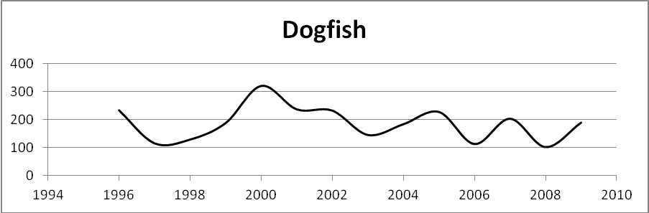

Figure 1a: Monthly Average Real Dogfish Revenue $,000 Can
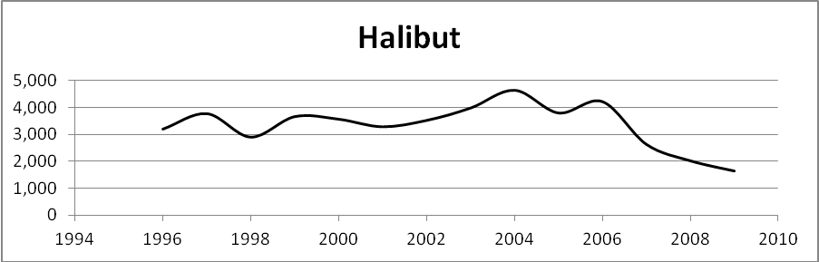

Figure 1b: Monthly Average Halibut Real Revenue $,000 Can
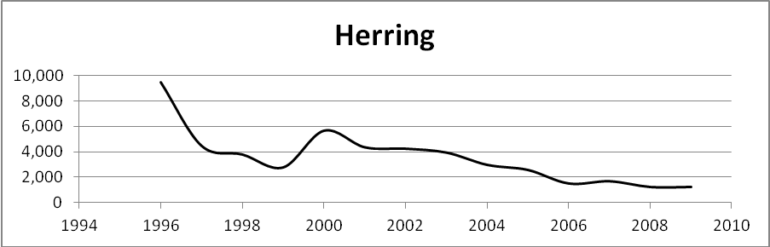

Figure 1c: Monthly Average Herring Real Revenue $,000 Can

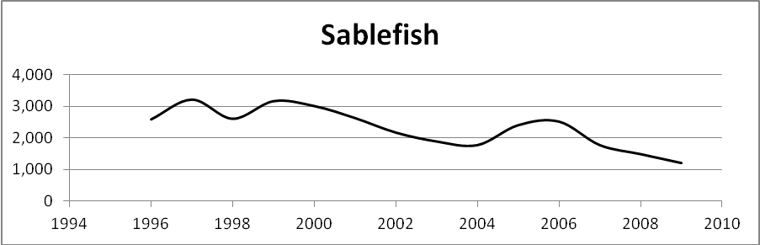

Figure 1d: Monthly Average Sablefish Real Revenue $,000 Can

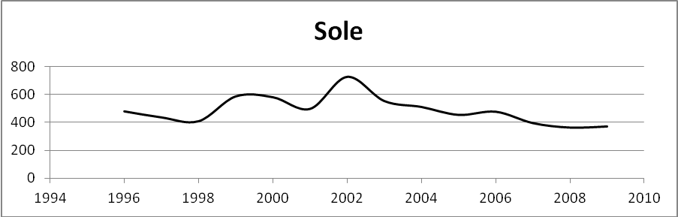

Figure 1e: Monthly Average Sole Real Revenue $,000 Can
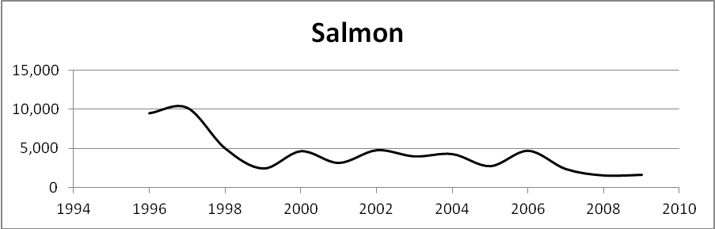

Figure 1f: Monthly Average Salmon Real Revenue $,000 Can
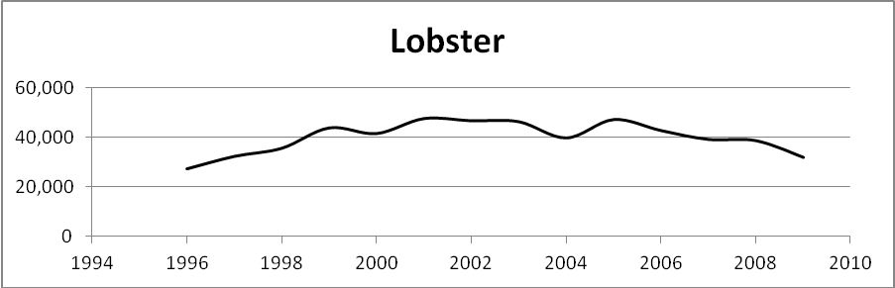

Figure 1g: Monthly Average Lobster Real Revenue $,000 Can
Six of the seven graphs show a negative trend over the period with only lobster showing a positive trend. There is a lot of variation in revenue particularly for dogfish and herring, and salmon revenue tends to stabilize in the mid to late 2000s. The decline in real revenue is certainly serious. Dogfish revenue in 2009 is 81% of the value in 1995; halibut 52%, herring 13%, sablefish 46%, sole 78% and salmon 17%. Lobster shows a healthy 17% increase in value over the period.

Statistical Results
In this section we will statistically characterize prices in the fish supply chain from ex-vessel to processing to export markets. We are particularly interested in the nature of seasonality in the fisheries, the time series probability structure of prices, univariate modelling of ex-vessel prices and equilibrium model of multi-variate prices.

Seasonality

We are interested in modelling real ex-vessel price movements that are free of or control for seasonality and trend in the series. By controlling for these effects we can then properly measure the impact of random shocks to the system or changes in say, the marketing cost index. We look at seasonality in two ways. First we will graph out monthly real ex-vessel prices and visually inspect for seasonality and trend. Next, we will use regression techniques to statistically measure seasonality and trend.
Figure 2a to 2g graphs out real monthly ex-vessel prices. For dogfish prices in Figure 2a we observe a price high of 0.85$ in January 2001 dropping to a low of 0.30$ in March 2003. We also observe long periods of relative stability in prices with occasional abrupt shocks most noticeable in January 2003 and January 2007. A modest negative trend in prices is observed in the graph.
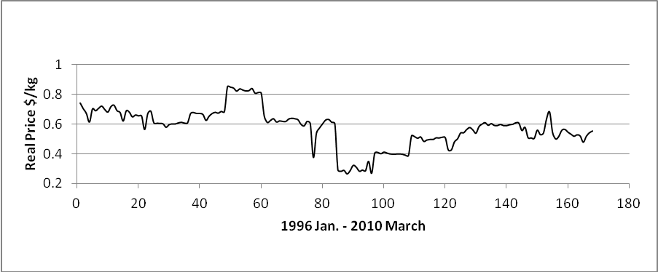

Figure 2a: Real Dogfish Price, January 1996 to March 2010

Figure 2b shows real halibut ex-vessel prices. This is a seasonal fishery from March to November but this changed in January 2007 with harvest in all months, albeit some months showing very low catch levels and high variation in prices.
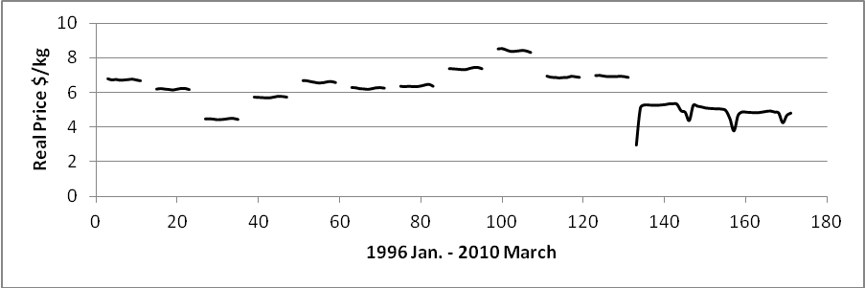

Figure 2b: Real Halibut Price, January 1996 to March 2010
Figure 2c shows real herring ex-vessel prices. This figure really points out the seasonality in this fishery. Harvest occurred in all months of the year up to May 2005. The fishery resumed in December 2005 with harvest in only select months of the year.
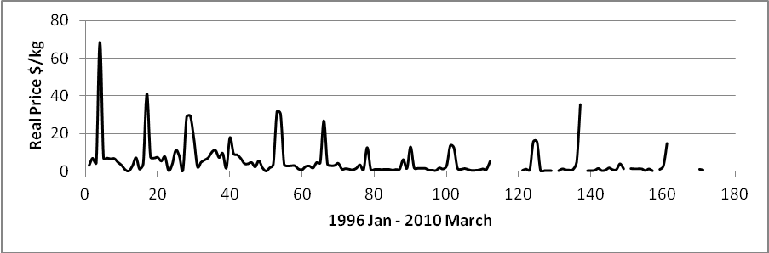

Figure 2c: Real Herring Price, January 1996 to March 2010
Figure 2d graphs out real ex-vessel prices for sablefish. This appears to be one of the more stable fisheries in our data set with some seasonal variations and a slight negative trend over time. As well, overtime it appears as if variation in prices is decreasing.
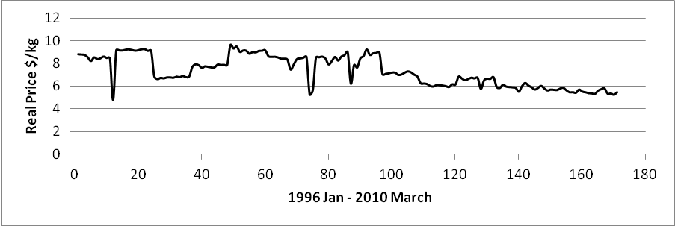

Figure 2d: Real Sablefish Price, January 1996 to March 2010
Figure 2e shows real ex-vessel sole prices. This is a very stable series with seasonality and very moderate negative trend overtime. (This appears to be a good candidate for equilibrium modelling latter in the report.)
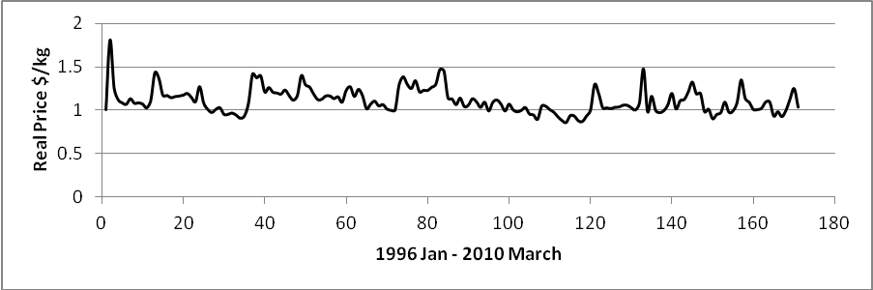

Figure 2e: Real Sole Price, January 1996 to March 2010
Figure 2f shows real ex-vessel salmon prices. There are several points of interest in this figure. First, we observe that harvest occurs only in select months of the year. But what is interesting is that there is a very noticeable seasonality in the data with increasing variation and positive trend in prices.
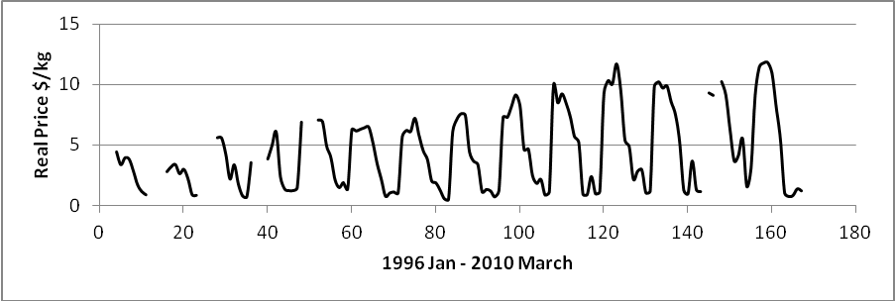

Figure 2f: Real Salmon Price, January 1996 to March 2010
Finally, Figure 2g shows real ex-vessel lobster prices. Harvest occurs in all months of the year (this is a management strategy) but there is strong seasonality in the series with only moderate declining trend in prices in the latter months of the data.
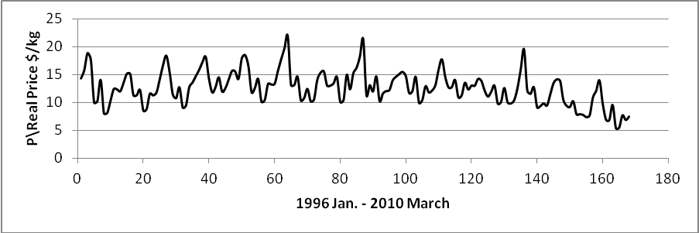

Figure 2g: Real Lobster Price, January 1996 to March 2010

To statistically measure the importance of seasonality and trend we run simple robust (corrected for heteroscedasticity) regressions of each real ex-vessel price on monthly dummies and a trend variable. The regression takes the form
(1)
Results are reported in Table 3.

Table 3: Regression Results for Seasonality and Time Trend
 | Dogfish | Halibut | Herring | Sablefish | Sole | Salmon | Lobster
Dm1 | -0.019 | -0.033 | 0.096 | 0.024 | 0.099* | 0.117 | 0.123*
Dm2 | -0.042 | -0.011 | 0.248 | -0.011 | 0.062 | 0.137 | 0.245*
Dm3 | -0.081 | 0.225* | 0.016 | -0.021 | 0.009 | 0.182 | 0.335*
Dm4 | -0.011 | 0.223* | 1.716* | 0.013 | -0.041 | -0.091 | 0.184*
Dm5 | -0.036 | 0.220* | 1.945* | 0.010 | -0.064 | -0.273* | -0.061
Dm6 | -0.005 | 0.215* | 1.730 | 0.021 | -0.083* | -0.430* | -0.053
Dm7 | 0.029 | 0.215* | 0.380 | 0.018 | -0.046 | -1.226* | 0.101
Dm8 | 0.013 | 0.220* | 0.327 | 0.001 | -0.040 | -1.405* | -0.251*
Dm9 | 0.029 | 0.227* | 0.388 | 0.032 | -0.064 | -1.348* | -0.214*
Dm10 | 0.023 | 0.227* | 0.610 | 0.049 | -0.072 | -1.912* | -0.018
Dm11 | 0.047 | 0.218* | -0.425 | 0.044 | -0.085* | -1.858* | -0.064
Dm12 | 0.029 | 1.725* | 3.490* | 2.695* | 0.329* | 1.342* | -0.002*
Trend | -0.002* | 0.001 | -0.012* | -0.003* | -0.001* | 0.002* | 2.961*
* Statistically significant at less than 5% level

Although the figures shown above for each fish species may have hinted at seasonality the regression results allow for statistical validation. From Table 3 both dogfish and sablefish show statistically no monthly variation in prices but with a slight negative trend in prices for dogfish. On the other hand, halibut, salmon and lobster show serious monthly price changes over the season. Herring and sole show only moderate price changes over the season. In order of statistical magnitude, herring, sablefish, sole and dogfish show statistically significant negative trend in prices. This is contrasted with a very positive trend in lobster prices and much less but still positive trend in prices of salmon. Halibut shows no trend in price series. This information will be included in further statistical modelling.

Time Series Characteristics

In this section we are interested in the probability structure of prices in the fish supply chain. Here we test for and measure the stability of the characteristics of the probability structure. This provides important information for both univariate and multi-variate modelling.

Processing Prices
We start with real industrial processing price indices (2002=100) and graph out the series in Figure 3 for three indices of processing prices; finfish, groundfish and salmon. Notice that the indices for finfish and groundfish are almost identical with salmon deviating from the common trend in August 2000 but regaining the trend in 2005 albeit at a lower price level. All three indices show a negative trend in prices over the period and what is more there appears to be little variation in prices from month to month.
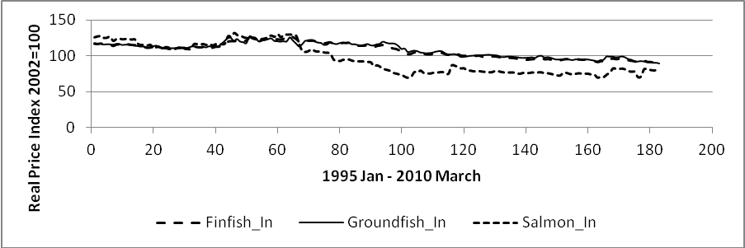

Figure 3: Real Processing Price Jan. 1995 to March 2010; Finfish, Groundfish and Salmon

Table 4 provides summary statistics for the three price indices. The table shows the mean, standard deviation and coefficient of variation (CV). As the prices are indices the mean and standard deviation are useful primarily in calculating the CV. The CV measures the ratio of the standard deviation to the mean. For presentation the CV has been multiplied by 100. The CV is a unit less measure and allows a comparison of dispersion across the variables of interest; the larger the CV the greater the dispersion in the variable.
Table 4: Summary Statistics of Real Industrial Processed Prices
January 1996 – March 2010
Variable | Mean | Standard  Deviation | Coefficient of Variation
Finfish ^{a)} | 108.04 | 10.67 | 9.87
Groundfish ^{b)} | 108.42 | 10.11 | 9.32
Salmon ^{c)} | 95.7 | 20.52 | 21.44
^{a)} Industrial processed price finfish
^{b)} Industrial processed price groundfish
^{c)} Industrial processed price salmon

For finfish and groundfish the mean, standard deviation and CV measures very similar characteristics over the period. Salmon is somewhat different with a lower mean value, higher degree of variation and a substantially larger CV.
Table 5 reports the time series, data generating properties of the three price indices. If the data generating process is stable this indicates that the mean, variance and pairwise correlations of the realizations are stable or stationary over time. If on the other hand this is not true, then econometric modelling of such non-stationary variables tends to measure common trends in the data and the underlying economic relationship of interest is obscured. A number of statistics are available for testing stationarity and here the augmented Dickey-Fuller approach is used with constant, trend and three lags for testing (Gordon 1995). In the level form of the variables, the null hypothesis is that the price series is characterized as nonstationary with an alternative hypothesis of stationary in first-differenced values of the variable. For each of the series the results of the test are reported in column 2. In all cases we cannot reject the null hypothesis at p-values less than 5% i.e. each series is nonstationary. Next, we take the first differences of the variables and reapply the test. The null hypothesis is that the series is stationary in second-differences against as alternative hypothesis of stationary in first-differences. The results are reported in column 3 and now for all price indices we can easily reject the null and accept the alternative hypothesis of stability/stationarity in the first-difference values of the variables.

Table 5: Tests for Stationarity Industrial Processed Prices ^{a)}
 | Dickey-Fuller  Levels | Dickey-Fuller  First-differences
Finfish ^{b)} | -1.46  (0.84)* | -7.61  (0.00)
Groundfish ^{c)} | -1.72  (0.744) | -7.94  (0.00)
Salmon ^{d)} | -1.59  (0.797) | -6.84  (0.00)
MCI^{e)} | -3.47  (0.042) | -
RD^{f)} | -3.47  (0.043) | -
^{a)} All statistics include constant, trend and 3 lags (except RD with 5 lags).
^{b)} Industrial processed price finfish
^{c)} Industrial processed price groundfish
^{d)} Industrial processed price salmon
^{e)} Marketing Cost Index
^{f)} Retail Demand shift variable
* Mackinnon approximate p-value

The first difference stationary result for industrial prices is important information in modelling in a multi-variate framework. In fact, it states that other variables combined in the regression must also be first-difference stationary. Put another way, it states that industrial prices cannot be included in a multi-variate framework with variables that are stationary in level form. This is important because in looking ahead we will show that for many fish species examined here both export and ex-vessel prices are trend stationary in levels.
An alternative way of looking at processing prices is a marketing cost index (MCI) described in Gordon (2010b). Gordon also describes a retail demand (RD) shift variable that may be useful in multi-variate equilibrium modelling latter in the report. The MCI is an aggregate index measuring costs of processing fish product, whereas the RD variable is an aggregate index measuring shifts in the Canadian retail demand function for fish products. The bottom rows of Table 5 show Dickey-Fuller test results for the MCI and RD shift variable. For both indices we measure trend stationary in level form.
Table 5 provides some useful information on prices and costs in the fish supply chain. First, price indices for processed prices provided by Statistics Canada are stationary in first differences. Whereas the MCI and RD complied by Gordon (2010) are stationary in level form.

Export Prices

Table 6 reports summary statistics for the monthly real export price for the fish species examined in the report. Note that we have separate categories for salmon fresh and frozen and lobster fresh and frozen. There are wide differences in prices per kg with dogfish on average receiving 3.35$/kg compared to frozen lobster at 26.47$/kg. Herring export prices show massive variation with a CV of over 80. On the other hand, halibut and lobster live have relatively small variations with CV of 15.3 and 14.12, respectively.
We again investigate the time series structure of prices using a Dickey-Fuller procedure. It is worth mentioning that there are some months of no values for herring and salmon fresh. I attempt two procedures for time series testing; first, following Ryan and Giles (1998) I ignore the missing observations, second I fill the missing observations with the mean of each series. The procedures provide similar results and we report the tests based on filling missing values with the mean of the series in Table 7. The most striking feature of this table is that all prices except sablefish show trend stationary (with three lags). This is striking in the sense that usually we find prices first difference stationary but I suspect that the trend in the price series dominates and we are measuring stochastic variation around the trend. For practical purposes this means that modelling with export prices must be carried out in level form.
Table 6: Summary Statistics Real Export Prices
January1995 to December 2009
Variable | Observations | Mean | Standard Deviation | Coefficient of Variation
Dogfish | 180 | 3.35 | 1.87 | 55.95
Halibut | 180 | 10.61 | 1.62 | 15.29
Herring | 168 | 11.87 | 10.06 | 84.77
Sablefish | 180 | 11.27 | 2.32 | 20.61
Sole | 180 | 8.29 | 1.57 | 18.89
Salmon Fresh | 166 | 6.32 | 2.46 | 38.92
Salmon Frozen | 180 | 5.79 | 1.26 | 21.76
Lobster Live | 180 | 16.64 | 2.35 | 14.12
Lobster Frozen | 180 | 26.47 | 5.10 | 19.27

Table 7: Tests for Stationarity Export Prices ^{a)}
Variable | Dickey-Fuller  Levels | Dickey-Fuller  First-differences
Dogfish | -7.96  (0.00) | -
Halibut | -5875  (0.010) | -
Herring | -6.74  (0.00) | -
Sablefish | -2.68  (0.25) | -9.49  (0.00)
Sole | -4.47  (0.00) | -
Salmon Fresh | -4.49  (0.00) | -
Salmon Frozen | -6.01  (0.00) | -
Lobster Live | -5.68  (0.05) | -
Lobster Frozen | -7.68  (0.00) | -
^{a)} All statistics include constant, trend and 3 lags.
* Mackinnon approximate p-value

Ex-vessel Prices

Table 8 reports summary statistics for real ex-vessel prices for the fish species examined here. Again we observe a wide variation in mean price with dogfish selling on average for 0.58$/kg and lobster for $12.60/kg. Note the great variation in CV across the different fish species with the standard deviation in herring larger than the mean value.

Table 8: Summary Statistics Real Ex-vessel Prices
January1995 to December 2009
Variable | Observations | Mean | Standard Deviation | Coefficient of Variation
Dogfish | 168 | 0.58 | 0.19 | 32.76
Halibut | 136 | 6.12 | 1.11 | 18.15
Herring | 149 | 5.37 | 8.89 | 165.49
Sablefish | 168 | 7.34 | 1.32 | 17.96
Sole | 168 | 1.11 | 0.14 | 13.04
Salmon | 148 | 4.47 | 3.21 | 71.82
Lobster | 168 | 12.60 | 3.02 | 23.96

Table 9 reports the time series tests for stationarity based on Dickey-Fuller statistics. These results are not unlike export prices and show stationary in level prices for herring, sablefish, sole, salmon and lobster. Dogfish and halibut show first difference stationary and follow a different stochastic trend relative to corresponding export values. Based on Tables 8 and 9 it appears that structural equilibrium modelling may be possible with sole and lobster. Both ex-vessel and export prices are trend stationary and we have no missing observations in the data series.

Table 9: Tests for Stationarity Ex-vessel Prices ^{a)}
Variable | Dickey-Fuller  Levels | Dickey-Fuller  First-differences
Dogfish | -2.86  (0.17) | -14.35  (0.00)
Halibut | -0.65  (0.98) | -7.10  (0.00)
Herring | -5.12  (0.00) | -
Sablefish | -3.65  (0.005) | -
Sole | -4.37  (0.00) | -
Salmon | -4.51  (0.002) | -
Lobster | -6.26  (0.00) | -
^{a)} All statistics include constant, trend and 3 lags.
* Mackinnon approximate p-value

Univariate Modelling

The initial modelling will be to fit an ARIMA model to the ex-vessel price data listed in Table 9. This is a univariate modelling technique based on the maintained assumption that current realizations of price can be explained by lagged values of the price (dynamic shocks) and current and lagged values of the stochastic error term (stochastic shocks). The ARIMA can be considered a reduced form price model for the purpose of short-run forecasting. It is possible to augment the ARIMA price model by including exogenous variables in specification for the purpose of improving forecasting possibilities and to reduce forecast error. These extensions are defined as ARMAX or transfer function models and for the case at hand we define three possible predetermined variables that may impact the stochastic behaviour of ex-vessel price; TAC, corresponding export price and US/Canada exchange rate. As well, based on our earlier seasonal work each equation will account for seasonal variation and where appropriate trend. Based on results in Table 9 all prices except dogfish and halibut will be modelled in level form.
The specification of the univariate price model is defined as:
(2)
Where is the ex-vessel price for fish in period t, is TAC (i.e. proxyied by total harvest), export price and US/Canada exchange rate, are seasonal monthly dummies, represents the autoregressive (AR) component (dynamic shocks), represents the moving average (MA) component (stochastic shocks) and is an iid random error term. Estimation of equation (2) is based on maximum likelihood procedures.
Selecting the correct lag specification for equation (2) is critical for generating an estimated equation with good forecasting potential. Our research strategy is to evaluate alternative AR and MA lag structures based on review of the autocorrelation and partial autocorrelation functions with possible candidate specifications defined on testing iid conditions in the stochastic error term using a Box-Lung Q-statistic. Among those candidate specifications the preferred model is identified by measured RMSE and BIC statistics. Finally, estimated models are reported in Table 10, seasonal and trend variables are not shown.
For each ex-vessel price variable the final estimated equation shows non-autocorrected error structure and statically significant AR and MA components. In each equation the first lagged value of the AR component is statistically important. Only salmon and lobster show statistically important second order lagged terms. Only four of the seven equations show statistically important MA first order terms. Of the pre-determined variables impacting ex-vessel prices dogfish and halibut show lack of statically support to include any such variables. On the other hand, herring, sablefish and salmon show a small but important impact of current TAC on price determination. Whereas sole and lobster witness external shocks on ex-vessel prices.
Table 10: ARMAX Regression Results
Variables | Dogfish | Halibut | Herring | Sablefish | Sole | Salmon | Lobster
TAC | - | - | -4.55e-08  (0.001) | 2.61e-07  (0.00) | - | -7.13e-08  (0.00) | -
Export price | - | - | - | - | - | - | 1.230  (0.00)
US/Can | - | - | - | - | 0.315  (0.003) | - | -
AR  L1 | 0.567  (0.018) | 0.603  (0.53) | 0.548  (.00) | 0.953  (0.00) | 0.566  (0.00) | 1.467  (0.00) | 1.203  (0.00)
L2 | - | - | - | - | - | -0.690  (0.00) | -0.265  (0.03)
MA  L1 | -0.732  (0.001) | -0.752  (0.065) | -  - | -0.367  (0.075) | -  - | -0.777  (0.00) | -0.819  (0.00)
Obs. | 168 | 168 | 168 | 168 | 168 | 168 | 168
BIC | -273.07 | -328.86 | -460.95 | -326.57 | -292.37 | -218.81 | -344.65
Q-stat^{a)} | 0.310 | 0.660 | 0.984 | 0.999 | 0.838 | 0.937 | 0.649
^{a)} p-value of Q stat with 10 lags

What is not surprising about the results in Table 10 is that in all cases very simple AR and MA specifications seem to characterize well the movements in ex-vessel prices. This is consistent with previous work on ex-vessel prices in Canada (Gordon 2010a). What is surprising is given that most of the harvests for the species examined here are exported only sole and lobster show statistically important ex-vessel price response to external shocks. For the other fisheries the external shocks are dissipated somewhere in the supply chain.
The estimated models will be used to provide forecasts both in-sample and dynamic. For in-sample forecasting the actual values of the right-hand-side variables are used in making the one-step ahead forecast. Whereas, for dynamic forecasting the predicted values of the ARMA components are combined with actual values of other variables and used in making the one-step ahead forecast. These results are reported in Figures 4a to 4g. For each figure we show both the in-sample and dynamic forecast. For all equations the in-sample forecast seem quite reasonable, but of course this is to be expected and does not offer much insight into price formation. For dynamic forecasts we observe an over prediction of prices for dogfish and halibut and a poor job of picking out turning points in the herring series. On the other hand, the dynamic forecasts look quite reasonable for sablefish, sole, salmon and lobster. For salmon we take a closer look at dynamic forecasting and show in Figure 5 dynamic forecasts over the period January 2008 to December 2009. The dynamic forecast looks reasonable in terms of capturing the turning points but it does underestimate the actual price over the period.

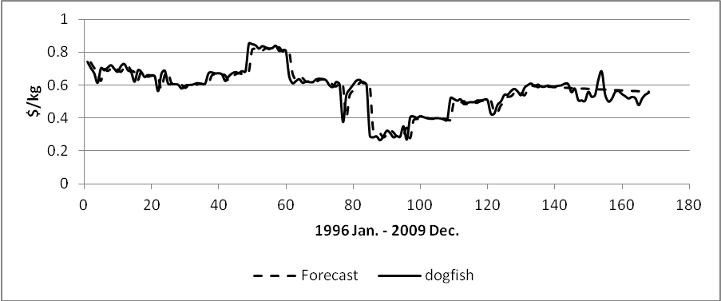

Figure 4a: Dogfish Ex-vessel Price Forecast; Dynamic after March 2007
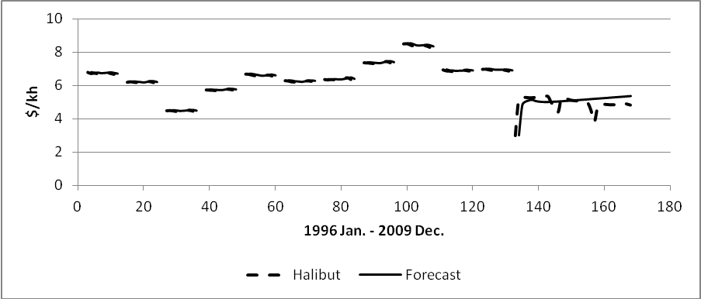

Figure 4b: Halibut Ex-vessel Price Forecast; Dynamic April 2007
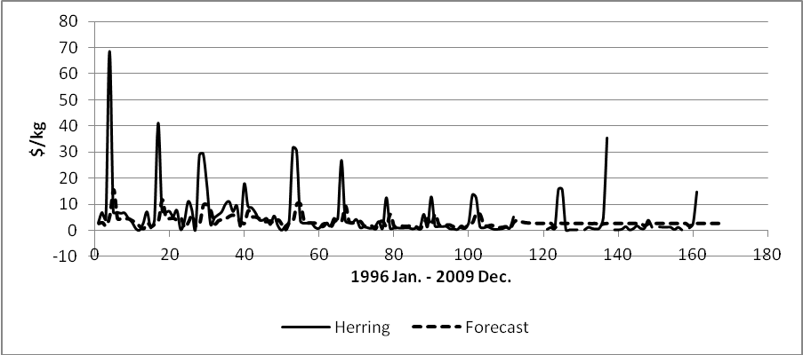

Figure 4c: Herring Ex-vessel Price Forecast; Dynamic after April 2005
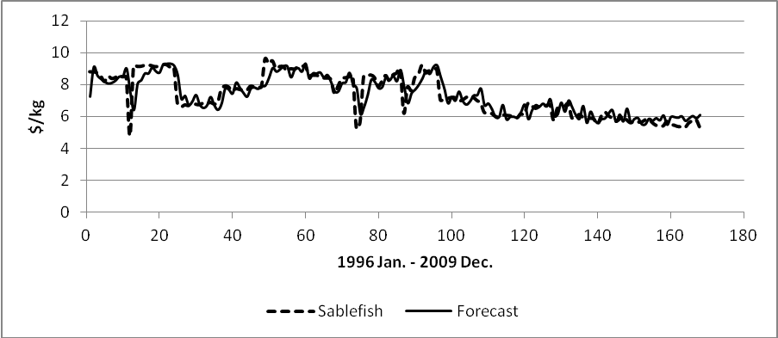
Figure 4d: Sablefish Ex-vessel Price Forecast; Dynamic after January 2009
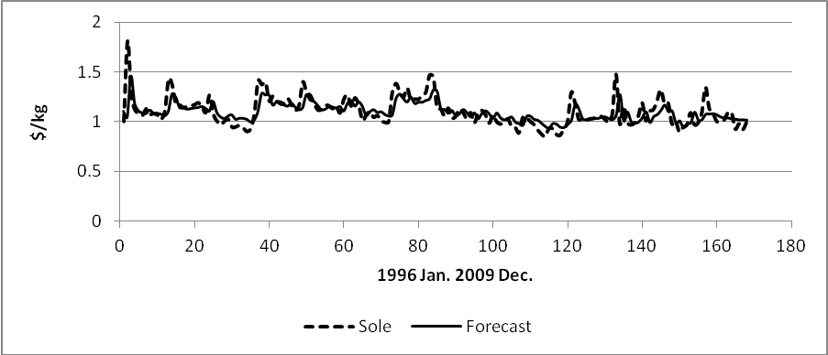

Figure 4e: Sole Ex-vessel Price Forecast; Dynamic after January 2009
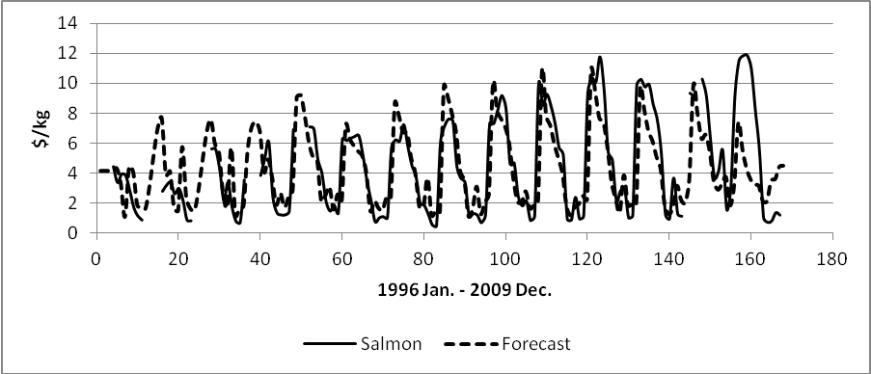

Figure 4f: Salmon Ex-vessel Price Forecast; Dynamic after January 2009
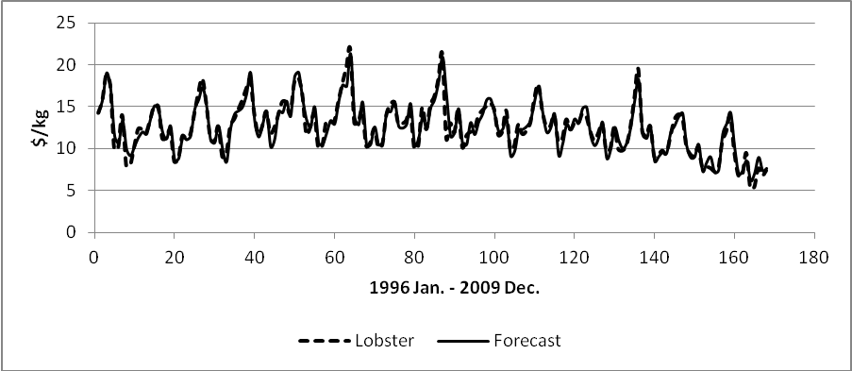

Figure 4g: Lobster Ex-vessel Price Forecast; Dynamic after January 2009

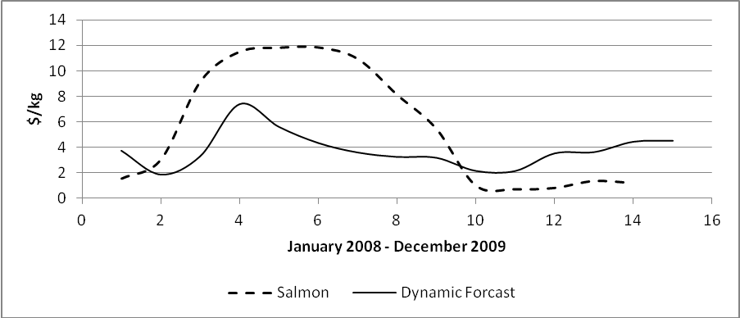

Figure 5. Dynamic Salmon Forecast

Equilibrium Modelling with Structural Components

In this section we will look more closely at multi-variate equilibrium models explaining the ex-vessel price determination for sole and lobster. Both of these prices show stability in level form (Table 9) and the corresponding export prices are also stationary in level form (Table 7). Consequently, if equilibrium exists between export and ex-vessel prices it must be modelled in level form. We also want to introduce other explanatory variables in the equation.
We will estimate an inverse demand curve for sole so it is important to control both for harvest quantity and price of substitutes. If Canada is a small player in the world sole market we would not expect much econometric response to ex-vessel price as harvest quantity changes but this is an empirical question that will be determined after estimation. I define sablefish as a reasonable substitute commodity and include the ex-vessel price of sablefish to capture this effect. All prices are in real terms. Following the work of Gordon (2010b) we introduce a marketing cost (MC) index and a retail demand (RD) shift variable. The MC index is a real aggregate price index of cost of processing and moving the fish product through the supply chain. The RD shift variable is a real index measuring demand factors that impact the price determination. Finally, based on results reported in Table 3 we include both seasonal and trend variables in the estimating models. The robust econometric results for sole are reported in Table 11.
I report three different specifications of the equation in order to examine robustness of results for the main variables. The first equation R1 includes export price of sole, harvest levels, MC, RD and seasonal and trend variables. Notice that the export price of sole, harvest level and RD shift variable are not statistically important in impacting the ex-vessel price. On the other hand, the price of sablefish and MC index are important determining variables. This equation implies that the structural variable for processing cost is important in ex-vessel price determination but that the RD shift variable lacks impact. Keep in mind that the RD index was built to measure shifts in the Canadian demand for fish products and the lack of importance of this variable in the equation probably reflects the export nature of the product.
Equation R2 drops RD (and the trend variable) but includes the lagged value of ex-vessel price of sole. The latter variable can be seen as a proxy for missing variables from the original specification and turns out to be important. However, the export price of sole is still not statistically important in the equation even though this product is heavily exported.
Table 11: Inverse Demand Equation Sole
(Dependent variable is ex-vessel price of sole)
Variables | R1 | R2 | R3
Lag Ex-vessel Price Sole | - | 0.381  (0.00) | 0.386  (0.00)
Export Price Sole | 0.054  (0.48) | 0.022  (0.76) | -
Ex-vessel Price Sablefish | 0.234  (0.00) | 0.178  (0.01) | 0.187  (0.00)
Harvest Sole | -0.027  (0.52) | -0.025  (0.05) | -0.026  (0.02)
MC^{a)} | -0.305  (0.04) | -0.156  (0.05) | -0.139  (0.12)
RD^{b)} | 0.128  (0.30) | - | -
Q1 | 0.128  (0.00) | 0.083  (0.02) | 0.082  (0.02)
Q2 | 0.014  (0.49) | -0.008  (0.0.64) | -0.009  (0.64)
Q3 | 0.026  (0.23) | 0.012  (0.49) | 0.012  (0.50)
Trend | 0.0002  (0.32) | - | -
Cons | 0.903  (0.23) | 0.380  (0.56) | 0.423  (0.49)
BIC | -265.96 | -296.24 | -301.18
Q stat^{c)} | (0.00) | (0.08) | (0.11)
^{a)} Marketing Cost Index
^{b)} Retail Demand Shift
^{c)} p-value on null of no serial correlation in the errors

The final equation (R3) drops the export price of sole and we justify this by reflecting on the lower value of the BIC statistic and the Q-statistic that tells us the error terms are not serially correlated. We further validate the final specification by graphing out (Figure 6) the predicted ex-vessel price in comparison to actual price. The equation does a very reasonable job of forecasting ex-vessel sole price.

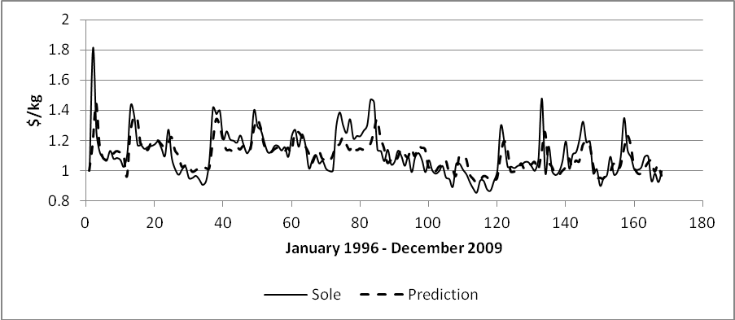

Figure 6: Ex-vessel Price of Sole, Multi-variate Predictions
Equation (R3) reports a substitute elasticity of 0.187 or a 1% increase in the ex-vessel price of sablefish results in almost a 0.2% increase in the ex-vessel price of sole. The inverse elasticity of demand and inverse elasticity with respect to the MC index are -0.03 and -0.14, respectively. The small demand elasticity seems reasonable for a world traded product and may even be too large. The MC elasticity tells us that not all cost increases at the processing level are passed down the supply chain to the ex-vessel level.
We offer a simple policy analysis by asking what does ex-vessel price realization looks like for two scenarios; first, a 10% increase in processing cost and second, and 10% increase in the ex-vessel price of sablefish. The scenarios are graphed out in Figure 7. Of course, the price forecast simply reflects the estimated elasticities but does visually show the extent of price variation under the two scenarios.
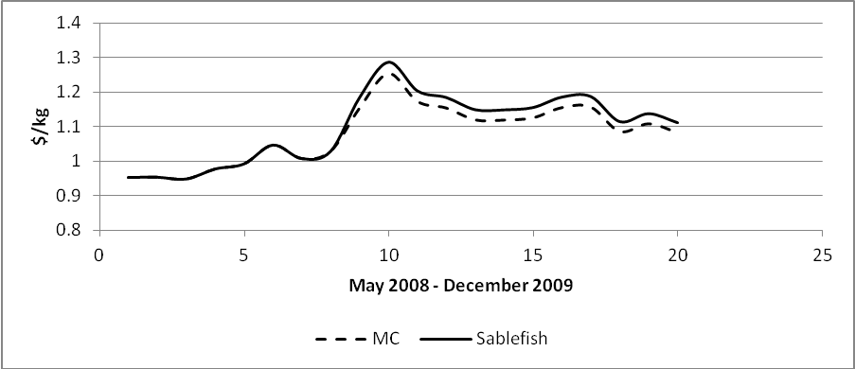

Figure 7: Marketing Cost (MC) and Predicted Ex-vessel price of Sablefish
We turn now to investigate the inverse demand curve for lobster. Similar to sole, are previous work has shown that both the ex-vessel and export price of lobster are stationary in level form. Consequently, it makes sense to model the structural equation in levels. Two interesting facts about Canadian lobsters; first, lobsters are an export product and it makes sense to ask what is the impact of the US/Canada exchange rate on the ex-vessel price of lobster and second, lobster is a high valued species and we would expect that price is impacted by the general economic wellbeing of society. As such we will include the retail demand shift variable as a proxy to capture this effect. Finally as Canada is a big player in the North American lobster market it is likely that harvest levels will also impact the ex-vessel price and thus we include this variable in specification. Finally, we control for seasonality and trend. (Note that we did try to include the marketing cost index to no avail.) The results of the investigation are reported in Table 12.

Table 12: Inverse Demand Equation Lobster
(Dependent variable is ex-vessel price of lobster)
 | R1 | R2 | R3
Lag Ex-vessel Price Lobster | - | 0.352  (0.00) | -
Harvest | -0.058  (0.00) | -0.074  (0.00) | -0.057  (0.00)
Export Price Live | 0.709  (0.00) | 0.426  (001) | 0.889  (0.00)
Lag Export Price Live | - | - | -0.305  (0.01)
US/Can | 0.295  (0.03) | 0.224  (0.07) | 0.344  (0.01)
RD^{a)} | 1.004  (0.01) | 0.622  (0.07) | 1.249  (0.00)
Q1 | 0.233  (0.00) | 0.126  (01) | 0.231  (0.00)
Q2 | 0.139  (0.00) | 0.041  (0.23) | 0.149  (00)
Q3 | -0.161  (0.04) | -0.175  (0.00) | -0.176  (0.00)
Trend | -0.002  (0.04) | -0.001  (0.19) | -0.003  (0.01)
Cons | -21.03  (0.11) | -12.38  (0.09) | -26.125  (0.00)
BIC | -169.41 | -198.19 | -169.65
Q^{c)} | 0.003 | 0.001 | 0.087
^{a)} Retail Demand Shift
^{c)} p-value on null of no serial correlation in the errors

Table 12 lists three different specifications of the inverse demand curve in an attempt to search out the best empirical form of the equation. Notice that the coefficient on harvest level is consistently and statistically negative for all three specifications, whereas the export price and US/Can exchange rate are positive and statistically important. Equation R2 introduces the lagged value of the ex-vessel price and equation R3 introduces the lagged value of the export price. We decide on equation R3 as the best empirical specification of the inverse demand curve because of the smallest BIC statistic and a p-value on the Q-statistic showing no correlation in the error terms. Again we add to the validation of the equation by reporting in Figure 8 the predicted value and actual value of the ex-vessel price of lobster. For most of the series the estimated equation does a good job of forecasting the high swings in the series but a poor job of capturing the low swings in the series. Note that at the end of the series, the equation over predicts on the low swing. This suggests that an important variable may be missing from the equation nonetheless, the equation does do a good job of picking turning points in the data.

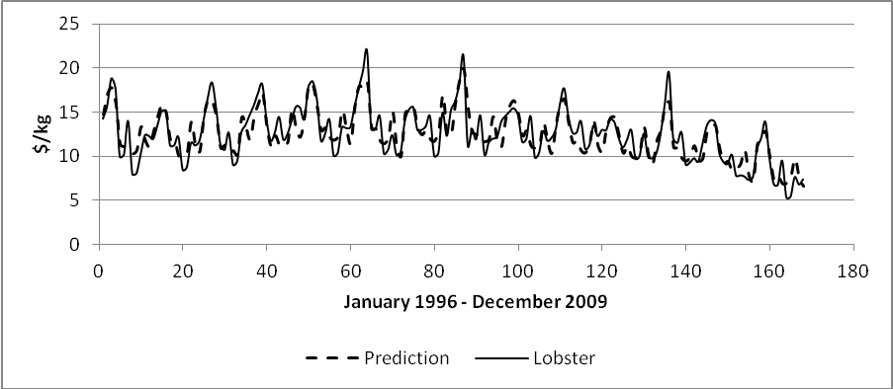

Figure 8: Ex-vessel Price and Prediction Lobster
What is interesting with the inverse demand curve is that corresponding elasticities can be read directly from the equation. All elasticities are statistically important with harvest supply elasticity measured as -0.057, ex-port price elasticity as 0.889 and US/Can exchange elasticity at 0.344. The harvest elasticity appears low for Canada being such an important player in the North American market for lobster. However, what is more interesting is that both the export price and US/Can exchange rate appear in the equation. Perhaps the US/Can exchange rate is picking up more general economic conditions in North America. The RD shift variable appears to work quite well with an elasticity of greater than one. This is a strong signal of the high value nature of the product.
We demonstrate the policy importance of the lobster empirical equation by simulating the ex-vessel price effect of a change in the US/Can exchange. For this simulation all variables take their mean value and we trace out the predictions of the exchange rate at mean data values over the period, the highest value attained during the period and finally (and consistent with current market behaviour) the US/Canadian dollars on par. The results are reported in Figure 9, of course the graph just traces out the elasticities reported in Table 12 but it does give a very nice visual presentation of the importance of the exchange rate on this market.
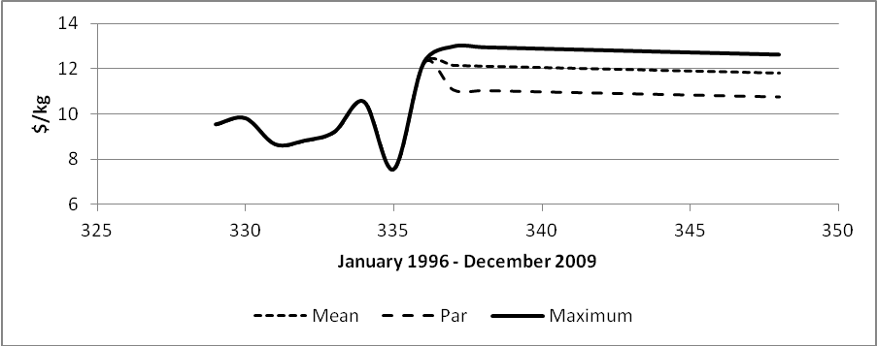

Figure 9: Ex-vessel Price Simulation with US/Can Exchange: mean, maximum and par levels

Conclusion
The purpose of this report was to empirically investigate price links in the Canadian fish supply chain. Seven fish and shellfish species are used in analysis. Three techniques are used to challenge the data; first, standard statistical summary tables showing seasonality, trend and time series properties are used to characterize the data, second, univariate ARIMA is used for short-run dynamic forecasting for all ex-vessel prices, and third, a multi-variate structural approach is used to define the inverse demand curve for sole and lobster.
The summary statistics show a negative trend in all ex-vessel prices except salmon. This negative trend continues through to the revenue data for all species except lobster. Clearly this is not a good sign of the economic health of the fishery. With revenue falling in most fish sectors real profits must be falling unless the number of vessels is reduced or the cost of effort is declining. The dynamic ARIMA models do a reasonable job of forecasting the short-run value of the ex-vessel price. Although there is no indication of rising ex-vessel prices in the near future these models do allow policy makers to put reasonable bounds on the likely negative trend in prices. The structural models have provided good elasticity estimates of harvest, substitute, marketing costs, retail demand variables and export prices.
What have we learned in terms of policy issues for the Canadian fishery? Of course, the most important issue in terms of sustainability is that a serious and proper TAC be set for each fishery, independent of political interests. Canadian politicians/policy makers have a chequered history of actually getting the TAC correct as evidenced by the collapse of the east coast cod fishery. However, lessons have been learned and there appears now to be evidence of serious effort in setting proper and sustainable TAC limits. Certainly, for the seven-fisheries examined in this report all are managed by a TAC based on sustainability and precautionary management approach.
Management of the fisheries examined here takes a number of forms. From an economic position of efficiency and effective cost of management, market allocated ITQs are to be preferred. Of the seven-fisheries examined in this report four are managed by ITQs; Dogfish, Halibut, Sablefish, and Sole. Whereas, herring, salmon and lobster are managed by limited entry or effort controls. Certainly, one might consider moving these fisheries towards ITQ management, however, the current management scheme for lobster is successful both in sustainability and profitability of the fishery and there is little incentive to alter management program. One the other hand, both herring and salmon would benefit from an ITQ program. It should be noted that the most important part of an ITQ program is transferability and marketability of the quota. Restricting transferability means a loss of economic efficiency (Asche, Bjørndal and Gordon, 2009)
It should be noted that both salmon and halibut are migratory fisheries requiring multi-nation cooperation and management. In fact these fisheries are jointly managed by Canadian-U.S. regulation.
For Canadian fishermen the future is not bright. Incomes are low and likely to stay that way as prices for the species examined here showing declining trends, with only lobster showing increased revenue over the period of study. Fishing incomes are generally set by a share system of vessel profits earned but, nevertheless must reflect opportunity cost of labour. Otherwise labour would leave the industry. But this is the problem for fishermen their opportunity value is low! With four of the six finfish fisheries managed by ITQs there is little opportunity for productivity gains resulting in increased fishing income. On the other hand, with a move to ITQ regulation the herring and salmon fisheries have the potential for improved productivity that will be reflected in the returns to labour.

References
Asche, F., Bjørndal, T. and D.V. Gordon. “Resource Rent in Individual Quota Fisheries” Land Economics, 85(2) May 2009, 280-292.
Asche, F., Menezes, R. And Dias, J.F. 2007 Price transmission in cross boundary supply chains Empirica 34:477-489.

Azzam. A.M. 1999 Asymmetry and rigidity in farm-retail price transmission American Journal of Agricultural Economics 59:570-572.

Bjørndal, T and Gordon, D.V. 2010 ‘Notes on Prices and Margins in Fish Marketing’ FAO Supply Chain Study’ Rome, FAO 2010.

Boswijk, H.P. and Urbain, J.P. 1997 Lagrange-multiplier tests for weak exogeneity: A synthesis Econometric Reviews 16:21-38.

Enders, W. 2010 Applied Econometric Time Series, 3rd Edition, Wiley.

Engle, R.F. and Granger, G.W.J. 1987 Cointegration and error-correction: Representation, estimation and testing Econometrica 55:251-276.

Gordon, D.V. 1995 “Optimal Lag Length in Estimating Dickey-Fuller Statistics: An Empirical Note” Applied Economics Letters, 2:188-190.

Gordon, D.V. ‘The Retail Demand Shift Variable and Marketing Cost Index: Fish Supply Chain in Canada: FAO Supply Chain Study’ Rome, FAO 2010b (revised April 2012).

Gordon, D.V. ‘Canadian Fisheries Background Report: FAO Supply Chain Study’ Rome, FAO 2011.

Gordon, D.V. ‘A Primer on Reduced Form Price Modelling: Canadian Fish Price Data’ FAO Supply Chain Study’ Rome, FAO 2010a (revised 2012).

Gordon, D.V. and W.A. Kerr. 1997 “Was the Babson Prize Deserved? An Enquiry into an Early Forecasting Model” Economic Modelling 14(3):417-433.

Hahn W.F. 1990 Price transmission asymmetry in pork and beef markets The Journal of Agricultural Economic Research 42:21-30.

K. F. Ryan and D. E. A. Giles, 1998. "Testing for Unit Roots With Missing Observations," in T. B. Fomby & R. Carter Hill (eds.), "Advances in Econometrics" JAI Press, 1998.
Pesaran, M.H., Shin, Y. and Smith, R.J. 2001 “Bounds testing approaches to the analysis of level relationships” Journal of Applied Econometrics 16:289-326.

Sumaila, U.R., Marsden, A.D., Watson, R. and Pauly, D. 2007 “A global Ex-vessel Fish Price Database: Construction and Applications” Journal of Bioeconomics 9:39-51.

Von Cramon-Taubadel, S. 1998 Estimating asymmetric price transmission with the error-correction representation: An application to the German pork market European Review of Agricultural Economics 25:1-18.

Wohlgenant, M.K. 1985 competitive storage, rational expectations and short run food price determination American Journal of Agricultural Economics 67: 739-748.

Zivot, E. and Andrews, D. W. K. (1992) ‘Further Evidence on the Great Crash, the Oil-Price
Shock, and the Unit-Root Hypothesis’, Journal of Business and Economic Statistics,
10(3), 251-270.

Appendix
Table A1 reports average real monthly revenue per year for the seven species examined in this report. The table shows some yearly variation in revenue, except for lobster all species show serious decline over the fourteen years of data.
Table A1: Real Average Monthly Revenue (Can$)
Year | Dogfish | Halibut | Herring | Sablefish | Sole | Salmon | Lobster
1996 | 2.33E+05 | 3.19E+06 | 9.46E+06 | 2.59E+06 | 4.80E+05 | 9.50E+06 | 2.71E+07
1997 | 1.15E+05 | 3.76E+06 | 4.46E+06 | 3.22E+06 | 4.37E+05 | 1.02E+07 | 3.22E+07
1998 | 1.28E+05 | 2.90E+06 | 3.77E+06 | 2.61E+06 | 4.10E+05 | 5.01E+06 | 3.55E+07
1999 | 1.87E+05 | 3.65E+06 | 2.76E+06 | 3.17E+06 | 5.86E+05 | 2.44E+06 | 4.38E+07
2000 | 3.20E+05 | 3.56E+06 | 5.65E+06 | 3.01E+06 | 5.80E+05 | 4.64E+06 | 4.15E+07
2001 | 2.36E+05 | 3.28E+06 | 4.34E+06 | 2.63E+06 | 4.97E+05 | 3.15E+06 | 4.76E+07
2002 | 2.32E+05 | 3.51E+06 | 4.23E+06 | 2.16E+06 | 7.24E+05 | 4.77E+06 | 4.67E+07
2003 | 1.45E+05 | 3.97E+06 | 3.93E+06 | 1.88E+06 | 5.53E+05 | 3.98E+06 | 4.63E+07
2004 | 1.83E+05 | 4.62E+06 | 2.96E+06 | 1.76E+06 | 5.11E+05 | 4.27E+06 | 3.97E+07
2005 | 2.27E+05 | 3.79E+06 | 2.56E+06 | 2.40E+06 | 4.55E+05 | 2.74E+06 | 4.72E+07
2006 | 1.12E+05 | 4.20E+06 | 1.49E+06 | 2.52E+06 | 4.77E+05 | 4.70E+06 | 4.27E+07
2007 | 2.03E+05 | 2.63E+06 | 1.67E+06 | 1.76E+06 | 3.97E+05 | 2.36E+06 | 3.91E+07
2008 | 1.01E+05 | 2.03E+06 | 1.22E+06 | 1.47E+06 | 3.65E+05 | 1.54E+06 | 3.86E+07
2009 | 1.89E+05 | 1.65E+06 | 1.22E+06 | 1.19E+06 | 3.73E+05 | 1.63E+06 | 3.18E+07
Source: http://www.pac.dfo-mpo.gc.ca/stats/comm/summ-somm/index-eng.htm http://www.gov.pe.ca/fard/index.php3?number=1024862&lang=E

kkd
jdj

Figure A1a to A1g graph average monthly harvest for each species over the fourteen-year period.
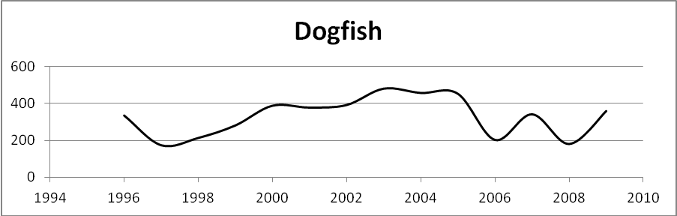

Figure A1a: Monthly Average Harvest Dogfish, tonnes
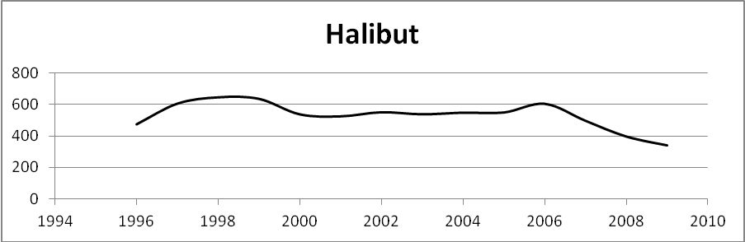

Figure A1b: Monthly Average Harvest Halibut, tonnes
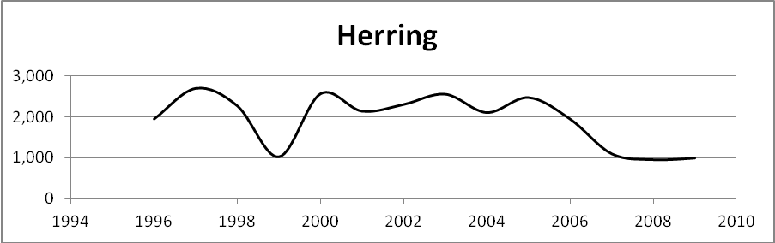

Figure A1c: Monthly Average Harvest Herring, tonnes
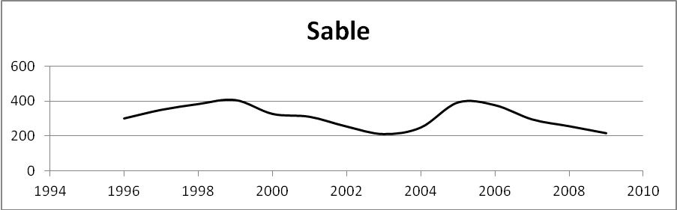

Figure A1d: Monthly Average Harvest Sable, tonnes
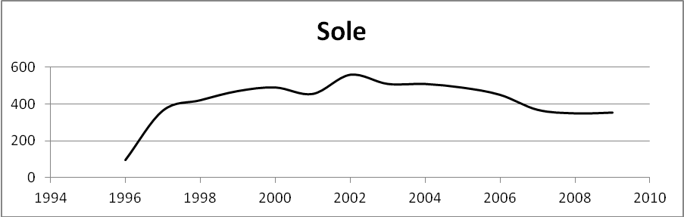

FigureA1e: Monthly Average Harvest Sole, tonnes
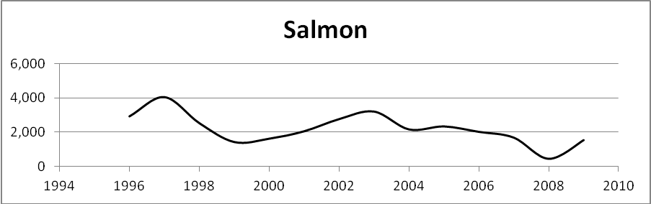

Figure A1f: Monthly Average Harvest Salmon, tonnes
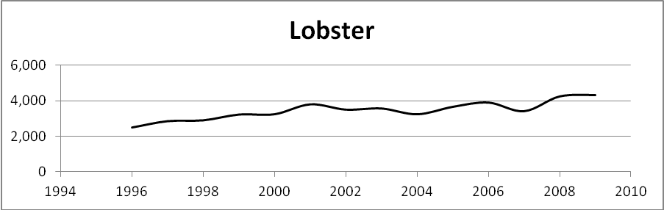
Figure A1g: Monthly Average Harvest Lobster, tonnes

See, Gordon, 2011.
The export market is the final market as far as Canadian fishermen are concerned but, of course, the exported quantity would enter a foreign fish supply chain and eventually reach the end consumer.
The retail market for fish in Canada takes approximately 15-20% of total landings (Gordon, 2011). But in order to compete successfully for product, the retail price of fish must reflect the export price. See Gordon, 2012 for a detailed investigation of retail fish prices in Canada.
The information in this section is recovered from DFO reports see, http://www-ops2.pac.dfo-mpo.gc.ca/xnet/content/mplans/mplans.htm
This is about 15% to 30% of historic levels (Beamish et al. 2004)
See, http://www.dfo-mpo.gc.ca/Library/344588.pdf
See, http://www.pac.dfo-mpo.gc.ca/fm-gp/ifmp-eng.htm#Salmon_
See, http://www.pac.dfo-mpo.gc.ca/fm-gp/commercial/ground-fond/index-eng.htm.
See, http://www.glf.dfo-mpo.gc.ca/Gulf/Lobster-Information/Lobster-Fisheries-Management
Price weighted by monthly harvest quantity.
Declining real ex-vessel prices have been observed worldwide see, Sumaila et al. 2007.
Modified from Gordon (2011)
The data has been checked for accuracy with source material.
Autoregressive Integrated Moving Average Model.
For an interesting discussion of the first serious price forecasting model see, Gordon and Kerr (1997).
The restriction on the exogenous variables requires no feedback effect to the dependent variable (Enders, 2010)
Estimation is carried out using STATA 11 software.
Root mean square error and Bayesian information criteria, respectively.
It is worth noting that the corresponding industrial price is stationary in first differences and therefore cannot be included in the specification of the inverse demand curve.
We should be careful, these estimates are in fact inverse elasticities or flexibilities.

