Revised May 2011

Canadian Fisheries Background Report
FAO Supply Chain Study

Daniel V. Gordon
Department of Economics, University of Calgary
2500 University Drive N.W. Calgary, Alberta, Canada
dgordon@ucalgary.ca

Abstract
Fish harvesting, aquaculture production and fish processing offers employment and income for thousands of Canadians. International trade is very important to this sector of the economy and it contributes in an important and positive way to the nation’s trade balance. However, while growth prospects in wild harvest are minimal, in the coming years, aquaculture holds the promise of both development and growth. This report provides a summary of the fish supply chain in Canada from harvester, to processor to final market.

- Introduction
The purpose of this report is to provide information on Canadian Fisheries to support the statistical reports linking the value chain in fish supply. Fisheries are not a large sector of the Canadian economy accounting for just under 0.015% of GDP in 2006 but on a local level, for both the east and west coasts of the country it is important for employment and income. In 2008 some 52,000 individuals were involved in the fishery as commercial fish harvesters and crew. This is primarily seasonal employment but it amounts to just over 10,000 full time equivalent positions in the primary process of marine fish harvesting. In 2008 this activity generated over 600 million Canadian dollars in direct income. In terms of production, sea harvesting is augmented with aquaculture, primarily in producing Atlantic salmon but also mussels and oysters generating some 4,000 employed positions with annual income of about 120 million dollars. The processing sector doubles the contribution of the producing sectors with an additional 22,000 jobs and generating income of about 600 million dollars annually.
In 2006 Canada ranked 20th in terms of volume of harvest in world fisheries production. However, the volume of harvest in Canada decreased from 1,193 thousand tonnes in 2004 to 1,074 thousand tonnes in 2006; a decline of about 9%. On the other hand, aquaculture has shown growth of about 18% from 2004 to 2006. Of course, the volume of aquaculture production is small compared with marine fisheries with total aquaculture production in 2006 of 171 thousand tonnes.
International trade is the important final market for Canadian fisheries with approximately 80% of the volume of production destined for the export market. This represented a value of 3.9 billion dollars in 2008. Canada is also a major importer of seafood products amounting to 2.2 billion dollars in 2008. Clearly international trade in seafood products represents a positive contribution to the Canadian trade balance.
In this report, we will review the fish supply chain in Canada focusing on production both in wild harvest and aquaculture, international trade, domestic retail trade, processing, employment, income and fisheries management.

- Background
Europeans have been fishing what are now Canadian ocean waters since the 16th century. At that time cod stocks off the east coast of Canada were plentiful, easy to catch and valuable. Although fishing techniques where common among the different fleets, processing the fish for storage and transportation depended on economic factors available to the fleets. Fleets from southern Europe, where salt was cheap and plentiful, processed the fish by cleaning and salting, whereas, fleets from northern Europe, not having access to an inexpensive salt supply, processed the fish on land by drying the fish before storage and transportation.
The 1800s saw development in both fleet design and gear type. The New England Schooner allowed for greater range in fishing for cod, halibut, haddock and mackerel along the east coast of North America. A French innovation, the long line, allowed for greater fishing effort and efficiency in harvesting. However, for the vast number of fishermen at this time operating only small vessels and fishing the inshore life was hard and the economic conditions were poor.
Interesting in a historical context, after Canada's Confederation in 1867 conflict with the U.S. over boundaries and fishing rights forced the Canadian government to act both in an aggressive and diplomatic manner to secure treaties with the U.S. that greatly supported Canada’s status as an independent nation.
The Pacific coast also saw the development of a serious fishing industry in the late 1880s with the development of salmon canneries. This industry encouraged a large fishing fleet to harvest the migrating salmon and the railway was used to transport the canned product to distant markets.
After World War II advances in technology brought into common use radios, radars, sonar, nylon nets, and hydraulically powered gear. This allowed for larger vessels but now overfishing and overcapacity became a serious management problem. In the mid sixties, licence restrictions where introduced and included all major fisheries by the end of the 1970s. Nevertheless, there was great optimism in the fishery with the extension of the Canadian exclusive zone to 200 miles in 1977. In fact the late 1970s and early 80s saw growth and relative prosperity in Atlantic fisheries. But this was relatively short lived and by the late 1980s groundfish stocks were in serious decline and in 1992 a moratorium on the cod fishery was enforced.
Today lobster and other shellfish have replaced cod and other groundfish as the most important and valuable fish stocks on the Atlantic coast.
On the west coast, although pacific salmon and halibut are still important wild stocks, farmed salmon production on a commercial basis, which started in the late 1970s is taking an important role in fish production.

- Production
For this report we categorize Canada’s fisheries under two headings; commercial and aquaculture. The difference between the two production methods is really one of heterogeneity and risk. Aquaculture production generates a homogeneous (i.e. in Canada primarily Atlantic salmon) product under industrial production conditions, whereas, commercial fisheries harvest numerous species with large variations in harvest volume and quality. Figure 1 shows the volume and value of commercial fisheries and aquaculture production over the period 2006-08.
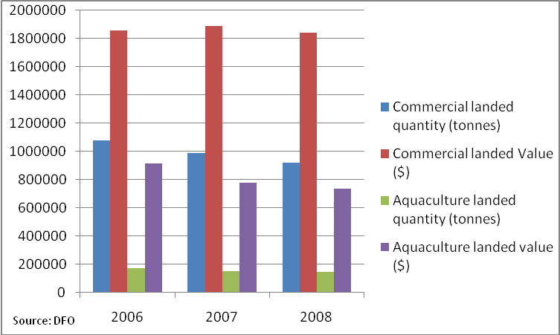
Figure 1: Volume and Value Commercial Harvest and Aquaculture Production 2006-08
Commercial landings show a steady decline over the period but value of landings is relatively constant. The decline in landings can be attributed to the decline in finfish harvest, whereas, value has been maintained by increased harvest and price received for lobster and snow crab. This contrasts with aquaculture where volume of production has been mostly stable although its value has declined over the period.
Figure 2 represents Canadian fishing activity in 2008. Canadian commercial fleets landed 918,125 tonnes of various species in 2008 that recorded about 86% of total fisheries landed value. Additionally, total aquaculture production added about 144,684 tonnes, valued at $736 million. In total, commercial catches and aquaculture production reached $2.6 billion in 2008.
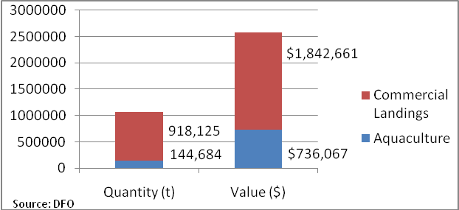
Figure 2: Relative Comparison, Volume and Value of Commercial and Aquaculture, 2008
Table 1a and 1b show summary statistics for marine fisheries landings and aquaculture production by major species. The largest value share of total commercial and aquaculture production is from shellfish harvest. Shellfish harvest amounted to about 58% ($1.5 billion) of total Canadian fisheries landed value. In particular, lobster is the focal point of shellfish production, which we will address in detail later in the report. In 2008, finfish harvest is second in landed value with 31% of total value of landings. This is mainly due to high value of salmon production. Similar to lobster, salmon production also carries a significant role for the Canadian fishery. Salmon is mainly farmed although there is a significant amount of wild salmon harvested in the Pacific Ocean. In sum, total finfish production reached up to 352,000 tonnes ($794 million) in 2008. Groundfish harvest is third in ranking after shellfish and finfish production in terms of economic value. Total groundfish landed value was about $253 million or 10% of the total Canadian fisheries.

Table 1.a: 2008 Marine Fisheries Landings, by major species
Major species groups | Landed quantity (tonnes) | % of Total landed quantity | Landed value (thousands) | % of Total landed value
Groundfish | 221751 | 24% | $253,111 | 14%
Pelagic & finfish | 238677 | 26% | $123,270 | 7%
Shellfish | 442625 | 48% | $1,450,547 | 79%
Other | 15071 | 2% | $15,732 | 1%
Total | 918125 | 100% | $1,842,661 | 100%

Table 1.b: 2008 Aquaculture Production, by major species
Major species groups | Landed quantity (tonnes) | % of Total landed quantity | Landed value (thousands) | % of Total landed value
Finfish | 113384 | 78% | $670,462 | 91%
Shellfish | 30715 | 21% | $56,725 | 8%
Re-stocking | 585 | 0% | $8,880 | 1%
Total | 144684 | 100% | $736,067 | 100%
Source: DFO

  - Commercial Landings
In this section we elaborate more on commercial landings by species and province. Shellfish harvest deserves the closest attention since it captured 48% of the total commercial (marine) landed volume as well as 79% of the total commercial landed value in 2008. In the first box of Figure 3 we present the distribution of shellfish landed value over species, while the second box depicts the landed quantity of the same group in the same year and finally the third box reports average price/kg of the same group in the same year. Among the most valuable crustacean’s species, lobster had the highest average landed value per kg at $10.52, queen crap had the second highest at $3.80/kg and finally, shrimp received only $0.46/kg. Lobster’s value reached up to more than a half billion dollars ($600 million) in 2008 although the total lobster landed quantity was only 57,048 tonnes.
2008 Shellfish landed value, by species (thousand $)
12,045
6,605
42,924
356,180
278,089
600,315
2
228
92,577
3,082
58,500
Other
Sea urchin
Crab, other
Crab, Queen
Shrimp
Lobster
Mussel
Squid
Scallop
Oyster
Clams/Quahaug
2008 Shellfish landed quantity (tonnes)
11,772
3,355
14,480
93,607
168,899
57,048
5
550
67,510
1,266
24,132
Other
Sea urchin
Crab, other
Crab, Queen
Shrimp
Lobster
Mussel
Squid
Scallop
Oyster
Clams/Quahaug
2008 Shellfish average price $/kg
$1.02
$1.97
$2.96
$3.81
$1.65
$10.52
$0.40
$0.41
$1.37
$2.43
$2.42
Other
Sea urchin
Crab, other
Crab, Queen
Shrimp
Lobster
Mussel
Squid
Scallop
Oyster
Clams/Quahaug
Figure 3: Shellfish Value, Landings and Average Price 2008 (Source DFO)
2008 Groundfish Landed Value by Species (thousand $)
27274
1152
744
16
591
29476
5401
24050
17615
45849
29076
26491
45376
Other
Dogfish
Skate
Catfish
Cusk
Hake
Pollock
Greenland turgot
Flatfishes
Halibut
Redfish
Haddock
Cod
2008 Groundfish Landed Quantity (tonnes)
7686
3727
1996
38
613
85272
7129
12167
23119
6803
2514
20542
27145
Other
Dogfish
Skate
Catfish
Cusk
Hake
Pollock
Greenland turgot
Flatfishes
Halibut
Redfish
Haddock
Cod
2008 Groundfish Average Price $/kg
3.55
0.31
0.37
0.42
0.96
0.35
0.76
1.98
0.76
6.74
11.57
1.29
1.67
Other
Dogfish
Skate
Catfish
Cusk
Hake
Pollock
Greenland turgot
Flatfishes
Halibut
Redfish
Haddock
Cod
Figure 4: Groundfish Value, Landings and Average Price 2008 (Source: DFO)
2008 Pelagic & Finfish landed Value, by species (thousand $)
2016
9915
362
21462
874
1501
27119
8801
10037
41184
Other
Capelin
Smelt
Salmon
Eel
Alewife
Tuna
Swordfish
Mackerel
Herring
2008 Pelagic & Finfish Landed Quantity (tonnes)
6787
38957
549
5348
186
3081
4282
1383
28551
149454
Other
Capelin
Smelt
Salmon
Eel
Alewife
Tuna
Swordfish
Mackerel
Herring
2008 Pelagic & Finfish Average Price $/kg
0.30
0.25
0.66
4.01
4.70
0.49
6.33
6.36
0.35
0.28
Other
Capelin
Smelt
Salmon
Eel
Alewife
Tuna
Swordfish
Mackerel
Herring
Figure 5: Pelagic & Finfish Value, Landings and Average Price 2008 (Source DFO)
Figure 4 reports value, landings and average price of groundfish in 2008. Groundfish occupy the second highest position in commercial fisheries according to 2008 data. Hake showed the largest landed value at 38% of total landed volume. Flatfish, redfish, haddock and cod are the other main groundfish species landed in Canada. However, despite landings of only 3% of the total groundfish landed volume, halibut recorded the highest share of the total groundfish landed value, about 18% of total value in 2008. Cod is still important in Canadian fisheries with landings of 27,145 tonnes worth $45,376,000. Note the large variation in prices from $11.57/kg for redfish to $0.31/kg for dogfish.
Figure 5 shows value, landings and average price of pelagic and finfish in Canada for 2008. Pelagic and finfish landed volume constituted 26% (about 238,677 tonnes) of the total commercial landed volume in 2008. Herring, capelin and mackerel are the most common species landed in Canadian oceans. However, the first box in Figure 5 shows that salmon and tuna are the most valuable species after herring. Salmon landed volume was only 5,348 tonnes (2% of total commercial pelagic and finfish landed volume) but it was valued at $22 million in 2008. Its average landed value per kg was $4.11 per kg in 2008 compared to herring at $2.75 per kg. Swordfish and tuna received the highest price at $6.36 and $6.33/kg, respectively.
Table 2a and 2b provide detailed information by province on landings and value of major species. Most of the marine commercial fishing activity is concentrated in the Atlantic Provinces of Canada; Newfoundland and Labrador (Nfld), Nova Scotia (NS), Prince Edward Island (PEI), Quebec (Q) and New Brunswick (NB) with a total of 84% of the total marine commercial fishing (Table 2a). Furthermore, almost all commercial shellfish (97% of the total marine shellfish landings) is landed in the Atlantic Provinces. In particular, Nfld alone harvested 47% of the total shellfish quantity that was valued at over 400 million dollars in 2008. NS follows Nfld very closely in shell fish production with 31% landed volume share although its revenue from this level of landing was more than a half billion dollars. This is due to high lobster landings in the province. Finally PEI, NB and Q share the remaining 21% of shellfish production. At the other end of the country BC shows only 3% of total Canadian shellfish harvest. In total, Atlantic Provinces recorded about 1.3 billion dollars from the shellfish landings that constitutes approximately 80% of the total marine commercial landed value in 2008 (Table 2b).
Table 2a: 2008 Atlantic & Pacific Coasts commercial landed quantity, by province (tonnes)
 | Groundfish | Pelagic & finfish | Shellfish | Others | Province Total
NS | 59,646 | 54,447 | 134,556 | 0 | 248,648
NB | 395 | 49,626 | 32,420 | 11,466 | 93,907
PEI | 247 | 14,691 | 17,129 | 1,148 | 33,214
Quebec | 6,329 | 5,434 | 44,126 | 8 | 55,896
Nfld. | 45,195 | 89,022 | 201,000 | 2,443 | 337,661
Total Atlantic | 111,811 | 213,219 | 429,230 | 15,065 | 769,326
B.C. | 109,940 | 25,457 | 13,395 | 6 | 148,799
Total Canada | 221,751 | 238,677 | 442,625 | 15,071 | 918,125

Table 2b: 2008 Atlantic & Pacific Coasts commercial landed value, by province
(thousand dollars)
 | Groundfish | Pelagic & finfish | Shellfish | Others | Province Total
NS | $78,477 | $33,414 | $549,485 | $29 | $661,405
NB | $789 | $12,823 | $146,604 | $856 | $161,072
PEI | $415 | $8,523 | $112,901 | $262 | $122,101
Quebec | $11,041 | $1,879 | $121,397 | $265 | $134,582
Nfld. | $60,228 | $21,538 | $431,406 | $14,316 | $527,487
Total Atlantic | $150,950 | $78,176 | $1,361,794 | $15,728 | $1,606,648
B.C. | $102,162 | $45,095 | $88,753 | $4 | $236,013
Total Canada | $253,111 | $123,270 | $1,450,547 | $15,732 | $1,842,661
Source DFO

Groundfish ranked a distant second in terms of total commercial landed value in 2008, contributing about 13% of the total marine commercial fishing value in Canada. BC comes first in groundfish landings with 109,940 tonnes (50% of total Canadian groundfish landings). Among Atlantic Provinces, NS and Nfld obtained 27% and 20% shares, respectively in groundfish landings.
About 90% of the total pelagic and finfish species were harvested in Atlantic Provinces. In particular, Nfld, NS and NB in total harvested about 81% (193,000 tonnes) of the total landed value worth $67.7 million. However, BC landed about 11% of the total volume, valued at $45 million. This is mainly due the high market value of wild salmon species, landed in Pacific waters.
3.2 Lobster
Lobsters (homarus americanus) follow a seasonal migration where they live in deep waters during winter and move to shallow waters in summer. As a result there is different lobster fishing districts open in different seasons of the year. Out of 41 Atlantic lobster fishing areas (LFA), only one is open during the entire year (LFA 41), whereas the rest open and close according to a schedule; April – June and the winter season (until December) are the peak seasons for lobster landing.
Figure 6: Lobster Value, Landings and Average Price/kg, 2006-08 (source: DFO)
Figure 6 shows value, landings and average price $/kg of lobster for the period 2006-08. Canadian fleets landed volume reached up to 57,000 tonnes after a sharp decline in 2007. The decline was about 10,000 tonnes or approximately 18% of the previous year harvest. The second box in Figure 6 shows that NS was the center of the decrease in lobster landings in 2007. The decline in NS, 9,200 tonnes was almost equal to the total fall in Canadian lobster landings, 9,900 tonnes in 2007. The decline is blamed on natural fluctuations including a significant increase in the number of lobster predators.
Demand for lobster is relatively stable so variations in lobster landings lead to substantial variations in the price of lobster. In 2006 landing of 534,000 tonnes resulted in a price of 11.86 per kg; in 2007 landing of 435,000 tonnes resulted in a price of 12.93 per kg and in 2008 landing of 570,000 tonnes resulted in a price of 10.53 per kg. Table 3 presents average landed value per kg by province for the years 2006-08. In 2006 the average price in the provinces ranged between $11.00 and $12.47. In 2007, the decline in NS’s supply pushed the average price up by 14% with the national price increasing by about 9%. It is also observed that prices in other provinces moved up although there was no significant change in their supplies, especially in Quebec and Nfld. This shows the strong affect of lobster supply on prices.
Table 3: Average lobster landing price, by province
Province | 2006 | 2007 | % change in price (06-07) | 2008 | % change in price (07-08)
NS | $12.02 | $13.70 | 14% | $10.97 | -20%
NB | $11.65 | $11.66 | 0% | $9.87 | -15%
PEI | $11.53 | $11.94 | 4% | $9.64 | -19%
Quebec | $12.47 | $13.68 | 10% | $11.42 | -17%
Nfld. | $11.02 | $12.47 | 13% | $9.40 | -25%
Total Canada | $11.86 | $12.94 | 9% | $10.52 | -19%
Source: DFO

Currently for the inshore LFAs there are no regulations on the total number of lobsters that can be harvested i.e. no total allowable catch enforced. For offshore lobster areas (LFA 41) there are harvest restrictions in place. In addition, there are conservation policies regulating the fishery, such as carapace size limit, trap limits, escape mechanism, berried female (v-notching), female size limits, trap designs and fishing day limitations. The size restriction (for the outer shell) is generally 82.5 mm in many LFAs although it differs (70 to 83 mm) depending on the harvest region. This means that only lobsters within specified limits can be landed. Lobsters greater than 82.5 mm are usually exported to US markets. The rest of the harvest is marketed as processed (i.e. frozen, tail, claws etc.). Also, catching and trading berried females (bearing eggs or v-notch) is prohibited. Baited lobster traps are required to be designed in a certain way where there has to be small escape holes for unwanted species.
Lobster fishing licences are issued by DFO. New licences are generally restricted and the only way to enter the business is to purchase an existing licence. Not surprisingly lobster licences carry significant value. Nevertheless, a number of marketing firms specialize in trading lobster licences. Price of the licence depends on the fishing area allocated to the licence and the allowable trap allowance.
Table 4 lists the number of lobster fishing licences issued by DFO. NS and Nfld combined hold 63% of the total licences. Quebec fishermen hold the lowest number of lobster licences. These numbers only show total number of people who are eligible to fish lobster not the total number of active fishermen. Table 4 also shows that the total number of licences increased by 1.2% over the period 2003-05.
Table 4: Number of Lobster Licence by Province
 | 2003 | 2004 | 2005
NS | 3352 | 3347 | 3360
NB | 1599 | 1578 | 1691
P.E.I. | 1290 | 1287 | 1318
Quebec | 641 | 637 | 638
Nfld | 2917 | 2911 | 2900
Total | 9799 | 9760 | 9907
Source: DFO
3.3 Wild Salmon
In this section, we will provide further information on wild salmon, more detailed discussion on farmed salmon is left to the next section.
Wild salmon is landed only in Pacific waters in Canada. It is a valuable species although its landed volume is generally not substantial. Figure 7 depicts landings and landed and wholesale market values of salmon catch over the period 2006-08. Landed value refers to the value of the fish dock side and wholesale value captures the value of processed fish.
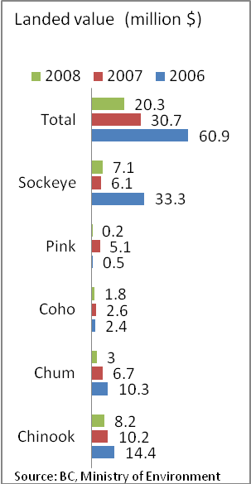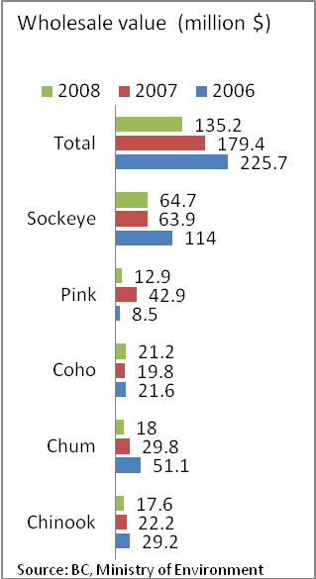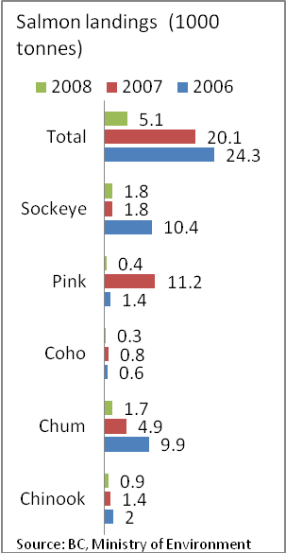
Figure 7: Wild Salmon Landed Value, Wholesale Value and Landings
The table shows a decline in landings over the period from 24.3 thousand tonnes in 2006 to just 5.1 thousand tonnes in 2008. This decline in harvest is due in part to conservation management policies implemented by the BC government. It is interesting that the substantial drop in wild salmon landings, about 75% had serious market implications. This caused landed value to drop by 34% as well as wholesale value by 25%. Most of the decrease in total landings came from two main wild salmon species; Pink (96%, relative to 2007) and Chum (66%, relative to 2007). In brief, the total drop in these two species was 11,800 tonnes that constituted 77% of the total drop in wild salmon landings in 2008.
An interesting point of Figure 7 is the substantial increase in value going from dockside to wholesale. As well, the dockside share falls from 27% in 2006 to just over 15% in 2008 in response to the decline in landings.
Table 5a and 5b list yearly average landing and wholesale price of salmon by species for the period 2006-07. Chinook and Coho are the most valuable wild species according to landing value although Coho, Pink and Sockeye generate higher wholesale value. In addition, prices changed dramatically over time due to supply related problems. Between 2006 and 2007, overall landing price change was about -39% while the change in overall average wholesale price was only -4%. Over this period landed price is more volatile compare to wholesale price.
Table 5a: B.C. Average landing price, $ per kg
Species | 2006 | 2007 | % change in price (06-07) | 2008 | % change in price (07-08)
Chinook | $7.20 | $7.29 | 1.2% | $9.11 | 25.1%
Chum | $1.04 | $1.37 | 31.4% | $1.76 | 29.1%
Coho | $4.00 | $3.25 | -18.8% | $6.00 | 84.6%
Pink | $0.36 | $0.46 | 27.5% | $0.50 | 9.8%
Sockeye | $3.20 | $3.39 | 5.8% | $3.94 | 16.4%
Total | $2.51 | $1.53 | -39.1% | $3.98 | 160.6%

Table 5b: B.C. Average wholesale price, $ per kg
Species | 2006 | 2007 | % change in price (06-07) | 2008 | % change in price (07-08)
Chinook | $14.60 | $15.86 | 8.6% | $19.56 | 23.3%
Chum | $5.16 | $6.08 | 17.8% | $10.59 | 74.1%
Coho | $36.00 | $24.75 | -31.3% | $70.67 | 185.5%
Pink | $6.07 | $3.83 | -36.9% | $32.25 | 742.0%
Sockeye | $10.96 | $35.50 | 223.9% | $35.94 | 1.3%
Total | $9.29 | $8.93 | -3.9% | $26.51 | 197.0%
Source: BC, Ministry of Environment

In contrast, landed and wholesale price movements between 2007 and 2008 show the opposite. In the 2007 and 2008 period, all prices have increased due to significant drop in supply. In particular, Coho, Chum and Chinook landing prices went up dramatically while the average wholesale price of pink salmon rose an incredible 742% in response to some 96% decrease in the supply relative to previous year.
According to the most current data there are 1,786 active salmon licences. The distribution of licences over gear and category are reported in Table 6. Reduced fee is the amount paid by an aboriginal fisherman while full fee is paid by all other fishermen. There has been a stable trend in the total number of wild salmon licences since 2002. In 1995 and 1998, Minister of Fisheries & Oceans implemented a retirement plan to reduce the number of active licences by purchasing current licences on a voluntary basis. As a result, 797 licence eligibilities in 1995 and 1,404 more licence eligibilities in 1998 were retired. In total, the number of licences was reduced by 2,201. Since then the number of licences has been quite stable over the last decade. Overall, entry is limited and subject to management policy.
Table 6 relates licence to gear type while Figure 8 shows volume of landings by gear type for 2008. Most licences are listed for gillnet fishing and the gillnet gear captures about 50% of the total landings with seine landing 29% and finally trawl at 22%.
Table 6: 2008 Number of wild Salmon Licences, Pacific Region
Gear | Category | Number | Total
Seine | Full fee  Reduced fee | 225  18 | 243
Gillnet | Full fee  Reduced fee | 865  163 | 1028
Trawl | Full fee  Reduced fee | 492  23 | 515
Total | Full fee  Reduced fee |  | 1786
Source: DOF
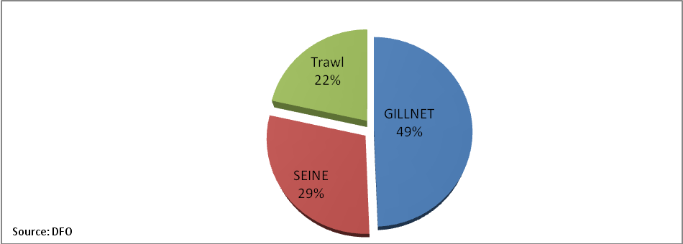
Figure 8: Wild Salmon Landed Volume by Gear

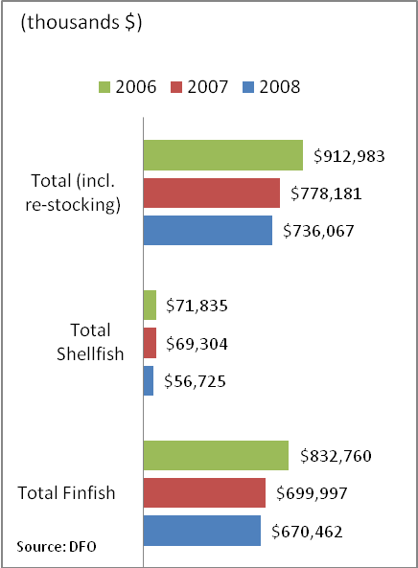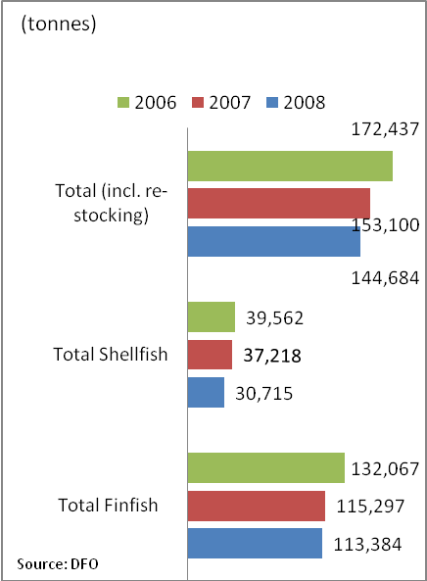
Figure 9: Aquaculture Landed Value and Volume, 2006-08
3.4 Aquaculture
Figure 9 reports value and total harvest of aquaculture production for the period 2006-08. Overall, total production declined by about 19% over the period. Finfish species historically constitute between 75 to 78% of the total farmed species with 22 to 25% for shellfish production. Farmed shellfish averaged $1.85 per kg less than finfish ($5.90 per kg) in 2008.
In Figures 10 information on the value, volume and average price $/kg of farmed finfish species in Canada for the period 2006-08 is presented. There was a serious drop in salmon production in 2007 of about 16,000 tonnes, which interestingly did not affect average harvest prices but overall value did fall. Trout production is very small with an average value of $4.75/kg in 2008, somewhat less than salmon at $5.97/kg in 2008. In total, 93% of the cultured finfish harvested value came from salmon in 2008. Similarly, farmed salmon’s share in the total aquaculture production was recorded at 85% in 2008. Salmon is the main cultured species in Canada.
Figure 10: Farmed Finfish by Species, Value, Volume and Average Price $/kg (source: DFO)
Figure 11 shows shellfish value, volume and average price $/kg for the period 2006-08. Shellfish production is primarily concentrated on mussels and oysters. Together, these two species captured 93% of total cultured shellfish production, which was about 20% of the total aquaculture production in 2008. Clams and scallops are valuable cultured crustaceans although their production is quite limited. It is interesting to note the variation in scallop prices over the three year period compared to relatively stable prices of clams, oysters and mussels.
PEI is the main shellfish producing area in Canada with 64% of the total shellfish harvest, valued at $28 million in 2008. BC is the second main shellfish producer with a 24% landing share.

Figure 11: Farmed Shellfish by Species, Value, Volume and Average Price $/kg (source: DFO)

3.5 Farmed Salmon
Table 7 provides additional information on value of production by province of farmed salmon for the period 2006-08. Farmed salmon reached 104,070 tonnes valued at $621.5 million in 2008, which was several times larger than wild salmon landings that year. Farmed salmon represents about 92% of the total farmed finfish and 72% of the total aquaculture landed value in 2008. BC is the major salmon producing region in Canada with 70% of production worth 400 million dollars in value in 2008. NB and NS combined produce about 35% of national farmed salmon production worth about 200 million dollars in 2008.
Table 7: Farmed Salmon Production by Province (thousand dollars)

 | 2008 | 2007 | 2006
NS | $23,175 | $39,209 | x
NB | $192,140 | $181,609 | x
BC | $406,200 | $384,099 | $407,405
Canada | $621,515 | $604,917 | $748,246

4 Processing
The fish processing industry prepares the fish for final market. Compared to other industries in Canada, this industry is not large generating 0.4% of GDP in 1999. The process involved includes eviscerating, skinning, filleting, breading, pre-cooking, blanching, canning and other methods of preparing fish. Industry Canada defines the principal activities as:

- Canned fish products, manufacturing;
- Clams, processed;
- Crab, canned, manufacturing;
- Crustacean processing;
- Fish and chip dinners, frozen, manufacturing;
- Fish canned, manufacturing;
- Fish cured, manufacturing;
- Fish dinners, pre-cooked, frozen, manufacturing;
- Fish fillets, steaks, blocks, etc., manufacturing;
- Fish liver oil extraction, crude, and manufacturing;
- Fish meal, manufacturing;
- Fish roe, processed, manufacturing;
- Fish, chilled or frozen, manufacturing;
- Fish, processed or prepared, manufacturing;
- Fish, salted or dried, manufacturing;
- Irish moss, processed;
- Lobster, processing;
- Marine animal oil extraction, manufacturing;
- Mollusc processing;
- Oyster canning;
- Ready-to-serve frozen fish products, manufacturing;
- Seaweed processing;
- Shellfish canning, manufacturing;
- Shellfish, processed or prepared; and
- Smoked fish, manufacturing
In 1998, the processing industry represented about 5.5% ($2.9 billion) of total food manufacturing shipments in Canada. The raw supply of fish is provided by salt water, fresh water and aquaculture fisheries. The latter is primarily sold with minimum processing and exported. The processed product is sold to wholesale or export markets.
The fish processing industry is dominated by a few large firms with many outlets and a large number of small independent firms. The eight largest firms in the industry handle about 30% of processed output (Industry Canada, 1995). There are about 400 firms in this industry with 60% in Atlantic Canada, 35% in BC and the remaining in Quebec (Source: Statistics Canada, 1997 Business Register)
According to Industry Canada the fish processing industry has been in a state of flux since the decline of the East Coast groundfishery. Production has shifted from groundfish species to shell fish and imported fish stocks.

5 Retailing
The retail fish sector in Canada represents only 20% total finished product with the vast majority of finished product going to the export market. With open markets for fish, prices in the retail sector reflect world fish prices.
Food retailing in general is a large and complex sector that includes supermarkets, grocery stores, restaurants and fast food operations. There are about 24 thousand retail stores and close to 63 thousand foodservice establishments in Canada, with total consumer sales of $131 billion in 2005.
Fresh fish does not warrant a separate category in Industry Canada’s retail food breakdown and it is aggregated under a category labelled ‘other fresh meat’. This category shows an annual value percentage change of 1% over the period 2005-2007. Frozen fillets, on the other hand, show an annual value percentage change of 18% for 2005-06 and 13% for 2006-07. Surprisingly frozen fish and chips, for the same period show a decline of 21% and 10% in value, respectively. Canned tuna faired better but still registered a decline over the period of 2% and 1% in value, respectively.
Figure 12 shows nominal average monthly price per can of tuna over the period 1995 to March 2010.
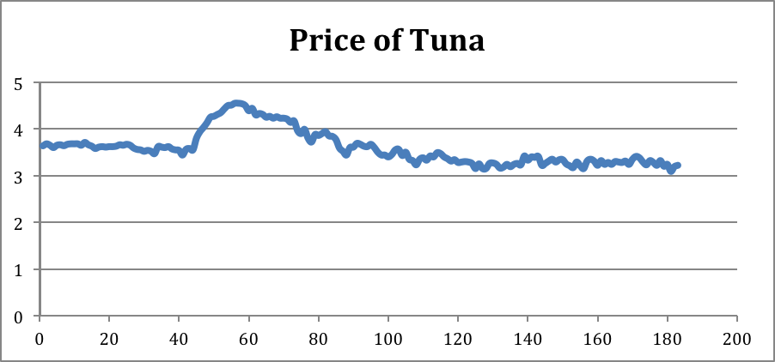
Figure 12. Nominal Price of Canned Tuna, January 1995 to March 2010
The nominal price of tuna has shown a modest decline over the period and of course in real terms the price has declined further. This reflects the very flat demand characteristice in the fish retail market in Canada.
To provide a more general index price of retail fish, Figure 13 provides an aggreate index of retail fin fish for the period January 1995 to March 2010. Over the period the index price shows a gradual increase in the nominial price but in real terms the price is rather flat.
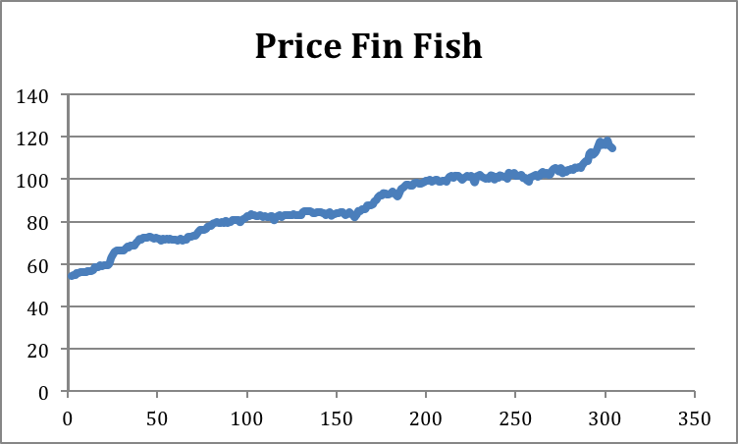
Figure 13. Price of Fresh and Froxen Fin Fish January 1995 to March 2010

The real action in Canadian fisheries is in the export sector and we turn to this issue in the next sector.

6 International Trade
6.1 Exports
International trade is a fundamental component of Canadian fisheries with some 80% of harvest exported. In this situation it is not unreasonable to consider the export market the final market of sale for Canadian fish products. Retail fish prices in Canada will reflect the export price. Table 8 reports the value of fish product exports for the years 2006-2009. Total Canadian fish and seafood exports showed a small increase up to 2008 but the world wide recession forced a decline in export value in 2009. In total, exports reached $3.6 billion in 2009 after a 6.4% decrease compare to the previous year. Fish and crustaceans exports carried the highest share, 89% while preparations of fish and seafood recording a 9.5% share of total Canadian fish and seafood exports in 2009.
Table 8a provides provincial level details about fish and crustacean exports by province for the period 2006-09. Whereas, Table 8b provides provincial level details about preparation of fish and seafood exports by province for the period 2006-09. According Table 8a, BC obtained the highest share among other provinces, 26.2% whereas Atlantic Provinces; NL, PEI, NS, NB and Q in total exported 64% of total Canadian fish and crustaceans exports in 2009.
Table 8: Total Canadian Fish and Seafood Exports (m $)
Product | 2006 | 2007 | 2008 | 2009 | % of Total Export | % Δ in Exports (08-09)
Fish and crustaceans | $3,481,353 | $3,369,921 | $3,378,263 | $3,222,433 | 88.8% | -4.61%
Preparations of fish and seafood | $522,257 | $433,798 | $426,233 | $343,864 | 9.5% | -19.32%
Source: Agriculture and Agri-Food Canada

Table 8a: Total Canadian Exports - (HS 03) Fish and crustaceans exports,
by province, (thousand $)
Province | 2006 |  | 2007 |  |  | 2008 |  | 2009 |  | % of Total Exports
Newfoundland and Labrador | $612,808 |  | $646,069 |  |  | $709,862 |  | $652,876 |  | 19.8%
Prince Edward Island | $152,685 |  | $153,423 |  |  | $155,325 |  | $125,329 |  | 3.8%
Nova Scotia | $916,188 |  | $902,787 |  |  | $792,344 |  | $771,517 |  | 23.4%
New Brunswick | $620,761 |  | $534,543 |  |  | $594,769 |  | $561,458 |  | 17.0%
Quebec | $144,103 |  | $160,747 |  |  | $158,442 |  | $155,021 |  | 4.7%
Ontario | $109,883 |  | $134,528 |  |  | $103,437 |  | $102,324 |  | 3.1%
Manitoba | $46,929 |  | $53,346 |  |  | $46,277 |  | $52,598 |  | 1.6%
Saskatchewan | $127 |  | $96 |  |  | $3,183 |  | $6,908 |  | 0.2%
Alberta | $537 |  | $1,002 |  |  | $285 |  | $1,289 |  | 0.0%
British Columbia | $961,750 |  | $882,731 |  |  | $881,346 |  | $862,418 |  | 26.2%
Yukon | $124 |  | $78 |  |  | $118 |  | $238 |  | 0.0%
Northwest Territories | $1,189 |  | $145 |  |  | $155 |  | $853 |  | 0.0%
Nunavut | $528 |  | $709 |  |  | $1,090 |  | $576 |  | 0.0%
 | $3,567,612 |  | $3,470,206 |  |  | $3,446,633 |  | $3,293,405 |  | 100.0%
Source: World Trade Analyser
Table 8b: Total Canadian Exports - Preparations of fish and seafood (thousand $)
 |  | 2006 |  | 2007 | 2008 |  | 2009 |  | % of Total Exports
Newfoundland and Labrador |  | $168,037 |  | $145,589 | $92,776 |  | $65,527 |  | 18.2%
Prince Edward Island |  | $39,439 |  | $36,684 | $44,453 |  | $24,861 |  | 6.9%
Nova Scotia |  | $41,787 |  | $29,979 | $25,359 |  | $14,930 |  | 4.1%
New Brunswick |  | $162,233 |  | $119,008 | $148,517 |  | $122,239 |  | 33.9%
Quebec |  | $57,120 |  | $55,041 | $63,534 |  | $75,868 |  | 21.1%
Ontario |  | $11,726 |  | $11,159 | $11,026 |  | $10,138 |  | 2.8%
Manitoba |  | $1,294 |  | $1,282 | $2,735 |  | $1,518 |  | 0.4%
Alberta |  | $381 |  | $120 | $483 |  | $1 |  | 0.0%
British Columbia |  | $66,296 |  | $50,896 | $54,150 |  | $45,249 |  | 12.6%
Yukon |  | $0 |  | $0 | $0 |  | $0 |  | 0.0%
Northwest Territories |  | $7 |  | $0 | $0 |  | $0 |  | 0.0%
 |  | $548,321 |  | $449,758 | $443,034 |  | $360,331 |  | 100.0%
Source: World Trade Analyser

Table 8b shows that NB exported the largest share of processed fish products whereas Q and Nfld obtained the second (21%) and third (18%) export positions. Despite the fact that there had been an increasing trend until 2008, almost all exported products experienced a serious decline in 2009. In short, the decline recorded 4.65% for the fish and crustaceans and 19.3% for the preparation of fish and seafood exports.
In order to provide a better understanding of the international markets, distribution of the fish and crustaceans exports by destination of countries is depicted in Table 9. The table presents the ten largest fish and seafood destinations of Canadian exports in 2009. The US is our largest customer with a 65% market share in 2009. Japan, China and Hong Kong are very valuable Asian markets for Canadian exports. In addition, several EU countries, notably Denmark, are also other Canadian exporting markets.
It is worthwhile to take a closer look at the US market to obtain an understanding of which US states import Canadian fish products. Table 10 breakdowns by state the US market for Canadian fish and crustaceans exports over the period 2006-09. Massachusetts recorded the highest share, 41% that corresponds to $851 millions. California is the second most important export market in the US with a 14% share. Geographically the major export pattern is to the eastern US states.
Table 9: Canadian Exports: Fish and Crustaceans exports, by importing country (thousand $)

Country | 2006 | 2007 | 2008 | 2009 | % of Total Exports
US | $2,160,683 | $2,153,458 | $2,119,803 | $2,060,740 | 62.6%
Japan | $335,924 | $292,874 | $288,530 | $260,040 | 7.9%
China | $271,258 | $235,466 | $257,454 | $220,551 | 6.7%
Hong Kong | $107,238 | $91,771 | $91,968 | $107,956 | 3.3%
UK | $42,442 | $54,542 | $45,144 | $68,817 | 2.1%
Russia | $36,865 | $55,763 | $88,998 | $61,918 | 1.9%
France | $62,315 | $68,106 | $65,088 | $60,772 | 1.8%
Denmark | $99,544 | $102,237 | $69,694 | $54,519 | 1.7%
Germany | $33,659 | $29,767 | $48,198 | $34,026 | 1.0%
S. Korea | $43,493 | $37,059 | $35,026 | $33,768 | 1.0%
Others | $374,192 | $349,161 | $336,731 | $330,299 | 10.0%
Total | $3,567,612 | $3,470,206 | $3,446,633 | $3,293,405 | 100.0%
Source: World Trade Analyser. Ranking is performed according to 2009 values

Table 10: Canadian Exports : Fish and Crustaceans exports, by US states (thousand $)

Country | 2006 | 2007 | 2008 | 2009 | % of Total Exports
Massachusetts | $802,749 | $778,233 | $834,138 | $851,134 | 41.3%
California | $312,042 | $284,469 | $244,071 | $280,548 | 13.6%
Washington | $145,775 | $195,229 | $204,242 | $124,294 | 6.0%
New York | $162,701 | $147,172 | $158,099 | $158,908 | 7.7%
Maine | $119,104 | $116,313 | $111,662 | $122,631 | 6.0%
New Jersey | $77,923 | $74,685 | $74,535 | $57,907 | 2.8%
Florida | $79,991 | $65,222 | $71,496 | $55,760 | 2.7%
N. Hampshire | $51,676 | $73,475 | $71,151 | $60,900 | 3.0%
Illinois | $33,879 | $42,247 | $43,803 | $36,223 | 1.8%
Oregon | $38,829 | $46,384 | $39,090 | $33,586 | 1.6%
Other States | $336,013 | $330,031 | $267,517 | $278,849 | 13.5%
Total | $2,160,683 | $2,153,458 | $2,119,803 | $2,060,740 | 100.0%
Source: World Trade Analyser. Ranking is performed according to 2009 values

Table 11 provides the distribution of total fish and seafood exports by species, over the last four years. As can be visualised from the table the main shellfish species; lobster, crab, shrimp and scallop, make up the biggest chunk of total fish and seafood exports at about 51% by value. Lobster and lobster products historically have been the most valuable Canadian fish export. They recorded 22 % of the total exports after a 13% decline in 2009. Similarly, the export of crabs and their related products reached up to 17% of the total exports while shrimp exports were about 9% in 2009. Additionally, farmed and wild salmon exports ware about 17% of the total exports despite a slight decline in 2009. Among other pelagic fish species, herring was about 4.4%. In total, the main four species; lobster, crab, shrimp and salmon make up 68% of the total Canadian fish and seafood exports. Finally, groundfish species; hake, halibut, cod, haddock and flatfish altogether add up to 7.3% of total fish exports. Among groundfish species, halibut recorded the largest export share at 2.9%
Table 11: Canadian Fish and Seafood Exports, by Species (thousands $)
Species | 2006 | 2007 | 2008 | 2009 | % of Total Exports | % Change in Exports (08-09)
Lobster | $1,003,698 | $907,214 | $924,183 | $805,265 | 22.2% | -12.9%
Crabs | $519,934 | $635,019 | $642,934 | $611,286 | 16.9% | -4.9%
Shrimp | $456,355 | $437,768 | $360,228 | $336,484 | 9.3% | -6.6%
Scallop | $100,013 | $111,610 | $104,892 | $95,070 | 2.6% | -9.4%
Clams | $101,310 | $83,812 | $83,644 | $90,859 | 2.5% | 8.6%
Hake | $92,849 | $81,386 | $94,081 | $62,882 | 1.7% | -33.2%
Halibut | $120,761 | $104,027 | $93,320 | $91,873 | 2.5% | -1.6%
Cod | $82,577 | $85,801 | $82,542 | $68,051 | 1.9% | -17.6%
Haddock | $29,751 | $27,332 | $30,728 | $35,348 | 1.0% | 15.0%
Flatfish | $8,811 | $4,786 | $6,516 | $6,271 | 0.2% | -3.8%
Herring | $134,387 | $123,063 | $149,841 | $158,694 | 4.4% | 5.9%
Tuna | $28,566 | $22,928 | $26,979 | $17,577 | 0.5% | -34.8%
Salmon | $697,604 | $610,314 | $629,746 | $616,506 | 17.0% | -2.1%
Other | $705,040 | $635,152 | $646,162 | $630,750 | 17.4% | -2.4%
Total | $4,081,656 | $3,870,213 | $3,875,795 | $3,626,917 | 100.0% | -6.4%
Source: Agriculture and Agri-Food Canada

6.2 Lobster
Figure 20 reports a detailed breakdown of exports by vlaue of lobster for the period 2006-09. Frozen products are the main component of Canadian lobster exports with live lobster exports as the second largest component. Over the four year period there has been a 20% decline in value of lobster exports.
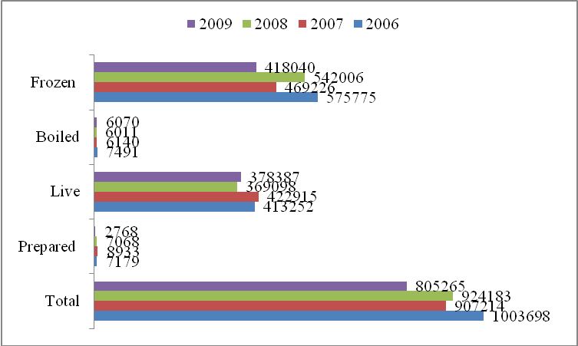
Figure 20: Lobster Exports 2006-2009 (thousand $): (source Agriculture and Agri-Food Canada)

Live lobster exports represent a true “Canadian origin” exported product in the sense that they are harvested and transported direct from Canada. Other product forms, however, are prepared using both domestic and imported small lobsters. In this process small imported lobsters are prepared and then re-exported. For instance, there is a very large trade of small lobsters from Maine to Canada for processing and then re-exported to other countries (mainly USA) as Canadian processed lobster products.
The general decline in lobster exports of 2009 hit the frozen market more so than the live market. Frozen exports experienced a sharp decline, of 23 %, as opposed to only a 9% decline in live exports. Finally, boiled in or not in shell and prepared or preserved lobster products represent a very small share of total lobster exports. This was only about 1% of the total lobster export products worth $8.8 million in 2009.
As presented in Table 12, NS and NB have been historically the largest live lobster exporting provinces in Canada. In 2009, these provinces together recorded 95% of the total live lobster exports. There was a very sharp decline, about 52 %, in the exports of Nfld, recorded in 2009. A similar drop was also present in the exports of Quebec. Nevertheless, aggregate live exports in 2009 increased somewhat (2.5%) from 2008 mainly because of the positive export performance of PEI and NS.

Table 12: Total Live Lobster Exports, by exporter province (thousand $)
Province | 2006 | 2007 | 2008 | 2009 | % of Total Exports | % Change between (08 - 09)
Newfoundland and Labrador | $4,980 | $4,953 | $5,383 | $2,609 | 0.7% | -51.5%
Prince Edward Island | $11,149 | $12,047 | $9,051 | $9,885 | 2.6% | 9.2%
Nova Scotia | $329,733 | $327,125 | $291,294 | $307,192 | 81.2% | 5.5%
New Brunswick | $61,803 | $71,682 | $56,005 | $53,056 | 14.0% | -5.3%
Quebec | $4,713 | $6,448 | $7,215 | $5,146 | 1.4% | -28.7%
Others | $895 | $660 | $149 | $500 | 0.1% | 236.3%
Total | $413,274 | $422,915 | $369,098 | $378,387 | 100.0% | 2.5%
Source: World Trade Analyser

Tables 13, 13a and 13b present further details concerning live lobster exports by the destination of country over the period 2006-09. Table 13 shows live lobster exported value by the destination of country. The US imported 76% of the total live lobsters from Canada. While Belgium and South Korea were the second and third live Atlantic lobster importers from Canada. In general, there was 2.5% increase in the value of live lobster exports in 2009.
Table 13a shows that the US is the largest importer in terms of volume of live lobster and this increased by 5.5% from 2008 to 2009. However, the impact of the world recession can be seen in Table 13a with substantial reductions in lobster imports in Germany, Japan and Korea. Nevertheless, total live lobsters exports by volume increased by 5.1% from 2008 to 2009.

Table 13: Live Lobster Exports Value, by destination of country (thousand $)
Country | 2006 | 2007 | 2008 | 2009 | % of Total Exports | % Change between (08 - 09)
US | $311,974 | $316,879 | $277,723 | $285,634 | 75.5% | 2.8%
Belgium | $21,954 | $20,281 | $16,643 | $17,794 | 4.7% | 6.9%
S. Korea | $11,954 | $12,737 | $11,269 | $11,891 | 3.1% | 5.5%
France | $3,097 | $2,252 | $4,647 | $8,077 | 2.1% | 73.8%
Japan | $15,433 | $14,697 | $9,790 | $7,376 | 1.9% | -24.7%
Hong Kong | $4,765 | $5,243 | $5,197 | $6,787 | 1.8% | 30.6%
Netherlands | $5,441 | $8,144 | $7,067 | $6,608 | 1.7% | -6.5%
Spain | $7,992 | $7,585 | $6,234 | $5,518 | 1.5% | -11.5%
UK | $10,249 | $9,221 | $4,492 | $5,217 | 1.4% | 16.1%
Germany | $4,440 | $5,948 | $9,581 | $4,961 | 1.3% | -48.2%
Subtotal | $397,299 | $402,988 | $352,643 | $359,864 | 95.1% | 2.0%
Total | $413,252 | $422,915 | $369,098 | $378,387 | 100.0% | 2.5%
Source: Agriculture and Agri-Food Canada

Table 13a: Live Lobster Exports, by destination of country (tonnes)
Country | 2006 | 2007 | 2008 | 2009 | % of Total Exports | % Change between (08 - 09)
US | 20,439 | 19,527 | 20,080 | 21,189 | 79.6% | 5.5%
Belgium | 1,211 | 1,079 | 965 | 1,111 | 4.2% | 15.1%
S. Korea | 612 | 661 | 652 | 594 | 2.2% | -8.9%
France | 178 | 113 | 246 | 485 | 1.8% | 97.3%
Japan | 814 | 809 | 525 | 377 | 1.4% | -28.2%
Hong Kong | 259 | 283 | 282 | 427 | 1.6% | 51.5%
Netherlands | 323 | 440 | 460 | 459 | 1.7% | -0.2%
Spain | 396 | 379 | 343 | 334 | 1.3% | -2.5%
UK | 507 | 479 | 249 | 354 | 1.3% | 42.6%
Germany | 242 | 326 | 571 | 280 | 1.1% | -50.9%
Total | 25,803 | 25,160 | 25,312 | 26,605 | 100.0% | 5.1%
Source: Agriculture and Agri-Food Canada

Table 13b shows the average live lobster value (price) by the destination of country over the period 2006-09. A general decline in the average value of live lobsters all over the world is quite obvious from the table. More specifically, average live lobster price to UK, Hong Kong and France decreased by more than 10% in 2009.
Table 13b: Live Lobster Exports , by destination of country (Average Value $)
Country | 2006 | 2007 | 2008 | 2009 | % Change between (08 - 09)
US | 15.3 | 16.2 | 13.8 | 13.5 | -2.5%
Belgium | 18.1 | 18.8 | 17.2 | 16.0 | -7.1%
S. Korea | 19.5 | 19.3 | 17.3 | 20.0 | 15.8%
France | 17.4 | 19.9 | 18.9 | 16.7 | -11.9%
Japan | 19.0 | 18.2 | 18.6 | 19.6 | 4.9%
Hong Kong | 18.4 | 18.5 | 18.4 | 15.9 | -13.8%
Netherlands | 16.8 | 18.5 | 15.4 | 14.4 | -6.3%
Spain | 20.2 | 20.0 | 18.2 | 16.5 | -9.2%
UK | 20.2 | 19.3 | 18.1 | 14.7 | -18.6%
Germany | 18.3 | 18.2 | 16.8 | 17.7 | 5.5%
Total | 16.0 | 16.8 | 14.6 | 14.2 | -2.5%
Source: Agriculture and Agri-Food Canada

6.3. Salmon
Salmon is also an important export product for Canada and we report export values by product form in Figure 21. Total salmon exports have been between 620 and 700 million dollars over the period 2007-09. Fresh or chilled salmon product historically has been the most valuable Canadian salmon product. Compared to other product types, export volume of fresh or chilled products have been quite stable since 2006.
Table 14a provides export destination by country for Atlantic salmon fresh or chilled products. These products represent about 81% of total fresh or chilled salmon products. The US is again the main market for Atlantic salmon with a 98.4% share. The US also experienced the lowest price for salmon at $6.46/kg compared to the highest price obtained in France at $8.93/kg.
Finally, exported quantities of Atlantic salmon are reported in Table 14b. The US imported some 66 million kg of fresh or chilled salmon in 2009. Interestingly all other countries combined imported less than 1 million kg.
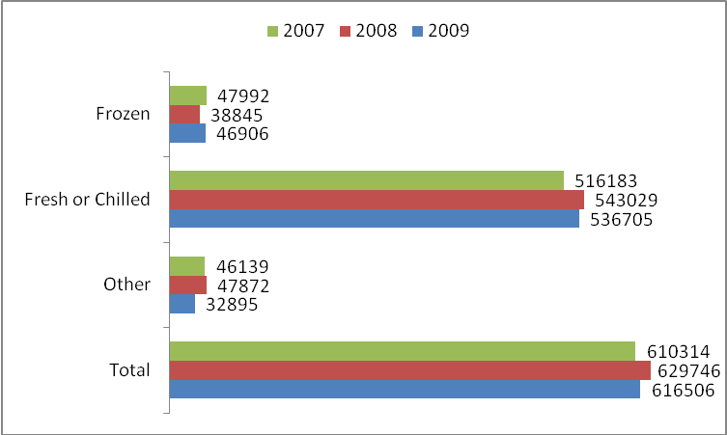
Figure 21: Salmon Exports by species, 2007-09: (thousand $)

Table 14a: Atlantic salmon, farmed (fresh or chilled), (thousands $)
 | 2007 | 2008 | 2009 | % of Total
US | 406,803,434 | 412,902,063 | 430,295,925 | 98.4%
Japan | 6,702,746 | 16,151,888 | 3,925,218 | 0.9%
Taiwan | 3,117,055 | 4,874,244 | 1,721,905 | 0.4%
Hong Kong | 523,750 | 2,507,089 | 1,107,644 | 0.3%
France | 56,809 | 222,425 | 71,476 | 0.0%
Others | 310059 | 1,063,503 | 134,903 | 0.0%
Total | 417,513,853 | 437,721,212 | 437,257,071 | 100.0%
Source: Agriculture and Agri-Food Canada

Table 14b: Atlantic salmon, farmed (fresh or chilled), (Kg)
 | 2007 | 2008 | 2009
US | 66,645,797 | 70,069,641 | 66,550,991
Japan | 1,160,952 | 2,212,645 | 509,548
Taiwan | 680,399 | 864,426 | 252,958
Hong Kong | 107,774 | 423,227 | 167,429
France | 8,558 | 46,152 | 7,999
Others | 51518 | 155,304 | 21222
Total | 68,654,998 | 73,771,395 | 67,510,147
Source: Agriculture and Agri-Food Canada

7 Income and Employment
To present a detailed picture of the industry in terms of employment and income, Canadian Fisheries can be categorized in three groups; commercial fisheries, aquaculture production and processing industry. Table 15 reports employment by category for the years 2007-08. Marine fisheries showed an increase in numbers of fish harvesters and crew of 9.48% over the period representing just over 58,000 individuals in 2008. Keep in mind that this number represents part time or seasonal employment and full time equivalent is about 10,000 individuals. The number of people involved in aquaculture is very much smaller compared to fish harvesters but this is a growing sector of the industry and shows impressive growth in employment up over 20% in 2007-08. The seafood products preparation and packaging sector is large but declining in employment importance. This sector lost over 2,500 employees over the two year period 2007-08. Nevertheless, the impressive growth in aquaculture helped increase employment in the overall fishing sector by 3.5%.

Table 15: Employment by industry, Canada 2007 – 2008
 | 2007 | 2008 | % Change
Commercial fish harvesters and crew¹ | 48,239 | 52,812 | 9.48%
Aquaculture operations^{1,3} | 3,970 | 4,900 | 23.43%
Seafood product preparation & packaging² | 30225 | 27641 | -8.55%
Total | 82,434 | 85,353 | 3.54%
Source:
1 Canadian Fisheries Fact 2009 Report by DFO.
2 Cansim, Table 301 – 0006.
3 Based on the most recent data (2006) and 2008 is from another DFO's report “socio economic impact of aquaculture in Canada"- only direct employment in the industry.

7.1 Marine (Commercial) Fisheries
Commercial fisheries’ employment numbers reported in Table 15 are based on the total number of licenses issued by government regulators but we do not know the number of active fishermen during this period. In this section, we will provide some additional details regarding fish harvesters’ employment and income in this sector.
The provincial distribution of registered fishermen (owners and crews) is reported in Table 16 for 2008. According to the table, most fishermen are located in NS, particularly in the Scotia-Fundy region. The total number of fishing licenses has been roughly constant since the federal government (DFO) does not usually issue new licenses. This has caused the formation of an active resale market for licenses since it is the only way to enter the market.
Table 16: Number of fishermen, by province 2008
 | Region | Core | Non-Core | Total
NS | Scotia-Fundy | 2,874 | 8,850 | 11,724
 | Gulf | 642 | 1,669 | 2,311
NB | Scotia-Fundy | 340 | 1,320 | 1,660
 | Gulf | 1,260 | 3,446 | 4,706
P.E.I. | Gulf | 1,303 | 3,427 | 4,730
Q¹ | Québec | 1,090 | 364 | 1,454
NL¹ | Newfoundland | 4,059 | 841 | 4,900
BC² |  |  |  | 8,505
Total |  | 11,568 | 19,917 | 39,990
Source: DFO
1 Quebec and Newfoundland regions register only those fishers who hold a professionalization certificate. In Newfoundland, this adds approximately 4,500 individuals. Estimated number of crew in Quebec region is 2,000.
2 The number for BC is from 2004, which is the most current by DFO.

License prices change dramatically depending on the region, fishing area and gear type and, of course, the license is very valuable. Nevertheless, it is still quite difficult to distinguish active fishermen, which complicates our analysis. To capture the number of active fishermen as well as their average income, we look at reported incomes for tax purposes.
Revenue Canada keeps detailed records of income of fish harvesters although due to confidentiality reasons not all information is released in the public domain. Nevertheless, some aggregate information is available. Table 17 presents net fishing income by self-employed boat owners and crews. Average income levels across the country are varied but overall income levels are at best dismal. Of course provincial fisheries selling into high end markets can be expected to generate higher employment income levels. For instance, NS with its large lobster and crab sectors recorded the highest average income in 2008 at just over 23,000 dollars.
Table 17: Net fishing income, (thousands $)

 | 2007 |  |  | 2008
 | Number of Reports | Total Income | Average Income | Number of Reports | Total  Income | Average Income | % Average Income
NF | 8,120 | 132,728 | 16.35 | 8,090 | 153,406 | 18.96 | 16.01%
PEI | 1,810 | 52,743 | 29.14 | 2,050 | 36,116 | 17.62 | -39.54%
NS | 3,370 | 99,319 | 29.47 | 3,590 | 82,953 | 23.11 | -21.60%
NB | 1,710 | 21,407 | 12.52 | 1,670 | 17,757 | 10.63 | -15.06%
Q | 560 | 18,280 | 32.64 | 700 | 11,591 | 16.56 | -49.27%
Atlantic | 15,570 | 324,477 | 20.84 | 16,100 | 301,823 | 18.75 | -10.04%
BC | 2,480 | 53,965 | 21.76 | 2,980 | 52,999 | 17.78 | -18.27%
Canada | 19,120 | 397,509 | 20.79 | 19,930 | 357,514 | 17.94 | -13.72%
Source: Revenue Canada

The most startling point of Table 17 is not that income levels are low but rather the overall decline in fishing income levels from 2007 to 2008. The decline in income is true for all provinces except Newfoundland, which reported a decrease in the number of fishermen and an increase in total fishing income. The latter affect is probably due to increased sales of shellfish. Notice that Quebec reports a 50% decline in income levels with PEI reporting a 40% decline. Overall, Canadian fishing income declined on average by 14% over the two year period.
7.2 Aquaculture
In Canada, aquaculture shows the promise of growth and development in the near future. At present it is not large in terms of employment but important in terms of direct and spinoff employment. Table 18 breaks down employment classifications for aquaculture in 2008. Direct employment in this sector is about 4,900 individuals generating average income of about $32,000 annually. This average income level is some 75% higher than for the harvesting sector. Table 18 also reports estimated spinoff jobs related to this sector. Almost 10,000 additional employment opportunities were created from this fishing sector.
Table 19 shows the distribution of employment levels and average income earned in aquaculture by province for 2008. Due to high volume of farmed salmon production, BC captures the largest employment share with 41% of the total jobs created by aquaculture in Canada. NB and PEI also show a large employment share with about 17% and 8% share, respectively.
Table 18: Economic impact of aquaculture in Canada (thousands $), 2008.
 | Employment | Labour Income | Average Labour Income
Direct | 4,900 | 156,800 | $32.00
Indirect | 6,400 | 241,200 | $37.69
Induced | 3,200 | 197,900 | $61.84
Total | 14,500 | 595,900 | $41.10
Source: DFO - Report: “Socio economic impact of aquaculture in Canada, 2008”. Employment number includes direct, indirect and induced jobs.

Table 19: Employment impact of aquaculture by Provinces, 2008 (thousands $)
 | Employment | % of the Total | Labour Income | Average. Lab. Income
BC | 5,960 | 41.10% | $223,900.00 | $37.57
NF | 405 | 2.79% | $13,300.00 | $32.84
NS | 670 | 4.62% | $23,400.00 | $34.93
PEI | 1165 | 8.03% | $31,300.00 | $26.87
NB | 2420 | 16.69% | $77,800.00 | $32.15
Quebec | 159 | 1.10% | $5,069.00 | $31.88
ON | 216 | 1.49% | $6,290.00 | $29.12
Other | 3,505 | 24.17% | $124,841.00 | $35.62
Total | 14,500 | 100.00% | $505,900.00 | $34.89
Source: DFO - Report: Socio economic impact of aquaculture in Canada, 2008. Employment number includes direct, indirect and induced jobs.

4.3 Processing Industry
The fish processing industry although declining in importance still provides valuable employment opportunities to the coastal regions of Canada. Not surprisingly the processing industry is clustered in NS, BC, NL and NB. Table 20 reports on the number of processing establishments by province for the period 2006-07. Statistics Canada defines this sector to include all establishments working in the area of preparation, packaging and shipping of fish products.
Table 20: Number of Establishments, by Province
 | 2006 | 2007 | 2008
BC | 167 | 173 | 173
Nfld | 168 | 168 | 164
PEI | 58 | 57 | 56
NS | 359 | 349 | 333
NB | 148 | 142 | 123
Quebec | 98 | 99 | 91
ON | 53 | 50 | 53
Other | 18 | 19 | 18
Total | 1,069 | 1,057 | 1,011
Source: Cansim, Table 301 - 0006

BC is the only province showing an increase in number of establishments during this period and overall, in Canada, the number of establishments declined by about 6%.
Table 21 provides detailed information on employment numbers in the processing sector by province for the period 2006-07. Again we can break down employment by direct and spinoff jobs. There are a couple of interesting points in the table. First, the processing sector does employ a great many individuals. We should keep in mind that many of these jobs are in areas of less development in Canada and provide seasonal jobs to a sector of the work force that otherwise faces a high probability of unemployment. Second, the job prospects in this industry are declining in all major processing regions of the country. Overall direct employment fell by 10% over the period 2007-08.
Table 21: Total Employment in Canadian Processing industry (number of persons)
 | 2006 | 2007 | 2008 | %Δ 2007-08
BC | 3,035 | 2,692 | 2,591 | -3.80%
Nfld | 7,695 | 8,349 | 7,644 | -8.40%
PEI | 1,619 | 1,749 | 1,627 | -7.00%
NS | 5,389 | 5,661 | 4,963 | -12.30%
NB | 6,394 | 6,952 | 6,004 | -13.60%
Total direct | 26,316 | 27,191 | 24,580 | -10.6%
BC | 486 | 395 | 366 | -7.30%
Nfld | 727 | 776 | 930 | 19.80%
PEI | 229 | 229 | 206 | -10.00%
NS | 717 | 695 | 626 | -9.90%
NB | 464 | 469 | 454 | -3.20%
Total indirect | 3,120 | 3,034 | 3,061 | 0.90%
Source: Cansim, Table 301-0006

Total 22: Salary Payment in Canadian Processing Industry (thousands $)
 | 2006 | 2007 | 2008 | %Δ 2007-08
BC | 82,650 | 71,794 | 68,038 | -5.20%
Nfld | 99,839 | 94,019 | 97,975 | 4.20%
PEI | 23,680 | 24,253 | 25,656 | 5.80%
NS | 73,710 | 74,840 | 69,595 | -7.00%
NB | 78,128 | 84,379 | 69,982 | -17.10%
Total direct | 412,154 | 403,253 | 385,027 | -4.50%
BC | 28,924 | 25,438 | 21,826 | -14.20%
Nfld | 28,755 | 30,829 | 34,199 | 10.90%
PEI | 6,706 | 7,123 | 6,716 | -5.70%
NS | 32,967 | 33,146 | 29,604 | -10.70%
NB | 17,473 | 17,422 | 17,716 | 1.70%
Total indirect | 139,802 | 140,860 | 137,833 | -2.10%
Source: Cansim, Table 301-0006

Table 22 lists salary payments for the processing sector by province for the period 2006-07. This table shows that consistent with the fall in employment total income to this sector fell by 4.5%. However, some consolation is that average annual income levels for direct employees increased from $14.8 thousand in 2007 to just over $15.6 thousand in 2008.

8. FISHERY MANAGEMENT
In this section we will briefly comment on procedures and regulations used in managing Canadian fisheries. Canada, with coasts to three oceans, holds an important position in world fisheries. Comprehensive regulations in the domestic industry are enforced to ensure sustainability of harvest. After setting the total allowable catch (TAC) for each species regulated, DFO allocates harvest shares according to inshore and offshore areas, vessel length, gear type and geography. From this allocation harvest is regulated using both individual quota and non-individual quota policies.
In practice, depending on circumstances there are several different forms of individual quota in use in Canada. In some cases, individual quota units are transferable from one harvester to another. Such individual transferable quota (ITQ) schemes use the market mechanism to ensure efficiency in the regulatory process. However, in many cases restrictions are imposed on transferability of quota and the quota or individual vessel quota (IVQ) is tied to a specific vessel. In each case, the vessel holding the quota has property rights over a certain share of the TAC. Quota can also be assigned to a specific enterprise, or enterprise allocation (EA) quota. To support quota regulations alternative policies are used for the management of some species such as lobster on the east coast and wild salmon on the west. For lobster regulations are based on size and sex of the lobster. For salmon it is common to set a TAC and allow a competitive fishery to fill the total allocation.
Aquaculture is a relatively new and developing industry. It’s potential is in the fact that the market not nature drives success or failure. Government regulation governs health and safety but management is left to the firm. Government regulation is particularly concerned with environmental impacts of production. Growth potential for this industry is based on the availability of abundant coastline and expected increase in seafood demand in North American by 40% by 2010.

9. Conclusion
Canada’s fishing sector is certainly diverse in terms of products produced, geographical location, and employment and income opportunities. It is true that marine fisheries are not the growth sector or driving force in regional development that it once was but with careful fish management policies this sector can still offer opportunities to the next generation. Aquaculture although currently small in terms of production volume holds the potential for future growth and regional development.

The information for this report is gathered primarily from Department of Fisheries and Oceans Canada and Statistics Canada.
China is ranked number one in world fisheries with harvest volume of 17 million tonnes in 2006.
Government attempts at regulation to maintain stocks and economic levels offered mixed results, but did lead to the development of individual transferable quotas as an efficient means to control the fishery. Today for example quotas are used to manage major groundfish stocks on the east coast and herring and halibut stocks on the west coast.
The total number of licenses in Table 16 differs from Table 15 since Table 16 does not include fresh water (sport fishing) as well as additional 6 500 licenses as explained in the footnote of the graph.
Direct employment refers to main production activities such as, hatchery operations, grow-out, harvesting, processing and corporate administration and marketing. Indirect employment refers to such areas as food for fish, oil, vessels etc. Induced employment refers to the estimated number of jobs that are somehow related to the sector.
This industry group (NAICS 3117) comprises establishments primarily engaged in canning seafood, including soup; smoking, salting and drying seafood; preparing fresh fish by removing heads, fins, scales, bones and entrails; shucking and packing fresh shellfish; processing marine fats and oils; and freezing seafood. Establishments known as "floating factory ships", that are engaged in shipboard processing of seafood, are included. (Statistics Canada)

