FOOD AND AGRICULTURE ORGANIZATION OF THE UNITED NATIONS (FAO)

FISHERIES AND AQUACULTURE DEPARTMENT
PRODUCTS, TRADE AND MARKETING (FIPM)



Final report

VALUE-CHAIN ANALYSIS OF INTERNATIONAL FISH TRADE
AND FOOD SECURITY IN THE REPUBLIC OF HONDURAS

Claudia Stella Beltrán Turriago
Consultant

San Salvador, El Salvador
February 2011

TABLE OF CONTENT

SUMMARY 1
INTRODUCTION 2
1. GENERAL CONTEXT OF THE REPUBLIC OF HONDURAS 3
1.1. Socioeconomic aspects 3
1.2. Main macroeconomic indicators 6
2. FISHERIES AND AQUACULTURE PRODUCTION 7
2.1. Shrimp farming 11
2.2. Tilapia farming 12
2.3. Industrial fisheries 13
2.4. Small scale marine fisheries 14
3. EXPORT PRICES FOR THE MARKETS OF UNITED STATES AND EUROPE 15
3.1. Evolution of monthly prices for exports to the United States 15
3.2. Evolution of monthly prices for exports to Europe 19
3.3. Trend of domestic sales prices 21
4. COSTS STRUCTURE 25
4.1. Profitability of the industrial fishing of Caribbean spiny lobster with pots 26
4.2. Profitability of the industrial fishing of Caribbean spiny lobster with scuba diving 28
4.3. Profitability of small-scale fishing of Caribbean spiny lobster 30
4.4. Profitability of the shrimp industrial fishing in the Caribbean 31
4.5. Profitability of the shrimp small-scale fishing 33
4.6. Costs structure of shrimp farming 33
4.7. Costs structure of tilapia farming 34
5. PRODUCTION AND PROCESSING OF PRODUCTS 34
5.1. Elaboration and quality control of export products 35
5.2. Preparation and quality control of products for the domestic market 38
6. TRANSPORT OF PRODUCTS 38
7. DISTRIBUTION CHANNELS 40
7.1. Distribution channels in foreign markets 40
7.2. Distribution channels in the domestic market 41
8. MARKETING 42
8.1. Shrimp 42
8.2. Tilapia 43
8.3. Spiny lobster 44
8.4. Marine fishes 45
9. PER-CAPITA CONSUMPTION IN HONDURAS 47
10. SYNTHESIS OF THE VALUE-CHAIN 50
10.1. Value-chain for industrial aquaculture 50
10.2. Value-chain for industrial fishing 51
10.3. Value-chain for small-scale aquaculture 52
10.4. Value-chain for small-scale fishing 53
11. DISTRIBUTION OF BENEFITS AMONG ACTORS IN THE VALUE-CHAIN 54
11.1. Distribution of benefits in the spiny lobster fishery 56
11.2. Distribution of benefits in the shrimp fishery 57
12. LEGAL FRAMEWORK OF THE FISHERIES AND AQUACULTURE SECTOR 59
13. CONCLUSIONS AND RECOMMENDATIONS 60
BIBLIOGRAPHY 65
ANNEX 1 – DATABASE ABOUT PRICES, VOLUME AND VALUE OF THE PRODUCTS EXPORTED TO UNITED STATES 69
ANNEX 2 – DATABASE ABOUT PRICES, VOLUME AND VALUE OF THE PRODUCTS EXPORTED TO EUROPE 106
ANNEX 3 - LIST OF PEOPLE INTERVIEWED 115

LIST OF TABLES

Table 1 – Indicators of population, employment and purchasing power in Honduras. Period 2000 - 2009 5
Table 2 – GDP at constant prices of 2000, exports and imports in Honduras. Period 2000 – 2009 7
Table 3 – Fisheries and aquaculture production in Honduras. Period 2000 - 2009 (metric tons) 8
Table 4 – Value of fisheries and aquaculture production in Honduras, period 2000 – 2007 (at current prices in millions of US dollars) 9
Table 5 – Summary of the sectoral contribution to the GDP of Honduras, period 2000 – 2007 (at current prices in millions of US dollars) 9
Table 6 – Sectoral exports contribution to the national exports, period 2000 – 2007 (at current prices and millions of dollars) 10
Table 7 – Trade balance of fisheries and aquaculture products from Honduras, period 2000 – 2007 (at current prices and millions of dollars) 10
Table 8 – Summary of the annual average of export prices per kilo to the United States. Period 2000-2010 16
Table 9 – Summary of the annual average of export prices per kilo to Europe. Period 2003-2010 20
Table 10 – Monthly prices per kilo and US dollars, to wholesalers in Honduras. Period 2007 - 2009 22
Table 11 – Summary of annual domestic prices per kilo to wholesalers. Period 2007 - 2009 23
Table 12 – Cash flow for industrial fishing trip of spiny lobster with pots, at current prices, 2007 27
Table 13 – Cash flow for industrial fishing trip of spiny lobster with scuba diving, at current prices, 2007 29
Table 14 – Profitability of the small-scale spiny lobster fishing with pots 30
Table 15 – Profitability of the spiny lobster fishing with scuba diving 31
Table 16 – Cash flow by trip of industrial shrimp fishing in the Caribbean, at current prices, 2007 32
Table 17 – Profitability of shrimp small-scale fishing in the Pacific, at current prices, 2007 33
Table 18 – Cost structure of the shrimp farming 34
Table 19 – National calculation of apparent consumption of fisheries and aquaculture products, 2000 - 2007 47
Table 20 – Estimated per-capita consumption of fisheries and aquaculture products, 2000 - 2007 (in kilos/person/year) 48
Table 21 – Distribution of benefits in the industrial and small-scale capture of Caribbean spiny lobster, with pots and scuba diving 56
Table 22 – Distribution of benefits in the industrial and small-scale capture of shrimp in the Caribbean and the Gulf of Fonseca 58
Table 23 – Summary of monthly prices of exports to United States, 2000-2010 69
Table 24 – Monthly volume and value of shrimp exports to the United States, period 2000 - 2010 73
Table 25 – Monthly volume and value of shrimp exports to the United States, period 2000 - 2010 78
Table 26 – Monthly volume and value of spiny lobster exports to the United States, period 2000 - 2010 84
Table 27 – Monthly volume and value of marine fish (nspf) exports to the United States, period 2000 - 2010 89
Table 28 – Monthly volume and value of snapper (Lutjanidae spp.) exports to the United States, period 2000 - 2010 95
Table 29 – Monthly volume and value of grouper exports to the United States, period 2000 - 2010 100
Table 30 – Summary of monthly prices of exports to Europe, 2003-2010 106
Table 31 – Monthly volume and value of shrimp exports to Europe, 2003-2010 109
Table 32 – Monthly volume and value of tilapia skin leather exports to Europe, 2003-2010 112

LIST OF CHARTS

Chart 1 - Export prices of shrimp tails to the United States, 2000-2010 16
Chart 2 - Export prices of tilapia to the United States, 2000-2010 17
Chart 3 - Export prices of spiny lobster to the United States, 2000-2010 17
Chart 4 - Export prices of marine fish (nspf) to the United States, 2000-2010 18
Chart 5 - Export prices of snapper to the United States, 2000-2010 18
Chart 6 - Export prices of grouper to the United States, 2000-2010 19
Chart 7 – Export prices of shrimp to Europe, 2003-2010 20
Chart 8 – Export prices of tilapia skins leather to Europe, 2003-2010 21
Chart 9 – Trend of national prices of shrimp, weakfish, grouper, red snapper and tilapia. Period 2007 – 2009 23
Chart 10 – Value-chain for industrial aquaculture 51
Chart 11 – Value-chain for industrial fishing 52
Chart 12 – Value-chain for small-scale aquaculture 53
Chart 13 – Value-chain for small-scale fishing 54

SUMMARY

The strategic lines of fisheries and aquaculture in Honduras are: farmed shrimp (71,2% of production volume), tilapia culture (21%), shrimp fishing (3%), spiny lobster (2,7%) and marine finfish (1,3%). The sector contributes with a 5% to the national GDP and 36,6% to the agricultural sector, with an average value of US$ 385 million per year and exports of US$ 184 million per year, that represents 4,4% of the total exports and 50% of the total production value of the sector.

Regarding shrimp (of fishing and farming) and tilapia, the profitability is largely influenced by Asian competition, while the lobster market is heavily dependent of the economic cycle in the United States economy, which is the main buyer of Caribbean spiny lobster. Shrimp prices have had a decrease of 80,5% between 2000 and 2010 (from US$ 11,82 to 6,55 per kilo), while tilapia prices increased a 34,2% (US$ 5,32 to 7,14 per kilo) and the value of lobster also increased 33,6% (from US$ 21,75 to 29,05 per kilo). In the case of marine fishes, snapper prices increased a 35% and grouper grew 66% over the decade.

Shrimp farming takes place at the south of the country and the culture of tilapia is concentrated in the central zone. There are 231 shrimp farms, 11 hatcheries for shrimp seed, two diagnostic laboratories for water quality and aquatic pathology, and 13 industrial tilapia projects. For processing there are eight shrimp plants and other three for tilapia. About marketing there is not information about the quantity of companies involved, because the same producers and processors are in charge of exports and sales in the domestic market, or through wholesalers and retailers.

Industrial fishing takes place in the Caribbean. The fleet includes 216 vessels (year 2009) for lobster, shrimp, finfish and queen conch. There are also 23 processing plants in La Ceiba and Bay Islands that also works with squid and crab. The estimated employment generation is distributed as follows: 5 430 in the industrial fleet, 17 200 in small-scale fisheries, 27 000 in shrimp farming, 11 600 in tilapia farming both at industrial and small-scale, and 1 980 in processing plants, for a total of 63 210 direct jobs. For the marketing stage there is no accurate data about the number of wholesalers, retailers and brokers involved in fishing and small-scale aquaculture.

About the creation of added value in the processed and unprocessed products for export, United States and Europe ask to the Honduran exporters for fresh and frozen seafood with little processing because they are mostly desired in a more natural state (as occurs with spiny lobster tails and the larger shrimp units) or because they use them as raw material for new products. Although a higher added value could be more profitable, the required investments to adapt the production line could affect profitability in the short and medium term, so only few producers have made the adjustments.

INTRODUCTION

FAO with the financial support from NORAD (Norwegian Agency for Development Cooperation), has undertaken a comprehensive analysis of the value-chain of international fish trade, with an impact assessment of the small-scale sector in developing countries, in order to identify ways to improve food security for local populations through more informed policy decisions.

The project will analyze the distribution of benefits in the value-chain and the linkages between the relative benefits obtained and the design of it. Comparisons will be made between national, regional and international value-chains, in order to understand better how developing countries can increase the value derived from their fisheries resources.

The project carries out case studies of the small-scale sector in 10 developing countries and two developed countries in order to examine the factors that determine prices and profit margins through the value-chain, as well as the distribution of benefits among different stakeholders (fishers, suppliers, traders, consumers, State, civil society, etc.). Includes marine fisheries, aquaculture and inland fisheries, and it makes particular emphasis on the processing to compare the differences in value creation from the export of unprocessed and processed products.

Among the 12 selected countries was included the Republic of Honduras, whose case study is the present document. The objectives of the study are:

- Provide an overview of the products to be included in the econometric analysis of the value-chain of fish products in Honduras. It will have basic information about each of the fisheries to be researched, including the linkages from the markets of first sale (capture / culture) to retail sales, as well as the market structure in each level. The selection of the five fisheries for the value-chain analysis will be done in consultation with the lead consultant.
- Undertake appropriate data collection and surveys (if appropriate), as well as relevant assessments, market analysis and econometric applications, including econometric analysis of the selected products for the value-chain in the small-scale sector.

For that, there will be a comprehensive analysis of the chain's most important resources for Honduras. About marine fisheries: Caribbean spiny lobster, shrimp and finfish fisheries in the Caribbean and the Pacific. On aquaculture: tilapia and farmed shrimp.

GENERAL CONTEXT OF THE REPUBLIC OF HONDURAS

The Republic of Honduras is part of the Central American Isthmus and has an area of 112 492 km². Shares land borders with Guatemala, El Salvador and Nicaragua, as well as marine borders on the Caribbean with Mexico, Grand Cayman, Nicaragua, Colombia, Guatemala, Belize, Jamaica and Cuba (the last four pending to define borders), while on the Pacific shares the Gulf of Fonseca with El Salvador and Nicaragua, where although the International Court of Justice in The Hague ruled in 1992 that the three countries must agree on the rights of each one on the shared use of the Gulf of Fonseca, disagreements persist between them.

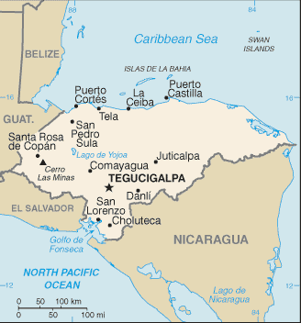
Source: www.maps.mygeo.info

Socioeconomic aspects

According to the National Statistics Institute (INE, for its abbreviation in Spanish), the national population for 2010 is estimated on 8 045 990 people, of which 50,5% live in urban areas and 49,5% in rural areas.

The Economic Commission for Latin America and the Caribbean (ECLAC) identifies as poor those whose incomes are below the minimum necessary to meet their basic needs. Extreme poor are those people whose incomes are below the minimum required to satisfy their food needs. When comparing the rates between 2002 and 2007 is shown that poverty in Honduras was reduced from 77,3% to 68,9%, while extreme poverty (included in the poverty rate) decreased from 54,4% to 45,6% during the same period. According to ECLAC, the growth in average incomes (revenues produced in the country and remittances by emigrant relatives) has been an important factor to reduce poverty and extreme poverty in Honduras.

Regarding food security and based on FAO data, between 1990 and 2005 undernourishment declined from 19% to 12%, which represents an improvement in food situation of its inhabitants. However, analysis about food security conducted in the country indicates that the Honduran staple diet is monotonous since 80% of calories come from only 10 foods with a high share of maize and beans. The domestic supply of animal origin food includes: beef, pork, milk, eggs, chicken and fish.

With regard to unemployment and also based on ECLAC data, the national average rate between 2001 and 2009 was 5,6% and ranged from 5,9% in 2001 to 4,9% in 2009. As for those employed, 50,2% are self-employed and unpaid family workers, 47,5% have a permanent wage and 2,3% are employers.

Another important social indicator is the minimum wage, which aims to establish a sufficient income level to fulfil the needs of workers and their families. However, its effectiveness is linked to inflation and the economic growth of the countries. According to a report of the International Labour Office (ILO), the minimum wage in Honduras grew from US$ 69 per month in 2001 to US$ 291 in 2009 that represents an increase of 355% during the decade. Furthermore, inflation fell a 46% during the same period, which could mean that purchasing power of those who live with the minimum wage (which in theory are on the poverty line limit) should have increased 400% and therefore they should have won more possibilities to purchase goods and services.

Despite the above, according to a recent ECLAC study, the situation is not so positive. To counter the effects of the economic crisis, the Honduran government increased the minimum wage of 2009 in 61% compared to 2008 but it brought as a consequence an increase of unemployment from 3,9% in May 2008 to 4,9% in May 2009. This result was influenced by the loss of 60 000 jobs in the automotive and maquila industries as well as in small enterprises, the contraction of the domestic demand and rising production costs.

Table 1 – Indicators of population, employment and purchasing power in Honduras. Period 2000 - 2009
Year | Population | Minimum monthly wage (US$) | Unemployment rate | Inflation rate
2000 | 6 369 200 | 64 |  | 10,1%
2001 | 6 530 331 | 69 | 5,5% | 8,8%
2002 | 6 694 761 | 72 | 5,9% | 8,1%
2003 | 6 860 842 | 79 | 7,4% | 6,8%
2004 | 7 028 389 | 83 | 8,0% | 8,2%
2005 | 7 197 303 | 92 | 6,1% | 8,8%
2006 | 7 367 021 | 102 | 4,6% | 5,6%
2007 | 7 536 952 | 113 | 3,9% | 6,9%
2008 | 7 706 907 | 181 | 4,2% | 11,4%
2009 | 7 876 662 | 291 | 4,9% | 5,5%
Sources: ECLAC and ILO.

The slowdown in the economy in 2008 intensified in 2009 by the international financial crisis which reduced the external demand and also due to the contraction of the domestic demand, partly caused by the reduced flow of remittances from Hondurans living abroad and also by the political crisis generated by the removal of the President Manuel Zelaya in June 2009, which increased the levels of political and economic uncertainty. The economy contracted a 1,9% and the most affected sectors were: manufacturing, agriculture and construction.

The political crisis also affected relations with the international community, the International Monetary Fund (IMF) and the multilateral banks withdrew their financial support, thus accentuating the decline in both public and private investment and domestic consumption.

In November 2009, new elections were held and with the new government of President Porfirio Lobo at the beginning of 2010, there has been a gradual restoration of relations between Honduras and the international community and multilateral financial institutions, except with the Organization of American States (OAS), that at the closing date of this report, still does not recognize the new government chosen by popular election and therefore the country is still excluded from the Organization.

The massive wave of dismissals in 2009 caused by the strong increase in the minimum wage, particularly affected the small and medium enterprises. This situation forced the Government to amend the measure in November 2010 as follows: Companies that are employing more than 50 workers will pay the minimum monthly wage of US$ 311 while maquila industries will pay at least US$ 206. It is expected that this new measure can contribute to revitalize domestic demand and to alleviate the socioeconomic crisis.

The political and economic situation has also affected the fisheries and aquaculture sector. Industry representatives interviewed for this project consider that although the level of crisis has been reduced is still perceived a political and legal instability, which implies a high vulnerability for the sector.

Although the national crisis did not affect the continuity of the majority of fishing enterprises since they are covered under the free zone regime, because shrimp and tilapia are classified as non-traditional exports, one of the major farmed tilapia companies since 1996, that annually produced 9 800 tonnes for export to the United States, had to shut down operations at the end of 2010.

Main macroeconomic indicators

The most important sectors of the Honduran economy are: agriculture (coffee, shrimp, tilapia, vegetables and fruits), construction, maquilas and manufacture (cigarettes, wood products including furniture, paper, board and silver).

The economic and political situation of the years 2008 and 2009 caused that manufacturing, particularly textile maquilas and harnesses for the automotive industry, had been reduced in 7,1% (but still represents 19,7% of the GDP). Was also weakened the construction (9,8%), trade (9,5%) and agriculture (1,7%) by the fall in the international prices of coffee, oil palm and banana. As a result, the exports of goods decreased 21% and imports in 28%.

According to ECLAC, these trends began to reverse on early 2010 and have now recovered exports of coffee, bananas and maquilas as well as imports of raw materials, fuel and supplies for the maquila industry.

Table 2 – GDP at constant prices of 2000, exports and imports in Honduras. Period 2000 – 2009
Year | National GDP  (prices 2000) | Primary sector GDP | Exports | Imports
2000 | 7 104 | 1 021 | 3 343 | 3 988
2001 | 7 000 | 1 000 | 3 423 | 4 152
2002 | 6 842 | 985 | 3 745 | 4 382
2003 | 6 774 | 954 | 3 754 | 4 774
2004 | 6 857 | 975 | 4 534 | 5 827
2005 | 7 047 | 923 | 5 048 | 6 545
2006 | 7 499 | 992 | 5 277 | 7 303
2007 | 7 972 | 1 047 | 5 784 | 8 888
2008 | 8 287 | 1 052 | 6 458 | 10 509
2009 | 8 130 | 1 034 | 5 090 | 7 560
Source: Central Bank of Honduras (BCH)

Based on statistics from the Central Bank of Honduras (BCH, for its abbreviation in Spanish), calculated at constant prices of 2000, though with some ups and downs Honduras GDP followed an upward trend from 14,4% between 2000 and 2009, with an average value of US$ 7 351 million. Within this, primary sector GDP "Agriculture, livestock, hunting, forestry and fishing" was less dynamic with an absolute increase of 1,2% during the same period and an average value of USD 998 million.

The trade balance had a deficit during this decade due to imports were always higher than exports. The average value of imports was US$ 6 393 million while exports amounted to US$ 4 645 million.

FISHERIES AND AQUACULTURE PRODUCTION

Since the early 2000s, the strategic lines of fisheries and aquaculture in Honduras have been shrimp and tilapia cultures, followed by marine fisheries: Caribbean spiny lobster (Panulirus argus), white shrimp (Litopenaeus occidentalis) and other varieties of deep-water shrimp in the Caribbean, as well as shallow-waters shrimp in the Pacific (Gulf of Fonseca), several species of finfish (Caribbean and Pacific) and queen conch of the Caribbean (Strombus gigas).

The 2000-09 statistics shown the sector is based on aquaculture, that represents 92,11% of the total production. The five resources analyzed in this study constitute 99,14% of the total volume, with the following order of importance: farmed shrimp (71,2%), farmed tilapia (21%), wild shrimp (3%), Caribbean spiny lobster (2.7%) and finfish (1.3%).

The queen conch of the Caribbean (Strombus gigas) was excluded of the value-chain analysis, which captures just represent 0,9% of the production volume during the period in question. This fishery has been subject of higher regulation in recent years both from the Caribbean countries and for the Convention on International Trade in Endangered Species of Wild Fauna and Flora (CITES), due to the downward trend of their stocks, illegal fishing and the insufficiency and inefficiency of the monitoring, control and surveillance systems.

Table 3 – Fisheries and aquaculture production in Honduras. Period 2000 - 2009 (metric tons)
 | 2000 | 2001 | 2002 | 2003 | 2004 | 2005 | 2006 | 2007 | 2008 | 2009 | Contri  bution
Marine fisheries | 5.343,8 | 3.349,9 | 3.447,2 | 2.098,5 | 2.552,8 | 2.547,5 | 2.111,5 | 2.520,2 | 2.154,7 | 1.862,1 | 7,9%
Shrimp | 2.876,3 | 1.558,3 | 1.032,1 | 652,4 | 853,2 | 968,5 | 571,3 | 771,3 | 670,6 | 623,8 | 3,0%
Spiny lobster | 959,8 | 1.101,0 | 1.021,9 | 951,2 | 1.107,1 | 958,8 | 705,0 | 1.112,3 | 973,2 | 716,5 | 2,7%
Finsfish | 431,9 | 277,9 | 391,2 | 406,2 | 592,6 | 620,2 | 711,9 | 517,6 | 410,9 | 384,9 | 1,3%
Queen conch | 1.075,9 | 412,7 | 1.002,1 | 88,8 | moratorium | moratorium | 123,3 | 119,0 | 100,0 | 137,0 | 0,9%
Aquaculture | 13.602,4 | 18.847,5 | 22.438,0 | 29.691,0 | 33.780,0 | 38.194,0 | 46.635,0 | 43.187,0 | 38.583,8 | 41.981,9 | 92,1%
Farmed shrimp | 12.041,0 | 16.718,0 | 18.149,0 | 25.427,0 | 27.748,0 | 28.385,0 | 35.811,0 | 30.367,0 | 25.793,1 | 32.112,8 | 71,2%
Tilapia | 1.561,4 | 2.129,5 | 4.289,0 | 4.264,0 | 6.032,0 | 9.809,0 | 10.824,0 | 12.820,0 | 12.790,7 | 9.869,1 | 21,0%
Total | 18.946,2 | 22.197,4 | 25.885,2 | 31.789,5 | 36.332,8 | 40.741,5 | 48.746,5 | 45.707,2 | 40.738,5 | 43.844,0 | 100,0%
Growth |  | 17,16% | 16,61% | 22,81% | 14,29% | 12,13% | 19,65% | -6,23% | -10,87% | 7,62%

This table shows that marine fisheries production declined 187% between 2000 and 2009, while aquaculture grew 209% over the same period. The decline in catches is due to the overexploitation of shrimp and the reduction in finfish and queen conch catches. Although management measures have been implemented and is expected that these measures will allow recovering the stocks in the medium and long term, perhaps its effects won’t be displayed in the short term.

By contrast, the excellent natural conditions, the optimization of production systems in the industrial projects, and positioning in the market of tilapia and farmed shrimp, has given to Honduras an interesting perspective of its aquaculture to the future.

Table 4 – Value of fisheries and aquaculture production in Honduras, period 2000 – 2007 (at current prices in millions of US dollars)
 | 2000 | 2001 | 2002 | 2003 | 2004 | 2005 | 2006 | 2007 | Annual average
Price per tonne (US$) | 10 649,41 | 10 929,55 | 10 673,21 | 10 441,05 | 11 096,81 | 11 259,19 | 12 990,42 | 12 997,66 | 11 379,66
Volume production | 18 946,23 | 22 197,38 | 25 885,25 | 31 789,51 | 36 332,78 | 40 741,48 | 48 746,45 | 45 707,15 | 33 793,28
Production value (million US$) | $ 201,77 | $ 242,61 | $ 276,28 | $ 331,92 | $ 403,18 | $ 458,72 | $ 633,24 | $ 594,09 | $ 384,56

Table 5 – Summary of the sectoral contribution to the GDP of Honduras, period 2000 – 2007 (at current prices in millions of US dollars)
 | 2000 | 2001 | 2002 | 2003 | 2004 | 2005 | 2006 | 2007 | Annual average
National GDP | 5 080,80 | 5 624,60 | 6 157,10 | 6 842,10 | 7 742,70 | 8 834,10 | 9 915,10 | 11 310,60 | 7 688,39
Primary sector GDP | 806,80 | 820,60 | 828,30 | 873,00 | 1 034,60 | 1 206,10 | 1 287,30 | 1 456,40 | 1 039,14
Fisheries and aquaculture GDP | 201,77 | 242,61 | 276,28 | 331,92 | 403,18 | 458,72 | 633,24 | 594,09 | 384,56
Primary sector contribution to national economy | 15,88% | 14,59% | 13,45% | 12,76% | 13,36% | 13,65% | 12,98% | 12,88% | 13,69%
Fisheries and aquaculture contribution to national economy | 3,97% | 4,31% | 4,49% | 4,85% | 5,21% | 5,19% | 6,39% | 5,25% | 4,96%
Fisheries and aquaculture contribution to primary sector | 25,01% | 29,56% | 33,35% | 38,02% | 38,97% | 38,03% | 49,19% | 40,79% | 36,62%
Sources: Central Bank of Honduras (national GDP and of primary sector) and Regional Workshop of macroeconomic indicators - FIINPESCA-FAO/OSPESCA/SWEDEN Project, 2009.

During the reviewed period, fisheries and aquaculture accounted 5% of the national economy and 36,6% of the primary sector, with an average value of US$ 384,6 million annually. Although the sectoral share in the GDP is higher than in other Central American countries, these activities are also of outstanding importance to Belize (11,3% of GDP), Panama (4.5%) and Nicaragua (4.4%).

Table 6 – Sectoral exports contribution to the national exports, period 2000 – 2007 (at current prices and millions of dollars)
Year | National exports | Fisheries and aquaculture exports | Contribution
2000 | 3 343,40 | 192,27 | 5,75%
2001 | 3 422,70 | 217,91 | 6,37%
2002 | 3 744,90 | 138,09 | 3,69%
2003 | 3 754,00 | 153,29 | 4,08%
2004 | 4 533,90 | 159,71 | 3,52%
2005 | 5 048,00 | 187,88 | 3,72%
2006 | 5 276,60 | 214,65 | 4,07%
2007 | 5 594,30 | 204,57 | 3,66%
Annual average | $ 4 339,73 | $ 183,55 | 4,36%
Sources: BHC (Honduras) and SIECA

Table 7 – Trade balance of fisheries and aquaculture products from Honduras, period 2000 – 2007 (at current prices and millions of dollars)
Year | Exports | Imports | Trade balance
2000 | 192,27 | 17,01 | 175,26
2001 | 217,91 | 14,76 | 203,15
2002 | 138,09 | 13,45 | 124,64
2003 | 153,29 | 13,13 | 140,16
2004 | 159,71 | 16,45 | 143,26
2005 | 187,88 | 18,70 | 169,18
2006 | 214,65 | 20,96 | 193,69
2007 | 204,57 | 21,31 | 183,26
Average | 183,55 | 16,97 | 166,58
Source: SIECA

Shrimp farming

Honduras is the largest producer of farmed shrimp in Central America. Between 2000 and 2007 produced 44% of the regional volume, followed by Nicaragua (14%), Belize (12%), Guatemala (11%), Panama (10%), Costa Rica (8%) and El Salvador (1%). The activity takes place at the south of the country, in the departments of Valle and Choluteca, in the Honduran portion of the Gulf of Fonseca (Pacific Ocean).

The cultures are in areas of exchange of inland and marine waters and mangrove areas in the Gulf. It began in the late 60's but became stronger during the 80s and as well as most farming shrimp countries in the Western Hemisphere, the objective specie is the white shrimp of the Pacific (Litopenaeus vannamei).

This activity began its development since the 80's, when the country offered political and legal security, as well as economic benefits to attract foreign investments. For this reason, some companies are from foreign investors and others have Honduran capitals.

In terms of size, cultures bigger than 151 ha are classified as industrial, from 51 to 150 ha are medium-scale and less than 50 ha of small-scale. From the social point of view, it is noteworthy that small-scale projects are not owned of peasants nor low-income people, but of people with some financial solvency level of different areas of the country, as this is a profitable but high cost activity.

According to the National Aquaculture Association of Honduras (ANDAH, for its abbreviation in Spanish), the water surface potential is 18 500 ha, of which 17 051 ha are in production (65% are large-scale enterprises while the other 35% are cultures of medium and small-scale). In 2010 there were 231 projects that produce annually around 21 360 tonnes for export. It is not expected to use the full potential of water surface because the Gulf of Fonseca has been declared as a zone of mangroves protection and the industry has committed to cooperate with mangrove reforestation projects, tree planting and environmental education in schools nearby communities. Moreover, the Gulf has problems of water pollution, thus shrimpers have developed systems to mitigate and manage semi-intensive cultures with densities from 10 to 20 post larvae/m².

Regarding the occupation of workforce, shrimp aquaculture generates 27 000 direct jobs, of which 40% are occupied by women and benefits 160 000 people. Also are estimated 120 000 indirect employments among suppliers for the stages of production, processing, transportation and marketing. As well, the activity has helped to boost development in the departments of Choluteca and Valle since the early 90's, where it is possible to buy several supplies, but the feed must be purchased in the city of San Pedro Sula (Cortés department) or abroad.

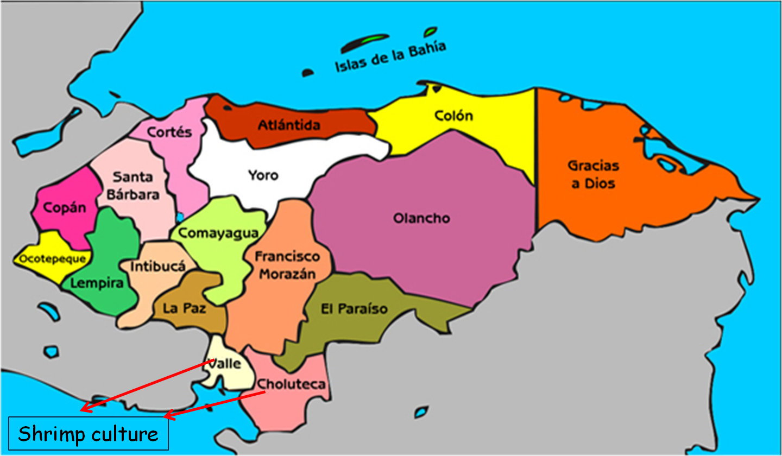

Tilapia farming

Tilapia farming grew 130% between 2002 and 2009. Currently Honduras is the leading Latin American supplier of fresh tilapia fillet in the United States market, displacing to Costa Rica and Ecuador to the second and third position respectively, due to Ecuador is facing technical problems on the polyculture of tilapia and shrimp. In Central America, Honduras is the second largest producer of tilapia (Costa Rica 58%, Honduras 26%, Guatemala 9%, El Salvador 6%, Belize and Panama 1%).

According to the 2007-2008 National Agricultural Survey of INE, in Honduras there are 557 ha cultivated where are developed industrial projects (over 50 ha), medium (5 to 50 ha) and small-scale (less than 5 ha). 61% of production comes from industrial cultures, and 39% are medium and small-scale projects. The aquaculture industry is concentrated in the departments of Cortes, Olancho, Comayagua, Copan, while small-scale is dispersed throughout the country.

As well as in the case of farmed shrimp, tilapia farming begans since the 80's, and the most important enterprises are of foreign investors, while the medium and small-scale projects are of Honduran producers.

Yojoa Lake, with a length of 16 km and width of 6 km, is located between the departments of Comayagua, Cortes and Santa Barbara and is one of the most important water bodies, which in 2010 are developed three industrial tilapia projects in cages and several small-scale projects. Likewise, in the Hydroelectric Dam Francisco Morazan - El Cajon (between the departments of Comayagua, Yoro and Cortes) there are other two large tilapia projects with cages.

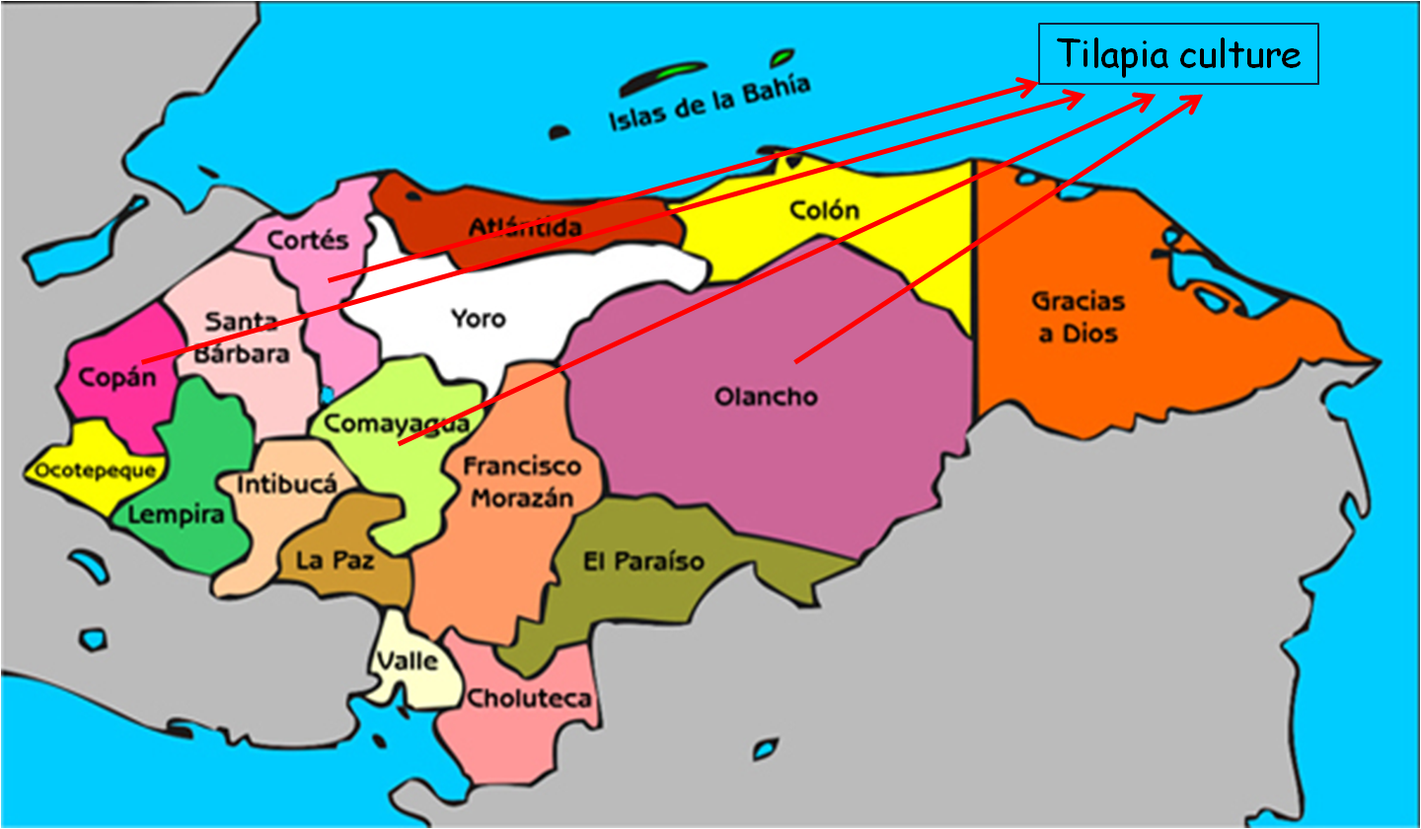

The cultured species are red tilapia (Oreochromis sp.) black (O. mosambicus) and white (O. niloticus). Culture systems are: intensive in floating cages and ponds, semi-intensive and extensive ponds. The growing season varies between 330 and 340 days to obtain individuals of 950 to 1 000 gr.

Regarding workforce occupation, there are no consolidated data available but estimates made with people interviewed for this study suggest that in the central region of the country, industrial and medium-scale fish farming generates about 6 000 jobs including projects with ponds, floating cages and processing plants while according DIGEPESCA (2007), small-scale aquaculture generates around 5 600 jobs, although it is difficult to quantify them accurately because many farmers and landowners combine fish farming with agriculture and / or livestock, as they seek to maximize the use of land and water sources available.

Industrial fisheries

Takes place exclusively in the Caribbean as in the Gulf of Fonseca there are just small-scale fishing. The resources of major interest include: spiny lobster (Panulirus argus), shrimp (Litopenaeus Aztecas, L. duorarum and L. schmitti), finfish fisheries (snapper - Lutjanus spp and grouper - Epinephelus guttatus, among others), as well as queen conch (Strombus gigas).

With regard to this last specie, currently is running a scientific research to determine the density of Strombus gigas in the industrial fishing areas, in order to suspend the permanent closure that will rule until it has a better knowledge about the response levels of the resource to the exploitation. After this, CITES may suspend the moratorium set on September 2003 to the industrial fishing and the exports of queen conch.

Regarding fleet, DIGEPESCA has reported for 2009 the active fleet is composed by 216 vessels distributed as follows: 91 (42%) spiny lobster vessels with pots, 52 (24%) spiny lobster vessels with scuba divers, 47 (22%) trawlers, 22 (10 %) long-liners and 4 (2%) for queen conch. Employment generation on board is 5 430 people, considering a crew of 12 in the lobster vessels with pots, 75 in the vessels with scuba divers and six in the trawlers, long-liners and for queen conch.

At national level but with emphasis on the Caribbean, there are 23 processing plants. It is estimated that each one generates about 86 jobs (17% full-time and 83% female at part-time to the processing area) for a total of 1 980 jobs.

Small scale marine fisheries

It develops in the Caribbean and the Gulf of Fonseca, usually within the first three nautical miles, with basic tools of production: wooden or fibreglass boats from 10 to 25 m in length, outboard motors of 25, 40 or 75 HP and different gears depending on the fishery (trammel nets, hand lines, traps and tanks for scuba divers in lobster and queen conch fisheries). The duration of the fishing trips is between 6 and 12 hours a day although most boats have autonomy for three days.

According to estimates of the FIINPESCA Project, in Honduras there are 17 200 small-scale fishers (63% in the Caribbean, 19% in the Gulf of Fonseca and 18% in inland waters). Although DIGEPESCA has several weaknesses that have limited its capacity to maintain current data, an exception is the Gulf of Fonseca where there is better information.

This zone produces about 50% of the national small-scale fishing; there are about 85 communities with more or less 3 220 fishers and 1 600 boats. Given its strategic importance, since 2003 the Spanish Agency for International Cooperation (AECID, for its abbreviation in Spanish) has been working in the region with the project "Fisheries Development in the Gulf of Fonseca AECID / DIGEPESCA" whose main objective is to improve food security through the development of fishing, processing and marketing of its products through training, quality improvement and equipping of a market called "Centre of marketing and sanitation of fisheries and aquaculture products in the Gulf of Fonseca", where works together: fishers, aquaculture producers, informal traders and local authorities involved in the regulation of prices.

In the case of small-scale fisheries in the Caribbean, since 2005 many fishers have been diversified or have been converted to eco-tourism to carry national and international tourists in their boats to diving, fishing, visiting coral reefs and to know other marine attractions. This alternative has proved to be more profitable than fishing.

EXPORT PRICES FOR THE MARKETS OF UNITED STATES AND EUROPE

The fisheries and aquaculture production in Honduras is mainly aimed to foreign markets. The calculation and analysis of social and economic indicators conducted by the FIINPESCA Project concluded that, between 2000 and 2007, 77,3% of processed products for human consumption were exported to the European Union, United States, Mexico and Central America, who are their main buyers. This means that domestic demand is supplied with 22,7% of production plus imports.

In the following paragraphs is presented monthly prices series for exports to the United States and Europe over the past decade (from January 2000 until October 2010) of the products from the five resources included in the value-chain analysis.

Evolution of monthly prices for exports to the United States

Given the importance of exports to the United States, has built the time series of monthly and annual average prices paid to the Honduran producers between January 2000 and October 2010, detailed for each product associated to the different fisheries and cultures. The source of information is the federal agency of the United States – National Oceanic and Atmospheric Administration (NOAA) that registers the monthly and annual purchases by product and country of origin.

In order to facilitate the processing of the information for the respective econometric analysis, at the end of this report is attached the annex 1 “Database about prices, volume and value of the products exported to United States”, as well as the Excel file "Honduras value chain analysis - Tables of the final report" The data recorded in the following tables are in the sheets "Detailed export prices US" and "Summary prices US".

From the referred data is constructed the following table and graphs of the annual prices behaviour. It’s important to highlight that the prices shown in this table are the arithmetic result of dividing the value of the exports in the volume, for each product.

Table 8 – Summary of the annual average of export prices per kilo to the United States. Period 2000-2010
Year | Shrimp | Tilapia | Spiny lobster | Marine fish | Snapper | Grouper
2000 | $11,82 | $5,32 | $21,75 | $2,66 | $2,84 | $3,90
2001 | $8,75 | $5,99 | $24,95 | $2,54 | $2,48 | $3,22
2002 | $7,92 | $6,04 | $27,08 | $5,86 | $2,57 | $3,65
2003 | $6,52 | $5,92 | $20,62 | $4,60 | $2,61 | $4,79
2004 | $7,09 | $5,86 | $25,82 | $5,39 | $2,96 | $4,85
2005 | $5,94 | $6,28 | $23,17 | $4,85 | $4,81 | $3,10
2006 | $7,16 | $6,58 | $23,77 | $4,57 | $3,87 | $4,62
2007 | $5,61 | $6,09 | $34,56 | $6,01 | $4,35 | $4,77
2008 | $6,90 | $7,33 | $32,63 | $7,78 | $4,45 | $6,18
2009 | $6,88 | $7,16 | $21,37 | $7,13 | $3,36 | $6,64
2010 | $6,55 | $7,14 | $29,05 | $5,73 | $3,84 | $6,47

Chart 1 - Export prices of shrimp tails to the United States, 2000-2010
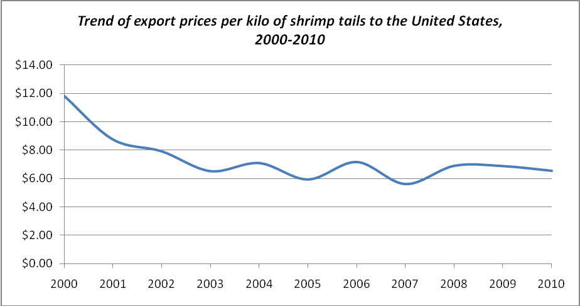

Chart 2 - Export prices of tilapia to the United States, 2000-2010
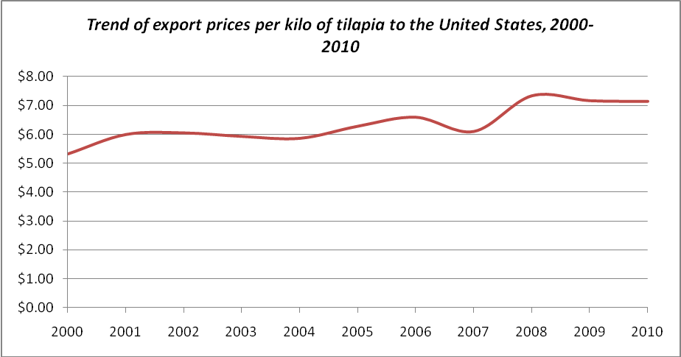

Chart 3 - Export prices of spiny lobster to the United States, 2000-2010
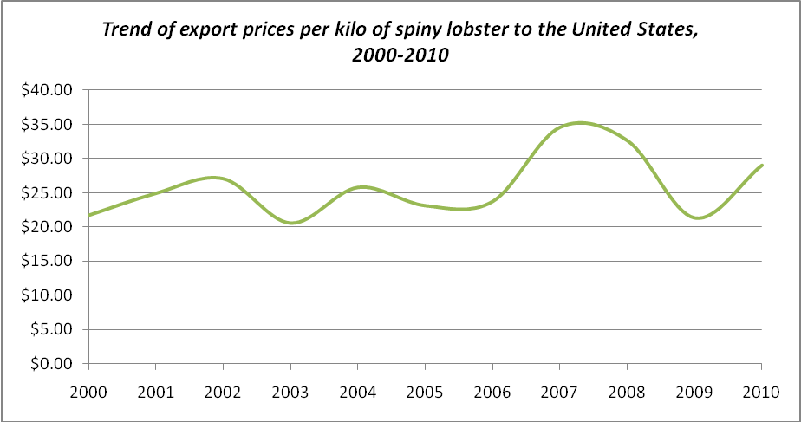

Chart 4 - Export prices of marine fish (nspf) to the United States, 2000-2010
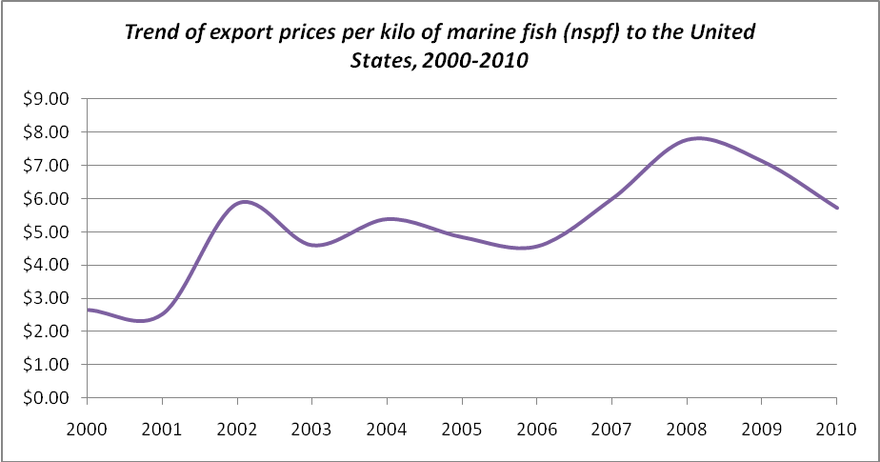

Chart 5 - Export prices of snapper to the United States, 2000-2010
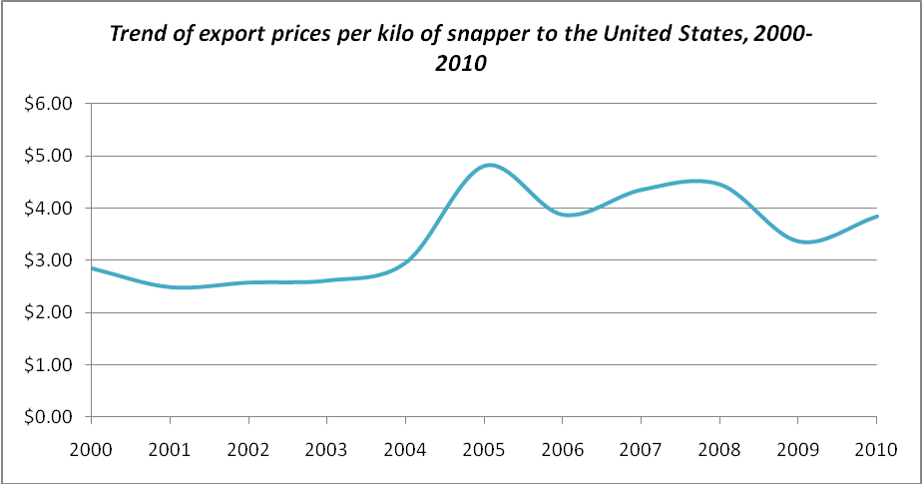

Chart 6 - Export prices of grouper to the United States, 2000-2010
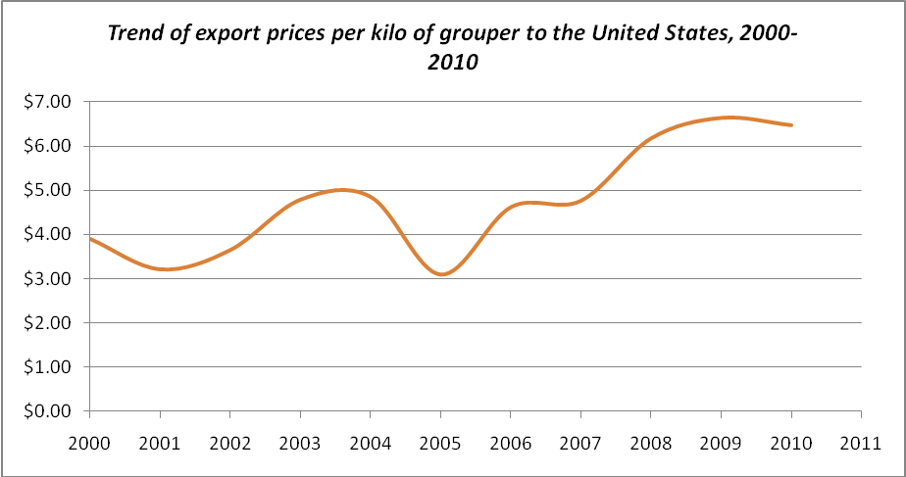

Evolution of monthly prices for exports to Europe

Was also constructed the time series of monthly prices and annual average prices paid to Honduran producers between January 2003 and September 2010, detailed by each of the products of fisheries and aquaculture analyzed. The source of information is the Centre for Export Procedures (CENTREX, by its abbreviation in Spanish), ascribed to the Secretariat of Industry and Commerce of Honduras.

The farmed shrimp and tilapia skins leather are the main products sold in Europe. Were also recorded some exports of marine fish, tilapia fillets and lobster tails, but because the latter three are sent to Europe sporadically and in low volume, were not included in the monthly data base.

As in the construction of the United States database prices, in the annex 2 ““Database about prices, volume and value of the products exported to Europe”, as well as the Excel file "Honduras value chain analysis - Tables of the final report" are the sheets "Detailed export prices Europe" and "Summary prices Europe". The data here reported is the result of dividing the monthly value of exports by product between the volumes in kilos by commodity exports.

From the referred data is constructed the following table and charts about the yearly trend of prices in the European market.
Table 9 – Summary of the annual average of export prices per kilo to Europe. Period 2003-2010
Year | Shrimp | Tilapia skin leather
2003 | $4,88 | --
2004 | $4,87 | $0,74
2005 | $5,23 | $0,73
2006 | $4,70 | $0,65
2007 | $4,89 | $0,65
2008 | $5,50 | $0,72
2009 | $4,92 | $0,75
2010 | $5,48 | $0,77

Chart 7 – Export prices of shrimp to Europe, 2003-2010
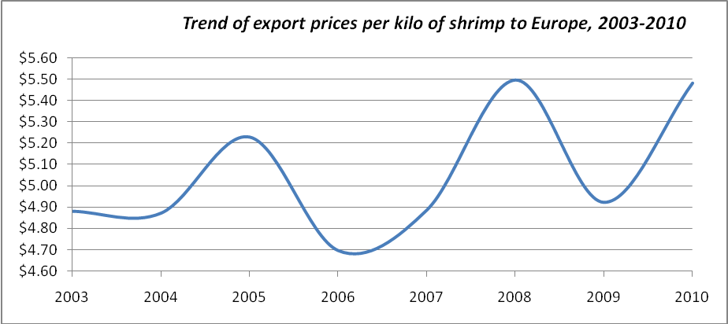

Chart 8 – Export prices of tilapia skins leather to Europe, 2003-2010
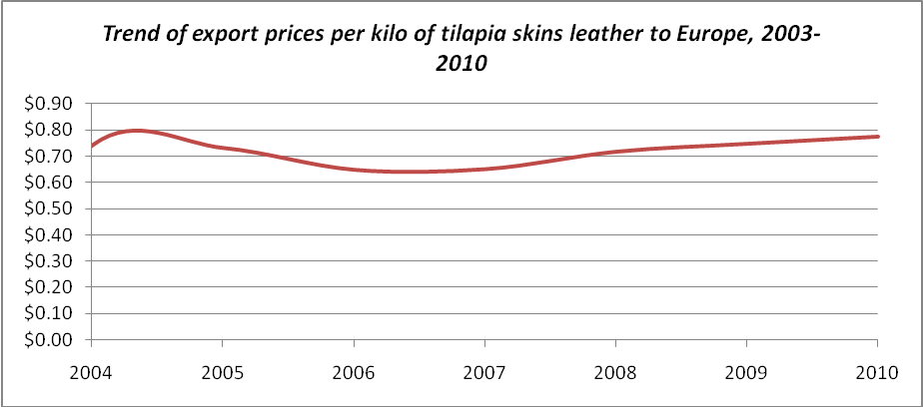

Trend of domestic sales prices

The Honduras case study prepared by the FAO project "Improvement of domestic markets for fishery products in Latin America - TCP/RLA/311" indicates that domestic demand is supplied with 85% of fishing products, 5% of industrial fisheries, 5% of industrial aquaculture and the entire small-scale aquaculture.

However, it should be taken into account that in the case of small-scale fisheries the estimates are approximated because the catches and marketing information is inadequate, fragmented and in some areas of the country is nonexistent. This is partly explained by the poor organization of fishers, the dispersion of fishing and disembarking sites, and also by institutional weaknesses of DIGEPESCA for taking information at national level.

Regarding the prices of domestic markets, the same study reported that prices vary depending on the commodities and the areas where are captured or cultured, which may oscillate between 25% and 50%.

Unlike the export prices, are not available monthly data series covering the entire 2000s, except for that compiled by INFORAGRO - Agrifood Information Service of the Secretariat of Agriculture and Livestock (SAG, for its abbreviation in Spanish), between January 2007 and March 2009. Although it is not an extensive series, is considered useful to visualize the trend of prices throughout the year.
Table 10 – Monthly prices per kilo and US dollars, to wholesalers in Honduras. Period 2007 - 2009
Year | Shrimp | weakfish | Grouper | Red snapper | Tilapia
2007 | $6,65 | $2,86 | $2,92 | $3,04 | $2,67
January | 7,93 | 3,26 | 3,17 | 3,17 | 2,91
February | 7,93 | 2,93 | 2,97 | 3,36 | 2,85
March | 7,57 | 3,21 | 3,30 | 3,30 | 2,91
April | 7,09 | 2,64 | 2,72 | 3,01 | 2,66
May | 6,19 | 2,72 | 2,81 | 3,06 | 2,61
June | 6,45 | 3,05 | 2,81 | 2,89 | 2,49
July | 7,02 | 2,71 | 2,90 | 3,05 | 2,66
August | 5,97 | 2,61 | 2,82 | 2,90 | 2,45
September | 5,73 | 2,58 | 2,77 | 2,77 | 2,54
October | 5,42 | 2,96 | 3,06 | 3,17 | 2,61
November | 5,82 | 2,74 | 2,77 | 2,77 | 2,62
December | 6,65 | 2,86 | 2,92 | 3,04 | 2,67
2008 | $7,15 | $3,05 | $3,22 | $3,28 | $2,86
January | 6,33 | 2,90 | 3,13 | 3,13 | 2,75
February | 7,02 | 3,03 | 3,24 | 3,28 | 2,80
March | 7,28 | 3,30 | 3,44 | 3,49 | 2,93
April | 7,68 | 3,25 | 3,50 | 3,35 | 2,85
May | 7,64 | 3,26 | 3,12 | 3,26 | 2,87
June | 7,67 | 2,87 | 3,21 | 3,25 | 2,78
July | 7,24 | 3,08 | 3,22 | 3,33 | 2,93
August | 7,32 | 3,17 | 3,12 | 3,17 | 2,96
September | 6,81 | 2,93 | 3,04 | 3,21 | 2,90
October | 6,55 | 2,74 | 3,17 | 3,31 | 2,87
2009 | $7,22 | $2,91 | $3,26 | $3,34 | $2,87
January | 6,99 | 2,80 | 3,14 | 3,14 | 2,80
February | 6,99 | 2,91 | 3,26 | 3,38 | 2,91
March | 7,69 | 3,03 | 3,38 | 3,49 | 2,91
Source: INFOAGRO. www.sag.gob.hn

Table 11 – Summary of annual domestic prices per kilo to wholesalers. Period 2007 - 2009
Year | Shrimp | weakfish | Grouper | Red snapper | Tilapia
2007 | $6,65 | $2,86 | $2,92 | $3,04 | $2,67
2008 | $7,15 | $3,05 | $3,22 | $3,28 | $2,86
2009 | $7,22 | $2,91 | $3,26 | $3,34 | $2,87

Chart 9 – Trend of national prices of shrimp, weakfish, grouper, red snapper and tilapia. Period 2007 – 2009

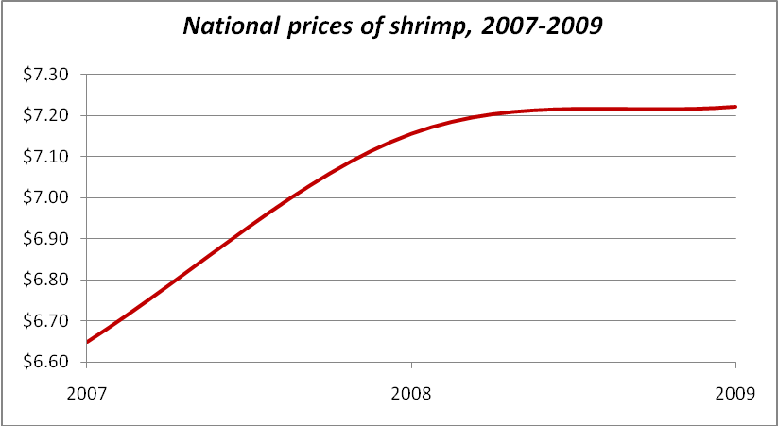

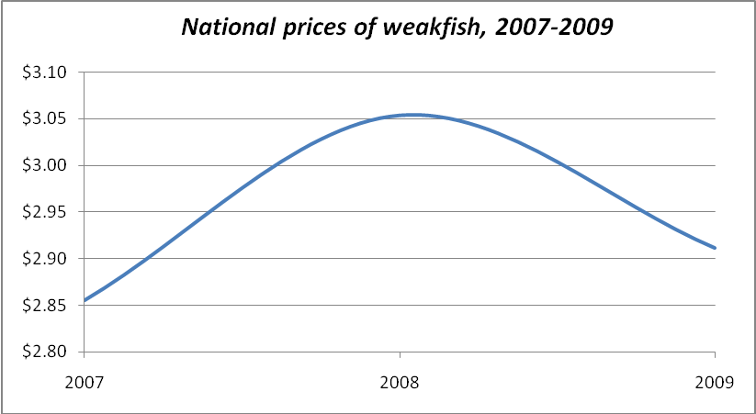

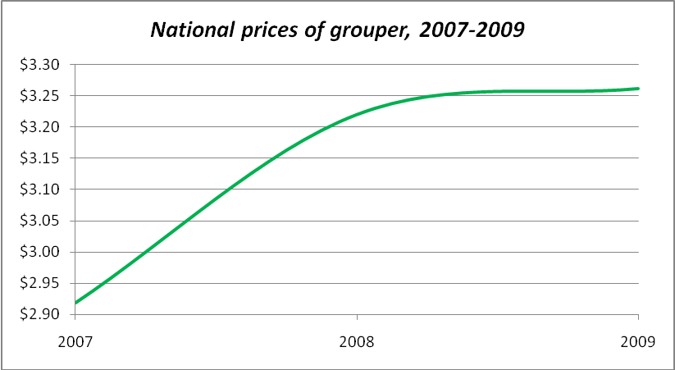

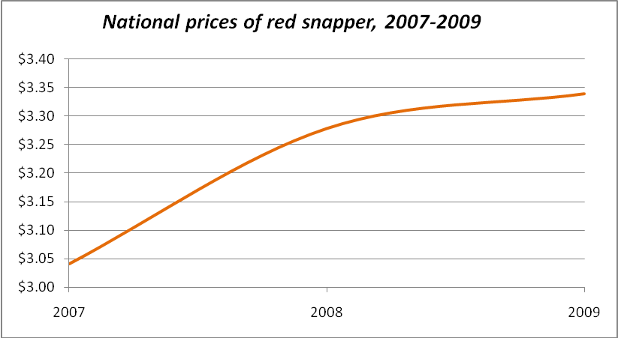

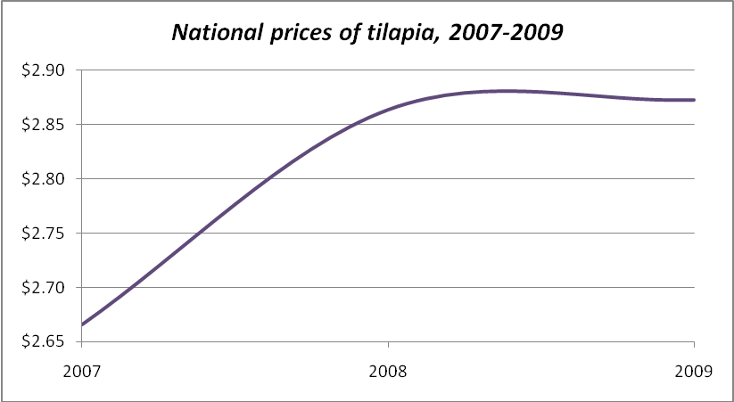
From the trend of domestic prices are obtained the following conclusions:

- Shrimp have an average price higher than the four types of fish, among which snapper is worth more than weakfish and grouper. Tilapia is of lower price and has grown its domestic market demand.
- The price of fishes is relatively stable throughout the year except Holy Week (March-April) when increase because it is the best seasonality. Shrimp has more fluctuations but as fishes, the time of Lent is of high sales and thus better prices.
- During 2007, shrimp prices had more fluctuations than in 2008 when they were more stable. This may be explained because the production of wild and farmed shrimp fell 4 675 tons while exports fell 2 887 tons. This means that supply of shrimp for the domestic market declined in 2008 and this may have kept more stable to wholesalers’ prices in the country.

COSTS STRUCTURE

Unfortunately in Honduras has not been prepared detailed economic analysis about all fisheries and aquaculture. An exception is spiny lobster and shrimp fisheries, where the FIINPESCA project worked between 2007 and 2009 the cost structure and profitability of the capture stage. The key results are the following:

- Current status of the spiny lobster fishery. It is summarized on three indicators that were analyzed in an interdisciplinary way:

- Biological indicator: The fishery is in full exploitation level. It is not sustainable because the effort is over-dimensioned and data suggest that there are environmental parameters that would probably affect the proper renewal of the resource.
- Social indicator: Only in the capture phase, the fishery generates 4 850 direct jobs. Due to its high levels of profitability and remuneration for small-scale fishers and crew members of the industrial fleet, workers are highly dependent on this resource. In Honduras, the indigenous Miskitos dedicated to scuba diving resist to leave it for lack of other profitable economic alternatives and fast incomes, which is why it generates a remarkable public and political pressure.
- Economic indicator: The fishery is profitable because it is of widespread interest, generates significant currencies, has high international prices and because the fishing trips still generate profits around 35% in the industrial fishing and over 100% in the small-scale fishing. These data is the result of calculating the average of pots and scuba diving systems, both for the higher and lower captures seasons. This is one of the most lucrative marine fisheries.

- Current status of the shrimp fishery. The results of the FIINPESCA Project indicate the following:

- Biological indicator: The fishery is a level of overfishing, the stocks have not been recovered despite management measures implemented for years, which is aggravated for the lower rainfall that have contributed to reduce salinity that carries sediment that increase productivity. Considering the impact of climate variability has not been yet proven, it is necessary to evaluate the trend of environmental variables.
- Social indicator: The shrimp fishery generates more employment in small-scale fisheries than in the industrial one, due to the reduction of the effort. Many small-scale fishers have been diversifying their economic activity, but the crew members of the industrial fleet are more vulnerable if they lose their jobs because they have minimal access to training programs to work, nor to the schemes of subsidiarity in periods of shrimp closure. On the other hand, fish processing plants subsist partly through the maquila of finfish and lobster. This fishery contributes to food security, more by the way of incomes to the families than by self-consumption.
- Economic indicator: Their products are for both export and domestic markets, although these last ones have grown in recent years. Profitability is affected by the recurrent reduction of the international prices caused by the strong competition of the Asian shrimp, as well as for the fluctuation of costs, highly conditioned by fuel value. Shrimp fishery and its bycatch, generates average profits of 72% to the industrial fishing and 71% to small-scale fishing.

Profitability of the industrial fishing of Caribbean spiny lobster with pots

This fishing method represents 66% of the industrial effort for spiny lobster and generates 27% of the sources of employment on board, including captains and sailors.

Financial data is presented at current prices of December 2007 when the FIINPESCA project conducted the analysis. It was considered that a fishing trip takes 45 days with three months of closure, which implies that the effective fishing time is reduced to nine months, during it is possible to make up to six trips. The average catch per trip is estimated at 3 185 pounds with a price of US$ 15,42 per pound.
Revenues ascend to US$ 49 113 by trip and the sum of the fixed and variable costs (including administrative fees, licensing and maintenance payments during the closure season, when the vessel is in port) US$ 41 833 giving a return of 14,82% equivalent to US$ 7 279 (Table 10).

Payments to the crew are an important item: captains receive 20% of the purchase price (based on USD 15,42 per pound, the captains receive USD 3,10 per pound from which derive their utility and pay food and crew remuneration).

Table 12 – Cash flow for industrial fishing trip of spiny lobster with pots, at current prices, 2007
Annual fixed costs per vessel, including the closure of three months
 | Value (USS) | Value per trip | Share (%)
Licenses, permissions (annual) | 1 300 | 217 | 0,52%
Dry dock and wharfage charges | 3 474 | 579 | 1,38%
Renewal of 3 000 pots | 28 203 | 4 700 | 11,24%
Maintenance personnel (electricians, mechanics, welders, carpenters, etc.). | 5 368 | 895 | 2,14%
Mechanical parts and materials | 12 571 | 2 095 | 5,01%
Cooling system maintenance | 421 | 70 | 0,17%
Fuel and lubricants | 2 632 | 439 | 1,05%
Administrative expenditures (annual) | 13 158 | 2.193 | 5,24%
TOTAL FIXED COSTS | $ 67 126 | $ 11 188 | 26,74%
Sources: APESCA (Honduras). INPESCA (Nicaragua)

Variable costs per vessel and per trip during the fishing season
 | Value per trip | % per trip
Fuel (5 200 gallons per trip of 45 days) | 15 600 | 37,29%
Lubricants | 395 | 0,94%
Bait | 855 | 2,04%
Materials for pots | 1 316 | 3,15%
Filters for machinery | 1 921 | 4,59%
Butane gas (for cooking) | 737 | 1,76%
Crew remuneration (20% of 3 185 pounds at US$ 15,42) | 9 823 | 23,48%
TOTAL VARIABLE COSTS | $ 30 646 | 73,26%
FIXED + VARIABLE COSTS PER TRIP | $ 41 833 | 100%

Average incomes per vessel and per fishing trip
Production per trip (in pounds) | 3 185
Average price of spiny lobster (pound) | 15,42
Total incomes per trip | $ 49 113

Calculation of return rates per vessel and per trip
Incomes | 49 113
Total costs | 41 833
Profits | 7 279
Profits margin | 14,82%

Profitability of the industrial fishing of Caribbean spiny lobster with scuba diving

Corresponds to 34% of the industrial effort of spiny lobster and generates 73% of employment on board between captains, sailors, divers and sacabuzos. The fishing trip takes 12 to 20 days, including travel time to the region of the Moskitia. After discounting the annual three-month closure season, is concluded that during nine months of work it is possible to make up to 13 trips. The average catch is estimated at 6 500 pounds per trip with a price of US$ 15,42 per pound.

The average income is US$ 100 230 per trip and the fixed and variable costs (including administrative and maintenance) are US$ 67 517, resulting a return of 32,64% equivalent to US$ 32 713 (Table 11). The remuneration of the crew represents between 20% and 25% of the costs. The sailors earn between US$ 265 and 370 per trip, and each diver according to their efficiency, can earn between US$ 635 and 1 587, including an advance between US$ 106 to 265 that usually they leave to their families before travelling.

Table 13 – Cash flow for industrial fishing trip of spiny lobster with scuba diving, at current prices, 2007
Annual fixed costs per vessel, including the closure of three months
 | Value (US$) | Value per trip | Share (%)
Licenses, permissions (annual) | 1 300 | 100 | 0,15%
Dry dock and wharfage charges | 7 158 | 551 | 0,82%
Diving equipment | 9 474 | 729 | 1,08%
Maintenance personnel (electricians, mechanics, welders, carpenters, etc.). | 7 474 | 575 | 0,85%
Mechanical parts and materials | 8 316 | 640 | 0,95%
Cooling system maintenance | 1 053 | 81 | 0,12%
Fuel and lubricants | 11 316 | 870 | 1,29%
Administrative expenditures (annual) | 20 842 | 1 603 | 2,37%
TOTAL FIXED COSTS | $ 66 932 | $ 5 149 | 7,63%
Sources: APESCA (Honduras). INPESCA (Nicaragua)

Variable costs per vessel and per trip during the fishing season
 | Value per trip | % per trip
Fuel (5 500 gallons per trip of 12 to 20 days) | 16 500 | 24,44%
Lubricants | 304 | 0,45%
Scuba diving compressors filters | 124 | 0,18%
Filters for machinery | 148 | 0,22%
Butane gas (for cooking) | 166 | 0,25%
Food supply | 3 239 | 4,80%
Remuneration to 35 divers (US$ 3,10 per 6 500 pounds) | 20 150 | 29,84%
Remuneration to the captain and sailors (20% of 6 500 pounds at US$ 15,42) | 20 046 | 29,69%
Remuneration to the “sacabuzos” | 891 | 1,32%
Transportation of scuba divers | 802 | 1,19%
TOTAL VARIABLE COSTS | $ 62 368 | 89,87%
FIXED + VARIABLE COSTS PER TRIP | $ 67 517 | 97,49%
Sources: APESCA (Honduras). INPESCA (Nicaragua)

Average incomes per vessel and per fishing trip
Production per trip (in pounds) | 6 500
Average price of spiny lobster (pound) | 15,42
Total incomes per trip | $ 100 230

Calculation of return rates per vessel and per trip
Incomes | 100 230
Total costs | 67 517
Profits | 32 713
Profits margin | 32,64%

Profitability of small-scale fishing of Caribbean spiny lobster

Data reported by small-scale fishers to the FIINPESCA project includes two levels of incomes and profits that are conditioned by the level of catches, while costs remain relatively constant during the year.

In the small-scale pots fishing, the best profitability is obtained when captures goes from 15 to 40 pounds per daily trip, that produce returns from 50% to 68%. On the other hand, when catches are reduced from 4 to 7 pounds, the profits are from 24% to 30% (Table 12). The average price obtained by fishers is US$ 11,50 per pound, earning a 34% less than industrial fishing, which is explained in part because operating costs are far lower compared to the vessels owners.

Table 14 – Profitability of the small-scale spiny lobster fishing with pots
 | US$
High incomes | 320
Low incomes | 210
Costs | 160
High profits | 160
Low profits | 50
High profit margin | 50%
Low profit margin | 24%
Source: FIINPESCA-FAO/OSPESCA/SWEDEN Project

In the small-scale fishing with scuba diving, the highest profits are achieved with catches from 30 to 60 pounds on daily trips that allow a maximum profitability of 90% while in times of lower catches, fishers can have even losses up to 33% (Table 13).

It is worth mentioning that in Honduras is still allowed to dive with compressed air tanks, even though the Government has tried to prohibit this method due to the frequent decompression accidents that have left more than 2 500 Miskitos indigenous killed or disabled in Honduras and Nicaragua.

Scuba diving to catch spiny lobster has been practiced for over thirty years and is the main economic activity for the Miskito indigenous. Much of the catch is done on board of the industrial fleet, but the divers do not have employment contracts, access to social security system, proper training for autonomous diving neither provision of specialized equipment, or if available, they do not used it.

Table 15 – Profitability of the spiny lobster fishing with scuba diving
 | US$
High incomes | 167
Low incomes | 42
Costs | 56
High profits | 111
Low profits | -14
High profit margin | 66%
Low profit margin | -33%
Source: FIINPESCA-FAO/OSPESCA/SWEDEN Project

Profitability of the shrimp industrial fishing in the Caribbean

Considering that a fishing trip takes from three to four months and during the year there are four months of closure, the effective fishing time is reduced to eight months, during which can perform two to three trips. The average catch is estimated at 31 200 pounds per trip, with a price of US$ 3,40 per pound.

Revenues reached US$ 106 080 by trip and the sum of fixed and variable costs (including administrative and maintenance costs during the closure season) to US $ 68 459, giving a return of 34,56% equivalent to US$ 37 621.

Table 16 – Cash flow by trip of industrial shrimp fishing in the Caribbean, at current prices, 2007
Annual fixed costs per vessel, including the closure of four months
 | Value (US$) | Value per trip | % per trip
Dry dock and wharfage charges | 3 474 | 1 737 | 2,54%
Maintenance personnel (electricians, mechanics, welders, carpenters, etc.). | 5 368 | 2 684 | 3,92%
Mechanical parts and materials | 17 111 | 8 556 | 12,50%
Cooling system maintenance | 421 | 211 | 0,31%
Maintenance of fishing nets | 4 632 | 2 316 | 3,38%
Fuel and lubricants | 7 895 | 3 947 | 5,77%
Administrative expenditures (annual) | 13 158 | 6 579 | 9,61%
TOTAL FIXED COSTS | $ 52 058 | $ 26 029 | 38,02%
Source: APESCA (Honduras)

Variable costs per trip during the fishing season (8 months = 2 trips of 3 to 4 months)
 | Value per trip | % per trip
Fuel (12 500 gallons per trip of 4 months) | 36 250 | 52,95%
Lubricants | 1 184 | 1,73%
Filters for machinery | 526 | 0,77%
Butane gas (for cooking) | 289 | 0,42%
Crew remuneration (10% of gross profits) | 4 180 | 6,11%
TOTAL VARIABLE COSTS | $ 42 430 | 61,98%
FIXED + VARIABLE COSTS PER TRIP | $ 68 459 | 100%

Average incomes per vessel and per trip
Production per trip (in pounds) | 31 200
Average price of shrimp (pound) | 3,40
Total incomes per trip | $ 106 080

Calculation of return rates per vessel and per trip, year 2007
Incomes | 106 080
Total costs | 68 459
Profits | 37 621
Profits margin | 35,46%

Profitability of the shrimp small-scale fishing

Data reported by small-scale fishers to the FIINPESCA Project includes two levels of incomes and profits according to the abundance of the catches, while costs remain relatively constant during the year.

The best profitability is obtained with catches of 10 to 56 pounds per daily trip, which produces returns from 61% to 89%. On the other hand, with catches of 1 to 11 pounds, profitability reaches 59% and even there are losses higher than 100%. The average price obtained by fishers is US$ 2,64 per pound which represents 29% less than their industry pairs and, as in the case of spiny lobster fishery, this is explained by minors operating costs (Table 15).

Table 17 – Profitability of shrimp small-scale fishing in the Pacific, at current prices, 2007
 | US$
High incomes | 161
Low incomes | 48
Costs | 39
High profits | 122
Low profits | 9
High profit margin | 76%
Low profit margin | 19%
Source: FIINPESCA-FAO/OSPESCA/SWEDEN Project

After the first sale in the domestic market, the profit margin earned by supermarkets, fish markets in the cities and other retailers, ranges from 40% to 50% per pound, particularly for pre-cooked and frozen shrimp.

Costs structure of shrimp farming

Although there is no updated neither complete data to calculate the profitability of the culture, according to industry representatives interviewed for this study, the cost structure of the shrimp farming is the following:

Table 18 – Cost structure of the shrimp farming
Item | Percentage
Concentrated feed | 25%
Shrimp post-larvae | 18%
Workforce | 20%
Electricity | 24%
Fuels | 13%

Costs structure of tilapia farming

As in the case of shrimp farming, there is no comprehensive data to calculate the cost structure and profitability of this activity, but from the interviews done for the present study was possible to obtain the following partial information:

The tilapia business is only profitable if handled high volumes of production; therefore this is an elastic product, highly sensitive to price changes. The most representative item is the concentrated feed which represents 60% of the costs.

In the small-scale aquaculture are harvested tilapias from 750 g after seven months of culture. In 2009 and 2010, the first sale price of gutted fresh tilapia was US$ 2,45 per kilo and the final consumer in Tegucigalpa paid $ 3,38 per kilo while in the aquaculture areas paid US$ 2,74 per kilo, which means that the profit margin of the intermediaries oscillates between 12% and 38%.

Small aquaculture producers who use floating cages in Lake Yojoa (where is possible to purchase fingerlings and concentrated feed) and they are allowed to use around 4 ha of water surface, can produce around 4 300 kilos per month.

Some industrial producers, such as the company "Aquafinca Saint Peter Fish SA", support small-scale aquaculture producers with training in business development. Likewise, in Lake Yojoa and Dam El Cajon, the company runs other social responsibility projects such as: community development, literacy campaigns, basic education and health brigades.

PRODUCTION AND PROCESSING OF PRODUCTS

Production and processing of products depend on customer requirements while the quality control is standardized in accordance with the target markets requirements. Although the quality should not depend on external demands, actually exportable products comply with international standards while fisheries and aquaculture products for the domestic market do not have the same attributes.

Elaboration and quality control of export products

The country has developed a good system of rapid alerts to detect faults that may arise in quality control. For this purpose have been taken as a basis the guidelines of the Directorate General for Health and Consumer Policy - DG SANCO of the European Union, as this market along with the United States, are their main buyers. These international requirements have forced producers to significantly improve their processes.

Honduras, like the other countries of the region, has the assistance of the International Regional Organization for Agricultural Health (OIRSA, for its abbreviation in Spanish) which was constituted by the governments of Mexico, Guatemala, El Salvador, Honduras, Nicaragua, Costa Rica, Panama and Dominican Republic, to ensure animal health and safety of foods for export. In Honduras, OIRSA works with the National Agricultural Health Service (SENASA, for its abbreviation in Spanish) which is the national authority in charge of monitoring animal health and safety of foods.

Employment stability and training of the SENASA team of inspectors has become a strength, because they are trained to advise the entire production process under the standards of good practice in fishery and aquaculture production, and ensure compliance with health standards. The controls start from the capture phase (on board) or culture (in the farms) until loading on airplanes or ships that transport to foreign markets.

Although Europe and the United States are traditional customers, the market has evolved and since 2009, Mexico, El Salvador, Costa Rica and Guatemala have also become on important buyers. In Mexico sells farmed shrimp and in other Central America countries also sells shrimp from fishing and from farming, marine fish, octopus, squid and crab.

Considering that safety and traceability starts since the production stage, in the case of aquaculture and through international cooperation, Honduras and Central America as a whole, have been developing protocols to implement good farming practices. To date it has been produced a guide for the management of white shrimp culture but has not yet developed a similar guide for tilapia culture, however thanks to the assistance of the Mexico's government is available the "Manual of tilapia production with quality and safety specifications". On the other hand, small and medium shrimp farmers who sell to exporters, are been trained to comply with the quality protocols in all stages of the value-chain, as do industrial producers.

The exportable goods are produced in processing plants that implement all the requirements of the two main systems of quality assurance: Good Manufacturing Practice (GMPs) and Hazard Analysis and Critical Control Points (HACCP). GMPs take care of the environment where food is prepared, the state of the equipments, know-how, the attitude of the food handlers and consumers. For its part, HACCP ensures that processes are developed within the limits which guarantee that products are safe. In that sense, GMPs constitute a prerequisite for the HACCP implementation.

In general terms, fish and fresh seafood become cooled or frozen products, either whole or in pieces (in the case of shrimp is sold as entire or as tails, and the spiny lobster as tails or meat), classified by size and packaged according to the kind of product in cardboard boxes waterproofed with paraffin or expanded polystyrene boxes, and depending on the terms negotiated with each client, the packages have the trade mark of the exporting company or the buying company.

Both customers in Europe as in the United States ask for fish and seafood with minimal level of elaboration in order to process higher value-added products in their local plants, according to the requirements of their customers. This means that although the current activity is profitable for Honduran entrepreneurs, could be higher if their foreign customers request more processed products.

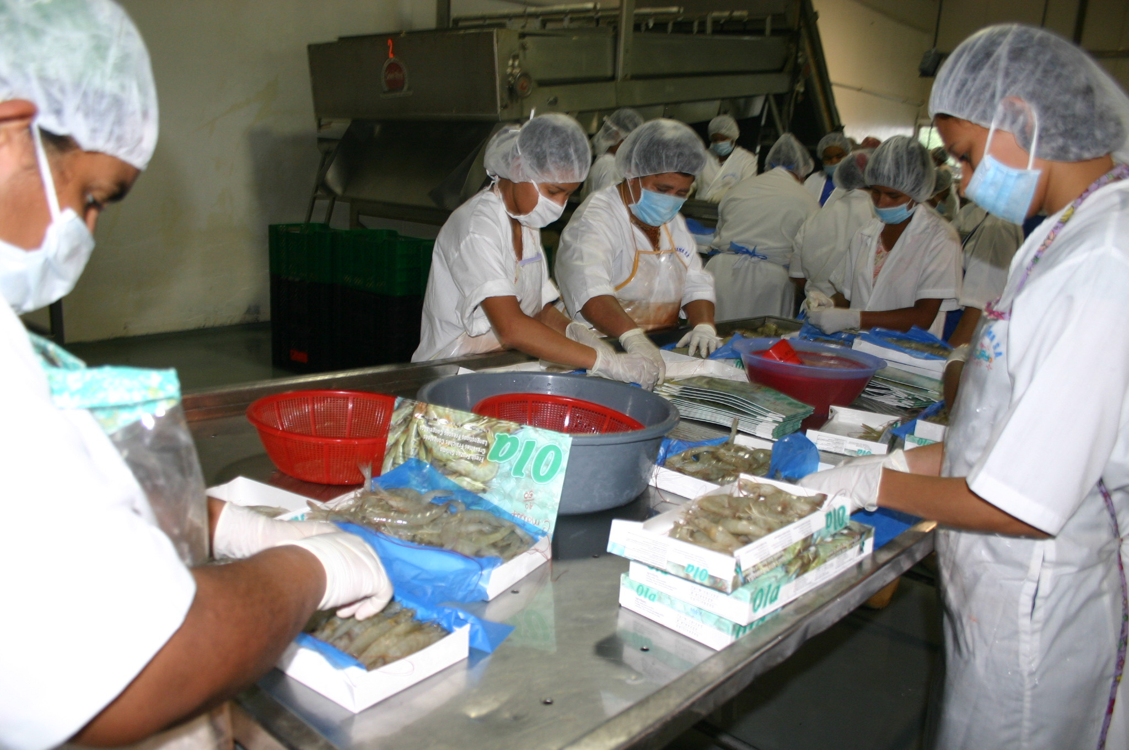

Though the majority of Honduran exports becomes on raw materials for new products manufactured in Europe and the United States, three of eight shrimp processing plants located at the south of the country (Choluteca and Valle departments) manufacture products of higher added value that represent an increase of 30% to 50% in the price per pound, compared to less processed commodities, being the European market that pays better prices than the United States.

The traditional shrimp products that are elaborated are: shell-on frozen, peeled frozen, peeled and deveining, butterfly or ¾ butterfly, Individual Quick Frozen - IQF, pre-cooked (ready to cook), and more recently has been included shrimp skewers IQF.

Regarding tilapia, products for human consumption exported to the United States are: fresh fillet skinless, boneless, without adhering fat and entire fish totally clean. Also is processed tilapia skin leather to export to Europe, where are produced leather goods such as handbags, wallets and shoes, among others.

On traceability and safety matters, Honduras recently received a distinction because in September 2010 the company "Aquafinca Saint Peter Fish S.A." was certified as the worldwide leading producer of tilapia due to was able to fulfil the ISTRA standards (International Standards for Responsible Tilapia Aquaculture) according to the WWF framework agreement and GLOBAL GAP. These new standards include tilapia production issues related to environment, animal welfare, labour and social responsibility, which have been worked since 2004 by the worldwide organizations grouped in the TAD (Tilapia Aquaculture Dialogue) supported by the ASC (Aquaculture Stewardship Council) and WWF. Aquafinca Saint Peter Fish S.A. was audited during the week of September 20, 2010 by the certificate company IMO (Institute for Marketecology) based at Switzerland.

On the other hand, the spiny lobster is usually beheading aboard the ships and only tails arrive to the processing plants, which are used to prepare three kind of frozen products: entire spiny lobster, tails and meat that are packed by size or weight. Honduras (as well as Nicaragua and Belize, also important producers of spiny lobster in Central America) must observe the rule emitted in January 12, 2009 for NOAA, to regulate imports of spiny lobster into U.S. as follows.

It is forbidden for any person to import spiny lobster in the United States:
- Less than 5 ounces tail weight (5 ounces is defined as a tail that weighs 4,2 – 5,4 ounces) or compliance may be demonstrated by meeting the greater than 3 inch carapace length or 5,5 inch tail length; or
- If imported into Puerto Rico or the U.S. Virgin Islands, less than 6,0 ounces tail weight (6 ounces is defined as a tail that weighs 5,9 – 6,4 ounces) or compliance may be demonstrated by meeting the 3,5 inch carapace length or 6,2 inch tail length.

Preparation and quality control of products for the domestic market

Not all products for domestic market have the same quality standards than those for export, particularly those from artisanal fishing or small-scale aquaculture, whose producers do not have enough knowledge nor tools to apply properly and constantly procedures of hygiene, sanitation and quality, since the beginning of the value-chain up to final buyers.

Those elaborated in processing plants that are available in supermarkets and fish markets of high level, have better conservation conditions although not always reach the same standards than export products, because often there are mistakes in handling the cold chain in the fridges. Spite of these improved conditions, sometimes arise doubts among buyers about the true freshness and quality of the offer, besides the price factor, that can impact on the low levels of seafood consumption in Honduras.

The quality is more affected for the popular products. Often, in local markets and fishing ports is highly visible inadequate management of cold chain, manipulation, conservation and presentation of seafood, as well as few mechanisms of pollution prevention, and incorrect or inadequate cleaning and disinfection procedures.

Furthermore, failures in the quality of products for domestic consumption are also explained by institutional weaknesses, particularly at the Ministry of Health which is the national authority responsible for applying health regulations related to production, conservation, management and distribution of food for human consumption. The Secretariat does not have adequate technical, financial and personnel resources, properly trained to do a strict application of management protocols and transportation of fish products, as well as crisis management related to outbreaks of food borne diseases.

Mechanisms such as obtaining sanitary registrations are only required to registered dealers but there are not controls over neither informal nor seasonal market. For this research was attempted to consult the respective managing by the Committee for Consumer Protection, but they have not acted on this issue because their point of view is that quality control of fishery products is responsibility of SAG, SENASA and DIGEPESCA.

TRANSPORT OF PRODUCTS

Transport occurs during all stages of the value-chain: from the purchase of inputs for fishing or culture until the placement of fisheries and aquaculture products at points of sale to final consumers. Generally, the mobilization of inputs in large quantities is paid by the different suppliers, but this section of the study will address the transport of the products from the vessels and aquaculture areas to processing plants, and from there to the international broker or the national retailer, who in turn is responsible for transporting the products to retail outlets.

Processing plants and storage facilities (such as the fish market created by the AECID / DIGEPESCA Project in the town of Coyolito, Valle department) which purchase product to small-scale fishers and aquaculture farmers, usually travel to communities on boats equipped with isothermal coolers or Styrofoam coolers, or refrigerated trucks (usually owned by companies) to transport the catch fresh and thus ensure the best handling and transport from the site of origin. However, this market has not yet been able to ensure total quality throughout the chain because 80% of the small-scale fishers do not usually carry ice on board, so the administrators of the market have invited them to land their products at their dock, in order to avoid problems of loss in the cold chain.

At the south of the country one of the most significant problems has been the frequent stealing of shrimp produced in the farms, and those who commit this crime, often argue that they obtain it by fishing. To avoid this, in mid-2009 ANDAH did an agreement with SENASA to co-finance the recruitment of inspectors to verify the origin of the products transported by road through a pass, or transport guide, that is a document requested by inspectors stationed at checkpoints on major roads to transporters of shrimp.

For its part, aquaculture enterprises use two kinds of transport: one to move the harvest of fishes from lakes or ponds toward the processing plant, using large trucks equipped with plastic bins whose load capacity is 350 kilos per unit and equipped with ice flakes where tilapia dies by thermal shock. The larger trucks can charge up to 12 bins, equivalent to 4 200 kilos of fish per trip.

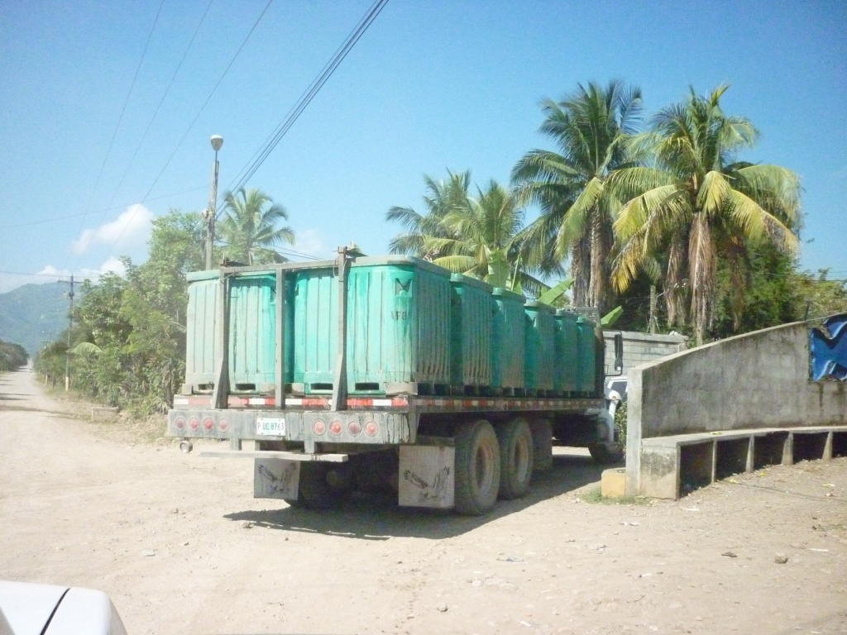

Once the products have been processed, packaged and ready for export, are kept in refrigerated trucks (contract with specialized firms) from the processing plant to the airports in Tegucigalpa or San Pedro Sula, where are taken flights toward Miami and New York. On this stage, the only inconvenience is that San Pedro Sula airport infrastructure does not have cold storage, so there must be good synchronization to ensure that trucks arrive at the airport shortly before the flight departs.

The small-scale aquaculture producers are also equipped with bins and ice flakes to harvest the production and to deliver it to the dealers. Usually this service is rented from local suppliers.

In the industrial fishing of the Caribbean, the transport of the products by road are carried out in refrigerated trucks, usually of their property, while exports are transported by sea in vessels adapted to carry refrigerated containers from both the port of La Ceiba, as the Bay Islands, toward Miami and New York.

DISTRIBUTION CHANNELS

Distribution channels in foreign markets

When products arrive to Europe or United States is created a new commercialization chain where participate small and medium suppliers, processors and distributors, who interact as follows:

- Importers: Buy and sell products to processing companies, multiple re-exporters and retailers, including some restaurants and upscale hotels that take charge to import directly the fish and seafood they need. Importers usually provide information to the producers in Honduras about quality exigencies, packaging requirements and forms of processing, as well as consumers’ preferences and market trends.
- Processing companies: Sometimes the importers also assume the role of processing plants in order to develop higher added value products aimed to the final consumers.
- Intermediaries’ processors: They buy fish and seafood in order to develop semi-final products, such as fish fillets and fish blocks which later sold to other processors.
- Agents: They are intermediaries between exporters and importers who earn commissions from 2% to 5% of the purchase prices. The agents are usually very well informed about prices, customers and market trends, but over time their role has changed because the evolution of information and communication technologies has facilitated the direct contact between exporters and importers, which reduces the intermediaries’ chain and favours the prices for both parties.

Distribution channels in the domestic market

There are many wholesalers and retailers who are in charge to put fisheries and aquaculture products through the formal and informal channels of commercialization.

- Wholesalers: Their supply comes from industrial producers, medium and small-scale producers, intermediaries who collect products at ports, cooperatives and associations of small-scale fishers, as well as from imports. They are usually located in the market places of cities and sold to retailers. Among wholesalers also are included the processing plants that sell directly.
- Retailers: Are those who sell to consumers. Includes points of sale in market places, fish markets, supermarkets, "cevicherías" and street sales. In this segment has been a growing share of supermarkets and hypermarkets as they are located on different areas of the cities and offer a wide range of products of best quality, price and customer service, which generates confidence and encourages the consumption.

The fisheries and aquaculture products coming from domestic production and from imports that consumes Honduras have three marketing channels:

- A formal channel with specialized locals in food market places, points of sale in ports, docks and fishing terminals, supermarkets, popular markets and specialist outlets. The population of low and middle incomes goes to popular markets while people of middle and high level prefer supermarkets and specialist outlets. For its part, buyers of restaurants and hotels prefer market places and fishing terminals.
- An informal channel of street sales, both seasonal and itinerant, whose supply is not constant, homogeneous neither of good quality. Most of his customers live in colonies or lower income neighbourhoods; however these street vendors also have clients in higher class neighbourhoods of the cities.
- The institutional channel, consisting by restaurants, fast food chains, hotels, clubs and institutions (hospitals, schools, military and corporate casinos, among others) that gradually have increased the inclusion of fish and seafood in their menus.

MARKETING

Shrimp

The American market buys frozen tails (shelled and shell-on) and value-added products (breaded frozen shrimp and other frozen preparations). The prices trend has been decreasing with an average drop of 80,5% between 2000 and 2010, from US$ 11,82 to 6,55 per kilo, primarily due to strong competition from Asian countries such as Thailand Indonesia, China and Vietnam, which sell a 65% of the shrimp imported into the United States. Data series of Honduran exports shows that participation of shrimp products is as follows: shell-on frozen 76,6%, peeled frozen 22,9%, breaded frozen 0,3% and other preparations of frozen shrimp 0,3%.

In Europe is sold entire shrimp, mostly from aquaculture. The main buyer countries are Spain and England and on a smaller scale Germany and the Netherlands. The CENTREX database makes a difference between prawns and shrimps, but in both cases it refers to farmed shrimp on frozen and cooked state. Between 2003 and 2010 there were some fluctuations on the prices but in absolute terms it showed a growth of 12,3%, from US$ 4,88 to 5,48 per kilo.

Prices in Europe have strong variations depending on the commodities, distribution channels and market trends, but the margins of the importers of frozen products varies among 5% and 25%, because the excessive competition do not allow to have high margins, so the final consumer pays an additional 50% over the CIF import price. By contrast, the importers can gain profits from 30% to 50% with fresh products, so the final consumer price is much higher.

Although Europe and the United States are the traditional customers, the market has evolved and today Mexico is a significant buyer of shrimp tails that pays attractive prices. According to SENASA, 60% of shrimp exports go to the European Union and 40% is distributed among the United States, Mexico, three Central American countries (El Salvador, Costa Rica and Guatemala) and Taiwan, where recently was opened the market. Although for the present study was not built the historical series of prices paid by Mexico, SENASA statistics indicate that the average price of farmed shrimp on 2009 was US$ 2,97 per kilo and in 2010 of US$ 3,33 per kilo.

In order to make the corresponding comparison, the average price of Honduran farmed shrimp in El Salvador, Costa Rica and Guatemala was US$ 2,53 per kilo on 2009 and US$ 2,92 per kilo on 2010, which means a 14% less than Mexico. One of the main attractions of these markets is the proximity to Honduras and the commercial benefits of to be part of the Central American Customs Union, established on June 2004 that is aimed to strengthen the regional integration through coordination and harmonization of economic policies, although this process has not yet been completed.

Representatives of the processing and exporting companies indicated that given the sustained reduction of shrimp international prices, the way they have managed to maintain profitability is to reduce costs with the greatest possible efficiency in the administration and use of money, supplies and labour force.

Tilapia

Tilapia fresh and frozen fillets are the products buying in the United States, being Miami the principal port of disembarkation. Between 2000 and 2010 prices had a growth average of 34,2%, from US$ 5,32 to 7,14 per kilo. The database constructed concludes that 98% of the exports are tilapia fresh fillets, and just 2% is frozen. One of the main competitive advantages is the proximity of Honduras to Miami and the facility to deliver products within the next 24 hours after leaving the process plant, because they are sent by air.

As regards the European market, sporadically are exported frozen fillets of tilapia because the freight charges are very high and left low profit margins. During the reported period, just there were sales to the Netherlands in 2007 when the kilo of fillet was sold to US$ 9,79 and in 2008 to US$ 9,13. Tilapia skin leather is the product that often is exported to France, Italy, Slovakia and the Netherlands, which price is relatively stable and ranged between US$ 0,65 and 0,77 per kilo during the period.

By the moment the industry is not considering to develop value-added products because it implies to carry out major changes in the production process that under current conditions would not be compensated in profitability. Therefore, it is more convenient to continue working with clients in United States specialized in breading and other value-added products.

Its international price is highly dependent on Asian competition, which tilapia is cheaper because they use chemical supplies that favours the price but not quality but in times of economic crisis, United States prefer to buy to Asia. This is the reason why large aquaculture producers in Honduras do not try to enter on the Mexico's and Central American's markets, where there are a wide offer tilapia from China.
The fact that a Honduran tilapia farming company has recently been certified as the first company in the world able to comply the ISTRA standards, gives a new position both to the company as to the country, but its effect will not be immediately reflected on prices because still there are effects of the economic crisis in United States and also due to Asian competition. However, the Honduran producers expect that improvement of the economy in China will allow to allocate more of their products for their own domestic consumption and thus to liberate the market of the United States, where they can increase the share of Honduran tilapia and shrimp.

Regarding the domestic market, tilapia production of small-scale is consumed inside the country and in many cases has been sold even since the culture stage. The fact that the country must to import tilapia fillets from Asia indicates that domestic production does not fully satisfy the needs of the demand, that seems to be growing, but in the opinion of the producers interviewed for this work, small aquacultures could get better returns if the Government promulgate national rules to safeguard this production because prices can not compete with the Asians.

Due to the limited development of business skills of small-scale aquacultures, many of them work with intermediaries who help them to finance the production and then to sell it at national level, being Tegucigalpa and San Pedro Sula the major markets. It is worth to highlight that many aquacultures were inland fishers 10 or 15 years ago.

Spiny lobster

Although NOAA database used in the construction of the export prices series differentiates three types of frozen lobster (Homarus spp, lobster rock and Caribbean spiny lobster), actually all Honduran exports are of Caribbean spiny lobster (Panulirus argus) and the products traded are: entire, tails and meat, that unfortunately the statistics show in an aggregated form.

Despite the global economic crisis that depressed the demand during 2007 and 2008, spiny lobster for being a sumptuous commodity which is not part of the basic food basket, its price increased 33,6% between 2000 and 2010, growing from US$ 21,75 to 29,05 per kilo. The major target market is the United States and the higher sales seasons are: Christmas, Valentine's Day and the month of July.

For all those involved in fishing, processing and marketing of spiny lobster, this is a very profitable business but also costly. Its main strength is to be an exquisite commodity that has not yet produced under culture and therefore maintains its high price.

In the domestic market is made the lowest proportion of sales, but is attractive because the major customers are restaurants and upscale hotels which pay good prices due to their clients are tourists and residents of high incomes. Although industrial producers maintain high quality standards for its domestic sells and they have the surveillance of SENASA, Secretary of Health and DIGEPESCA, it is not necessary to submitted to the international audits required for export.

Some Honduran entrepreneurs interviewed by the FIINPESCA project in 2008, indicated that the level of incomes and expenditures depends on the season: the highest profits are obtained during the first five months of the fishing season (July to November) and then decline from December until the end of February. During the closure period, most processing plants are dedicated to process shrimp and marine fishes.

Is worth mentioning that Honduras and the other six Central American countries agreed in May 2009 to homologate the management measures of the spiny lobster fishery, including the closure period with effect since 2010, which was fixed from 1 March to 30 June of each year, except in Belize where it is held from 15 February to 14 June. This scheme has allowed to improved the management of the fishery and protect the renewability of the resource.

Marine fishes

NOAA data employed to construct the series of export prices to the United States refers to three resources: snapper, grouper and several marine fishes. In all cases the trend of prices was increasing over the decade and shows that grouper is the most valuable product, while the snapper is of higher volume. Grouper had a price increase of 66% while snapper grew 35%.

Snapper and grouper, fresh and entire, are the most appreciated products and represent 98% of the volume of exports, while frozen entire fish is the other 2%. In the category of other marine fishes are included species such as snook (Centropomus nigrescens), scad (Selar crumenophthalmus), weakfish (Cynoscion albus) and sharks, being these fishes (entire, fresh and frozen) 60% of exports while fillets are the other 40%.

United States is the main target although some producers find attractive the markets of Central America, particularly El Salvador and Guatemala. However negotiations have not advanced because is necessary to have more certainty about the export potential, considering that formalities and costs of health inspection approaching US$ 8 000.

Regarding small-scale fishing, so far the most organized marketing system is the mentioned above "Centre of marketing and sanitation of fisheries and aquaculture products in the Gulf of Fonseca, municipality of Coyolito", opened in 2009. Although its principal purpose is to provide infrastructure and support to fishers to assume the marketing of their products instead of leaving it in charge of intermediaries, still it has not achieved the expected results. The managers of the AECID / DIGEPESCA Project have assumed the marketing of the products, which not only are offered at the south of the country but also at national level.

Although the market offers seafood in optimal conditions, the problem of poor quality products sold outside the market and informally under the traditional scheme of negotiation between intermediaries and fishers, constitutes a threat to profitability and sustainability of the market, particularly when the Spanish technical assistance ends, which is scheduled for 2012. For this reason, its current managers are looking for self-sustainability alternatives like acting as intermediaries between small shrimp farmers and processing plants, as well as to obtain the required permits to assume by themselves the exports of shrimp.

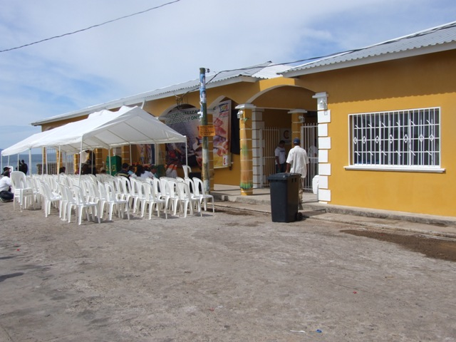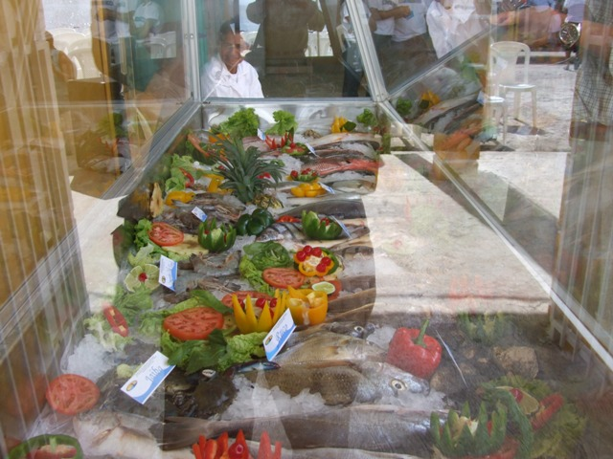

Except in the case of the mentioned market, in the rest of the country, intermediaries are the unavoidable link in the marketing chain between small-scale fishers and the wholesalers, retailers, supermarkets and consumers.

PER-CAPITA CONSUMPTION IN HONDURAS

Per-capita consumption is low if compared with the importance of the fishing activity in the Honduran economy. This is partly explained by the high price these commodities represents for a significant proportion of the population, and because fish and shellfish are not part of their daily basic diet, except in the areas of fisheries and aquaculture vocation.

Table 19 – National calculation of apparent consumption of fisheries and aquaculture products, 2000 - 2007
Year | National production (1) | Imports (2) | Exports (3) | Apparent consumption (1) + (2) - (3)
2000 | 18 946 234 | 4 147 495 | 13 467 161 | 9 626 568
2001 | 22 197 383 | 4 059 926 | 15 825 866 | 10 431 443
2002 | 25 885 246 | 3 873 371 | 21 947 901 | 7 810 716
2003 | 31 789 510 | 4 509 637 | 24 904 501 | 11 394 646
2004 | 36 332 785 | 4 100 346 | 28 416 401 | 12 016 730
2005 | 40 741 484 | 5 591 877 | 32 335 345 | 13 998 016
2006 | 48 746 451 | 5 105 122 | 39 615 111 | 14 236 462
2007 | 45 707 152 | 6 128 347 | 33 994 434 | 17 841 065
Sources: DIGEPESCA and SIECA. Note: Only includes data about production, exports and imports of products for human consumption: chapter 03 and positions 16.03, 16.04 and 16.05 of the customs nomenclature SAC. Excludes the position 23.01 - Fish meal not suitable for human consumption.

The analysis conducted by the FIINPESCA Project for the period 2000 – 2007 indicates that per-capita consumption in Honduras had an average of 2,12 kilos per person per year. Despite it is still low, had a growth rate of 61% suggesting that gradually has been increasing the preference for fish products. Besides, every year there is a traditional seasonal of high sales in the months of March and April (Easter time), a characteristic also shared by the rest of Latin American countries.

Table 20 – Estimated per-capita consumption of fisheries and aquaculture products, 2000 - 2007 (in kilos/person/year)
Year | Apparent consumption | Potential consumer population (5 - 80 years) | Per-capita consumption (kg/person/year)
2000 | 9 626 568 | 5 296 531 | 1,82
2001 | 10 431 443 | 5 402 682 | 1,93
2002 | 7 810 716 | 5 511 890 | 1,42
2003 | 11 394 646 | 5 624 255 | 2,03
2004 | 12 016 730 | 5 739 880 | 2,09
2005 | 13 998 016 | 5 858 874 | 2,39
2006 | 14 236 462 | 5 974 440 | 2,38
2007 | 17 841 065 | 6 093 437 | 2,93
Average 2000 – 2007 |  |  | 2,12
Source: FIINPESCA-FAO/OSPESCA/SWEDEN Project
Note: 85% of the total population is potentially consumer

Most of the supply of fish and seafood fresh, frozen and dried-salted, comes from marine artisanal fishing, inland fishing and aquaculture. Also a significant proportion of canned tuna and canned sardines are produced in neighbouring countries like El Salvador and Costa Rica, and there are also a wide range of high-value added products aimed at higher income population (octopus, squid and clams canned, salmon filets, seafood casserole, breaded fillets, fingers, sushi ingredients, etc.) that are imported from different countries of Europe, South America, North America, Asia and even from the Far East.

In the coolers of the supermarkets, the entire fish usually is displayed by columns separated by species and in each of them are placed between 10 and 15 units, which make contact one another on an ice cap that sometimes is not enough to ensure freshness.

In the market places there are entire fish and in portions, refrigerated in freezers that ensure a better quality, but on the other hand, on the places of popular sales there are many sellers who offer their products placed outdoors in plastic containers with limited provision of ice blocks or ice flakes, sometimes protected by umbrellas, which affects the quality and proper preservation of fish and shellfish. However, unlike the supermarkets, there is a most frequently rotation of the products due to fishers and intermediaries supplied daily, and many consumers preserve the tradition of buying seafood in the market places.

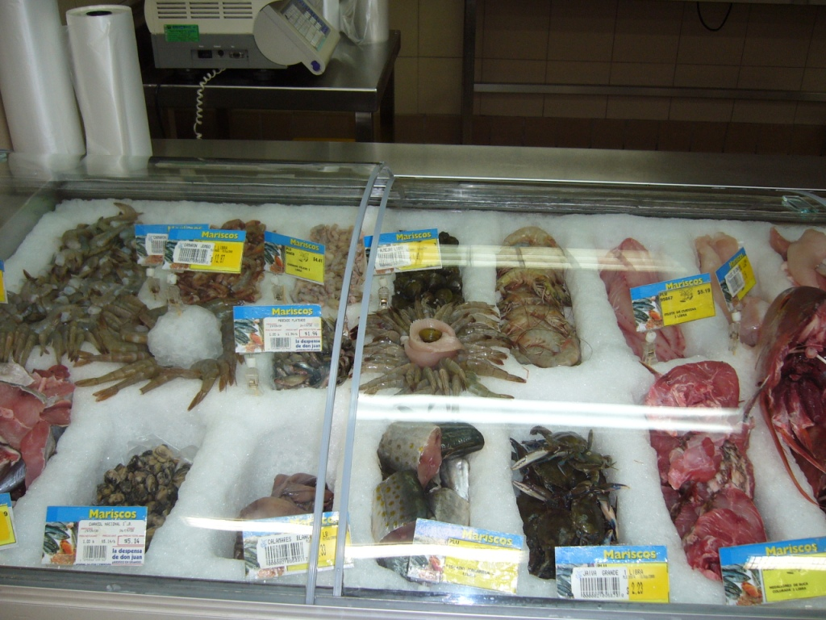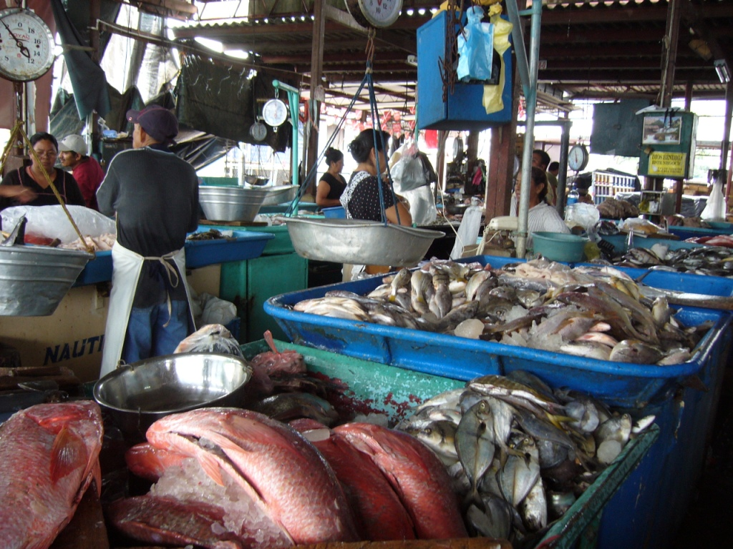

The fact that low quality products remain into the market supports the conclusion that Honduran consumers, particularly those with lower incomes and access to education, have little knowledge about how to recognize the good quality of fish and seafood, as well as their good conservation.

Although no consumers were interviewed for this study, this behaviour could be understood because the habits of the country give priority the consumption of beef, pork and chicken and also because there are no campaigns to promote consumption of fish products, which strengthens the prevention of buyers by the spines and the quality of fish, sometimes well-founded.

The variety, quality and volume of supply do not depend exclusively on the abundance of fish and seafood, but also of the demand requirements. Unfortunately, domestic buyers are less demanding regarding the quality and type of products available on the market, which may partly explain the fact that retailers are not forced to improve its offer. As so often happens, the fact that buyers do not express their nonconformity, allows the producers to think that their products are well accepted and therefore they are working well, but really not.

In Honduras as well as in the other Central American countries, keep silent about the poor quality is one of the most common attitudes of those who goes to a sales point of fish and seafood but they do not make the purchase (whether in a supermarket, plaza market, fishing port or street vendors). This is because the buyers does not want to be exposed to a negative or indifferent reply from the sellers against a claim, and also because they think it makes no sense to express their inconformity when health authorities or consumer advocacy and even the same traders does not take corrective actions.

Developing a better culture of the consumers requires educational campaigns aimed at the whole population but with emphasis on people of lower economic and educational level, who tend to think that the fact of have little money, restrict them from demanding their right to acquire products of good quality.

SYNTHESIS OF THE VALUE-CHAIN

Although throughout the document have been described the characteristics of the stages of the value-chain, their behaviour will be put in diagrams for its two subsectors (fisheries and aquaculture), both industrial and small-scale. Unfortunately there is no database completely updated for 2010 about the number of independent enterprises and producers involved in all the stages of the chain. For this reason, the following information is that recorded by DIGEPESCA, SENASA and FIINPESCA project between 2007 and 2010.

Value-chain for industrial aquaculture

Shrimp farming is developed at the south of the country and tilapia farming is concentrated in the central zone. According to DIGEPESCA and SENASA, in the production phase are counted 231 shrimp farms, 11 hatcheries for shrimp seed production, two diagnostic laboratories for water quality and aquatic pathology and 13 industrial projects of tilapia.

In the processing stage are registered eight shrimp processing plants and three for tilapia (associated with the three largest farms). Finally, in the marketing stage there are not quantified how many companies are involved on it, because frequently the same producers and processors are responsible for export and sales in the domestic markets, or through wholesalers and retailers. For that reason, it is estimated that almost the whole production remains across the different levels of the value chain.

From the labour outlook, the industrial and small-scale shrimp farming generate about 27 000 direct jobs, while industrial tilapia farming generates 6 000 direct employments.

Chart 10 – Value-chain for industrial aquaculture
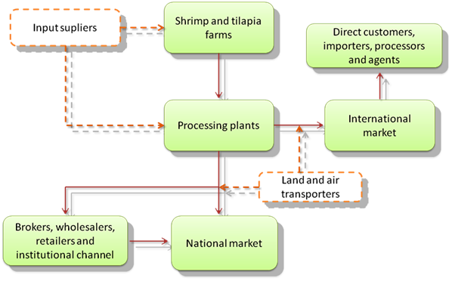

Value-chain for industrial fishing

Is developed exclusively in the Caribbean (the fleet arrives to the Bay Islands and the port of La Ceiba, Atlántida department). The industrial fleet is composed by 216 vessels for the fisheries of: lobster, shrimp, finfish and queen conch. In the processing phase, there are 23 packing plants, which also work with squid and crab. As in the aquaculture industry, there is no accurate record of traders because producers are in charge of exports while domestic sales are done directly or through wholesalers and retailers.

In terms of employment generation are estimated 5 430 crew members and other 1 980 people in processing and packing plants.

Chart 11 – Value-chain for industrial fishing
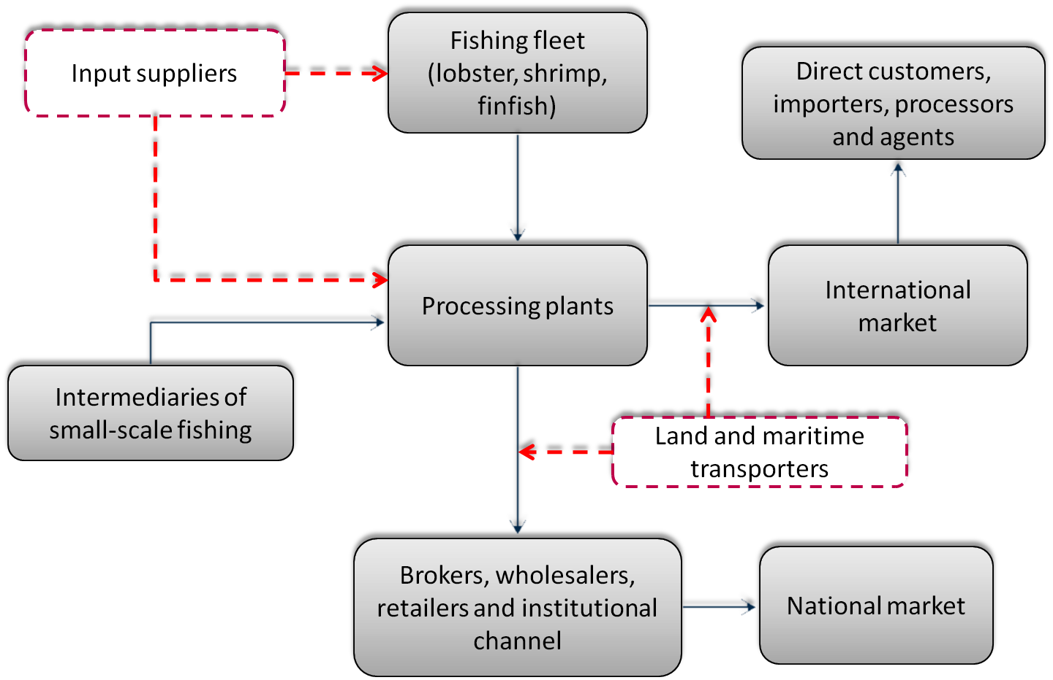

Value-chain for small-scale aquaculture

According to estimates of DIGEPESCA, the country has around 5 600 medium and small scale tilapia aquacultures, who basically sell gutted and fresh fish. Regarding the marketing, there is no accurate data about the number of wholesalers, retailers and intermediaries involved in this phase of the business, but it is known that practically the entire production supplies national market.

Chart 12 – Value-chain for small-scale aquaculture
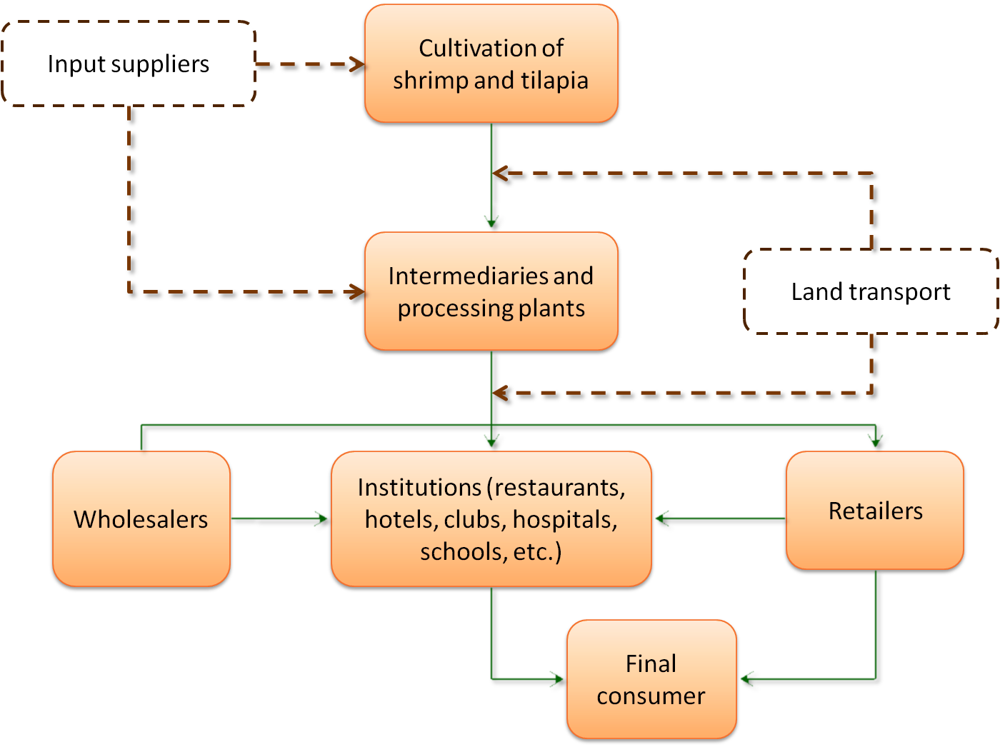

Value-chain for small-scale fishing

Regarding the quantification of small-scale fishers still there is not precise data. Up to date, OSPESCA (Organization of Fisheries and Aquaculture Sector of the Central American Isthmus) is conducting a census of fishing and aquaculture producers in the country. However, according to estimates of the FIINPESCA Project, in Honduras there are 17 200 fishers (63% in the Caribbean, 19% in the Gulf of Fonseca and 18% on inland waters). As in small-scale aquaculture, there is no estimate data about the number of intermediaries, wholesalers and retailers involved in the processing and marketing of its commodities.

Chart 13 – Value-chain for small-scale fishing
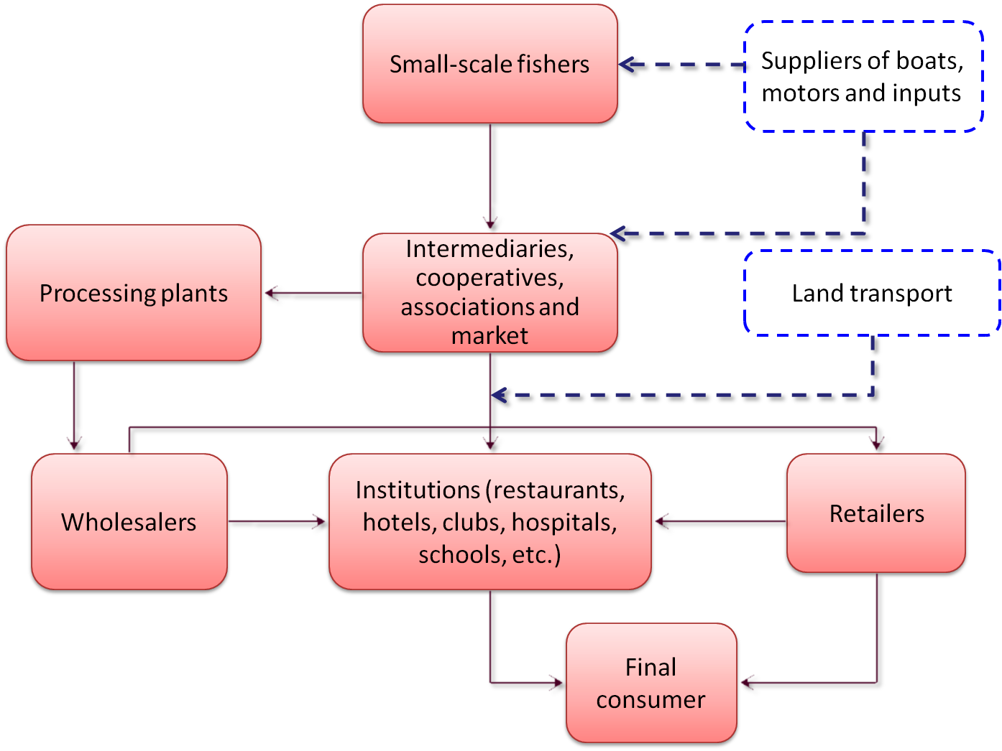

DISTRIBUTION OF BENEFITS AMONG ACTORS IN THE VALUE-CHAIN

Each of the actors in the value chain obtains several benefits expressed in monetary terms and / or welfare. The most relevant stakeholders are: fishers and aquaculture producers, suppliers of equipment, materials and supplies, traders at wholesale level, retailers and brokers, final consumers (individuals and institutions who are part of civil society) and the State.

In monetary terms, higher-earning producers are the industrials of the fisheries and aquaculture, particularly those who have integrated the processes of production, processing and marketing, because they have more possibilities to avoid the entry of intermediaries, which keep a significant portion of profits of the business. In Honduras, this is the case of large shrimp and tilapia farmers, while between the industrial fishers of lobster and shrimp is more common to find companies exclusively involved in the capture stage, while other companies are engaged in processing and marketing, mostly for export.

In the case of small-scale fishing and aquaculture, intermediaries are who earn the highest profits. Usually they provide the inputs for the capture or culture stage and then they buy their production and sell it to wholesalers, retailers, processing plants or institutional channel. In the marketing stage of these two activities is where there are major quantity of actors, thus increasing the prices paid by final consumers, which can be between 60% and 100% higher than the first sale price, i.e. that the intermediary pays the small-scale fishers or aquaculture producers.

The benefits to suppliers of equipment, row materials and supplies for fishing and aquaculture at industrial and small-scale level, depend on the dynamism of the sector because it determines their possibility to maintain, decrease or increase their business opportunities. Except for feed for aquaculture, navigation equipment, fishing equipment and ties of mooring for boats, that are purchased abroad or with international suppliers, in Honduras can be found most of the inputs required for both activities.

The benefits for the final consumers and institutional channel (restaurants, hotels, schools, military forces, etc.), which are the principal representatives of civil society in the value-chain, are defined in terms of access to fisheries products. Although according to INE, 60% of the Honduran population is within the poverty line and per-capita consumption reached in 2007 was 2,9 kg/person/year, in the market there is a wide offer of fish and seafood of different prices and presentations, accessible to all socioeconomic strata and consumer preferences.

The benefits for the State are several: the generation of foreign exchange by approximately US$ 183 million per year by the exports of commodities originated on the five resources analyzed in the value-chain, generating around 65 470 direct jobs (26 250 in small-scale fishing and aquaculture, 32 000 in the industrial aquaculture, 5 420 in the industrial fleet and 1 800 in 23 processing plants) and internationally recognition as the largest producer of farmed shrimp in Central America, the first country at global level to obtain the international certification for compliance the ISTRA standards relating to good practices in the culture of tilapia, and the second largest producer in Central American of Caribbean spiny lobster, being Nicaragua the first.

Based on the data reported in numeral 4 of this document (cost structure) and numeral 8 (marketing), is constructed the distribution of economic benefits of the fisheries of spiny lobster and shrimp, which are the activities with more quantitative information available.

As was said in the chapters 4.6 and 4.7, there aren't available detailed information about the costs of each production stage in aquaculture (tilapia and shrimp), so was not possible to do the respective exercise of distribution of benefits.

Distribution of benefits in the spiny lobster fishery

Based on the volume of catch per fishing trip, the travel costs of industrial and small-scale fishing (with pots and scuba diving), the prices paid to the crew and fishers when production is landed from vessel in port (first sale price) and export prices (second sale price) profits are calculated both in monetary and percentage terms.

Table 21 – Distribution of benefits in the industrial and small-scale capture of Caribbean spiny lobster, with pots and scuba diving
(In American dollars per pound. At current prices, 2007)
Stage | Item | Industrial fishing of lobster with pots | Industrial fishing of lobster with scuba diving | Small-scale fishing of lobster with pots | Small-scale fishing of lobster with scuba diving
Capture | Catch per fishing trip (in pounds) | 3 185 | 6 500 | 265 | 105
Capture | Costs per fishing trip ($) | 41 833 | 67 517 | 160 | 56
Capture | Unitary cost per pound ($) | 13,13 | 10,39 | 0,60 | 0,53
Capture | First sale price ($) | 14,72 | 14,72 | 11,50 | 11,50
Capture | Profits per pound (first sale) | $1,59 | $4,33 | $10,90 | $10,97
Capture | Percentage of benefits (first sale) | 84,54% | 93,73% | 75,64% | 75,75%
Process | Process costs per pound ($) | 0,70 | 0,70 | 0,70 | 0,70
Exports to USA | Export price ($) | 15,71 | 15,71 | 15,71 | 15,71
Exports to USA | Profits per pound (exports) | $0,29 | $0,29 | $3,51 | $3,51
Exports to USA | Percentage of benefits (exports) | 15,46% | 6,27% | 24,36% | 24,25%
Final profit of the product (per pound, $) |  | $1,88 | $4,62 | $14,41 | $14,48
Final profit of the product (per pound, %) |  | 11,94% | 29,43% | 91,70% | 92,15%

As noted in the table above, the higher costs are generated in the capture phase and the larger share of profits stays in this stage also. Due to decrease of international prices of spiny lobster, the processing stage does not generate high profits, even more considering those products have minimum level of processing.

Although fishing with pots is the most convenient method because is more selective and it does not threat human life, from a technical perspective is less efficient in terms of volume of catches. By contrast, industrial fishing with scuba divers is more risky and more productive but also more expensive.

In the end, industrial fishing could be less profitable compared with small-scale fishing, which is explained by the remarkable difference in production costs of each system. Despite the high profits that often receive fishers dedicated to spiny lobster fishery, that is not reflected on better living conditions and food security for them nor their families because of their lifestyle, low levels of education, practically null savings and investment culture, as well as their limited prospects of economic diversification for the indigenous misquitos, that maintains this population under poverty conditions.

In synthesis, of the US$ 15,71 that constitute the final price to wholesalers, industrial owners keep US$ 14,72 (89,1% of average earnings between the systems of pots and scuba diving), while small-scale fishers keep US$ 11,50 (75,7% of average earnings between the two systems), which means that processing plants and exporters earn between 6,3% and 24,4% of the final profit of the spiny lobster fishery.

For the present study are not available sales prices of spiny lobster to final consumers on Miami or New York, however it is known that these prices can exceed 60% of the price paid by the importers.

Distribution of benefits in the shrimp fishery

With the same methodology used on the above case, is constructed a table that shows the costs, revenues and profits in the stages of capture, processing and marketing up to the final consumer, as most of shrimp catches goes to the domestic market.

Table 22 – Distribution of benefits in the industrial and small-scale capture of shrimp in the Caribbean and the Gulf of Fonseca
(In American dollars per pound. At current prices, 2007)
Stage | Item | Industrial fishing of shrimp (Caribbean) | Small-scale fishing of shrimp (Gulf of Fonseca)
Capture | Catch per fishing trip (in pounds) | 31.200 | 70
Capture | Costs per fishing trip ($) | 68.459 | 39
Capture | Unitary cost per pound ($) | 2,19 | 0,56
Capture | First sale price ($) | 2,80 | 2,60
Capture | Profits per pound (first sale) | $0,61 | $2,04
Capture | Percentage of benefits (first sale) | 21,46% | 45,80%
Process | Process costs per pound ($) | 0,30 | 0,30
Sales on the national market | Wholesale price ($) | 3,50 | 3,50
Sales on the national market | Profits per pound (second sale) | $0,40 | $0,60
Sales on the national market | Percentage of benefits (second sale) | 14,17% | 13,45%
Final consumer | Supermarket price ($) | 5,32 | 5,32
Final consumer | Profits per pound (supermarket) | $1,82 | $1,82
Final consumer | Percentage of benefits (supermarket) | 64,38% | 40,75%
Final profit of the product (per pound, $) |  | $2,82 | $4,46
Final profit of the product (per pound, %) |  | 53,10% | 83,88%

Also as in the case of the lobster, the higher production costs occurs on the capture stage because the process stage produces minimum value added, and industrial fishing is more expensive than the traditional, mainly due to fuel consumption, the duration of fishing trips and the number of crew members among whom costs and profits are distributed.

Thanks to the sector diagnostic carried out by DIGEPESCA in 2007, there are available the supermarket prices to final consumers for that year. This data allows concluding that biggest profits are in hands of traders, while the consumer price increases between 90% and 105% since the first sale.

In conclusion, the percentage distribution of profits on the industrial and small-scale fishing of shrimp and considering first-sale prices of US$ 2,80 and 2,60 respectively and the final consumer price of US$ 5,32 is as follows: the capture stage keeps an average of 33,6% of the profits, 13,8% between wholesalers and retailers (second sale) and 52,6% among the retailers who sell to final consumers.

LEGAL FRAMEWORK OF THE FISHERIES AND AQUACULTURE SECTOR

The main rules govern the performance of the fisheries and aquaculture sector as well as the processing, quality control and marketing of its products are the following:

- Decree 154 of May 19, 1959 - Fisheries law. Gives the general legal framework of the fisheries and aquaculture sector in the country. Its main objective also includes the rules for fauna and flora, their utilization, marketing and industrialization. Available on: http://www.fao.org/fishery/shared/faolextrans.jsp?xp_ISIS_MFN=000850&xp_faoLexLang=S&xp_lang=es
- Phytosanitary law, Decree 157 of 1994, updated with the Decree 344 of December 16, 2005. Its purpose is to ensure the health of people, animals and to preserve vegetables, as well as the conservation and safety of their products and by-products of the damaging effects of pests and diseases of economic and quarantine importance. Available on: http://www.senasa-sag.gob.hn/index.php?option=com_content&task=view&id=100&Itemid=132
- Regulations for inspection and zoo sanitary certification of fisheries and aquaculture products, Agreement 1081 of September 23, 1999, updated by the Agreement 728 of January 15, 2009. Its purpose is to govern the hygiene-sanitary and technology inspection procedures of fisheries and aquaculture products of any species, in facilities where are processed or sold, and which are for domestic consumption or export. Available on: http://faolex.fao.org/docs/pdf/hon19965.pdf
- Regulation of the fishing and aquaculture health, Agreement 1418 of 2000, updated with the Agreement 189 of February 19, 2001. Its objective is to establish the technical, administrative and legal measures to preserve the fishing and aquaculture health of the country through actions to prevent the introduction, establishment and spread diseases of economically, quarantine and social importance that threaten the human and animal health. Available on:
http://www.ahprahonduras.org/uploaded/content/category/2064531778.pdf

Furthermore, although not part of the national law, but in compliance with the rules previously mentioned, SENASA developed in 2009 the "National Programme for analyzing chemical and microbiological residues in the fishery and aquaculture products" that should be applied along the entire productive chain. Available on: http://www.ahproaba.com/leyes/Programa_nacional_de_an%F1alisis_de_residuos_qu%EDmicos_y_microbiol%F3gicos_en_productos_pesqueros_y_acu%EDcolas.09.pdf).

CONCLUSIONS AND RECOMMENDATIONS

The conclusions are aimed to answer to the basic objectives of the FAO project about the comprehensive analysis of the value-chain of the international market of fishery and aquaculture products and their impact on small-scale production, in order to identify ways to improve food security of the Honduran population and to propose policy decisions.

- The main factors that determine prices and profitability margins of fisheries and aquaculture activities in Honduras are: the commercial importance of each product, the ability to produce large volumes of high quality and the performance of international prices for exportable commodities. In the case of shrimp (from fishing and farming) and tilapia, profitability is largely influenced by Asian competition, while the lobster market depends largely on the economic cycle in the United States economy, which is the main buyer of Caribbean spiny lobster.
Since the point of view of production, the cost of fuel is a key determinant of the profitability of industrial and small-scale fisheries, except in the case of industrial fishing of spiny lobster with scuba diving, where the payment to divers and the rest of the crew represents 61% while the fuel is 24% of the cost of fishing trips.
In the shrimp and tilapia culture, the profitability is defined by four factors: (a) The scale economies that could be achieved through the best possible efficiency in the technical management of the crop (seed quality, feed, stocks densities and water quality), (b) Efficient use of infrastructure, equipment and materials for processing products and the best use possible of the skills and time of the labour force, (c) Efficiency in the use of money, (d) Developing skills of negotiation because the shrimp and tilapia are commodities highly elastic to prices. Any change in cents per kilo can make sales volumes increase or decrease and therefore to produce impacts in the business profitability.
Count on complete information, updated and accurate about costs, prices and market trends, is essential to know the profitability and visualize future trends. It is recommended to strengthen SAG and DIGEPESCA in order to help to overcome their weaknesses to take and analyze production statistics, market performance and socioeconomic indicators of the sector.
- The distribution of benefits among the different stakeholders (fishers, suppliers, traders, consumers, State, civil society, etc.) is quite mixed. In economic terms, in the fishing and aquaculture activities at industrial level the higher profits are obtained by the entrepreneurs who have integrated the processes of production, processing and marketing, because they avoid the action of intermediaries throughout the chain.
In the fishing and aquaculture of small-scale, profitability remains on intermediaries hands (which usually provide inputs and buy the final production), as well as of wholesalers and retails, while fishers and farmers receive less than 40% of the final price that consumers pay in the domestic market.
The benefits for the final consumers and civil society are defined in terms of access to fisheries and aquaculture commodities. Although according to INE, 60% of the Honduran population is within the poverty line and per-capita consumption of 2007 was calculated just in 2,9 kg/person/year, in the market there is a wide offer of fish and seafood of different prices, accessible to all socioeconomic strata and consumer preferences.
Benefits for providers are determined by their opportunity to supply the industrial and small-scale producers, so while the sector can grows increase their business opportunities. Except for feed for aquaculture, navigation equipment, fishing equipment and ties of mooring for boats, that are purchased abroad or with international suppliers, in Honduras can be found most of the inputs required for fishing and aquaculture.
The benefits for the State are several: the generation of foreign exchange by approximately US$ 183 million per year by the exports of commodities originated on the five resources analyzed in the value-chain; the generation of about 63 210 direct jobs (5 430 on board of industrial fleet, 1 980 in processing plants of the Caribbean, 17 200 in small-scale fisheries, 27 000 in shrimp farming and 11 600 in tilapia farming) and internationally recognition as the largest producer of farmed shrimp in Central America, the first country at global level to obtain the international certification for compliance the ISTRA standards relating to good practices in the culture of tilapia, and the second largest producer in Central American of Caribbean spiny lobster, being Nicaragua the first.
For the present study was possible to define the profit margins of the production and marketing stages for spiny lobster and shrimp fisheries. In the case of spiny lobster, that is aimed to export, the capture phase for both industrial and small-scale methods, represents 82,4% of profits while the processing and exports the other 17,6% of the final earnings. However there is not available information about prices paid by final consumers in United States.
Regarding the shrimp derived from fishing and also adding the industrial and small-scale production for the domestic market, it is concluded that capture phase keeps 33,6% of final earnings, the second sale of wholesalers and / or retailers keeps 13,8%, while retailers who goes to the final consumer retain 52,6% of total profits.
To improve benefits for consumers, producers and other actors linked to the production and domestic marketing of fisheries and aquaculture commodities, it is recommended to advance the required steps in order that OIRSA or other competent bodies, can provide advice and support to the production destined to the domestic markets according the quality standards required for export, and carry out the necessary arrangements with the sanitary and health authorities of the country.
It is also recommended strengthen the "Centre of marketing and sanitation of fisheries and aquaculture products in the Gulf of Fonseca", better known as Coyolito fish market, in order to achieve its future sustainability and increase the sense of belonging of fishers, aquacultures and traders.
- Regarding the creation of value of fisheries and aquaculture products processed and unprocessed for export, the markets of United States and Europe ask to Honduran exporters, fish and seafood in fresh and frozen state with low degree of processing because they are most desired in a more natural state, as in the case of lobster tails and larger shrimps, or because they use them as raw material for new more elaborated products.
Although the production of high added value is profitable and at least three Honduran industrial plants are exporting shrimp of high added value, other industrialists prefer to continue with traditional commodities because the production lines are already adapted and also because the higher price they can obtain for products more manufactured, do not compensate the increased costs and technological changes involved.
Surveys to consumers are recommended to know the preferences and needs of domestic demand, in order that producers and traders can improve the supply of the most desired products, both in volume and quality, at fair prices. The current trend indicates that frozen fish and seafood with low degree of process as well as canned are those preferred by the Honduran consumers, but the quality and rising prices caused by the chain of intermediaries are restricting demand.
- The main features of the value-chain for the Caribbean spiny lobster fishery are as follows: The major ports of landing are the Bay islands and La Ceiba. Industrial fishing is executed by two methods: vessels equipped with 3 000 traps or pots made ​​of wood (for trips of 45 days) or with 35 scuba divers with compressed air tanks (for trips of 12 to 15 days and a total crew of 75 people), while small-scale fishers use the same methods but on daily trips or a maximum of three days.
Upon arrival at port, the industrial production of the fleet is transferred to processing plants (usually the vessels are affiliated to the companies or are of their property). For its part, the intermediaries who buy to small-scale fishers sell to the plants and in smaller amount to hotels and restaurants. During the processing phase are produced three traditional products in the United States market under the GMPs and HACCP standards: entire spiny lobster, tails and frozen meat of spiny lobster.
The transport of the final products to La Ceiba or Bay Islands is made with trucks and refrigerated containers towards the docks where merchandise is shipped to Miami and New York on maritime voyages which last three to four days. Thanks to the advances of information and communication technologies, many exporters do direct negotiations with foreign clients (processors, restaurants, hotels and other merchants). This implies that agents, who in the past acted as intermediaries, are becoming less frequent.
- The characteristics of the value-chain on the shrimp fishery are similar to spiny lobster. Industrial fishing is concentrated on the Caribbean and is executed by vessels owned or affiliated to the companies, crewed for eight people on trips of three to four months, while the small-scale fishing is predominant in the Gulf of Fonseca and performed by two or three people by boat, on daily fishing trips. This fishery has problems of overexploitation, which is why producers have been forced to diversify with finfish and in the case of small-scale fishers, to work on ecotourism, as merchant sailors and other activities.
The products are taken directly from the boats, where they are kept refrigerated in ice flakes, to the plants in order to process frozen shrimp in shell, peeled, deveining, butterfly, IQF and pre-cooked. Subsequently are packed and placed in refrigerated containers to transport them by ship to Miami and New York.
On the small-scale fisheries and although the shrimp is the target specie, during the last 10 years has been higher bycatch captures. Because the trips last no more than six hours per day, most of the fishers do not carry ice on board and at reaching the beach sold the production almost immediately to the intermediaries, or in the case of the Gulf of Fonseca is sold to the Coyolito fish market, which put the shrimp on the domestic market or is sell to the processing plants. Those surplus stocks that fishers can not sell immediately, often give them to their wives, who are responsible of selling them at the local markets.
- Regarding the value chain of finfish, its conduct is very similar to shrimp and is also associated often. The products come from small-scale and industrial fisheries. The long line fleet is composed of 22 vessels, operating in the Caribbean and the most important species are snappers and groupers. Its objective is to export to the United States, Cayman Islands in the Caribbean and on a smaller scale to Europe, while lower-value fish are destined for domestic consumption. Processing and packaging is done on the same plants located in Bay Islands and La Ceiba, which also work with lobster and shrimp.
- The value chain of shrimp farming is perhaps the most important among the five selected, since between 2000 and 2007 contributed with 39,4% to GDP in the fisheries and aquaculture sector and 2% to the national GDP. Honduras is the largest producer of shrimp farming on Central America (44% of regional production with 231 projects of large, medium and small scale).
Because its target market is the export, complies with all standards of quality from the production of seed in the hatcheries until send the final commodities abroad. Most supplies to the entire production cycle can be purchased in the country except the feed and some equipment which is acquired through international suppliers.
The whole process is developed at the south of the country (departments of Valle and Choluteca), where in addition to the 231 cultures, there are eight processing plants and 11 hatcheries. The transport of the products is carried by road in refrigerated trucks to the airports of Tegucigalpa and San Pedro Sula to export them to the United States and Europe.
- Regarding the value-chain of tilapia farming, its dynamics is quite similar to shrimp farming. Currently, Honduras has positioned itself as the largest Latin American exporter of fresh tilapia fillets to the United States and besides, a local firm has been certified by comply with the ISTRA standards relating to good tilapia farming practices.
The industrial fish farming meets all quality standards required to export to the United States and Europe. For its part, the domestic market absorbs all the production of small-scale producers, sold mainly as gutted fish, and a lesser amount like fillets.
Tilapia farming is carried out throughout the country with emphasis on the central area. Farming methods are floating cages (particularly in Lake Yojoa and Dam El Cajon) and earthen ponds in many small and medium-sized farms that combine aquaculture with agriculture and/or livestock.

BIBLIOGRAPHY

- Banco Central de Honduras. “Estadísticas e indicadores económicos”. Available on: http://www.bch.hn.
- Banco Central de Honduras. 2009. “Honduras en cifras 2007-2009”. Tegucigalpa (Honduras). Available on:
http://www.bch.hn/download/honduras_en_cifras/hencifras2007_2009.pdf
- ECLAC. “Bases de datos y publicaciones estadísticas”. Available on:
http://websie.eclac.cl/infest/ajax/cepalstat.asp?carpeta=estadisticas.
- ECLAC. “Estudio económico de América Latina y el Caribe 2009-2010 – Honduras”. Available on: www.eclac.org/publicaciones/xml/3/40253/LCG2458_HONDURAS.pdf
- ECLAC, ILO. June, 2010. “Coyuntura laboral en América Latina y el Caribe”. Available on: http://www.eclac.org/publicaciones/xml/1/39781/2010-410-Boletin_3_CEPAL-OIT-WEB.pdf.
- CONGRESO NACIONAL. “Decreto 154 del 19 de mayo de 1959 – Ley de Pesca”. Available on:
http://www.fao.org/fishery/shared/faolextrans.jsp?xp_ISIS_MFN=000850&xp_faoLexLang=S&xp_lang=es
- DIARIO LA PRENSA. December 31, 2009. “Honduras sin delimitar seis fronteras marítimas”. Available on:
http://www.laprensa.hn/Pa%C3%ADs/Ediciones/2010/01/01/Noticias/Honduras-sin-delimitar-seis-fronteras-maritimas.
- DIGEPESCA. “Diagnóstico pesquero y acuícola”. November, 2007. Tegucigalpa (Honduras).
- FAO – Coalición de instituciones que trabajan en SAN. 2005. “La seguridad alimentaria y nutricional en Honduras”.
- NOAA – Fisheries Statistics and Economics Division. Monthly trade data summarized by country. Available on:
http://www.st.nmfs.noaa.gov/st1/trade/monthly_data/TradeDataCountryMonthSummary.html
- NOAA. Southeast fishery bulletin – FB09-002. January 12, 2009. Available on:
http://sero.nmfs.noaa.gov/
- OIRSA / OSPESCA. “Manual de buenas prácticas de manejo para el cultivo de camarón blanco (Litopenaeus vannamei)”. Available on:
http://www.oirsa.org/aplicaciones/subidoarchivos/BibliotecaVirtual/ManualBuenasPracticasCamaronCultivo2010.pdf/
- OSPESCA. “Reglamento OSP-02-09 para el ordenamiento regional de la pesquería de langosta del Caribe (Panulirus argus)”. Available on:
http://www.sica.int/busqueda/secciones.aspx?IdItem=53444&IDCat=48&IDMod=1&Criterio=2.1.%20Productos%20finales%20de%20car%C3%A1cter%20regional&IdEnt=47&Idm=1&IdmStyle=1/
- Programa Desarrollo Sostenible en Centroamérica GTZ-FIDE. “Honduras si exporta – Ficha de camarón”. Available on: http://www.hondurassiexporta.hn/documentos-de-interes/fichas-producto-mercado-para-exportar-a-la-union-europea/
- FAO – TCP / RLA / 311 Project “Mejoramiento de los mercados internos de productos pesqueros en América Latina”. Eloisa Espinoza. September, 2007. “Caso de Honduras”. Tegucigalpa (Honduras).
- FAO – LDED / DIGEPESCA Project “Procesamiento y mercadeo de productos pesqueros de la Cooperativa San Vicente, puerto de Tela, Honduras (PR-31233)”. Claudia Beltrán. July 2005. “Informe de consultoría en desarrollo empresarial aplicado al procesamiento y comercialización de productos pesqueros”.
- FIINPESCA – FAO / OSPESCA / SWEDEN Project. Claudia Beltrán. November, 2008. “Resultados del trabajo de campo para el análisis integral de las pesquerías de langosta y camarón en los países centroamericanos”. San Salvador (El Salvador). Available on:
http://www.sica.int/busqueda/secciones.aspx?IdItem=53447&IDCat=48&IDMod=1&Criterio=3.1.%20Productos%20finales%20de%20car%C3%A1cter%20regional&IdEnt=47&Idm=1&IdmStyle=1
- FIINPESCA – FAO / OSPESCA / SWEDEN Project. Claudia Beltrán. January, 2009. “Indicadores macroeconómicos para la evaluación socioeconómica de las pesquerías de langosta y camarón en Centroamérica”. San Salvador (El Salvador). Available on:
http://www.sica.int/busqueda/secciones.aspx?IdItem=53447&IDCat=48&IDMod=1&Criterio=3.1.%20Productos%20finales%20de%20car%C3%A1cter%20regional&IdEnt=47&Idm=1&IdmStyle=1
- FIINPESCA – FAO / OSPESCA / SWEDEN Project. Claudia Beltrán. January, 2009. “Análisis regional e interdisciplinario de las pesquerías de langosta y camarón en los países centroamericanos”. San Salvador (El Salvador).
- FIINPESCA – FAO / OSPESCA / SWEDEN Project. Claudia Beltrán. February, 2009. “Estudio de mercadeo para las pesquerías de langosta y camarón en los países centroamericanos y factibilidad de establecer una certificación regional”. San Salvador (El Salvador). Available on:
http://www.sica.int/busqueda/secciones.aspx?IdItem=53447&IDCat=48&IDMod=1&Criterio=3.1.%20Productos%20finales%20de%20car%C3%A1cter%20regional&IdEnt=47&Idm=1&IdmStyle=1
- FIINPESCA – FAO / OSPESCA / SWEDEN Project. Claudia Beltrán. October, 2009. “Indicadores macroeconómicos del sector pesquero y acuícola del Istmo Centroamericano, período 2000 – 2007”. San Salvador (El Salvador). Available on:
http://www.sica.int/busqueda/secciones.aspx?IdItem=53447&IDCat=48&IDMod=1&Criterio=3.1.%20Productos%20finales%20de%20car%C3%A1cter%20regional&IdEnt=47&Idm=1&IdmStyle=1
- FIINPESCA – FAO / OSPESCA / SWEDEN Project. Claudia Beltrán. November, 2009. “Valoración económica de las pesquerías de langosta y camarón en los países centroamericanos”. San Salvador (El Salvador). Available on:
http://www.sica.int/busqueda/secciones.aspx?IdItem=53447&IDCat=48&IDMod=1&Criterio=3.1.%20Productos%20finales%20de%20car%C3%A1cter%20regional&IdEnt=47&Idm=1&IdmStyle=1
- FIINPESCA – FAO / OSPESCA / SWEDEN Project. Sergio Martínez. 2009. “Estado actual de la pesca de caracol gigante del Caribe (Strombus gigas) en Centroamérica”. Available on:
http://www.sica.int/busqueda/secciones.aspx?IdItem=53444&IDCat=48&IDMod=1&Criterio=2.1.%20Productos%20finales%20de%20car%C3%A1cter%20regional&IdEnt=47&Idm=1&IdmStyle=1
- SAG. “Reglamento para la inspección y certificación zoosanitaria de productos pesqueros y acuícolas”. Available on: http://faolex.fao.org/docs/pdf/hon19965.pdf
- SAG. “Reglamento de salud acuícola y pesquera”. November, 2000. Available on:
http://www.ahprahonduras.org/uploaded/content/category/2064531778.pdf
- SAG – INFOAGRO. “Serie de precios de mariscos y pescados en Honduras”. Available on:
http://www.sag.gob.hn/index.php?option=com_content&task=view&id=2008&Itemid=1032
- SENASA. “Ley Fitosanitaria Decreto 157/94”. Available on: http://www.senasa-sag.gob.hn/index.php?option=com_content&task=view&id=101&Itemid=132
- Unión aduanera en Centroamérica. Avances a Julio de 2010. Available on: http://www.sieca.int/site/VisorDocs.aspx?IDDOC=Cache/17990000003359/17990000003359.swf

Undernourishment: Status of people whose food energy consume is permanently below the minimum requirements to have healthy living and to do light physical activity with a minimum acceptable weight for the attained height (FAO, 2008).
FAO - Coalition of institutions working in SAN. 2005. Food security and nutrition in Honduras.
This information is based on the inflation statistics published by the Central Bank of Honduras.
ECLAC. Economic Survey of Latin America and the Caribbean 2009-2010 (Chapter: Honduras).
Op.cit.
Op.cit.
Op.cit.
FIINPESCA – FAO/OSPESCA/SWEDEN Project. Macroeconomic indicators of fishery and aquaculture sector of the Central American Isthmus, period 2000 - 2007, updated for 2008 and 2009 with DIGEPESCA data.
FIINPESCA – FAO / OSPESCA / SWEDEN Project. Current status of the queen conch fishery (Strombus gigas) in the Central American Caribbean.
FIINPESCA – FAO / OSPESCA / SWEDEN Project. Macroeconomic indicators of fisheries and aquaculture sector of the Central American Isthmus, period 2000 - 2007.
Op.cit.
NOAA. Information available on: http://www.st.nmfs.noaa.gov/st1/trade/monthly_data/TradeDataCountryMonthSummary.html
SAG-INFOAGRO. Database seafood prices in Honduras. Available on: http://www.sag.gob.hn/index.php?option=com_content&task=view&id=2008&Itemid=1032
FIINPESCA-FAO/OSPESCA/SWEDEN Project. Regional and interdisciplinary analysis of lobster and shrimp fisheries in Central America. January 2009.
Op.cit.
FIINPESCA – FAO/OSPESCA/SWEDEN Project. Economic evaluation of lobster and shrimp fisheries in Central America.
"sacabuzos" is the person who seeks the scuba divers in the Mosquitia region and negotiates with them to join the crew.
Op.cit.
Op.cit.
Personal interview with representatives of ANDAH and the firm "Deli de Honduras S.A de C.V” (Annex I).
OIRSA/OSPESCA. Manual of best management practices for white shrimp culture (Litopenaeus vannamei). Available on: http://www.oirsa.org/aplicaciones/subidoarchivos/BibliotecaVirtual/ManualBuenasPracticasCamaronCultivo2010.pdf
SICA / Mexico’s government. Mesoamerican Cooperation Programme 2009-2010. "Training project for Central American farmers of middle and small scale". Available on: http://www.funprover.org/formatos/cursos/Manual%20Buenas%20Practicas%20Acuicolas.pdf
NOAA. Southeast fishery bulletin – FB09-002. January 12, 2009. Available on: http://sero.nmfs.noaa.gov
Program of sustainable development for Central America GTZ-FIDE. “Honduras si exporta”. Available on: http://www.hondurassiexporta.hn/documentos-de-interes/fichas-producto-mercado-para-exportar-a-la-union-europea/
Cevichería is a small artisanal restaurant that sells seafood coctels, molluscs and similar products, generally next to the beaches, touristic places in ports and in some cities.
FIINPESCA-FAO/OSPESCA/SWEDEN Project. Marketing study for lobster and shrimp fisheries in Central America and viability to establish a regional certification. 2009.
Program of sustainable development for Central America GTZ-FIDE. “Honduras si exporta”.
Central American Customs Union. Advances to July, 2010. Available on: http://www.sieca.int/site/VisorDocs.aspx?IDDOC=Cache/17990000003359/17990000003359.swf
FIINPESCA-FAO/OSPESCA/SWEDEN Project. Results of the field work for the comprehensive analysis of lobster and shrimp fisheries in Central America. 2008.
OSPESCA. Regulation OSP-02-09 for the regional management of the spiny lobster fishery (Panulirus argus). Available on: http://www.sica.int/busqueda/secciones.aspx?IdItem=53444&IDCat=48&IDMod=1&Criterio=2.1.%20Productos%20finales%20de%20car%C3%A1cter%20regional&IdEnt=47&Idm=1&IdmStyle=1
FIINPESCA-FAO/OSPESCA/SWEDEN Project. Macroeconomic indicators of fishery and aquaculture sector of the Central American Isthmus, period 2000 – 2007. Year 2009.
DIGEPESCA. Diagnosis of the fisheries and aquaculture sector. November, 2007.
Op.cit
DIGEPESCA. Diagnosis of the fisheries and aquaculture sector. November, 2007.

