Notes on Prices and Margins in Fish Marketing

Trond Bjørndal  CEMARE  University of Portsmouth  UK  Trond.Bjorndal@port.ac.uk | Daniel V. Gordon  Department of Economics  University of Calgary  Canada  dgordon@ucalgary.ca

March 2010

I. Introduction
The ex-vessel price of fish is ultimately set by the end-user/retail demand for the commodity. Given that the ex-vessel price of fish defines the profits and welfare of fishermen and their communities, it is of interest to enquire as to the link between retail and ex-vessel prices.
Much of the work in price linkage between producer and retailer is drawn from agricultural economic studies. The standard approach to measuring retail/farm price linkage is based on work by Gardner (1975), where demand and supply functions are specified for both farm and retail sectors, and the equilibrium is solved under general competitive conditions. Estimation is based on the reduced form model, and current period retail and farm prices are treated endogenously (see Brorsen, Chava, Grant and Schnake, 1985; Wohlgenant, 1989; Holloway, 1991; Lyon and Thompson, 1993). Heien (1980) extended this model to allow both for non-market clearing conditions (i.e., inventories) and for dynamic adjustments to shocks in the farm and retail sectors.
The assumption of perfect competition seems appropriate when applied to setting the ex-vessel price of fish but inappropriate for setting price at the processing-distribution-retailing (PDR) sector of the fish market. This is due to the fact that in many industrialised countries a few supermarket chains account for more than 80% not only of retail sales in general but of fish products in particular. This notion of non-competitive pricing at the PDR sector of the market may therefore have important welfare implications for fishermen. A study of fish price linkage should account for monopoly/monopsony pricing power at the PDR sector of the market.
The purpose of these notes is to summarise some alternative models of price linkage that may be useful for studying the price relationship from the vessel to the retail sector.

II. Methodology
Structural Models
The demand for fish from the fisherman or fish farmer is derived from demand for the end-user/retail commodity. The retail price will reflect the fish price plus the cost of marketing the commodity from the vessel or fish farmer to the retail level. “Marketing” is here to be understood in a broad sense. It includes not only transportation of the product from point of production or capture, but also processing, if applicable, and distribution to the point of end use.
Let the retail/vessel price margin be the difference between the retail and vessel price. The impact of a shock say to fish landings on retail price (and equally important to the fisherman is a demand shock at the retail level impacting the ex-vessel price of fish) will depend on the structure of the relationship between the two sectors (see Wohlgenant and Haidacher, 1989).
First, let us consider a fixed proportions relationship between fish supply and marketing inputs used in processing the fish product for the retail market. What this means is that, say one kg of raw fish is combined with a fixed amount of labour and capital in terms of processing and transportation of the product to the retail market. Let us further assume a perfectly elastic supply of marketing inputs which means that the cost of using these inputs is constant per unit produced. This implies that the supply of the fish commodity at the retail level is the sum of fish supplied and the fixed supply of marketing inputs. This relationship is described in Figure 1 and 2.
In Figure 1, S(f) is the supply curve for fish. The fish supply function is upward sloping, indicating a positive harvest response to increases in the price of fish, or larger production of farmed fish when the price increases. The supply of marketing inputs S(w) is horizontal, representing the assumptions of fixed proportions and constant input prices. Vertically “adding” S(w) to S(f) gives the supply curve at the retail level, given by S(r).

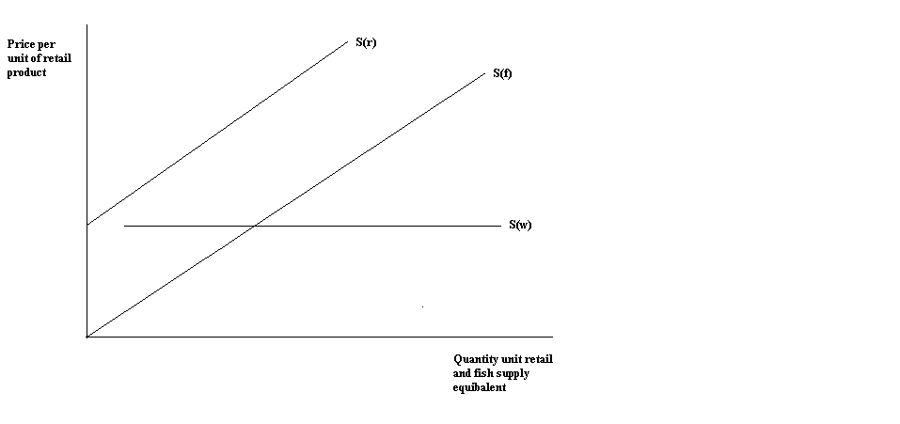
Figure 1. Ex-vessel and Retail Supply of Fish; Fixed Marketing Costs.
Figure 2 adds to Figure 1 the demand function for fish at the retail level (D_{r}) and the derived demand for fish at the vessel level (D_{f}) The ex-vessel price (Pf) is set by the intersection of the ex-vessel supply of fish (Sf) and the derived demand for fish product (Df). The retail price is set by the intersection of the retail demand for fish and the retail supply of fish. In this simple model, the derived demand at the farm level is obtained by subtracting the marketing margin from the retail demand function. We see for this model that an increase fish supply, S(f) shifting to the right, will have no effect on marketing margin but will decrease retail and ex-vessel price.

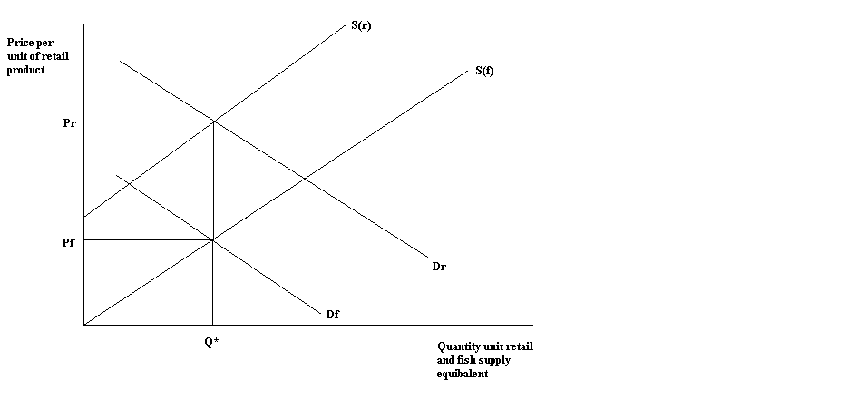
Figure 2. Retail and Ex-vessel Price; Fixed Marketing Costs.

Next, let us consider the case of less than perfectly elastic supply of marketing inputs. We look at the case of a non-constant proportional relationship between fish supply and marketing inputs, in particular the case where proportionally larger amounts of marketing inputs are required to process increased supply of fish. In this situation, increases in fish supply will cause changes in the margin. This is represented in Figure 3. The upward sloping supply function for marketing inputs (Sw) represents the need to use proportionally larger amounts of marketing inputs to process increased levels of fish supply. Keep in mind that we are keeping the cost of marketing inputs constant but require a greater proportion of marketing inputs to process increased levels of fish supply. At the initial equilibrium level represented by farm price (Pf) and retail price (Pr) the marketing margin is the difference (Pr-Pf). A leftward shift in the supply of fish product to say (S’f) caused, say, by an increase in fishing costs, results in an increase in fish price to (Pf’) and under the assumption of fixed proportions, an increase in retail price (P’r) and a decrease in the marketing margin. In this framework, decreases in fish supply cause an increase in both ex-vessel and retail price but a decrease in the margin.
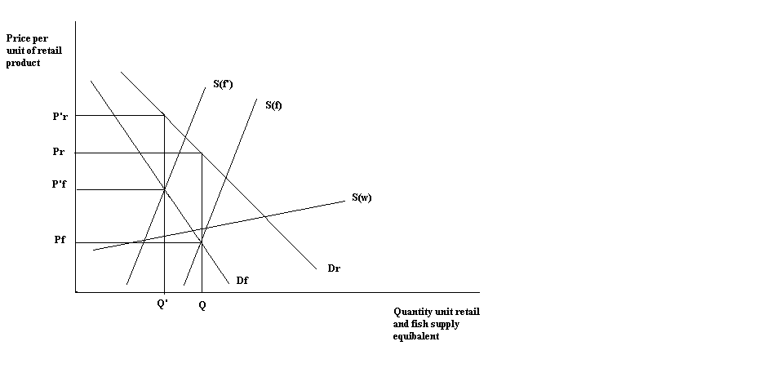
Figure 3. Retail and Ex-vessel Price; Variable Marketing Costs.

A third case might be that of a fixed proportions relationship between fish supply and marketing inputs, but where the prices of inputs increase as larger quantities are used. An example might be the use of overtime labour to process a larger volume of fish. This would correspond to the case illustrated in Figure 3.
Finally, if the supply of marketing inputs is perfectly elastic but substitution possibilities exist between the fish commodity and marketing inputs, the derived fish demand curve is more elastic than in the previous case. This situation is shown in Figure 4. It is now assumed that the (initial) supply of fish is constant and set at Q. This might, for example, be the case in a seasonal fishery regulated by a Total Allowable Catch quota (TAC), so that the supply is given by the TAC. This will give a fish price of Pf and a retail price of Pr.
If a “shock” to the system results in a decrease in harvest to Q’, e.g. because the TAC is reduced from one year to the next, the price of fish under fixed proportions would increase along the original farm demand curve (Df’) to Pf’. However, if it is possible to substitute some marketing inputs for the now higher priced fish the derived fish demand curve (Df’’) is more elastic and the price of fish increases to only Pf’’, less than Pf’. Under these conditions a decrease in fish supply can be associated with an increase in margin.
The assumption of variable proportions technology appears to have some merit at the processing level. Wohlgenant and Haidacher (1989) argue that processors can choose alternative production processes, including different modes of transporting the commodity, interproduct substitutability and the substitution of quality for quantity. These points are very relevant also for fish products. Over the decades there have been major improvements in transportation and distribution systems. Moreover, processing plants have in general become more capital intensive. In recent decades, production in the processing plants have been standardised, arising from the Hazard Analysis Critical Control Point (HACCP) specifications imposed by the developed countries as a prerequisite for exports and imports. These and other developments all influence on the marketing of fish.
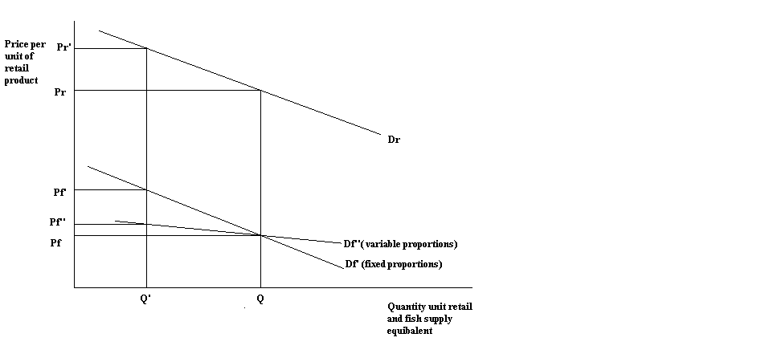
Figure 4. Retail and Ex-vessel Price; Substitution of Fish Commodity and Marketing Inputs.

As a consequence of this, the attributes of products may change over time, or even be different at the same point in time. A fresh tilapia farmed in Zimbabwe for export to Europe will be different for product going to the domestic market.
An interesting model that might be of use in a fish linkage study is the model developed by Wohlgenant (1989) and Holloway (1991). They specify a competitive equilibrium three equation model to measure variations in marketing margin $(M_{i})$, retail price $({\text{pr}}_{i})$ and (for our purposes) ex-vessel price $({\text{pf}}_{i})$. The explanatory factors are the same for each equation and are defined as i) a marketing cost index $({\text{MC}}_{i})$, which is a weighted price index of the inputs used in moving the commodity through the processing stage to the retail market, ii) a retail demand shifter $({\text{RD}}_{i})$, which is a weighted index representing at the retail level the price of substitute commodities, non-food commodities, income and population levels, and iii) a fish supply variable, say landings $(L_{i})$. This model provides summary measures of the price and margin flexibilities with respect to the exogenous variables. However, a problem is that it is a data intensive technique and although data may be available for developed countries it might not be as useful for developing countries.
The Holloway model can be written as:
$$M_{i}=β_{m}+β_{\text{mmc}}{\text{MC}}_{i}+β_{\text{mrd}}{\text{RD}}_{i}+β_{\text{mq}}L_{i}+ε_{1}$$
${\text{pr}}_{i}=β_{\text{pr}}+β_{\text{prmc}}{\text{MC}}_{i}+β_{\text{prrd}}{\text{RD}}_{i}+β_{\text{prq}}L_{i}+ε_{2}$
${\text{pf}}_{i}=β_{\text{pf}}+β_{\text{pf}}{\text{MC}}_{i}+β_{\text{pfrd}}{\text{RD}}_{i}+β_{\text{pfq}}L_{i}+ε_{1}$
The disadvantage of the model is that the third equation is incorrectly specified for competitive markets where quantity, not price, is the choice variable for the fishermen. We will need to modify the equation so that landings will be the dependent variable.
The advantage of the model specified is that linear restrictions imposed on the parameters can be used to test a null hypothesis of perfect competition in the different sectors (Holloway, 1991).
A number of authors have provided variations on the general model described here. Lyon and Thompson (1993) present a simple mark-up model to explain variations in marketing margin. In their model, the margin is specified as a linear function of retail price and marketing input costs. This model allows for a combination of absolute and percentage markups to influence the margin.
Wohlgenant (1985) is concerned with capturing the effect of retail price lagging commodity price. Arguments for such lagged effects depend on price stickiness in the retail market, perhaps due to the cost of making the price change. In Wohlgenant's model, a multi-period lag structure for commodity price is combined with a marketing cost index to explain margin. This model has the advantage of measuring the lagged impact of commodity price on retail price and providing an estimate of the elasticity of marketing margin with respect to commodity price at each lagged point. An example is provided by a product like frozen fillets sold through supermarkets. The retail price of this kind of product will usually change only gradually over time, implying that the processor will have to absorb short run changes in the ex-vessel price. Should there be a permanent increase in the ex-vessel price, the processor will have to pass this on to the consumer, however, the retail price is likely to increase only with a time lag.
For further discussion let us define the above models as ‘Structural Models’.

Reduced Form Models
There are alternatives to these more structured models in measuring price linkage. Asche et al. (2007) is a good example of the ad hoc spirit of simply measuring the relationship among prices at different levels in the fish PDR chain. These models rely on statistical techniques to capture price linkage, where some form of cointegration among the prices defines the market and allows for predicting the consequence of price and random shocks in the price chain. These models require a time series of data on prices at different stages of the supply chain – ex-vessel, processing and retail - for estimation. Estimation necessitates a fairly long time series, giving a sufficient number of observations.
Although these models reduce the need for data, they provide less information than the structural models described above. Nevertheless, these statistical models may be useful in studying fish price linkage in developing countries where price data may be more readily available.
For further discussion let us define the time series models as ‘Reduced Form Models’.
III. Modelling Imperfect Competition in the PDR Sector
In processing sectors with high concentration ratios, it is possible that individual firms play an active role in price-setting and that in setting prices, each firm pays close attention to the likely reactions of other firms. The outcome of such interdependent or oligopolistic behaviour will be determined by the extent to which the major players in an industry can coordinate actions to take advantage of whatever monopoly rents are available. The standard presumption in oligopoly analysis is that the more concentrated an industry, the more likely it is in achieving the joint-profit maximising price and capturing monopoly rents.
The key characteristic of profit maximising imperfect competition, both oligopoly and monopoly, is that price is set to equate marginal revenue to marginal cost, and thus is higher than marginal cost, since demand is not perfectly elastic (e.g. Holloway, 1991). This proposition is summarised by the ‘Lerner mark-up rule’, which relates retail price (P_{r}) to marginal cost (c) for a profit-maximising imperfect competitor by the formula
$P_{R}(1+1/η)=c$ (1)
where $η$ is the price elasticity of demand perceived by the price setter. This is just a first-order-condition and not an estimating model, since elasticity could depend on other variables. If it does not, we simply can write:
$P_{R}=m⋅c$ (2)
with m a constant proportional markup. In this case, a shift in the retail demand curve will have no effect on price, and a change in costs will have the same effect, regardless of whether m is equal to or exceeds one. This is important because if we have a competitive market, m=1 and if we have an imperfectly competitive market, m>1. But, in either case, competitive or imperfectly competitive behaviour cannot be distinguished in Equation (2).
This is a simple but important insight: an industry could be capturing substantial oligopoly rents but still be indistinguishable in its response to cyclical shocks from a competitive industry just earning normal profits, if elasticity is constant. Nor is this implausible. Most processing and retailing operations have technologies that enable output to be changed even in the short run at fairly constant marginal cost. In addition, such firms may be constrained by threat of entry from taking advantage in their markups of cyclical changes in demand or supply conditions.
What if elasticity is not constant? Choose units such that total revenue (TR) and cost functions (TC) can be written as:
TR = aQ – Q (3)
TC = cQ
where a is a constant and marginal cost, c, is also constant. Then, solving for the profit maximising point or where marginal revenue equals marginal cost we get:
$a−2Q=c$ (4)
which solves for profit maximising quantity and price as:
Q* = (a-c) / 2; P_{r}* = (a+c) / 2 (5)
Now, consider the elasticities of P_{r}* with respect to shifts in demand $({ηP}_{\text{Ex}})$and in costs $({ηP}_{c})$ (e.g. changes in ex-vessel price or marketing input price). These elasticities can be written:
$({ηP}_{\text{Ex}})$= a / (a+c); $({ηP}_{c})$= c / (a+c). (6)
Both of these elasticities are less than one, and with a > c, price elasticity with respect to the demand shifter is larger than the elasticity with respect to cost.
In contrast, the elasticities for the competitive (P_{r} = c) case is simply:
$({ηP}_{\text{Ex}}=0)$ and $({ηP}_{c}=1)$ (7)
This gives us a way of distinguishing competitive from non-competitive behaviour. Of course, the particular model used here is highly simplified and stylised, but its insights are fairly robust: if elasticity increases with price then imperfectly competitive price-setting behaviour should result in larger price responses to demand shifts and smaller responses to cost changes than would be generated by perfect competition. On the other hand, if costs are increasing in output, then even a perfectly competitive industry will show a price response to a demand shift and a less-than-unitary price elasticity with respect to changes in input prices. Nevertheless, the competitive retail/ex-vessel price equation should be robust in measuring the price response at the retail level over both competitive and imperfectly competitive market conditions, and provide reasonable price flexibility measures for the fish commodities examined in this study.

IV. Data Requirements
Ideally, time series data throughout the value chain – capture/aquaculture, transportation/processing and retail – preferable for a fairly long time period and with as much frequency (monthly, weekly etc.) as possible are required for the estimation of Structural Models. In general the variables will represent price indices at different points in the value chain, an aggregate measure of retail demand factors, an aggregate price index measuring marketing cost inputs, and the different foreign exchange rates necessary for the different countries examined.
Specifically the variables are defined as i) a marketing cost index (MCI), which is a weighted price index of the inputs used in moving the fish product through the processing stage to the retail market. This index should include information on labour, transportation, fuel and power, maintenance and repair, services and utilities. ii) A retail demand shifter, which is a weighted index representing at the retail level the price of substitute commodities, non-food commodities, income, population levels, and exogenous shocks such as the BSE disease on fish demand, and iii) the price of the fish product at different points in the value chain.
The data requirements may be challenging, even for developed countries. For developing countries, the situation is likely to be very variable. For example for the Maldives, we would expect time series for ex-vessel and export prices for skipjack tuna to be available. Such data may well be suitable for a Reduced Form approach to price links. For other fisheries in other countries, data may need to be collected, but it is unlikely that they will be available for long periods. Nevertheless, the insights from the models presented here, combined with other quantitative as well as qualitative information, may be used to obtain a better understanding of developments over time.
Mention was made that product attributes may change over time, e.g. due to further processing or changes in hygiene standards. These changes need to be incorporated in the analysis.

V. The Way Forward
A possible research strategy for investigating ex-vessel-retail price supply links might be the following:
a) Identify countries and relevant capture and/or farmed products of interest. Although a few developed countries will be included, the emphasis will be on developing countries. It is best practice to over identify countries of interest, particularly developing countries, with the understanding that some of these countries may be dropped from the analysis depending on the availability and reliability of appropriate and adequate data to undertake such price link research. As well, some countries may be more willing and interested in participating and supporting the report project and this would certainly make any necessary data collection more successful.
b) A country analysis to be carried out that identifies for the fisheries sector important government regulations on marketing fish, the market structure from the vessel to either domestic retail or to the export market, identification of ‘small scale’ fisheries within this market structure and the fish species of interest.
c) An investigation to be carried out for each country that identifies for each segment of the fish supply chain the type, quality, quantity and time period of data available for analysis. From this each country identified in a) is to classified according to the data available for analysis
i. Category one countries: meet complete data demands to undertake a full Structural Model analysis of ex-vessel-retail price links;
ii. Category two countries: meet data demands to undertake a Reduced Form analysis of the ex-vessel-retail price links;
It is essential that at least some developing countries fall in category one or two classifications. (Reasons for this will be presented below.)
iii. Category three countries: very limited or no data available to meet requirements of either the Structural or Reduced Form models. As mentioned above for such countries it will be necessary for the project to collect primary data from source. It is likely that such data would be limited in a time series perspective but could provide a cross-section snap-shot of price links from ex-vessel to export markets or domestic retail outlets.
The research strategy for category one and two countries would proceed under normal research parameters; model development either Structural or Reduced Form, data summary and presentation, econometric modelling, estimation and evaluation, and policy analysis.
Category three countries would be handled in a multi-complex framework. First, what data available or collected would be analysed within the framework of the market structure of the fish supply chain for the country of interest as defined by b) above. This snap-shot of data and country specific market structure would then be evaluated within the structural and/or reduced form framework previously identified and estimated for other closely related countries form category one and two. The idea would be to combine general information on the links and parameter estimates in the fish supply chain from other developing countries accounting for changes in the market structure for the country of interest and available data. In this way, we could build a model describing the fish supply chain for countries with limited data.

References

Al-Zand, O., Barewal, S. and Hewston, G. (1985) The Food Marketing Cost Index. Agriculture Canada, Marketing and Economics Branch Working Paper 1/85.

Asche, F, Jaffry, S and Hartmann, J. (2007) Price transmission and market integration: vertical and horizontal price linkages for salmon Applied Economics 39 (19) 2535-45.

Brorsen, B. W., Chavas, J.P., Grant W.R. and Schnake L.D. (1985) Marketing Margins and Price Uncertainty: The Case of the U.S. Wheat Market, American Journal of Agricultural Economics 67, 521-28.

Gardner, B.L. (1975) The Farm Retail Price Spread in a Competitive Food Industry, American Journal of Agricultural Economics 57, 339-409.

Hassan, Z. A. and Johnson, S.R. (1976) Consumer Demand for Major Foods in Canada,
Agriculture Canada, Economics Branch Publication No. 76/2.

Heien, D.M. (1980) Markup Pricing in a Dynamic Model of the Food Industry, American Journal of Agricultural Economics 62, 10-18.

Holloway, G. J. (1991) The Farm-Retail Price Spread in an Imperfectly Competitive Food Industry, American Journal of Agricultural Economics 73, 979-89.

Kinnucan , H. W. and Forker, O.D. (1987) Asymmetry in Farm-Retail Price Transmission for Major Dairy Products, American Journal of Agricultural Economics 69, 285-92.

Lyon, C. C. and Thompson, G.D. (1993) Temporal and Spatial Aggregation: Alternative
Marketing Margin Models, American Journal of Agricultural Economics 75, 523-36.

Wohlgenant, M. K. and Haidacher, R.C. (1989) Retail to Farm Linkage for a Complete Demand System of Food Commodities, U.S. Dept. of Agriculture, Technical Bulletin No. 1775.

Wohlgenant, M. K. (1985) Competitive Storage, Rational Expectations, and Short-Run Food Price Determination, American Journal of Agricultural Economics 67, 739-48.

Wohlgenant, M. K. (1989) Demand for Farm Output in a Complete System of Demand
Functions, American Journal of Agricultural Economics 71, 241-52.

The derived demand for fish is based on the demand function for fish at the retail level. At the retail level the supply of fish is just one of a number of inputs used to produce the final retail commodity. Mathematically this can be represented using a cost function at the retail level. Consider the cost of producing the final fish commodity at the retail level. The cost will reflect the price and quantity of all inputs used to makeup the final retail product. We can write this as: $$C=P_{F}Q_{F}+\sum{P_{i}Q_{i}}$$ where subscript F defines the fish product and subscript i defines all other inputs. Q_{F} represents the demand for fish and is a function of the other inputs used in the retail process and the total amount of fish demanded at the retail level.
.

