infosamak
Value chain Report
Morocco
2011

Table of Contents
Page

1. Background and objectives 3
2. General overview of the sector 3
2.1 Introduction 3
2.2 Key indicators 3
2.2.1 Production 3
2.2.2 Exports 3
3 Focus on artisanal fisheries 5
4 Price evolution: 6
5 Methodology 7
5.1 Species choice 7
5.2 Fishing sites choice 7
5.3 Companies choice 7
6 Results 7
6.1 Anchovy 7
6.2 Demersal fish 10
6.3 Hake 12
6.4 Octopus 14
6.5 Sardine 21
6.5.1 Fresh sardines 21
6.5.2 Canned sardine 25
6.5.3 Frozen sardine 26
6.5.4 Headless/gutted/frozen sardine 27

Background and objectives
Fish exports and trade is a major source of income for developing countries and they represent around 50% of global fish exports with annual export revenue exceeding US 25billion. Apart from generating revenue, the activity creates jobs and it contributes to human protein intake.
In fish production in the developing countries, specifically the Arab Region, around 80% is carried out by the small scale sector. Enabling small scale fisheries products to reach international markets as well as obtaining sustainable margins is a priority to safeguard their interests.
Increasing margins, inter alia those of small scale fishermen, requires an analysis of the dynamics of the value chains. The distribution of benefits as well as the identification of existing linkages between the different stakeholders in the chain is the objective of this project.

General overview of the sector

2.1 Introduction
Morocco has a coastline of 3,500 km and is characterized by the diversity of its marine resources, with a potential for fish production estimated at 1.5 million tons.
The seafood sector is a key sector in the Moroccan economy; the annual fish production is over one million tons and it is 2.5% of the country’s GDP. Exports average 1.4 billion representing 15% of total exports and over 50% of Moroccan exports of food products. The fisheries sector generates around 170,000 direct jobs and 490,000 indirect jobs, i.e. around 660,000 jobs.

Key indicators

2.2.1 Production
The Moroccan fishery resource is diverse but it’s characterized by the prevalence of pelagic and cephalopod species that represent a high percentage in Moroccan seafood exports. The evolution of fish production originating from coastal and artisanal fisheries is shown in the table below.

2.2.2 Exports
Morocco is now a regional platform essential for recovery and export of fish destined for the most demanding markets.
Indeed, during the last two years, exports have been allocated as follows:
Moroccan seafood exports are mainly those of processed species: canned pelagics (sardines and mackerel), semi-canned anchovy. Frozen seafood is also an important component of the exports, mainly with cephalopods (octopus) and white fish. The EU remains the main market of export, although other countries source their fish from Morocco.
Table 1 : Fishery Product's Export Statistics (2010)
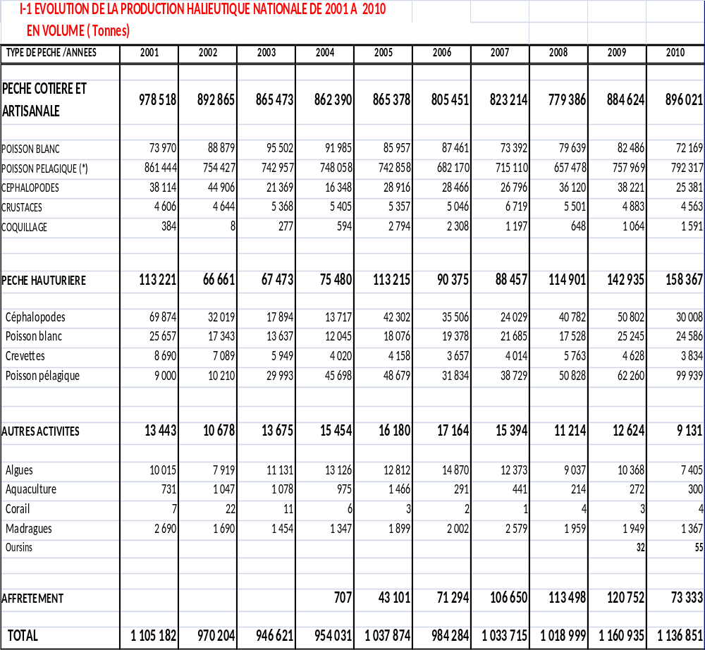

EXPORTS OF SEAFOOD BY DESTINATION AND ACTIVITY FOR THE YEAR 2010
Volume in tons:
Destination/Activity | Frozen | Fresh | Canned | Semi-Canned | Flour | Oil
European Union | 75 491 | 18 743 | 51 200 | 14 834 | 39 286 | 28 036
Rest Of Europe | 12 944 | 46 | 1 287 | 39 | 21 601 | 15 230
Oceania | 431 |  | 491 | 123
Middle East | 3 101 | 2 | 15 583 | 54 | 2 441
Asia | 23 947 | 14 | 294 | 110 | 3 887 | 364
America | 27 934 | 0 | 5 186 | 1 381 | 6 803
Africa | 26 347 | 44 | 60 625 | 14 | 2 407
TOTAL | 170 194 | 18 848 | 134 667 | 16 554 | 76 424 | 43 630
Value in thousands of dirhams :
Destination/Activity | Frozen | Fresh | Canned | Semi-Canned | Flour | Oil
European Union | 3 124 581 | 869 327 | 1 527 470 | 862 508 | 419 293 | 232 027
Rest Of Europe | 85 543 | 5 843 | 41 165 | 3 131 | 242 848 | 132 942
Oceania | 2 671 |  | 13 373 | 10 947
Middle East | 21 421 | 194 | 380 939 | 4 852 | 28 171
Asia | 693 277 | 11 243 | 10 637 | 12 736 | 28 519 | 2 469
America | 199 801 | 3 | 195 840 | 123 693 | 74 380
Africa | 203 195 | 988 | 1 511 747 | 939 | 14 585
TOTAL | 4 330 490 | 887 598 | 3 681 171 | 1 018 805 | 807 796 | 367 438
Source : EACCE

Focus on artisanal fisheries
The turnover generated by seafood products is witnessing an annual growth of 5%, it hovers around 800 million U.S. $ (Average turnover of 817 million U.S. $). Coastal and artisanal fishing generates more than half of sales (54%), followed by offshore (40%).
The artisanal fleet consists in wooden boats from 5 to 6m, equipped with outboard motors. Their number increased significantly from 3,600 in 1981 to around 15,000 boats nowadays.
The fishing fleet is highly selective, targeting the high commercial value fish (white fish and cephalopods), generally intended to international markets.

Price evolution
4.1 Wholesale prices

- Management of fish markets in Morocco: The National Fisheries Office (ONP)

The ONP is in charge of marketing seafood products. It manages fish markets which are the first sale markets located in ports and traditional fishing villages. The ONP acts as an interface between ship-owners and wholesalers on the one hand, and as a market regulator on the other.
The Office has gradually developed, since 2000, its information system called "MAIA". This helped computerize all administrative operations in terms of management of trade and the processing of accounting and statistical data. The MAIA system is currently operational in all ports and fishing villages managed by the ONP. It provides an integrated and quasi real-time management of seafood flows and the related financial flows.
Infrastructure: Ports

The supply chain in the Moroccan fisheries sector is managed through the ONP. Following are the current number of fish markets:
• 22 first sale markets in the major fishing ports
• 29 first sale markets in the fishing villages and landing sites, these include artisanal fisheries
• 8 outlets for industrial fish (pelagics) called “Comptoirs d’Agréage du Poisson Industriel” (CAPI) or Counters of Grading of Fish Industrial
• A cooling outlet in Agadir (2400 tons)
• 2 wholesale markets (second sale) in Casablanca and Oujda;
The distribution of these outlets is shown in the figure bellow:
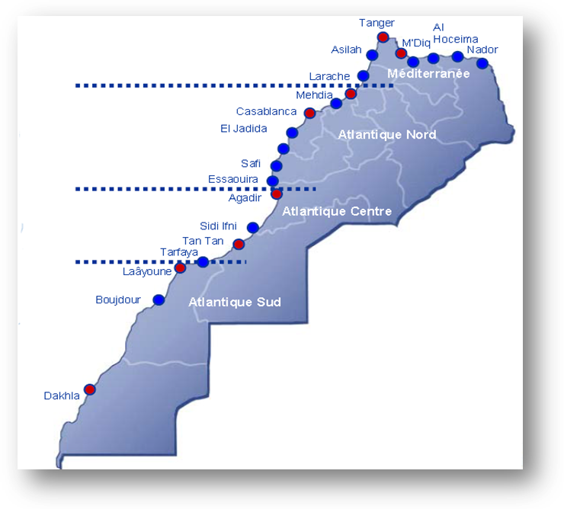

Figure 1: Geographical distribution of fishing ports in Morocco

Methodology
In order to analyze the value chain for the five species considered for this study, a preliminary determination of the profit margins in each link in the chain was made. To achieve this, a qualitative approach was adopted, based on field visits, interviews and meetings with professionals at landing sites (ship-owners, fishermen, professional associations’ members and fish mongers) and in fish processing plants. Meetings were also arranged with Delegates of the Ministry of Marine Fisheries and the ONP (National Fisheries Office) to have a better insight on the organization of the fishing activities in the different fishing ports.

These interviews enabled, at each link in the chain, to determine the various charges and income relating to the activity.

5.1 Species choice
There are five species, among others, which generate high income and remain important to this study. These are sardine, anchovy, hake, whitefish and octopus, generate the most important income nationally and remain important to this study.

5.2 Fishing sites choice
On the basis of production data by landing site, the main potential sites for each selected species were identified. The survey was undertaken in seven different cities shown in the table below:
Table 2: Fishing sites
Sardine | Anchovy | Hake | whitefish | Octopus
- Safi  - Agadir  - Tan Tan  - Dakhla | - Mehdia  - Agadir | - Moulay Bouselham | - Souiria Qdima | - Safi  - Souiria Qdima  - Tan Tan  - Dakhla

5.3 Companies choice
The choice of companies was based on the importance of their turnover, both in the national and international level. These companies produce and/or process the five fish species for the local market and/or for the export market.

Results
In this section the results of the study will be presented based on the species.

6.1 Anchovy
Anchovy passes through different levels until it reaches the consumer, thus the value chain for anchovy is presented in figure 2 below. First sale of anchovy landings is done either in the CAPI (Counters of Grading of Fish Industrial), when there is abundance in landings, or the first sale market. Mongers get hold of the sales and fish is directed either to the processing plants or to the local markets through the second sale market and retailers.
Sale to semi-canning units
Sale at the wholesale market
Wholesalers
Retailers
Final Consumer
Export
Anchovy Fishing
Landing at the port
Sale at the first sale market
Sale at the CAPI
Fishmongers

Figure 2: Anchovy value chain
Overview
The fishing port of Mehdia is 12km from the city of Kenitra (North of Morocco). The fishing activity lasts 6 days/week and the main species caught is anchovy.
Catch statement
The average anchovy catch per boat is 500 boxes, which makes an average harvest of 10,000 kg. As for the price, it varies between 50 and 500 Dhs/box with an average of 250Dhs/ box. The average price per Kg is 12.5Dhs /kg. The main customers of anchovy are wholesalers whom supply mainly to the semi-canned anchovy factories.

Price evaluation
According to fishermen, the prices have witnessed a light increase over the years, as well as loads. This simultaneous increase has guaranteed an average stability of the profit margin for the fisherman.
Costs structure
The main variable costs of the anchovy fishing activity are fuel (4.192 Dhs /trip) and ice (MAD 380 /trip). Charges average of MAD 4,500 by fishing trip. Additional costs include the tax paid by the fish owners which is 22% of the sale price.
Profit determination
The determination of the profit margin was based essentially on declarations of the interviewees. The ship owners profit is calculated after deduction of the common loads, 1.5% of the sale price goes to the boat maintenance and 3% is paid to the fishermen who work at the ship hold. The rest of the revenue is divided equally among the ship-owner and the vessel crew (50-50).
The table bellow shows the structure of the various costs incurred, and consequently the determination of the net profit of the owner:
Table 3: Anchovy’s costs and profit structure
Taxes | 22%
Maintenance | 4%
Fuel | 20%
Other costs | 10%
Crew share | 22%
Ship-owner profit | 22%
Total | 100%

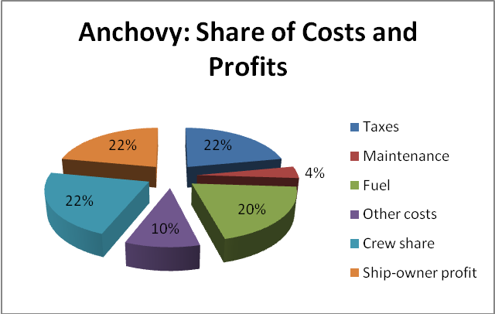
Figure 3: Anchovy's costs and profit structure

Demersal fish

Demersal fish is noble fish and most of the catch goes to export, mainly to the EU markets. The export is mainly whole fresh, frozen or chilled.

Fishing of Demersal Fish
First sale in the port
Fishmongers
Sale to processing plants
Processing

Export Sale
Landing at the port

Figure 4: Demersal fish value chain
Overview
The Demarsal fish catch is done mostly in a fishing village called "Souiria Kdima" which is situated in the region of Safi (West of Morocco). In the village there are 290 boats operated by 1400 fishermen.
Aside from octopus, which is fished in large quantities, whitefish are also captured regularly throughout the year. The main species are capelin, red mullet, sole and hake. The fishing gear used to catch whitefish is the net mesh (30mm in diameter).Table 4 indicates the monthly trips made by demersal fishermen.
Table 4: Monthly fishing trips
Month | J | F | M | A | M | J | J | A | S | O | N | D | Total trips/year
Trips | 15 | 10 | 10 | 15 | 24 | 24 | 24 | 24 | 24 | 24 | 15 | 15 | 224

Catch statement
Whitefish landings for each boat usually vary between 5 and 60 kg with an average of 20 Kg. As for the price, it can vary from MAD 40 to MAD 180 with an average of MAD 80.The main buyers of whitefish are wholesalers who supply factories that export fresh fish.

Price evolution
According to fishermen, fish prices have increased slightly over the years, and so have costs, which guarantee stability of the average profit margin of the fisherman.
Cost structure
The main variable costs related to the fishing activity of whitefish are fuel (MAD 500-600/trip), ice (MAD 30-50/trip) and food (MAD 100/trip). The total expense per trip is around MAD 700. As for taxes paid by the ship-owner, they stand at 5.62% of sale price.
Fixed costs are generally related to the fishing equipment maintenance (boat, motor and jig). Table 5 details the various fixed costs.
Table 5: Fixed costs of demersal fish
Costs | % of selling price
Boat maintenance | 3%
Motor maintenance | 10%
Net mesh maintenance | 50%
Transportation (rental cost) | 15%
Cost of keeping a boat on the broads | 22%
License fee | 0%
Total | 100%
Profit determination
Generally, there are three fishermen working on board. The profits, after deduction of commons, are shared equally between the owner and the crew. Fishermen, in turn, share their earnings equally. As for depreciation, it is included in the share of the ship-owner.
The ship-owner profit will be made on the basis of average numbers of trips, the average sale price and the average landed quantity in every trip:
- Average trip numbers: 224 trips
- Average sale price: MAD 80 /kg
- Average landed quantity: 20 kg/trip.
The table bellow shows the structure of the various costs incurred and consequently the determination of the net profit of the owner:
Table 6: Cost and profit structure of demersal fish
Taxes | 6%
Fixed costs | 8%
Variable costs | 44%
Crew share | 21%
Ship-owner profit | 21%
Total | 100%

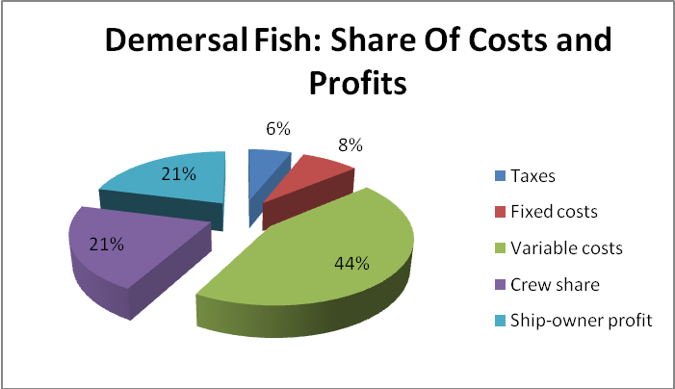
Figure 5: Demersal fish costs and profit structure
Fishermen thoughts
According to the interviewed fishermen, the region with the largest profit margin is the South Atlantic. It can reach up to 30%.Considering the whole chain of whitefish; it is wholesale fish merchants who generate the higher profit their margin can raise up to 50%.

Hake
Overview
Hake is mostly fished in a fishing village called «Merja zerka», which is situated in the lagoon of Moulay Bouselham (North of Morocco). It is harvested daily all over the year except during the months of November, December and January. There are around 126 boats operated by 400 fishermen. Lately, the fishing activity decreased due to general fish resources depletion. Hake is captured by trammel nets

Catch statement
The average hake catch is 50 Kg per boat. This production fluctuates based on the seasons; it can reach 100 kg as it can decrease to 10 kg. As for the price, it varies between 20 and 45 Dhs/Kg with an average of 30Dhs/Kg.
Customers of hake are regular buyers. The sale is made at the fish market and controlled by officers of the national office of fisheries.
Price evolution
According to fishermen, fish prices have increased slightly over the years, and so have costs, which guarantee stability of the average profit margin of the fisherman.
Costs structure
The main variable costs related to the hake fishing are fuel and ice, which is around 500DHs/trip. As for taxes, they stand at 4.72% of sale price.
Fixed costs are generally related to the fishing equipment maintenance (boat, motor and trammel nets). Table 7 details the various fixed costs:
Table 7: Hake fishermen’s various fixed Costs
Costs | % of selling price
1. Boat maintenance | 48%
2. Motor maintenance | 9%
3. Trammel net maintenance | 2%
4. Changing an engine part | 29%
5. Oil change | 9%
6. License fee | 3%
Total | 100%
Profit determination
Profits is shared after deduction of commons, there are three sailors working on board besides the owner. The profits are shared equally between the owner and the boat crew. The sailors, in turn, share their earnings equally.
Ship-owner profit is calculated based on the average number of trips, the average sale price and the average landed quantity in every trip. Following are information on the average number of trips, sale price and average landed quantity:
- Average number of trips: 180 trips
- Average sale price: 30DHs/kg
- Average landed quantity: 50 kg/trip.
Table 8 indicates the structure of the various costs incurred and consequently the determination of the net profit of the owner.
Table 8: Hake’s cost and profit structure
Costs | % of selling price
Taxes | 5%
Charges | 30%
Crew share | 33%
Ship-owner profit | 32%
Total | 100%

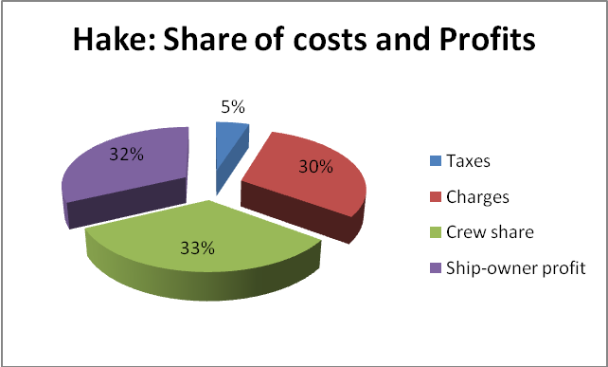
Figure 6: Hake's costs and profit structure

Octopus

Octopus fishing is operated by small scale fishermen, although octopus is caught by industrial fishing boats in the South of Morocco. They are sold in the first sale markets and head directly to processing plants (freezing units) by fishmongers. Local consumption of octopus is very low; almost the overall production is exported as whole frozen/chilled or as beaten and chilled octopus. Figure 7 indicates octupus value chain.

Octopus Fishing
Sale at the first sale market

Fishmongers
Sale to processing plants (freezing units)
Freezing
Export Sale
Landing at the port

Figure 7: Octopus value chain
- Fresh octopus
For this study the case of two fishing regions, where octopus is the major fish, were taken in to consideration.
Case n°1:
Overview
The region of “Oued Eddahab-Legouira” has four fishing villages which the main activity is octopus fishing. With 3,080 fishing boats, these villages are located as follows:
- Lassarga (1200 Boats) : 8 km away from Dakhla,
- N’tirift (920 Boats) : 67 km North of Dakhla,
- Imotlan (260 Boats) : 111 km North of Dakhla,
- Labouirda (800 Boats): 140 km South of Dakhla.

Octopus fishing is focused on the period from January until the end of April, with an average of 86 trips per boats. According to the status of the fishing area, two types of fishing gear may be used: the jig or the octopus pot.

Catch statement
Octopus landings per boat vary between 90 and 400 kg, this is when weather conditions are suitable and the stock is high, otherwise, this quantity varies between 20 and 100 kg per boat.
Unlike 2010, when the average selling price of octopus was 45 DH/kg, 2011 have known a very significant increase in price of octopus that has touched MAD 86/kg with a minimum of MAD 50/kg. Fishermen affirm that the average selling price is 65 DH/kg. The Octopus goes primarily to industrial units for processing, then export.

Price evolution
As reported by fishermen, the profit margin generated by the owner of an octopus fishing boat and his team has increased. This is mainly due to the scarcity of resource and the octopus high demand, especially, in the international market.
Cost structure
For each trip, the main costs for an octopus fisherman are as follows: fuel (MAD 430), food (MAD 150) and bait (MAD 30).The tax paid by the fisherman at the hall is set at 4.2% of total sales.

Fixed coasts depend on the fishing season and are presented as: MAD 10.000 for fishing equipments, MAD 2500 for boat, motor and fishing gear maintenance, MAD 160 (Annual) for License fee.
Table 9 indicates the cost structure by fishing season, considering 86 trips as an average number of trips.

Table 9: Cost structure of Octopus (Case n°1)
Common costs | % of selling price
Fuel and lubricant. | 57%
Bait | 4%
Food | 20%
Costs in charge of the ship-owner
Fishing equipments | 15%
Motor and fishing gear maintenance | 4%
License fee | 0%
Total | 100%
As reported above, the tax payable by the fisherman at the first sale market is set as 4.2% of total sales.
Profit determination
In general, the fishing crew is made up of three people (the boat responsible person and two sailors). The distribution of the money generated from the activity is as follows:
- After deduction of tax and common costs (fuel, food and bait), the rest is shared equally between the owner and the two fishermen. Fishing crew shares their part into three equal parts. The ship-owner deduces the costs in his charge and offers an amount equal to the half of sailor’s part to the “Raîss”.
The ship-owner saves 10% from his part for the boat amortization and its equipments. To calculate different margins for each link of this chain, the following parameters were taken in to consideration (see table 10).
- Trips by fishing season : 86 trips
- Selling price : MAD 65/kg
- Landed quantity: 150 kg/trip
Table 10: Cost and profit structure of Octopus (case n°1)
Costs | % of selling price
Tax | 4%
Common costs | 6%
Amortization of the boat and its equipment | 4%
Other costs borne by the ship-owner | 2%
Raîss share (boat responsible) | 22%
Crew share (2 sailors) | 30%
Owner Margin | 32%
Total | 100%
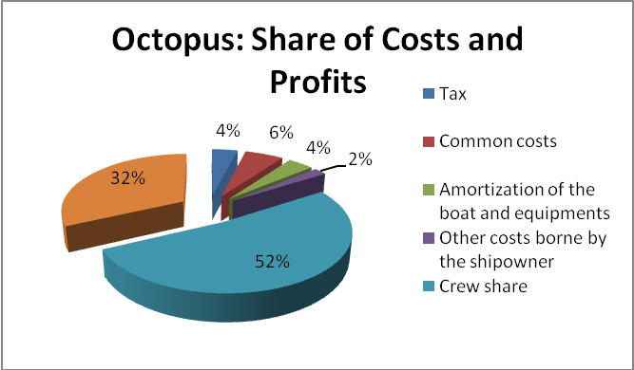
Figure 8: Octopus costs and profit structure (Case n°1)
Case n°2
Overview
"Souiria Kdima" is a fishing village situated in the region of Safi (West of Morocco). It accounts about 290 boats operated by 1400 fishermen.
Octopus is the most important fished species in the area. Octopus fishing activity goes from April to October with a frequency of 20 days per month depending on weather conditions (moderate sea). The fishing gear used to catch octopus is the jig.
Catch statement
Octopus landings per boat usually vary between 30 and 150 kg with an average of 60 Kg. As for the price, it varies depending on octopus sizes:
- 400-600g : MAD 20/kg
- 600-1100g : MAD 35/Kg
- Plus de 1100g : MAD 50/Kg
Wholesalers are the main buyers of octopus at the fish market.
Price evolution
According to fishermen, fish prices have increased slightly over the years, and so have costs, which guarantee a stability of the average profit margin of the fisherman.
Costs structure
The main variable costs related to the fishing activity of octopus are fuel, ice and food. The total of these expenses per trip on average is around MAD 500. As for taxes paid by the fisherman, they stand at 5.62% of sale price.
Fixed costs are generally related to the fishing equipment maintenance (boat, motor and jig). The following table details the various fixed costs:

Table 11: Various fixed costs of octopus (Case n°2)
Costs | %
1. Boat Maintenance | 8%
2. Motor Maintenance | 23%
3. Jig Maintenance | 15%
4. Transportation rental | 21%
5. Guards fees | 32%
6. License fee | 1%
Total | 100%
Profit determination
Sharing of profits is made after deduction of Commons. Generally, the sharing system depends on the number of fishermen on board. If there are two fishermen working on the boat, the benefits are shared equally between the owner and the two fishermen (50-50). On the other hand, if there are three fishermen, they take 60% ​​of benefits and the rest goes to the owner; which is 40%.
The calculations of the ship-owner profit will be made on the basis of average numbers of trips, the average sale price and the average landed quantity in every trip:
- Average trip numbers: 140 trips
- Average sale price: MAD 35 /kg
- Average landed quantity: 60 kg/trip.
The table bellow shows the structure of the various costs incurred and consequently the determination of the net profit of the owner:
Table 12: Costs and profit structure of Octopus (Case n°2)
Costs | %
Taxes | 6%
Fixed costs | 4%
Variable costs | 24%
Crew share | 40%
Ship-owner profit | 26%
Total | 100%

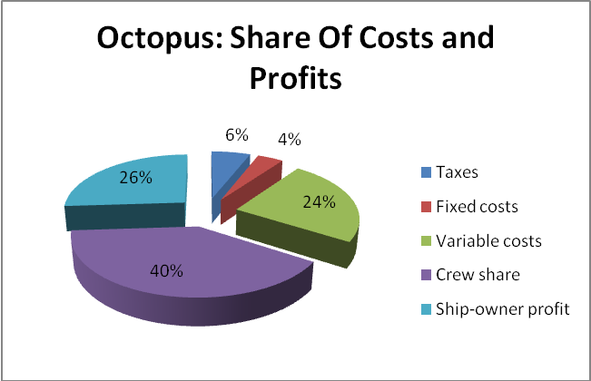
Figure 9: Octopus costs and profit structure (case n°2)
Fishermen thoughts
According to the interviewed fishermen, the region with the largest profit margin for the fisherman is the South Atlantic. It can reach up to 35%.
Considering the whole chain of Octopus, fish processors are the ones to generate the higher profit. Their margin can rise to 40%.
- Frozen octopus
Overview
There are 84 freezing units in the industrial zone of Dakhla, working on different species. The activity of frozen octopus is irregular because the products scarcity. These plants freeze and export octopus, when available, and work on other fish species (especially sardine).

Supply of raw material
Nowadays, the average annual quantity of processed octopus by freezing unit is 800 tons per year; it is exported, especially, to Japan and Spain.
The large fluctuation of octopus purchasing prices (from MAD 50 to MAD 86 per kg in 2011, instead of MAD 45/kg in 2010) has influenced selling prices for export that are between €9 and €11 per kg in 2011 instead of € 6 per kg in 2010.
Price evolution
The owners of octopus freezing units’ report that the profit margin generated by an industry has decreased significantly, as purchasing prices increased and export selling prices have not followed the same rate.

Costs structure
The production cost for frozen octopus producer includes the following inputs: carton, plastic, energy, labor, and transportation. In addition it includes all costs related to food, cleaning products, and other costs which will be noted as “various”. This production cost is set by the industrial at MAD 5/kg which includes the following costs:
- Carton : MAD 0.36 /kg,
- Plastic : MAD 0.05 /kg,
- Labor : MAD 1.00 /kg,
- Transportation : MAD 1.00 /kg,
- Energy : MAD 1.76/kg,
- Various: MAD 0.83 /kg.
Table 13 shows the percentage of each element relative to the production cost.
Table 13: Structure of Octopus production costs
Costs | %
Carton | 7%
Plastic | 1%
Labour | 20%
Transportation | 20%
Energy | 35%
Various | 17%
Total | 100%
It is also noted that the tax paid by the industrial is 3% of the purchasing price. The fee is paid at the hall by the buyer.
Profit determination
Before determining the net margin that a producer of frozen octopus can generate, we report that the performance of the octopus during freezing is 90%, that is to say that evisceration operation causes a loss of 100 grams per kilogram. Net margin will be determined based on the following parameters:

- Average quantity dealt (quantity purchased) : 800 Tons
- Performance : 90%
- Sold quantity : 720 Tons
- Purchasing price : MAD 65 /kg
- Tax : 3% of purchasing amount
- Production cost : MAD 5/kg
- Selling price : € 9/kg (MAD 100.8 /kg)
The table below shows the structure of industrial costs and margins reported to the turnover achieved:
Table 14: Octopus costs and profit structure
Costs | %
Raw material | 72%
Tax | 2%
Production cost | 6%
Industrial Profit | 20%
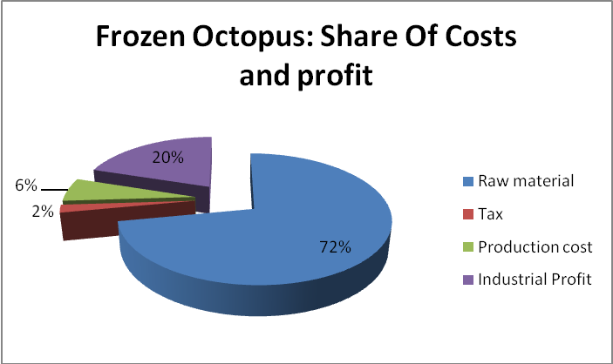
Figure 10: Frozen Octopus costs and profit structure

Sardine

Unlike the other species, sardine is very well appreciated by local consumers; sardine is sold in the local markets, fresh/frozen and canned, and it is also exported. The first sale takes place in the CAPI or in the first sale market, like anchovy. Sardine is then bought by fishmongers or by the processing plants (having in-place representatives in the fishing ports). Figure 11 indicates the sardine value chain.

6.5.1 Fresh sardines
Overview
In 2010, the landed quantity of sardines at Dakhla’s port was 137.619.214 kg; that’s why the region of “Oued Eddahab-Legouira” is considered as most the important sardine fishing areas, at the national level. With a seine, the sardine fishery is maintained all over the year if weather conditions allowed it.

Catch statement
A sardine fisherman makes an average of 220 trips per year, and fish catches reach around 60 tons/trip. The catch is shared as follows:
- 20 tons : for industrial export units with a price of MAD 1.35/kg
- 40 tons: for fishmeal production units with a price of MAD 0.80/kg

The tax applied by the national office of fisheries is 4.2%. The sale price is fixed on MAD 1.50 /kg for entire quantity landed. This significant value loss is decreasing since early April 2011, because of the standard plastic boxes new project which will allow ensuring quality products and also selling all quantity landed at a fixed price of MAD 2/kg. The quantity landed will not exceed 32 tons/boat referring to the space which boxes will take into the boat.

Sardine Fishing

Landing at the port
Sale at the first sale market
Sale at the CAPI
Supporting by fishmongers
Sale to canning units
Sale at the whole sale market
Acquisition by the semi wholesalers
Retailers
Final Consumer
Export

Figure 11: Sardine value chain
Price evolution
The president of the professional association of the ship-owners of coastal fishing affirms that the standardisation of boxes has allowed to increase profit margin for the whole fishing crew, and also to know accurately this profit margin as the selling price is no fixed at MAD 2/kg.
Cost structure
The main costs of sardine fishing are as following:
- Common costs: the ship owner and fishing crew are responsible for this cost and are estimated per trip at:
- Fuel and lubricant : MAD 3.900 (600 liters of gasoil “MAD 6/l” + MAD 300 for engine’s oil)
- Ice : MAD 900 (3 Tons of ice MAD 300 /T)
- Food : MAD 800
- Boxes : MAD 1.500 (MAD 1 for 1 box leasing)
- Tax : is set at 17,2% of the turnover and it’s shared as follow :
- ONP: 4.2%
- ANP : 1%
- CNSS : 6%
- Communal tax : 3%
- AMO : 1.5%
- Professional association of the ship-owners of coastal fishing: 0.3%
- Development regional association : 0.5%
- Other taxes: 0.7%
- Costs of the ship-owner: The ship owner is responsible for some costs this include:
- Fishing gear maintenance : MAD 60.000
- Insurance : MAD 70.000
- Fishing gear amortization: MAD 120.000 (the seine costs MAD 600.000 and it’s amortized over 5 years)
- Boat and engine reparation on shipyard cost : MAD 400.000
- Store rental, and guarding fees : MAD 24.000
- License fee : MAD 6.000
- Conformity certificate for sailors: MAD 2.000
It should be noted that whole taxes to be paid are set at 17.2% of total sales. The table below summaries the common and the ship-owner costs per year (220 fishing trips):
Table 15: Sardine costs structure
Common costs | %
Fuel and lubricant | 55%
Ice | 13%
Food | 11%
Boxes rental costs | 21%
Total (Tax free) | 100%
Ship-owner costs | %
Fishing gear maintenance | 9%
Insurance | 10%
Fishing gear Amortization | 18%
Boat and engine reparation on shipyard cost | 58%
Store rental, and guarding fees | 4%
License fee | 1%
Conformity certificate for sailors | 0%
Total | 100%

Profit determination
The fishing crew is generally composed of 30 people, including the “Raîss”, the second boss, the mechanic, sailors and other persons. The revenue is shared as follows:
- The total revenue, after deduction the tax and common costs (fuel, food, Ice, rental boxes fees), is shared among the crew (60%) and the ship owner (40%)
- Fishing crews share their part in respect of the boat flow chart (3 parts for The Raîss, 2 for the second boss, one and a half for the mechanic etc.)

The table below shows the costs and profit structure, considering the following parameters:
- Average of annual fishing trips : 220 trips/year
- Landed quantity : 32.000 kg/trip
- Selling price: MAD 2 /kg
- Annual Turnover : MAD 14.080.000
Table 16: Sardine Costs and profit structure
Costs | %
Tax | 17%
Common costs | 11%
Crew share | 43%
Shipowner costs | 5%
Shipowner profit | 24%
Total | 100%

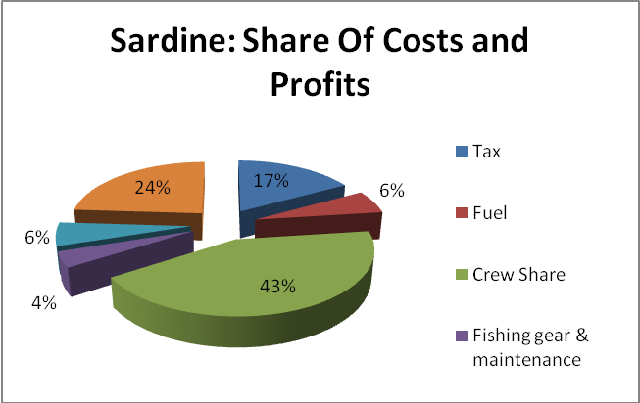
Figure 12: Sardine's costs and profit structure

6.5.2 Canned sardine
Overview
The fish canning industry in Morocco is the result of long evolution and accumulation of know how. The main canned species are sardine, tuna and mackerel. There are 32 processing units. Annual production capacity is 300.000T of raw material with total export sales of 3.63 billion Dirhams (in 2009). Sardine is the most important commodity in the Moroccan seafood business and most internationally demanded. In volume, it represents 90% of canned exports.
The following data was provided by the UNICOP (Union Nationale des Industries de la Conserve de Poisson) that undertook a recent study on “Contribution to the upgrading of supply and productivity of canned fish processors in Morocco” (February, 2010).
Supply of raw material
Sardine is harvested along the Moroccan coast mostly the south part of the country. Production units get the raw materials at all fish markets based on the landing sites.
Price evolution
Input costs have significantly increased, but the percentage allocation of costs is appropriate.
Costs structure
Table 17 lists the processing cost of a crate of canned sardines (100 cans of ¼ clubs 30).

Table 17: Production costs of a box of canned sardines
Direct costs | Quantity | Unit cost  (DHS) | Total  (DHS) | % of total  direct costs | % of sale price
Raw material (Kg) | 25 | 3 | 75 | 28.2 | 25.6
Wage (hours) | 2 | 14 | 28 | 10.5 | 9.6
Oil (litre) | 2.35 | 12 | 28.2 | 10.6 | 9.6
Energy (KwH) | 1.48 | 1 | 1.48 | 0.6 | 0.5
Water (m³) | 1.5 | 10 | 15 | 5.6 | 5.1
Fuel (litre) | 1.41 | 3 | 4.23 | 1.6 | 1.4
Tins | 100 | 1 | 100 | 37.5 | 34.1
Salt (Kg) | 2.55 | 0.7 | 1.79 | 0.7 | 0.6
Other costs |  |  | 12.7 | 4.8 | 4.3
Total |  |  | 266 | 100 | 90.9
Profit determination
The operating margin after deduction of the industrial production costs, based on the information in table 17, is 9.1%.
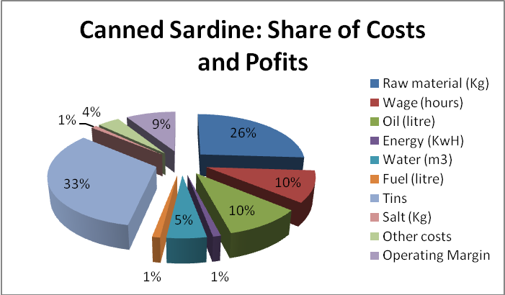
Figure 13: Canned sardine's costs and profit structure

6.5.3 Frozen sardine
Overview
The total export of frozen sardine is 80%b and the rest is consumed locally. Sardine freezing plants work about 220 days a year, frozen sardine is sold directly to retailers (to be sold in the local market) and canning units.

Supply of raw material

Industrial units in Dakhla process about 30 tons/day. Currently, the export price of entire sardine is MAD 4.20 DH per kg (FOB Dakhla’s Port) while it was set at MAD 6.60 per kg at 2010.

Price evolution
At present, whole frozen sardine export prices allow the owners of an industrial unit to benefit the same margin as before. For companies that export whole frozen sardine, margins stayed almost the same MAD 2 per kg, given the fact of the increase of purchasing prices.
Cost structure
There are some costs, in addition to the raw material costs, intervening before starting the processing. These are:
- Tax: set at 3% of purchasing price i.e.MAD 0.06 /kg
- Box rental costs, labor at the port, ice and transportation cost are estimated at MAD 0.35 /kg
Thus, the cost of raw material is MAD 2.41 /kg. Production costs are estimated at MAD 1.40/kg and include labor in the factory, transport, pallets, boxes, plastic, cartons and cleaning products.

Table 18: Frozen sardine’s cost structure
Costs | %
Raw material purchasing | 52%
Other costs (labor at port, ice, boxes rental costs, …) | 9%
Tax | 2%
Production cost | 37%
Total | 100%
Profit determination
Selling price (MAD 4.20 /kg) and total costs (MAD 3.81 /kg) will be taken in to consideration while calculating the profit margin of frozen sardine.

Table 19: Costs and margin structure
Costs | %
Raw material cost | 48%
Other costs (labor at port, ice, boxes rental costs etc.) | 8%
Tax | 12%
Production cost | 33%
Industrial Profit | 9%
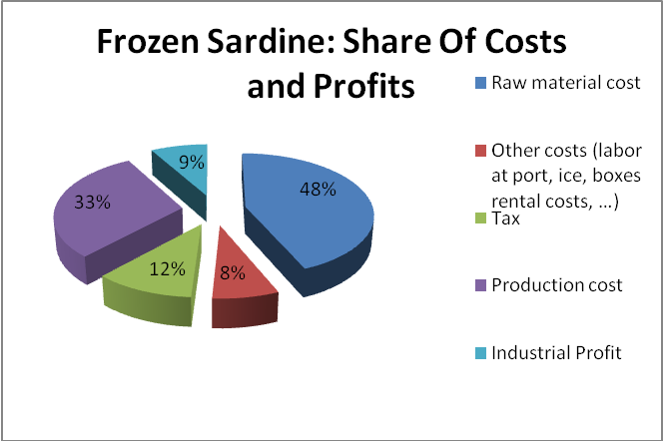
Figure 14: Frozen sardine's costs and profit structure

6.5.4 Headless/gutted/frozen sardine
Overview
Generally, the profit margin depends on the market and the range of products. Brazil is the main export market for headless/gutted/frozen sardine.

Supply of raw material
Monthly processed fish quantity varies between 100 and 159T/month. The purchase price is fixed at MAD 2.5/ Kg in the fish market.
Price evolution
In General, the profit margin fluctuates depending on the seasons. Sale prices have increased slightly in recent years. This is mainly due to the rarity of the raw material.
Costs structure
Expenses relating to the processing of headless/gutted/frozen sardine differ according to the targeted market and the importer’s specifications of the product. Table 20 gives the costs of production in the turnover percentage.

Table 20: Headless/gutted/frozen sardine
Costs | % of the turnover
Raw material | 56%
Wages (direct labor) | 9%
transportation | 4%
Energy and fuel | 4%
Indirect labor | 3%
Packaging | 1%
Depreciation | 7%
Industrial profit | 16%
Total | 100%

Profit determination
Profit sharing is made after deduction of Commons. Generally, there are three fishermen working on board. The profits are shared equally between the owner and the boat crew and fishermen share their earnings equally. As for depreciation, is included in the ship-owner share. The selling price is MAD 7/Kg, and the operating margin for exported sardine is 16.58%.
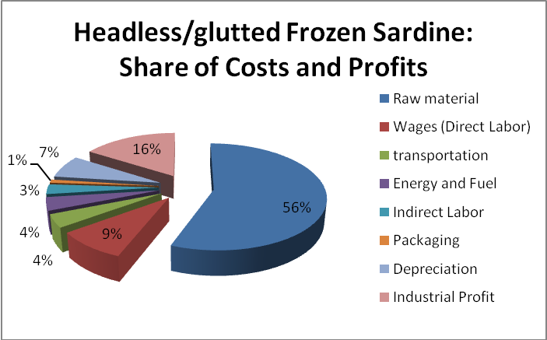
Figure 15: headless/gutted/frozen sardine's costs and profit structure

