Value chain analysis of dried and salted cod
From Norway to Portugal
Bjørn Tore Nystrand
Møreforsking Marin, N-6021 Aalesund
Norway
This report is written as part of a project on value chains in fisheries at Aalesund University College.
Table of contents

Page

Value chain analysis of dried and salted cod from Norway to Portugal 2
- Introduction 2
2. Production 2
3. Processing 6
4. Transportation 7
5. Final consumption 8
6. Regulations 8
7. Market structure 9
8. The Norwegian-Portuguese price transmission for dried and salted cod 11
9. Data availability 14
10. Summary 15
References 16

Value chain analysis of dried and salted cod from Norway to Portugal

Introduction
Seafood is the third most important export commodity in Norway after petroleum and metals. Norway exports seafood to about 140 countries, and is the second largest seafood exporter in the world. Total export value in 2010 amounted to 53.8 billion Norwegian kroner (NOK). Preliminary figures for 2011 show strong growth compared to the previous year.
The purpose of this report is to present a preliminary analysis of the value chain for dried salted cod produced in Norway and exported to Portugal. The report is organised as follows: Section one introduces the report and section two deals with production of cod, including catches, first-hand prices and organisation. Section three describes processing of cod into a dried and salted product, followed by a description of transportation to Portugal (section four). Final consumption is discussed in section five, and section six is concerned with regulations as regards participation in fisheries and management of marine resources. Section seven is on market structure, while the Norwegian-Portuguese price transmission for dried salted and cod is analysed in section eight. The last two sections present the data availability and the report’s summary.

Production
Cod (Gadus morhua) is one of the most important demersal fish species in Norwegian fisheries. The total catch of cod in 2010 was 283,312 tonnes, an increase of 16 per cent compared to 2009 (figure 1). Whitefish fisheries are the second largest in Norway, with a total catch of 675,000 tonnes in 2010.

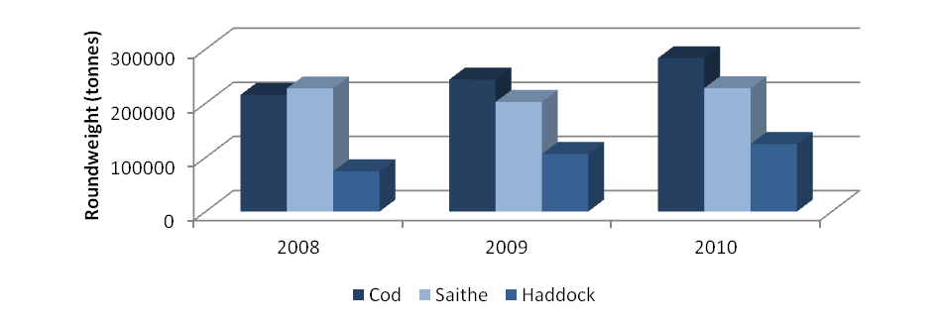
Figure 1 Annual Norwegian whitefish catches 2008-2010 in tonnes
Source: Directorate of Fisheries

Measured by landed value of total catch, cod fishing was the most important of fisheries in 2010 altogether-see figure 2.

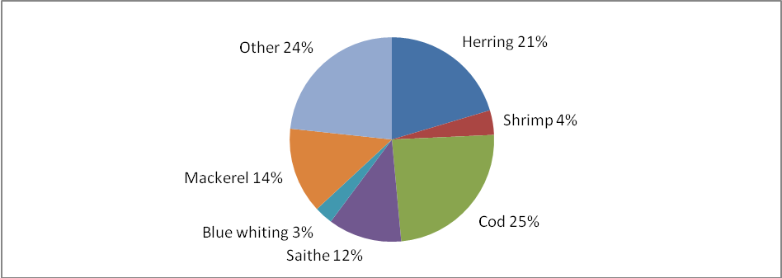Figure 2 Total value of catch by species in per cent, 2010, preliminary figures
Source: Statistics Norway

Between January 1990 and March 2011, the monthly average price per kg for cod is NOK 12.64 (ex-vessel). The lowest price occurred in June 1996 (NOK 8.25), while price peak occurred in February 1999 (NOK 19.69).

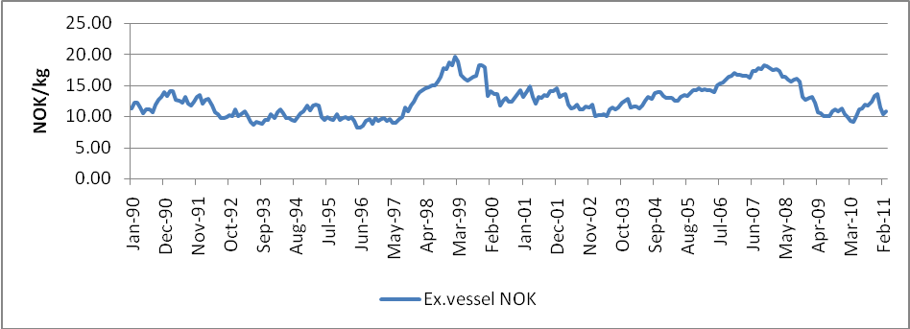
Figure 3 Nominal monthly average ex-vessel price for cod January 1990 – March 2011 Sources: Prof. Rui Menezes, Lisbon University Institute / the Directorate of Fisheries / Norges Bank

All first-hand sales of demersal fish are regulated by the Act of 14 December 1951 No. 3 on the marketing of raw fish (Raw Fish Act), and are organised in sales organisations (SOs). SOs handle the first-hand sales of all commercially caught whitefish in Norway, including cod. Depending on where the fish is landed, different SOs are responsible; Norges Råfisklag from Nordmøre in the south-west to Finnmark in the north-east, Sunnmøre og Romsdal Fiskesalgslag in Møre og Romsdal county, and Vest-Norges Fiskesalgslag in Sogn og Fjordane and Hordaland counties being the three largest sales organisations of six.
To secure equal competition conditions for participants in the raw fish market, a market-based minimum price is set by the SOs and the industry in cooperation. By applying minimum prices, fishermen’s income is safeguarded (Norges Råfisklag).
Current minimum prices for cod (September 19 – not beyond December 18 2011) are given in table 1.
Table 1 Minimum prices for cod from September 19, 2011 until further notice, but not beyond December 18, 2011.
Species/size | Minimum price
Cod > 6,0 kg | NOK 18,50
Cod 2,5-6,0 kg | NOK 15,50
Cod 1,0-2,5 kg | NOK 13,50
Cod < 1,0 kg | NOK 10,00
Source: Norges Råfisklag.

The Directorate of Fisheries (2011) has carried out a profitability survey on the Norwegian fishing fleet for 2009. It shows that the fishing fleet had a total operating profit of 1.5 billion NOK, or an operating margin of 13.3 per cent. Vessels in demersal fisheries had a positive trend in margins compared to 2008.
Since the 1940s the number of fishermen has decreased by almost 90 per cent. A total of 121,961 fishermen were registered either as having fishing as main or secondary occupation in 1940, compared to 12,280 in 2010. At the same time the number of registered fishing vessels increased about 50 per cent between 1930 and 1960, before decreasing in line with the number of fishermen. The 2010 figure for registered vessels was 6,309 (figure 4). Annual permits to fish cod, haddock and saithe with conventional gears north of 62º N have decreased by 37 per cent (ocean-fishing vessels) and 21 per cent (coastal fishing vessels) between 2001 and 2010.

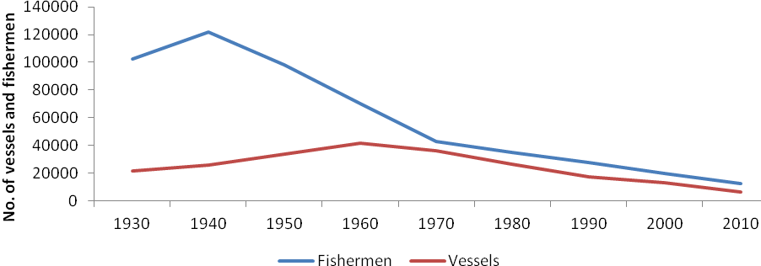
Figure 4 Registered fishing vessels and fishermen 1930-2010 in Norway
Source: Directorate of Fisheries

There are two management areas for cod in Norway; the North East arctic cod in the Barents Sea (NEAC) and the North Sea cod (NSC). The NEAC stock is the largest cod stock in the world, and is jointly managed with Russia. Total allowable catch (TAC) quotas are set on an annual basis. The NSC on the other hand is shared with the EU. The stock is in a fairly poor condition, mostly due to overfishing as well as high grading and discards (fisheries.no). A new management plan has been introduced to cope with these challenges. The International Council for the Exploration of the Sea (ICES) has recommended that no catch should be taken from the NSC stock in 2011.

Various fishing gears are being used in the cod fishery; bottom trawl, gill net, longline, Danish seine and hand line. As indicated in figure 5 bottom trawl and net are among the most commonly used fishing gears, and hand line is the least used gear. The cod fishery is conducted on a year around basis, but with a high-season in the first half of the year. Participation in the commercial fishing for whitefish requires a license permitted by the authorities, and is regulated by the Act of 5 December 1917 No. 1 relating to registering and marking of fishing vessels and Act of 1999 No. 15 on the regulation of the participation in fisheries. The purpose of the latter act is to (i) adapt the fishing fleet’s catch capacity to the resource basis in order to ensure a rational and sustainable exploitation of the marine resources, (ii) increase profitability and value creation in the industry and thereby secure settlement and employment in coastal areas, and (iii) facilitate for the harvesting of marine resources in the future.

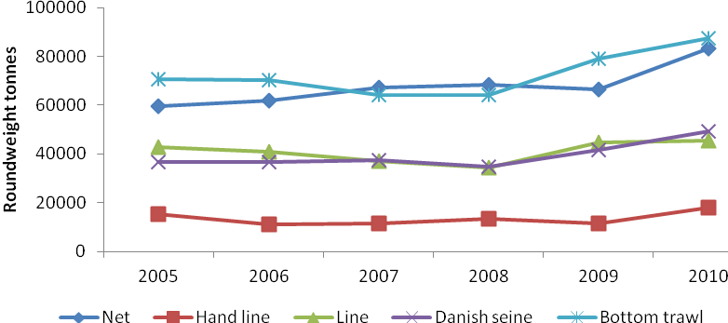
Figure 5 Annual total catch of cod by fishing gear in the period 2005-2010 (Tonnes)
Source: Directorate of Fisheries

Processing
Cod is the most common fish species used for the production of dried and salted fish in Norway. Both fresh or frozen and thawed raw materials are used. In general, production in Northern Norway is based on fresh cod while in the western part the raw material is frozen and thawed. Fresh cod is usually processed post-rigor after 2-5 days storage in plate ice.

Dried and salted saithe, haddock, ling and tusk are also produced and exported, but in smaller quantities and exported to other geographical markets than Portugal.
The production of dried and salted fish can be divided into three steps; pre-salting, salting, and curing during storage. The pre-salting step is done after splitting / butterfly filleting, and introduced by brine-injection. The salting phase is carried out by pickle salting, with fish and salt laid in alternating layers in sealed tubs. The final step involves taking the fish out of the tubs for dry salting on pallets, allowing excessive brine to drain off. In the 21th century it has become more and more common to add brine in the beginning of the salting step (Þórarinsdóttir et al., 2010).
The costs for production of dried salted cod are raw materials (80%), work force (11%), and energy (5.9%) (Hellevik et al., 2008).

Transportation
Raw materials are commonly transported directly to the land-based production plants by the fishing vessels. In some cases, the fish is landed at a different port and transported to processing by road. According to Molnes (2010), dried salted cod is transported in bulk by road or container vessels to the respective import countries. Regarding exports to Portugal dried and salted cod is primarily transported by road.
Transportation by road takes approximately 5-6 days from Ålesund in Møre og Romsdal county to central locations in Portugal. By comparison, transportation by container vessels takes 12-14 days. Lorries are loaded with 21.5-22.5 net tonnes and one shipment costs somewhere between NOK 36,000-42,000, depending on destination. Containers come in two lengths; 20 feet and 40 feet (Molnes, 2010). The capacity of the largest container is about 26 tonnes of dried salted fish and one shipment costs around NOK 28,000.
Portugal imported about 24,900 tonnes dried salted cod in 2010, and is by far the largest market for Norwegian dried salted cod (60 % of total export). Given that all dried salted cod is transported by road, and the average transportation cost per shipment is NOK 39,000, total transportation cost for 2010 was NOK 44.1 million distributed on 21 weekly shipments. Transportation cost equals 1.77 NOK/kg.

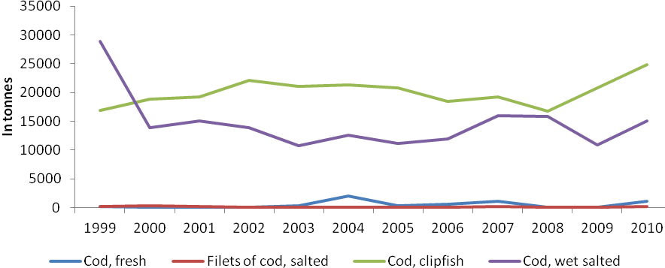Figure 6. Annual cod exports from Norway to Portugal 1999-2010 (Tonnes)
Source: Statistics Norway

Final consumption
Before consumption the dried and salted cod needs to be rehydrated for one to two days. This process reduces the salt concentration in the fish from 20 per cent to 2-3 per cent. After rehydration the product’s shelf life is decreased substantially, and storing must not exceed one week in refrigerated conditions (Þórarinsdóttir et al., 2010).
Dried and salted cod is commonly distributed via a few Portuguese super- and hypermarkets covering the entire country (80%). It is said to be available everywhere in Portugal, and consumers will find dried salted cod at restaurants, bistros, diners, etc. (Nordahl, 2010).
Domestically, dried and salted cod is sold in numerous variants, such as whole fillet, different loin products and bits & pieces. Products exported to Portugal are whole fillets.

Regulations
The country’s general acts of fishery regulations include:

- Act of 5 December 1917 No. 1 relating to the registration and marking of fishing vessels
- Act of 14 December 1951 No. 3 on the marketing of raw fish (Raw Fish Act)
- Act of 26 March 1999 No. 15 on the regulation of the participation in fisheries (Participant Act)
- Act of 6 June 2008 No. 37 relating to the management of wild living marine resources (Marine Resources Act)

Market structure
The market structure of dried salted code can roughly be illustrated as in figure 7, and it incorporates different agents like primary processors, secondary processors, retailers and consumers.
The primary processors are the fishing fleet, both coastal and ocean fleets. Their catches make up for the input to the secondary processors. All first-hand sales of cod is regulated by the Raw Fish Act and organised in sales organisations which handles the trade between primary and secondary processors. Secondary processors are land-based processing plants which transform fresh or frozen raw cod into dried salted cod. In all seafood export from Norway, including dried and salted cod exports, the Norwegian Seafood Export Council (NSEC) plays a vital part as the marketing body, among other tasks. The retailers in Portugal consist of retail chains and independent supermarkets.

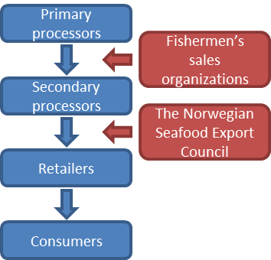
Figure 7. Market structure for dried salted cod Norway-Portugal

Portugal is the only other country which produces dried and salted cod, and imports cod from Norway at different processing levels. Figure 8 shows Portuguese imports of various salted/dried and salted cod products from key exporters including Norway, Iceland and China.

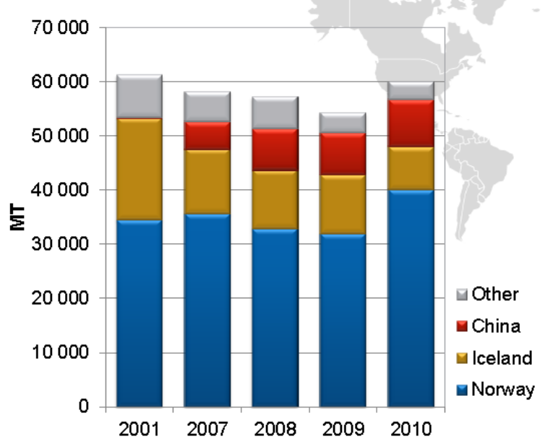
Figure 8 Export of salted/dried (salted) cod to Portugal.
Source: Haagensen, 2011

Besides dried and salted cod, Norway also exports wet salted cod and frozen cod for domestic production in Portugal into dried salted cod. Lower production and labour costs are some of the explanations for why Portugal chooses to produce dried salted cod from Norwegian raw material themselves. Portugal imported 42,055 tonnes frozen cod in 2010 for domestic production of dried salted cod, whereas 5,470 tonnes came from Russia (Haagensen, 2011).
Other substitutes to dried and salted cod from Norway are salted products of cod from Iceland, dried and salted cod of other cod species (Gadus macrocephalus) from Portugal and Iceland, and dried and salted / salted products of other fish species such as saithe (Pollachius virens), tusk (Brosme brosme) and ling (Molva molva). Atlantic cod is though the preferred species in Portugal and accounts for almost the entire dried and salted fish consumption. Icelandic dried and salted cod has been known to be more expensive than its Norwegian and Portuguese counterparts.

The Norwegian-Portuguese price transmission for dried and salted cod
The relationship between ex-vessel price, export price and retail price in Portugal is illustrated in figure 9. While ex-vessel price for cod remains relatively stable throughout the period, export price fluctuates to a higher extent. Still, the correlation between the two prices is .8217 (Spearman’s rho), depicting that there is a fairly close relationship between them. Worth noticing are the slopes of the regression lines for ex-vessel price and export price. The slope for export price is far steeper than the slope for ex-vessel price. This indicates that export price has experienced a relatively larger growth compared to the ex-vessel price, i.e. the gap between the two prices has grown larger.

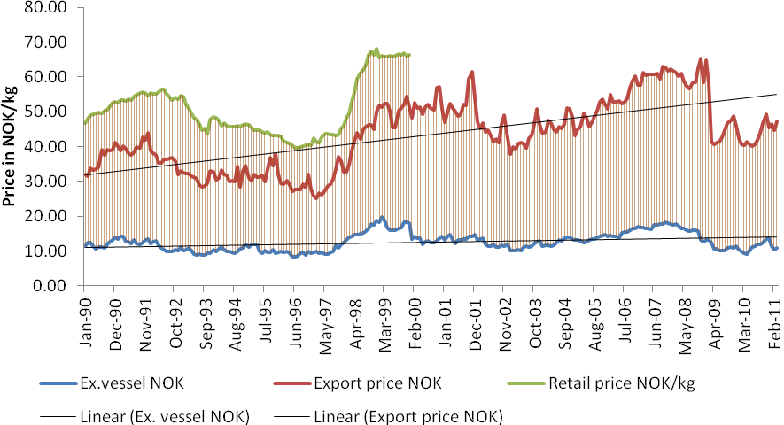
Figure 9 Norway-Portugal price transmission for dried salted cod (ex-vessel NOK and Retail price NOK/kg are converted from EUR) January 1990 – February 2011

The correlation between ex-vessel price and export price in NOK is indicated in a scatter diagram below- figure 10. The diagram shows a positive correlation, i.e., export price increases in line with ex-vessel price. A perfect relationship is expressed by a straight line. Consequently, the relationship between the two prices is not perfectly correlated.

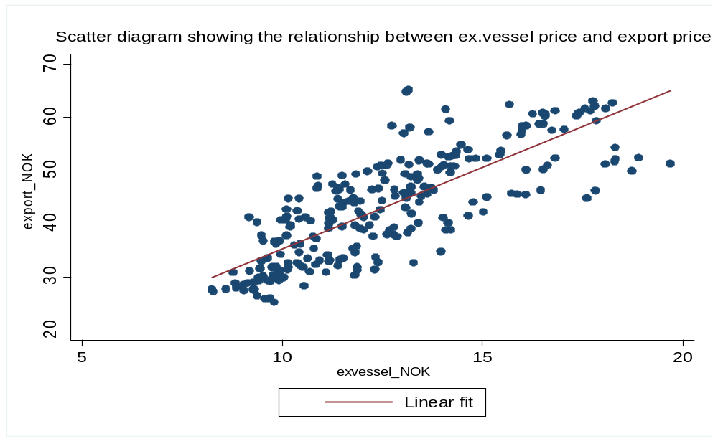
Figure 10 Relationship between ex-vessel price and export price in NOK

All exports are affected by exchange rates. A devaluation of NOK relative to EUR will result in Portuguese importers being able to buy more dried salted cod measured in NOK for the same amount of EUR. Oppositely, a revaluation of NOK will be followed by a decreasing demand from Portuguese importers as the price for the same amount of dried salted cod increases relative to EUR. Hence, a rise in exchange rate EUR/NOK will result in decreasing demand from Portuguese importers. Conversely, a low exchange rate triggers an increasing supply. Figure 11 shows exchange rate over time (NOK per 1 EUR).

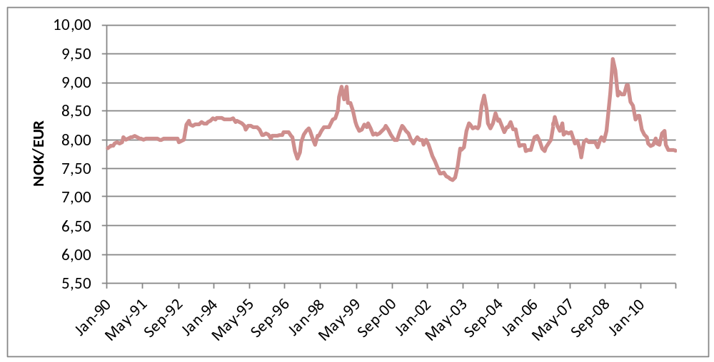
Figure 11. NOK/EUR exchange rates, indicative mid rates, monthly average of daily listings
Source: Norges Bank Jan.90 – Dec. 98: XEU, Jan.99 – Mar.11: EUR

Figure 12 illustrates the relationship between export price and export volume. Analyses show that the relationship is weak. Further, export price has increased quite substantially from 2003 to 2008. The average export volume in the period 2003-2005 was 1,757 tonnes, and decreased in the period 2006-2008 to 1,517 tonnes.

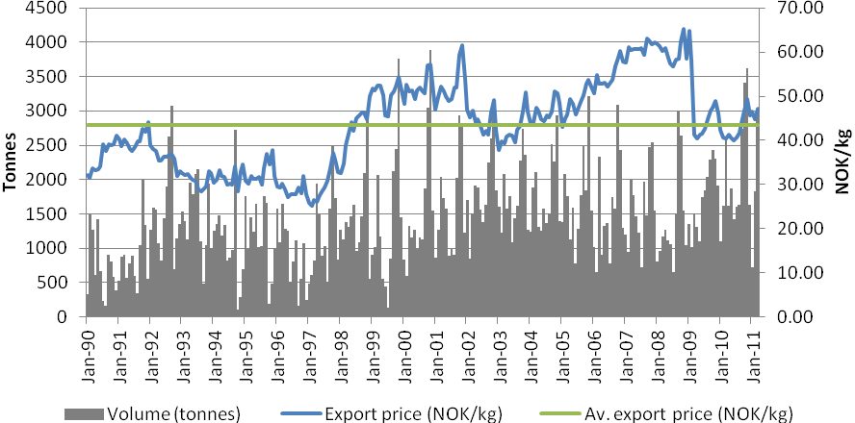Figure 12 Export price in relation to export volume
Source: Norwegian Seafood Export Council

Looking at the Consumer Price Index (CPI) for the category Salted, dried and smoked fish, shellfish and molluscs, the prices from 2003 to 2008 have increased by over 21 per cent. From 2008 the CPI decreased to the level of 2000, which can contribute to explain the increase in imports in the years 2009-2010 (figure 13).

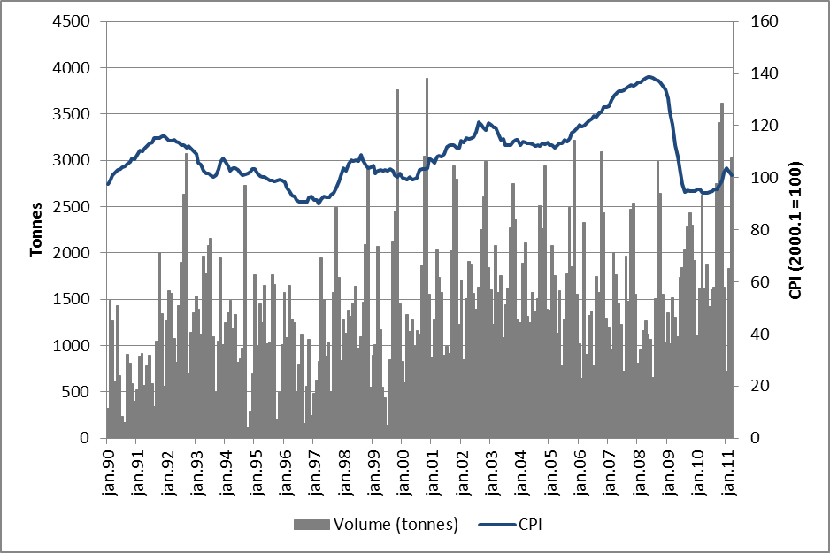Figure 13. Consumer Price Index (base 2000.1 = 100) for the category Salted, dried and smoked fish, shellfish and molluscs, and export volume in tonnes
Source: Statistics Portugal

Data availability
Data on ex-vessel prices has been obtained partly from Full Professor Rui Menezes at the ISCTE Business School, Lisbon University Institute (1.1990 – 12.1999), and from the Norwegian Directorate of Fisheries’ public database (1.2000 – 3.2011). Price data from 1.1990 to 12.1999 are in EUR. From 1.2000 to 3.2011 prices in NOK are converted to EUR based on exchange rates from the Bank of Norway.
Export prices in NOK are acquired from market analyst Ove Johansen at the Norwegian Seafood Export Council (1.1990 – 3.2011), and converted to EUR based on exchange rates from the Bank of Norway.
Professor Frank Asche at the University of Stavanger has contributed with retail prices in EUR (1.1990 – 12.1999). Amund Bråthen, Norwegian Seafood Export Council, has contributed with retail prices in four-week averages from January 2007 (first period 2007) to May 2011 (fifth period 2011).

Data is missing for retail prices for the period 1.2000 – 3.2011. Neither of the aforementioned sources has been able to obtain these data. Statistics Portugal has contributed with index data (CPI) for the period 1.1990 – 4.2010.

Summary
This report is a contribution in describing the Norway-Portugal dried and salted cod value chain. Key factors in focus have been production, processing, transportation and final consumption. The value chain is affected by regulations, market structure and fluctuating exchange rates. The relationship between ex-vessel price and export price has been investigated, showing a positive correlation. Through the period from January 1990 to March 2011, the ex-vessel price has remained relatively stable compared to export price.

References

Asche, F., Menezes, R., Dias, J.F. 2002. Price transmission in cross boundary value chains. Working paper no. 54/02. Institute for research in economics and business administration. Bergen.

Directorate of Fisheries. 2011. Profitability survey on the Norwegian fishing fleet year 2009. ISSN: 0809-8174.
http://www.fiskeridir.no/english/statistics/booklets/fishery-booklets

Haagensen, K. 2011. Trender i Salt/klippfisk markedet. Trusler og trender. Presentation at Marin Samhandlingsarena, 18.10.2011. Rica Parken, Ålesund

Haugnes, S.E. 2010. Consumers in industrial networks. A study of the Norwegian-Portuguese bacalhau network. Series of dissertation 4/2010. BI Norwegian School of Management. Department of marketing.

Hellevik, A.H., Bjørkevoll, I., Gjerstad, T.B., Ystgaard, P. 2008. Kartlegging av muligheter for økt automatisering i norsk saltfisk- og klippfiskindustri. Rapport Å0809. Møreforsking. Ålesund.

Menezes, R., Dias, J.F., Guia, F., Filipe, J.C., Guerreiro, V. 2002. European markets integration: The case of the Norway-Portugal cod value chain. Paper presented at the XIV EAFE Conference 255-27 March 2002.

Molnes, H.J. 2010. Norsk klippfiskindustri. En analyse av industriens konkurransemessige struktur, forsyningskjede og muligheter for implementering av Radio Frequency Identification. Norges Handelshøyskole. Bergen.,

Nordahl, C.B. 2010. Er det krise i hvitfisk markedene i Sør-Europa? Presentation at Nor-Fishing 18 August 2010.

Nøstvold, B.H., Østli, J. 2007. Hvordan kan bruk av riktig informasjon gjøre det enklere å kjøpe klippfisk i Portugal? Økonomisk fiskeriforskning. Årgang 17.

Þórarinsdóttir, K.A., Bjørkevoll, I., Arason, S. 2010. Production of salted fish in the Nordic countries. Variation in quality and characteristics of the salted products. Skýrsla Matís 46-10.

Others:
Norges Råfisklag
Statistics Norway
The Norwegian Directorate of Fisheries
www.fisheries.no
Bank of Norway
Norwegian Seafood Export Council

Ex-vessel prices in NOK are converted from EUR.
J. C. Pettersen, personal communication, August 10, 2011; S. Solbakk, personal communication, August 9, 2011.
Statistics Portugal has stated that the majority in this category is dried salted cod.

