Price Modelling in the Canadian Fish Supply Chain with
Forecasts and Simulations of the Ex-vessel Price of Fish

Daniel V. Gordon
Department of Economics, University of Calgary
2500 University Drive N.W. Calgary, Alberta, Canada
dgordon@ucalgary.ca

Abstract
Fisheries management with an interest in the welfare of fishermen should be aware of the factors that impact the price of fish. This research reports the results of two time series models defined on the ex-vessel price of fish in Canada. An ARMAX model is specified to provide a univariate characterization of ex-vessel prices and is used for short-run dynamic forecasting. An error-correction (EC) model is specified to link the price in the ex-vessel market to the price in the processing market in the fish supply chain. The EC model allows measurement of both the short- and long-run parameters in defining price links in the first hand market, provides predictions on the length of time to regain the equilibrium from short-run price shocks and to simulate ex-vessel price response. The models are estimated with monthly data for the period January 1981 to March 2010 and used to evaluate some policy issues of interest to Canadian fisheries.

JEL: Q22, C53

Keywords: Fish Supply Chain, ARIMA, Error-Correction Model, Price Forecasts

I would like to thank Frank Asche, Trond Bjørndal and participants at the FAO workshop on Supply Chain Analysis Tokyo, Japan December 2010 for comments and suggestions on an earlier draft of this paper.

- Introduction
The price of fish is an obvious and important factor in the economic welfare of fishermen. Of course, the level of harvest and cost of harvesting are other important variables and all in combination determine income levels of fishermen. But in many ways fishermen have control at least to some extent over harvest and cost of harvesting. On the other hand, the price of fish is set by external factors exogenous to fishermen. These external factors are certainly dictated by demand and supply forces but may also be influenced by monopoly and strategic pricing behaviour in downstream markets (Wohlgenant 1985). Strategic pricing can impact the magnitude of price pass through between the market segments and the length of time to adjust to price shocks. Fisheries management with an interest in welfare and income implications for fishermen must be aware of the factors that impact the ex-vessel price of fish. It is of some interest then to identify and measure some of the factors important in setting the price of fish.
One way to approach this problem is to model and measure price links in the fish supply chain (Asche et al. 2007). Three market segments define the supply chain linking the first-hand market/ex-vessel price to the intermediate market/industrial process price and then to the final market/retail price. The focus here is the derived demand for product from processing to the first-hand market. This price approach is based on the theory of derived demand where the processed price of fish is used as a proxy for market factors setting the ex-vessel price (Azzam 1999).
The purpose of this research is to carry out a statistical investigation of market prices in the Canadian fish supply chain with particular attention to price setting in the first-hand market for fish. Monthly Canadian fish price data for the period January 1981 to March 2010 or a total of 352 observations are available for statistical evaluation. The empirical strategy is to apply time series techniques to measure ex-vessel price relationships. First, a univariate analysis (ARMAX) is carried out on the ex-vessel price of fish. This simple but often powerful short-run forecasting technique relates current ex-vessel price to the history of prices in the market and current and historical stochastic shocks (Enders 2010). We include the US/Canada exchange rate as an exogenous variable in the model and control for seasonality to improve forecasting and to reduce forecast error. The ARMAX model is well identified econometrically and will allow for dynamic forecasts of ex-vessel prices. The estimated ARMAX will be used to evaluate ex-vessel price implications of alternative US/Canada exchange rate scenarios. Second, recognizing the structural links between the first-hand and processing market segments in the fish supply chain we postulate a long-run price relationship. If the long run exists, then there must also exist a short-run model defining the links and behaviour of prices to short-run shocks. An error-correction (EC) model can be used to econometrically identify both the short- and long- run parameters for the first-hand market, to predict the length of time for price adjustment to regain the long-run equilibrium after shocks to the equilibrium and to simulate price response (Von Cramon-Taubadel 1998).
The paper proceeds in the following way. Section 2 will present and describe the price data available for analysis. Section 3 will outline the ARMAX model used for ex-vessel price forecasting, report estimated parameters and show statistical validation of the model. Section 4 specifies and estimates an EC model describing the price links in the ex-vessel/ processing market and simulates price response to shocks. Section 5 provides a summary and conclusion.

- Canadian Fish Price Data
Statistics Canada reports a number of price indices at each stage in the fish supply chain. For the purposes of this research, data for the period January 1981 to March 2010 have been collected on the price of processed fish and the ex-vessel price of fish. The processed index represents a monthly processed price (Process) of filleted fresh/frozen fish. And the price in the first-hand market is a monthly index for the ex-vessel price (Exvessel) of ground fish. The data represent Laspeyres price indices and are transformed to real values using a monthly all commodity consumer price index (CPI) for Canada.
2.1 Price Graphs
To provide a visual inspection of the data, the two real price series are graphed out in Figure 1. For the real processed price index for filleted fresh/frozen fish the interesting points are the wide swings in the price data up the early 2000s and then after this time the price follows a general downward trend to the current period. Within the data set the highest processed price of fillets is observed in March 1982 and lowest in May 2008. 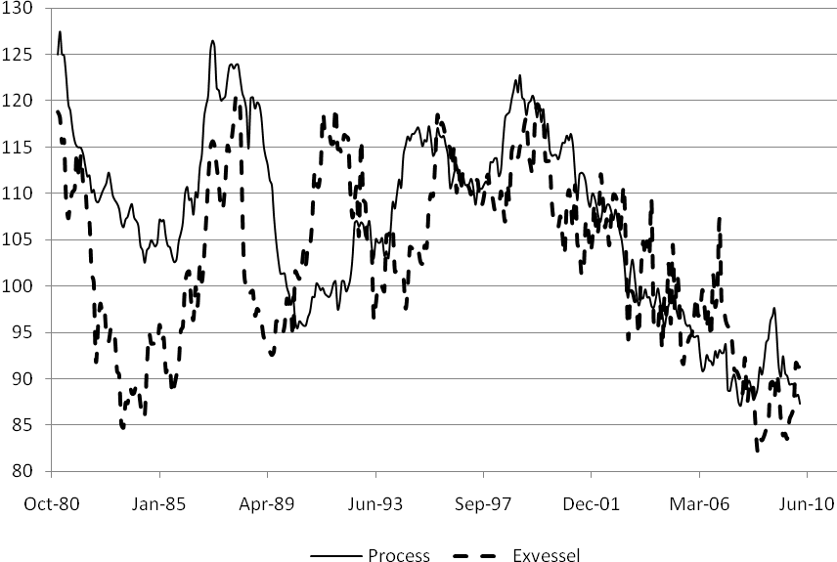
Figure 1: Processing and Ex-vessel Price of Fish, January 1981 to March 2010

In the first-hand market for fish we observe an upward or positive trend in ex-vessel prices over the period 1981 to 1999. Notice the wide swings in prices similar to the processed price over the period. After 1999 the price trend is very much negative. In fact, a simple trend line over the two periods shows a positive trend of 0.066 (p-value 0.00) over the first period and a negative trend of -0.221 (p-value 0.00) over the latter period. It also appears as if the variation in price is much wider in the former period compared to the latter. The main point here is that over the last ten years the price received by fishermen for their catch has decreased substantially from a real price index of 119.6 in November 1999 to 91.3 in March 2010. This has implications for both revenue and profit generation. On the revenue side, the price fall tells us that without increases in individual vessel harvest (or constant fleet harvest with a decline in the overall number of fishermen) real revenue to individual fishermen must decline. More so, under this scenario unless the real cost of harvesting has fallen, real income to fishermen must also decline.
It is important to keep in mind that each segment in the supply chain represents a well defined and functioning market. Price determination within each segment is subject to market specific supply and demand characteristics and, of course, supply links between the two segments. Visually it appears that price development in the processing and ex-vessel sectors follows a somewhat similar path. The pairwise price correlation between ex-vessel and processing is measured at just over 60%. The large price shocks early in the data are certainly visible in both sectors and both sectors suffer a general decline in real price over the last ten years.
2.2 Summary Statistics
Table 1 provides summary statistics for the two price series. The table shows the mean, standard deviation and coefficient of variation (CV). As the prices are indices the mean and standard deviation are useful primarily in calculating the CV. The CV measures the ratio of the standard deviation to the mean. For presentation, the CV has been multiplied by 100. The CV is a unit less measure and allows a comparison of dispersion across the variables of interest; the larger the CV the greater the dispersion in the variable.
Table 1: Summary Statistics of Processed and Ex-vessel Price of Fish
January 1981 – March 2010

Variable | Mean | Standard  Deviation | Coefficient of Variation
Process ^{a)} | 106.84 | 9.82 | 9.19
Exvessel ^{b)} | 102.63 | 9.45 | 9.21
Obs. | 352
^{a)} Industrial price fresh/frozen
^{b)} Ex-vessel price

It is interesting that Figure 1 appears to show a difference in variation between the two series but in fact the CV measures very similar variation for the two prices over the period. Given what appears to be a structural break in the ex-vessel price in November 1999 (Figure 1), the calculated CV varies somewhat from 8.67 prior to the break to 9.06 after the break. Consequently, whatever the cause, the break not only changed the direction of the price trend but also increased the variation in ex-vessel prices.
The final summary table will describe some time series or data generating properties of the price variables. If the data generating process is stable this indicates that the mean, variance and pairwise correlations of the realizations are stable or stationary over time. If on the other hand this is not true, then econometric modelling of such non-stationary variables tends to measure common trends in the data and the underlying economic relationship of interest is obscured. A number of statistics are available for testing stationarity and here the augmented Dickey-Fuller approach is used with constant, trend and six lags for testing (Gordon 1995). In the level form of the variables, the null hypothesis is that the price series is characterized as nonstionary with an alternative hypothesis of stationary in first-differenced values of the variable. For each of the price variables the results of the test are reported in column 2 of Table 2. In both cases we cannot reject the null hypothesis at p-values less than 5%. Next, we take the first differences of the variables and reapply the test. The null hypothesis is that the series is stationary in second-differences against as alternative hypothesis of stationary in first-differences. The results are reported in column 3 and now for all price variables we can easily reject the null and accept the alternative hypothesis of stability/stationarity in the first-difference values of the variables.
Table 2: Tests for Stationarity^{a)}

 | Dickey-Fuller  Levels | Dickey-Fuller  First-differences
Process ^{b)} | -1.92  (0.64)* | -6.08  (0.00)
Exvessel ^{c)} | -2.50  (0.33) | -8.79  (0.00)
^{a)} All statistics include constant, trend and 6 lags.
^{b)} Processed price
^{c)} Ex-vessel price
* Mackinnon approximate p-value

What these stationarity results mean is that, in most cases, we must approach modelling using the first differences of the prices rather than the levels. It is argued that using first differences rather than levels removes long-run price information in the data but this can be recovered within an error-correction model as we will see below. First, we will concentrate on a univarate short-run model using first differenced price data.

- An ARMAX Model of Ex-vessel Prices
The initial modelling will be to fit an ARIMA model to the ex-vessel price data. This is a univariate modelling technique based on the maintained assumption that current realizations of price can be explained by lagged values of the price (dynamic shocks) and current and lagged values of the stochastic error term (stochastic shocks). The ARIMA can be considered a reduced form price model for the purpose of short-run forecasting. It is possible to augment the ARIMA price model by including exogenous variables in specification for the purpose of improving forecasting possibilities and to reduce forecast error. These extensions are defined as ARMAX or transfer function models and for the case at hand the US/Canada exchange rate and seasonal dummy variables may serve this purpose well. Of course, as our data are nonstationary the price equation will be modelled in first differences rather than levels.
3.1 Univariate model
The specification of the univariate price model is defined as:
(1)
where represents first differences, 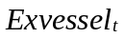 is the ex-vessel price index for fish in period t, 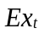 is the US/Canada exchange rate, are seasonal monthly dummies, 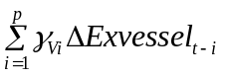represents the autoregressive (AR) component (dynamic shocks), 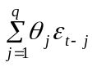 represents the moving average (MA) component (stochastic shocks) and is an iid random error term. Estimation of Equation (1) is routine using maximum likelihood procedures.
Selecting the correct lag specification for Equation (1) is critical for generating an estimated equation with good forecasting potential. Our research strategy is to evaluate alternative AR and MA lag structures based on review of the autocorrelation and partial autocorrelation functions with possible candidate specifications defined on testing iid conditions in the stochastic error term using a Box-Lung Q-statistic. Among those candidate specifications the preferred model is identified by measured RMSE and AIC statistics. For comparison and evaluation purposes both the estimated ARIMA and ARMAX models will be reported.
Initial evaluation of the ex-vessel price showed very strong monthly effects with prices slightly but significantly higher in the months August through January. Testing showed that we are able to control seasonal effects using a single dummy variable with the value 1 in the months mentioned and zero otherwise. Following this procedure the final specification of the ARIMA model resulted in an AR specification of one and twelve lags and a MA specification of twelve lags. The results for both the ARIMA and ARMAX are reported in Table 3.
Table 3: ARIMA and ARMAX Equations for the Ex-vessel Price
Variables | ARIMA | ARIMAs | ARMAX
Exchange^{a)} | - | - | 0.129  (0.111)
Seasonal^{c)} | - | 0.016  (0.000) | 0.017  (0.000)
^{d)} | -0.212^{b)}  (0.000) | -0.240  (0.000) | -0.244  (0.000)
^{e)} | -0.352  (0.037) | -0.406  (0.008) | -0.425  (0.003)
^{f)} | 0.577  (0.000) | 0.585  (0.000) | 0.607  (0.000)
Intercept | -0.001  (0.624) | -0.009  (0.000) | -0.009  (0.000)
RMSE | 0.0276 | 0.0264 | 0.0263
AIC | -1507.03 | -1537.52 | -1538.02
Q-statistic | 60.97  (0.018) | 36.02  (0.649) | 37.26  (0.594)
Observations | 350 | 350 | 350
^{a)} US/Canada exchange rate
^{b)} p-value in parentheses, robust standard errors
^{c)} Seasonal dummy variable
^{d)} AR lag 1
^{e)} AR lag 12
^{f)} MA lag 12
The second column in Table 3 reports the basic ARIMA model with all ARMA components statistically significant but the Q-statistic, testing the null hypothesis of no correlation in the estimated errors is rejected with a p-value of less than 2%. We were unable to find any reasonable combination of ARMA structure that generated statistically significant parameters and non-correlated predicted errors. This lead to a search for seasonality in the price series and resulted in the estimates reported in column three under the heading ARIMAs. Here we observe that the seasonal dummy and the ARMA components are statistically important with a small Q-statistic. Also, note the reduction in RMSE and the AIC statistic relative to ARIMA. Clearly ARIMAs is statistically preferred to ARIMA.
We extend the ARMAX structure one step further by including the US/Canada exchange rate in specification. These results are reported in column four under the heading ARMAX. The inclusion of the exchange rate variable does in fact reduce the RMSE of the specification and lowers somewhat the AIC criteria relative to the ARIMAs model. However, the exchange rate although correctly signed is itself only significant with a p-value of 11%. Nevertheless, international trade is very important for Canadian fisheries and short-run price forecasting will be carried out using the ARMAX model.
3.2 Price Forecasts
The ARMAX model will be used to forecast both in-sample and dynamic forecasting. For in-sample forecasting of the ex-vessel price the actual values of the seasonal dummy, exchange rate and ARMA components are used in making the one step ahead forecast. Whereas, for dynamic forecasting the actual values of the seasonal dummy and exchange rate are combined with the predicted value of the ARMA components for forecasting. For purposes of presentation in-sample forecasting is carried out for the period January 1981 to October 2007 with dynamic forecasts over the period November 2007 to March 2010. Figure 2a graphs out the in-sample forecasting of ex-vessel price whereas Figure 2b provides a closer look at the dynamic forecast.
Figure 2a shows that one step ahead in-sample forecasting of the ex-vessel price of fish is very good but this is what is expected in a well specified equation. But it does provide further evidence that the ARMAX model is a reasonable candidate for short-run ex-vessel price forecasting.
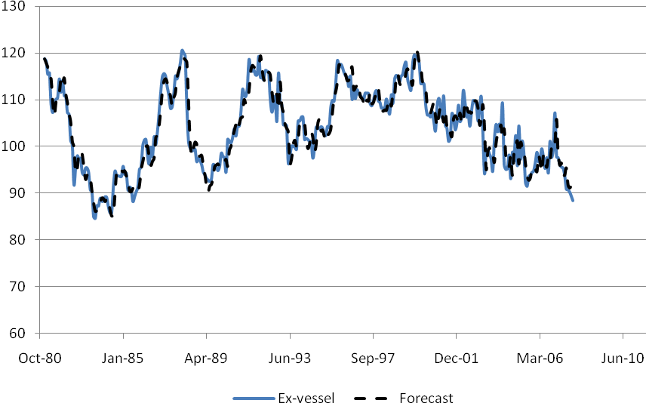
Figure 2a: In-Sample Ex-vessel Price Forecasts: January 1981-October 2007
Figure 2b shows the dynamic forecast over the last months of the data period. The merit of ARIMA modelling is in dynamic forecasting. The dynamic forecast does a good job of picking up all four turning points in the series but does not capture the full magnitude of the variation in actual ex-vessel prices. Nevertheless, this model has much to recommend it and we will move on to out-of-sample forecasting under alternative exchange rate scenarios.
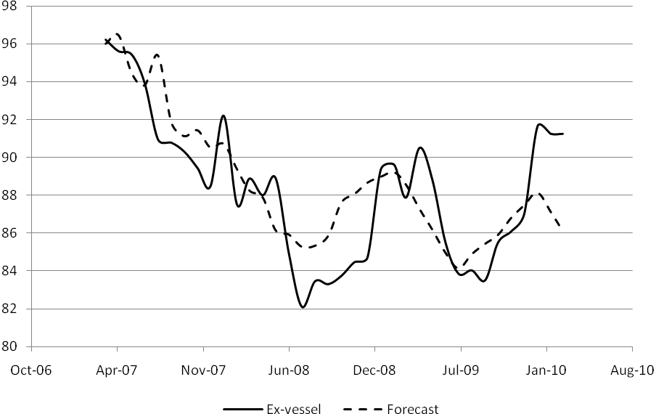
Figure 2b: Dynamic Ex-vessel Price Forecasts: November 2007-March 2010

Over the period of our data the US/Canada exchange rate reached a high in January 2002 (1US=1.61Can) and low in November 2007 (1US=0.967Can) and for simulation purposes these rates are set as the upper and lower bound on the exchange. Dynamic forecasting will follow ex-vessel price realizations as we simulate the exchange rising from par to the highest bound and repeat the simulation from par to the lowest bound. The purpose is to compare the difference in forecasted ex-vessel prices from the different exchange rate scenarios. In interpretation we must be mindful that such out-of-sample forecasting depends on starting values or in other words the forecast is path dependent. The starting point is set as October 2007 when the actual exchange rate was par. The results of the two exchange rate dynamic forecasting scenarios are shown in Figure 3.
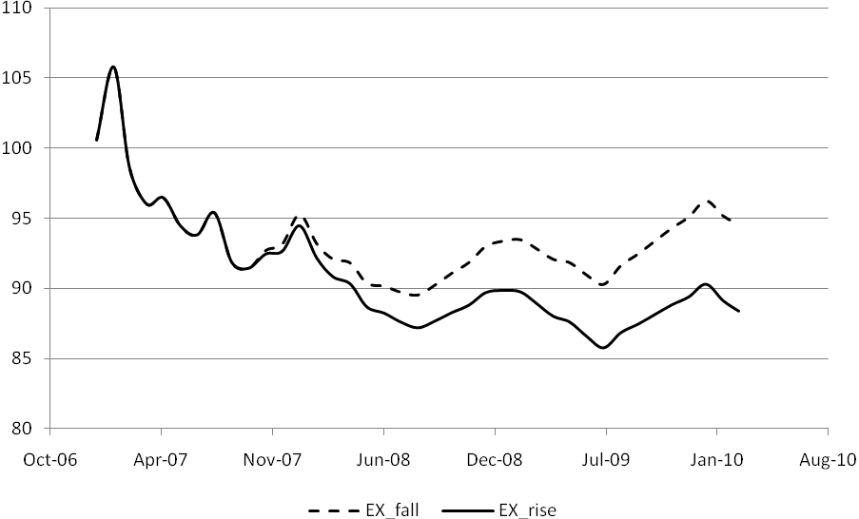
Figure 3: Ex-vessel Price Forecasts, Two Exchange rate Scenarios

The upper dashed line in Figure 3 shows ex-vessel price predictions as the value of the Canadian dollar falls relative to the US dollar and the solid bottom line shows price predictions as the value of the Canadian dollar rises relative to the US dollar. The results are as expected with ex-vessel price increasing as a cheaper Canadian dollar increases US demand for Canadian fish.
At the upper and lower bounds of the simulation, predicted values reflect a 6.3% difference in the high to low ex-vessel price. This is an interesting but serious complication for fisheries managers: Interesting because it statistically shows the importance of international factors impacting the welfare/income of Canadian fishermen and complicating because regardless of the success of fisheries management on stocks and harvest levels the ultimate impact on fishermen is influenced by external/exogenous factors.
To provide an alternative but realistic exchange rate scenario consider the current world situation where the US dollar is falling against the major world currencies. In this scenario we will simulate the ex-vessel price impact of the Canadian dollar on par with the US. For dynamic forecasting we pick as a starting point March 2009 when the actual exchange rate was 1US=1.265Can and allow the Canadian dollar to gradually rise each month until par with the US dollar. Under this scenario the movement of the exchange rate to par causes the real ex-vessel price to Canadian fishermen to fall by 5.3%.
Dynamic price forecasts are certainly useful in providing probable ex-vessel price paths in the short run and can be used to predict the consequence of exogenous shocks in the system. We turn now to multi-variable price modelling of the links in the Canadian fish supply chain.

- Error-Correction Modelling of Ex-vessel Prices in Canadian Fisheries
Research in applied time series econometrics is concerned with the issue of short-run dynamics and long-run equilibrium (Engle and Granger 1987). The problem is that short-run dynamics, as represented by vector autoregressive models are subject to omitted variable bias if long-run parameters are neglected in specification. Error-correction modelling is an attempt to combine both short- and long-run parameters in a single equation. What is interesting is that long-run parameters are derived from prices in level (i.e., non-stationary) form and short-run parameters are derived from prices in first difference (i.e., stationary) form. The idea is that there may exist a vector of parameters that in combination with the level prices forces stationarity. Estimation of the error-correction model for the first-hand/processing segment will provide a statistical picture of the short- and long-run price parameters that link the markets.

3.1 The EC Model
In a pairwise comparison of prices in the two market segments of the fish supply chain, it is not unreasonable to think of an economic equilibrium describing the long-run relationship and written as:
(2)
where is a specific market price in log level form, and represent the vessel and processing market segments, respectively. If equilibrium exists then represents a cointegrating vector that produces a random error term that is stationary. Moreover, defines the equilibrium link (or long-run parameter) between prices in the different market segments. Rearranging equation (2) and lagging one period the equation can be written in error form as:
(3)
In equilibrium the error term takes the value zero, but if process prices are above the equilibrium the error term is negative and below the equilibrium the error term is positive. The error equation in combination with the short-run model ensures that prices above the equilibrium are adjusted downward and prices below the equilibrium are adjusted upward. By including equation (3) in a short-run distributed lag representation the error-correction model can be written as:
(4)
where short-run parameters are defined by , long-run parameters by , and is the speed of adjustment to regain the equilibrium. The speed of adjustment to recover the equilibrium is an important characteristic of the market. The first point of interest is that all arguments in Equation (4) are stationary () and with correct specification of lag structure on the distributed lag (short run) variables the error term is non-autocorrelated and asymptotically normal. Second, the speed of adjustment to a short-run price shock can be approximated with the simple expression. Finally, a possible serious econometric problem in Equation (4) may result if there is correlation between the current valued process price and the error term i.e. and between the change in actual vessel price and the error term This problem can arise by feedback links between the market segments and will cause inconsistent parameter estimates in both Equations (3) and (4) (Hahn, 1990). To avoid this problem it is necessary that current valued process price and the change in current valued process price be weakly exogenous to the error term both in Equations (3) and (4), respectively. What this means is that in an economic sense price leadership both in the short run and long run, moves from the process sector to the vessel sector without feedback effects. Boswijk and Urbain (1997) suggest a modified application of the Hausman test or variable inclusion test to test weak exogeneity. Consider a distributed lag model defined for processed price
(5)
Von Cramon-Traubadel (1998) refers to Equation (5) as a marginal model. Long-run exogeneity can be tested using Equation (5) by including the error-correction term, of Equation (3) as an additional regressor. The equation is estimated under the assumption of weak exogeneity in processed price and an F-test is appropriate in testing.
Short-run exogeneity can be tested by estimating first Equation (5), calculating the fitted residuals and including this as an additional variable in Equation (4). Equation (4) is re-estimated under the null hypothesis of exogeneity in processed price. An F-test is appropriate in testing.
3.2 Validation and Hypothesis Testing
As with the univariate model, selecting the correct lag specification in Equation (4) and (5) is critical in model specification and selection. The autocorrelation function is used to provide possible candidate specifications and this is augmented with both t-tests of individual parameters and tests to measure for correlation in the stochastic error term. The final specification is based on iid error terms defined using a Box-Lung Q-statistic and comparisons of measured RMSE and AIC statistics.
Following Halicioglu (2008) cointegration is tested in Equation (4) from a null hypothesis of no cointegration or against the alternative of cointegration. Critical values for the test are provided by Pesaran et al. (2001).
3.3 Model Estimates
Table 5 reports the results from estimating the error-correction and testing equations. Column 2 reports the test for short-run weak exogeneity based on Equation (4) by including the predicted errors from Equation (5). Column 3 reports the test for long-run weak exogeneity based on Equation (5) including the error-correction term from Equation (3). The F-statistics used in testing are reported at the bottom of the table. Both F-statistics provide support for the conclusion that process price in terms of vessel price can be considered weakly exogenous in both the short-run and long-run equations. This is a strong result and indicates that process price is the driving factor or price leader in determining ex-vessel price. Although a strong result it is consistent with published research in agricultural economics from producer to processor (Von Cramon-Taubadel, 1998).
The error-correction results are reported in column 4 of Table 5. Final specification of the equation relies on the current change in process price plus the first and third lags of the process price variable. The second lag on process price was insignificant and was dropped with no statistical consequence from the equation. The first lag of vessel price is also included as is the error-correction term from Equation (3). It is interesting that this specification fails to produce white noise error terms based on the Box-Lung test. From experience with the ARIMA selection process, we search for omitted seasonality in vessel price data. We found that by including a 12th lag on vessel price the Box-Lung test showed white noise error terms. Note the speed of adjustment coefficient is measure at 0.072 (absolute value) and statistically significant implying a somewhat long time to adjustment of approximately 13 months. It is the long lag on vessel price that causes the lengthy adjustment process.
Prior to evaluation of the error-correction model, we test to ensure a long-run cointegratred model exits. This test will also generate the long run parameter of interest. The empirical process is to re-estimate Equation (4) but include the full specification of the long run model (Equation 3). The hypothesis of no cointegration is tested from a null of against a general alternative. The testing generated a calculated F_{(2, 330)} -statistic of 8.45 and falls outside of the bounds test rejecting the null hypothesis and indicates a cointegrated system. The long-run estimated equilibrium is written as (p-value in parentheses):
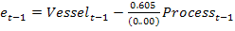 (6)
This equation supports a long-run price elasticity where just over 60% of a price change at the processing level is passed on to the vessel level.
Returning to Table 5, the short run parameters show the response elasticities of the changes in vessel price to a shock in the system. Short run vessel price is impacted by current and lagged values of change in process price and past change in vessel price. Note that short-run elasticities with respect to process prices are less than half the magnitude of the long run value and declining in lagged response.

Table 5: Marginal Equation Error Correction, Processing and
Error Correction Equation

Variables | Marginal  Error Correction | Marginal  Processing | Error Correction
ΔProcess | -0.250  (0.530) | - | 0.321  (0.002)
ΔProcess_1 | 0.325  (0.009) | 0.127  (0.040) | 0.244  (0.023)
ΔProcess_2 | - | 0.008  (0.890) | -
ΔProcess_3 | 0.196  (0.094) | -0.023  (0.689) | 0.212  (0.070)
ΔProcess_4 | - | 0.105  (0.023) | -
ΔProcess_12 | - | 0.137  (0.030) | -
ΔProcess_13 | - | 0.134  (0.017) | -
ΔProcess_14 | - | -0.123  (0.015) | -
ΔVessel_1 | -0.161  (0.022) | 0.017  (0.503) | -0.149  (0.031)
ΔVessel_2 | - | 0.020  (0.484) | -
ΔVessel_3 | - | 0.015  (0.645) | -
ΔVessel_4 | - | -0.052  (0.095) | -
ΔVessel_12 | 0.279  (0.000) | - | 0.224  (0.000)
EC_v | -0.067  (0.001) | 0.008  (0.403) | -0.072  (0.000)
r_v | 0.618  (0.36) | - | -
RMSE | 0.0272 | 0.0128 | 0.0272
AIC | 1460.97 | -1959.76 | -1471.14
Q-statistic | 46.93  (0210) | 50.86  (0.117) | 50.15  (0.131)
Obs. | 338 | 336 | 338
Short-run  F-statistic | 2.23  (0.136) | - | -
Long-run  F-statistic | - | 0.70  (0.403) | -

A useful way to evaluate the equilibrium and the error-correction model is to graph out the dynamic response to a shock in process price. This dynamic response is shown in Figure 4 and 5 for two alternative scenarios. In Figure 4 we allow for a one time price shock to the process price and then return to pre-shock levels in the next period. Figure 4a graphs out the dynamic response of vessel price to the shock to process price (i.e., the cointegrated equation) and Figure 4b graphs out short run changes in prices (i.e., the error-correction equation). In Figure 5, we allow for a persistent price shock to process price and report price dynamics in Figure 5a and short run changes in price in Figure 5b.
In Figure 4a, equilibrium vessel price at first jumps up in response to a one time shock to process price. However, in the next period process price returns to pre-shock levels and now the response process reduces vessel price but overshoots the pre-shock vessel level. There are two reasons for this; the return to pre-shock process price in the second period causes a negative adjustment in vessel price, and at the same time in the second period the error-correction forces an additional correction on vessel price caused by the first period positive price shock. The oscillations in vessel price decrease overtime but note we observe the seasonal impact in the market at long lag lenghts. Figure 4b drafts out the change in vessel price from the change in process price. Notice the short run vessel prices both increase and decrease in response to the shock but are not long lasting.
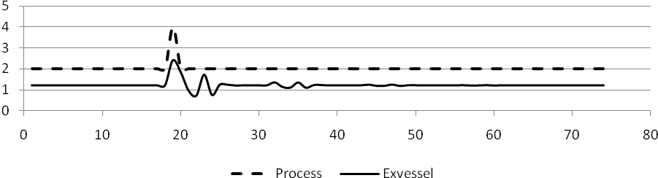
Figure 4.a Price Simulation: One time price shock
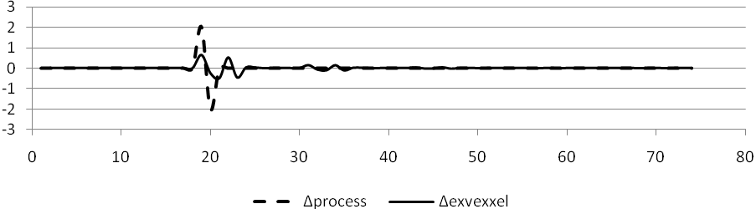
Figure 4.b Change in Price Simulation: One time price shock
Figure 5a shows the long run effect of a positive and persistent price shock to process price. In response vessel price initially overshoots the new equilibrium price level but stability in the system forces a return to the new equilibrium price. Notice in Figure 5b that short run price adjustment shows a more moderate adjustment to a persistent price shock relative to Figure 4b.
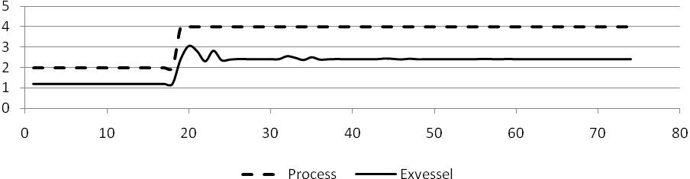
Figure 5.a Price Simulation: Persistent price shock
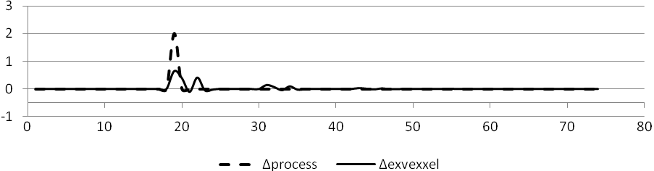
Figure 5.b Change in Price Simulation Persistent price shock

5. Summary and Conclusions
The purpose of this research was to investigate the stochastic structure of ex-vessel prices in the Canadian fish supply chain. Time series modelling is the technique used to focus directly on ex-vessel prices using an ARMAX model and to investigate the link between vessel price and process price using an error-correction model.
The ARMAX model fit the data well providing dynamic forecasts and policy evaluation. Interestingly we show that changes in the US/Canada exchange rate impact the vessel price with rising Canadian dollar value causing downward pressure on ex-vessel prices. This is an important fisheries management issue to the extent that it is an exogenous shock impacting income levels of fishermen. The ARMAX model is statically straightforward and can be updated by fisheries managers for up-to-date short-run price forecasts
The error-correction model provided a statistical characterization of the links between the process and vessel markets. Importantly testing showed that there exists a long run-equilibrium relationship across process and vessel prices. What this means is that there exists natural market forces that allow for price deviations in the short run but eventually force price to return to the equilibrium. Second, we show that process price can be considered weakly exogenous with respect to both the short and long run. In other words, process price acts like a price leader in determining vessel price. We measure that a one time shock can cause serious variation in vessel price but the shock is stable and prices do return to pre-shock levels Future research in this area could approach the price problem in the spirit of structural modelling and concentrate on introducing a retail demand shift variable and a marketing cost index to augment model specification and improve forecasting. In addition, the issues of asymmetric price response to upside and downside process price shocks is a natural extension to this work.

References
Asche, F., Menezes, R. And Dias, J.F. 2007 Price transmission in cross boundary supply chains Empirica 34:477-489.

Azzam. A.M. 1999 Asymmetry and rigidity in farm-retail price transmission American Journal of Agricultural Economics 59:570-572.

Boswijk, H.P. and Urbain, J.P. 1997 Lagrange-multiplier tests for weak exogeneity: A synthesis Econometric Reviews 16:21-38.

Enders, W. 2010 Applied Econometric Time Series, 3rd Edition, Wiley.

Engle, R.F. and Granger, G.W.J. 1987 Cointegration and error-correction: Representation, estimation and testing Econometrica 55:251-276.

Gordon, D.V. 1995 “Optimal Lag Length in Estimating Dickey-Fuller Statistics: An Empirical Note” Applied Economics Letters, 2:188-190.

Gordon, D.V. and W.A. Kerr. 1997 “Was the Babson Prize Deserved? An Enquiry into an Early Forecasting Model” Economic Modelling 14(3):417-433.

Hahn W.F. 1990 Price transmission asymmetry in pork and beef markets The Journal of Agricultural Economic Research 42:21-30.

Pesaran, M.H., Shin, Y. And Smith, R.J. 2001 “Bounds testing approaches to the analysis of level relationships” Journal of Applied Econometrics 16:289-326.

Von Cramon-Taubadel, S. 1998 Estimating asymmetric price transmission with the error-correction representation: An application to the German pork market European Review of Agricultural Economics 25:1-18.

Wohlgenant, M.K. 1985 competitive storage, rational expectations and short run food price determination American Journal of Agricultural Economics 67: 739-748.

Zivot, E. and Andrews, D. W. K. (1992) ‘Further Evidence on the Great Crash, the Oil-Price
Shock, and the Unit-Root Hypothesis’, Journal of Business and Economic Statistics,
10(3), 251-270.

Long run equilibrium depends on statistical cointegration amongst the price variables of interest.
Processed prices are Statistics Canada Cansim series number v1574627 and ex-vessel prices v1576476.
CPI Statistics Canada Cansim series number v41690973.
Statistically significant at the 99% level.
Because of what appears to be a structural break in the trend for the ex-vessel price (Figure 1), an alternative test was carried out to check for stationary in levels with a structural break. However, the stationary test is calculated as -1.07 with p-value of 0.72 and the null is not rejected (Zivot and Andrews, 1992).
The level nonstationary series can be used in long-run cointegration models.
Autoregressive Integrated Moving Average Model.
ARIMA models could be specified for each variable in the data set.
For an interesting discussion of the first serious price forecasting model see, Gordon and Kerr (1997).
The restriction on the exogenous variables requires no feedback effect to the dependent variable (Enders, 2010)
Estimation is carried out using STATA 11 software.
Root mean square error and Akaike’s information criteria, respectively.
Monthly dummy variables were generated and used in estimation. Testing showed a null hypothesis of equal parameter estimates in the months of August through January could not be rejected ( with p-value=0.8623)
In testing the US/Canada exchange rate is found nonstationary and first differences are used in modelling.
To be clear, with actual exchange rate at par in October 2007, we allow the exchange rate to gradually change each month until the upper bound is reached. These values are included in the dynamic forecast of ex-vessel price. We repeat the exercise allowing the exchange rate to reach its lowest level.
Here we assume all variables
An intercept could be included in equation (4) but this would require a time trend variable in equation (3).
The 12th lag was also necessary for specification in the ARIMA model.
Keep in mind that we are assuming symmetric price response in the market.

