
Value Chain Approach to Poverty Reduction:
Equitable Growth in Today’s Global Economy

Abstract: This paper provides an overview of the Value Chain Approach as an effective tool for identifying and analyzing the relationships between firms to effectively design donor-sponsored economic growth interventions that reduce poverty by increasing the competitiveness of an industry and the firms within that industry.
Overview


Globalization is a process by which people, companies, goods and services, capital, information and ideas are exchanged across international boundaries. Although cross-border trading has existed for centuries, modern day trade—fueled by multi- and bi-lateral trade agreements, global investments and innovations in information and communications technology—has expanded in volume and geographic reach. Today, most countries are directly integrated into the global economy and have experienced varying degrees of economic growth and different levels of benefits. While economic growth generally reduces poverty, it does so at different rates in different contexts, with the greatest impact on poverty reduction occurring in those countries with the most equitable income distribution.
Globalization of markets ties the sustainability of small firms to the competitiveness of the industries in which they participate. This occurs as firms within an industry in a country or region increasingly must compete—even in local markets—with firms and industries from across the globe. To succeed in global markets, entire industries (or value chains) must be able to move a product from production to the consumer more efficiently, in a higher-quality and/or in a more unique form than the value chains in competing countries. In this way, competitiveness at the firm level and at the industry level are interdependent; increasing the competitiveness of the firm, leading to higher income, is only effective at sustainably creating wealth and alleviating poverty when the competitiveness of the industry is similarly raised by interventions at all levels of the value chain. The challenge for development practitioners is to promote economic growth strategies that make entire industries more competitive, while ensuring broad distribution of benefits, including skills and income, at all levels of the industry.
Competitiveness is the ability of a firm or industry to develop and maintain an edge over market rivals. This edge can be achieved by increasing efficiency, quality, product differentiation or by influencing demand.
AMAP BDS seeks to create wealth in poor communities and promote economic growth by sustainably linking large numbers of micro and small enterprises (MSEs) into productive markets. USAID’s Microenterprise Development office is promoting a economic growth with poverty reduction strategy through AMAP BDS, a program focused on linking MSEs into global and domestic value chains, while addressing the constraints these small firms face in competing in lucrative and sophisticated markets. AMAP BDS advocates that small firms benefit from participation in a global economy in certain situations and under certain conditions. After identifying those conditions, AMAP BDS targets sectors where the poor are concentrated—the agriculture and informal sectors—and aims to improve the competitiveness of industries (or value chains) in which significant numbers of small firms participate. AMAP BDS’ economic growth with poverty reduction strategy seeks to foster small firms’ access to the resources needed to compete in new markets and to promote incentives for mutually beneficial relationships, improved learning and expanded benefits.

The Value Chain Approach to Generating MSE Wealth in Competitive Industries

Value chains encompass the full range of activities and services required to bring a product or service from its conception to its end use and beyond. Value chains include the final markets into which a product or service is sold, whether that market is local, national, regional or global.
The Value Chain Approach focuses on four key factors that affect competitiveness:
1. Inter-firm cooperation and coordination is crucial to competitiveness in the global market. This cooperation generates opportunities for more efficient inputs, product and information flows between firms, enabling them to better respond to their competition in other countries. Increased coordination and cooperation result in more effective allocation of resources and assets between firms.
2. Relationships among firms in a value chain can influence the distribution of learning and benefits within that chain, which in turn determines the sustainability of that industry’s competitive position. Facilitating mutually beneficial, or “win-win," relationships among firms in a value chain creates incentives for firms to seek higher levels of efficiency and outputs, increase efficiencies in moving products and information between firms, and developing industry level strategies to compete in a global market place. Industry coordination for quality control and branding in horticulture high value coffee and fruits illustrate these advantages. Conversely, power imbalances in market relationships can deny access to revenues needed to finance upgrading, particularly for smaller firms. This occurs in markets where there is only one or two buyers, none of whom have incentives or access to the information needed to upgrade the value chain.
3. Distribution of benefits creates incentives or disincentives for performance. Benefits within a value chain are varied, but can translate into increased income, reduced market risk (more stable income), and increased value of assets. Firms in a value chain that have more power typically receive the greatest benefits from business transactions. Those firms able to wield power through product branding or by controlling access to worldwide suppliers or market information are best positioned to ensure that the distribution of benefits favors the most themselves. Understanding the power dynamics in value chains can point to interventions that improve the benefits to MSEs in competitive value chains.
4. Learning and innovation are essential for creating and sustaining competitiveness. Rapid and efficient learning about consumer preference and access to the skills and technologies needed to respond to consumer preference are very important, particularly if small and very small firms are to remain competitive and continue to upgrade in response to market opportunities. In some chains, learning comes primarily from buyers, who transmit information about consumer preference to producers. In other chains, input suppliers are the main sources of innovation. Regardless of how it takes place, learning is crucial and must be central to intervention strategies aimed at improving and sustaining value chain and MSE competitiveness.
Research shows that the distribution of learning and benefits and the structure of relationships in a value chain are flexible and can be influenced by programmatic interventions.
The Value Chain Approach identifies the opportunities and constraints to growth in a particular industry and takes the additional step of identifying the factors that drive firms’ behavior in markets. These factors include:
- mutually beneficial relationships among firms that are related horizontally and vertically;
- learning that takes place through vertical and/or horizontal cooperation; and
- the depth and breadth of benefits from participation in a value chain.
Understanding how industries in which MSEs participate can become more competitive requires a systemic view of markets, industries and the firms that comprise them. Improving industry and MSE competitiveness in a meaningful way requires a framework that examines the fabric of relationships between firms in a single industry to identify and prioritize the opportunities and constraints to improving industry competitiveness. The Value Chain Approach does this.
The Value Chain Methodology

The overarching program goal of an intervention is to increase industry growth while assuring meaningful poverty reduction. The Value Chain approach is a powerful tool for designing interventions. An intervention strategy must start with an understanding of the threats and opportunities for participants in a market; in other words, the strategy must start with a competitive analysis of the market(s) targeted. The Value Chain Approach assesses the constraints to and opportunities for enhancing an industry’s competitiveness through a diagnostic framework that includes five elements:
- End Market Opportunities
- Enabling Environment (international and national)
- Inter-firm Cooperation: Vertical Linkages
- Inter-firm Cooperation: Horizontal Linkages
- Supporting markets (sector-specific and non-sector specific services, including financial services)
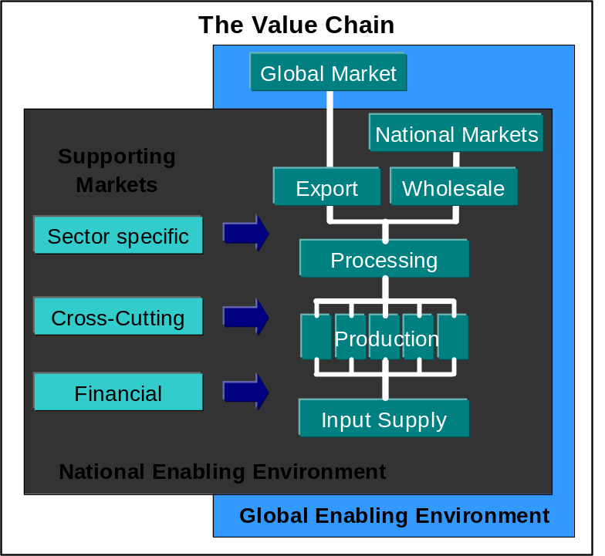
- Firm-level Upgrading (product and process upgrading)
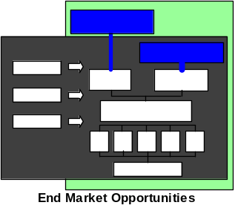
End Markets
End markets determine the characteristics of the final product or service generated. The demands of the end market drive quality and standards. They are important because of demand information, learning and benefit flows from the final buyer. Analysis of end markets needs to demonstrate the potential for competitiveness. The Value Chain Approach assesses the opportunities in all the possible markets into which products and services flow.
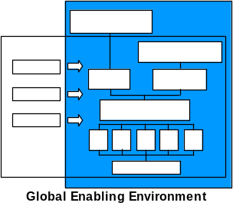
Enabling Environment (Local, National, and Global)
International trade agreements and standards tremendously affect the constraints and opportunities for industries’ growth. Both present opportunities for market expansion, but both, especially standards, can be extremely expensive for firms, especially MSEs, and can easily preclude a developing country from being competitive in a market.
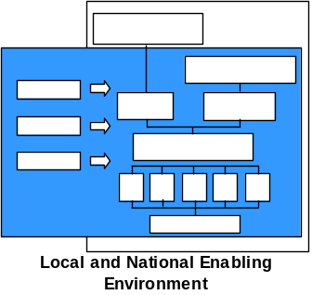
The national policy and regulatory environment is critical to the functioning of markets and enterprises; it should create incentives for private sector growth and involvement in the policy process. Moreover, poor local government operations and poor enforcement of legal and regulatory regimes increase transactions costs, informality and the risk that contracted suppliers or producers will not deliver, limiting investments in relationships and upgrading. Conversely, conducive local and regional policies can provide opportunities for rapid improvement of the enabling environment.

Inter-firm Cooperation: Vertical Linkages
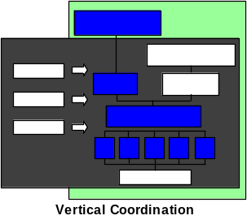
Cooperation between firms through vertical or horizontal relationships are critical to transferring skills and reducing transaction costs. Vertical linkages are the relationships among firms between the input supply and distribution to the final market. Vertical linkages are critical for getting a product from inception to the market, and for transferring learning and embedded financial and business (skills and know-how) services from firms up the chain to firms down the chain or vice versa. More efficient transactions among firms that are vertically related in a value chain increase the competitiveness of the entire industry.
Inter-firm Cooperation Horizontal Linkages
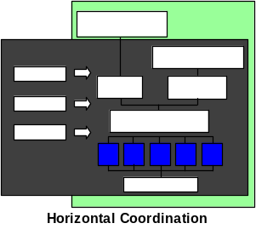
Horizontal linkages among producers / artisans are needed to reduce the transaction costs - for exporters or local buyers - of working with many small suppliers. By allowing for buying in bulk or meeting large orders, horizontal linkages can help small firms to generate economies of scale, which can contribute to their competitiveness and bargaining power. Horizontal linkages among MSEs can take the form of informal or formal groupings of MSEs, as well as networks of MSEs that are managed through a third party (e.g., lead firm, broker, trader, etc.).
Fostering win-win relationships among firms can result in the kind of vertical and horizontal cooperation needed among firms to reduce transaction costs, achieve scale, and create incentives for the adoption of more value-added functions or activities. Win-win relationships among vertically related firms can improve MSEs’ access to new markets, new skills, and a wide range of services. They can also reduce market risk by securing future sales.
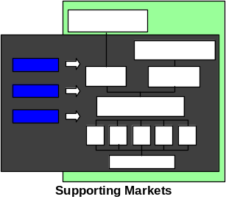
Supporting Markets
Supporting markets are key to firm-level upgrading and include sector specific markets (e.g. input and equipment providers), financial services, business management services (e.g. auditors, lawyers, etc.), and information technology (particularly as it pertains to market information access and dissemination). Where these services are needed over the long run, they must be provided commercially or by markets. These markets can include services provided by actors in the chain, or they can be provided by stand-alone providers. Services provided by actors in the chain – such as input suppliers - tend to be embedded, such that the cost of the service (the input) is embedded in the mark-up on a product sold (i.e. the input). New technologies or technical services can have a substantial effect on the competitiveness of the industry and can even change the competitive dynamic in certain markets.
Firm-level Upgrading
Individual enterprises improve their competitiveness in one of two ways. First, enterprises can produce their product more efficiently through improved techniques or processes that allow the enterprise to produce more quickly and/or at lower cost. Or, second, enterprises can improve the product’s quality so that it is differentiated from competitors’ products.
Continual upgrading of the product and process allows the enterprise to meet the market’s constant demand for innovation. This upgrading requires access to capital, technology and information. Within a value chain, learning and innovation are closely tied to the incentives that encourage or discourage the transfer of new knowledge or skills. In order for firms and value chains to constantly innovate, internal or external learning mechanisms are needed to push new skills and know-how from where it is located within the chain to where it is needed. Value chains that institutionalize these learning mechanisms are the most competitive.

The volume of world trade increased by twenty times from just 1997 to 1999
Accelerated Microenterprise Advancement Project – Business Development Services Indefinite Quantity Contract (AMAP BDS)

