


Value Chain Analysis in the Fisheries Sector in Africa

Erik Hempel

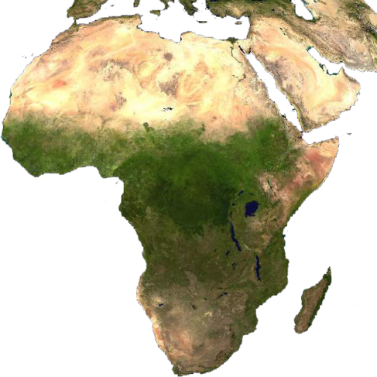

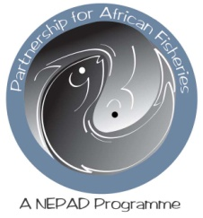

November 2010

The Present study was carried out by Mr. Erik Hempel from Hempel Consult, Norway in collaboration with INFOSA and funded by the Trade Working Group of the PARTNERSHIP FOR AFRICAN FISHERIES, an AU/NEPAD Programme.

November 2010

Contents

Executive summary 5
1. Introduction 8
2. Value chain analysis 9
2.1. The general value chain concept 9
2.2. The value chain concept applied to fisheries and aquaculture 11
2.3. Conclusions about using the value chain analysis 14
3. The international seafood industry and Africa’s place in it 16
3.1. African seafood exports and imports 18
3.2. Main destinations 20
3.3. Imports 21
3.4. Value addition in Africa 21
4. Studies where value chain analysis has been used 22
4.1. Revenue distribution through the seafood value chain 23
4.2. Lake Victoria Nile perch fishery, Tanzania 25
4.3. Pelagic fishery in Morocco 32
4.4. Value addition opportunities in the Namibian seafood industry 38
4.5. Ugandan Nile perch quality management and certification 41
4.6. The Kenya capture fisheries value chain 45
4.7. Nigerian domestic catfish production 50
4.8. Gender analysis of aquaculture value chain in Nigeria and Vietnam 54
4.9. Private sector applications of value chain analysis 60
5. On-going value chain analysis studies 68
5.1. Value chain analysis of international fish trade and food security 68
5.2. Ghana: Value Chain and Cost Earnings Analysis 69
6. Example from Asia: Analysis of the fishery sector in Sri Lanka 70
6.1. Value chain summary 71
6.2. Production 71
6.3. Ownership and collective action 72
6.4. Fisheries value chain structure and dynamics 74
6.5. Value chain participants 76
6.6. Supporting markets 77
6.7. Inter-firm linkages 78
6.8. Value chain governance and power relations 79
7. Conclusions 81
References 82

Executive summary

Executive summary

The Trade Working Group of the Partnership for African Fisheries (a NEPAD programme) is undertaking a review of value chain analysis specifically in the fisheries sector in Africa in order to provide an overview of the countries where value chain analysis has been undertaken in the fisheries sector, and report on the main findings.
The main purpose of this study is to provide a baseline analysis for informed discussions and future activities of the NEPAD Working Group of Trade and for other interested stakeholders of the industry. As such, the study is meant to provide a theoretical framework for future studies and development projects within fisheries and aquaculture in Africa.
In the first part of this report, a brief introduction to the value chain concept is given. The value chain concept was introduced 25 years ago by Michael Porter in his 1985 best-seller, Competitive Advantage: Creating and Sustaining Superior Performance.
In Michael Porter’s description of the value chain, he identifies the various steps, or links, in the generic value chain:
- Inbound logistics: the receiving and warehousing of raw materials and their distribution to manufacturing as they are required;
- Operations: the process of transforming inputs into finished products and services;
- Outbound logistics: the warehousing and distribution of finished goods;
- Marketing and sales: the identification of customer needs and the generation of sales;
- Service: the support of customers after the products and services are sold to them.
A value chain is thus a chain of activities. Products pass through all activities of the chain in sequence and at each activity the product gains some value. The chain of activities gives the products more added value than the sum of added values of all activities. It is important not to mix the concept of the value of the product with the costs of producing it.
The value chain does not, however, only include a straight line. There are external activities that influence activities within the value chain proper. If we include the surrounding environment in this model, we are expanding the value chain, in a way. In such an expanded model, we may distinguish between the core activities, which include the industry’s own activities, and upstream and downstream activities. Upstream activities provide inputs into the industry, while downstream activities relate to the outputs from the industry.
The fishing vessel catches the fish and brings it to the landing site or port, where there is some primary processing – such as for example sorting and freezing or chilling – taking place. From here the fish is transported to secondary processing, such as for example filleting and freezing. The product is then shipped to the wholesaler, who distributes it further to the retailer before it ends up with the consumer.
The second part of the report includes a brief presentation of African fisheries in relation to the rest of the world. In spite of its great potential, African production of seafood is relatively small. In 2008, only 8.1 million tonnes was produced, which is very small when compared to the rest of the world.
The largest fishing nation in Africa is Egypt, followed by Morocco, Nigeria, South Africa and Uganda. Together, these five countries account for almost half of the continent’s total fish production.
Africa’s aquaculture production is even less impressive. In 2008, total farmed production was 955,000 tonnes, of which Egypt alone accounted for 73%. By far the largest part of this production was freshwater fish.
Africa accounts for a very small part of the total trade in seafood. In 2007, African exports of seafood amounted to US$ 4.8 billion (or 4.7% of the world total), while African imports of seafood amounted to US$ 2.4 billion (2.2% of the world total). In other words, Africa as a continent showed a “surplus” in its international trade with fish and fish products.
By far the largest seafood exporter in Africa is Morocco, followed by South Africa and Namibia. While Morocco’s exports have been growing steadily over the past 10 years, the exports of South Africa and Namibia have been more stable.
Value added production in Africa is lower than in the rest of the world. While African total production of fish (catches and landings plus aquaculture production) constitutes 5.7% of the global production, Africa’s share of fishery commodity production, i.e. processed products, amounts to only 4.3% of the world total. African production of dried, salted and smoked fish constitutes a higher percentage of the total (8.3%) than for the other products.
In recent years, there has been a lot of focus on this, and many governments in Africa have tried to stimulate the production of value added seafood in their countries.
The third part of the report includes reviews of studies where value chain analysis has been applied to the fisheries and aquaculture industries in Africa. Although value chain analysis may have been used in a number of studies related to fisheries in Africa, time and resources only allowed the study team to review a few cases. Eight cases were selected:
- The Lake Victoria Nile perch fishery in Tanzania
- The Moroccan anchovy fishery
- The Ugandan Nile perch quality management and certification
- The Kenya capture fisheries value chain
- The Nigerian domestic catfish production
- A gender analysis of the aquaculture value chain in Nigeria and Vietnam
- A private sector case: investment analysis for tilapia farming in Uganda
In addition, a case from Asia was reviewed: An analysis of the fishery sector in Sri Lanka.
This brief overview has shown that the value chain analysis approach is useful for analyzing the fisheries and aquaculture industries in Africa, and that through the application of this approach, new insights may be gained and valuable new strategies may be developed, both at the micro-economic (company) level and at the macro-economic (national) level.
The value chain analysis can be applied to pure descriptive studies, where the purpose is to describe a process and for example allocate portions of the costs to the various elements. But it can also be used as a model in more analytical studies, where relationships and mechanisms are described.

Introduction

The Working Group on Trade under the Partnership for African Fisheries (a NEPAD programme) is undertaking a review of value chain analysis specifically in the fisheries sector in Africa in order to provide an overview of the countries where value chain analysis has been undertaken in the fisheries sector, and report on the main findings.
The main purpose of this study is to provide a baseline analysis for informed discussions and future activities of the NEPAD Working Group of Trade and for other interested stakeholders of the industry. As such, the study is meant to provide a theoretical framework for future studies and development projects within fisheries and aquaculture in Africa.
In recent years there has been increasing focus on value creation in African fisheries, and a number of studies have been undertaken. Some of these studies have used the value chain analysis approach, but there still seems to be some differences in how the methodology is applied.
Although widely referred to both in Academia and in business, the value chain concept at times seems to be somewhat vaguely known and understood. This is in spite of the fact that a great many books and articles have been written about the concept over the past 25 years. Most of the studies examined in this study had relatively short presentations of the value chain concept, and some did not refer to the concept at all. Therefore, it is felt that a brief introduction to the concept as it applies to the fisheries industry would be useful. In Chapter 2 we have included a short presentation of the value chain concept.
This overview is based on a literature review of available material. We do not by any means claim to have access to all studies and analyses that have been done on African fisheries and aquaculture using this approach, but we believe that the few examples we have examined may provide a set of useful experiences that others may draw on and develop further.
The report is divided into the following main parts:
- A presentation of value chain analysis as applied to fisheries and aquaculture;
- An overview of African fisheries, aquaculture and seafood trade;
- Presentation of value chain analysis studies undertaken in African fisheries and aquaculture;
- Presentation of a value chain analysis case from Asia;
- Conclusions and recommendations for future activities using the value chain analysis approach in African fisheries and aquaculture.

Value chain analysis

The value chain concept was introduced 25 years ago by Michael Porter in his 1985 best-seller, Competitive Advantage: Creating and Sustaining Superior Performance.
In Michael Porter’s description of the value chain, he identifies the various steps, or links, in the generic value chain:
- Inbound logistics: the receiving and warehousing of raw materials and their distribution to manufacturing as they are required;
- Operations: the process of transforming inputs into finished products and services;
- Outbound logistics: the warehousing and distribution of finished goods;
- Marketing and sales: the identification of customer needs and the generation of sales;
- Service: the support of customers after the products and services are sold to them.
A value chain is thus a chain of activities. Products pass through all activities of the chain in sequence and at each activity the product gains some value. The chain of activities gives the products more added value than the sum of added values of all activities. It is important not to mix the concept of the value of the product with the costs of producing it.
A diamond cutter can be used as an example of the difference. The cutting activity may have a low cost, but the activity adds to much of the value of the end product, since a rough diamond is a lot less valuable than a cut diamond.

The general value chain concept

The concept of the value chain is really quite simple. It just means that we link all the steps in production, processing, and distribution together, and that we analyze each step in relation to the preceding steps and the steps that follow.
The value chain describes the full range of activities which are required to bring a product or service from conception, through the different phases of production (involving a combination of physical transformation and the input of various producer services), delivery to final consumers, and final disposal after use.
Fig. 2.1: A simple value chain
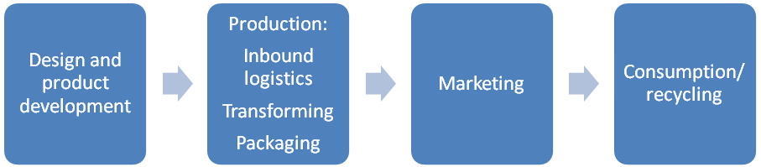
There are also ranges of activities within each link of the chain. Although often depicted as a vertical chain, intra-chain linkages are most often of a two-way nature – for example, specialised design agencies not only influence the nature of the production process and marketing, but are in turn influenced by the constraints in these downstream links in the chain.
The most important implication of applying the value chain approach, however, is the fact that all decisions made at one step in the process have consequences for the following steps, and often such decisions may be irreversible. For example, if you kill and dress the fish when you catch it, this means you cannot sell it as a live fish later.
The value chain does not only include a straight line. There are external activities that influence activities within the value chain proper. For the sake of simplicity, we may call these external parts of the value chain upstream activities and downstream activities. If we include the surrounding environment in this model, we are expanding the value chain, in a way.
In such an expanded model, we may distinguish between the core activities, which include the industry’s own activities, and upstream and downstream activities. Upstream activities provide inputs into the industry, while downstream activities relate to the outputs from the industry.
Fig. 2.2: The extended value chain
The challenge is to define your company’s place in the value chain, and to understand the opportunities represented by the surrounding environment.
Obviously, there are business opportunities in the upstream and downstream activities. If a company has the resources, it may enter into some of these activities as a strategic initiative.
Many large companies of corporations have adopted or co-opted some or all of such external activities into their business concept. For example, a large producer may take on the role of producer of supplies, such as packaging material, either because it is not readily available locally, or because it represents a substantial saving.
Some of these external activities may be highly profitable, and one might ask therefore: why are we not involved in these activities? The usual answer is: “It is not part of our core business.”
While that may be a valid reason, the decision to go into parts of the “external environment” of the value chain should be based on an analysis of the value chain and the technologies involved in relation to the company’s capabilities and resources.
Many previously integrated companies have decided to divest themselves of external activities or outsource these activities. Usually, such decisions are based on profit centre thinking or on the belief that others can undertake these activities more efficiently and at less cost to the core activities.

The value chain concept applied to fisheries and aquaculture

The general concept of the value chain is easily adapted to the fisheries and aquaculture industries. In fact, the value chain is very similar for the two industries, although some parts may differ slightly.
In the fisheries industry, one may describe the value chain as in Figure 2.3, consisting of seven links in this case.
The fishing vessel catches the fish and brings it to the landing site or port, where there is some primary processing – such as for example sorting and freezing or chilling – taking place. From here the fish is transported to secondary processing, such as for example filleting and freezing. The product is then shipped to the wholesaler, who distributes it further to the retailer before it ends up with the consumer.
Fig. 2.3: Example of a simple value chain in fisheries.

To illustrate more specifically the relationship between the core activities and the upstream and downstream activities we may use aquaculture as an example (Fig. 2.4).

Fig. 2.4: The extended value chain in aquaculture

Upstream activities produce inputs to the core activities, both products and services. Typical upstream activities are illustrated in this figure, and include feed suppliers, transporting companies, research organizations, veterinarians, equipment suppliers etc.
Downstream activities are those related activities that handle the products from the core activities, i.e. the output of the core activities, such as harvesting, live transport, processing, exporting and distribution.
Over the years, a wide variety of both upstream and downstream activities has been developed to support the aquaculture industry.
It is important to note that the more of these upstream and downstream activities that are physically close to the core activities, the easier it is to develop the industry. This means that African aquaculture has a definite disadvantage, since so much of the inputs must be important or are not readily available in the local market. Consequently, we should strive to help develop these related activities as part of the plan to develop the core industry.
The challenge is to define your company’s place in the value chain, and to understand the opportunities represented by the surrounding environment.
As an example of a more complex value chain, we may use the Icelandic cod fishery.
Fig. 2.4: The value chain in Icelandic cod fisheries

The Icelandic cod fishery is a highly capitalized fishery with multiple fleet segments and a wide variety of seafood products. The cod fishery is also the single most important fishery in Iceland in terms of export value.
Catch is harvested year round by vessels of three main categories: the in-shore fleet using hook and line, the long lining and gillnet fleet, and the trawler fleet. Over the past decade the total annual catch has ranged between 200,000 and 260,000 tonnes. This catch is sold fresh, frozen, salted and dried.
The utilization of the catch depends on factors like the size and texture of the fish. Large cod is preferred as an input in the processing of salted cod while medium sized cod is preferred for processing frozen cod fillets.
The figure shows that there are several underlying value chains in the production of Icelandic cod products. These value chains have different levels or stages from the very short ones with whole fish sold at foreign fish markets to the longer value added products with two or more processing stages selling their products to catering and restaurants.
Cod products are mainly sold to three markets; Europe, US and Asia, with the bulk of the catch going to Europe and the US. The US market focuses primarily on the restaurant/catering business while the European market is more mixed between restaurants and retail.

Producer-driven or buyer-driven?
Industries may differ according to the prevailing perspective that the industry actors have. For example, we may distinguish between a producer-driven value chain and a buyer-driven value chain.
Producer-driven commodity chains are those in which large, usually transnational, manufacturers play the central roles in coordinating production networks (including their backward and forward linkages). This is characteristic of capital and technology-intensive industries such as automobiles, aircraft, computers, semiconductors, and heavy machinery.
Buyer-driven commodity chains refer to those industries in which large retailers, marketers, and branded manufacturers play the pivotal roles in setting up decentralized production networks in a variety of exporting countries, typically located in the third world. This pattern of trade-led industrialization has become common in labour-intensive, consumer goods industries such as garments, footwear, toys, housewares, consumer electronics, and a variety of handicrafts. Production is generally carried out by tiered networks of third world contractors that make finished goods for foreign buyers. The specifications are supplied by the large retailers or marketers that order the goods.
In many countries the fisheries industry has been producer oriented in its perspective. The focus has been primarily on the producer (the fisherman) rather than on the market (the consumer). In some cases this perspective has had detrimental consequences for the industry and for individual companies.
Value chain analysis can help shift the focus away from only the producer and over to the market and the consumer, while at the same time paying adequate attention to all the steps in between. In a market economy, this is important, for if we produce products that the consumers do not want or need, we will soon be out of business.

The uses of value chain analysis
The method may be used for two major purposes: either as a way to describe an industry, or as a tool that provides a basis for an analytical study.
In a purely descriptive value chain analysis, one strives to describe what happens chronologically through the production process, and perhaps allocate values to the different links, such as has been done in the 2006 FAO study on revenue distribution through the seafood value chain.
In an analytical study, one uses the description of the value chain as a starting point in searching for causal relationships between the links, often to explain why or how this or that is influencing that and the other. In this overview, we will see examples of both these approaches.

Conclusions about using the value chain analysis

By using value chain analysis, it should be obvious that it is very important that the company has efficient and working linkages backward and forward in the value chain. This means having reliable and good suppliers, and good customers. Consequently, it is also important to decide which parts of the value chain the company should be involved in.
I also believe that one must concentrate on one or a very few species. It requires a lot of information and expertise to do aquaculture well, and it is limited as to how much resources the company can spend.
But it is also important that the necessary upstream and downstream elements are in place. If they are not, the company may have to provide then itself, and that can be a costly undertaking.
The company must be market oriented. Preferably, marketing starts well ahead of production, because you have to produce what the customer wants.
Value chain analysis provides a systematic and analytical tool that can help management see and understand the processes in the company, and especially know the costs related to the various steps in the chain. Experience has shown that proper cost control is crucial. One must know the costs at every level, and work continuously to reduce costs wherever possible, but not by compromising on quality and safety. As we shall see, value chain analysis helps uncover this knowledge.

The international seafood industry and Africa’s place in it

Global fisheries production has continued to grow although there have been some ups and downs. In 2008, total production (including aquatic plants) amounted to almost 160 million tonnes. The total amount of seafood produced (i.e. excluding aquatic plants) stood at 142 million tonnes.
In spite of its great potential, African production of seafood is relatively small. In 2008, only 8.1 million tonnes was produced, which is very small when compared to the rest of the world.

Fig. 3.1: Global fish production by continent (aquatic plants excluded)
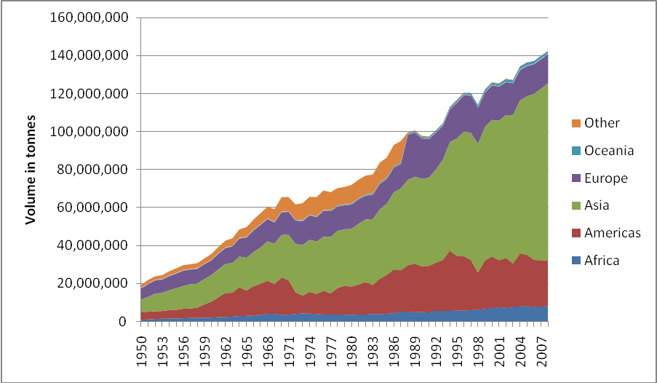
Source: FAO Fishstat

Tab. 3.1: Global fisheries production and trade
Source: FAO
 | Capture | Aquaculture | Total | Exports | Imports
Region | Million tonnes |  |  | US$ billion
Asia | 46.9 | 46.7 | 93.6 | 34.8 | 33.1
Africa | 7.2 | 0.9 | 8.1 | 4.8 | 3.0
Central America | 2.1 | 0.3 | 2.4 | 2.2 | 1.2
South America | 13.8 | 1.4 | 15.2 | 10.4 | 1.9
North America | 5.5 | 0.6 | 6.1 | 8.5 | 16.2
Europe | 13.0 | 2.3 | 15.3 | 38.9 | 50.9
Oceania | 1.1 | 0.2 | 1.3 | 2.3 | 1.4
World total | 89.7 | 52.5 | 142.2 | 101.8 | 107.7

The largest fishing nation in Africa is Egypt, followed by Morocco, Nigeria, South Africa and Uganda. Together, these five countries account for almost half of the continent’s total fish production.

Fig. 3.2: Global aquaculture production (aquatic plants excluded)
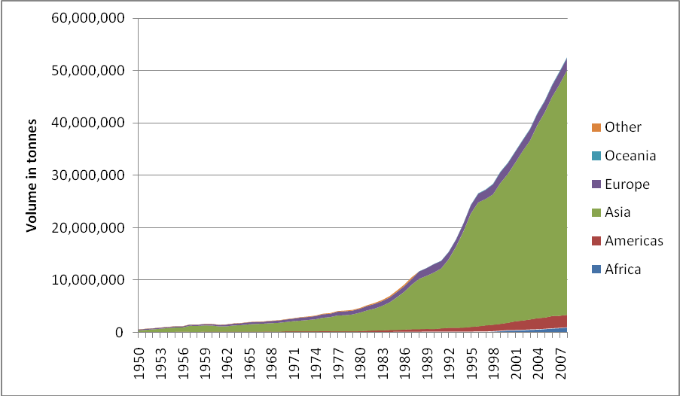
Source: FAO Fishstat

Africa’s aquaculture production is even less impressive. In 2008, total farmed production was 955,000 tonnes, of which Egypt alone accounted for 73%. By far the largest part of this production was freshwater fish.

Fig. 3.3: Africa’s aquaculture production
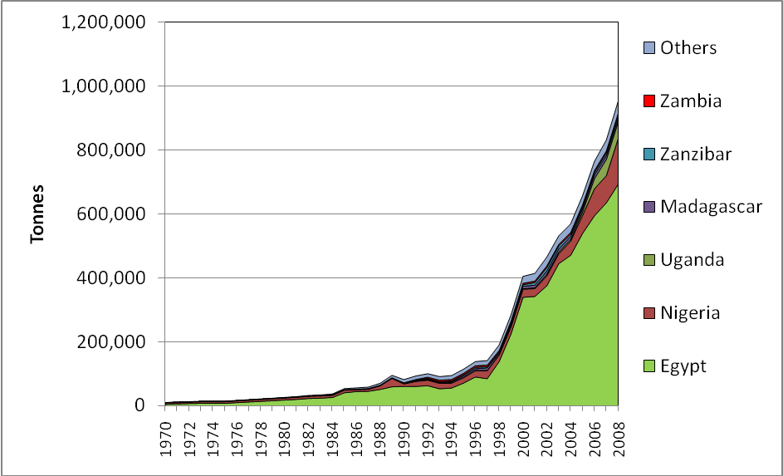
Source: FAO Fishstat

Fig. 3.4: Global exports of seafood by continent (Value in US$ 1000)
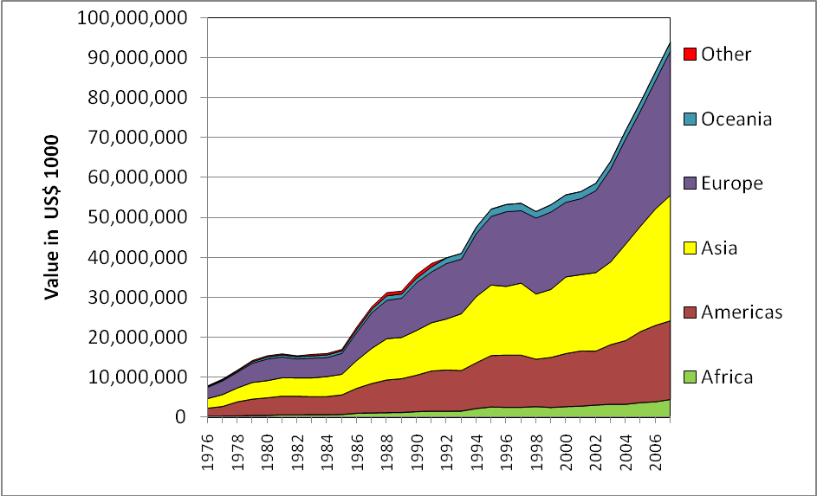
Source: FAO Fishstat

3.1. African seafood exports and imports
International trade with fishery commodities is an extremely important activity, and it is growing steadily. Total world imports of fish and fishery products in 2008 amounted to US$100 billion.
Africa accounts for a very small part of the total trade in seafood. In 2007, African exports of seafood amounted to US$ 4.5 billion, while African imports of seafood amounted to US$ 2.4 billion. In other words, Africa as a continent showed a “surplus” in its international trade with fish and fish products.
Fig. 3.5: African seafood exports and imports
Value in US$ million
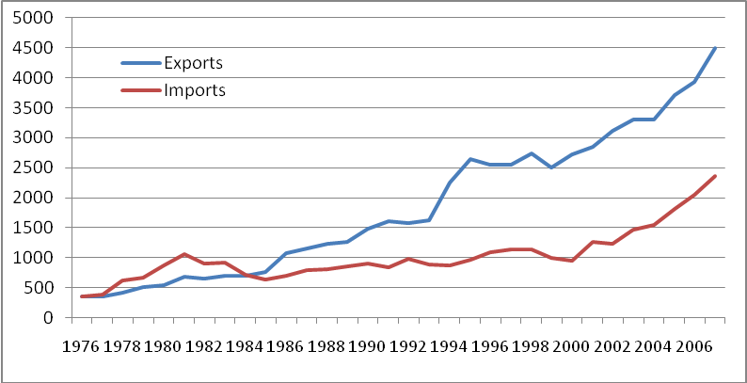
Source: FAO Fishstat
If we compare the export performance of Africa vs the rest of the world, we see that Africa was falling behind until 2000. However, since 2000 there has been strong growth in African seafood exports, and at the moment the growth in Africa is stronger than the world average.
Fig. 3.6: Seafood exports: Africa vs the rest of the world
Volume in US$ 1000
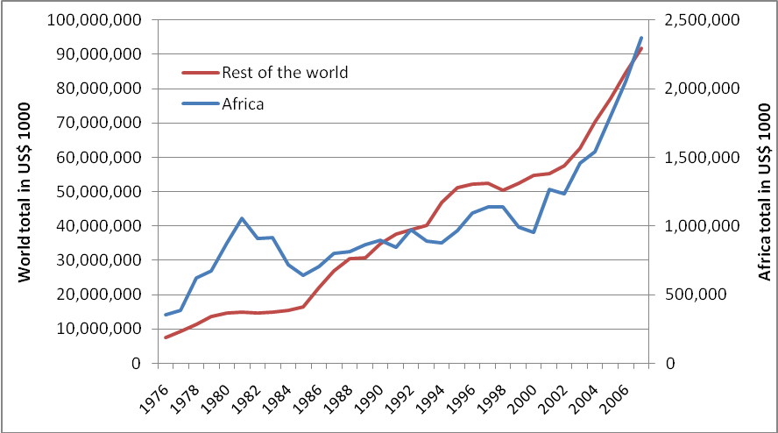

Fig. 3.7: African exports of fish and fish products
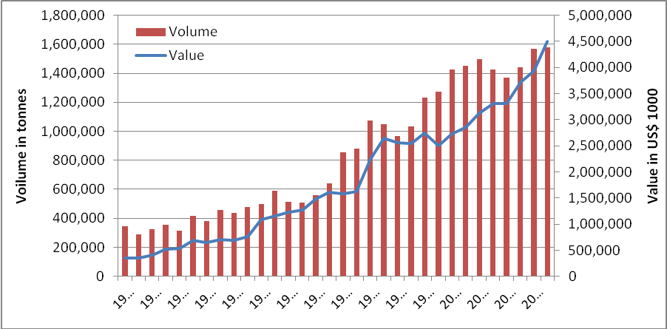
Source: FAO Fishstat

Table 3.2: Largest African fish exporters
Value in US$ 1000
Country | 2000 | 2001 | 2002 | 2003 | 2004 | 2005 | 2006 | 2007
Morocco | 976,427 | 874,408 | 964,134 | 1,014,499 | 831,813 | 1,094,479 | 1,266,340 | 1,410,329
South Africa | 272,550 | 284,536 | 321,485 | 395,004 | 419,420 | 444,585 | 406,069 | 512,968
Namibia | 283,931 | 330,327 | 291,749 | 332,362 | 362,484 | 376,924 | 458,531 | 485,570
Senegal | 260,354 | 251,884 | 224,874 | 282,866 | 316,178 | 251,700 | 194,503 | 313,495
Mauritius | 36,659 | 63,193 | 68,414 | 75,027 | 84,202 | 109,424 | 160,250 | 205,819
Seychelles | 113,465 | 122,150 | 162,733 | 210,869 | 180,167 | 191,901 | 199,423 | 197,763
Tunisia | 88,862 | 89,028 | 97,054 | 110,031 | 125,687 | 161,404 | 156,043 | 189,662
Madagascar | 38,075 | 127,809 | 152,828 | 86,152 | 73,499 | 132,840 | 162,275 | 186,358
Côte d'Ivoire | 128,876 | 107,679 | 140,481 | 140,902 | 159,478 | 103,059 | 125,080 | 171,924
Mauritania | 87,190 | 91,302 | 95,916 | 107,103 | 124,149 | 124,305 | 129,381 | 169,039
Others | 439,399 | 508,044 | 598,638 | 547,732 | 628,294 | 728,469 | 672,624 | 660,274
TOTAL | 2,725,788 | 2,850,360 | 3,118,306 | 3,302,547 | 3,305,371 | 3,719,090 | 3,930,519 | 4,503,201

By far the largest seafood exporter in Africa is Morocco, followed by South Africa and Namibia. While Morocco’s exports have been growing steadily over the past 10 years, the exports of South Africa and Namibia have been more stable.

Table 3.3: Largest African fish exporters
Volume in tonnes
Country | 2000 | 2001 | 2002 | 2003 | 2004 | 2005 | 2006 | 2007
Morocco | 330,744 | 373,164 | 354,842 | 334,953 | 276,397 | 356,035 | 427,263 | 408,700
Namibia | 411,198 | 342,132 | 363,830 | 341,711 | 335,287 | 287,797 | 431,174 | 351,383
South Africa | 162,359 | 155,941 | 168,678 | 183,462 | 142,601 | 177,045 | 142,551 | 144,072
Mauritania | 86,424 | 86,781 | 94,868 | 89,515 | 76,690 | 105,165 | 95,495 | 129,967
Senegal | 88,033 | 83,494 | 93,343 | 97,841 | 128,983 | 101,685 | 59,400 | 117,577
Tanzania | 49,843 | 55,678 | 54,997 | 59,415 | 61,495 | 58,794 | 47,367 | 62,836
Mauritius | 18,160 | 27,382 | 28,945 | 32,555 | 33,412 | 36,770 | 52,852 | 61,128
Côte d'Ivoire | 64,870 | 51,237 | 55,794 | 48,260 | 53,388 | 33,341 | 37,400 | 47,682
Seychelles | 48,427 | 51,944 | 50,515 | 47,582 | 40,004 | 50,423 | 46,961 | 40,869
Uganda | 14,911 | 17,318 | 25,534 | 8,051 | 31,958 | 39,324 | 36,935 | 31,986
Others | 152,866 | 203,565 | 204,390 | 181,901 | 191,261 | 195,252 | 190,137 | 181,843
TOTAL | 1,427,835 | 1,448,636 | 1,495,736 | 1,425,246 | 1,371,476 | 1,441,631 | 1,567,535 | 1,578,043
Source: FAO Fishstat

Main destinations

Because of the lack of reliable statistics, we do not have a full overview of where African seafood is exported. Therefore, we have to make some estimates based on the statistics we do know.
The largest exporters, Morocco, South Africa and Namibia, export most of their products to the EU. In the case of Namibia, as much as 80% of all seafood exports end up in the EU, with over 70% going directly to Spain.
Morocco is also heavily Europe-oriented, although part of its cephalopods exports are destined for Japan. South Africa exports over 50% to the EU, but have other main trading partners also. Approximately 9 – 12% goes to each of the countries, Japan, Australia and Asia. In later years, both South Africa and Namibia have made an effort to diversity their markets in order to reduce the dependability on the EU market.

Imports
Africa does import seafood, but on a very small scale. In 2007, African seafood exports amounted to almost US$ 2.4 billion, or about 2.4% of the world total. In terms of value, Africa’s foreign trade in fish products showed a healthy US$ 2.1 billion surplus.
Table 3.4: Global seafood imports by continent (Value in Million US$)
Country | 2000 | 2001 | 2002 | 2003 | 2004 | 2005 | 2006 | 2007
Africa | 957 | 1,264 | 1,233 | 1,460 | 1,538 | 1,805 | 2,053 | 2,369
Americas | 13,091 | 12,886 | 12,545 | 14,303 | 15,053 | 15,405 | 17,263 | 18,326
Asia | 24,429 | 22,636 | 23,663 | 23,017 | 26,887 | 28,245 | 29,053 | 30,095
Europe | 22,051 | 23,352 | 24,593 | 29,083 | 32,364 | 36,351 | 41,721 | 47,304
Oceania | 675 | 680 | 723 | 827 | 906 | 1,052 | 1,141 | 1,328
TOTAL | 61,204 | 60,819 | 62,757 | 68,690 | 76,749 | 82,859 | 91,231 | 99,423

Value addition in Africa
Value added production in Africa is lower than in the rest of the world. While African total production of fish (catches and landings plus aquaculture production) constitutes 5.7% of the global production, Africa’s share of fishery commodity production, i.e. processed products, amounts to only 4.3% of the world total. From Table 3.5, we see that African production of dried, salted and smoked fish constitutes a higher percentage of the total (8.3%) than for the other products.

Tab. 3.5: Global fishery commodity production: World vs Africa, 2007
Volume in tonnes
Commodity | World total | Africa | African share in %
Crustaceans and molluscs | 3,860,836 | 185,280 | 4.8%
Crustaceans and molluscs, prep or pres | 1,435,215 | - | -
Fish, dried, salted, or smoked | 5,054,596 | 419,112 | 8.3%
Fish, fresh, chilled or frozen | 23,614,262 | 882,387 | 3.7%
Fish, prepared or preserved | 6,989,215 | 334,932 | 4.8%
Meals | 5,621,712 | 168,071 | 3.0%
Oils | 1,011,886 | 32,986 | 3.3%
TOTAL | 47,587,722 | 2,022,768 | 4.3%

Scope for further value addition
In general, the level of value addition in African fisheries and aquaculture has been relatively low. This is partly because of the continent’s history as a colonial region whose main function, was to provide cheap raw materials for the colonial powers’ own industries at home. Consequently, practically all production was focused on raw material production and export.
This situation is reflected in the value of African seafood exports (Fig. 3.7). Although Fig. 3.7 shows an increase in exported unit value over the years, this may not be real, as the figures used to produce this graph are not adjusted for inflation. In order to obtain a truer picture, we must therefore compare the unit value of African exports with the rest of the world and with other regions (Fig. 3.8).
Fig. 3.8: Global exports of seafood: export unit price in US$ per kg
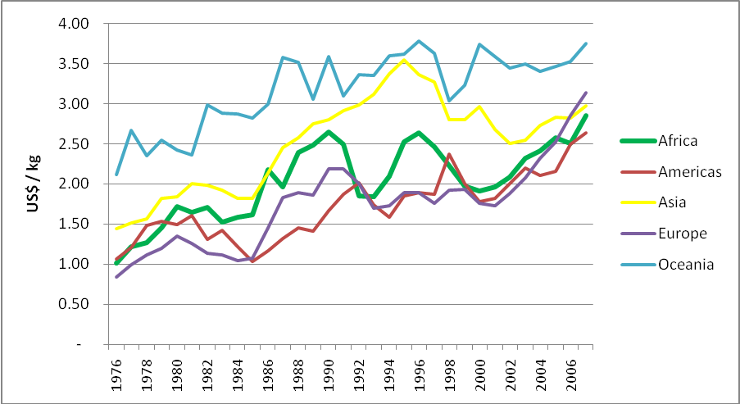
Source: FAO Fishstat

In recent years, there has been a lot of focus on this, and many governments in Africa have tried to stimulate the production of value added seafood in their countries. However, these efforts have been met with counter-measures on the part of the importing countries (EU, USA), amounting to complex import regulations which favour a raw materials trade rather than exports of value added products.

Studies where value chain analysis has been used

Through a relatively simple search on the Internet, we located a few studies that employ the value chain analysis approach on African fisheries. Common to all the studies are that they are all relatively recent, indicating that the use of this approach is a relatively new phenomenon.
The various studies differ in their presentation of methodology, although there are of course elements of close similarity in all of them. The studies also differ in their purpose and focus.

4.1. Revenue distribution through the seafood value chain

In 2006 the FAO published a study entitled “Revenue Distribution through the Seafood Value Chain”. The study was undertaken in order to generate more information on the fish trade of developing countries and to generate a better understanding of the disposition of income from fisheries in developed and developing markets. Thus, the study was primarily of a descriptive nature.
This study is perhaps the most interesting of the studies examined because it focuses on revenue generation and distribution within the value chain. However, the other studies, while focusing on different aspects, show that the value chain analysis approach is useful in a number of different cases with very different purposes.
The study applies value chain analysis to the study of revenue distribution to the various (and defined) “links” in the value chain:
Fig. 4.1: The value chain in fisheries

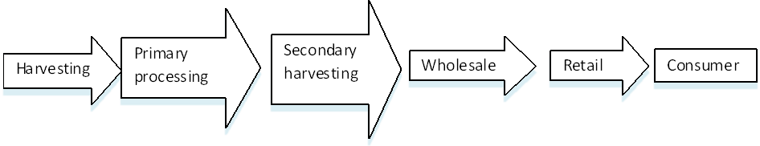
Source: Frank Asche et. al (2006)
Allocating the revenue to each defined link in the chain requires very detailed data, which is not always possible to obtain. It is especially difficult to get this at an aggregated level.
The study includes case studies on four different fisheries in four different countries. Two of these countries are in Europe (Iceland and Denmark) and two are in Africa (Tanzania and Morocco). These case studies are all systematically described in the same manner. The first step is to describe the marketing chain (product form) for the selected species. Most marketing chains have several different value chains, servicing different consumer markets. The criteria for selecting each value chain are based on the relative share of the product in the total production of each species, data availability and relevance to other case studies for comparison of results. Once the value chain has been selected individual components are identified and value added activities at each level are calculated. Finally the value chain is constructed from the value added activities at each level of the chain.
Data used in these case studies are mostly secondary data collected from official documents and Web resources. In some cases this data is supplemented by primary data collected at source in each country.
The value chains were shown to have similar characteristics to value chains for agricultural products where the primary sectors receive a relatively lower share of the retail value of highly processed products and a higher share in less processed and fresh products.
The study also revealed that the developing countries seemed to control a relatively lower share of the overall value chain than developed countries. An example is the Icelandic case where Icelandic owned companies control as much as 70 percent of the entire value-chain while Tanzanian and Moroccan companies controlled less than 50 percent.
This is perhaps the most important lesson to be learned. The Icelandic and Tanzanian fisheries produce very similar products, going into the same markets, or market segments, in Europe and the USA. The Icelandic export sector has been developing over the past 60 years and started with state monopolies on exports (or monopolized export licences), ending with completely free trade of seafood products in the early 1990s. This has been a long process for the Icelandic companies but it created strong export companies which strategically marketed their products under their own brand names.
The Danish companies in this study seemed to control a larger share of the value chain than their Moroccan counterparts, but this did not ensure profitability of the harvesting sector. The European Union has been struggling with its fisheries policy for decades. Overfishing caused by too large fishing fleets has forced cuts in quotas, making it difficult for fishing companies to survive financially. Control of the seafood value chain does not necessarily guarantee good livelihoods for fishermen or fishing companies.
The study clearly shows that good fisheries management is a necessity in order to allow fishermen to reap the benefits from higher export prices. Without proper management in place increased prices can lead to increased fishing pressures and hence threaten the sustainability of the resource and profitability of the fishing companies. This was also shown in the Icelandic and Moroccan fisheries where in both cases good management practices are in place, limiting the total catch to sustainable levels. Price changes then do not threaten the resource but simply have a direct impact on the income fishermen receive. In Morocco increased prices force the processors to import anchovies from other countries but when prices drop they buy only from domestic sources.
This shows how international trade can actually help in relieving the pressure on fishing grounds when prices become very high due to increased demand or if catches decline through natural fluctuations. Fishing is based on a natural resource which can fluctuate dramatically over time. International trade helps seafood companies in diversifying these risks by opening up access to different sources of raw material. This again helps stabilize markets and increased stability helps in operating seafood businesses.

Lake Victoria Nile perch fishery, Tanzania

One of the studies included in FAO’s report focuses on the Nile perch fishery in the Tanzanian part of Lake Victoria.
Lake Victoria is the second largest lake in the world after Lake Superior in North America. It is shared by three East African countries: United Republic of Tanzania (51 percent), Uganda (43 percent) and Kenya (6 percent). It is estimated that the lake has a catchment area of about 194 200 km2. The lake provides all the basic resources for the population in the area such as food and water as well as means for trade and transport linking the three riparian states. It forms a natural, social, geographical and political bridge linking the three countries.
The lake supports the most important fisheries in East Africa owing to its diversity, nutritional and economic values. It is the most productive inland fishery in the world; an introduced species, Nile perch (Lates niloticus), holding the leadership in abundance and socio-economic value. Other fish in order of importance are the native, sardine-like dagaa (Rastrineobola argentea); and the Nile tilapia (Oreochromis niloticus), which was also introduced to the lake’s ecosystem.
During the late 1970s Nile perch contributed only 2 percent of the lake’s fisheries, while Haplochromis contributed about 80 percent and the remainder was other mixed species. The Nile perch population exploded and became the dominant population in the lake by mid-1980, followed by a rapid decrease or disappearance of other native species.
As Nile perch increased it consumed a good proportion of the indigenous fish species, which then formed a relatively good source of income and cheap protein for the local population. Being an exotic fish species, Nile perch was not well accepted initially by the local consumers and this triggered an outcry by the local population that Nile perch was a menace that should be eliminated from the lake. However, this was no longer a feasible approach since elimination of Nile perch at this stage would have had a further adverse impact on the whole ecosystem.
In the early 1990s investment began for the exploitation of the Nile perch stock on the Tanzanian side of the lake, resulting in the establishment of a number of Nile perch processing plants. Its abundance has led to the development of several important export-oriented Nile perch fish processing establishments in the riparian regions of Kagera, Mara and Mwanza; as well as the processing of by-products for local and regional markets. The main products are frozen and fresh/chilled fillets as well as headed and gutted fish and more recently skins, which are exported to various overseas markets.
Trimmings and carcasses are processed locally for local consumers and the regional markets of Congo DR, Rwanda and Burundi. In general, the Nile perch industry provides direct and indirect benefits to more than 2,000,000 individuals (i.e. fishers/processors/traders and service providers).
The structure of the marketing chain for Nile perch in the Tanzanian economy is shown in Figure 4.2. Harvesting is primarily based on artisanal fisheries from canoes, using either sails or outboard motors. Fishermen own their own boat or operate boats owned by a processing plant or a fish collector. Often the fishermen are obliged to land at a specific processing plant or a fish collector due to loan contracts. These contracts are on a barter level, i.e. a fisherman is provided with an outboard motor or net but a certain percentage of the future catch is retained as a payment for the motor or net.
Fig. 4.2: The marketing chain for Nile perch in Tanzania

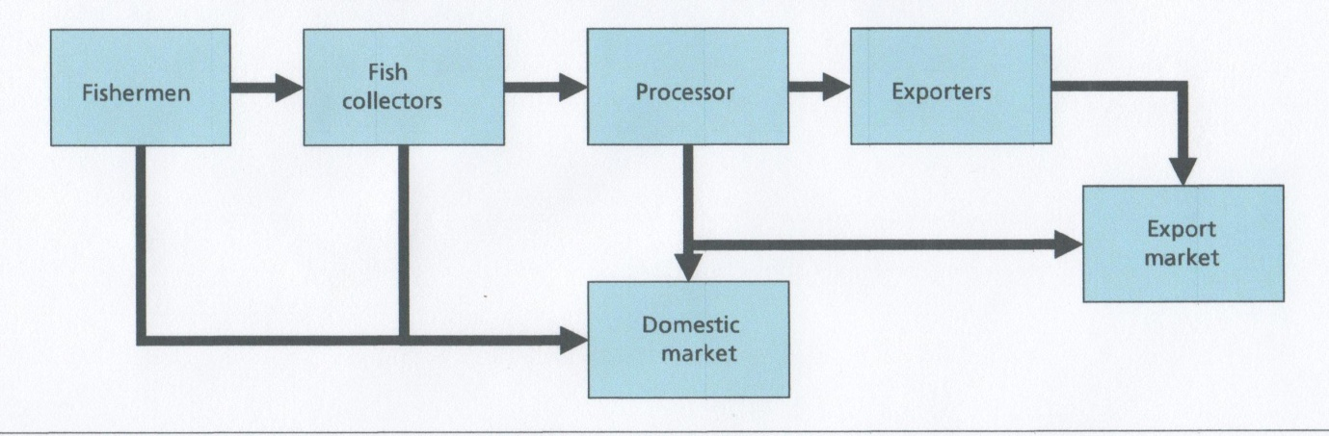

Nile perch fish processors are of two categories; artisanal and industrial processors. The artisanal fish processors aim exclusively at the internal and regional market while the industrial processors are geared for the export markets, the main markets being the European Union, Japan, USA, Israel and Australia. What is rejected by the processing plants for export is sold to the domestic/regional market in various product forms, including fresh, smoked and salted.
The processing plants primarily produce fresh and frozen fillets. These fillets are exported directly, or through export brokers, to foreign markets. Nile perch exports account for about 15 percent by value of Tanzania exports and the European Union market absorbs about 60 percent of Nile perch fillets exports. Since the European market is the most important for Tanzania it was decided to make a detailed examination of the value chain for Nile Perch fillets exported to the European Union.

The value chain
The value chain for the Tanzanian Lake Victoria Nile perch fishery, exported to the European Union, is split into five different segments; fishing, fish buyers/collectors (on shore collectors), processors, exporters and the EU retail market, as shown in Figure 16.
Fig. 4.3: The value chain for Lake Victoria Nile perch from Tanzania

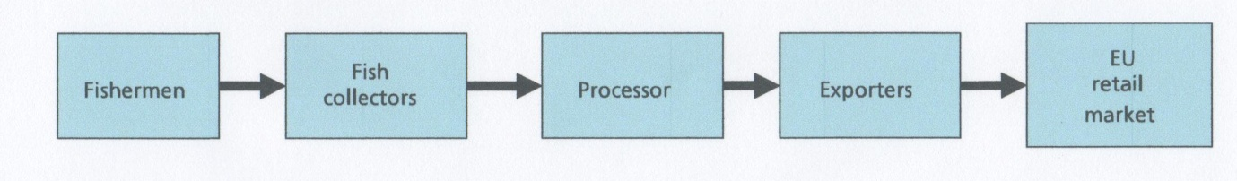

Mechanized industrial fishing was prohibited in 1994. Fishers with little capital use canoes (planked and/or dug-out) that are propelled by paddles and sails and only a few relatively rich fishers utilize outboard engines. Use of outboard engines has made it possible for poor fishers to reach distant fishing grounds as their fishing boats are towed by a mother fishing boat under a special arrangement whereby the engine owner is paid a fee for towing a fleet of canoes to and from the fishing grounds. Gillnets and long lines are the major fishing gears for catching Nile perch for export purposes.
The second group of fishers is that with all modern facilities for commercial small scale fishing. Such fishers have boats with hygienic fish holds and are powered by engines. On average such boats can carry up to five tonnes.
The standard practice for processing Nile perch is to land the fish at one of many landing stations dotted along the lake’s shoreline and on the numerous islands in the lake. It is also collected directly from fishers by collector boats at the fishing grounds and ferried directly to the fish processing plants without passing through the landing sites.
The fish processing establishment forms the third segment in the flow diagram. This segment receives all fish (raw material) collected from segments 1 and 2. The segment is also important as it is the main source for raw materials used in preparing products intended for local and regional markets. The raw materials for these two segments come from the fish rejected by the exporter as being of poor quality, by-products or illegally caught fish seized by the authorities and later sold as low grade fish.
The final market segment is the export market. Usually, fish is sold in bulk to EU importers. They in turn sell the fish to wholesalers, supermarkets, processors, etc. The fillets are also re-exported straight away (with the same or different identity). There are companies or consignors based in the European Union that are major importers of Nile perch fillets and trade the same product to other destinations such as USA, Australia and South America. Fillets are also sold to factories for further processing.
The annual average ex-vessel price for Nile perch from 1994 to year 2003 is shown in Figure 4.4.
Fig. 4.4: Average landing values for Tanzanian Nile perch

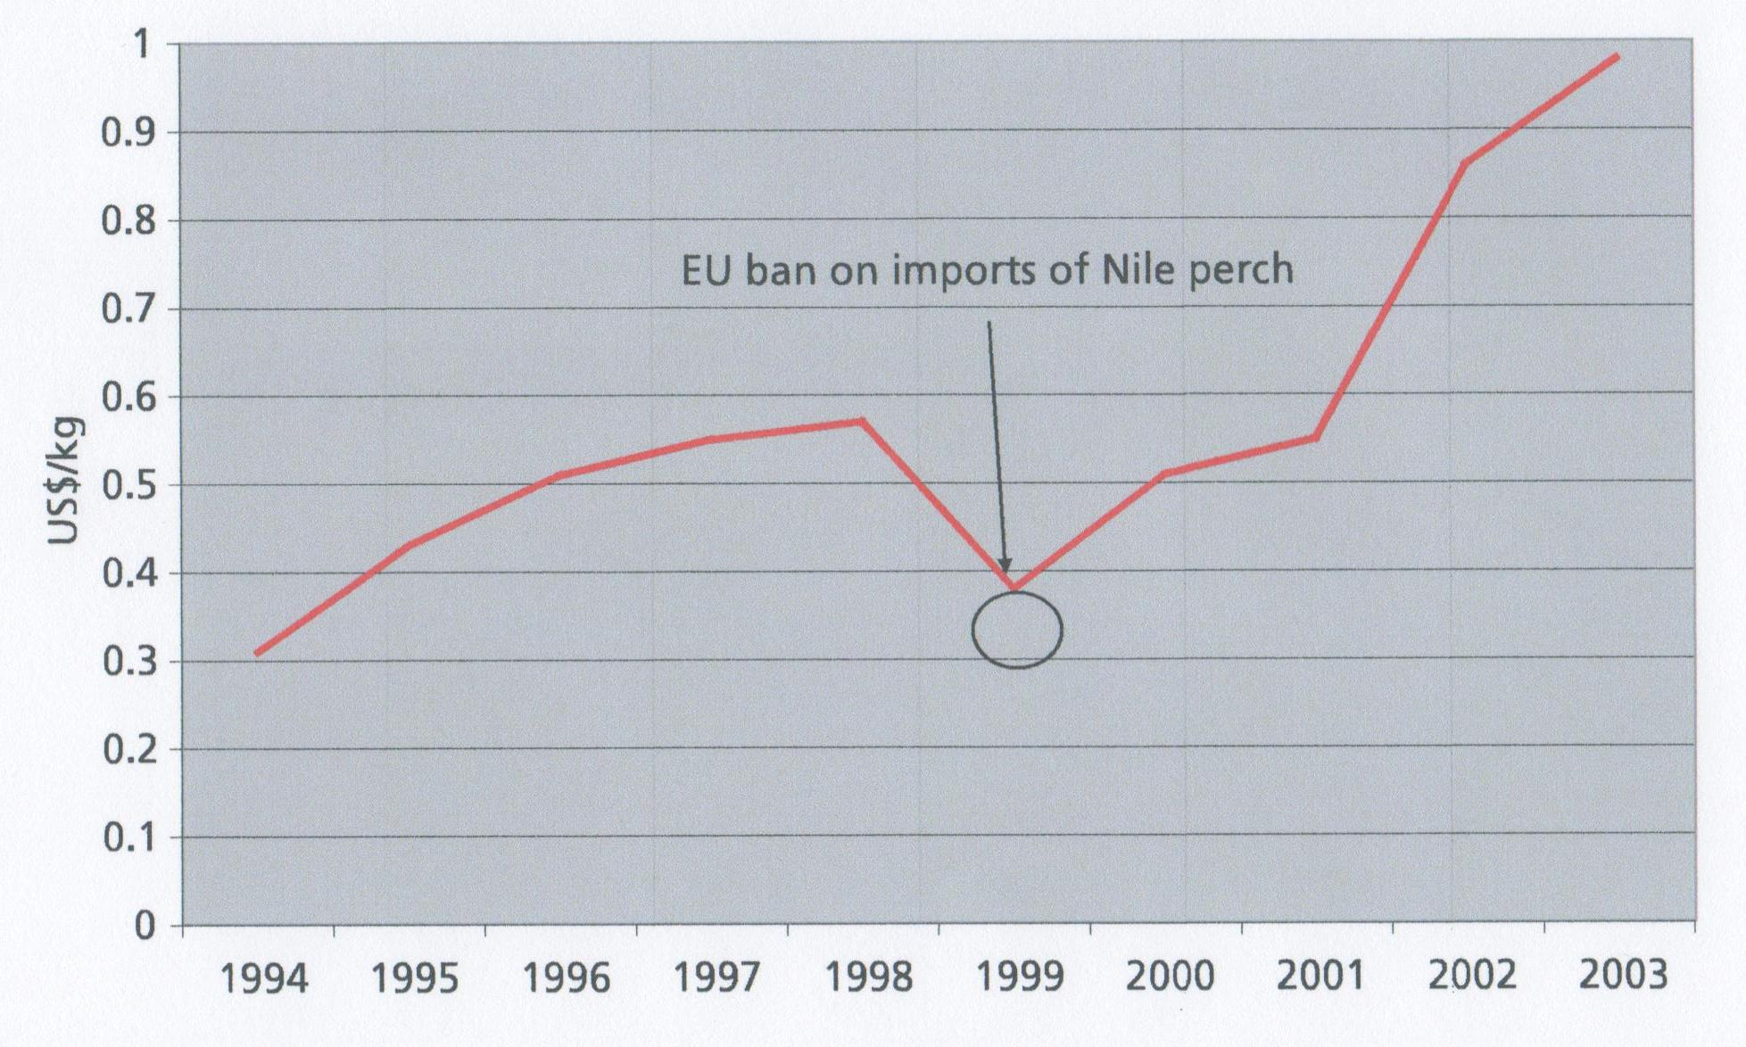
In almost all cases, respondents informed interviewers that the price for Nile perch at the landing station or at beach level is not determined by fishers but by collectors who are directly influenced by the processing plants. Factors such as transportation costs, availability of transportation vessel or vehicles at the time of landing will automatically influence the prices at this level. Independent fishers can have their day when there is a shortage of fish while “contract” fishers’ work at the prices agreed. The growth of an individual fisher’s operation is constrained by the fact that they have no preservation facilities and therefore any delay in sale would result in low quality fish, which means lower prices.
Figure 4.4 shows a progressive increase in Nile perch prices at the landing sites, except for 1999 when the European Union imposed a ban on imports of Nile perch products from the Lake Victoria region due to a cholera outbreak. The ban resulted in significant economic losses to the population of the three riparian countries of Lake Victoria.
In the last three years covered by the study prices have abruptly gone up because of a decline in landed quantities of Nile perch. This might be due to over exploitation of the resource leading to shortage of supply of raw materials. A fisher is now forced by circumstances to invest more in terms of fishing effort and has to fish in distant places compared to the end of the 1990s. The national fishers survey for 2002 shows a substantial increase in the fishing effort, but at the end of a day a fisher comes back home with less Nile perch than before. That means that Nile perch harvesting costs are higher compared to past years.
The average prices in US$ paid to fisherman by collectors, and to collectors by processing plants is shown in Figure 4.5. The shaded areas show the net price for each market segment. Increased demand from the EU has obviously resulted in increased prices at these levels though the price increase has not been symmetrical.
Fig 4.5: Prices paid at ex-vessel level and the factory gate

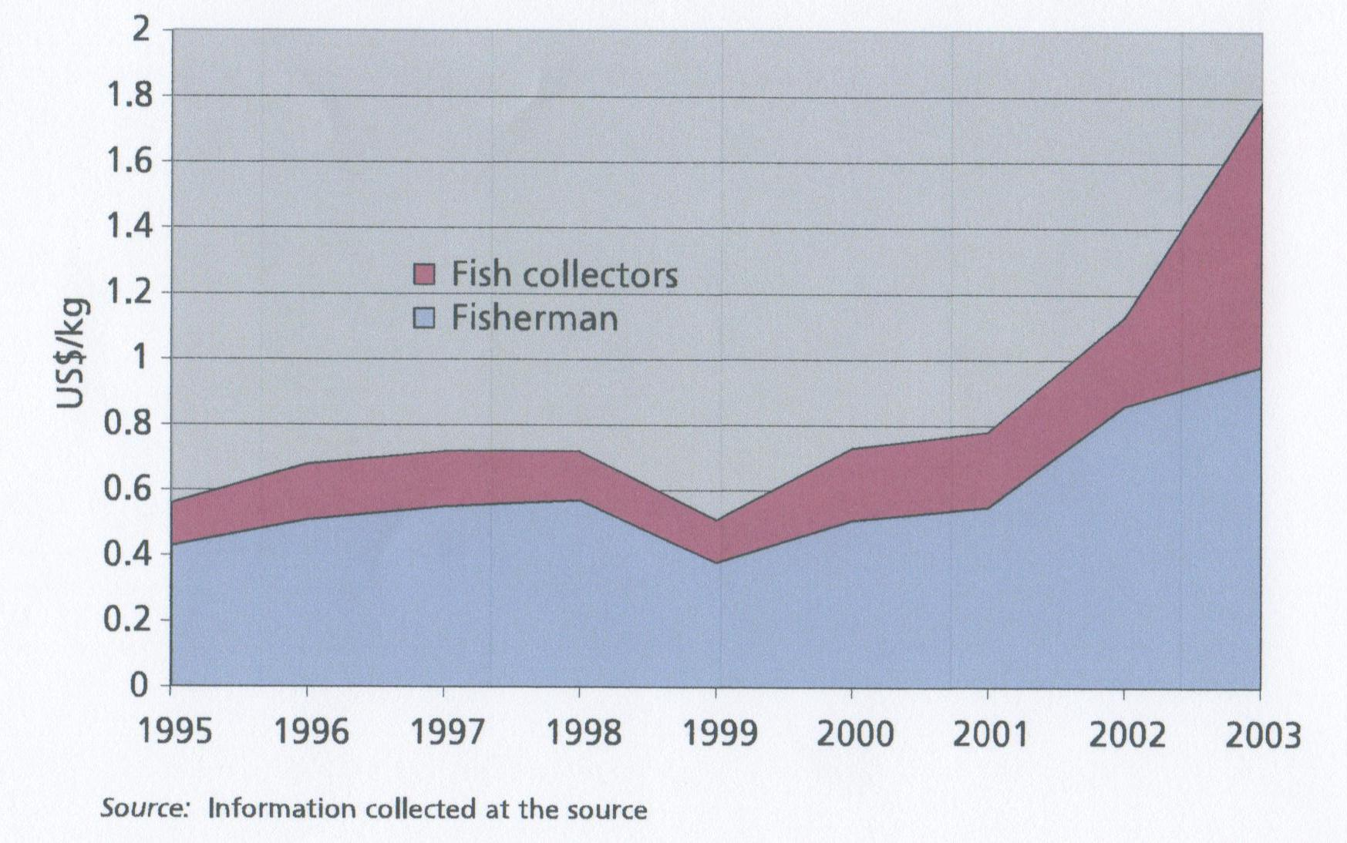

Other factors such as raw materials, cost of packaging materials, salaries and other running costs (electricity, taxes etc.) are not shown on the graph; hence it only shows net revenues but not cost of harvesting, transporting and handling.
The export market will determine the type of product traded and this reflects the final price to the consumer. Higher orders of fresh chilled Nile perch fillets by a buyer from the EU market will drive an exporter to increase his bid price in acquiring raw materials so that the order is filled in the shortest possible time. Such instances result in intense competition resulting in price increase which benefits the collecting agent but not necessarily the fisher. Figure 4.5 shows this situation towards the end of 2003. Prices increase both at the fishing and fish collecting levels, but the increase at the fish collecting level is relatively higher than at the fishers’ level.
In 1996 the government imposed a minimum export price to be reported for all exports. This was due to systematic under-reporting of prices by the fish processors and other exporters of Nile perch from the United Republic of Tanzania. This minimum export price was lowered in 2000 after the market collapse because of the cholera scare in 1999. Fish collectors have increased their share in the past few years but fishers still get a higher share than the collectors. From the fishers revenues one must subtract cost of harvesting, including nets, capital costs for investments, wages, etc. Unfortunately this information was not available. However, it has been noted that increased pressure on the Nile perch fish stocks has lead to increased effort per kilgram of harvest. This simply means that fishermen must work harder for each kilogram of fish harvested.
Fig. 4.6: Prices at the processing level

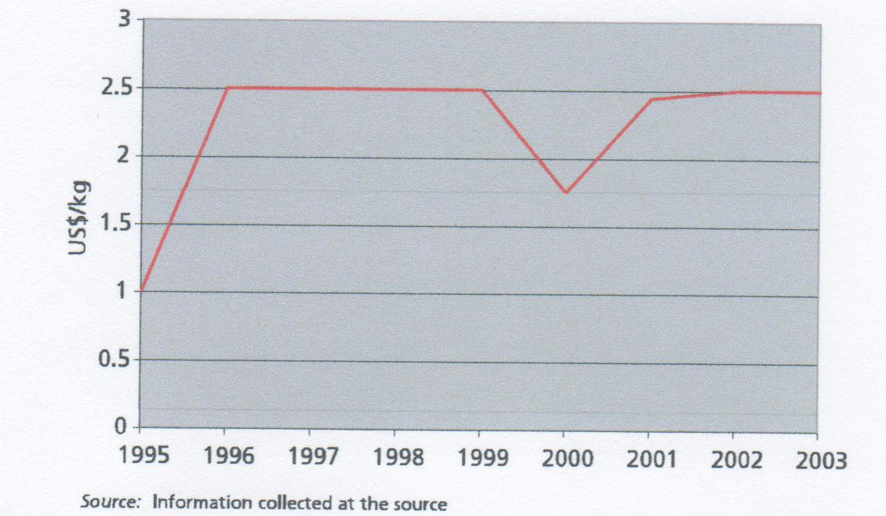

Fig. 4.7: Import value (US$/kg)

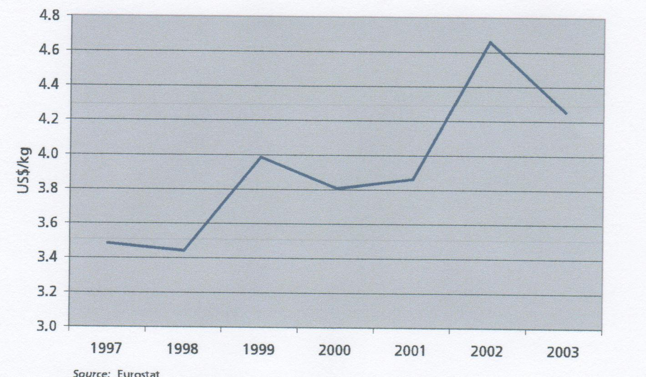

Figure 4.7 shows average values for fresh and frozen fillets imported by the EU. Import prices have risen over the past seven years, reflecting increased demand for, and less supply, of Nile perch in the EU. Though this price increase has not been reflected in the export prices from the Tanzania it has obviously been reflected in the increase in prices to fish collectors and fishers, as shown in Figure 4.5. The price increase is therefore transferred through the entire value chain.
In order to look at the distribution of value through the value chain the year 2001 was selected. The biggest challenge was to establish a retail price for Nile perch. Retail values are difficult to obtain but a retail value of between US$11 and US$12 per kilogram of fillet was estimated in 2002.
Hence in this study a retail value of US$10 was selected as the price for a kilogram of fresh fillet sold at the retail level in EU in 2001. It is emphasized that this is a rough estimate of the true retail value. When the retail price has been established one simply subtracts the import value to find the value added at the retail level, and then subtracts the export value from Tanzania from the import value in order to find the value added at the import level.
The value added at the processing level is shown with the value added at the import level due to problems with reporting of export prices in the country, as mentioned earlier. Value added at the collector level is the fish purchased by the processors minus the cost of raw material.
The raw material is the harvest by the fisherman. In order to make one kilogram of fillets one needs 2.8 kilograms of raw material, assuming a yield ratio of 35 percent. Since only 35 percent of the fish is used to make the fillet 65 percent is left as by-products. In Tanzania most of these by-products are sold on local and regional markets. Hence, the price of the raw material should be split proportionally between the main product (fillets) and the by-products (offcuts, skeleton, head, etc.). This is however rather problematic and complicates the analysis considerably. One can also argue that the cost of raw material for the by-products is almost zero, since the processor would simply throw the by-products away if there was no market for them. If there is no market for the fillet it would simply mean that there is no market for the fish at all. Hence in this analysis the price of the whole fish is considered to be the cost of the raw material for producing fish fillets from Nile perch.
In order to make one kilogram of fillet the processor needs to buy 2.8 kilograms of fish. The revenue received by the collectors and fisherman is therefore the value of 2.8 kilograms rather than price/kg as is usually reported. Unfortunately individual cost categories are not available for each segment of the value added chain, but the major categories are known. Hence Figure 21 shows the percentage of value addition at each segment in the value chain, with references to the major cost categories at each level.
Figure 4.8 shows that fishers obtain about 15 percent of the value of the retail price for Nile perch while fish collectors obtain about 5 percent of the retail value. The processing and export sector in Tanzania obtain between 10 and 15 percent of the retail value and the processor and EU importers (which might be the Tanzanian exporter) receive a combined about 20 percent of the retail value. The retailer receives about 60 percent of the retail value. The 15 percent received by the fishermen is similar to the average 19 percent received by the US farmer for his products, and is also similar to the percentage share the Icelandic fisherman receives for a cod fillet.
Fig. 4.8: Value added for one kilogram of Nile perch fillet in the Tanzanian Nile perch fishery

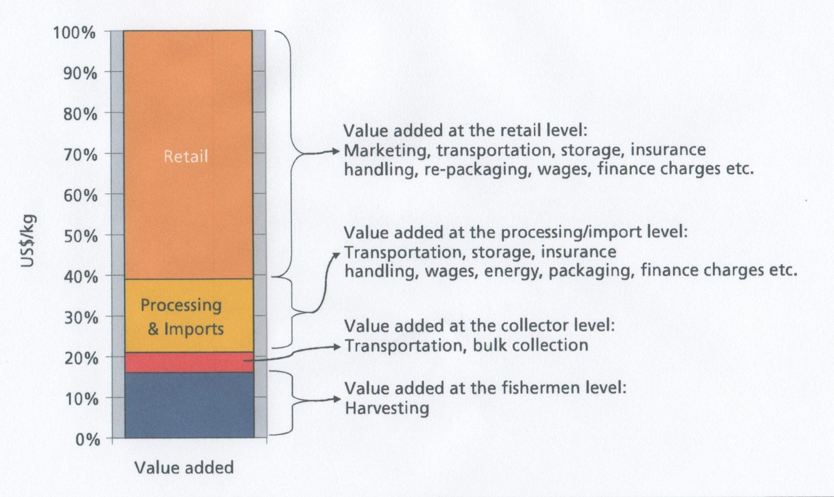

Data collected at collector and factory level in Tanzania indicate that several changes have occurred in the cost of producing Nile perch fillet in Tanzania. Notably labour costs have increased over the years but transportation costs have declined due to better roads and other infrastructure. Transportation costs are still a big part of the domestic and export value added, though. Transportation cost pr. kg. of fillet is as high as US$1.50 from Tanzania to the EU, and higher to the USA and Asian markets. Domestic transportation costs might be as high as 20 to 25 percent of the value added at the collector and processing levels.
The above analysis has shown that the value chain for Nile perch fillets from the United Republic of Tanzania to the EU has a similar structure to other value chains for fisheries and agricultural products. Fishermen are receiving higher prices due to increased demand, but the price increase is not perfectly symmetric between market segments, indicating that price formation could be improved through better distribution of information. Higher prices should mean higher revenues for Tanzanian fishers and hence they should be better off. However, this does not have to be the case and reports of decreased landings and increased effort on behalf of the fishers is an indicator that higher prices are starting to have adverse effects on the Nile perch fish stock in Lake Victoria. In order for the Tanzanians to enjoy the benefit of higher prices it is necessary to implement a sustainable fisheries management system.
Tanzanian fishers cannot expect to obtain a much higher percentage in the value chain compared to other value chains. The marketing system of Nile perch seems to be fairly efficient in distributing the products from Tanzania to the marketplace. However, high transportation costs due to lack of infrastructure make the system relatively expensive. The system also seems to be very ad-hoc as short term fluctuations in demand and supply can cause considerable (and often local) price fluctuations. This increases uncertainty and makes it more difficult for businesses to engage in long term arrangements with wholesalers and retailers.
Regulated minimum export prices also make it difficult to estimate the share which Tanzania receives in the entire value chain, but it seems that Tanzanian fishing industries control a smaller part of the value chain than for example Icelandic companies. This makes it more difficult for Tanzania to compete on the globalized world market for white fish fillets.
The analysis above also shows that there is considerable room for improving efficiency and profitability in the Tanzanian fisheries by improving infrastructure, establishing a fisheries management system (which controls total allowable catch) and by assisting Tanzanian fish traders to gain control over a bigger portion of the value chain, through collective efforts and improved business strategies.

Pelagic fishery in Morocco

The other study concerning Africa included in the FAO report focuses on the Moroccan anchovy fishery, which shows a quite different value chain.
The Kingdom of Morocco has a 3,500 km coastline extending along the Mediterranean in the north to the Canary Islands on the Atlantic coast in the south. This corresponds to an EEZ of 1.1 million km². Morocco is the top fish producer in Africa and ranked as the 21st largest producer in the world in 2000. According to official information the exploitable aquatic resources of Morocco can be estimated at between 1.5 and 2.5 million tonnes annually, with a value of US$1 billion.
Fishing in Morocco can be categorized into three major fisheries; coastal, artisanal and industrial. In total more than 21,000 vessels participate in these three fisheries of which the artisanal fleet has the greatest in number of vessels (18,000) but the industrial fleet is largest in GRT (146,000 GRT). The coastal and artisanal vessels fish in the coastal areas but the industrial vessels fish in deep sea waters within the Moroccan EEZ.
The artisanal fleet consists of 18,000 vessels scattered along the entire coast, though the biggest concentrations are on the south part of the Atlantic coast. They have outboard engines and usually a crew of two to three. These are day-fishers that land their catch fresh.
There are four different types of boats used in the coastal fleet; purse seiners, bottom trawlers, longliners and mixed gear boats. In 1999 there were 2,523 vessels with a total 76,761 GRT (an average size of 30 GRT). However, these vessels differ greatly in numbers, length and GRT. In 1998 this fleet segment consisted of 428 trawlers, 397 purse seiners, 971 long-liners, 587 multipurpose vessels and 103 other fishing vessels. The majority of these boats makes 150 to 250 fishing trips per year and contributes about 70 percent of total catches. In 2002 the coastal fleet landed 770,000 metric tons, valued at EUR 208 million, with pelagic species (mostly sardines and anchovies) being the mainstay of the catch. Most purse seiners harvest both anchovies and sardines.
The industrial fleet had 454 vessels in 1998, totalling 146,000 GRT (an average size of 321 GRT). In some cases these vessels have freezing capacity and can stay out fishing for several days or weeks. This fishery harvests the most valuable species, including several mollusc species, whitefish and shrimp. In 2002 the industrial fleet caught 134,000 tonnes, valued at US$460 million, by far the most important category measured in terms of value.
In terms of volume the sardine is the most important species accounting for 60 to 75 percent of the annual catch between 1997 and 2002. Anchovies are the second most important species for the coastal fleet, with a total of 40,220 tonnes in 1999, valued at MDH 79.39 million, or US$7.7 million.
Fish caught on the Moroccan coasts is sold at the central fish market, fish landing sites or through the certifying counter for fish destined for further processing into canned fish or by-products (fishmeal or fish oil). This counter is called “Comptoir d’agréage du poisson industriel” or CAPI.
Wholesalers and retailers are the main agents involved in fresh fish distribution and trade. This study is mostly concerned with value added products from Morocco. Semi-processed anchovies are the most important of these and this product also has the major part of the total market share of similar products in the USA and several European countries. Though there is no specific anchovy fishing fleet, the majority of the anchovies are caught by the coastal fishing fleet (purse seiners) and the artisanal fleet targeting sardine. Hence, information for the purse seiners and information about anchovy processing was used for this study.
Anchovy is a small pelagic fish which can be marketed fresh, frozen, dried, smoked, salted and/or canned and is destined for human consumption. It can also be processed as fishmeal and fish oil for animal feed.
Similar to other small pelagic fish, anchovy is handled and transported in fish boxes with or without ice both for processing and marketing for human consumption. More recently, some fishing boats have introduced tanks using refrigerated sea water or chilled sea water to preserve the fish until landing.
The most common way of processing anchovies is by packing the salted fillets in oil, mainly olive oil. The traditional three-piece can has been replaced by new easy open cans of 48 g to 800 g. The other popular packaging medium for salted anchovies is glass containers.

4.3.1. The value chain
There are several value chains for anchovy products, based on product form and the final market for consumption. In terms of country of destination: 35 percent of anchovy exports go to France, 24 percent to Italy and 16 percent to the United States. The market share of Moroccan anchovies in the US semi-processed anchovy market is close to 50 percent (based on trade statistics from 2000) and hence the US market is an important market for Moroccan producers. Due to ease of data collection from US trade statistics and the fact that the US market is a major market for Moroccan anchovy processors the value chain for semi-processed anchovies produced for that market was selected as the objective of this study. The value chain for this market is shown in Figure 4.9.
Fig. 4.9: The value chain for exports of Moroccan anchovy

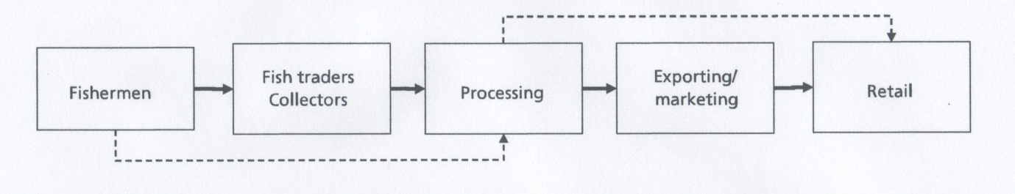

The fishermen land their catch either directly at the processing plants, through CAPI offices or to a fish trader who buys on behalf of the processing companies. The processing companies for semi-processed anchovies are concentrated in the middle part of the country with 10 out of 25 factories situated in Agadir. Some of the processing firms produce and export under their own label while others produce for specific marketing companies.
In Morocco both the coastal fleet and the artisanal fleet harvest anchovies which are used for salted products subsequently exported to the EU, Japan and the USA. The bulk of the catch comes from the coastal fleet: up to 85 percent of the pelagic catch.
The focus here is therefore on purse seine vessels in the coastal fleet. In order to estimate operating costs for these vessels a survey of 15 vessels in this category was conducted. The vessels have a crew of 24 to 35 fishermen, depending on size and technology used on board. Looking at the expense side of the operation Figure 4.10 shows that crew share and other wage related costs (wage taxes, social security, etc.) account for 39 percent of total revenue of this fleet. Fuel accounts for 9 percent and fishing gear and maintenance account for 6 percent.
Fixed costs and other non-categorized costs make up 24 percent of total revenue, a figure that includes insurance costs, taxes (other than income tax) and fees, various rental charges, auction charges etc. The operating margin comes to 22 percent of total revenue. The operating margin is used to pay for depreciation of equipment, capital costs, income tax and dividend to owners.

Fig. 4.10: Share of individual cost items for Moroccan purse seine fishery

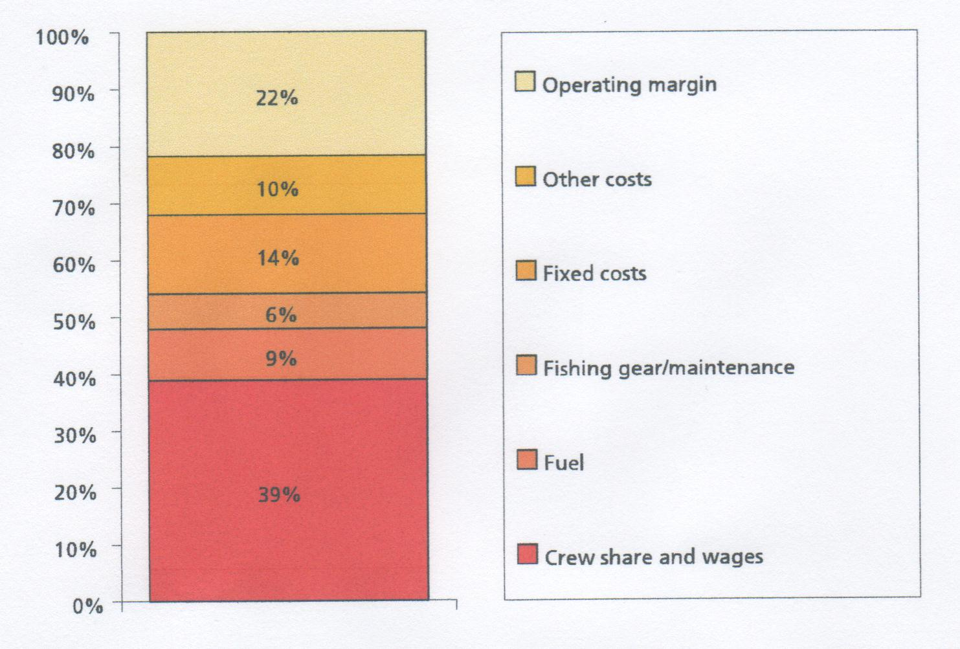

In 2000 Moroccan fishermen harvested close to 40,000 tonnes of anchovy which 25 factories used to make about 12,000 tonnes of semi-preserved anchovies in various product forms. The two main product forms are salted and cured in olive oil. Both processing methods take several months and require substantial manual labour and know-how. In Morocco this know-how has evolved over the past 80 years, making many of the Moroccan anchovy products well known, with big market shares for this specific product, both in the USA and in Europe. In order to estimate the production cost for semi-preserved products figures were obtained from the annual operating costs of a medium sized processing facility using 1,500 tonnes of anchovies per year. Given that this is a representative company rather than information based on the average values for several firms the numbers in Fig. 4.10 must be seen as a crude approximation of overall production costs in the anchovy industry.
The cost of raw material represents more than 57 percent of total revenues while wages take only 10 percent. The raw materials are anchovies and other fish used in the process, oil and salt. Energy, packaging and transportation and other costs account for 3 percent of the total costs. The operating margin of 30 percent is quite high but there may be two explanations for that. First in the data collected no fixed costs were included and hence the fixed costs must be a part of the operating margin. Also the processing method takes several months which means that it ties up operating capital.
Fig. 4.11: Relative processing costs for Moroccan anchovy

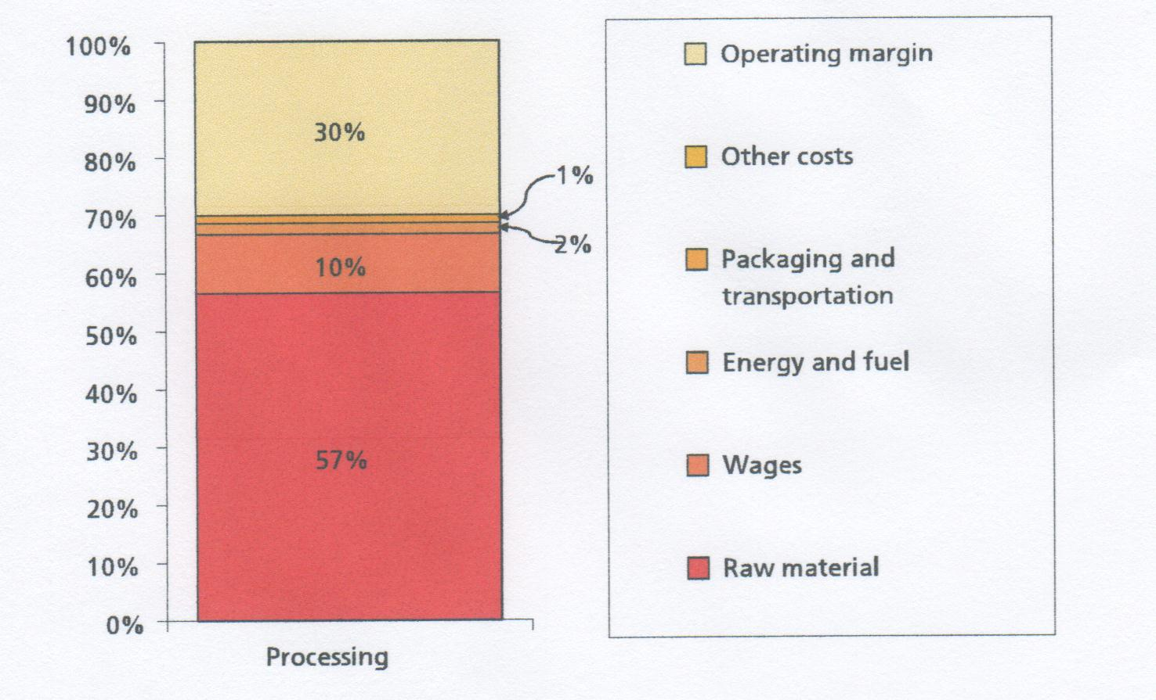

Fig. 4.12: The export value chain for Moroccan anchovies exported to the USA in 2000

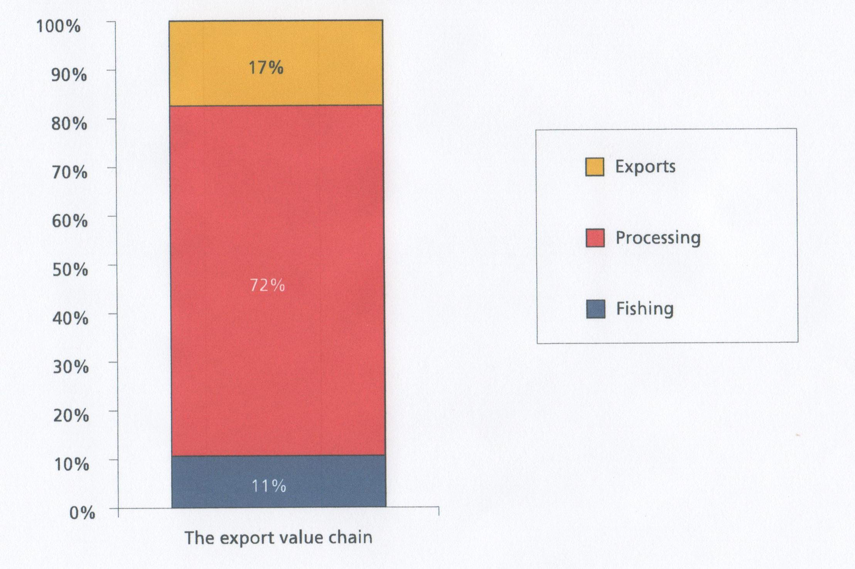

Capital costs might therefore be high for this industry. Unfortunately it was not possible to verify these hypotheses due to lack of data. It is interesting to note that despite substantial price decreases in landed value of anchovies they still account for as much as 40 percent of the total production costs, while oil and salt account for 19 percent combined. The average wholesale value at the factory gates for processed anchovy was DHM 52.2 per kg or equivalent to US$4.91 in the year 2000.
It proved difficult to obtain a reliable estimate of anchovy prices at the retail level in the USA. Estimates ranged from US$10 to US$39/kg. Since average retail prices and volumes were not known it was decided to use only the import values to estimate the value chain for Moroccan anchovies imported to the United States. In 2000 the average import value for whole anchovy fillets cured in olive oil was US$5.95/kg, and had decreased by 21 percent from its high of US$7.46 in 1998.
Figure 4.12 shows only a part of the value chain: that part which represents the export value chain from fishing to importing the product into the USA. This indicates that the value chain for Moroccan anchovies follows a similar pattern to other highly processed food products, such as canned tomatoes, corn flakes and corn syrup. This is not surprising since the processing is complicated and requires several ingredients and time before it matures as semi-preserved anchovy fillets.
This is however only part of the value chain because in order to complete the picture information on retail prices is needed. A website advertised Moroccan anchovy fillets in oil for US$39/kg in 2004 but in April 2004 a similar product sold for US$11/kg in Rome, Italy and a household consumption survey done in 2001 in Italy calculated average prices paid for anchovies as US$19/kg.
Assuming that prices have not changed considerably since 2000, and assuming that there have not been substantial changes in the cost categories over the same time period it would be possible to construct the value chain for Moroccan anchovies exported to Italy. Though these calculations are based on strong assumptions the value chain for Moroccan anchovies sold in Italy is shown in tFigure 4.13. This is done to show how it could look, but it is emphasized that the Moroccan data needs to be updated in order to make this more realistic.
Fig. 4.13: The value chain for Moroccan anchovies sold in Italy

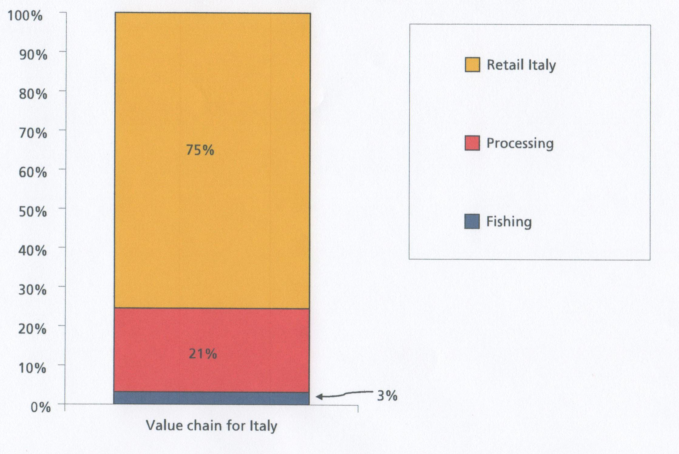

Figure 4.13 shows that 75 percent of the added value occurs within the retail sector, 21 percent within the processing sector and 3 percent within the fishing sector, reflecting a value chain for a highly processed product.
The analysis shows that the fish stocks are stable providing a relatively stable supply of anchovy for the processing firms. The processing level is fairly sophisticated and the market for raw material seems to be relatively transparent, since processors start to import raw material if local prices rise. The CAPI system should also be able to provide accurate information on prices and quantities available at any given time. The strong traditions and development of private labels by Moroccan processors have resulted in Moroccans apparently controlling a fairly high portion of the value chain. Hence the proportion of the retail price retained by the retail sector is surprising.
Given the inaccuracy of the data those results should not be extrapolated to all Moroccan anchovy products but it shows that the Moroccan value chain warrants much more detailed study in order to estimate each segment in the value chain.

Value addition opportunities in the Namibian seafood industry

In a study commissioned by the Namibian Ministry of Fisheries and Marine Resources in 2006, the purpose was to describe the current level of value addition in Namibian fisheries, and to point out opportunities for further value addition in the future.
The study was undertaken by INFOSA (the Inter-Governmental Organization for Marketing Information and Technical Advisory Services for the Fisheries Industry in Southern Africa) and without presenting a theoretical framework, in fact used the value chain approach to describe the current affairs in Namibian fisheries.
The main findings of the study may be summed up as follows:
- Namibia is basically an exporter of fish raw materials
- However, at present we are beginning to see more value addition done by a number of Namibian processing companies
- More could be achieved with regard to value addition, employment creation and foreign exchange earnings if:
  - Seafood processing companies are given Manufacturing Status
  - The seafood industry is accorded Export Processing Zone status
  - An export promoting organization is established
  - Increased Government support for export promotion is made available.
Government encouraged companies to add value by reducing quota levies proportional to value added production, and by rewarding performance with additional quota.
Most of the profits in the fishing industry in terms of ultimate price achieved in the market, come from value addition. The stability that comes from introducing value-addition as an industry structural base is significant. Value added product (VAP) staff are higher skilled and will result in better competence in the sector. There are also significant spin-off benefits to support sectors for the fishing industry, through areas such as market research, introduction of more sophisticated equipment, servicing, packaging, art layout, advertising and promotion.
In 2003, there were 13,500 jobs in the Namibian fishing industry, according to the Permanent Secretary of the Ministry of Fisheries and Marine Resources. By 2004 this had been reduced to 12,720 according to official Ministry of Labour figures. Much of this downturn was caused by the volatility in price of primarily unprocessed commodity seafood products exported by Namibian companies. This reliance on commodity products exposes the industry to worldwide supply and demand trends, prices having the potential to change quickly, and are outside the control of the Namibian suppliers. A heavy dependence on commodity products de-stabilizes the industry.
Value addition, widely spread across the Namibian fishing industry will generate economic stability, and create many jobs, both direct and indirect. Given the right enabling environment, the industry stands on the verge of significant positive growth. However, if value addition is not encouraged, as is currently the case, with Government not providing any legislative incentives, the future of the industry and its consequent impact on the Namibian economy, is bleak.
To a large extent, Namibia’s fisheries industry has been and is a raw materials producer. Most of the production is exported as fresh, chilled or frozen products, and limited value addition is done in Namibia.
Fig. 4.14: Namibia’s fishery exports by commodity type

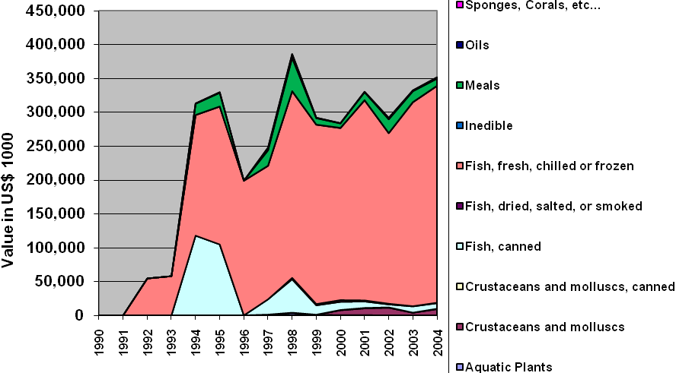
Source: FAO Fishstat
Of the exports of fresh, chilled and frozen fish, frozen hake and horse mackerel are the dominant products.
An indication of the lack of value addition in Namibian seafood exports is the average export price per kg (Fig. 4.15). Namibia, the largest exporter in terms of volume (293,500 tonnes worth US$ 352 million in 2004) has the lowest export price at only US$ 1.20 per kg, of all SADC countries.
Fig 4.15: Export price per unit in SADSC countries

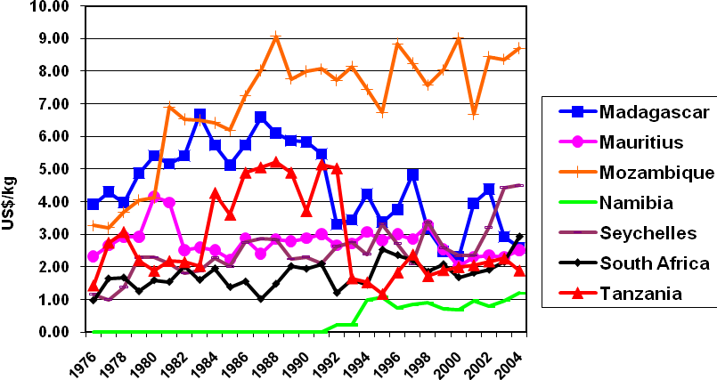
Source: FAO Fishstat. NB: Namibia achieved independence in 1990, and the collection and publication of national fishery statistics did not start until 1992. Thus, before 1992, there are no export statistics available for Namibia.
The export price is of course dependent of what is exported, both in terms of species and product form. We know that Mozambique, for example, with a high export price of US$ 8.70 per kg in 2004, exports mainly shrimp, while Namibia exports mainly round frozen fish (raw material for other countries' processing industry).
In recent years the Namibian unit price has increased slightly. Frozen hake fillets have become a valuable export item, followed next by frozen whole horse mackerel, and then by frozen, primarily headed and gutted hake.
Since 2004 a lot of new species and product forms show themselves as being exported in increasing quantities, partly due to introduction of new statistical product codes. It does, however, show innovations in catching and processing priorities. These include: whole frozen sharks and swordfish, as well as swordfish and shark fillets and meat. Also frozen cuttlefish and squid; frozen livers, roes and milt; frozen pomfrets; dried, frozen and canned abalone through aquaculture production; frozen tuna loins and fillets, as well as fresh / chilled Bigeye tuna; and even imported Alaska Pollack raw material, exported as frozen fillets.
Today, Namibian companies with Spanish shareholding are producing value added retail and foodservice products. Namibian companies with little or no overseas shareholding are also now producing retail products, but due to the enormous cost of developing an internationally recognized “brand” name, are doing so under other companies’ labels. For Namibian companies concentrating on value added foodservice products, service is more critical than branding, so from a monetary perspective this is a less costly way to enter the international value added market, but culturing market contacts and undertaking market research and promotion, is still critical. The technology for producing value added products has been acquired, however.
A number of different forms of value addition are currently occurring in Namibia, which shows that the expertise is there, and is working successfully. That expertise is not spread across the Namibian industry, however. Through enabling more Namibian company representatives to make overseas market contact at overseas seafood trade shows, as well as through generic industry market research and promotion, more companies will be able to add value to their products, rather than just relying on their established distribution links which primarily involve selling commodity products.
Over 70 per cent of Namibia’s fish and fishery products are exported to Spain because of Spanish involvement in the Namibian industry. This has put the Namibian fishery industry in a precarious position, with little or no control over market and prices, particularly in the case of commodity products. Namibia needs to diversify its markets in order to achieve more flexibility. It also needs to shift production more in the direction of value added production in order to achieve more stability, since commodity prices tend to vary a great deal more than prices for value added products.
In order to make the changes necessary, it is essential for the industry itself to be actively involved. The industry has been far too focused on production and too little focused on the market. This is partly because marketing has been taken care of by mainly foreign partners. As in any industry, whoever controls the market controls the industry, because marketing is where most of the money is made. Therefore, the Namibian fishery industry must become more market oriented and get engaged more deeply into the value chain by producing more value added products.
However, it must also be understood that within certain sectors of the industry, there are limits to how far value addition can be taken, either because of the nature of the industry, or because of lack of critical mass (too low volumes of raw material). One cannot, therefore, expect that value addition can be done across the board. Instead, one needs to focus on those sectors and areas that most readily lend themselves to value addition, and then allow the industry in other sectors to continue with commodity production.
In addition, a certain flexibility would be desirable. By allowing the industry to be flexible with regard to commodity vs. value added production and exports, one would ensure that individual companies would be able to maximize their profits, depending on developments on world markets.
The Government has several options to help improve the situation of the Namibian fishery industry, mainly by creating an enabling environment in which the industry can develop and prosper. The industry must first and foremost be allowed to become profitable, for without profitability, change will not be possible. And without a profitable industry, there will be little or no revenue to the Government.

Ugandan Nile perch quality management and certification

This case study looks at certification processes that help ensure safety and quality for the final consumers of Nile perch. The case considers the Nile perch export value chain in Uganda, which extends from Lake Victoria fishermen to dinner tables in Europe and around the world, and how quality and safety issues impact the value chain. The Ugandan value chain successfully improved its quality management when faced with potentially losing its sizable European market. This case also highlights the value that different certifications have within the value chain.

4.4.1. Background
Opportunistic growth in the 1990s led to an undisciplined value chain (Figure 4.16) that caused sector quality issues. In the early 1990s, Kenya, and then Uganda, started exporting Nile perch to Europe. Fish became a major Ugandan export during the mid-1990s. Despite the profitability of these initial years, the Ugandan fish industry failed to invest in quality control measures central to the value chain’s long term strength.
Fig. 4.16: Ugandan Nile perch value chain



From 1997 to 2000, several health incidents in the European Union and in Uganda caused the EU to place numerous bans and restrictions on Nile perch imports (and other fish) from Uganda, as well as on other countries that export fish from Lake Victoria. Problems first surfaced when Spanish and Italian authorities found contamination in Nile perch and issued bilateral bans. These steps forced the European Commission to send several missions to Uganda to test the product and the processes within the value chain. Some of the problems that were identified from these missions included:
- Fish-processing plants failed to meet conditions laid out in EU regulations
- The Uganda National Bureau of Standards (UNBS) issued health certificates incorrectly
- Lack of microbiological tests to support government health certificates
- Lack of routine government monitoring for presence of chemicals in fish and water
- Lack of sanitary infrastructure and fencing at landing sites
- Fish handling was not hygienic throughout the chain In response to the missions’ findings, two Ugandan processing plants were prohibited from exporting Nile perch to the EU.
In 1999, the Ugandan press reported instances of fish poisoning in Lake Victoria. The UNBS notified the EU that it could not guarantee the safety of fish exports, and the EU then banned all fish imports from Lake Victoria. The EU import bans had wide-ranging effects in Uganda; in addition to lower fish exports and export revenue, fishing communities suffered tremendous damage, as did fish processors and related service industries (packaging, transport, and others). As a result of the bans, three plants closed down completely. The remaining plants worked at 20 percent capacity, while 60–70 percent of employees were laid off.

4.5.2. Intervention
The EU bans shut off the supply of a product that was much in demand in the EU marketplace, and the market had few substitutes. Pressures on both the demand and supply sides of the market therefore provided major incentives for actors throughout the value chain to face the problem. The members of the Uganda Fish Processors and Exporters Association (UFPEA), European fish importers, the Government of Uganda (GoU), and the EU worked together and took action to deal with the issues.
The GoU and UFPEA had several working group meetings to design an action plan. Their major initiative was to restructure the government agencies responsible for managing Uganda’s certification process. Since Europe was the fish’s major destination, the government and industry wanted its certification process to match the EurepGAP process.
4.5.3. Creating a EurepGAP certification process in Uganda
The GoU streamlined its fish regulatory and inspection systems, with the Department of Fisheries (DFR) formally becoming the sole competent authority for fish safety issues. DFR would be responsible for certifying fish exports as EurepGAP compliant, and it needed to achieve HACCP accreditation to regulate the value chain to EurepGAP standards.
The DFR completely revised its guidelines as well as its monitoring and inspection systems. A manual of standard operating procedures was established to guide inspections, and training programs were carried out for inspectors. In 2008, DFR’s central offices were staffed with 17 inspectors who monitor the overall system and operations at processing plants. Another 20 or so inspectors operate at the 14 landing sites that are approved as sources of fish for export.
These inspectors issue local fish-health inspection certificates that are required to move fish from a landing site to a processing factory. These certificates contain information on both the supplier and buyer of fish at the landing site and on the fish’s origin.
However, DFR did not have the capacity to handle quality control with the fishermen or at many of the landing sites away from major urban centres. There are 600 landing sites in Uganda, but only 14 are approved for export. As a result, different monitoring procedures were put in place at the local level, including the formation of committees at landing sites and Beach Management Units (BMUs) that started registering boats and gear. This approach follows what, in fisheries, is known as co-management—power-sharing between state and local communities and a shift of responsibilities from the former to the latter.
In this framework, BMUs are supposed to coordinate with local governments via the formation of Lake Management Organizations. As of 2004, BMU-managed landing sites were not authorized to export to Europe, so many processors, agents, and traders transfer fish at one of the 14 approved landing sites.

4.5.4. The important role of pesticide laboratories in the certification process
The EurepGAP certification process requires biochemical tests to check for pesticide residue. No laboratory in Uganda could perform the pesticide residue test, so samples were being shipped to Belgium, where a Belgian firm, Chemipher (U) Ltd., did the tests. Chemipher recognized that there was sustained business for them in Uganda, so they opened a laboratory there. Having a local lab helped streamline the certification process and reduce costs.

4.5.5. ISO 9001 certification
Many of the fish processors and exporters wanted to add another layer of quality standards to their production. Mainly, to demonstrate (and to help the market perceive) that they were serious about quality. With the assistance of a USAID financed project that trained the fish processors in ISO 9001 (a subset of ISO 9000) process, the processors were then certified by an outside consulting firm.

4.5.6. Industry-level certifications
The association of fish processors, UFPEA, has adopted a voluntary code of Good Manufacturing Practices (GMPs). The fish processors implemented HACCP and good quality management systems with support from EU funding, and 11 processors were upgraded to handle fish for export. The voluntary GMPs were monitored by UFPEA and proved helpful in improving processors’ practices.

4.5.7. The results: a more competitive industry
In short, compliance with EU standards (including HACCP procedures) by the Ugandan fish industry in reaction to the import bans resulted in:
- Streamlined regulation under a single, strong, and competent authority (DFR)
- Formulation of a new fisheries policy
- Improved monitoring and inspection systems supported by inspection manuals, standard operating procedures, and the training of inspectors
- Regional efforts for the harmonization of handling procedures in the three countries sharing Lake Victoria
- Upgrading of a (small) number of landing sites and plans for upgrading a substantial number of others
- Upgrading of processing plants’ procedures and layouts
- Opening up of the U.S. market, which also requires HACCP compliance
- Installation of two local laboratories (Chemipher and UNBS) and general improvement of service provision to the industry
- Increased number of processing plants and improved export performance.

4.5.8. Lessons learned
There was and still is a strong incentive for the value chain and government to work together to ensure a quality product. The potential total losses of poor quality management were apparent to all parties.
Paradoxically, banning the supply of all Nile perch from the Lake Victoria region created incentives for European fish importers and the EU itself to support Uganda because there were few replacement sources.
Recognition of the importance of quality management, and of building a secure reputation for quality, led to actions beyond the minimum needed, such as implementing ISO 9001 and GMPs.
The fish processors and exporters were natural actors to take the lead in determining and disseminating information about the standards required within the value chain. They were responsible for a large part of the value-added and were the portion of the value chain most knowledgeable about export markets’ requirements. They could serve as the “control point” for the rest of the value chain. The government had reason to listen to them because they employed a large number of people and recognizably controlled the market linkage that tens of thousands of people working within the value chain helped to supply.
There is multilayer monitoring at the fish processing and export stages, but monitoring is much weaker at the landing sites and with the fishermen. Currently, local governments do not have the capacity to do much monitoring, so the exporters and processors have most of the responsibility to ensure that they receive fish that meets the EU market’s quality requirements.
Fishermen and fish traders also understand and remember that markets can be “turned off ” and, consequently, have incentives to supply fish that meets quality requirements.

The Kenya capture fisheries value chain
This study is part of a series of case-studies on the role of finance in value chain analysis and sub- sector growth strategies. It is the outcome of a collaborative effort between two USAID funded projects: the Financial Services Knowledge Generation (FSKG) task order and the Kenya Access to Rural Finance (KARF) program.
Analyzing finance in the fisheries value chain provides an interesting case because unlike for example grains, tree crops or vegetables, seasonality issues play less of a role. The case is also interesting for the complexity of interwoven value chains: fresh and processed fish, industrial and artisanal processing, domestic and export markets, food and feed products. Analyzing the fishing value chain, with its unique social fabric and direct relationship to a fragile natural environment, also demands a discussion on the triple bottom line of economic, social and environmental issues.
Kenya’s fisheries resources are important sources of food, employment and foreign exchange. Driven by a 6% GDP growth rate in recent years and changing consumer habits, fish has become an increasingly important part of the Kenyan household’s diet, both directly and indirectly (as a key feed ingredient for livestock and dairy). It is estimated that the fishing industry employs over 50,000 fishermen and women, and another 800,000 persons are engaged in fish processing and trade. In addition, fish exports generated US$50 million in export earnings in 2006.
This case-study shows how a more in-depth analysis of the strongly interlinked finance and governance issues in a value chain leads to a deeper understanding of why stakeholders behave the way they do, a way which at first glance may appear to be irrational. For example:
- Artisanal fish processors near Kisumu buy Nile perch offal from a processor at considerable expense, only to bury it right away in the ground at a total loss;
- Fishmongers at Kisumu fish market buy fish from wholesalers at credit with an interest rate of more than 10% (per week) while alternative credit at 2% is readily available;
- Ice plant operators around Lake Victoria either do not sell ice or sell volumes far below capacity, while at the same time there is a large unmet demand.
In turn, this deeper understanding of the value chain will facilitate the design of more effective growth strategies. For the case of the capture fisheries sub-sector in Kenya, the study shows that a weak financial structure is a key constraint and that addressing it while taking the triple bottom line into account should be an integral part of any development program aimed at sustained growth in this value chain.

Markets
A wide variety of markets are linked to the capture fisheries value chain. The four main markets are the export markets for industrially processed fresh and frozen Nile perch filets, and the domestic markets for fresh tilapia, artisanally processed fish (Nile perch, tilapia, omena) and feed grade omena. These freshwater species markets handle 96% of Kenya’s annual fish production of around 175,000 MT. In addition, a fifth set of markets are those related to Kenya’s marine capture fisheries (shrimp, tuna, octopus, crab, etc.). Each of those markets is growing with supply generally lagging demand.
Nile Perch: There is a high demand for fish in industrialized markets, in part due to consumers perceiving fish as a healthier product relative to alternatives such as meats from a disease-plagued industry. The demand is especially good for fresh fillets which are seen as both healthy and convenient. This consumer preference finds expression in an FOB price of $6/kg for chilled versus $4.5/kg for frozen fillets. Kenya, along with Uganda and Tanzania, is one of the few non-EU countries that can competitively deliver fresh (chilled) fillets according to the exacting specifications of the EU market (e.g., food safety standards, delivery regularity). The broader market potential for Nile perch fillets was further underscored when Kenya, faced with an EU import ban in the late 1990s, could readily find buyers in other markets such as Israel, Australia, the US and Japan, which today combine for more than 40% of sales. However, Kenya’s competitive position is undermined by reduced Nile perch landings which resulted from over-fishing and the fishing of undersized fish.
Fresh Tilapia: Fresh tilapia is the preferred and most widely consumed fish product in Kenya. There is no official import competition in this market, but unknown quantities of tilapia (and Nile perch) enter Kenya over water, as Ugandan fisherfolk bringing their catch illegally to Kenyan beaches. The export of tilapia, which also has good markets overseas, is hampered by too low volumes and is also actively discouraged by the Kenyan government who sees tilapia as a key source of protein in the Kenyan diet.
Artisanally processed fish: Fried Nile perch skeletons, fried, smoked and sun-dried tilapia, and sun-dried food-grade omena are the dominant processed fish products in the domestic food market. Both the supply and demand of these products are to a large extent driven by the nearly total absence of cooling facilities. Processing is mainly a means to preserve some of the value of these highly perishable products. Competition with imported products in this market is limited to small quantities of smoked tilapia imported from Uganda.
Feed grade omena: Typically sun-dried in poor hygienic conditions, a significant volume of the omena is classified as feed-grade quality. This omena still needs to meet certain quality criteria related to for example the maximum percentage of foreign material. It is the main protein, and most expensive, ingredient in feed in Kenya, especially for the large feed manufacturers who set minimum order quantities at 30MT. Unlike the informal ‘jua kali’ feed manufacturers, these large manufacturers do not use fishmeal made from fish offal because of quality issues, most notably adulteration. Feed-grade omena is not available in sufficient quantities throughout the year, due to resource constraints, regulatory restrictions and a weak supply chain structure. As a result, nearly 80% of the feed-grade omena is imported from Tanzania.
Marine species: There are readily available and profitable markets for marine fish, crustacean and mollusk species, both domestically (the tourism industry) and internationally. Nevertheless, the landed value represents less than 10% of the potential Ksh5 billion (US$70 million), mainly because of a local lack of deep sea fishing capacity and an unsupportive government policy.

Structure of the sub-sector
Fishing: Fishing is done using small wooden boats propelled mostly by sail or paddles and manned by hired crews, and using drift nets, seine nets, and long-lines that are set out overnight. Industrial fishing techniques are banned to protect both the livelihood of the fishing communities and the lake’s fish stock levels. There are clear indications that Nile perch has reached its maximum sustainable yield (MSY), and over-fishing in Kenya’s shallow lake waters is now reducing the landed volumes. Fisherfolk are forced to incur higher costs to go to deeper waters for decreasing quantities of fish caught per trip. Although there are associations and all the beaches have beach management units as part of the government fisheries policy, there is little collaboration between fisherfolk in terms of procurement, fishing or marketing. Government policy further affects fishing through the Fish Act which i.a. establishes minimum catch sizes for Nile perch and a seasonal fishing ban on omena.
Trading & distribution: The fish catch is sold directly on the beach to various traders. Industrial Fish Processor (IFP) agents buy the Nile perch that meets the processors’ criteria (e.g., size, freshness) who take the IFP’s ice-laden trucks to the mainland beaches. Lower quality grade Nile perch, tilapia and omena are sold to a number of successive intermediaries along the supply chain: collecting traders, regional traders, wholesalers, and retailers. Most of the retailing takes place in urban open-air markets and through street vendors. Sales of domestic fish products in modern retail outlets such as supermarkets are limited. Grading and the use of ice are minimal in these domestic end-market channels, resulting in high spoilage levels.
Processing: The processing of Nile perch takes place in modern facilities that are fully compliant with the food safety standards of export markets. Fish is filleted, packaged in 6kg labelled cartons and either exported chilled by airplane or frozen by surface transport, depending on the fish quality and the pertinent orders. In the domestic market, processing is artisanal and varies by the three main fish species. Tilapia is processed only when it is the only way to avoid a total loss of its value due to spoilage. For example, the fisherfolk operating on the more distant lakes sun-dry a large portion of their fish, and fish not sold fast enough in the urban markets is fried and sold as street food. Omena is bought by women traders who immediately sun-dry the fish near the beaches and then take it in bulk to the nearest wholesale markets or regional traders. Nile perch offal (skeletons, skins, etc.) is sold by the IFPs directly to the women who are specialized in processing this raw material (mostly frying). The governance mechanism is such that the women have to buy what the IFP offers to them, independent of what the women can actually sell. Artisanal processing in Kenya uses primitive technologies and takes place with little to no regard for food safety regulations.

Governance and finance in the value chain
The following are the salient general aspects of finance in the fisheries value chain in Kenya:
Cash flows: The annual landed value (at ex-vessel price) is estimated at Ksh8 billion (US$ 100 million) at least half of which is paid out in cash on the beach by the boat owners or boat renters to the fishing crews (hired labor). This has led to a situation that is both inefficient and insecure.
“Unbanked” value chain actors (socio-cultural factors): Value chain actors, especially upstream in the value chain, are characterized by low financial literacy levels and largely operate outside of the formal finance system. The lack of a savings culture is probably the single-most important constraint to growth of the fish value chain. Historically, the fishing communities have shown little interest in saving because of the perception that there is always fish to catch if they need money. Furthermore, the fishermen typically spend a large part of their earnings on alcohol and prostitutes, both of which are in ample supply on the beaches. As a result, HIV/AIDS is wide-spread in the communities along the shores of Lake Victoria, destroying households and creating the most vulnerable and poorest sub-populations in Kenya.
Weak financial structure: Apart from cash transactions, trade credit is wide-spread. Value chain actors are highly dependent on informal sources of finance which are unreliable, inadequate and highly expensive. Options to save money through formal bank accounts are for most fisherfolk a costly and time-consuming boat trip away. In the last few years, commercial banks have begun to develop fish sub-sector specific loan products and to bring them closer to the beaches. While they are clearly changing the dynamics, formal finance institutions face an uphill battle, as they are perceived by most value chain actors as cumbersome and high-risk options.
Poor business management skills: Value chain actors throughout the value chain (with the exception of the IFPs) do not (know how to) use proper costing and pricing methods in their business operation. Financial records are not kept. As a result profitability is likely low or negative, thus effectively blocking growth of the MSMEs.
Weak group organization: Throughout the value chain, actors behave individualistically. Groups are formed mostly to provide entry points for larger buyers (IFPs) and government and donor programs. There are BMUs on all the beaches and many associations and cooperative societies for fisherfolk, fish traders and fishmongers, but these are weak and badly managed. Especially at the level of the fisherfolk, there are few if any economies of scale and market power is low, leaving them at the mercy of the potentially exploitative practices of the fish traders.
Vertical power imbalances (governance): Overall, vertical power imbalances result from the well-capitalized larger traders initiating a wave of supplier credit that ripples through the value chain and creates buyer dependency (viscous cycles of debt). On the beaches, the imbalance between low fish supplies and many women traders trying to secure these supplies has led to the jaboya system of fish-for-sex whereby the women are forced to pay an “in-kind” premium on top of cash. Vertical power imbalances play out strongly in the Nile perch channel. The dominant players in this value chain are the IFPs who via their buying agents exert market power over the fisherfolk. They also create dependencies by providing equipment on (low-cost) credit to boat owners, which puts the latter in a debt position and locks them in. The greatest dependencies however play out in the artisanal fish processing channel where governance mechanisms keep the small processors of Nile perch offal in a highly dependent position with little or no room for upgrading and growth.

Strategic recommendations
Given that: (1) the objective is to improve the profitability of the various types of micro-enterprises along the value chain, while simultaneously addressing social constraints and assuring the sustainability of the fisheries resources; (2) domestic and export markets are readily available and growing; (3) supply is severely constrained by biological bottlenecks, regulatory constraints, and inefficiencies throughout the value chain; and (4) the different value chains overlap or face the same challenges; the following are the three key components of the recommended fish value chain upgrading strategy:
(1) Increase the catch of omena, tilapia and marine species; stabilize the catch of Nile perch
Facilitate and improve access to outboard engines (shift to the deeper waters);
- Work with the BMUs and the fish processors association to enforce the Fish Act (catch size);
- Restock the lake with tilapia fry from improved hatcheries;
- Revise the policy on fishing rights for deep water vessels in the EEZ;
- Align commercial and environmental interests by training fisher folk.
(2) Reduce losses and operational costs along the value chain (process upgrading)
- Improve cold chain (storage & transportation), packaging materials, transportation logistics, and better communication throughout the value chains;
- Promote the use of appropriate drying technology (drying racks);
- Facilitate a shift from competitive to more collaborative horizontal and vertical governance structures (collective action, contracts).
(3) Strengthen the financial structure
- Develop fish sub-sector specific loan products for asset and working capital finance for fisher folk, artisanal processors, and traders;
- Bring financial services closer to beach (mobile banking, ATMs);
- Promote a savings culture and provide financial literacy and business management training (pricing and costing skills).

Conclusion
This value chain analysis of the Kenya capture fisheries sub-sector illustrates that a myopic focus on particular upgrading activities is unlikely to lead to growth. Strengthening the weak financial structure, reducing power imbalances in the governance structures, and resolving socio-cultural and environmental concerns have to take place concurrently.
For example, the high levels of post-catch losses indicate that the introduction of coolers and improved ice distribution systems would be an upgrade strategy that could stimulate value chain growth. While this could indeed lead to higher profitability at first, without retaining these profits and reinvesting them back in to their business, value chain actors will not be able to grow their business. In addition to a dearth of accessible finance services, exploitative governance mechanisms, and limited business management skills, socio-cultural aspects of the fishing communities favouring consumption over savings stand in the way of business growth through reinvestment.
Even if the savings rate of fisher folk, artisanal fish processors and fishmongers improves and they reinvest in their business, growth will be severely hampered if environmental aspects are not taken into account. For example, more boats and more nets could lead to accelerated over-fishing in the shallow waters and a reduction of the overall fish stock. This risk needs to be addressed through a systemic enforcement of environmental protection measures and a diversification strategy that will direct some profits to other high-potential economic activities such as aquaculture or irrigated horticulture.

Nigerian domestic catfish production

Despite government support for major investments in some 40 additional public fish farms and hatcheries, aquaculture expansion has been a slow process in Nigeria, because private sector fish farmers have faced major constraints, including lack of supporting feed and seed companies.
Nigeria is the second largest aquaculture producer in Africa. In Nigeria, domestic fish is a preferred protein that rivals red meat in consumer demand. Domestic demand for fresh catfish has grown as Nigerian incomes increase. Nigeria has become one of the largest importers of fish in the developing world, bringing in some 600,000 metric tonnes (MT) annually. There is a growing awareness of aquaculture in Nigeria, with more than 100 private commercial fish farms currently in production.
At the New Partnership for Africa’s Development (NEPAD) 2005 “Fish for All Summit,” Nigeria’s president Olusegun Obasanjo stated that, “If Africa’s per capita consumption of fish is just to be kept at its present level, though grossly low and unacceptable, then fish production must be increased by over 250 percent by 2015. This unhealthy situation calls for urgent action and indeed poses a great challenge to all of us.” President Obasanjo further remarked in his closing address that “although fishing brings Africa export earnings of US$2.7 billion annually, these benefits are at risk as the exploitation of African natural fish stocks is reaching its limits, and aquaculture production has not realized its full potential”.

The tool: market assessment
Value chain participants must consult the market when determining how to increase profits, reach new markets, innovate, and increase productivity. There are seven widely accepted means of developing market analysis that contribute to identifying opportunities to capture more value:
- Secondary research refers to the use of data that have already been collected, analyzed, and made available for other purposes. Value chain participants may find such research useful for identifying sectors experiencing growth, as well as for understanding government regulations and policy.
- Group discussions permit value chain participants to explore issues in general terms, and then seek more specific information by using focus group discussions.
- In-depth interviews provide qualitative and quantitative information on the value chain and are particularly useful for different participants of value chains to understand their complementary relationships.
- Market observation can be used by value chain participants to obtain qualitative and quantitative data from local markets on transactions, interactions, processes, and embedded services. Observations are also a simple tool to cross-check information obtained from other sources.
- Interactive workshops or meetings can be used to validate and deepen previously gathered information. They can generate ideas for addressing constraints or opportunities in the market. In addition, these workshops may lead to a common approach in solving market problems among all of the value chain participants.
- Product concept testing aims to gauge the demand for a service or product that the value chain does not yet produce and about which the value chain customers have no knowledge.
- Market and consumer surveys are useful (as evidenced by the Nigerian case study) to obtain an accurate picture of serviceable aspects of the market for the product or service.
In Nigeria, a market survey was used to gather quantitative and qualitative information about buyers, sellers, volumes, prices, market trends, market share, and market segments, along with qualitative information on competitors. The rationale behind this approach was that surveys can accurately represent the opportunities and demand characteristics of the markets studied. Value chain participants can use surveys to identify broad problems in a market, such as lack of knowledge about a particular service, limited understanding of its benefits, or failure to assign appropriate value to outside assistance. This type of information is useful for establishing new products or services within the value chain.

Background
Africa produced 7.5 million tons of fish and seafood in 2002. On the continent, aquaculture development has been most notable in Egypt, where a combination of tradition, market demand, available and well-managed water resources, marketable species, and private sector initiative resulted in dramatic growth during the 1990s. The top three African producer nations were Egypt (accounting for 85.6 percent of the total), Nigeria (6.5 percent), and Madagascar (1.8 percent). Egypt’s aquaculture growth and development has been the most significant because it has increased production levels from 85,000 tons in 1997 to 376,000 tons in 2002, a 35 percent average annual growth rate.
By 2006, farmed catfish accounted for approximately 50 percent of Nigeria’s domestic annual fish production. The catfish industry provides approximately US$75 million in revenues at the farm gate and accounts for nearly US$180 million in consumer spending. The sector contributes to the employment of nearly 25,000 people, with the majority (over two-thirds) employed as restaurant workers. Aquaculture and Nigerian farm-raised catfish have also been identified as a growing source of income for Nigerian farmers.
To ensure success, any new investments or expansion of production must be driven by market demand and consumer preferences. This case study features the information gathered from a domestic market assessment for the farmed and fresh catfish value chain to demonstrate the value of market information in determining future investments and/or interventions in a value chain.

The Nigerian catfish value chain
The domestic market demand for fresh and smoked Nigerian catfish is outstripping the supply. Tastes and preferences for catfish have been increasing due in large part to the availability, cost, and consumer preference for white meat, perceived health benefits over substitute products, and some popular catfish dishes served by restaurants.
Production
The value of Nigerian catfish produced and sold by aquaculture farmers is about US$75 million, which assumes a production level of about 30,000 tons of catfish per year. At the retail level, this tonnage rises in value to about US$120 million. Restaurant operators capture an additional US$60 million dollars on catfish, for a total of US$180 million in sector wide consumer spending. Estimates indicate that approximately 70 percent of fresh fish in Nigeria is sold in restaurants, especially in bukas. The major cost of production for farmers is European catfish feed, which amounts to approximately US$39 million. Nigeria currently relies on imports because a sizeable fish-feed industry has yet to develop. The majority of domestic feed supplies are farm made, with only a few animal feed millers providing domestic commercial feed pellets.
Supply
Farmed catfish are almost universally sold at the farm to primary wholesalers, retailers, or buka owners. Primary wholesalers have been chiefly responsible for developing the trade from the major fish farms in Nigeria. Traditionally, these wholesalers transport live catfish to secondary wholesalers who sell to other retailers, restaurants, or consumers. It is worth noting that, in the major production areas, retailers and restaurants are increasingly buying directly at the farm, thus cutting out middlemen and vertically integrating.
Demand
Nigerian consumers’ requirements and demands with respect to catfish and catfish products are fairly common across regions and markets. Key consumer motivations for consuming catfish were 1) availability, 2) taste/smell, and 3) familiarity. Over 90 percent of consumers said that they were increasing their purchases of catfish, and 15 percent identified bird flu as affecting their purchases. Comments were made about the health benefits of white meat (for example, catfish), and a significant number made reference to a perception that after a certain age (normally about 35), red meat should be given up entirely. Nearly 80 percent said that they would use catfish to prepare pepper soup—by far, the most popular use—and about 40 percent said it would go into other soups or stew dishes.
Opportunity
According to traders and retailers, product losses (fish death, quality loss) and finance are the most common challenge cited by fresh catfish traders and retailers. Fresh and living catfish command a retail price twice that of frozen fish. Traders and retailers do not use proper storage facilities, do not change the water sufficiently, and often leave the fish in the sun for long periods—all leading to product loss and lower quality, which translate into lower revenues. Traders indicate that limited finance constrains the ability to develop and invest in business operations or expansion. Secondary issues are problems with debt recovery, market location, electricity (mainly for refrigeration), skin damage to the fish (which reduces the sale price), and transport costs.
Nigerian catfish farmers report that the marketing of fresh catfish is becoming more difficult because of increasing competition. Some farmers in the southeast also recognize that the difficulties in selling fish result from a general lack of organization (for example, farms all try to sell fish on the same day). To control marketing problems, farmers say that they would like to have direct contact with traders further down the marketing chain. Farmers have indicated that information sharing within the value chain is sparse and that there is frustration that primary wholesalers shield their sources of supply from secondary wholesalers and retailers. In addition, in some locations, retailers feel that they have to pay higher prices than necessary because they are unable to buy direct, or at least need better information about the selling prices at the farm.
The Nigerian catfish market projections provided by the surveyors imply that the undersupply of farmed catfish may amount to some 5,000 tonnes per year, which could be rapidly addressed by expanding production. The urban markets, where farmed fish is primarily sold, will grow by about 3 percent annually purely through population growth. Once these sources of demand have been met, additional supplies will have to be absorbed by stimulating sales through lower retail prices, the addition of value-added operations, or exports. Fish farmers and their value chain colleagues will have to take a much more proactive approach to learning about the market and initiating sales and marketing activities. This is likely to involve conducting their own market research and establishing closer contacts with retailers, traders, restaurants, and processors. These will be new activities for producers.

Interventions in the Nigerian fresh catfish value chain
The survey results point to many possible value chain initiatives. Unmet and clearly increasing market demand should be addressed by increasing supply from producers (“Value Chain Possible Action #1” in Fig. 4.17), taking advantage of the opportunities to vertically integrate operations (“Value Chain Possible Action #2”), and developing more sophisticated marketing and distribution systems in order to capture more value (“Value Chain Possible Action #3”). There is also ample opportunity for producers to band together and gain a competitive advantage through economies of scale. Costly inputs can be purchased at significant savings with effective cost-share agreements and in larger quantities. Also, associations of producers or the firms linked to them can combine to act in groups to attain the scale and market power necessary to create permanent marketing links and secure contracts to provide restaurants with guaranteed supply and quality.
These new distribution systems will have an opportunity to increase the marketing of catfish and improve the safe transport of products. The market assessment confirms that consumers prefer catfish based on its purported health qualities, its cost, and its availability, as well as enthusiasm for its taste and preparation in popular dishes and as a complementary product to beer. There is an opportunity to capitalize on these preferences in marketing initiatives while simultaneously expanding the market supply.
Currently, losses during transportation are estimated to be between 10 to 15 percent of value, with practices varying widely across the sector. With better organization, appropriate postharvest methods suited to Nigerian conditions can be propagated to the retail, trading, and restaurant sectors.
Fig. 4.17: Nigerian catfish farming value chain – possible actions

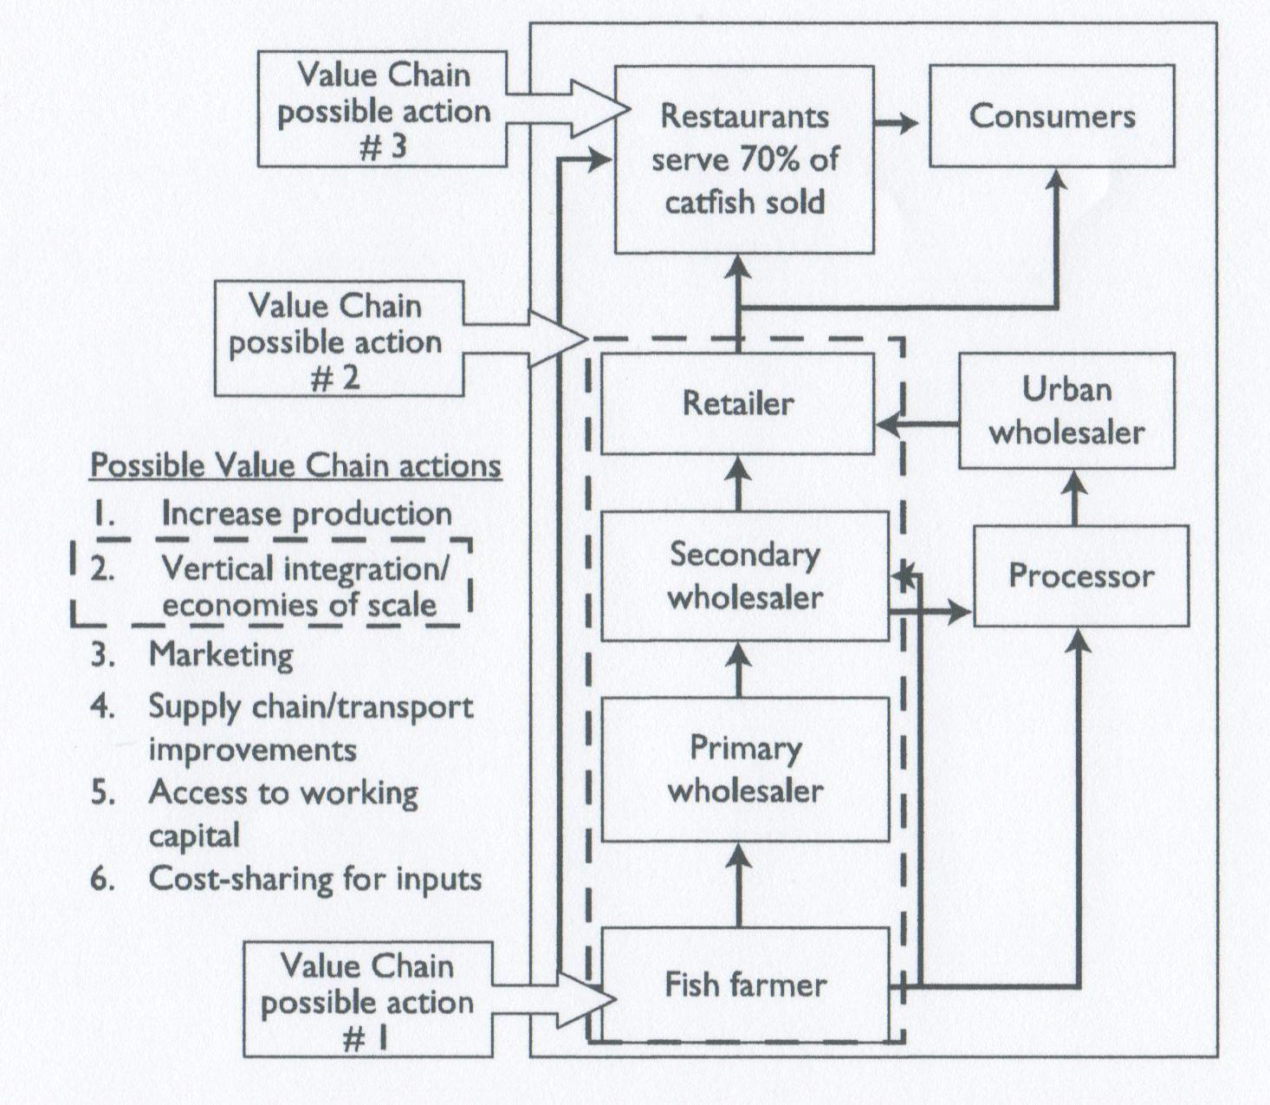

Producers or wholesalers should seek technical expertise and assistance to lower these loss rates and improve the quality of the catfish that they distribute. Financing is still not widely available for restaurants and bukas to increase their working capital and expand their businesses. With growing demand and falling prices, there is an opportunity to provide financing to promising end market businesses that may pull the value chain toward higher growth vectors.

Conclusion
The market assessment survey furnished important information that allowed the value chain actors to identify growth opportunities and priority interventions. The Nigerian domestic catfish market is clearly rich with opportunity for increasing sales; there are numerous constraints and other issues that can be addressed, and there is room for value chain collaboration cantered on production, investment in transport and infrastructure, marketing, commercialization, and vertical integration.

Gender analysis of aquaculture value chain in Nigeria and Vietnam

Aquaculture is the fastest-growing food sector in the world and is expected to contribute more than 50 percent of total fish consumption by 2020. Just over 90 percent of aquaculture production originates in Asia and nearly 70 percent in China alone. Efforts to expand aquaculture production to meet the ever increasing worldwide demand for seafood continue. Although the boom in international demand for shrimp has drawn attention to this sector, the development potential of aquaculture stems partly from the variety of products (such as catfish, tilapia, grouper, scallops or lobster culture, and seaweed), production systems, and scales of production it covers. In comparison with the dominance of large-scale coastal aquaculture systems in Latin America, North America, and Europe, the vast majority of aquaculture production in Asia is carried out in rural areas, is integrated into existing farming systems, takes places on a small scale, depends on the cooperation of family members, and involves large numbers of the rural population. In the case of shrimp production in Bangladesh, for example, as many as 1.2 million individuals are reported to be directly involved, with a further 4.8 million household members indirectly dependent on it for their livelihoods
Aquaculture has yet to play a major role in any African economy. To date, there has been limited aquaculture activity in Africa, but studies suggest huge potential of aquaculture as a pathway toward economic growth, food security, environmental sustainability, and poverty reduction in that region.
Aquaculture is a promising business venture in many contexts, and the private sector drives and plays a major role in this. However, for aquaculture to fulfil its development objectives, the public sector also plays a key role by creating an enabling environment for private sector engagement, which requires a favourable business climate and regulations and institutions in place for markets to work. The public sector also has a role in facilitating and ensuring equity and environmental sustainability. Ensuring equity entails effective targeting for service provision and capacity development and requires laws and regulations to curtail different forms of discrimination and inequalities at all levels. There have been many relevant development projects and programs (for example, aquaculture projects with social and gender dimension and projects that focus on women’s economic empowerment through aquaculture).
Numerous lessons can be learned from the successes and failures of these endeavours. One important lesson is that success in achieving development objectives through aquaculture depends on contextual realities, mechanisms, and structures in place to ensure equity and environmental sustainability.
The aim of this study is to guide two potential World Bank operations in Vietnam and Nigeria with the aquaculture value chain as their focus. These two operations recognize the important role of aquaculture in the development objectives of these countries. The report describes the specific contexts of Vietnam and Nigeria and recommends concrete project entry points and actions gender integration, applying the lessons learned from past experiences.
Two aspects were examined in order to suggest concrete ways to ensure gender equity while improving food security and reducing poverty: (1) assessing the aquaculture value chain and suggesting how to develop the sector and (2) assessing differences in women’s and men’s roles, access, and decision making, as well as differences in the constraints and opportunities for women and men.
The report employs an integrated value chain analysis that critically assesses the constraints and opportunities at different nodes or stages of the chain from policy, institutional, market, socio-cultural, and gender perspectives.
Nigeria and Vietnam represent two very different experiences in relation to aquaculture. Vietnam, as one of the global leaders in seafood production and exports, has one of the fastest-growing aquaculture sectors. Driven by the goals of promoting aquaculture growth for export since the 1980s, government at all levels has contributed significant resources to strengthening the sector’s performance. Although much of the driving force for this growth has been world demand, especially for shrimp production, the diversity in species and farming systems in Vietnam help build a strong agricultural sector both in terms of employment and in its contribution to GDP.
Most existing literature focuses on the Mekong Delta, where majority of aquaculture activities takes place and where an estimated 2 million farmers involved directly in the shrimp industry alone are located. Nevertheless, as much as possible, incomes are diversified and include both farm and nonfarm sources; this partly reflects the success of the policies of the late 1990s that supported increased rural employment, small farm productivity, diversified rural livelihoods, and improved rural infrastructure. Although the rural population remains large (80% of the population), poverty has increased and underemployment remains a problem in rural areas. Consequently, rural-to-urban migration is increasing and includes both women and men. Some suggest that the numbers for women are greater than those for men.
In all these respects, Vietnam contrasts dramatically with Nigeria, which is entering its fifth decade of economic dependence on oil (95% of exports). Traditionally, Nigeria relied on export crops of rubber, cocoa, groundnuts, and annual grains grown mainly on small farms within customary tenure systems. During the period of oil dependency, there has been limited government interest in and support for the agricultural sector, although this has shifted recently as oil income has declined and concerns about food availability have increased.
Aquaculture in Nigeria is still a new sector with a small number of species and systems and thus far remains focused on satisfying local demand. The case of catfish production included in this report is centred on the two major cities of Kaduna and Lagos. However, as the case study demonstrates, the development of local catfish production is heavily constrained in a national context where infrastructure development, especially the supply of power, is poor.
Significant differences also exist in terms of gender relations, with Vietnam situated generally within a “region of weaker patriarchies” characterized by no or limited cultural prohibitions on women’s signifying weaker distinctions between the public and private domains, the organization of households along corporate lines (often around the conjugal unit) with each member contributing to a common purse managed by women, and less clear divisions of labour by sex. The case study from Vietnam shows men and women working together (that is, providing capital, labour, and expertise) to establish a joint enterprise that will contribute to their diverse livelihoods portfolio regardless of who is listed as the owner.
This contrasts with the two Nigerian settings. Kaduna is situated in the north within a predominantly, although not entirely, Muslim Hausa area with strong cultural prohibitions on women’s mobility, possibly accompanied by purdah (female seclusion). Households are integrated into wider lineage networks where the conjugal unit is less cohesive and polygamy may be practiced.
Lagos, the old capital of Nigeria and still the largest city, has long attracted migrants from all over the country and therefore has a very diverse population. As in a number of other sub-Saharan countries, spouses generally do not share a common purse, although this should not always be interpreted to mean that there is no joint decision making between spouses, and clearly these customary institutions are no longer universal. Nevertheless, similarities between these two countries are evident in the challenges they face to develop aquaculture and create gender equity.
Government policies support modern farming (in Vietnam: intensive farming) to a certain extent; however, statistics on aquaculture farms exclude the smaller units, and the formal banking system does not provide financial capital to them.
In neither country do the credit terms enable the growth of these smaller units. Following structural adjustments, both governments have withdrawn (are still withdrawing in Vietnam) from direct participation in the economy, and information, as well as inputs, is expected to be provided by the private sector.
Funds for research are considered to be insufficient. Gender norms support the involvement of individual women and men in the wider economy in both countries; yet in Vietnam, farms are almost always registered by communes in the name of men (to represent households), and customary male-dominated patterns of control over land remain a constraint for women in Nigeria. In Nigeria, Muslim women have more rights to land than non-Muslim women (which has implications for credit access), and, at least in urban and peri-urban areas, there is a market for land ownership and development. Finally, in both countries it is, in fact, labour burdens relating to the needs of women to earn an independent income while continuing to perform their domestic responsibilities that prescribe the contributions women can make to the sector.

Fig. 4.18: Catfish hatcheries value chain, Nigeria

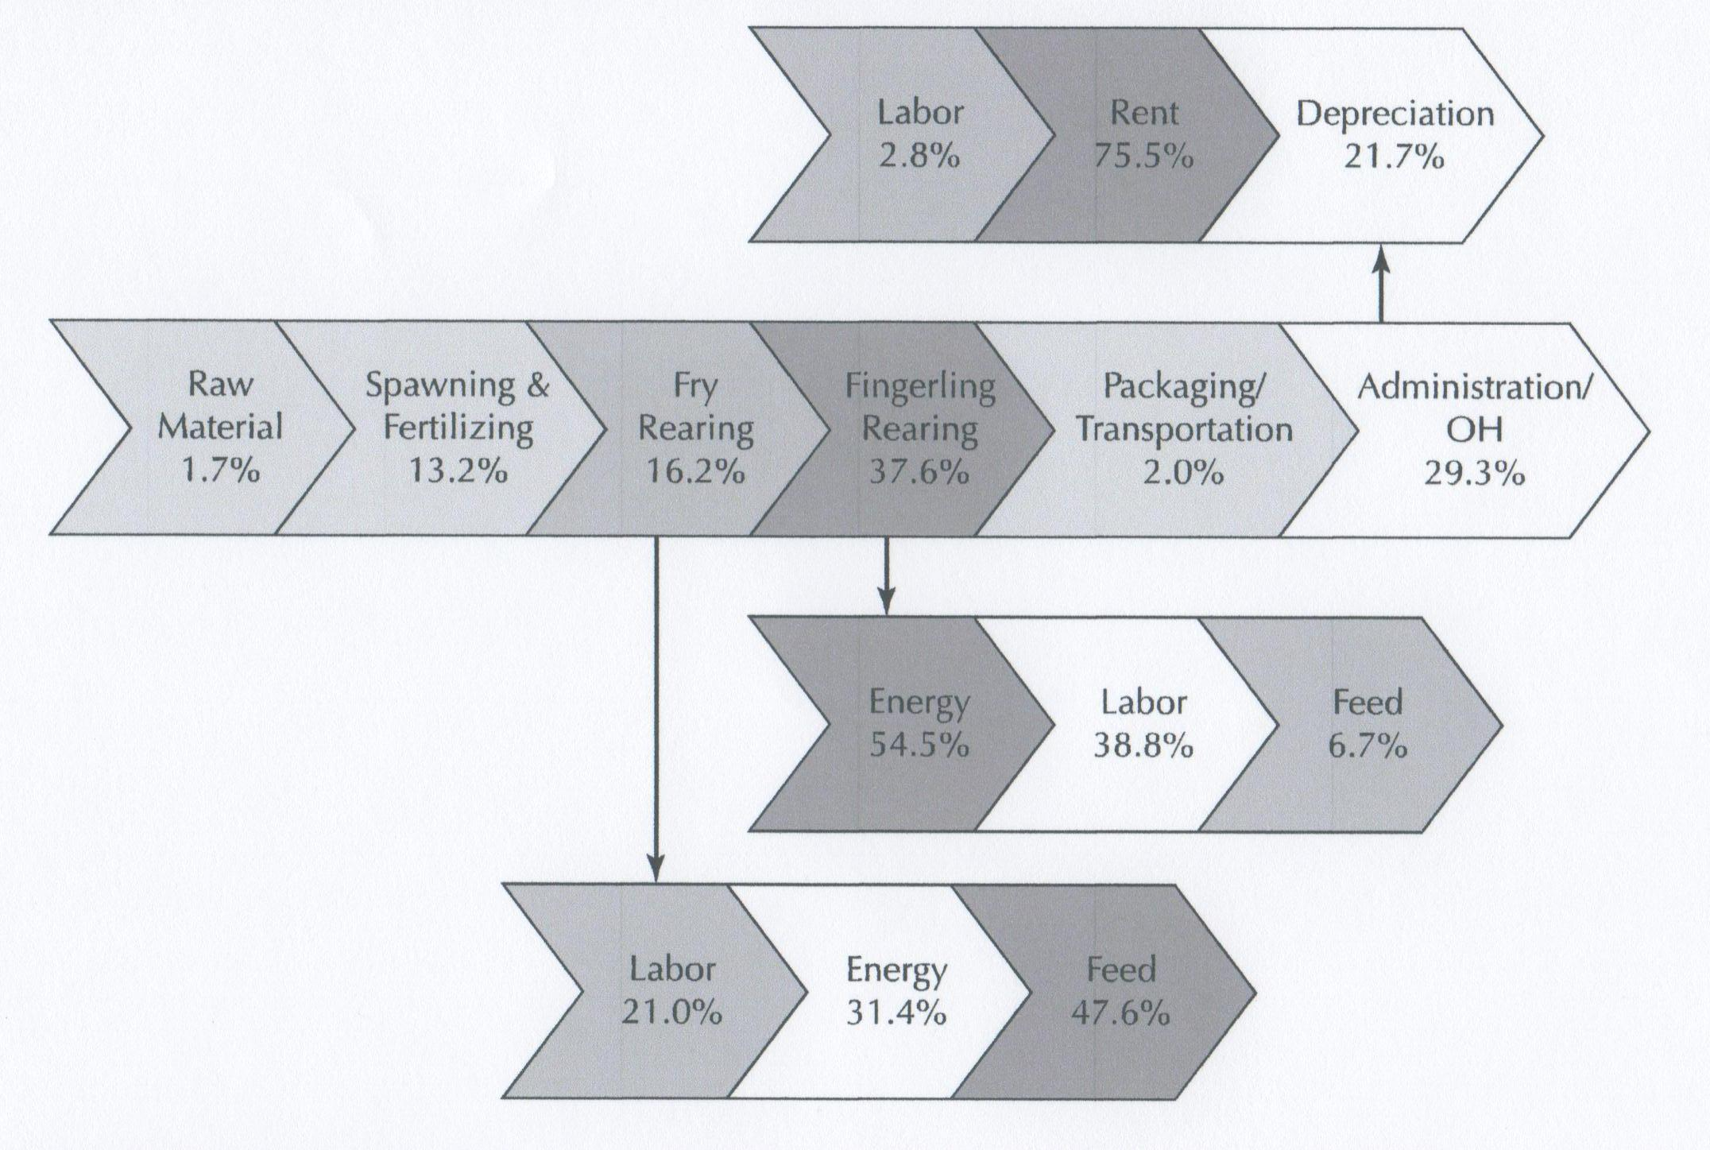

The study examines in great detail the various value chains for different activities in aquaculture (hatchery, nursery, grow-out farming, marketing and processing). In each of these integrated value chain analyses the distribution of cost within each link and between major links is described (see Fig. 4.18 as an example)

Conclusions and recommendations
In the Nigeria case study a set of conclusions and recommendations is presented. The following outlines interventions recommended at government, institutional, and firm levels in order to address the issues eroding the competitiveness of the aquaculture sector.
- Increasing Participation of Women in the Aquaculture Sector 
Capacity Building: In order to engage women in the sector, create sector awareness and transfer of knowledge and skills with special focus on women through dedicated female extension agents. This approach is believed to reverse the low percentage of female participation in aquaculture-related training.
Capital: Women are disadvantaged in accessing sources of finances required to enter the aquaculture business. The existing collateral base credit facility should be revisited so as to accept start-up projects based on the strengths of the project document incorporating mechanism for credit extension through holding the project itself as collateral.
The availability of investment capital is expected to alleviate problems related to access to land for aquaculture farming, and improved technologies for processing.
Creation of Joint Forum for Stable Catfish Market: The establishment of the catfish selling centers by the Department for Fisheries Service of the Lagos State Government (LSG) Agriculture and Cooperation and the Lagos State Catfish Farmers Association (LACAFA) with a view to curtail the strengths built up by the women sellers’ association should be viewed with utmost caution. It is believed that it will eventually distort the catfish market, which may result in displacing women from economic activities in marketing. Instead of colluding against women sellers, it would be beneficial to form a joint public–private partnership forum in order to solve existing problems with a view toward creating a collaborative and conducive environment in the market. In this case, the state government should play a coordinating role and facilitate the establishment of a joint forum among the concerned stakeholders for resolving existing and future problems related to the catfish market.
Development of National Policy and Guidelines for Aquaculture: Even though there are adequate numbers of institutions catering to aquaculture development in Nigeria, in Lagos and Kaduna states in particular, the lack of a national policy and related guidelines for implementation is creating duplication of efforts and ineffective relationships between the two major actors in the sector. The finalization of the national policy and pertaining guidelines under preparation is of paramount importance for streamlining aquaculture activities in a competitive manner.
Establishment of Specialized and Certified Hatcheries for Proven Quality Seedlings: In order to ensure the availability of proven quality seedlings, the research institutions and the extension services should facilitate the trace ability of fingerlings from proven quality brood stocks through the encouragement of specialized hatcheries, which should be certified by a pertinent accredited body. Moreover, dissemination of fingerlings from unknown sources should be prohibited. This recommendation is not meant to limit the production of fingerlings but to focus on improving the quality and performance of aquaculture farmers.
Local Production of Fish Feed: The cost of feed is the biggest cost component in the IVCA. This is mostly due to the underdevelopment of fish meal production in spite of existing resources in Nigeria. The government and concerned institutions should come up with special incentives and technical support that encourage investment in the fish meal and fish feed industry. With this, investors have to be made accountable for the fulfilment of standards of fish meal and fish feed, which also must be set by pertinent bodies. The availability of standardized fish meal would facilitate local production of standardized fish feed and increase the competitiveness of aquaculture.
Consistent Supply of Power from the National Grid: At present, there is no shortage of electrical energy in Nigeria. The country can produce 5,287.4 MW (thermal 3,349 MW and hydro 1,938.4 MW). However, power supply from the grid is unreliable due to a high level of corruption. The power supply problem is one of the major challenges in the aquaculture sector. This is an area where only government intervention can bring about positive changes.
Adequate Access to Cold Chain: Cold chains are needed to cope with the envisaged increase in aquaculture production in order to ensure efficient utilization of the products, as well as to open up opportunities for more value added processing of fish meat. Therefore, cold chains will ensure the sustainability of aquaculture and its overall development as such requires a proactive intervention in the immediate future by the concerned stakeholders.

Private sector applications of value chain analysis

It is known that many private sector companies find it very useful to apply the value chain analysis when assessing investment projects. The method allows a more precise analysis of a planned project, and exposes the weaknesses of the project in terms of linkages from one link to the next in the value chain.
Practically all such investment proposals and feasibility studies are confidential and proprietary to the investor. Consequently, it is difficult to gain access to these studies.
However, in one case that we came across, the study was financed by a development aid agency (Norad), and as a consequence, the study report was made public. The study focused on the potential for establishing modern, large-scale tilapia farming in Uganda. We have obtained permission to include a short summary of the study in this report. The investor is referred to as “the Company” in the following.

Background
Uganda has substantial fishery production with export earnings exceeding 100 million USD annually. Brands and products from Uganda are recognized in Europe, USA, Middle East and Singapore and it seems that demand surpass supply many times over.
The processing industry around Lake Victoria is well developed and most are HACCAP and ISO certified. According to statistics and information provided during this study the overall utilization capacity of the installed processing industry is below 50%.
Local demand for tilapia is also growing and neighbouring Democratic Republic of Congo imports big volumes of fish. The local and regional markets are huge, surpassing the export market in demand.
Wild catch of Nile perch and tilapia has been declining over the last 15 years. Therefore, prices of captured fish had increased steadily. Continuous overexploitation is likely to worsen this scenario over the years to come.
The aquaculture industry is in its very infant stage. Only one Government owned hatchery is operating in Uganda and is selling low quality fingerlings for commercial standards performance. A few fish farmers using fishponds are growing catfish and tilapia. Tilapia grow-out trials in the lake were not very successful; either the fish grew unevenly and slowly, nor was the cage technology and feed properly designed for tilapia culture.

Objective
The Company has estimated that the processing industry would need approximately 100-150.000 tonnes of whole fillet size tilapia annually only to fill the existing underutilized capacity in the processing industry.
Tilapia would be the preferred species for Uganda since most feed ingredients are available at least in the medium term perspective. Unlike Nile perch, salmon or cod that are predators (carnivore) tilapia is a vegetarian (omnivore) fish feeding on products from the agricultural industry. In other words, no extensive raw materials imports are required to sustain a rapidly growing tilapia fish farming industry in the country.
The Company looks at Uganda as an interesting market that will need considerable technical assistance and guidance to be developed. The foundation for such development will be appropriate supply of fingerlings and technical training. The USAID is launching a program to support the fish farming industry in Uganda together with the government. USAID has allocated above US$ 2 million for technical assistance and training.
The Company therefore believes that the timing for entering into the Ugandan market is good. A grow-out test in ponds is on-going and partnership negotiations about to be concluded. The annual demand for fingerlings over the next 5 years could reach 250 million fingerlings.

Methodology
The study comprises frequent visits by the Company’s management in the beginning of the study period when meetings at high levels were conducted. After confirmation from the Government that tilapia farming in Uganda will be given a high priority the Company decided to stay in the market to interview stakeholders and to work closely with potential local partners.
The Company realized early the need for training of technical personnel. An initiative has been taken for establishing a Peace Corps exchange program starting in August 2005. This program will provide training for two persons from Uganda at the Company’s training facilities in the Philippines. Furthermore, one Filipino will stay approximately one year working in Uganda.
Up-country trips looking for potential sites for grow-out and hatchery operations were taken. After visiting more than 20 sites, it was concluded that both hatchery and grow-out operations could take place into some of the good areas selected. Also interviewing local companies and doing a research on commodity prices in the market accessed an overall status on the animal feeds industry.

Value chain analysis
A number of external activities (upstream and downstream activities) as well as the core activities were examined in the study.
Legal infrastructure
The Fisheries Department of Uganda is the sector’s lead agency that provides support services and policy guidelines and is responsible for monitoring and evaluation of fish catches, fishing affords, marketing trends and socio-economics of the lake environment.
The Fish Act of 1964 regulates fishing, fish conservation, and fish marketing and processing.
Unprocessed fish is not to be exported, but the processing can be minimal to achieve approval.
The Fish (Quality Assurance) Rules of 1998 outline the authority of fish inspectors, describe the sanitary certification process, and stipulate the hygienic conditions that must be in place at landing sites, during transport, and processing.
The Manual of Standard Operating Procedures for Fish Inspection and Quality Assurance serves as a guide for inspectors in verifying the quality and safety of fish and fish products.
Resource Conservation and Environmental Monitoring: Uganda’s strict rules on the minimum size acceptable for fish catch promote resource conservation. Nile perch must be 20” in total length, and the Nile tilapia must be 11”.
The Government predictions for the sector outlined in the document “Government Interventions to Promote Production, Processing and Marketing of Selected Strategic Exports are to increase output from current levels to about 280,000 tonnes by 2004/5. With the introduction of the resource through the introduction of commercial aquaculture (18,000 tonnes from ranching in dam lakes and 12,600 tonnes from commercial farms) by 2005, foreign exchange earnings are predicted to increase to more than US$ 120 million annually. Whether the expansion in the capture fisheries is sustainable is questionable, and the forecast for aquaculture may appear over-optimistic considering the low base from which it must develop. Furthermore the practicalities of raising large quantities of fingerlings in the short term are considered optimistic without considerable private sector investment.
The fishing community that has developed over the past 20 years is a heterogeneous group of investors, businessmen, professionals and opportunists. Resource extraction is being driven by market forces external to the region. These are rapidly propelling Lake Victoria’s fisheries in particular from boom into bust: huge demand for export markets for Nile perch, and from local animal feed industries for mukene is placing the fishery resources under strain.
Fingerlings
A healthy and good quality fingerling is a key factor for any successful fish farming industry. Quality is determined by (i) Genetics, (ii) quality and selection of breeders, (iii) water quality management, (iv) feeding of breeders and larvae, (v) packing and handling and, most important, (vi) management.
There is a huge lack of technical knowledge and skills in most tilapia hatcheries in Uganda. Not even the National Agricultural Research Organization (NARO) can offer good quality fingerlings related. In Uganda there are no sex-reversal techniques being applied. NARO sells monthly 80,000 – 100,000 non sex-reversed tilapia seeds, at a price of US$ 0.03/unit. This figure is almost three times of a sex-reversed tilapia in terms of world market prices, so the opportunities in this area are very good. Catfish is sold 20,000 – 30,000 per year at a price of US$ 0.17/unit.
When male tilapias are grown alone, the resultant harvest size of individual fish is greater than when they are grown as mixed sexes. The first four months there is not much difference in the growth rate between all male tilapia and mixed sex tilapia. But after four months, the mixed sex tilapia females start to breed and the average growth rate of the fish slows. The growth rate of the all male tilapia does not decline, resulting in a fish more than twice as large, by the end of one year.
The government of Uganda will rely on the private sector to supply the fry and fingerlings, for the stock enhancement of Ugandan reservoirs and inland lakes. It is also anticipating the development of private hatcheries and commercial aquaculture. At present the country lacks development of hatchery capacity even for the native tilapia and catfish. Most fry comes from outside of the region and as a result fry are expensive and farmers tend to under stock their ponds or not stock at all. Anecdotal evidence suggests that most of the fry being sold are in fact stunted fish left over from pond drainage.
Relating to the domestication of Nile perch, it will require considerable technical and financial inputs for the development of hatchery skills. A hatchery process should be established, including the spawning, fertilization, feeding and maturation of the fry and fingerlings. In addition they need to establish a Fisheries training program, technical assistance, production demonstrations and develop production manuals for the targeted aquaculture species.
In a visit to a private hatchery it was detected several problems in terms of pond construction, structures, and management issues. At the same time the current fingerling prices practiced by the farmer were incredibly high, as US$ 0.14/unit. The same farmer was selling catfish by US$ 0,19/unit. As a conclusion, fish farmers don’t have options for good quality fingerlings and this is the major constraint to fish culture in Uganda.
Fish feeds
Another big stumbling block for aquaculture is the availability of high quality feeds. Except from some larval feeds purchased outside Uganda, the country does not import fish feed. Therefore, companies starting tilapia projects will have to consider using farm-made aqua-feeds or setting up their own feed processing operations.
Currently the majority of fish farmers are feeding their fish by adding chicken or cow dung manure. Homemade feeds are used at present at some seed producing farms and grow out farms, but the quality of such feeds and the problems associated with producing them make it impractical even for subsistence production. Manufactured feeds with standard nutritional and physical quality are essential for all levels of production.
Nutritional quality is primarily determined by the quality of its ingredients. The limiting nutrient is protein measured first by total protein and second by amino acid quantity and balance. The best sources of quality protein are fish and soybean meals. Tilapia feeds will require total protein levels of 45% for fry and 30% for grow out. These levels can be obtained with hi-pro soybean meal inclusions of 40 or 50% or with combinations of soybean, fish and/or other oilseed meals. Fish meal and fermented (brewery) grains are good, but limited, ingredients available in Uganda.
There are several livestock feed mills in the country, however, there is no specific tilapia feeds being produced in the country. The only fish feed available is produced by Ugachick, a chicken feed mill located in Kampala that claims to have a formulation (sold bulk) in powder for the African catfish (Clarias gariepinus). This catfish powder has 28-36% crude protein, and is sold by US$ 0.15-0.25/kg (2004).
Physical quality refers to feed form and size (e.g. meal, crumbles or pellet), particle size, manufacturing process (compressed or extruded pellet), whether it floats or sinks and water stability (length of time in water before it breaks apart).
At least two manufacturers are interested in making tilapia feed, but not until the market is there. This is the attitude in the industry and this will slow down the development in the early stages.

Grow-out
The grow-out industry in Uganda could be based both in fishponds or floating cages. There is no information about existing or ongoing projects with the use of cages. Some foreign companies have made attempts in the Lake Victoria area (Lake Harvest), but pulled out at the planning stage. Major obstacles for cage farming are large upfront investments, environmental and social issues related to the projects. Large scale cage projects are still said to be favoured by government officials.
Aquaculture has some critical production components such as water environment, quality and quantity of fish stock and quality of nutrient inputs. Small scale production in ponds of about 100 – 400 m² each, totalling not more than one hectare per farm is currently practiced in Uganda. According to Ministry of Agriculture & Animal Industries there are 20,000 ponds in the country, divided among 12,000 owners, where only 4,000 were really in production. The mean pond area is only about 200 m², and average yield is only 1.5 tonnes per ha/year. Total national aquaculture production is unknown, but simple mathematical calculations indicate the total doesn’t exceed 150 tonnes/year.
To identify each and every fish farmer is a large job. The size of the ponds, the degree to which these ponds are a source of food to a family or a full blowing business varies. Most ponds are not being utilized as a business to the farmers. The potential to grow a lot more fish in existing ponds is present.
There is currently no registry of farmers, to be able to inform, educate and communicate with them. Some associations exist, but they only cover some regions. This can be done through the District Fishery Officer, using the district, county and sub county structure.
No concepts of modern technology are being applied in Uganda today. Some farmers are using technical advisors, but the advisors are not adequately trained. Since modern technologies are absent in Uganda, there are no points of reference for farmers, extension personnel, educators, researchers and governmental decision makers to properly evaluate the existing technology and find ways to improve or replace it. The knowledge and skill base is lacking at all levels. Most of the fish ponds in Uganda are sited in wetlands. Despite the values, wetlands have been regarded as “wastelands” and have been reclaimed and degraded.
Farmers are face with problems of low quality fry: inadequate use of feed, poor access to technical assistance and other support services for both fry and commercial production; inappropriate selection of fish species; improper stocking practices; inadequate training in technical and business skills for both fry and fish producers; improper pond designs and water supply systems; weak producer organizations; inadequate fish harvesting equipment; lack of access to credit; and public programs that distort markets for fry.
Processing
Uganda has developed a vibrant fish processing industry in the last ten years, with the processing technology and sanitary procedures complying with EU and USA Hazard Analysis Critical Control Point (HACCP) procedures. The industry has been certified by EU. Many are also ISO9001 certified.
The fisheries sector is the second leading foreign exchange earner in Uganda. In 2003 Uganda had the following operational processing plants which processed for the export market:
Table 4.1: Ugandan fish enterprises

Fish enterprise location | Number | Daily average installed capacity (tonnes) | Capacity utilization
Kampala | 6 | 47.5 | 47.8%
Jinja | 2 | 35.0 | 42.5%
Entebbe | 1 | 25.0 | 68.0%
Kaliisizo | 1 | 60.0 | 50.0%
Source: Uganda Fish processing & Exporters Association 2003

There are 15 processing plants today in Uganda, all of them situated around Lake Victoria. The total processing capacity is estimated at 540 MT of raw material per day, with an average capacity in use of 38% (redundant capacity of 62%).
The largest landing site of Lake Victoria is called Kasenyi, and in 2003 five processing plants processed tilapias, as follows: Green Field (all year); Nge ge (all year); Fish Packer (October); Gomba (May, August); Tropical (August).
During the feasibility study period the Company have been approached by one of the top 3 fish processing companies for a possible partnership on grow out and tilapia hatchery operations. This company named Nge ge Limited, has installed capacity 60 MT/day (2 shifts).
It operates with ISO-9002 since 1990, and in addition to the local and regional markets, Nge ge ltd exports to European Union, Israel, Japan, Australia, Egypt, U.A.E, Singapore and Lebanon. (99% of sales of this company are made from these countries). Nge ge had exported some fish to U.S.A. trying to develop that market. Lately, they had experienced a 40% idle capacity because of lack of raw material, where inland aquaculture can fill the gap.
The owners are very interested in the hatchery and grow out production of tilapia as a possible solution for the problem. A grow out trial is undergoing in association with this company at Masaka area (120km from Kampala) and a joint venture is to be signed based on first results obtained.
The market
Total fish capture in Uganda in 2003 was 240,000 MT. Of this total 50,000 MT (20.8%) was exported by road to Congo (DRC), Rwanda, Kenya and Sudan. 90,000 MT was exported by air to the EU, Japan and USA (37.5%) and 100,000 MT (41.7%) goes to the local market.
The government intends to triple the value of fish exports and to increase the domestic consumption significantly over the next 25 years. It is also a goal to have 10% of the exports from aquaculture by the year 2006. Earnings with fish exports in 2002/2003 were 90 million dollars.
Export Market
Europe: This market takes about 97% of the chilled/fresh fillets with the remaining going to the Middle East. The preference of fillet sizes is 75% 200-500 grams and 25% 500-1000 grams. The preferred packing is in Styrofoam/ Tampex boxes taped with the customer’s preferred colour of tape for each grade. The other product for Europe is H&G (Head off and gutted). This is packed in 15 kg Styrofoam boxes.
The price per kg ranges from $3.0 to $5. F.O.B Entebbe per Kg.
Fourteen other companies share the European market with Nge ge ltd remaining consistently among the top three.
Middle East: This is the other market currently taking the Chilled/fresh fillets. The quantities range from 30,000kg to 40,000 kg per month. The shelf life in this market is 9 days. The fillets are taken straight to the supermarkets. It should be noted that these existing customers are willing to take more from Uganda farmed fish when available.
Japan: This is a very quality-sensitive market for frozen products with special requirements. The preferred sizes of fillets are 500-800grams, 800-1,200 grams, and 1,200-1,800grams. The fillets should be either skin on IWP (Individually wrapped packaging) in 6 kg food grade waxed cartons or I.Q.F (individually quick frozen) in 10 kg waxed food grade cartons. The IWP is plate frozen while the I.Q.F. is spiral freezer frozen.
The fish fillets are transported on land and sea in refrigerated containers. The shelf life is 18 months stored at minus 18 degrees centigrade. This market takes 30- 50 tons a month. The prices range from $ 2.75 - $ 3.5 F.O.B. Kampala per kg.
Egypt / Dubai: This has grown to be a very demanding market. The sizes preferred are the big sizes of frozen fillets. These are 1000 grams upwards. The fish is packed in 6kg-waxed cartons. The market is capable of taking 20 to 40 tonnes of fillets per month. The shelf life is 18 months.
Lately a high demand for big sized fillets cannot be supplied because of inconstancy of wild catch tilapia.
Regional Market
Democratic Republic of Congo (DRC): This is a fast growing market for all sizes, qualities and types of fish. However due to the fluid political situation on the eastern part and the lack of established revenue collection and monitoring procedures it is difficult to quantify the exports to this region. Currently the fish is being transported by air and road. Exports by road can only reach eastern parts due to poor condition of the roads. The capital, Kinshasa receives cargos mostly by air.
Some constraints rise on fast tilapia quality deterioration caused by lack of iced and cold chain structures. Transportation deep inside DRC is prohibitive for insulated trucks, reefers, etc…. Limitations became bigger when inadequate storage facilities reduce marketing period less than 24hs. The limitation ends up with the need to sell the fish in less than 24hrs. What is not sold is smoked limiting the choice of consumers. On the other hand, regional untapped market turns into a huge opportunity, after some investment on the cold chain and transport.
Tilapia is first choice of fish into local and regional markets being considered a delicacy. This is one factor which leads to its depletion in the lake once is a target species. It will not be new flesh to the consumers it is already well acceptable in the market. Regional market includes: DRC, Rwanda, Burundi and Sudan.

Local market
Retailing in the local market is by direct supply to the supermarkets, schools, colleges and shops on demand. The local market is growing very fast due to the realization of the need for white meat instead of red meat in the diet. The demand in this market is limited by the prices since the purchasing power of the population is still low. The alternative markets such as Europe have very competitive prices
The local market consumes all by-products namely fish heads, skeletons, fats, fish skins, trims. By products sold range from 200 to 400 tons per month.
It is good to note that we are currently having very little quantities of tilapia from the wild. The European market requires a certain range especially the small size. It is difficult to get this uniform size from the wild. On the other hand farmed tilapia can easily give homogeneous harvesting size in a great production scale.

Conclusion
Gathering all the above cited information as an overall picture for the tilapia value chain, Uganda presents adequate resources on land and climate issues. The Ugandan government had established, already, strong support for the activity with immediate targets to be accomplished. Being part of Sub-Saharan group of countries turns it as a normal channel for international aid funds also important support on developing the fish industry. There is a ready willingness to buy local production on regionally and export markets.
On the other hand, tilapia industry lacks proper inputs for its development. Crucial factors are high quality reliable supply of fingerlings; appropriate fish feeds and technical assistance outreach from fish farm projects and grow out best-practices management.
We strongly believe that this is the right timing for entering into Uganda market to supply the tilapia industry with high quality fingerlings, technical assistance services plus technical advice on the fish feeds industry. Only this way would it be possible to replace fish from wild catch from lakes by aquaculture to be used avoiding great environmental problems in a near future.
The Company concluded that it would not invest in Uganda at the present time, mainly because of:
- Lack of input factors (supply of fingerlings, supply of feed)
- Lack of availability of technical assistance and maintenance (infrastructure);
In other words, important elements in the value chain – especially in the upstream sector – were not present. It would require the company to make additional investments in these elements, which in turn would make the total investment unprofitable.

On-going value chain analysis studies

5.1. Value chain analysis of international fish trade and food security
FAO and the Norwegian Agency for Development Cooperation (Norad) have initiated a comprehensive value-chain analysis of international fish trade with an impact assessment of the small-sale sector in developing countries (1). The aim is to identify ways to improve food security for local populations through more informed policy decisions.

5.1.1. Background
Fish exports and trade is a major source of income for developing countries. They now represent close to 50% of global fish exports with their annual net export revenues exceeding US$ 25 billion. Jobs are created in production, processing and trade, and local food-security is strengthened through the nutritional contribution of fish to human consumption.
In fish production, a large share is carried out by the small-scale sector. It is therefore of crucial importance to arrive at polices that safeguard the interests of the small-scale producers not only by enabling them to access international markets but also to obtain prices and margins that let them achieve long-term sustainability from an economic, social and biological resource perspective.

5.1.2. Project objective: improved knowledge of value chain dynamics
The objective of the project is to achieve a better understanding of the dynamics of relevant value-chains in international fish trade and arrive at policy recommendations. The project will analyse the distribution of benefits in the value-chain and the linkages between the relative benefits obtained and the design of the chain. Comparisons will be made between domestic, regional and international value-chains with the view to understand better how developing countries can increase the value derived from their fishery resources.

5.1.3. Case studies
The study will in part build on available value-chain analyses carried out by other institutions, including those concerning developed countries which will serve as a reference of comparison with value-chains in developing countries.
The study will through the use of about 10 case studies in selected developing countries (Bangladesh, Cambodia, Honduras, Kenya, Malawi, Maldives, Morocco, Mozambique, Peru, Thailand and Vietnam) and two studies from the small-scale sector in developed countries (Canada and Japan) analyse the factors that determine prices and margins throughout the value-chain as well as the distribution of benefits among the various stakeholders. Aquaculture and inland fisheries will be considered in addition to capture fisheries.
Particular attention will be given to processing in order to compare the difference in value creation from the export of unprocessed and processed fish.
5.1.4. Dissemination of results
The results of the project report will be disseminated through complementary activities of FAO and presented at FAO conferences such as the COFI Sub-Committee on Fish Trade. The results will be used in follow-up work at the field-level and included in specific projects benefiting small-scale operators.
Further dissemination will be carried out at the local level in the countries of study. Particular attention will be given to providing feedback to all local informants, interviewees and their communities.
The results of the study will be presented through various regional and sub-regional workshops and the final report published by the end of 2011.

5.2. Ghana: Value Chain and Cost Earnings Analysis
The Government of Ghana has requested a project preparation advance from the World Bank, and a “Request for Expressions of Interest” was published in March 2010.
The analysis will provide a typology of beneficiaries within each value chain and identify the distribution of revenues and costs (including capital costs) at each level of the value chain. Key technological and other barriers to value chain improvement will be identified.
Interested consultants must provide information indicating that they are qualified to perform the services (brochures, description of similar assignments, experience in similar conditions, availability of appropriate skills among staff, etc.). Consultants may associate to enhance their qualifications.

Example from Asia: Analysis of the fishery sector in Sri Lanka

Sri Lanka has been affected by prolonged armed conflict, and attendant chronic governance failures, for the past three decades. Evaluating its impact on the performance of specific productive sectors, such as ocean fisheries, remains a timely and important exercise. The value chain analysis methodology offers an insightful way to approach this critical topic due to its focus on identifying the actual and potential competitiveness of particular products and the areas of possible economic development and growth.
The USAID AMAP program commissioned this study to ascertain the ability of a value chain analysis to determine the impact these two types of conflict have had on the fisheries industry in southern Sri Lanka—both the direct and indirect physical and other effects the armed conflict has inflicted and the structural consequences of institutional and governance failures. The study used the analysis to compose recommendations for effectively developing the capacity of the fisheries sector to contribute to equitable economic opportunities in Sri Lanka.
The research team based their analysis on data from primary and secondary sources at both the national and regional levels. Team members obtained secondary data from fishery-related institutes—community-level organizations, the Ministry of Fisheries and others—and used a participatory appraisal approach to collect primary data from stakeholders involved directly and indirectly in the fisheries value chain—fishermen, traders, processors, government officials and other informed groups. The team selected three study sites—Negombo, Chillaw and Hambanthota—and convened focus groups representing the ethnic and religious heterogeneity of the country’s fishing communities and the range of impacts the conflict was having on different regions of the country.
The study addresses the research question, ‘How can value chain analysis and the value chain framework help to identify and understand both the major opportunities for upgrading and the driving constraints to market growth of the fisheries sector given the context of conflict?’ To fully demonstrate the opportunities and constraints associated with the direct and indirect impacts of the conflict, the team developed a value chain/conflict dynamics matrix that identifies both the different chain segments affected directly and indirectly by conflict and the ways in which they are affected. Further analysis of the opportunities and constraints posed by the various dimensions of the conflict yields case-specific examples of the ways the conflict interacts with and affects a given value chain.
Opportunities generated by the continuing violent conflicts and related institutional failures in Sri Lanka are negligible compared to the large number of constraints they present to the entire chain, including lack of access to and competitiveness in end markets; sluggish or dormant firms and supporting markets; the need for firm-level upgrading, and a poor business enabling environment. The limited supply of fish to end markets, both domestic and export, and the increased cost of inputs are the most visible impact of conflict on the fisheries industry at the present time. Further, increased security measures and related expenditures have increased the transaction costs for the industry. Such conditions have made ocean fishery a high-cost industry in Sri Lanka, thus reducing not only its competitiveness but also its ultimate potential for growth and ability to act as a driver of poverty reduction.
Many entrepreneurs in Sri Lanka’s fisheries industry have identified the constraints to and potential of the sector, but they are unable to bring about substantial change in the conflict-affected environment. The research concludes that the current situation is one of impact-mitigation and maximization of gains because of constraints imposed by the conflicts. Issues related to the generation of a favourable enabling environment through the improvement of public infrastructure (harbour facilities and roads) and services (research, extension and institutional support such as policy reform, quality assurance, input delivery, etc.) depend primarily on the capacity and commitment of relevant state agencies. Although private-sector actors may be able to play a role in advocating for needed reforms the weak governance environment poses obstacles to targeting such efforts and driving meaningful change. To improve competitiveness of the industry, the state should focus on identifying niche markets and product categories, introducing technology, facilitating support services, revising existing trade and export policies and developing needed infrastructure.
The private sector can improve the functioning of the value chain through wider access to credit, infrastructure enhancement and increased inter-firm cooperation. These changes are not easily implemented by individual actors, but are possible through collective action with existing fisheries cooperative societies playing a role. In addition, the development of micro-credit facilities is a promising way to circumvent the problems fishers experience with formal financial institutions and could provide them with an alternative to the private moneylenders who are part of an often highly exploitative industry. Cooperative societies can increase fishers’ bargaining power with large organizations higher up the chain and conduct lobbying efforts with state authorities for better operating conditions. Successful cooperative organizations have the potential to enter into public-private partnerships to facilitate the provision of much-needed infrastructure, such as harbours, anchorages and related facilities and to participate in broader development of the sector.
To further an understanding of how the conflict affects Sri Lanka’s fisheries industry and how the chain might realize its competitive potential, this study analyzes the value chain as well as the way it interacts with direct and indirect conflict dynamics. Section 1 provides an overview of the conflict context and the fisheries sector and identifies the key development and relief initiatives currently being implemented. Section 2 presents the methodology employed in conducting this study, and Section 3 gives a detailed analysis of the conflict environment in Sri Lanka. In Section 4, a detailed analysis of the fisheries industry leads to a discussion of the links between value chain and conflict dynamics. The concluding section highlights insights from applying the value chain analysis in a conflict-affected context, as well as possible ways forward identified by the integrated conflict/value chain analysis.

6.1. Value chain summary
The Sri Lankan fisheries sector can be divided broadly into two subsectors—marine and inland freshwater. Overall, the sector provides livelihoods directly for approximately 150,000 people and indirectly for about 250,000. The marine subsector, which is the subject of this study, can be further subdivided into two major components—coastal and offshore or deep sea fishing.

Production
A critical element of the chain is the broad base of numerous small-scale fishers who operate in small motorized, traditional craft and relatively large, multi-day boats that are able to exploit offshore and deep sea fisheries and carry out fish production. Of the two marine fishing categories, the major share of production (about 60 percent) comes from coastal fishing along the entire coastline. Fishers harvest a variety of species that reflect the spatial variations of the fishing grounds. The output of coastal fishing is marketed through diverse channels to different, mainly domestic end markets that include urban and rural retail fish outlets, small mobile vendors, supermarket chains and the state-owned Ceylon Fisheries Cooperation (CFC) outlets. Urban wholesale markets, such as St. Johns Fish Market in Colombo and Kandy wholesale fish market, play an important role in distributing coastal fishery outputs.
While coastal fisheries still dominate the overall fish output of the country, production from offshore and deep sea fishing has been increasing rapidly since the early 1990s. This trend is largely in response to higher demand for tropical fish, particularly tuna species, from markets in industrial economies such as Japan, the EU and the U.S. As a result, deep sea fish production reached nearly 100,000 MT by 2004, an increase that has gone hand in hand with a number of improvements throughout the entire chain such as more reliable and larger vessels with cold storage, modern navigation instruments and fishing gear, fish processing plants (for frozen fish), and laboratory and quality testing facilities. These improvements have been instrumental in attracting significant amounts of foreign exchange earnings to the sector and have had an important impact on the entire Sri Lankan fisheries sector, bringing substantial technological advancements and marketing changes.
Responding to rising demand in Japanese, EU and US markets, tuna has rapidly become Sri Lanka’s main fish export, overtaking cultured prawns, which dominated fish exports over the last two decades. The attendant investments in fishing vessels and other equipment and operational funds for fishing trips have come mainly from private investors. In line with this growth in the offshore and deep sea fish industry, the government has developed infrastructure such as fishing harbors, anchorages and associated road networks. Despite the absence of statistics, it is clear that the growing numbers of multi-day craft, which provide a significant number of jobs to rural youth in fishing villages, are instrumental in bringing economic benefits to the poverty-stricken fishing villages in certain coastal areas.

Ownership and collective action
The fisheries value chain is dominated by the private sector at all levels. Although the value chain map presented in Figure 6.1 includes the CFC (the state fish marketing arm) as a separate channel, in reality it controls less than 3 percent of the total market. It is apparent that the structure of the fishery supply chain as well as the roles and responsibilities of its multiple stakeholders are undergoing rapid transformations in response to dynamic changes taking place in the sector. In progressive markets, some actors who are successfully performing multiple roles at different levels of the supply chain are contributing to the momentum of the system. For instance, coastal operators venturing into deep sea fishing have moved from being local market suppliers to suppliers for the export market, thus helping to expand the fish processing industry from the previously dominant cultured prawns to tropical marine fish production, especially tuna. In addition, the recent emergence of cooperative societies of fishers has led in some instances to both horizontal and vertical linkages, enhancing the bargaining power of small-scale operators while keeping pace with the dynamics in the sector.
Fig. 6.1: Sri Lankan marine fisheries value chain map

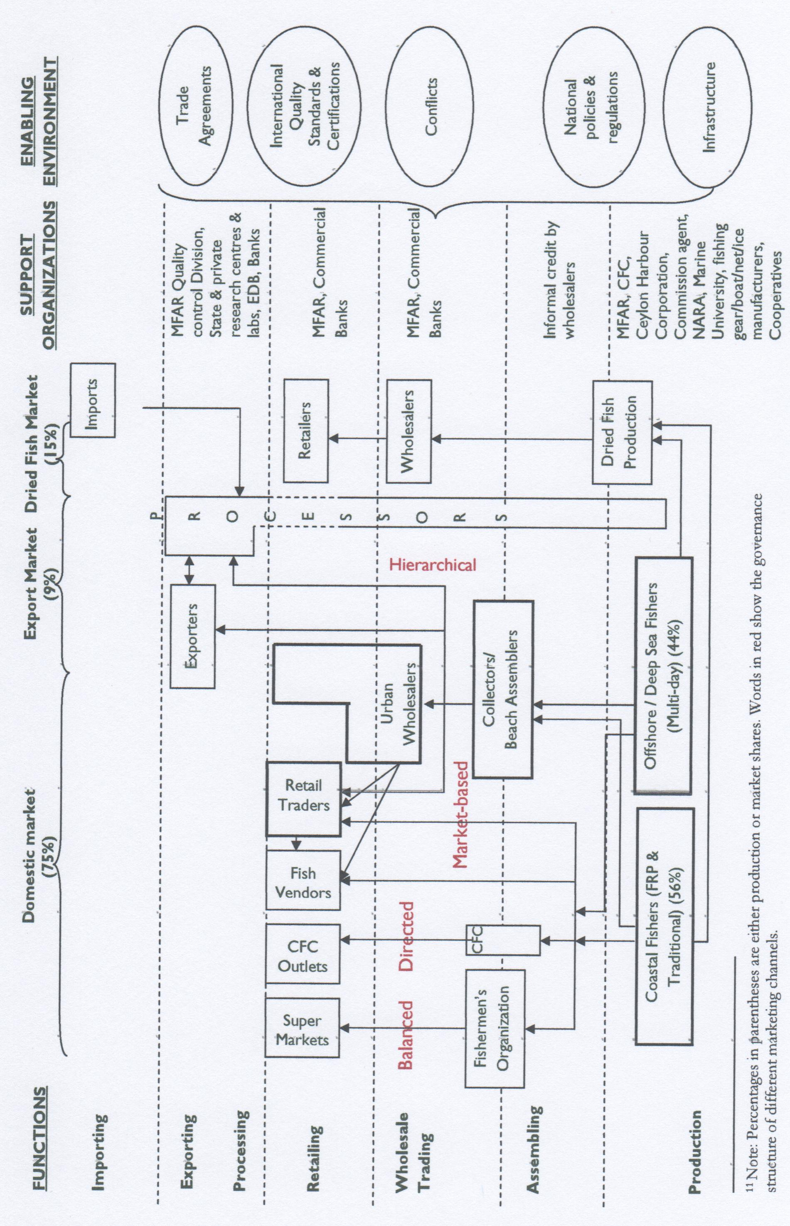
In spite of these important signs of progress, their impact remains limited and recently, Sri Lanka’s fisheries sector has performed less than satisfactorily with domestic supply unable to provide the quantities of fish products required at affordable prices to meet the nutritional needs of the country’s population. Likewise, the rapidly growing opportunities for fish exports have not been fully exploited. As a result, poverty and inequity among producers remains rampant in this sector. The chronic armed conflict and related governance failures of state institutions mandated to support the sector continue to have a significant negative impact on the Sri Lankan fisheries industry, driving the inequities and inefficiencies that characterize the sector.

Fisheries value chain structure and dynamics

End markets for marine fish
The Sri Lankan fishery sector serves both the domestic and export markets, with the domestic component attracting 75 percent of the marine fish production. In 2006, total marine fish production was 215,980 MT, and the export market and dried fish production accounted for 9 percent and 15 percent, respectively. The domestic fish market comprises a number of diverse end markets including urban wholesale fish markets, retailers, fish vendors, CFC and supermarket outlets.
St. John’s fish market (SJM) in Colombo is the largest wholesale market and domestic trading hub in Sri Lanka. SJM, where most retail activities also take place, receives supplies from all over the country; the bulk of distribution to island-wide destinations begins there. However, this internal trade has decreased drastically since the late 1980s and at present less than 20 percent of the average daily fish load at SJM comes from the north and east5—two heavily conflict-affected areas—despite the fact that these regions account for nearly 65 percent of the country’s coastline. Regional wholesale fish markets operate in the rest of the country, while a considerable amount of trading occurs through retailers.
The GoSL established the CFC in 1964 with a mandate that covered all activities pertaining to the fishing industry. After its reorganization, the CFC’s role has been limited to that of a distribution and marketing outfit with the major aim of providing competition to private traders. Due to the presence of economic and physical barriers to entry into the fish trade, producers still do not receive a fair price for their products. However CFC is intensifying its efforts to compete with the private fish trade, including through the purchase of fish at competitive prices at auction alongside private merchants. Though still insignificant in terms of scale, CFC and various supermarket chains (such as Cargills) involved in fish trading represent emerging markets.
There is a growing demand for fishery products by both local and export markets, and world demand for all types of fish products is increasing. The UK and Japan are the largest international buyers of Sri Lankan fisheries products, accounting for 25 percent and 22 percent of total fish exports respectively, followed by France, Germany and the U.S. The European Union is the main buyer for Sri Lankan fisheries exports, and the Maldives, being duty free and cost competitive, is Sri Lanka’s main competitor in the EU market. As part of its cooperation with the Bay of Bengal Initiative for Multi-Sectoral Technical and Economic Cooperation (BIMSTEC, which groups Bangladesh, Bhutan, India, Myanmar, Nepal, Sri Lanka and Thailand), Japan assists the Sri Lankan fishery sector to increase the productivity of its offshore and deep sea fisheries industry and the quality of its fish not been able to fully capture these opportunities and supply remains far below the potential capacity and existing demand.
The competitiveness of fish depends on price, quality and the stability of supply. The importance of these factors varies depending on the end market; price is the major factor determining competitiveness in the local market, while quality and regularity of supply play a major role in export market competitiveness. Although the armed conflict has drastically reduced fish supply from the north and east areas, which provided more than half of total production in the mid-1980s, Sri Lanka’s fish products currently compete well in export market in terms of both price and quality, although steadiness of supply remains a problem. Most of the fish product categories are in the ‘champions’ quadrant with positive annual growth of world imports and parallel positive growth in Sri Lanka’s exports. However, in some product categories, such as lobster and frozen shrimp, Sri Lankan exporters have not been able to fully exploit potential global demand. The focus of the sector should be on products that are experiencing negative export growth, but are in a favourable position vis-à-vis growing world demand.
Export earnings have shown steady growth during recent years—increasing from 7,126 MT in 1995 to 18,646 MT in 2006—and now account for approximately 2 percent of total GDP. Sri Lankan fish exports include fresh and frozen fish (tuna, sword fish, shark, sear, etc.), crustaceans (prawns, lobsters, crabs), sea cucumber and shark fins.

Business enabling environment
The regulation, conservation and development of fisheries and aquatic resources are addressed in the Fisheries and Aquatic Resources Act No. 2 of 1996, which comprises a number of regulations and provides for conservation and management at both national and regional levels. The National Fisheries and Aquatic Resources Policy of 2006 and The Ten Year Development Policy Framework of the Fisheries and Aquatic Resources Sector (2007-2016) include strengthening the legal framework to support fishery management, improving productivity through the use of new technology, preventing the use of habitat- and resource-destructive methods, diversifying fishing methods, promoting harvesting of underutilized species, improving the quality of fish, minimizing post-harvest losses, and increasing foreign exchange earnings from fish products. National and local fishery-related institutions provide a variety of technical and advisory support services, including research, extension and environmental conservation.
Responsibility for the implementation of policies, laws, plans and programs is centralized around the MFAR as well as departments and regional and local-level state organizations established under its auspices. The Quality Control Division of the ministry provides services such as supervision, factory approval, export certificates and awareness-raising programs on EU procedures for exporters, quality management techniques, and other relevant issues. The Department of Fisheries and Aquatic Resources (DFAR), operating under the Fisheries and Aquatic Resources Act No. 2 of 1996, is responsible for managing, regulating, conserving and developing fisheries and aquatic resources. The National Aquatic Resources Research and Development (NARA) is primarily responsible for conducting research and establishing policies designed to improve and conserve fishery resources, in particular mapping resources to determine stock levels and rate of exploitation. NARA also provides laboratory facilities for quality control. District fishery offices under the ministry are responsible for local extension services, the registration of boats, the distribution of subsidies (fuel subsidy for small boat owners and a proposed price subsidy for buying boats), maintaining environmental standards and conflict resolution at the local level.
Fish exports are regulated by the 1998 Fish Product (Export) Regulations to ensure that Sri Lankan exports meet specific international quality standards. Exporters have to obtain certificates of health and food safety and Hazard Analysis and Critical Control Points (HACCP), and obtain approval to export to the EU by the Ministry of Fisheries and Aquatic Resources. Approved laboratories in different institutions such as the Sri Lanka Standard Institution (SLSI), the Industrial Technology Institution (ITI) and NARA perform quality inspections and there are several approved private laboratories that also provide this service. These institutes are generally perceived as supportive and transparent given that the industry does not face significant difficulties or administrative obstacles in meeting export market quality and safety standards.
The Export Development Board (EDB) is responsible for promoting fish and fish product exports and it also provides capital grants at concessionary interest rates to selected exporters to enable them to upgrade their processing units according to HACCP standards. As a result, most processing plants have the necessary equipment to meet these standards, but continue to operate below their potential capacity. Currently, 26 medium- and large-scale export companies are reported to have their own processing units compliant with EU standards.
Recently, the CFC extended its support to small fishermen by assisting them in marketing and providing price support under a guaranteed price scheme. The CCD is responsible for the conservation, protection and development of the coastal zone under the Coastal Conservation Act, as amended by Act No 64 of 1988. The basic objectives of Ceynor Foundation, Ltd., established in 1967, are to build and sell fishing vessels and related marine equipment, fishing nets and other gear and to operate workshops for the fishing industry.
Fishery harbours, controlled and managed by the Ceylon Fishery Harbour Corporation (CFHC), provide anchoring facilities; harbour maintenance facilities; ice, water and fuel for vessels; boat repair and net making facilities; auction halls; and electricity and sanitary facilities. Except for a handful, most harbours are still under development, so most of these services are still provided on a subsidized basis. Currently there are 12 harbours on the coastline with the main fishery harbour in Colombo. However, existing harbour facilities are largely inadequate and privately-owned boat yards provide a considerable service to fishers around the country. The existing 37 anchorages and 710 fish landing places (or thotupola) are also inadequate, poorly managed and often lack even basic facilities.

Value chain participants

Producers
There are approximately 130,8008 fishers in Sri Lanka’s marine fishery value chain, of which approximately 90 percent operate in coastal and offshore subsectors, with the remaining 10 percent in the deep sea subsector. The total marine fishing fleet of 42,678 vessels consists mostly of small to medium-sized craft such as day boats with an inboard engine, FRP boats with outboard motors, traditional motorized and non-motorized craft and beach seine boats owned and operated by private individuals. With respect to small-to-medium sized boats, owners normally fish with a few crew members. Multi-day boats used for deep sea fishing make up only 6 percent of the total fishing fleet. Multi-day boat owners do not usually get involved directly in fishing, but hire crews instead.
Unlike modern fishing techniques that use multi-day boats, traditional fishing activities are seasonal since they depend on sea surface currents that are directly influenced by the monsoons. During the off-season, most fishermen find employment as laborers on multi-day boats or migrate to other areas that are in season. Sometimes they find wage work in other, fishery-related activities, including dried fish production.

Assembling, wholesale trading and retail
Wholesalers, collectors/beach assemblers and various categories of retailers including the CFC, supermarkets and fish vendors purchase fish as it is being unloaded from the. Consumers also assemble on the beach to buy their daily requirement of fish. Retail traders and fish vendors buy their daily market requirements from numerous fish landing sites along the coastal strip, urban wholesale markets or nearby regional markets. These small vendors and traders include those who operate fish stalls at market places or roadside locations, push-bicycle traders, motorcycle traders, pingo carriers, basket carriers and head loaders, and they tend to be relatively poor compared to other chain participants. The CFC operates purchasing centers at major fishing sites where fish is purchased at pre-determined prices, which are usually set a little above beach prices and are revised every three months.
Along the marketing channel, beginning with the beach assembler, all value chain participants maintain a profit margin that accumulates to determine the retail price. The beach assemblers’ margins depend on the wholesale market selling price and commission agents charge 5-10 percent of product value for handling. Retailers’ profit margins tend to be highly variable and are assumed to be anywhere from 25 to 50 percent or more of the selling price.

Processors
Participants in the supply chain to the export market include multi-day boat owners, assemblers, processors and other exporters. Processors are also engaged in exporting and some process the products of other exporters who do not have that capacity. In general, processors have contract arrangements with multi-day boat owners and assemblers and tend to purchase only their product if it meets quality standards. In certain cases, processors use their own multi-day boats to meet their requirements, and they import fresh fish from countries like the Maldives, Yemen and Thailand to maintain continuous production during off-seasons.

Supporting markets

The industry is supported by a number of state and private-sector fishery-related services, including boat building, fishing gear manufacture, ice production, credit, research, extension, marketing and export promotion. However, such support, particularly access to credit, is far below required levels. Due to the inherent risk and uncertainty attached to the sector and the lack of collateral, small-scale fishers are often unable to access much-needed financial and insurance services. Informal credit markets play a significant role in the small-scale fishery sector with collectors, or mudalali, usually providing credit for boat owners who consign fish to them in order to buy boats or repair their vessels in times of distress. Collectors can be wholesalers, commission agents9 at SJM or individuals operating from out-station, urban wholesale market centres. Beach assemblers also buy fish directly from the fishermen and deliver it to urban wholesale markets like SJM and regional market centres. In addition, beach assemblers who operate from villages often finance the fishermen. At times the urban wholesaler may finance the assembler so that he is assured of a continued supply of fish. These are informal credit arrangements largely operating on trust, without any guarantees or collateral. Most small traders obtain credit on interest from moneylenders operating in the market at exorbitant interest rates and/or binding obligations.

There are several other supporting market actors serving the sector including vessel manufacturers and mechanics, fuel suppliers, transporters, and so on. Fish mixed with ice are normally packed in wooden boxes, which are transported in trucks or vans to the wholesale trading centers, with only a few freezer trucks owned by private traders and CFC. The total production capacity of the 60 existing ice plants is approximately 1,200 MT—well below existing demand. Ice quality is also often below the required standards. There are about 50 boatyards and 7 gear manufacturing factories, and most are privately owned. The Ceynor Foundation is the only state-owned manufacturer.

Inter-firm linkages

Strong inter-firm linkages, both horizontal and vertical, are seen at different levels of the fishery supply chain, but they vary substantially and are dependent on other social and economic factors. For example, differences in inter-firm linkages can be observed between the two sample study sites, Negombo and Hambantota. Negombo is located close to urban centres and there are strong linkages between firms; whereas in Hambantota, which is further away from urban centres, these relations are quite weak. Differences in infrastructure and access may be the reason for this variation. Moreover, cohesion within strong fishing groups and fishery communities is observed in Negombo, but cohesion is weak among the Hambantota fishers. Although the causes of this long-standing difference are not entirely clear, what is evident is that it puts Negombo at a comparative advantage when it comes to strengthening possible future collective action.
Even though the degree of cohesion among firms varies substantially across the country, these linkages provide mutual benefits to all the parties in terms of supplying continuous and high-quality produce, regular supply of inputs, reasonable prices, financial assistance and the like, irrespective of the scale of operation.
The majority of linkages are based on formal agreements, while certain informal arrangements also exist based on mutual relationships. Contract agreements are a very effective mechanism of product transfer at both the lower and upper ends of the fishery supply chains. For example, poor fishermen who lack operational capital for fishing obtain credit from merchants on the promise of a certain percentage of the yield. Alternatively, the total catch is given to the merchant, who charges a commission for its sale. Supermarket chains such as Cargills have also entered into long-term contracts with fishery organizations on different terms and conditions; and large fish processors and exporters enter into contracts with multi-day boat owners or commission agents. This obviously restricts the freedom of fishers to sell to the buyer offering the highest price for their product, but this institutional arrangement has gained popularity as it assures a timely supply of inputs.
Horizontal linkages also exist at certain stages of the supply chain. For example, fishers with multi-day boats develop relationships with small boat-owners to provide the latter with employment as wage workers on their larger vessels during the off-season when the small boats cannot operate. At the processor level, horizontal links allow those who have surplus plant capacity to process the produce of those who do not.
The major form of inter-firm cooperation in the study area is the formation of fishery cooperative societies and the umbrella federation of such societies. Although this is primarily an outcome of the country-wide campaign for small producer cooperatives, conditions created by governance failures and the need to adapt accordingly could also represent a contributory factor. Small-scale fishers lack bargaining power and these cooperatives are an effective way of providing them a collective voice that can articulate their problems and grievances with the relevant authorities. The activities these societies encourage and facilitate include household savings, credit facilities to acquire capital assets (especially boats), the establishment of links with supermarket chains and NGOs, common property management, conflict resolution and collective bargaining.

Value chain governance and power relations

Sri Lanka’s fisheries value chain is governed by a combination of market-based, directed, balanced and hierarchical governance structures. Market-based governance is dominant in the domestic market and there tend to be minimal amounts of formal cooperation, documentation or paper transactions among participants since the entire operation is based more on trust and mutual understanding than on formal business practices.
The major reason for the emergence of other governance structures in the market is the existence of different inter-firm linkages. Balanced governance is seen in the special domestic marketing channels involving farmers’ organizations (FOs) and supermarkets. The FOs coordinate with supermarkets such as Cargills on behalf of their members to market their fish products. Since no party is dominant and the participants enjoy equal bargaining power, this can be considered a balanced marketing channel.
Directed governance is prominent in the domestic marketing channel involving the CFC and also in the export marketing channel. The CFC directly contacts either the fishers or collectors to purchase according to its own product requirements, while processors buy fish from collectors on contractual agreements. In both these instances, they determine product quality specifications, pricing structures and other regulations. Hierarchical governance is rare in Sri Lanka’s fisheries industry except for a few occasions where vertically integrated processing companies operate at different levels of the value chain.
Table 6.1 provides a summary of the opportunities and constraints related to the fisheries value chain.
Table 6.1. Opportunities for and Constraints to Upgrading

End Markets | Opportunities | Constraints
Export market | Unmet and increasing demand in the export market for tuna fish | Limited supply of quality fish for exporters and processors due to:  - Post-harvest losses (poor storage facilities and handling methods)  - Fuel costs  - High operational costs make it difficult to compete with other competitors in the export market  - High initial capital costs to comply with HACCP standards
Local market | High demand in the local market for fresh fish | - Demand in the local market for imported canned fish  - Cheap fish imports for local consumption  Declining fish catch over time due to:  - Increased number of boats  - Use of undesirable and illegal methods that destroy fish breeding grounds (destructive, resource-unfriendly gear, e.g., certain gill nets with smaller mesh size and light course methods).
Enabling Environment | - EU - Generalized System of Preferences (GSP) scheme provides duty free access for Sri Lankan fish to European markets  - Future opportunities to export fish to Japan under BIMSTEC agreement  - EDB support – grant scheme for exporters to upgrade their factories to comply with EU standards  - Support of MFAR quality control division to comply with standards | - Levies charged by Sri Lankan ports for foreign vessels comparatively high  - The CFC buys 25 percent of foreign vessel fish catch at fixed prices (lower than the market price)  - Conflicts over exceeding Sri Lanka’s boundaries  - Increasing fuel prices  - High air freight charges for edible fish exports  - High aviation security charges for exports  - Flight delays and no direct flights to certain countries  - Difficulties in obtaining health certificates for urgent orders (MFAR works only weekdays and during specific hours)  - Delay in refunding VAT for the exporter  - Poorly targeted ad hoc subsidies  - Inefficient use of available institutions and facilities (CFC)  - Inadequate and poorly targeted research and development that does not cater to the industry  - Inadequate infrastructure facilities  - No proper anchorages in remote areas  - Overcrowding of existing harbours and anchorages  - Limited space to expand harbours due to encroachments.

Conclusions

This brief overview has shown that the value chain analysis approach is useful for analyzing the fisheries and aquaculture industries in Africa, and that through the application of this approach, new insights may be gained and valuable new strategies may be developed, both at the micro-economic (company) level and at the macro-economic (national) level.
The value chain analysis can be applied to pure descriptive studies, where the purpose is to describe a process and for example allocate portions of the costs to the various elements. But it can also be used as a model in more analytical studies, where relationships and mechanisms are described.
Value chain analysis has been of particular use in business investment analyses, where it can provide a firmer ground for making decisions about investment opportunities.

References

Albrigtsen, Tom: Tilapia farming in Uganda. The supply and demand in fish farming value chain, from grow-out to end user markets. Report published by Norad, Oslo, December 2004.
Ardjosoediro, and Neven, David: The Kenya Capture Fishery Valaue Chain: An AMAP-FSKG Value Chain Finance Case Study. USAID Microreport #122. Washington DC, October 2008.
Asche, Frank and Gudmundsson, Eyjolfur, and Nielsen, Max: Revenue distribution through the seafood value chain. FAO Fisheries Circular No. 1019, FAO, Rome, 2006.
Blakstad, Frode (Ed.): The value chain in Norwegian aquaculture. A series of articles published by KPMG Aquaculture and Fisheries, Trondheim (Norway), 2001.
Bolwig, Simon and Stefano Ponte, Andries du Toit, Lone Riisgaard and Niels Halberg: Integrating Poverty Gender and Environmental Concerns into Value Chain Analysis. Danish Institute for International Studies, Copenhagen, 2008.
Chen, Fen-Lan et al.: Traceability and Supply Chain Management for Cage Culture Industry in Taiwan – the Case of Cobia.
Dubay, Kirsten and Saori Tokuoka and Gary Gereffi: A Value Chain Analysis of the Sinaloa, Mexico Shrimp Fishery. Center On Globalization, Governance and Competitiveness, Duke University, Durham (NC), March 2010.
Ducker, Michael and Webber, Martin: Ugandan Nile Perch Quality Management and Certification. Case study presented in “Building Competitiveness in Africa’s Agriculture. The World Bank, Washington DC, 2010.
Gorman, Michael and Webber, Martin: Understanding the Value Chain and Integrating Information into Strategy – Nigerian Domestic Catfish. Case study presented in “Building Competitiveness in Africa’s Agriculture. The World Bank, Washington DC, 2010.
Hempel, Erik and Russell, David: Value addition: Assessment of Opportunities for Increased Value Addition and Improved Marketing of Namibian Marine Fish Products. Ministry of Fisheries and Marine Resources, Windhoek, Namibia, April 2007.
Hempel, Erik: The strategic role of the value chain. Presentation at INFOSA Regional Workshop on International Markets for Fish and Fish Products. Stellenbosch, South Africa, 25 – 28 August 2008.
Hempel, Erik and Russel, David and Mapfumo, Blessing and Uahengo, Loide: Value addition - Assessment of Opportunities for Increased Value Addition and Improved Marketing of Namibian Marine Fish Products. Ministry of Fisheries and Marine Resources, Windhoek, Namibia, April 2007.
Høyum, Morten: Report of Feasibility Study for establishing Tilapia Hatchery Operations in Uganda. Confidential report. Oslo, 2004.
Kaplinksy, Raphael and Morris, Mike: A Handbook for Value Chain Research. IDRC.
Kasulo, Victor and Charles Perrings: Fishing down the value chain: Biodiversity and access regimes in freshwater fisheries – the case of Malawi. Article available on the net: www.sciencedirect.com. Published 27 December 2005.
Kurien, John: Responsible fish trade and food security. FAO Fisheries Technical Paper 456. FAO, Rome, 2005.
Macfadyen, G. and A.H.S. Ediriweera, U.L.K. Perera, R.P.S.P. Rajapakshe, K.H.M.L. Amaralal and M. Mahipala: Value Chain Analysis of Beche de Mer in Sri Lanka. National Aquatic Resources Rsearch and Development Agency, Sri Lanka, May 2009.
OECD: Globalization in Fisheries and Aquaculture – Opportunities and Challenges. OECD, Paris, 2010.
Russell, David: Issues and strategies for value addition and trade of African fish and fish products. Unpublished draft prepared for FAO, August 2005.
USAID: Finance in Value Chain Analysis – A Synthesis Paper. USAID, Washington DC, October 2008.
Veliu, Atdhe et al.: Gender Analysis of Aquaculture Value Chain in Northeast Vietnam and Nigeria. World Bank Agriculture and Rural Development Discussion Paper 44, Washington DC, 2009.
Webber, C. Martin and Labaste, Patrick: Using Value Chain Approaches in Agribusiness and Agriculture in Sub-Saharan Africa. A Methodological Guide. The World Bank. Washington DC.
Webber, C. Martin and Labaste, Patrick: Building Competitiveness in Africa’s Agriculture. A Guide to Value Chain Concepts and Applications. The World Bank, Washington DC, 2010.
Yu, Run and Lotus E. Kam and PingSung Leung: The Seafood Supply Chain and Poverty Reduction. Department of Molecular Biosciences and Bioengineering, University of Hawaii at Manoa, Honolulu, 2006.

From “Revenue distribution through the seafood value chain” by Frank Asche et al., FAO Fisheries Circular No. 1019, Rome, 2006
Frank Asche et al., 2006
A relatively recent study on this subject, which also used the value chain approach, is the study by the Namibian Ministry of Fisheries and Marine Resources on “Value addition - Assessment of Opportunities for Increased Value Addition and Improved Marketing of Namibian Marine Fish Products”.
Asche, Frank and Eyjolfur Gudmundsson and Max Nielsen,: Revenue distribution through the seafood value chain. FAO Fisheries Circular No. 1019, FAO, Rome, 2006
EurepGAP is a common standard for farm management practice created in the late 1990s by several European supermarket chains and their major suppliers. GAP is an acronym for Good Agricultural Practices. The aim was to bring conformity to different retailers' supplier standards, which had been creating problems for farmers. It is now the world's most widely implemented farm certification scheme. Most European customers for agricultural products now demand evidence of EurepGAP certification as a prerequisite for doing business. The standard was developed using theHazard Analysis and Critical Control Points (HACCP) guidelines published by the United Nations Food and Agriculture Organization, and is governed according to the ISO Guide 65 for certifications schemes. Unlike other farm certification schemes, it has definitive rules for growers to follow, and each production unit is assessed by independent third party auditors. These auditors work for commercial certification companies who are licensed by the EurepGAP secretariat to conduct audits and award certificates where merited. In September 2007, EurepGAP changed its name to GLOBALGAP. The decision was taken to reflect its expanding international role in establishing Good Agricultural Practices between multiple retailers and their suppliers. A series of the standards can be accessed online
“Omena” is the Kenyan name for Silver Cyprinis, a small, silvery 2-inch fish, unique to its natural habitat Lake Victoria. It is called “dagaa” in Tanzania and “mukene” in Uganda.
The word “buka”refers to a “canteen or eating house” in the Hausa language.
This is a follow-up to a 2004 study on the impact of international fish trade on local food security, published as FAO Fisheries Technical Paper 456.

