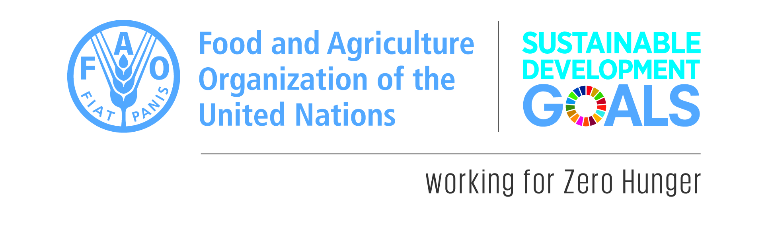
SUBMISSION TEMPLATE
Deadline: 10 October 2018

The FAO Regional Office for Europe and Central Asia is launching a Call to European Union countries for good examples of partnerships that support achievement of Sustainable Development Goals relating to sustainable food and agriculture.
On 25 September 2015, the 193 Member Countries of the United Nations adopted the 2030 Agenda for Sustainable Development underpinned by 17 aspirational objectives, i.e. Sustainable Development Goals (SDGs), to guide collaborative actions of governments, international agencies, civil society and other institutions until 2030. The 2030 Agenda sets forth a transformational and ambitious plan which requires strengthening cooperation and global partnerships between multiple actors and across a broad range of areas for the achievement of the SDGs.
FAO aims to collect good and innovative examples of partnerships in order to share them with a wider audience in the countries of the region and beyond.

* The guiding questions below are adapted from the general FAO template for good and promising practices, available at http://www.fao.org/3/a-as547e.pdf.
Submission Form

Title
[What is the title that best describes your good example of partnership?]

Summary
[Provide a summary of the good example of partnership including the expected outcome – up to 70 words]

Modality of the partnership
[Please tick the relevant box and provide further details]

Partnership with official partnership agreement, i.e. Memorandum of understanding or others [Please specify the type of agreement]

Partnership without official partnership agreement
[Please provide further details, if available]

Type of Partnership
[Please tick the relevant box]

State actor with State actor

Non-state actor with Non-state actor

State actor with Non-state actor

Others

Please provide further details on the type and names of the actors involved, e.g. government institutions, civil society organization (CSO), academia, private sector:
Start date of the Partnership
[Month and year]

Geographical coverage
[Country, region, province, district, town, village]

Authors
[Name, organization, email]

Sustainable Development Goals (SDGs)
[Which Sustainable Development Goal(s) does the initiative address? Please refer to specific SDG targets. – multiple contributions are possible]

The good example of partnership is on:
[Please check the box with the most relevant answer for your partnership]
1. SDG IMPLEMENTATION i.e. partnerships for the implementation of projects/programmes/policies related to sustainable food and agriculture in the context of the SDGs at national and sub-national level.
As SDG implementation related to food and agriculture comprises a wide range of sub-topics, please tick which action(s) below the proposed good example of partnership is contributing to.
Facilitate access to productive resources, finance and services
Connect smallholders to markets
Encourage diversification of production and income
Build producers’ knowledge and develop their capacities
Enhance soil health and restore land
Protect water and manage scarcity
Mainstream biodiversity conservation and protect ecosystem functions
Reduce losses, encourage reuse and recycle, and promote sustainable consumption
Empower people and fight inequalities
Promote secure tenure rights
Use social protection tools to enhance productivity and income
Improve nutrition and promote balanced diets
Prevent and protect against shocks: enhance resilience
Prepare for and respond to shocks
Address and adapt to climate change
Strengthen ecosystem resilience
Enhance policy dialogue and coordination
Strengthen innovation systems
Adapt and improve investment and finance
Strengthen the enabling environment and reform the institutional framework
For further details, please refer to Transforming Food and Agriculture to Achieve the SDGs: 20 Interconnected Actions to Guide Decision-makers.
2. SDG NATIONALIZATION, i.e. partnerships that facilitate and promote collaboration between state actors in areas related to food and agriculture or the engagement of non-state actors working in the food and agriculture sector in the SDG national processes (e.g. these might relate to mechanisms and processes in place, such as SDG multi-stakeholder bodies, SDG monitoring and reporting, alignment of national policy frameworks, SDG localization).
__________________________________________
Describe the challenge that the proposed good example of partnership is addressing/addressed? (up to 250 words)
This section should provide an overview of the challenge in the country or region in which the partnership is being implemented in (or has been implemented) and what is required to address it for the achievement of one or more of the SDGs.

Towards a solution (up to 700 words)
In this section, kindly ensure the following ‘guiding questions’ are addressed in the answer. The answer should not exceed 700 words.
Do not answer the questions under each question, but address them in the “insert text here” section.
- What does the initiative/partnership aim to achieve in response to the challenge(s)? Please indicate all the relevant SDG(s) the solution aims to address.
- Who are the beneficiaries and the partners involved in the initiative (i.e. governmental institutions and non-state actors, such as academia, CSOs, private sector)? Is there any disaggregated data on stakeholders (i.e. by sex, age, race, ethnicity, migratory status, disability, geographic location and other characteristics relevant in national contexts)?
- In what way has the initiative contributed to not leave anyone behind, in line with the principles of the Agenda 2030?
- What methodology has been used to address the challenge that led to a successful outcome and in accelerating/achieving the SDGs? How was the participatory approach ensured?
- What makes the partnership particularly effective, impactful and innovative?
- What were the outcomes achieved in relation to the SDG(s) targets? (Please include quantitative data highlighting the outcomes)
- Does the initiative promote an integrated approach to sustainable development (i.e. balancing all three dimensions: social, economic growth and environmental protection; an integrated approach implies managing trade-offs and maximizing synergies across targets)?
- What are the elements that make the initiative institutionally, socially, economically and environmentally sustainable?
- What are the challenges that came up during the partnership and how they were negotiated?
- If you were giving advice to governmental institutions and non-state actors in another geographical area, what would you indicate as preconditions required for the initiative to be replicated/adapted to the new context or scaled up (at national, regional or international level)?

It is highly recommended to include information that is sensitive to gender, or the difference between men and women.
Insert text here: (up to 700 words)

Contact details
The contact information for further inquiries regarding the proposed good example of partnership:
Name and Last name:
Address:
Country:
E-mail address:
Organization (please specific if it is a government institution, academia, CSO, private sector, other):
Telephone number:
Photo:
Short bio (10 lines max):

Please include 3-4 high resolution photos related to the initiative, with photo credit, copyright and caption details for each

Related resources
What training manuals, guidelines, technical fact sheets, posters, pictures, video, audio documents, websites have been created on the initiative? Please provide any available web links.

Metadata
Project/Initiative name:
Implementing Partners:
Project status:
Project period:
Website of the project/initiative:
Website of the partners:
For more information
Please contact Ms. Valeria Rocca, International Consultant for SDG support: valeria.rocca@fao.org

