2013/2014 NAMIBIA CENSUS OF AGRICULTURE

SUPERVISOR's INSTRUCTION MANUAL

November, 2013

CONTENTS
Page
CHAPTER I
INTRODUCTION
  - Objectives of the 2013/14 Namibia Census of Agriculture …………………….……
  - Role of Supervisors…………………………………………………………………………………......
  - Training……………………………………………………………………………………………………….
  - Census Documents……………………………………………………………………………………..
Chapter II
ORGANIZATIONAL AND ADMINISTRATIVE DUTIES
2.1 Introduction…………………………………………………………………………………………………….
2.2 Communications with the regional coordinator and implementation
of his instructions……………………………………………………………………………………
2.3 Field supplies and information………………………………………..……………………………….
2.4. Contacting local authorities…………………………………………………………………………….
2.5. Briefing enumerators on field conditions………………………………………………………..
2.6. Transferring collected data other materials ……………………………………………………
2.7. Other administrative tasks………………………………………………………………………………
Chapter III
SUPERVISORS DUTIES
3.1. Introduction…………………………………………………………………………………………………….
3.2. Dealing with non-response………………………………………………………………………………
3.3. Spot checking………………………………………………………………………………………………….
3.4. Re-interviewing sampled holder………………………………………………………………………
Chapter IV
Field Operation………………………………………………………………………………………………..

Chapter 1

Introduction

  - Objectives of the Census
The main objectives of the 2013/2014 NCA is in the first place to provide basic agricultural data on the communal and commercial farming sectors required for policy making at national, regional and constituency levels. For the WCA 2010 round, the objectives of the agricultural census are to:

- Provide data on the structure of agriculture, especially for small administrative units, and to enable detailed cross-tabulations.

- Provide data to use as benchmarks for current agricultural statistics.

- Provide frames for agricultural sample surveys.

- Use the census as a vehicle for developing the national agricultural statistics system,
- Secure data for items whose production is limited (rare crops),
- Secure benchmark data for improving the annual agricultural sample survey in the future,
- Make use of the census experience and trained personnel for capacity building and strengthening the Namibian Statistical Agency in the field of agricultural statistics,
- Provide data to help monitor progress towards NDP4, Vision 2030 and global development targets, in particular the MDGs.
There are needs for more accurate data for:
- Monitoring the performance of the sector
- Policy analysis
- Crop and livestock production
- Rural Development Planning
- Agricultural Marketing
- Early Warning and Food Security Monitoring

  - Role of the supervisor
The supervisor serves as a link between the census organizers and the enumerators. He goes out in the field with the enumerators, assigns them work, supplies them with necessary material, collects and checks their work and makes sure that they act in accordance with the instructions of the census organizers. He also provides instruction and helps the enumerators during the field work.

In addition, a supervisor receives from the census organizers instructions, field equipment and other necessary supplies. He promptly returns the census documents to the organizers, and keeps them informed regarding the general progress of the work. He also records and communicates enumerator’s difficulties to the organizers and receives their advice on these problems.

Much of the training the enumerators undergo, is concerned with teaching them how to conduct good interviews and apply correctly objective techniques. An enumerator’s behavior can obviously influence the answers he receives. He has to learn to conduct an interview in such a way that he obtains accurate and complete information from the respondent (usually the head of the household or holder of selected household). A good interview, of course, also requires a thorough understanding of the meaning of all questions in the questionnaire. You, as a supervisor, also have to be a good enumerator, since one of your main duties is to supervise enumerators’ work. You will be assigned to 4 enumerators working as a team whose work you will have to supervise during the field operation.

Your regional supervisor will give you a list of selected Primary Sampling Units (PSUs) where interviews and other census activities have to be done. You will, in return, distribute the work among your enumerators.

We stress here a very important principle: only those selected according to the census instruction must be interviewed; it is also important that a very serious attempt be made to obtain interviews for all selected units, households’ holders, fields, etc.

The regional supervisor will have a special task in the overall control of the field work. This means that he will pay periodic visits to your unit during which he will supervise your, as well as the enumerators’ work. This controlling operation is an integral and necessary part of every census which aims to collect data of high quality. Specially, where a number of enumerators are involved in the field work, there is imperative need to ensure that standard and uniform procedures are followed by all.

  - Training
Your training, as well as the enumerators’, is crucial to the success of the survey operation. Since you will be responsible for supervising the work of the enumerators, you must be familiar with the interview procedures, measurements techniques and the Census documents used. In short, you must be a good enumerator, and also must know how to evaluate and check enumerators work. This is the first purpose of your training program.

In addition to supervising the enumerators’ work, you must also organize and assign the work to the enumerators, keep records with regard to the progress of the work and perform other organizational and administrative tasks. The second purpose of your training program is to give you instruction in this phase of your job. You will learn how to handle situations which may arise, which the enumerator is unable to resolve.

During the training time you will study and discuss the survey documents as they relate to your responsibilities and tasks. The questionnaires will be explained in detail and measurement techniques will be demonstrated in the field. Your performance during the training will be evaluated on the basis of observation by the trainers plus the results of tests which will be given during the training program.

After you have completed the first part of your training program you will then participate in the enumerators’ training and you do some more practical interviews in the field as well as measurement techniques. It is necessary for you to participate in the enumerators training because, as supervisors, you must have an understanding of the essentials of enumerators work. In addition, you will be able to see how your supervisory responsibilities relate to the interviewing procedures and measurement techniques.

Prior to beginning their actual field work, the enumerators will go into non sample areas and conduct practice interviews and measurement techniques. They will be required to check and edit these interviews and measurement, just as they would during their actual assignments. You as supervisors, will review, edit and discuss the work with the enumerators, just as you will do during the main survey field work.

The training of enumerators and supervisors does not end when the formal training is completed. Each discussion the regional supervisors hold with the field supervisors’ amounts to a continuation of their training. Likewise, each time a supervisor meets with an enumerator, the training is being continued. The formal training period provides the enumerators and supervisors with the basic knowledge and information regarding the census questionnaire, area measurement techniques, etc. and continued observation and supervision during the field work continues the training process.
  - Census documents
The basic Census documents to be used in the field are:
- Questionnaires on CAPI

- Section 01: Household listing within PSU
- Section 02: Demographic characteristics and activity status of household members
- Section 03: Land under different land uses
- Section 04: Extension services and agricultural information
- Section 05: Access to facilities
- Section 06: Means of transportation
- Section 07: Storage facilities
- Section 08: Loan/credit
- Section 09: Farm Management Practices
- Section 10: Aquaculture
- Section 11: Forestry
- Section 12: Apiary
- Section 13: Food security
- Section 14: Economic activity
- Section 15: Labor inputs
- Section 16: Equipment
- Section 17. Production and disposition of products
- Section 18: Livestock
- Section 19: Area Measurement
- Section 20: Selection of Crop cutting plots
- Section 21: Crop-cutting results
B. Instruction manuals (hard copy)
-Enumerators’ Instruction Manual,
-Supervisors’ Instruction Manual,
C. Table of random numbers
As supervisors, you must be thoroughly familiar with the material in these documents.
We now give you more details about each of these three groups of documents.
As mentioned above, there are 21 basic questionnaires which are used for interviewing and for objective measurements (area measurement and crop- cutting experiment).

The enumerators’ instruction manual and supervisors’ instruction manual inform you in detail of procedure to follow in the survey. They specify your duties and help you to follow the training course properly; they also serve as reference during the field work. You must study these carefully and repeatedly during training, and must always carry them with you during visits.

Chapter 2

ORGANIZATIONAL AND ADMINISTRATIVE DUTIES

2.1 Introduction

Your duties as supervisors may be divided into three basic area: organizational and administrative, and supervisory. Your organizational and administrative tasks concern:
- Regular communication with the regional coordinator and implementation of his instructions;
- Obtaining necessary information about the area (Enumeration Area) you will work in and securing required field supplies;
- Making contact with local authorities in the constituency and EA
- Assigning your enumerators to the selected areas and arranging for travel and accommodation when required;
- Briefing enumerators about the area
- After the enumerators have completed the field work, the CAPI (Laptops) and census documents and equipments, it is also your duty to return these promptly to the head office along with other relevant material. In addition, you may have to perform other administrative tasks like paying the enumerators for their work, etc.
2.2 Communications with the regional coordinator and implementation of his/her instructions.

The regional coordinator has the overall and ultimate responsibility for the census carried in his particular region. Since he cannot do all the work himself, this responsibility is delegated the supervisors. It is one of your responsibilities to see that all his instructions are followed properly. A major part of these instructions, of course, consists of the field procedures to be followed, field procedures are described in the enumerators’ instruction manual. In addition, however, you may receive further instructions from time to time. It is important to follow all these instructions in order to ensure the good quality of the work.

2.3 Field supplies and information

Before going into field with your enumerators you must make sure that you have been issued all materials you will need for carrying out the survey. In addition, check that all the necessary information that you need during your stay in the field is available to you.
You will need adequate supplies of:
- Survey documents (manuals, questionnaires, identification cards and letters of introduction to HHs) ;
- Stationary (pens, notebooks) ;
- Funds (for making payment and other expenses); and ????
- CAPI, GPS, Car-chargers, portable balance scales, poles (for marking starting point), 5m x 5m ropes, a 7.07m rope, etc
For each area, you will need information on:

- General information about the area, for example, travel, accommodation, and how to make initial contact;
- How to list all households, without omissions or duplications
- How to deal with non-response,
- How to deal with area and crop cutting experiments
- Details of any other administrative duties to perform.
2.4. Contacting local authorities

Before you go into an area it is expected that constituency/regional staff will give you instructions as to whom you should contact regarding the census. For example, it may be necessary to visit the local authorities in the area to explain the purpose of the census. You should stress the confidential nature of the information you collect.

2.5. Briefing enumerators on field conditions
Using the information you have received about the area in which the field work is to be done, you should brief the enumerators about expected length of stay in the area, general travel and accommodation situation, distances over which travel will be required, etc. also, familiarize them with the area, and any other aspects which may be relevant.

2.6. Transferring collected data other materials
After the enumerators have returned to you the work assigned to them and you have checked this work, it is your responsibility to transfer promptly all the collected information through the system lay down by the census organizers to the regional office. It is your responsibility to make sure that arrive at the region safely.
2.7 Other administrative tasks
You must also perform satisfactorily any other administrative tasks the census organizers may assign to you from time to time. This could include regular payment to the enumerators for work and travel, contacting particular persons in the area for special information required during the field work in the area, etc
Accommodation and Transportation
- Accommodation
Arrangement of the accommodation for interviewers will be your responsibility. The guideline to follow is that the interviewers should be as close as possible to the PSU. The residential area of the interviewer should also be taken into account. If they are residing within 80-Km radius of the PSU then they should operate from their own residence.
ii. Transportation
The supervisor will be solely responsible for all the vehicles, which have been assigned to her/his team and should abide by all the regulations concerning the usage of government vehicles. From time to time you may allocate vehicles to interviewers for local transportation of the team within PSU or between PSU. When you do so the interviewer concerned should have a valid driving license and he/she should abide by the other regulations. You will be responsible for such allocations of vehicles. This should be done in collaboration with the head office. Once an interviewer is appointed to drive a vehicle Head Office should be informed immediately.
Chapter III
SUPERVISORS DUTIES

3.1. Introduction
Your supervisory duties concern checking the quality of enumerators’ work and generally ensuring correct conduct during the field work. You will:
- Assign work to enumerators
- Promptly collect the completed work and edit it
- Deal with cases where complete interview or objective measurements could not be obtained/non-response. Make field visits to check, for selected cases, that only sampled households have been interviewed and appropriate fields were measured/spot-checking;
- Re-interview selected cases and re-measure selected fields, and
You also ensure that enumerators’ conduct is proper, that they are continuously briefed with a view to improving their performance and that the census organizers are promptly informed of any practical problems on which you need their advice.
3.2. Legal Provisions
You should be very well conversant with the Statistics Act and should be able to explain it to the interviewers as well as to the respondents whenever it is necessary.
3.3. Dealing with non-response
It is essential for the quality of the census data that all the sampled agricultural households are interviewed to obtain the required information, and all the fields are measured. Failure to obtain a complete interview or objective measurement is called non-response. One of your important supervisory duties is to reduce the extent of non-response. Non-response may arise from various sources but the most important ones are:
- the enumerators’ inability to locate the holders/households for an interview, or their inability to find the holders/household heads at home for interview, and
- the holders’ refusal to be interviewed or to have their fields measured
Note: 1. substitution of other non sampled households/holders for the non-responding cases is not a solution to the problem, and must never be done.
2. One of the most effective ways of reducing the extent of non- response is to make repeated visits to the sampled households/holders
3.4. Spot checking
It is very important that the enumerator contacts the correct agricultural households and interviews all the agricultural holders within the sampled household. It is also important that the enumerator measures all the fields of the sampled households according to the instruction and procedures. Two kinds of checks should be made to ensure what has been done by the enumerator is correct:
- Check by field visit that the sampled households have been visited by the enumerator and all the fields of the sampled household have been measured.
- Check by the field visit that all sampled households are indeed selected and the enumerator has interviewed the right persons
In general, it is your duty to visit for spot checking any doubtful cases you come across.
One of your most important tasks is to ensure that reliable and accurate data is forwarded to head office from the field.
To achieve this purpose, you should develop a good checking procedure as soon as the fieldwork has started.
To get a better understanding of your interviewers' work, as soon as they start working you should check each and every one of them in the field. You should also check a few completed questionnaires from each one of them. In this way you will get to know about the better and the weaker interviewers. Then you must pay more attention to the work of the weaker ones than the others.
Never allow the interviewers to feel that their work will not be checked. Therefore you must build up a systematic checking procedure throughout the fieldwork period from start to end.
Once the fieldwork of a PSU has started you should monitor the work of the interviewers continuously up to the end.
You should take over the completed questionnaires from the interviewers on a continuous basis without waiting till they finish the work of the PSU completely and perform the checks described below.
This will enable you to find out about the various discrepancies in the completed questionnaires, which can be rectified, either by discussing with the interviewers or by asking them to revisit the households while you are still in the field.
This will also spread your workload over the assigned period and at the end of the period the pressure will be less.

3.5 Re-interviewing sampled holder/household
Re-interviewing is another method of assessing the quality of the enumerator’s performance. Re-interviewing should be very frequent during the first and last weeks of the field work. During your visit, you should conduct at least one re-interview and one re-measurement of field area according to instruction given and if found discrepancy, it should be corrected before transferring the data to the regional office.

3.6 Call Backs

Enumerators have been instructed to leave a word with neighbors or to leave call back cards in the urban areas. The enumerator should report all outstanding callbacks to the Team Supervisor at the end of each enumeration day. The Team Supervisor should advise the enumerator appropriately after the third unsuccessful visit.

3.7 Coverage Check

Field coverage check is intended to ensure that the following have been enumerated.

All farms, all villages, all homesteads in the enumeration area
- To do so ensure that all houses, all buildings and structures have a sticker.
- Be particularly meticulous with checking coverage in areas adjacent to PSU boundaries. You should record in your notebook date of visit, whether you carried random checks and your findings and action taken.

FIELD NOTEBOOKS

The field notebook is used to record all matters relating to the census operation. Specifically you should record in the notebook:
Your daily observations on the progress of work, e.g. how many households are
enumerated on each day.

- The nature of Enumerators errors noted when observing an interview and when editing each enumerator’s work.
- Ensure that the notebook is clean and handwriting is clear and legible
- Challenges faced by your Enumerators and yourself and how you solved them.

- Remember that you will have to return your notebook to the Regional Supervisor. Your comments and those of other supervisors will help in the preparation of the Census Administrative Report. Your comments should, therefore, be as clear as possible.

Chapter 4
Field operations
1. Meet the responsible persons such as councillors, town clerks, headmen etc. before commencing the listing operation and explain to them about the tasks involved and request their co-operation.

2. As soon as you move into a new area check whether the public relations activities have taken place. If you find out that no such activities have taken place or what has taken place is not adequate it is your responsibility to arrange for the public relation activities before commencing the listing operation. A copy of the most recent Press Release should always be with you.
3. For each field team of one supervisor and interviewers there will be 2 interviewer sub-teams, each consisting of 2 interviewers.
As soon as work can be started you should allocate one PSU to each team and instruct them to start the listing operation. During the 5 weeks of fieldwork each sub-team of 2 interviewers will have to cover 2-3 PSU's.
Chapter 5

How to download Tracks (Area Measurements) and Waypoints (DU coordinates) from GPS
First before you open ozi-explorer, ensure that your GPS is connected to your laptop and it should be switched on.
- Open ozi-explorer, by double clicking on the icon on your desktop or by clicking/selecting it from your programs.


- From the main menu select file – from the file menu select configuration (This is to set up the software to be able to recognise the GPS model that it is reading from)

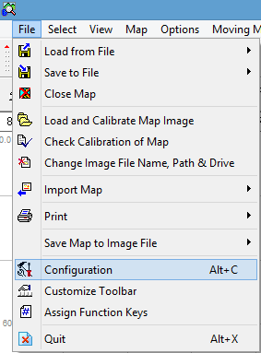

- Once the configuration page is open ensure that the GPS and COM pages are set up as follows:
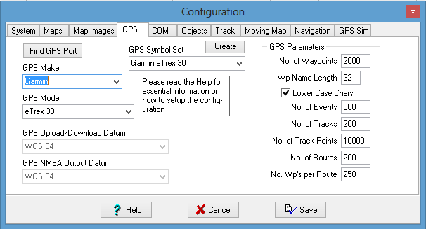
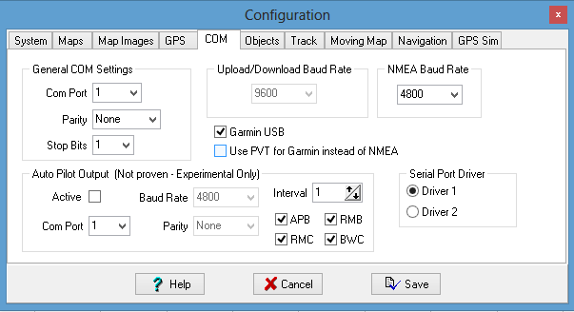

Once all is setup as indicated above then click on SAVE.

Downloading Waypoints (DU coordinates) from GPS

- From the toolbar find the icon GET WAYPOINTS FROM GPS and click on it (this is the icon that will enable you to receive the DU coordinates from the GPS)
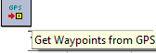

- The massage below will appear as an indication that the download was successful:

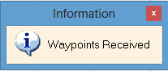
After seeing the above massage you should now be able to see the point dataset that you captured.

You should note that this points you downloaded are in a temporary location on your PC are not in a format easily readable by most GIS applications there for you are required to save it as shape file.

- To save downloaded files to shape file click on file from the main menu, select save to file, select export to ESRI shape file, and select waypoint to points.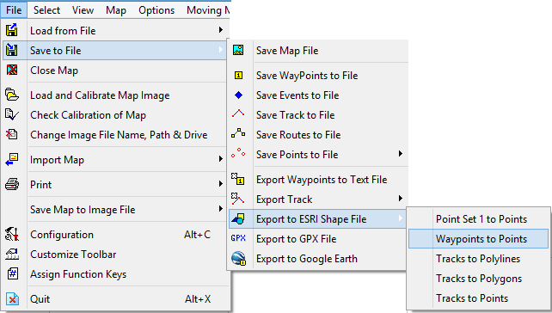
- Brows to the location where you are saving all your work for this project
(This should be the order of how you fill your data)

C-drive
Agric Census Pilot
Dwelling Unit
Team 1
Team 2
PSU number

PSU number

Below is an example (Ensure that for the file name is that of the PSU you are working in)
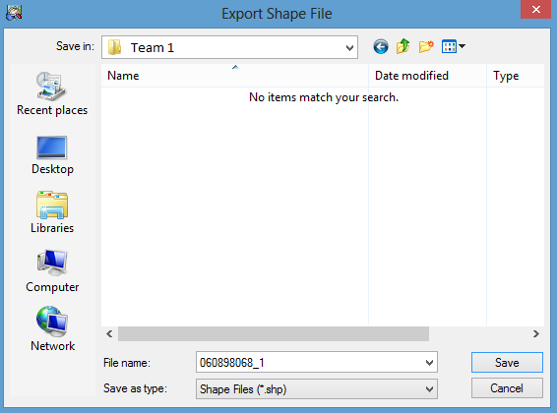

Downloading Tracks (Area Measurements) from GPS

- From the toolbar find the icon GET TRACK FROM GPS and click on it (this is the icon that will enable you to receive the Tracks area measured polygones) from the GPS)
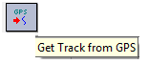

- A massage will appear as an indication that the download was successful:

After seeing the above massage you should now be able to see the track dataset that you captured.

You should note that this points you downloaded are in a temporary location on your PC are not in a format easily readable by most GIS applications there for you are required to save it as shape file.

- To save downloaded files to shape file click on file from the main menu, select save to file, select export to ESRI shape file, and select tracks to polygons.
- Brows to the location where you are saving all your work for this project
(This should be the order of how you fill your data)

C-drive
Agric Census Pilot
Waypoints
Team 1
Team 2
PSU number
PSU number

Below is an example (Ensure that for the file name is that of the PSU you are working in)

NB!!!
It is required that all this dataset are sent back to head office at the end of the survey
Chapter 6

