Benefits of Improving Ground Water Recharge
Wardha district is comprised of 1006 villages located in its eight blocks. The total population of Wardha district is 1.29 million (12,96,157); out of this, 4, 20,873 population (32.47%) lives in urban area, whereas 8,75,284 population (67.52 %) is inhabitant of rural areas. The total geographical area of Wardha district is 6309 sq km or 6,29,000 ha of land, of which 4,26,200 ha area is under cultivation. Around 3, 83,300 ha area is covered under Kharif season, while only 43,600 ha area is cultivated under Rabi season. The important crops like cotton, soya bean and pigeon pea (Tur) are raised during Kharif season, wheat and green gram during Rabi season and ground nut during the summer season.
Average rainfall of Wardha district is 1062 mm. The surface rain water runoff takes away fertile top soil and that leads to severe soil erosion. This enormous loss of soil adversely affects its fertility status and land use. About 10 % of the eroded material usually gets deposited in streams and rivers resulting in silting up of river beds and reservoirs, thereby reducing water flows, ground water recharge and water retention capacity of the soil. This, in turn, decreases the crop productivity, ultimately resulting into lower incomes to the farmers.
Measures like rejuvenation of rivers/streams, construction of check dams, percolation tanks, farm ponds, recharging of existing wells, promotion of group lift irrigation, group water lifting device, group wells, etc. along with soil & water conservation measures such as Nala plugging, construction of Gabion structures, farm bunds and contour bunds have been initiated by Kamalnayan Jamnalal Bajaj Foundation with an active participation of the local community. For efficient and judicious use of available water, drip and sprinkler irrigation systems have also been promoted along with less water intensive and short duration cash crops. Following are the few experiences shared by the farmers of the region.

The efforts were made by Kamalnayan Jamnalal Bajaj Foundation for improving productivity with creation of various rain water harvesting structures. Following are the few of the experiences shared by the farmers.

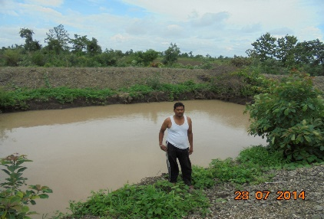
Mahadev Vithobaji Mate is a famer of village Kinhala of Deoli taluka. Most of the agriculture land ina the village is rainfed and the farmers are in loss due to low productivity in absence of irrigation facilities. He was convinced about the benefits of farm pond as discussed in the village level meetings conducted by KJBF. He constructed a farm pond of size 15m x 10m x 3m with a total storage volume of 450 m³. He established drip irrigation system on his farm to optimize the use of water available in the farm pond. He experienced substantial rise in the productivity of cotton and pigeon pea which improved his net earnings from Rs 39000 to Rs. 81500/-.
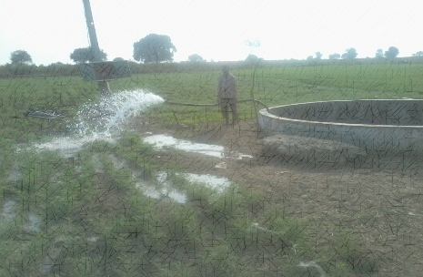
Diwakar Shankarrao Chavare is a farmer of village Andori of Deoli taluk. He has 3 acres of rainfed land and was cultivating crops during Kharif season only. With the creation of group well in 2010 with the support given by KJBF, he began to cultivate crops during Rabi season also, because of which his net earnings were enhanced from Rs. 16500 to Rs. 100500.

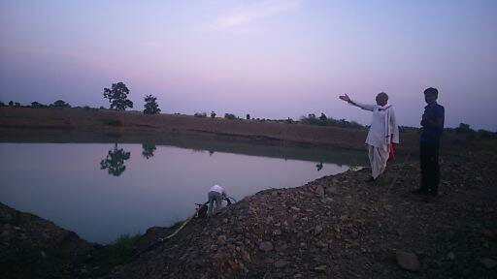
Babanraoji Yewale is a resident of Amangaon village of Seloo taluka. He has 5 acres of rainfed land and he was growing cotton and pigeon pea crops only. A percolation tank was constructed in the village by KJBF to improve the rate of recharge of ground water table. Babanraoji began to lift the water available in the percolation tank for irrigation. This has not only improved the productivity of crops but also the number of crops as he began to cultivate vegetables and wheat. As a result, his net earnings got increased from Rs.16700 to Rs.101400.
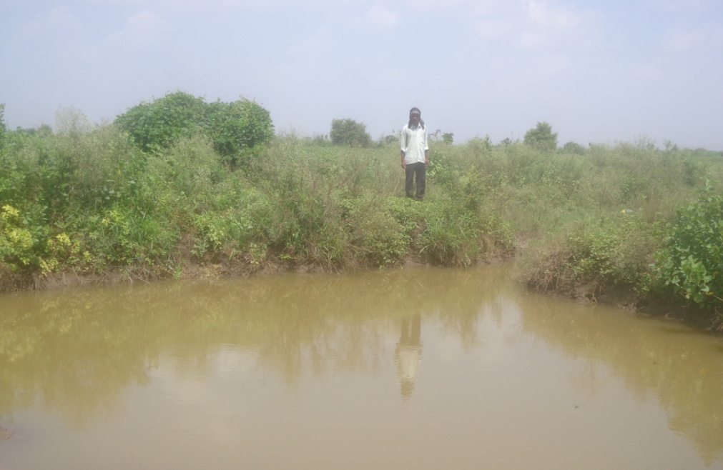
Anil Chintaman Itware is a farmer of Sujatpur village of Samudrapur taluk. He has 5 acres of land which was rainfed till 2014. In rainy season, the land used get water logged and he could not cultivate any crop during Kharif. On the other hand, he could not cultivate crops in Rabi season too due to lack of irrigation facility. In 2014, he was helped by KJBF to construct a recharge pit of size 22 ft diameter and 7 ft deep. As a result, he could now irrigate 2.5 acres of his farm in Kharif as well as Rabi which has improved his net earnings from loss to Rs.64900.
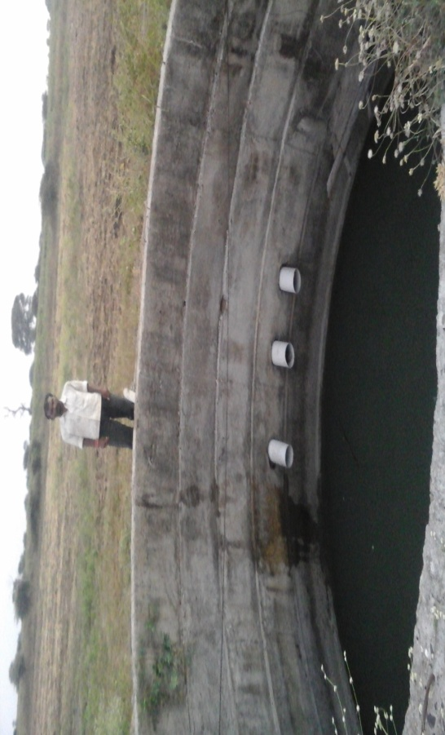
Avinash Shambhaji Lende is a farmer of village Andori of Deoli taluka. He has 3 acres of land and a farm well. He was not able to support the required irrigation to the Kharif crops and was also not able to raise Rabi crops due to less water availability in the farm well. In the year 2013, he was guided to have a well recharge pit to improve the water availability in the well. Due to this, the level of water in well got increased by 6 ft and he began to cultivate wheat on one acre of land. The productivity of Kharif crops also got improved as he could provide required number of irrigation cycles. Now, his net earnings have been raised from Rs.16000 to Rs.67000.

