A Research Note On

“A GENDER COMPARATIVE STUDY ON COMMUNICATION SYSTEM AMONG THE FARMERS AND FARM WOMEN IN KEONJHAR DISTRICT OF ODISHA”

SUBMITTED BY:- Bibhu Santosh Behera,PhD Research Fellow,OUAT,Bhubaneswar
Major Stake Holder of MGCY-UNEP-10YFP-SCP(Asia and Alternate Focal Point)
Chairman,State Anticorruption Cell,AIASA-Odisha Cabinet
BrandAmbasador,TJPRC Pvt.Ltd,India
Presently working as Principal,Green College,Livingfarms,Muniguda,Rayagada
Submitted To
FAO-UN,FAO GFFSN for further Research and social Devt.

INDEX
- Introduction
- Review of Literature
- Theoretical Framework
- Research Methodology
- Presentation of data regarding gender
- Result and Discussions
- Case Study
- Conclusion
9. Appendix
10. Bibliography
11. Some Models
ANNEXURE-A, B,C

Date Of Submission:-14th July 2016

Preface
Before Conducting this Research an idea came to the mind and this was being refined and accessed through the Chairman and Advisory Committee members. The Problem was selected purposively with some valid reasons. As Gender is the thrust area of Research, a new burning Concept so selected as Quantitative Research by blending with Communication System which is an emerging concept for Qualitative mode of research.Here Comparative study was being conducted for achieving the real meaning of Sustainable Development Goal as per the paraphonia of UNEP.Finally the suitable suggestions and policy document will be Submitted for Future Research and Development of Farmers and Farm Women in the Sample area of Research
Advisory Committee For research
Chairman:-Dr.Bibhuti Prasad Mohapatra
Members:-Dr.Bibudha Parasar,Prof and Head Dept.of Extension Education
Dr.R.K.Mishra,Associate Professor,Dept.of Agriculture Economics
Dr.A.K.Parida,Professor and Head,Dept.of Agriculture Statistics
Research Topic
“A Gender Comparative Study on Communication System among the Farmers and Farm Women In Keonjhar District Of Odisha”
Chapter-1 Introduction
Gender Play a Vital role in the Society .In the era of Research, now-a-days every country and also whole world follow the thumb rule of Gender Studies. As Gender may be classified 3 types such as 1.Male 2.Female and 3.Transgender, so we can make gender comparative studies in every aspects like Gender in various field of studies. Here I have taken the above research problem entitled as “A Gender Comparative Study on Communication System among the farmers and farm women in Keonjhar Dist. Of Odisha” as I have a special interest to take a lucrative research based on Gender which is the current demand in every sector. The current communication system is mandatory for Gender and farmers to empower them and uplift in a developmental action hence be justified. According to UNEP, Gender studies should be introduced in Education Systems along with climate and environmental programs. To maintain Gender stability through gender equity and gender main streaming Gender study is important. In the era of pluralistic extension our extension communication system must be developed for Gender as Gender is the main client of any type of study and research. Here my research work will be conducted in Keonjhar Dist. Of Odisha , which is a big platform to conduct quantitative and qualitative research by taking various clients like Gender, Farmer and Tribal’s along with the communication and extension system existing in this Dist. to bridge the gap among all clients.

Objectives of the Study
- Analysis of socio-economic situation of the farmers and farm women of the sample area.
- Identification and gender wise comparison of the sources of information among the respondents and their nature of influence.
- Analysis of communication of the farmers and farm women with the extension methods and materials.
- To identify the extent of contact of the farmers and farm women with community organizations and institutions.
- To correlate the socio economic parameters of the respondents with the extent of contact with institutions and extension methods.
- To list out the communication constraints with the farmers and farm women of the sample area.

RESEARCH MATRIX

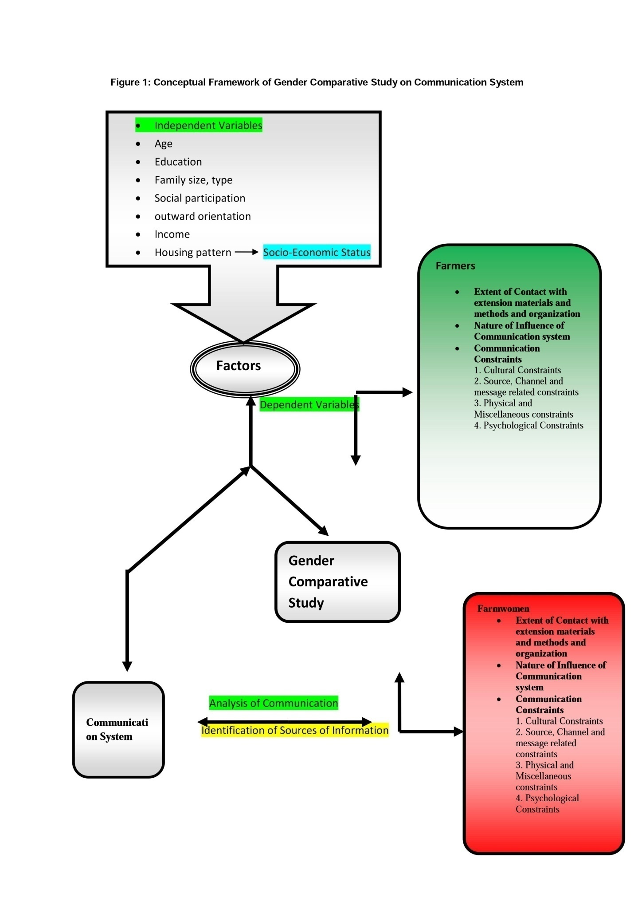

CONCEPTUAL FRAMEWORK

Chapter-2 THEORITICAL FRAMEWORK

Information System:

An information system is a collection of message that transforms data into knowledge and methods desired by and useful for individual and group users in organizations and other entities.

Communication:

Leagens says, ”it is a process by which two or more people exchange ideas, facts, feelings or impressions in ways that each gains a common understanding of the message. In essence it is the act of getting a sender and a receiver tuned together for a particular message or series of message

Importance of communication:

Paul Leganes has very rightly said that, for development of any nation, three things are necessary, (i) investigation, (ii) interpretation and (iii) administration. Our country India is self-sufficient in investigations i.e. improved technology. Also administration is not posing any problem. But only due to lack of proper interpretation we failed to achieve significant success as compared to developed countries. Interpretation is nothing but communication.

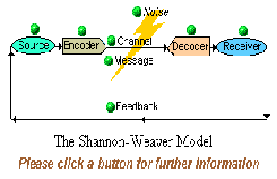
Models of Communication
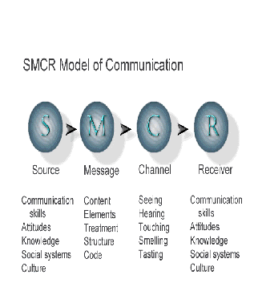

- Farmer: A hard working individual whom may be male or female. Provides food for everyone. They work 24hours a day normally from a very young age. A dangerous and selfless occupation to which all should be thankful.
- Farmwomen:In rural India, the percentage of women who depend on agriculture for their livelihood is as high as 84%. Women make up about 33% of cultivators and about 47% percent of agricultural labourers
- CommunicationSystem
A system or facility for transferring data between persons and equipment. The system usually consists of a collection of individual communication networks transmission systems, relay stations, tributary stations and terminal equipment capable of interconnection and interoperation so as to form an integrated whole. These individual components must serve a common purpose, be technically compatible, employ common procedures, respond to some form of control and generally operate in unison.
["Communications Standard Dictionary", 2nd Edition, Martin H. Weik].
(1995-02-06)
- Comparative Study. The comparative method is often used in the early stages of the development of a branch of science. It can help the researcher to ascend from the initial level of exploratory case studies to a more advanced level of general theoretical models, invariances, such as causality or evolution.
- Communication Constraints:-Communication constraints are nothing but the barriers and draw back in Communication Channel.Ex:-SemanticBarrier,MirageDistoration,Fog Distoration,Technical Jargons,In adequate Message.

Chapter-3 REVIEW OF LITERATURES
Reviews on Gender
Advisory Services (NAADS) and NARO (NARO, 2000) in their plans have recognized the need for addressing gender concerns in all their activities. The paramount driving force is the desire to increase relevance, efficiency and effectiveness in addressing the needs and objectives of all stakeholders (Opio, 2003).

Yaqoob et al. (2009) in their study on the “Gender Equity in Agriculture” found that the maximum participation of rural women in different sub-sectors of agriculture but further analysis reflected clear cut discrimination in land ownership, tenure, access to inputs, trainings, and credit facility. The finding of research study highlighted the immediate attention of Government, policy makers and law and order authorities to have a glance over such discrimination and reframe their rules and regulation, and mode of implementation.

Reviews on Communication system
Demiryurek (2000) also used agricultural information system theory to analyse the current information systems used by organic and non-organic hazelnut producers and found that the information systems for the two groups of farmers were largely separate. The conversion to organic production clearly demanded changes in the information system to allow producers to acquire the appropriate new knowledge and skills. The organic producers had used more information sources more frequently and more actively than non-organic producers.
Naidoo & Rolls (2000) also investigated agricultural information use by small-scale cattle farmers in Mauritius and found that the farmers managed information as a production resource. The personal characteristics and cattle husbandry practices of the farmers were major influences on their management of information. The practices were mainly learnt from family elders. Extension advice was only partly remembered, or rejected as the information from this source was sometimes not useful.

SOCIO-ECONOMIC CHARACTERISTIC OF FARMERS AND FARM WOMEN

Chavan et al (2010) state that the personal and socio-economic characteristics of the televiewing farmers namely, size of land holding, extension contacts, mass media exposure are significantly correlated with the perceived effectiveness of agricultural programmes.

Okwu and Umoru (2009) have taken a sample size of 70 women farmers for the study but only data for 65 respondents have been analyzed.

The result reveals that 35.4% of the respondents have had no formal education, 40% primary/adult education, 18.5% secondary education and 6.2% tertiary education. About 29% of the respondents are within the high income bracket while 46.2 and 24.6% are in the average and low income brackets respectively. The farm size distribution of the respondents shows that
36.9 and 40% of the respondents have large and medium size farms, respectively, while 23.1% have small farm size.

Azadeh N. Noorivandi (2009) have studied that majority of respondents are male (90%). Approximately 27.4% of respondents are between 31 to 40 years of age. Farmers have been asked to report their highest level of education, approximately 37% of farmers have had elementary education and 7.99% high school and post high school education.

Waman et al (2008) have attempted to assess the scientific orientation of respondent farmers to study the socio-economic status and also to study the agro-technological status of the respondent farmers. The finding of the study reveals that more than three-fourth proportion of respondents are mediocre in their scientific orientation and a majority of them have medium socio-economic status. The information about agro technological status of the respondent farmers indicates that the adoptions of some selected technologies are observed to be less.

Yeshwanth Kumar Naik (2008) has reported that nearly half (48.00%) of groundnut FFS participants belong to young age category, followed by ‘old’ (30.00%) and ‘middle age’ (22.00%), respectively. Education wise one fourth number of groundnut FFS participants (26%) have ‘middle school’, 24% ‘high school’ education and primary school, whereas,
12.00 per cent respondents are illiterate. Farming experience wise half (52.00%) of the groundnut FFS participants have ‘medium farming
2.2:- Identification and gender wise comparison of the sources of information among the respondents and their nature of influence
Sangha and Gupta (1995) reported that Television was considered as the most credible sources of information for agriculture by the rural T.V. viewers followed by Agricultural university, Radio, Block extension staff & relatives friends neighbours.
Popat and Salvaliya (1999) reported that more than half (53 percent) of the small and marginal farmers were the most regular in attending the meetings of V.L.Ws. They also revealed that majority (61 percent) of the small and marginal farmers .sometimes got satisfactory answers from the V.L.Ws. as 42 percent of them felt it necessary to discuss with somebody else for better understanding of the messages. Gupta (1999) revealed that majority of the small and marginal farmers sought information regarding modern, agricultural extension officers.
2.3:- Analysis of Communication of the farmers and farm women with the Extension methods and materials
Joshi and Vekaria (1996) reported that 55 percent of farmers passed on information to fellow farmers about improved agricultural technology.
Sonlanki and Kadam (1998) concluded that farmers consult different information sources before deciding whether to adopt or not any innovation. Farmers attach varying degree of credibility to different information.Because of close intimate and face to face contacts with the agriculture assistant farmers,V.E.W and Agricultural Extension Officers, the farmers under study might have believed in them to the maximum extent. Demonstration had received less credibility from the farmers under study in getting the information about agricultural developmental activities.

Communication Constraints
A major problem in extension projects dealing with the poorestfarmers in developing nations is the communication constraint (Ascroft, 1971; Roling et al., 1976).
The fault, according to thisauthor, may reside within the extension process rather than thereceivers, particularly with the capacities of agents/agencies tocommunicate adequately and systematically with project recipients,especially the small-scale farmers.The problem this authoraddresses is not diffusion in general, but rather the special casepresented by the poorest farmers.In fact, many attempts atdiffusion of innovations have enjoyed moderate success.Forexample, innovations such as the miracle rice, hybrid maize andwheat have diffused quite widely in many developing nations.Countries such as India and China which were once food importershave now become exporters.So, the problem discussed in this paperdeals explicitly with the poorest sub-group of farmers, whoapparently, constitute a fairly large proportion in developingnations
Limited Concept of Knowledge
In the correlational analyses of diffusion studies, the farmervariables were associated with a rather limited concept of knowledgeof new practices with no measurement of the shallow depth of suchknowledge or their conditional association with adoption.Shingiand Mody caution that, 'the long-range competence of farmers toevaluate and adopt (or reject) future innovations is not directlyfaciliated by mere awareness of a great number of innovations... Inour opinion, the innovation- deci.ion process is considered to beinitiated not when the individual is merely exposed to informationon the innovation but when he gains some understanding of how itfunctions" (Shingi and Mody, 1976:95).
Chapter-4 RESEARCH METHODOLOGY
Selection of problems
Selection, delineation and conceptualization of the research problem are the most important consideration in behavioral research. Good investigation gives priority on the formation of clear, realistic and unambiguous problem. Therefore delineation of problem is more important and essential than finding out solutions.
Therefore the present situation calls for an analysis of facts for the affinity of the farmers and farm women towards communication system as it is one of the leading Districts in Agriculture activities and also 8th position in population.. Hence the research study entitled “A Gender Comparative Study on Communication System among the Farmers and Farm Women In Keonjhar District Of Odisha”has been selected for the purpose of investigation.

- Research Design:-- The present research project was formulated on the basis of ex-post facto. Accordingly, specific objects were set to provide the basis of inquiry. In the light of objectives, the scope of study was oriented and due techniques of investigation were followed; tools used and pattern of statistical analysis decided. Then the study was outlined from observation levels up to interpretation of observation, giving correct operational definitions of concept used. The study was then carried out in the light of objectives set and within the frame work of selected outlines.
- Plan of work
The researcher has made all attempts to make a detail survey of all related aspects of the study before actual investigation. A good number of interaction sessions were organized through seminars, focused group discussion workshops, meetings at the institutional level as well visit to the proposal areas of investigation in the depth discussion with the farmers and field level functionaries. In spite of time constraints as being a part course curriculum, all adequate attention was made to make the study as realistic as possible
Sampling Technique
The following sampling procedure was followed for the sampling in this Research Study.
1. Selection of the District:-
The purposive sampling procedure has been followed for selection of Sample District. The State of Odisha is comprised of 30 Districts. Out of which Keonjhar District. Was selected for study purposively as the Researcher belongs to the Sample District. And it will help in collection of Data Properly. As per 2011 Census Kendujhar is the 4th district in terms of size and 8th in terms of population. In terms of population per Sq. Km Kendujhar is 18th densely populated district in the state. Kendujhar has 12th rank in terms of sex ratio in the state.
2. Selection of the Blocks:-
The Keonjhar District is Comprised of 13 Blocks, out of which 2 Blocks namely Patana and Champua were selected at Random for the Study.
3. Selection of Grampanchayats:-
The Block Patana is Composed of 20 Panchayats, out of which Turumunga and Rajanagar G.P. are selected at Random.Simillarly; the Champua Block is composed of 23 Gramapanchayats out of which Jajaposi and Bhanda G.P. were selected at Random.
4. Selection of Villages:-
From Turumunga Grampanchayat Turumunga and From Rajanagar Grampanchayat Rajanagar were selected at Random.Simillarly , from Jajaposi Grampanchayat Jajaposi and from Bhanda Grampanchayat Nandapur villages were selected at random.All total of 4 villages were selected at Random.
5. Selection of Sample respondents:-
From each selected villages the total no. List of farmers and farm women was prepared; out of which the farmers and farm women sample was drawn through Proportionate Random Sampling.
Table 4.1.
DISTRICT | NAME OF THE BLOCK | NAME OF THE GRAMPANCHAYAT | NAME OF THE VILLAGE | TOTAL MALE FARMER POPULATION(P1) | SAMPLE MALE FARMERS(S1) | TOTAL FEMALE FARMER POPULATION(P2) | SAMPLE FEMALE FARMERS(S2)
KEONJHAR | PATANA | TURUMUNGA | TURUMUNGA | 264 | 44 | 121 | 28
 |  | RAJANAGAR | RAJANAGAR | 166 | 27 | 134 | 31
 | CHAMPUA | JAJAPOSI | JAJAPOSI | 163 | 26 | 145 | 34
 |  | BHANDA | NANDAPUR | 141 | 23 | 112 | 27
 |  |  | TOTAL | 743 | 120 | 512 | 120

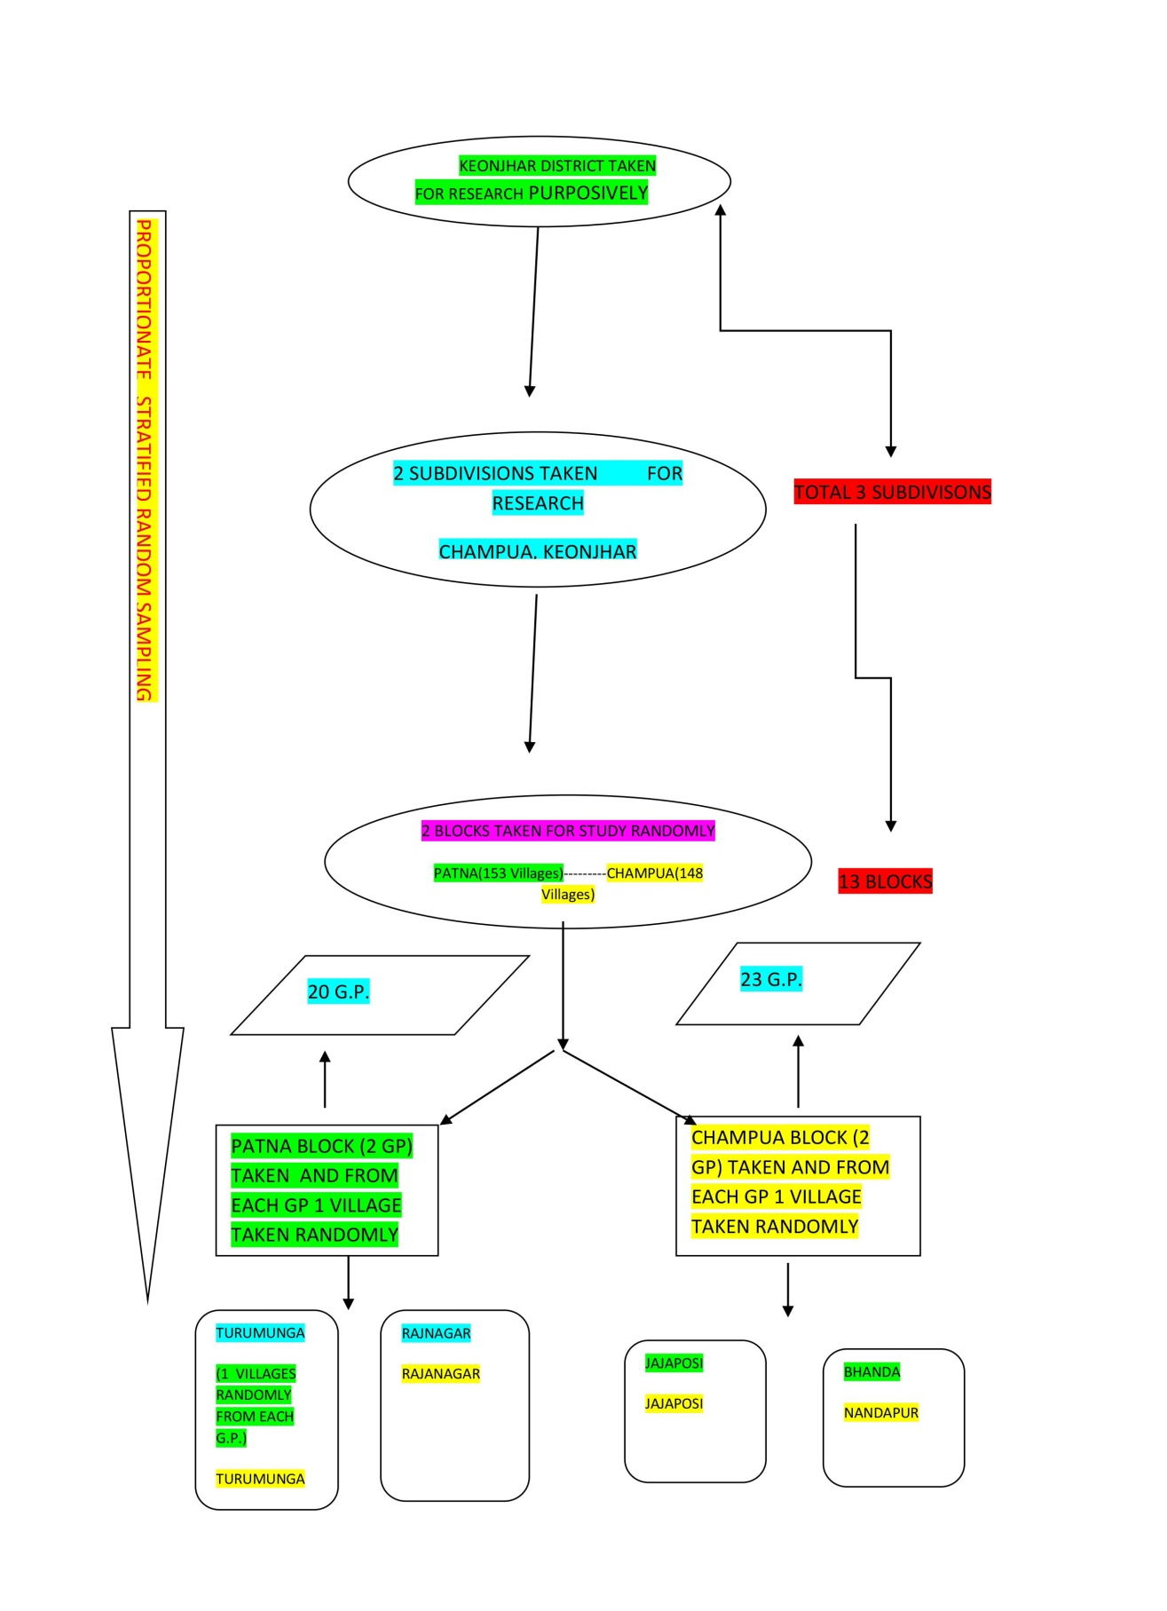
Sampling Design

LOCALE AND SETTING
The purposive sampling procedure has been followed for selection of Sample District. The State of Odisha is comprised of 30 Districts. Out of which Keonjhar District. Was selected for study purposively as the Researcher belongs to the Sample District. And it will help in collection of Data Properly. As per 2011 Census Kendujhar is the 4th district in terms of size and 8th in terms of population. In terms of population per Sq. Km Kendujhar is 18th densely populated district in the state. Kendujhar has 12th rank in terms of sex ratio in the state.
Situation of District:-The KeonjharDistrict emerged as one of the District on 1st January, 1948. The District is bounded by Mayurbhanj District and Bhadrak District to the east, Jajpur District to the south, Dhenkanal District and Sundargarh District to the west and West Singhbhum district of Jharkhand State to the north. Covering a geographical area of 8240 sq kms, the Keonjhar District lies between 21⁰ 1’ N to 22⁰ 10’ N latitude and 85⁰ 11’ E to 86⁰ 22’ E longitudude.
Basic Information of Keonjhar District
Agro climatic Zone:-North Central plateau & North Central coastal Plain.
Land Utilization Pattern(Figure in Ha)
Geographical area:-831000
Cultivable area:-297873(36% of Geographic area)
a)High land:-158653(53.3% of cultivable area)
b)Medium land:-99832(33.5% of cutivable area)
c)Low land:-40336(13.2% cultivable area)
Irrigation Potential
a)Kharif:-81653
b)Rabi:-31327
Cropped area
a)Single cropped area:-2959409
b)Double cropped area:-6504
c)Tripple Cropped area:-278

ORISSA MAP FIG-1

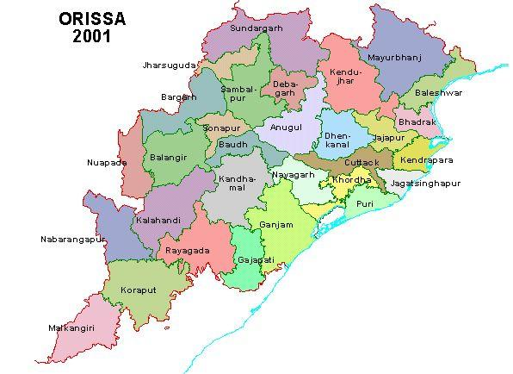FIG-2 KEONJHAR DIST .MAP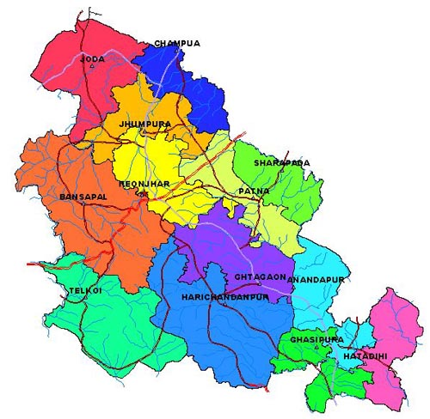
Administrative Setup

The Collector and district Magistrate is the administrative head of the district. For smooth running of administration, he is assisted by the Additional District Magistrates, Deputy Collecters, Sub-Collecters, Block Development Officers, Tahasildars and other officers. Within the district there are also district level officers of other departments. Collector as the head of administration of the district, he exercises general supervision.

The district consists of three subdivisions namely Kendujhar, Anandapur and Champua and each subdivision is under the administrative control of a sub collector. For smooth running of revenue administration the district is divided into 13 tahasils viz. Telkoi, Barbil, Champua,Patna,Kendujhar, Ghatgaon, Anandapur, Hatadihi, Jhumpura, Banspal, Saharapada, Harichandanpur and Ghasipura. Each tahasil is in charge of a Tahasildar. Similarly in order to look after the developmental activities the district is divided into 13 CD blocks and each Block is kept under the administrative control of a Block Development Officer. The list of CD Blocks with number of Gram Panchayats and villages are given below.

Sl | Name of CD Block | No. of | Gram | No. of villages
No |  | Panchayats
1 | Joda | 15 |  | 120
2 | Champua | 23 |  | 150
3 | Jhumpura | 22 |  | 153
4 | Banspal | 21 |  | 164
5 | Telkoi | 22 |  | 149
6 | Harichandanpur | 25 |  | 219
7 | KendujharSadar (Kendujhar) | 24 |  | 225
8 | Ghatgaon | 26 |  | 142
9 | Patna | 20 |  | 153
10 | Saharapada | 20 |  | 139
11 | Anandapur | 16 |  | 127
12 | Ghasipura | 22 |  | 164
13 | Hatadihi | 31 |  | 223
 | Total | 287 |  | 2128*
*Includes 5 villages declared as Census Town.

For maintenance of law and order there are 24 Police Stations viz. Telkoi, Kanjipani, Nayakote, Kendujhar Sadar, Kendujhar Town PS , Barbil, Joda, Champua, Bolani, Rugudi, Bamebari, Jhumpura, Baria, Turumunga, Patana, Ghatagaon, Pandapara, Harichandanpur, Daitari ,Ghasipura, Anandapur, Soso, Nandipada and Sainkul.

There are four Municipalities viz. Barbil, Joda , Kendujhar and Anandapur. Besides, there are five non-statutory towns i.e. Census towns viz. Balagoda (Bolani), Jajanga, Champua, Jhumpura and Daitari within the district.

Important Statistics

 |  |  | State |  | District
Number of Villages |  | Total | 51,311 |  | 2,123
 |  | Inhabited | 47,675 |  | 2,064
 |  | Uninhabited | 3,636 |  | 59
Number of Towns |  | Statutory | 107 |  | 4
 |  | Census | 116 |  | 5
 |  | Total | 223 |  | 9
Number of Households |  | Normal | 96,05,629 |  | 4,03,869
 |  | Institutional | 21,857 |  | 1,113
 |  | Houseless | 10,334 |  | 290
Population | Total | Persons | 4,19,74,218 |  | 18,01,733
 |  | Males | 2,12,12,136 |  | 9,06,487
 |  | Females | 2,07,62,082 |  | 8,95,246
 | Rural | Persons | 3,49,70,562 |  | 15,48,674
 |  | Males | 1,75,86,203 |  | 7,74,667
 |  | Females | 1,73,84,359 |  | 7,74,007
 | Urban | Persons | 70,03,656 |  | 2,53,059
 |  | Males | 36,25,933 |  | 1,31,820
 |  | Females | 33,77,723 |  | 1,21,239
Percentage Urban Population |  |  | 16.69 |  | 14.05
Decadal Population Growth
2001-2011 |  |  | Number | Percentage | Number | Percentage
 |  | Persons | 51,69,558 | 14.05 | 2,39,743 | 15.35
 |  | Males | 25,51,566 | 13.67 | 1,16,451 | 14.74
 |  | Females | 26,17,992 | 14.43 | 1,23,292 | 15.97
Area (in sq Km.) |  |  | 155707 |  | 8303.00
Density of Population (Persons |  |  | 270 |  | 217
per sq Km.)
Sex Ratio |  | Total | 979 |  | 988
(Number of females per 1000 males) |  | Rural | 989 |  | 999
 |  | Urban | 932 |  | 920

Important Statistics

 |  | State |  | District
 |  | Number | Percentage | Number | Percentage
Literates | Persons | 2,67,42,595 | 72.87 | 10,52,518 | 68.24
 | Males | 1,50,89,681 | 81.59 | 6,05,119 | 78.12
 | Females | 1,16,52,914 | 64.01 | 4,47,399 | 58.28
Scheduled Castes | Persons | 71,88,463 | 17.13 | 2,09,357 | 11.62
 | Males | 36,17,808 | 17.06 | 1,04,684 | 11.55
 | Females | 35,70,655 | 17.2 | 1,04,673 | 11.69
Scheduled Tribes | Persons | 95,90,756 | 22.85 | 8,18,878 | 45.45
 | Males | 47,27,732 | 22.29 | 4,05,927 | 44.78
 | Females | 48,63,024 | 23.42 | 4,12,951 | 46.13
Workers and Non-Workers
Total Workers (Main and | Persons | 1,75,41,589 | 41.79 | 7,66,514 | 42.54
Marginal) | Males | 1,19,02,655 | 56.11 | 4,98,077 | 54.95
 | Females | 56,38,934 | 27.16 | 2,68,437 | 29.98
(i) Main Workers | Persons | 1,07,07,543 | 25.51 | 4,42,497 | 24.56
 | Males | 87,94,413 | 41.46 | 3,62,695 | 40.01
 | Females | 19,13,130 | 9.21 | 79,802 | 8.91
(ii) Marginal Workers | Persons | 68,34,046 | 16.28 | 3,24,017 | 17.98
 | Males | 31,08,242 | 14.65 | 1,35,382 | 14.93
 | Females | 37,25,804 | 17.95 | 1,88,635 | 21.07
Non-Workers | Persons | 2,44,32,629 | 58.21 | 10,35,219 | 57.46
 | Males | 93,09,481 | 43.89 | 4,08,410 | 45.05
 | Females | 1,51,23,148 | 72.84 | 6,26,809 | 70.02
Category of Workers (Main & Marginal)
(i) Cultivators | Persons | 41,03,989 | 23.4 | 1,98,044 | 25.84
 | Males | 33,75,350 | 28.36 | 1,65,481 | 33.22
 | Females | 7,28,639 | 12.92 | 32,563 | 12.13
(ii)Agricultural Labourers | Persons | 67,39,993 | 38.42 | 3,10,075 | 40.45
 | Males | 34,81,836 | 29.25 | 1,32,616 | 26.63
 | Females | 32,58,157 | 57.78 | 1,77,459 | 66.11
(iii)Workers in household | Persons | 7,83,080 | 4.46 | 21,314 | 2.78
industry | Males | 4,39,215 | 3.69 | 12,288 | 2.47
 | Females | 3,43,865 | 6.1 | 9,026 | 3.36
(iv) Other Workers | Persons | 59,14,527 | 33.72 | 2,37,081 | 30.93
 | Males | 46,06,254 | 38.7 | 1,87,692 | 37.68
 | Females | 13,08,273 | 23.2 | 49,389 | 18.40

Sl. No. | Social Group | Total | Percent
1 | SC | 181488 | 11.6
2 | ST | 695141 | 44.5
3 | Hindu | 1525874 | 97.7
4 | Muslim | 20390 | 1.3
5 | Christian | 6144 | 0.4
6 | Buddhist | 37 | 0.002
7 | Other | 9545 | 0.6
 | All social groups | 1561990
(Social Composition of The Population of The District. As per 2011 census)

Some Basic Facts about Keonjhar Dist. As per 2011 census
Some Basic Facts About The District
Sl. No. | Feature | Unit | Value
1 | Geographical Area | Sq. Km. | 8303
2 | Population as per 2011 provisional | Lakh | 18.02
3 | Sub-divisions | Number | 3
4 | Block | Number | 13
5 | Cluster/circles | Number | 8
6 | Revenue Village | Number | 2122
7 | Urban habitations | Number | 65 wards
8 | Gram Panchayats | Number | 286
9 | Panchayat Samitis | Number | 13
10 | Municipal Councils | Number | 4
11 | National Highways | Km. | 287
 | State Highways | Km. | 79
 | Major District Roads | Km. | 78
 | Other District Roads | Km. | 367
 | Rural Roads | Km. | 1225
 | Forest Roads | Km. | 252
 | Panchayat Samiti Roads | Km. | 926
 | Gram Panchayat Roads | Km. | 2436
12 | Length of rail network | Km. | 155
13 | Watershed | Number | 1289
14 | Irrigated Agriculture | Hectares | 65779
15 | Rain-fed Agriculture | Hectares | 23204
16 | Wasteland | Hectares | 26522
17 | Forest | Sq. Km. | 310672
18 | Major and medium dams | Number | 4

Tools and techniques used for data collection.
In order to ensure maximum objectivity of the study, a number of standard tools developed by different expert in the field of science were considered. However selected tools were modified to required extent as per applicability.
Pilot study:- The study was conducted in keonjhar district of odisha.The twp blocks namely patana,champua were selected at random for the study.Two grampanchayat two from each block were selected & two villages from each grampanchayat were selected for study.The datas are collected by door to door visit method and applying PRA tools.Then liasioning with various line departments like Agriculture dept. Horticulture dept.,I.T.D.A office,J.D.A office,Panchayatraj inst. & peoples organisation like PRADAN,WOSCA,KIRDTI,CYSD Etc. available in keonjhar districts.
Consultation made with Scientists of CIWA, Bhubaneswar, DDM NABARD Keonjhar,Sr.Scientist,KVK,AAO,AHO& Social Activist Padmashree Tulashi Munda of Adivasi kalyan vikas samiti Keonjhar. And Keonjhar Krushak kalian mancha
Pre-Testing of Interview Schedule
Based on the objective of study an interview schedule was prepared. Initially the schedule was pretested with twenty farmers and farm women to test the reliability. Here the questions are remain close ended because the research is specific in nature. In order to collect the broad data from their open mind the format is very common and general. Later the interview schedule was modified based on the experience gained at field level and to be modified with proper scaling techniques as per the requirement.
Collection of information
Collection of information is another important consideration in securing qualitative results personal contact was made by investigation in interviewing the respondents selected for the investigation. Good report was established along with desirable climate setting with the respondents which helped a lot to ask questions and discuss various dimension comfortable relating to study. At the outset, purpose of the study was clearly apprised to the respondents. The information received was duly recovered for analysis. The investigator usually makes use of the free time of respondents to personally interview and records all information.
Interviewing and Data Collection
The interviewer first of all introduced himself and gave a clear picture of the subject and purpose of the study. The interviewer made the respondents felt that her answer were important. Systematically the questions were asked as specified in the schedule and in informal manner from January 2016 to April 2016. The data thus collected were tabulated and subjected for empirical measurement and analysis.
Scaling Method
For conducting this Research Likert’s Type scale was being used for administering the Interview Schedule and analysis work. 3 point to 5 point scale is being used based on type of Question . Accordingly Scoring is given from 0 to 5 as per response being collected from the respondents.
Measurement Procedure
Sl No | Variable | Empirical Measurement
1 | Age(X1) | Schedule developed for the study
2 | Education (X2) | Trivedi(1963)
3 | Land holding Size(X3) | Schedule developed for the study
4 | Family Type(X4) | Venkatramaish and Suthurao (1983) with modification.
5 | Family Size (X5) | Schedule developed for the study
6 | Occupation (X6) | Schedule developed for the study
7 | Social Participation (X7) | Schedule developed for the study
8 | Annual Income (X8) | Trivedi(1963)
9 | Outward orientation(X9) | Schedule developed for the study
10 | Housing Pattern (X10) | Schedule developed for the study
11 | Ownership right(X11) | Schedule developed for the study
12 | Credit status(X12) | Schedule developed for the study
13 | Savings status(X13) | Schedule developed for the study

Dependent Variables
Sl No | Variables | Empirical Measurement
1 | Extent of Contact with( Institutions(y1) | Structured schedule
2 | Extent of Contact with Extension of methods(y2) | Structured schedule
3 | Extent of Contact with community organizations(y3)  . | Structured schedule
4 | Analysis of Communication with Extension Methods and Materials(y4) | Structured schedule
5 | Nature of Influence(y5) | Structured schedule

Processing and analysis of data
The data collected from all 120 farmers and 120 farm women respondents were manually processed. Each respondents was serialized, block wise and information received from them were tabulated on a master sheet. Weightage was given to different items with regards to their relative position of the scale and scoring was done accordingly. Then data were tabulated, processed and analyzed by using SPSS (Statistical package for social science)
Statistical methods used
(i)The following statistical methods were used for the analysis of data basing on its mature and type of information obtained.
(a). Frequency-
Number of respondents under a particular category.
(b). Percentage-
Percentage was used in description analysis for making paragraph comparison. For calculating percentage, the frequency of a particular cell was multiplied by 100 and divided by the total number of respondents in the particular category to which cell they belonged.
Percentage=

ii. Gap Analysis:
It is worked out by finding out difference between maximum obtainable score and actual score obtained and expressed in terms of percentage by following formula.
Gap percentages = (E-A) x 100
A
Where,A
E = Maximum score obtained
A= Actual score obtained

iii. Rank Order:
On the basis of mean score rank order was made. The item securing highest mean score was given first rank and then next highest was given second rank and so on. ) Ranking is an expression of people’s priority about their thoughts and feelings. Ranking was done by assigning the first rank to highest percentge and the second rank to the next highest percentage and so on.
iv. Persons co-efficient of correlation
It is employed to find out the association of independent variables with the dependent. The formal use of calculating co- efficient of correlation is as follows.

N = Number of pairs correlated.
X & Y = Variables being correlated
Critical Ratio (CR)=Difference Between P1 and P2/$√PQ[\frac{1}{N1}+\frac{1}{N2}$
Where P=N1P1+N2P2/N1+N2

Calculation of information scores
Information scores for each component of the farmers' agricultural information system were calculated by multiplying the weights of information contact with degree of information usefulness. Total Information Score is formulated as:
TIS_{ij} = FC_{ij} x IU_{ij}
where FC is the number of contact with information sources for the i-th farms and IU is the usefulness of information for the i-th farms

Chapter-5 Result and Discussion at a glance with respect to Objective-1
(Socio-Economic Status of Farm women and Farmer in the Sample area)
Table 5.1.1: Age distribution of the respondents
Age is an important social factor that influences individual working ability. Research findings linking age to productivity abound, Age as a social factor has been subject of social study by the social researchers on many situations relating to social research. Age is significant in terms of experience, maturity of judgment, decision making and power of understanding..
Age is one vital personal variable which has contribution on various parameters in life. Usually it is hypothesized that comparatively young individuals are having better adoption, communication and information sharing attitude than older generation.
The Table 5.1.1 depicts a gender comparative data on age distribution of respondents.
The respondents of the study were categorized into 3 groups as reflected in the table below.
Table 5.1.1:
Sl.No. | Age Category | Male Farmer N1=120 |  | Female Farmer N2=120 |  | Pooled Data
 |  | Frequency | Percentage | Frequency | Percentage | Frequency | Percentage
1. | Young(Upto30 years) | 61 | 51 | 52 | 44 | 113 | 47.08
2. | Middle( Above30-50 years) | 44 | 37 | 58 | 48.33 | 102 | 42.5
3. | Old(Beyond 50 years) | 15 | 12 | 10 | 8.33 | 25 | 10.41

The data revealed that 51 percent of farmers were young up to 30 years of age,37 percent belong to middle age category and 12 percent were old above 50 years of age.
With respect to the farm women were concerned 48.33 percent were middle aged within the age of 30 to 50 years.44 percent were young and rest 8.33 percent were old.
Therefore it may be concluded that the research study was mainly reflecting the views of young farmers and middle aged farm women how ever in this gender comparative research study the size of sample belonging to old age category was minimum.
So , my findings from the above study is in accordance with the the result of the study by Kiranvani (2007) reveals that more number of groundnut growers are ‘young’ followed by ‘middle age’ and ‘old age’ respondents. It underlines that young farmers show more interest in participating in FFS. Further, the FFS organizers might have felt that the training given to young farmers is better utilized, as they have sufficient scope for practicing.
Table.5.1. 3 Family types of the respondents
Various research findings suggested that the joint families are fast disintegrating to nuclear ones due to various socio-economic and cultural issues.
Each family type has its own advantage and disadvantages. Generally two types of families are found in our society those are nuclear family and joint family. A family is considered as nuclear or single when it consisted of husband, wife and unmarried children. . A joint family consisted of other blood relations also. Results of investigation were presented in the table 5.1.3
Table.5.1. 3
Sl.No. | Family Types | Male FarmerN1=98 |  | Female FarmerN2=94 |  | Pooled Data
 |  | Frequency | Percentage | Frequency | Percentage | Frequency | Percentage
1. | Nuclear | 67 | 55.83 | 69 | 57.5 | 136 | 56.66
2. | Joint | 53 | 44.16 | 51 | 42.5 | 104 | 43.34
The data compiled in the Table.5.1.3 indicated that out of 120 farmers 55.83 percent had nuclear type of families, whereas 44.16 percent belonged to joint family type. Due to social, economic and cultural pressure in the l society majority of the joint families are segregating to nuclear families. It symbolized their change proneness in the society and care to their family culture. But on the other hand, due to large family their per capita income and socio-economic development index is very poor. It is also note worthy that the farmers were still binding to their cohesiveness in joint family system.
The above table revealed that out of 120 farm women, 57.5 percent of the respondents belonged to nuclear family followed by 42.5 percent of the respondent’s belonged to joint family system. This might be due to the reason that now a day’s everybody wants more freedom and development. The findings suggest that there is more freedom for women who belonged to nuclear family and they are free to take their own decision as well as involve themselves in other activities rather than housewife. These findings are on par with the findings by Singh (1997), Prasad (1998) and Das (2004).
Table.5.1.5 Social Participation of the respondents
Social participation in this study refers to the involvement in social activities and membership of respondent in various formal and informal organizations, either as member or as an office bearer. It was measured in terms of membership or official status in any formal or informal organizations, along with the frequency of participation and type of organization in which she is a member using the scale developed by Trivedi (1963) with slight modifications. Social participation was expected to have positive relationship with the dependant variable
Table.5.1.5
Sl.No. | Social Participation | Male Farmer N1=120 |  | Female Farmer N2=120 |  | Pooled Data |  | C.R.
 |  | Frequency | Percentage | Frequency | Percentage | Frequency | Percentage | C.R VALUE
1. | Yes | 53 | 44.16 | 47 | 39.16 | 100 | 41.66 | 0.864
2. | No | 67 | 55.83 | 73 | 60.83 | 140 | 58.33 | 1.028

This table shows the level of social participation of farmers and farm women in various fields in society. Among the farmers 44.16 percent respondents were having social participation and 55.83 were not attending the Social activities as they want to remain in active and neutral. It was due to illiteracy, superstition, lack of awareness and interest due to communication gap. Similarly from farm women 39.16 percent respondents having social activities and 60.83 percent farm women had not that previlage.It is due to their overburdening of their productive roles in the family by getting less freedom and lower privilege to access all social activities due to family norms, shyness and taboos along with non preference in decision making due to male headed family and society.Here as the CR Value is 2.5 so non significant in nature.
Here my findings are matching with the research and findings with Natarajan and Santha Govind (2008) have stated that majority of the farmers have taken self decision in most of the tapioca cultivation practices. Further, the decision making pattern among farmers is found to be high when compared to women.
Conclusion
India being a male dominated society, women are assumed to be economically and socially depend on them and also in decision making. But this notion seems to be diluted as women in India are becoming more and more aware towards their personal needs after their productive roles and demanding greater equality. As farm women’s involvement in Agriculture sector is more than man, So feminization of Agriculture occurs. But if we consider gender balancing in day to day life, information and communication system is the only panacea for this matter. As per constitution ,Right to Information is accessible for all(RTI Act 2010) so communication system should be upgraded for the betterment and welfare of Farmers and Farm women in the agrarian society in order to achieve vision 2020 along with sustainable development goal.So we should follow the slogan “Suchana aur sanchar pranali se kisan ki museebat ka samadhan”(Rashtriya Kisan Sangathan, Delhi)
PRADAN BRINGS SMILE IN THE FACE OF MADHABANANDA SAHU OF SADANGI VILLAGE,AS A CASE STUDY
Madhabananda Sahu is a Small farmer having less cultivated land finally showed the way of living to poor's by Adopting SRI (System of Rice Intensification) Technique being facilitated under PRADAN, a leading NGO of that Area.
Madhabananda is a 51 years old man having positive attitude and strong determination like youths. During his youth time he had been practiced paddy in traditional method but after the invade of OTELP PLUS project and PRADAN Organization he had get a hope of producing more yield in paddy cultivation. So he had exposed to himself by taking Technical support from PRADAN and finally become an example among all farmers. His modus of operendi was as follows.
Details about Field Management of Madhabanand
Variety Taken For Cultivation:-Subarna (Masoori)
Area: - 2 Acre
Supports from PRADAN:-Detail information,Technical help by providing Package of Practice Training, TOT training,Exposure visit to NRRI,Cuttack and DRR Hyderabad and Process Demonstration
Vermicompost Unit:- Provided by ATMA
Time line:-
He had started Traditional rice cultivation in 1999 and SRI in 2010.

Comparative Study of Traditional rice cultivation Vs SRI method

 | Traditional Rice | SRI Method | Remarks by Cost-Benefit Analysis
Parameters
Production
Yield | 10-12 quintal | Above 14 quintal | 2 kg more in SRI
Productivity | Moderate | High | Good
Taste | Very Good | Good | Manageable
Input Cost(Expenses) | Rs7000/- | Rs5700/- | RS1300/-Saving
Out Put Cost(Profit) | Rs10,500/- | Rs18,200/- | RS7700/- More Earning
Consumption of Basic inputs | High | Low | Good
Water requirement | High | Moderate | Good
Orgnic culture required | Low | High | Good

Sources of Information
- Department Of Agriculture,Govt.of Odisha
- Department of Horticulture,Govt.of Odisha
- ITDA,Keonjhar & Champua
- DDM, NABARD Office,Keonjhar
- PRADAN,WOSCA,CYSD,KIRDTI,ORISSA,PRAKALPA NGO,Keonjhar.
- Panchayat Raj Institutes of Respective area, Block office & Collectorate,Keonjhar
- Department of Anthropology & Tribal Studies, North Orissa University,Baripada
- District Statistical Office,Keonjhar
- ICAR-CIWA Bhubaneswar
- OUAT e-library Bhubaneswar

BIBLIOGRAPHY

1. Agarwal, B (1981). Agricultural Modernization and Third World Women: Pointers from the

Literature and an Empirical Analysis. Geneva: ILO.

2. Gender Mainstreaming in Education: A Reference Manual for Governments and Other

Stakeholders. London: Commonwealth Secretariat.

3. Food and Agriculture Organization (1999).

4. Hannan, Ferocious and AKM Abdul Hannan Buiyan (1994). Role of Women in

Agriculture: Some Conceptual Issues.

5. Razavi, S and Miller, C (1997). Conceptual Framework for Gender Analysis within the

Development Context. New York: UNDP Gender in Development Programme.

6. Beoku, Betts, J. (1990) Agriculture Development in Sierra Leone: Implications for Rural

Woman in the Aftermath of the Woman's decade, Africa today.

7. Brown, Lynn. R., and Haddad L. (March 1995) Time Allocation Patterns and time Burdens: A Gender Analysis of seven countries, The Gender CG Newsletter, International Food Policy Research Institute (IFPRI), Vol. 1, No 2.

8. Hulsebosch, Jositske, and Ombara, Doris, (1995). Towords Gender Balance in Irrigation

Management: Experience in Kenya South West Karu Project Irrigation and Drainage System, Vol. 9: 1-14.

9. Khushk Ali M. and S. Hisbani (2004) Rural women at work.

10. censusindia.gov.in/Tables Published/S.
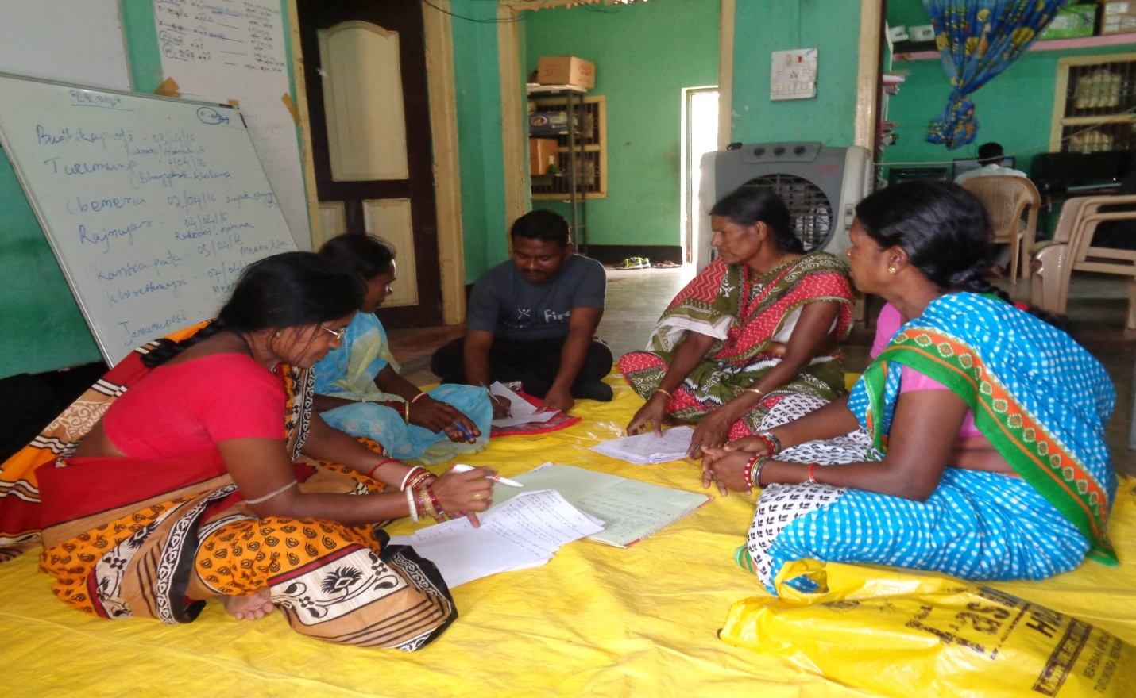
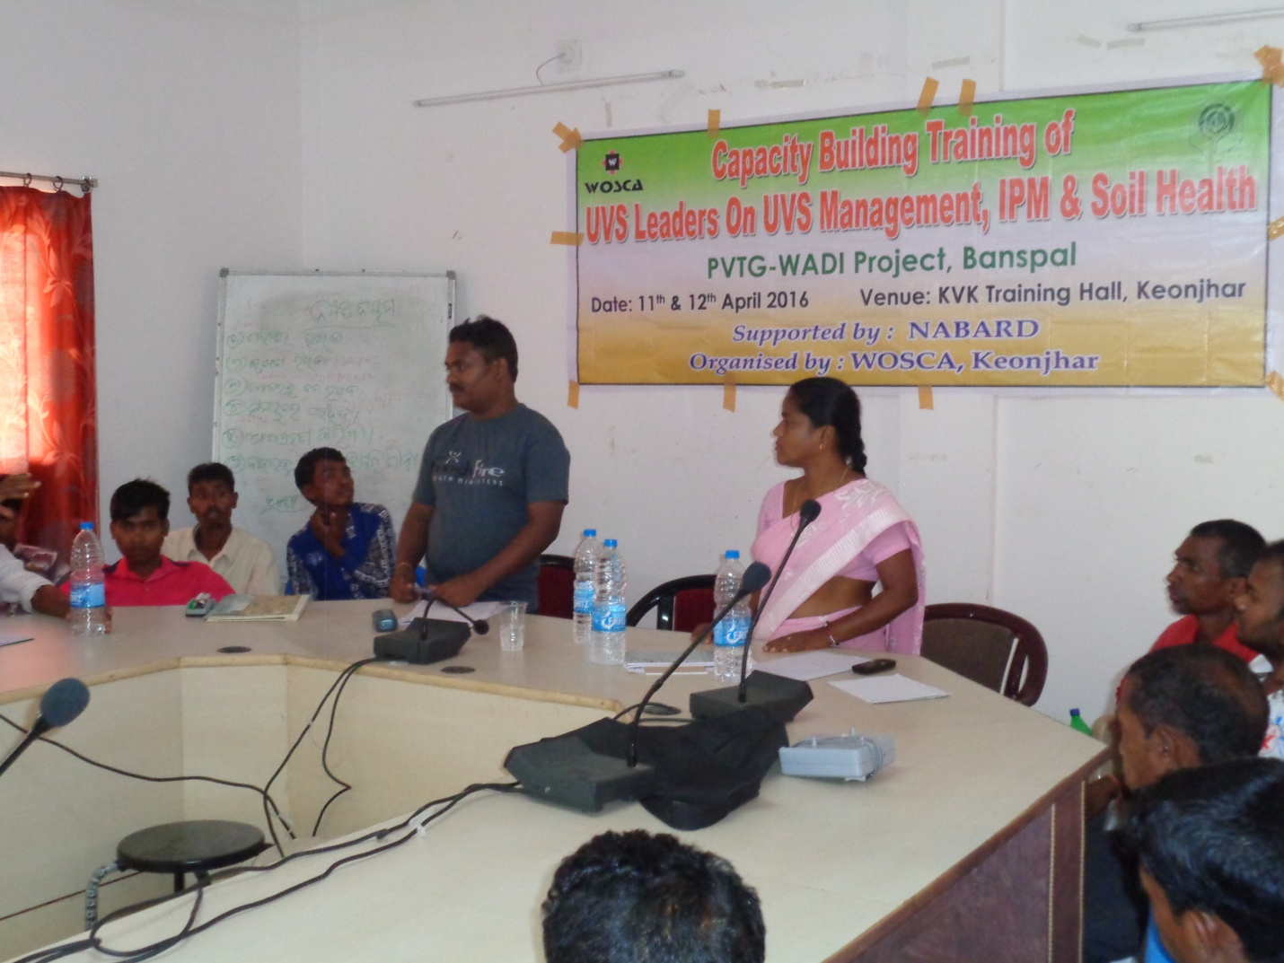
Glimpses during Data collection

