CFS POLICY PROCESS ON THE DEVELOPMENT OF THE VOLUNTARY GUIDELINES ON FOOD SYSTEMS AND NUTRITION
WORLD CANCER RESEARCH FUND INTERNATIONAL

- Does Chapter 1 adequately reflect the current situation of malnutrition and its related causes and impacts, particularly in line with the goals and targets of the 2030 Agenda? What are the underlying problems that currently hinder food systems to deliver healthy diets?
General comments:

We welcome the ambition to develop evidence-based guidance and promote policy coherence and address fragmentation in food systems. We believe that the current food system is not delivering healthy diets and requires significant transformation. To achieve this, we urge that the guidelines reinforce and promote robust evidence-based policymaking to the highest standards of governance, transparency and accountability.

We think there could be further elaboration on the impact of food and nutrition on the global burden of disease and the significant contribution that poor diet and nutrition makes. For example, our evidence shows that body fatness and weight gain increase the risk of up to 13 different types of cancer.

Specific comments:
Para 9: We think the following text should be added as follows: ‘Food systems and diets are major contributors to the nutritional and health status of populations”.

Para 10: We think the following text should be amended as follows ‘Fostering policy, institutional and behavioural changes are key to reshaping or promotion sustainable food systems that improve nutrition and enable healthy diets that meet the evolving dietary needs of growing populations.

Para 24 (c): We welcome the consideration of including fiscal policies separately (which is broader than food policy) (which would be in addition to the categories in the five areas highlighted by the High-Level Panel of Experts).

Para 26: Caution should be applied in listing the private sector in policy discussion and implementation processes. There should be stipulated limits in the role that the private sector (namely food manufacturing companies) should play, given that these companies are often the targets that policy makers seek to regulate. Managing conflict of interest should be a key priority.

- What should be the guiding principles to promote sustainable food systems that improve nutrition and enable healthy diets? What are your comments about the principles outlined in Chapter 2? Are they the most appropriate for your national/regional contexts?
Para 36 (c): We think there should be a specific mention of policies that contribute to the reduction of non-communicable diseases.

- In consideration of the policy areas identified in Chapter 3 and the enabling factors suggested in paragraph 41 of the Zero Draft, what policy entry points should be covered in Chapter 3, taking into account the need to foster policy coherence and address policy fragmentation?
General comments:
From our experience of monitoring food policy around the world (through our policy database NOURISHING), we have seen that voluntary policy action is not as effective as mandatory policy action and is very vulnerable to conflicts of interest and industry interference. Therefore, when Part III is developed in further drafts we consider it would benefit from the most rigorous wording possible in relation to good practice policy design. We would advocate that the guidelines promote mandatory measures where possible as it is shown that these are the most effective tools for delivering change within the food system.

Specific comments:
Para 40: We think it would be worth adding an objective to the Voluntary Guidelines around ‘supporting robust and evidence-based policy design’.

Para 41: It would be helpful to add ‘managing conflict of interest’ explicitly when talking about transparent and accountable governance of food systems.

Para 43: Managing commercial practices and conflict of interest to promote healthy eating would also be welcome throughout a-k.

Para 47: It would be good to understand why the WHO Best Buys and other recommended interventions are not explicitly cited in the section relating to Food Environments as this would aid policy coherence and address policy fragmentation.

Furthermore, it is important to add civil society, who also have an important role in supporting the shift towards healthier and more sustainable food environments.

Para 50 (b): We welcome the inclusion of fiscal policies in the document as evidence shows this is an effective way to change consumption patterns. However the introduction of fiscal policies can be vulnerable to attack from the private sector so the guidelines should reflect robust and transparent policy development processes. More information about designing and implementing sugar sweetened beverage taxes (which can apply to other fiscal policies) can be found here in our report ‘Building Momentum: Lessons on implementing a robust sugar sweetened beverage tax.

Para 51 (b) It would be good to state that mandatory labelling (where possible) would be the preferred option. More information about designing and implementing front of pack labelling can be found here in our report ‘Building Momentum: Lessons on implementing a robust front-of-pack labels.

- Can you provide specific examples of new policies, interventions, initiatives, alliances and institutional arrangements which should be considered, as well as challenges, constraints, and trade-offs relevant to the three constituent elements of food systems presented in Chapter 3? In your view, what would the “ideal” food system look like, and what targets/metrics can help guide policy-making?
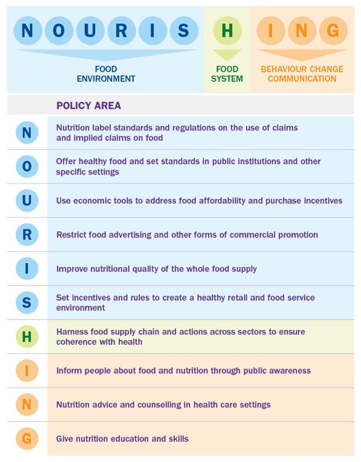
We have the NOURISHING policy framework which lists a comprehensive package of policy interventions that can address non-communicable diseases and obesity. We believe these should be considered in the design of any food system. The framework is supported by a database which list examples of policy actions and evaluations.

Furthermore, we have developed an index tool within the NOURISHING policy areas that is undergoing finalization. The index tool is designed to benchmark governments on their nutrition policy environments. The policy index comprises policy areas, benchmarks, indicators and a coding scheme which attributes values to good practice policy design. The elements of the most effective nutrition policy design have been developed with experts to establish an aspirational standard to hold governments to. It is important to note that the index and indicators present a suite of policy options and do not represent a hierarchy of desired or preferable policy options.

It is possible that some policy indicators outlined in the policy indexes are not currently implemented by any government, but through expert consultation, the most practical aspirational policy options were developed to create a robust and comprehensive benchmark.

We would be happy to share a copy of the index with the CFS in the coming months when it is finalised to support the development of the Voluntary Guidelines further. Please contact Kate Oldridge-Turner (k.oldridge-turner@wcrf.org) if this is of interest.

- How would these Voluntary Guidelines be most useful for different stakeholders, especially at national and regional levels, once endorsed by CFS?
It would be difficult to give an objective answer without seeing an updated draft and to see how the guidelines manage challenging areas such as conflict of interest; and if it promotes mandatory regulation in a range of policy areas. It would be welcome to have the support and legitimacy of the CFS to encourage stronger policy action in this area.

