Exposure visit on Farmer’s Field School to DRCSC, Purulia and Bankura, Districts of Westbengal and to study about the process and methods of FFS with reference to men and women participation
Bibhu Santosh Behera,Principal,Living-Farms Green College,Muniguda,Rayagada-Main Author
Artta Bandhu Prusty,Tapan Bihari Pattanaik,Kamalakanata Barik-Co authors(Lecturers of Green College)
Sudarsan Sahu,Chitta Ranajan Mohapatra,Goura Tripathy,Jagannath Sethi-Reporters(Demonstrators of Green College)
Extended Summary
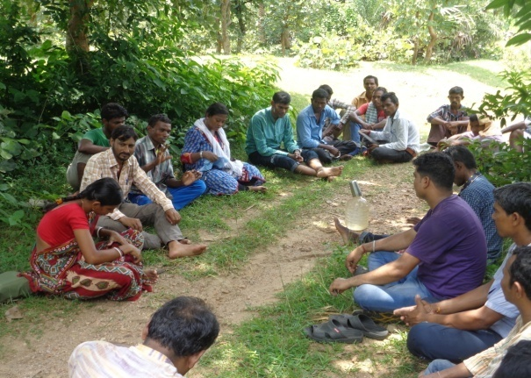
Exposure Visit is nothing but the outward orientation of the beneficiaries for a new type of learning to grasp the new innovations and interventions. As per Kolb’s ELC Cycle every one can get best access if learning should be at par doing, seeing and by internalizing. For getting maximum output from FFS formation 12 numbers of Leader farmers from various expertise of farming intervention such as SRI Paddy, Vegetable farming,Fishery,Mixed Cropping and other allied agricultural activities.6 numbers of Living Farms-Green College staffs also accompanied with these future farmers to guide them and for their refinement of knowledge in terms of participatory sharing.As this program is a conglomeration program idea,knowledge and technical skills are being interchanged among all.No doubt the farmers of various expertise are well known about the Concept of Farming and FFS.But still for filling of gap everyone were inducted for that program to learn the process as well methodology of executing FFS based intervention round the year. The details of all activities were presented date wise and place wise as below:-

Date | Place | Activities | Major findings
DAY-1  28th August 2016 | Muniguda | - Started Journey from Muniguda to Joychandi Pahar Station with 12 numbers of farmers and 6 numbers staffs  - Boarding and Lodging at Kashipur,Purulia | Defreezing among all farmer participants and one family one way and one approach with multiple varsity
DAY-2  29th August 2016 | Kashipur Boarding Place | - Introduction Session and orientation of Farmers by Staff members of Living Farms Green College at morning hour  - Visit Plan to Ledabona Village  - Reach at DRCSC Project Office ,Krushjori and after refreshment and breakfast introduction and welcome ceremonial activities made by DRCSC staff members at Training hall by giving a Scenic and brief presentation about their activities by PPT mode and open sharing method.  - Post Lunch session was executed by visiting Pindriah , a tribal village with FFS intervention.  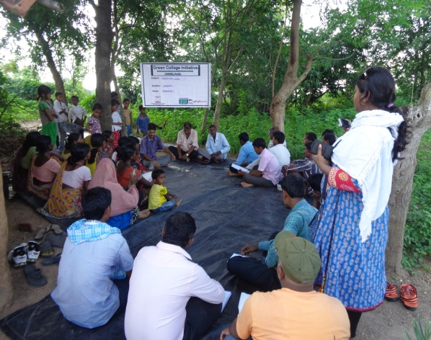  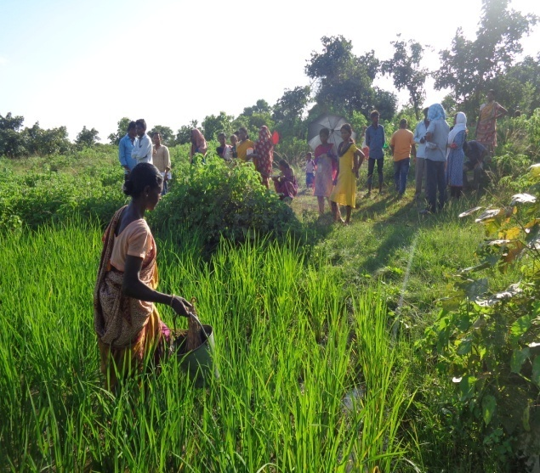 | Common orientation on FFS and other allied agriculture activities was being made through AV-aids and two way sharing mode.  Brief overlook on Green manuring,vermicomposting,Azolla cultivation,Neem oil exploration unit,Puffed rice preparation unit (being prepared by Dept.of Agri.engg,IIT-Kharagpur)  By demonstration method FFS methodology was being presented on the expertise of grafting of Lemon Tree.  Basic idea on multistoried cropping was gained by field movement to Pindhria farmers.  Finally, the participants were learnt about Pond based farming along with contour cropping pattern .  The cropping at the Ridge point of a Land was learnt to gain maximization of land use pattern and testing of water by using P_{H} card for Fish farming and their reclamanation.The day activities were ended by a group dinner at night.
DAY-3  30th August 2016 | DRCSC Project Office | - Recap Session of Farmers participants at the early morning session with the leadership of Staffs of green colleges  - After breakfast at DRCSC office ,movement of participants towards Hetasure Village to interact with Ramakrishna Murmu and to see the FFS and mixed cropping activities in that village via transact mode.  - On the way of transact a common forum meeting among Farmer participants,Hetasure farmers and DRCSC Bankura staffs was made to discuss about the Benefit of Mixed farming.Comparative analysis was made between monocropping Vs Multiple cropping.  - Post lunch session was executed by visiting Rangagora FFS and interacting with womenfarmers to indulge gender involvement in Agriculture.2 sessions were made to study the process and methodology of FFS based on Demonstration on Root Rot Disease and about Rhizobium culture application in Blackgram to prevent Leda worm in cultivation. | Memorizing learning activities by following Thorndike Method.  Learning was made on Mixed cropping pattern by intervention of Relay cropping activities. Comparative benefits from wasteland by using mixed farming concept. Basic knowledge about Bio-fertilizer culture application for seed/transplanting saplings inoculation.  Finally getting a brief idea about the modus of operandi on FFS execution.
DAY-4  31st August 2016 | DRCSC Project office | - Farmers-Staffs Recreation Ceremony was made by visiting the Tourist places like Joychandi pahar,Nehru park,Panchet Dam and Snake Resource Centre at morning hour  - Post Lunch session was executed with Planning and Impact evaluation. Group remarks by giving own experience sharing and finally valediction with Thank You note to each other and started the journey to Muniguda. | Mind relaxation was made and all farmers and staffs were aware and get motivated for installation of a Ideal model FFS in their living area with enthusiasm and expertise.

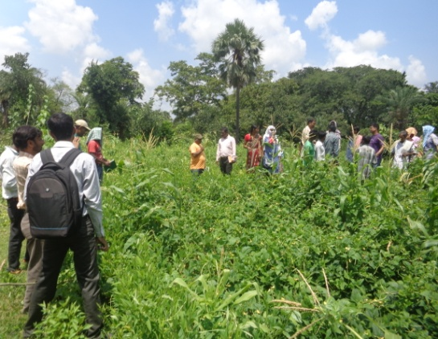
The Details of activity photo gallery is attached as below.
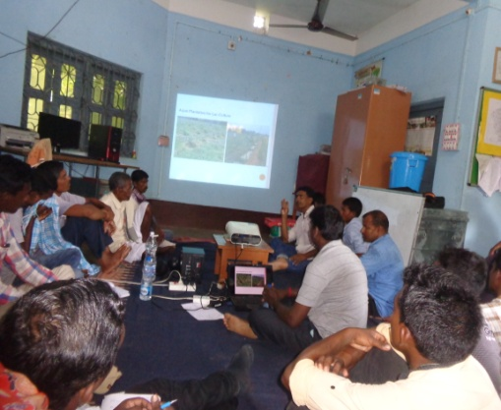
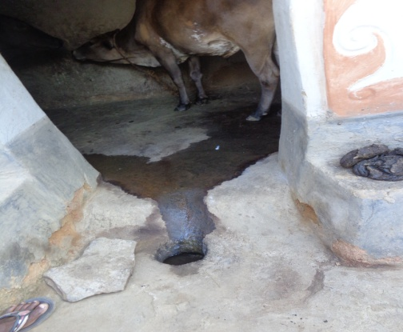

Acknowledgement and Concluding Remarks
For this 3 days contusive visit and organizing such a successful group activity we are acknowledging the help of following Team and Team leaders as posted below.
- Group organizing and Participation –Credit goes to Tapan Behari Pattanaik and all staff members and farmer friends
- DRCSC office for all 3 days travel,hospitality
- Artabandhu Prusty Ji for Group Ticket and On the way activities, Report recording of 3 days activities and presentation
- Kamalakanta Barik Ji for Financial settlements,Communication, arrangement and facilitating the learning processes
- Chitta,Sudarsahan and Saina for Observation and Disciplinary activities.
- Planning,Monitoring & Evaluation with Report drafting:-Bibhu Santosh Behera(Principal)
- Course design:-All Staff members of Green College
- Accounts Section for releasing fund in time.(Jagannath)

The Remarks from Staffs,DRCSC and farmers were reflecting on the smiling faces of farmers resemble that the program executed in 3 days are meaningful,fruitful and successful one with a positive enthusiasm.
This Report is authored by the President ship of Principal Green College,Muniguda

