“Go back to village...............and save our own culture... Agriculture” a program has been started in Hasinipur of Ganijang an ideal village of Bhadrak Dist. Of Odisha,India as a new initiative in Asia.
Bibhu Santosh Behera,Independent People’s Scientist
Email id:-bibhusantosh143@gmail.com

Abstract of the Program
In order to stop migration and to love our traditional wisdom and development of village with villagers this program has been started in Hasinipur Village with a great effort by Bibhu Santosh, a 27 year Young People’s Scientist who is presently a PhD Research Fellow of OUAT,Bhubaneswar and working as an Independent Scientist(Climate Smart Extension Education) for establishing climate smart and agriculture smart villages through extension education approaches by making awareness,campign,village meetings, road show and street play methods.
Proceedings of the meetings
Go back to village and give priority to Agriculture,villagers,youth mass,women and farmers.This program has been started in my village on dated 14th November 2016 in association with "SATYABHAMA" a People's Organization of Hasinipur,Ganijang Bazar Bhadrak and Odisha Rajya Sanskruti Surakhya Mancha,Ganijang,Bonth,Bhadrak with support from MGCY-UNEP-10 YFP-SCP and GFFSN-FAO support with the Major Stakeholders and advisor members. The theme of the program is on Sustainable agriculture practices, village development approach, production of poison free food via natural and good agriculture practices.In this meeting the following members are supported a lot to make this program successful,meaningful and aware all the villagers to implement this important program to stop migration via green jobs existing in the village and propose to establish the FPO,FIG,Farmer's Knowledge center and a Green Vocational Training Institute by self help mode and with people's contribution. Finally every one take promise to make Hasinipur village an organic and climate smart and agriculture prosperous ideal village in India and in the world.
The following great personalities and innovator mentors are present in this farmer-scientist interaction meeting, awareness camp and village conference to make this program in to a new height and pass the message of sustainability throughout the world.
Chief Mentor and Patron
Bibhu Santosh Behera,PhD Research Fellow,OUAT,Bhubaneswar
Independent People’s Scientist (Climate Smart Extension Education)
Major Group on Children and Youth-10YFP-SCP-Asia and Alternate Focal point
State Chairman,Anti-corruption cell,AIASA-Odisha Cabinet
Member,GFFSN-FAO-UNEP

Program Executing Organizing Secretary
Mrs.Sataya Bhama Behera,Social Worker Chairperson ,SATYABHAMA a People’sOrganization,Hasinipur,Ganijang,Bhadrak,Odisha,India
Er.Choudhury Champaty Charan Behera,Secretary
Odisha Rajya Sanskruti Surakhya Mancha,Ganijang,Bonth,Bhadrak
Program Executive
Er.Rudra Ashish Behera
Local Advisor Groups
Prof.Anama Charan Behera
Chinmayee Behera
Laxmi Priya Pradhan Behera
And
All Villagers and Farmer Leaders of Hasinipur village,Ganijang and Bhadrak District

Glimpses of Photo gallery during village conference
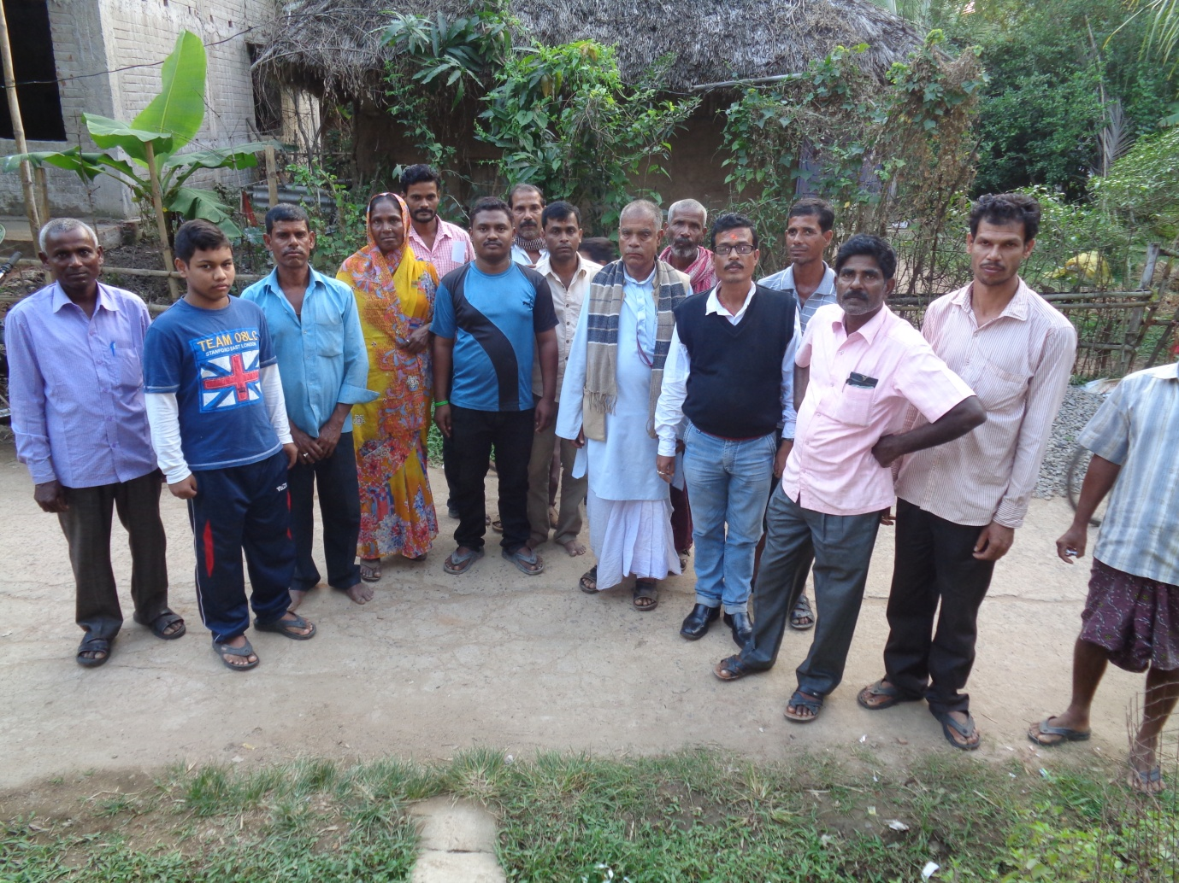

During Farmers-Scientist Interaction
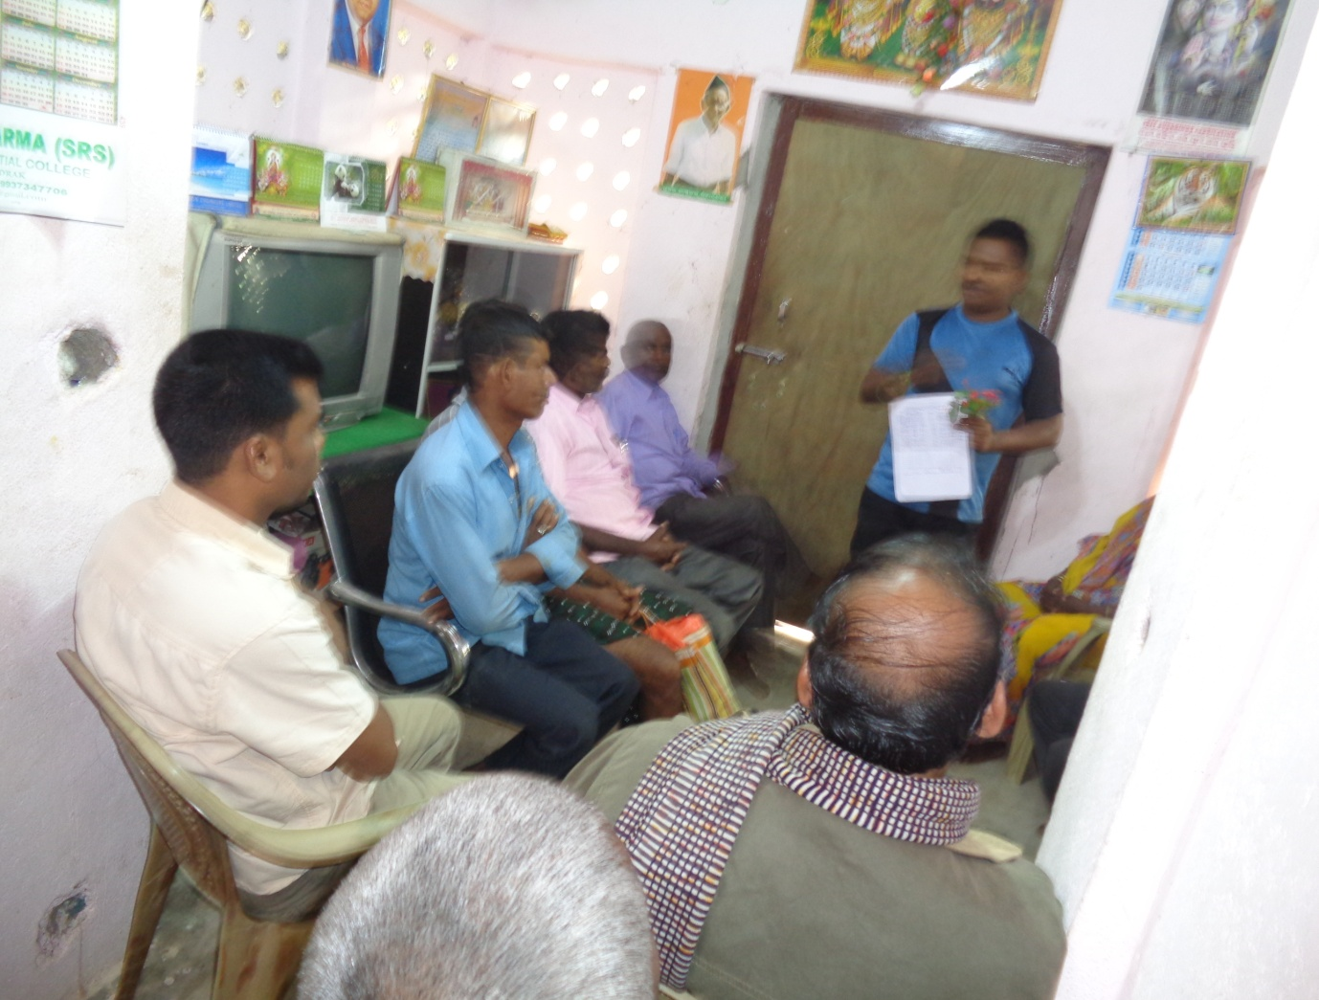

Concluding Remarks
The villagers is the main mobilizer and motivator for any program. For changing their behaviour,attitude and practices a Scientist who is for People’s Specific is necessary for the village and Society.Here the People’s Scientist Concept has been invented and applied by Bibhu Santosh ,PhD Research Fellow of OUAT and inhabitant of Hasinipur Village.Apart from his all type of job or work who is first in the world to take such type of initiative with selfless approach.
References
Self
Face Book Publication
Local Media Publication
Hard Copy of Proceedings

