green college
2016
IMPACT AND CASE STUDY
GREEN COLLEGE ACTIVITIES
Living Farms
green college muniguda

Editorial Board
Debjit Sarangi-Managing Trustee,Living Farms,Bhubaneswar-Chief Patron
Bibhu Santosh Behera-Principal,Living Farms-Green College,Muniguda,Rayagada-Chief Editor
Members
Kamalakanta Barik-Subject Matter Specialist
Artta Bandhu Prusty-Course Coordinator
Tapan Behari Pattanaik-Business Devt.Executive
Sudarsan Sahu-Senior Field Officer
Chitta Ranjan Mohapatra-Field officer
Saina Saraka-Field Officer
Jagannath Sethi-Accountant
Message from the Principal, LivingFarms-Green College Muniguda, Rayagada
(Funded by SDTT-WHL-GIZ and Affiliated with ASCI)
I am very happy and feel proud privilege to take this opportunity to present the case study and impact of Green College in tribal areas of southern Odisha to make the students skillful with green and clean initiative. I am very thankful and grateful to every faculty members, students as well as Managing Trustee for their intermittent support at need based.
I wish all the best for the future
Bibhu Santosh Behera,Ph.D
Principal cum Independent People’s Scientist
Living Farms Green College,Muniguda,Rayagada,Odisha,India
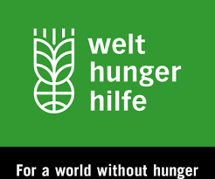
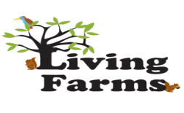

Impact from the Villages
Changes in the Life of Community
Kachhapaju Village
The Community of Kachapaju mostly Tribal’s and most of the people are droup out from School .They prefer to remain as per the Culture and Tradition of Tribals.For food and Livelihood purpose they believe on Traditional Agriculture and Forest based livelihood.
But after the intervention of Green College being managed by Living Farms in the Remote Tribal Pocket of Bissam- Cuttack Block of Rayagada District is really praise worthy .For this reason the life style and livelihood pattern is changed to some Extent. A 30 day’s training program on “Nursery management” was being conducted in this regard from 27th June 2016 to 29th July 2016
Now from 18 Trainee participants of Green College are practicing Nursery based intervention in Kachapaju and nearby area of Kachapaju.The trainees feel proud to have this green business by becoming ecopreneur.20 percent trainees are ready to supply the grafted nursery seedlings and rest are under pipeline. One trainee named Bishnu Saraka have got the offer from a local farm to graft the various plants by getting a lucrative remuneration. This is a good sign to provide the employability to the tribal’s in this competitive age.
Another Qualitative approach by Green college was made prepared for “Organic Marketing “ Linkage with Christian Medical College by opening a “Sabji Mandi” inside the Hospital premises on Every Sunday.This is a very Innovative and welcome approach for marketability in order to increase the economic and financial status of the Poor marginal tribal farmers.
Naringponga
Naringponga is a very ideal village of Bissam-Cuttack block having good natural resources. This area is very fertile and the community mostly belongs to Tribal’s having unique interest to accept Agricultural and Horticultural activities. In off/on season due to paddy cultivated lands the lands remain fallow, but after the Green College’s short duration training program on Commercial vegetable cultivation showed a way to cultivate the crops in the concept of “Diversified Agriculture by adopting Organic Olericulture”.Now 20 participant trainees have got this valuable training and able to earn their selves in the Concept of Collective marketing of Vegetable Crops in the local markets. An Excellent training methodology has been practiced in this short course by giving same priority on Theory and Practical Classes. (50 % Lecture+50% Practical)
Nuagada
Nuagada is also a very innovative tribal village of Bissamcuttack having keen interest to raise the livelihood status by adopting vegetable cultivation; hence during the selection of participant’s trainees this village is taking into consideration .In this village 25 no of trainees have trained. Finally out of them more than 50 percent trainees are under the Agripreneurship process by selling their products in Sunday Market and local markets with a very reasonable price.

Sunkurupada
Sankurupada is also a tribal village under Bissamcuttack block and suitable village for cultivation due to a seasonal canal facility for irrigation and well fertile soil. In this village 30 no of participants have been trained.Finally 20 percent trainee participants are showing interest for cultivating vegetable as a major green business in this locality.
Dhobagudi
Dhobagudi is a Tribal and Remote village of Muniguda Block having well exposure in Agricultural activities.27 no participants have trained on Commercial vegetable cultivation. Now more than 10 percent participant trainees are coming to Sunday market and made linkage with local markets.
Newhope Training Centre Muniguda
As Green college infrastructure is under pipeline and to be finished shortly, Livingfarms green college now running at temporary basis in village sites and Newhope a local training centre having adequate facilities.Here a “Mass Commercial Vegetable Cultivation” Training program is conducted for 3 major blocks like Bisamcuttack,Chandrapur and Muniguda in 2 batches.Around 26 trainees are participating in 1st Batch and 20 participants in 2nd Batch.Now the trainees are aware about the benefits of Commercial vegetable cultivation by using organic practices in order to achieve food security, food souvergnity and nutritional balance in this tribal patch. Marketing linkage is tie up with Local markets and Christian Medical College and Hospital in Sundays initially. But major planning is under pipeline to open a Tribal Organic Market at Muniguda,Bissam-Cuttack in locality and Rayagada and outside as a outstanding green business after a huge quantity production.
Kakarmaska
Kakarmaska is a tribal village under Bissam-Cuttack Block having suitable condition for rice diversity. So here the farmers are very needy to learn “SRI method training in Paddy”. In order to meet this challenge, around 30 potential trainees have been trained for 15 days at the peak period.More than 30 percent trainees have been adopted SRI paddy in their land and 10 percent trainees disseminated this novel technology in that locality is a grand success for this area.
Khadisore
Khadisore is a tribal village under Chandrapur Block having suitable condition for rice diversity. So here the farmers are very needy to learn “SRI method training in Paddy”. In order to meet this challenge, around 25 potential trainees have been trained for 15 days at the peak period.More than 20 percent trainees have been adopted SRI paddy in their land and 5 percent trainees disseminated this novel technology in that locality is a grand success for this area.

Singari
Singari is a tribal village under Muniguda Block having suitable condition for rice diversity. So here the farmers are very needy to learn “SRI method training in Paddy”. In order to meet this challenge, around 25 potential trainees have been trained for 15 days at the peak period.More than 80 percent trainees have been adopted SRI paddy in their land and 50 percent trainees disseminated this novel technology in that locality is a grand success for this area.
Newhope,Muniguda
As Green college infrastructure is under pipeline and to be finished shortly, Living farms green college now running at temporary basis in village sites and New hope a local training centre having adequate facilities.Here a “Mass pond based farming” Training program is conducted for 3 major blocks like Bisamcuttack,Chandrapur and Muniguda in 2 batches.Around 12 trainees are participating in 1st Batch and 27 participants in 2nd Batch.Now the trainees are aware about the benefits of pond based farming by using Integrated farming system in order to achieve food security, food souvergnity and nutritional balance in this tribal patch. In this local area only Sikabandha trainees are reflecting their interest by harvesting the fish and selling it in the local market in the first initial step. They are also getting some vegetable and agricultural crops as an insurance crops for their consumption and selling. The other trainees are under the pipeline to sell fish as well as fingerlings soon.
Siali leaf Plate
Siali leaf plate making is a forest based intervention for Women farmers in the Tribal belts.So the training has a demand in this tribal area.So “Siali leaf plate making” training has been conducted in 2 villages namely Kerandiguda having 22 participants and Chanchraguda having 27 participants of Bissamcuttack Block.Simillarly in Pisikapanga village of Chandrapur Block having 23 participants has been trained.
Newhope
As Green college infrastructure is under pipeline and to be finished shortly, Living farms green college now running at temporary basis in village sites and New hope a local training centre having adequate facilities.Here a “Mass siali Leaf plate making” Training program is conducted for 3 major blocks like Bisamcuttack,Chandrapur and Muniguda in 2 batches with 16 participants each.Now the trainees are aware about the benefits of siali leaf plate making .In this local area there is a huge demand of Siali leaf plates in ceremonial activities like function,marriage.Out of all area only Chanchraguda village Siali leaf plate making group is best of best among all groups by selling and supplying huge leaf plates through SHGs and having sound economic condition of families.
Mushroom
Mushroom is a very demandable business in Bissam-Cuttack block .But supply of mushroom is from outside by importing mode and very scanty.In order to fulfill this goal a “Mushroom Cultivation” training have been conducted in Chnachraguda where 22 participants from Chanchraguda,Nuagada,Sanyasiguda and Hurugudi have been participated.Simillarly from Jhiari and Machripadu no of participants are having this training.But only Chanchraguda village participants are selling mushroom worth Rs3500/- is a very small beginning among all area.
Farmer Field School Set up for Farmers and Farming Communities
For set up of wall without school for farmers and farming communities Green College also promotes FFS in Singari village,Kachapaju village and project villages.Around 3000 FFS will be completed by 2018.

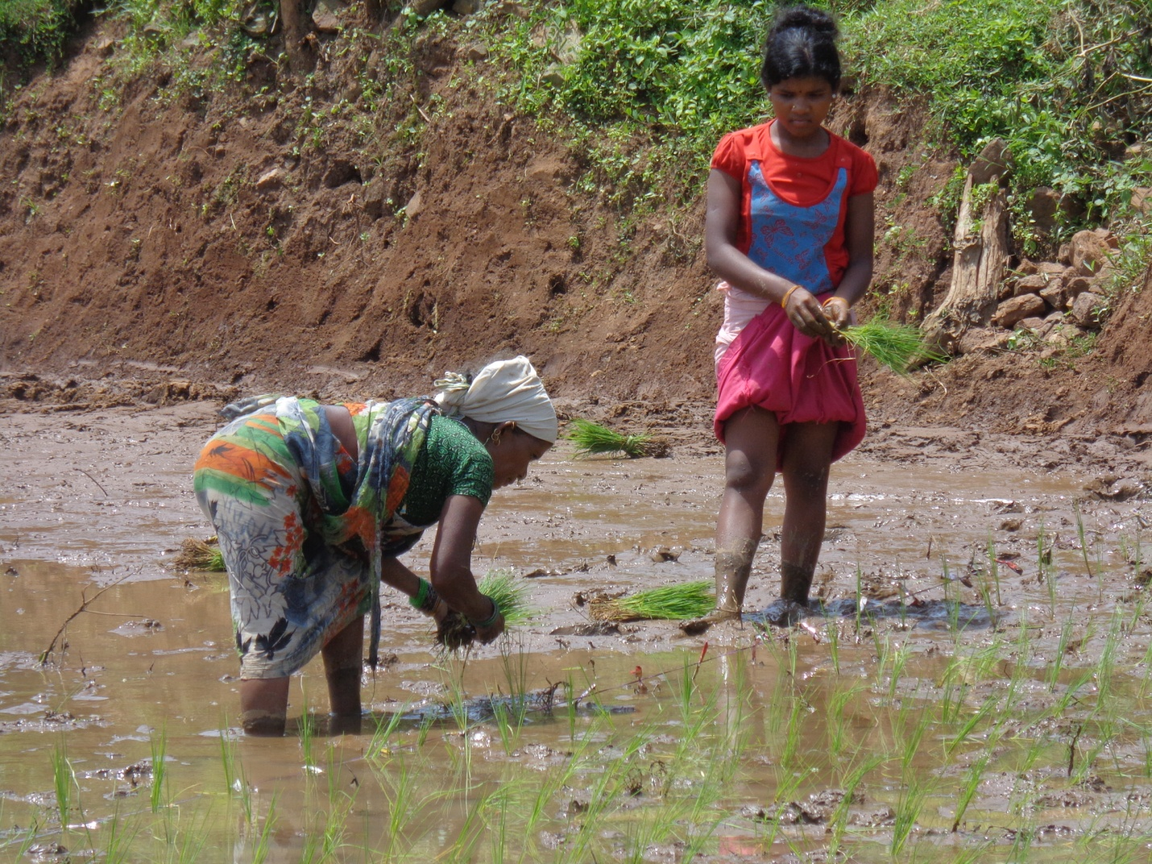
The Green Face of Green College

CASE STUDIES RELATED TO TRAINEES
Green College Brings Smile among the Trainees of Singari Village
Singari village is a very small tribal village of Muniguda block having all suitable conditions for Agriculture and Horticulture Interventions. 2 Nos of case studies have been collected and illustrated as below.
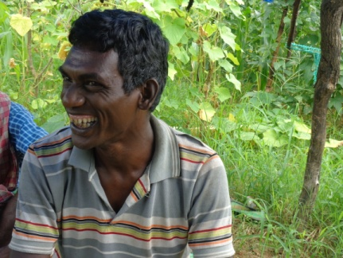
Case Study of Bharat Kasi
Bharat kasi is a Tribal farmer of Singari Village having Nuclear family.He is a very innovative farmer of multi crops like Paddy,Vegetables.After getting training from Green College he has made intervention of SRI paddy in 1Acre of his land and in another acre he has grown mixed vegetable crops by giving intercrop of Cereal crops like Maize,Mungbean and Cow pea.Before joining in this college in 2014 he had been applied fertilizer and got a huge loss by crop-pest infestation and more investment.Bharat was going for an Exposure on horticulture crops being organized by Dept. of Horticulture,Govt. of Odisha.But, after joining the training his life style is changed.Now, he is not using any fertilizer.He is preparing his own compost like Green manures,Forest compost and Amrit pani of his own in his farm and applying during peak season.He is very happy now by getting a poison free food and a profit of Rs 70,000/- per year by investing only Rs 25,000/-.Now his vegetable farm has been selected as one ideal FFS and he is a farmer icon by becoming a master farmer in his locality.He is thankful to LivingFarms green college.
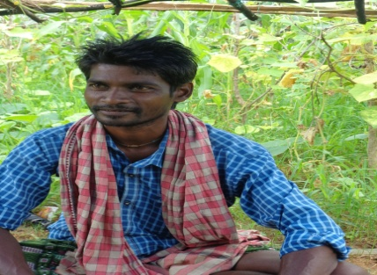
Case Study of Shashi Bhusan Kasi
Shashi Bhusan is an Indigenous paddy farmer of Singari Village belongs to tribal family having 5 no of family members. Before his joining to Green College he was cultivated his paddy by using traditional method. When he is getting exposure on SRI of paddy after having training from Green College he is practicing SRI method in his own land and also contract land. Due to his cultural traits he has not left traditional paddy cultivation by cultivating traditional SRI method along with modern SRI method.This is very interesting in his field.In one way in traditional method he is using local traditional variety for his taste and farm yard manure and ITK practices for getting a True Crop with real taste for maintaining food security. The Row to Row and Plant to plant distance in SRI paddy is 5’x10’ .In case of modern SRI method he is maintaining the distance 10’x10’ only but the package of practices and crop management is same as per traditional. Due to his innovativeness he is also getting an Exposure from Govt. of Odisha,Horticulture Dept. by visiting Bhawanipatna.Previously he was getting Rs 30,000/- by investing Rs10,000/- for paddy.But in this season he is more anxious and expected to get more yield by this SRI method.
Every farmer is a field scientist.Here Shashi is the key farmer of SRI to conduct research on Traditional paddy vs Modern Paddy cultivation.His field has been demarked by Green college to prepare a FFS on SRI paddy and he will be the Master farmer for this.He is now happy to get this wisdom from Green College and he is planning to grow vegetables and aromatic rice in next concurrent season.

Siali Leaf Plate Making Brings a Socio-Economic change in the Women led farming
Case Study of Singari Wadaka
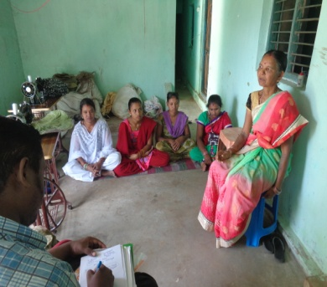
Singari Wadaka a Tribal woman of Chanchraguda Village having a great contribution to society in terms of Agriculture, farming and social activities.She is a very notable leader, activist by doing welfare activities of women groups in her locality in general and outside in particular.She is blessed with a Nuclear family.Initially she is doing her traditional vocation by collection of Forest and NTFP products and sell it in market.When she was becoming a leader member of “Adivasi Bikas Mahila Sangha” , at the mean time she has started her ground work on Siali leaf plate making by making a discussion with her group members. Initially, they made the leaf plate by own hand stitching and facing drudgery and lower income. But when she is joining in Green College and getting the proper training on Value addition and Supply chain management aspects ,now she is an Agroecopreneur in the field of Siali leaf plates by supplying 10,000 paper plates in a very short duration training.As leaders make other leader, she is attracting other youth women , women farmers to involve them in her business.Every women can get maximum profit and also their basic fundamental right like Education,Freedom and satisfication in job without any gender discrimination. Now she is also getting offer to be the master trainer of Siali leaf FFS being executed by Green College.
She is very happy because she is getting maximum profit by this business and also fed other women by giving opportunity to work with her in order to achieve Socio-Economic empowerment in this competitive age.
Singari is famous as “Singari Maa” due to her dedication and contribution to society and always with her smile face she is acknowledging the help of Green College and expressing that “Green College has changed our Life”.
Case Study of Aparti Wadaka
Aparti is a very active women trainee of Siali leaf plate making aged 18 years having 10th Class of Education. Due to her family burden and poverty she can’t able to attend any College. She is feeling very sad and Employment is a problem now a days.She is assisting her mother during her bad days. When she is listening about Green College from Singari Maa, she has came with her own interest and attended a Training program on “Siali Leaf Plate making”.Finally the training is over and now she is happy and feel proud to get her own way of living by working with Singari Wadaka in Adivasi Bikash Mahila Sangha.Every moment she is sharing her happiness that “I am a Green College student directly after matriculation”.
Case Study of Mahima Wadaka
Mahima Wadaka is a Tribal women trainee of Green College; aged 18 years having matriculation always search for a job and working in her own field as a female farmer. Due to the advent of Green College intervention for women led farming Mahima is getting the right platform to grow up with Siali Leaf Plate making business.After training from Green College now she is an active worker of Adivasi Bikash Mahila Sangha and also invited for trainer in locality.
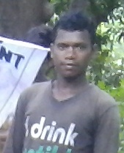
Case Study of Bishnu Saraka
Bishnu Saraka is a young tribal trainee of Green College; aged 22 years who is always searching for doing some work due to his poverty and lower profile of Education. But when he is getting enrollment in Green College for “Nursery Training and Management” course his life was completely changed. He has got the right platform for skill based green education and after his training he is now getting offer from doing budding, grafting and nursery work in the local NGOs and farms. At the beginning stage he is also opening his own nursery of 20 nursery plants. Bishnu is very happy and obliged to Green College.
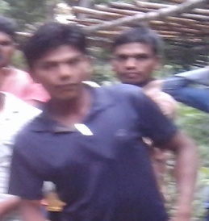
Case Study of Debaraj Saraka
Debraj Saraka is a very young innovative trainee participant of Green College; aged 20 years show the path by becoming a leader for the Tribal youths. Before entry to Green College he is doing cultivation work with his parent’s land and in Dunger (Hilly area) of his village Kachapaju.Some times he is going for helping the village animals in grazing field.As he is a drop out and interested for education , he has joined in Green College to learn something.After attending Nursery management course, he is now able to prepare nursery plants by budding,grafting and layering. He is ready to sell his nursery plants soon.
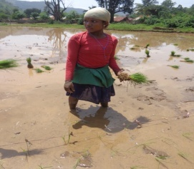
Case Study of Sunita Kadraka
Sunita Kadraka is a Tribal women trainee aged 15 years of Khadisor village .Before joining to green college; she is usually working as agriculture laborer in her village area due to less education status. But after becoming a student of Green College she is able to get the skill based education on SRI paddy. Now she is working in her field and also popularizing SRI paddy method in the locality.
Case Study of Karna Gangaranga
Karna is a 18 Year old youth having basic knowledge in traditional agriculture to help his father .This is the daily routine of Karna, but when he is becoming a Student of Green College he is very happy to learn the new techniques in SRI Paddy training. Finally he is called as a Leader farmer of SRI to train his local farmer friends. Now he is getting a chance to become the Master Farmer of FFS on SRI paddy in his village.
Case Study of Nabin Kambaka
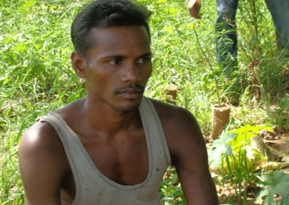
Nabin Kambaka who is a 18 years old boy, a school dropout always roaming here and there without any job.But when he is getting chance to learn from Green College on SRI paddy he is very happy and finally learning tricks and tips of line sowing.He has working in his own field as a Farmer by cultivating paddy by SRI methodology. He is also getting offer for master trainer of FFS on SRI paddy in his village.

Testimonials from Beneficiary of Green College
- This is a Real College for Tribal’s, women and poors. I am now financially sound by making siali leaf plates as a major livelihood option in my area by helping others.(Singari Wadaka).
- I am a Green College Student directly after matriculation and feel proud that I am getting a Job to manage my family by working independently in Siali leaf plate making.(Aparti Wadaka).
- Green College is a very good college for providing skills for getting a sustainable job in the locality. I am happy for becoming a Student of this college by making a Horticulture Nursery with my own.(Bishnu Saraka).
- This is a College with unique talents having both practical skills and traditional knowledge. I am happy to start a pond based integrated farming enterprise and can able to maintain my family happily.(Madhaba Kandamaka)
- I am obliged to Green College for learning new concept of SRI of paddy.(Shashi Bhusan Kasi)
- Green College is a very good college for giving life based education and skills for Agriculture Application.I am happy to become an Organic Vegetable Agripreneur.(Pitambar Meleka)
- Green College is a college of all agricultural vocational skills.I am happy to get an offer for becoming a Master trainer of FFS on SRI paddy in my village.(Karna Gangaranga)
- I am a very lucky girl student to learn at Green College and learn many things on SRI paddy to make myself skillful.(Sunita kadraka)
- Green College is the only base to give learning and earning.I am happy to be a part of Green college and now working as a Skillful Farmer.(Nabin Kambaka)
Green College may be the only panacea for creating sustainable green revolution for the future. Be a part of it.
