Using information technology in the agriculture of APEC economies and beyond.
The use of Information and Technologies has becoming more common in agriculture. Evolving of electronic data collection android tools and using online databases like GeoODK, SurveyCTO, SEL, Ona and Kobo has increased the application of ICTs in agriculture.
Information technologies through GeoODK Application for instance can be used by government agents (village and district extension officers/analysts) to enter and submit their summary observations and reports on local crop conditions from production to harvesting (Figure 1).
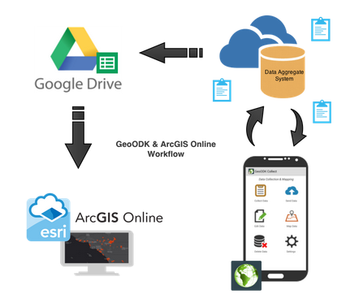
Figure 1: Shows the flow of information from field to the government online database

A good example here is AgriSense, a “Spurring a Transformation for Agriculture through Remote Sensing (STARS)” Project lead by the University of Maryland (UMD) and Sokoine University of Agriculture (SUA) works in Tanzania and Uganda. The project has successfully managed to use satellite remote sensing technologies for improving the basis and flow of information for agricultural monitoring and food security forecasting by the National Food Security Department in Ministry of Agriculture (MAFC) of Tanzania. Crop condition monitoring was done only in three main categories namely pre-season, in-season and end-season. The case study covered only Morogoro region (Figure 3), this calls the same study to be conducted in other regions of Tanzania.
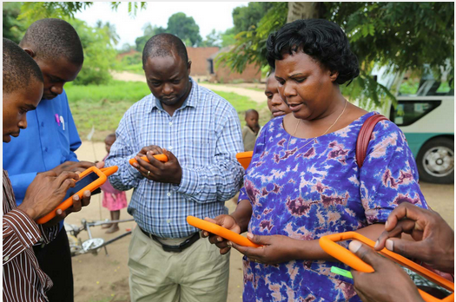
Figure 2: MAFC trained experts sending in-season crop condition data to the Government online database

GeoODK’s smartphone based electronic field has replaced paper based data collection process to an electronic field data collection system that allows for faster and more efficient data collection and fosters easier submission of field data to government ministry offices and decision-makers. The GeoODK system is projected to significantly increase the efficiency of data collection and delivery by directly submitting the data from the smartphone or tablet to the online database The system allows the enumerator to collect field GPS and let the government/donors to know exactly where the problem is(Figure 3).
Figure 3: Show field points (farms) monitored by village extension officers in Morogoro region
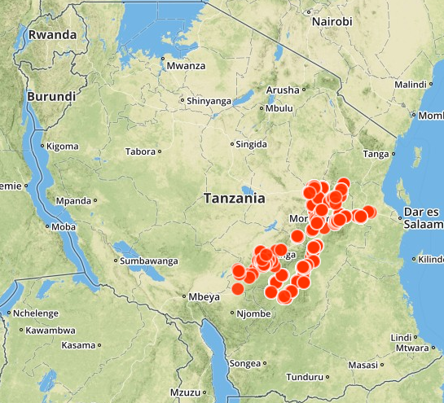
Since STARS project has proved that ICTs can be possible, FAO Tanzania use the same technology be extended to post-harvest management, to collect and submit any signs of critical loss points to the central system where interventions can timely be proposed and implanted. Extension officers in the village can be trained and equipped with smartphone or tablets for easier weekly data collection and reporting.

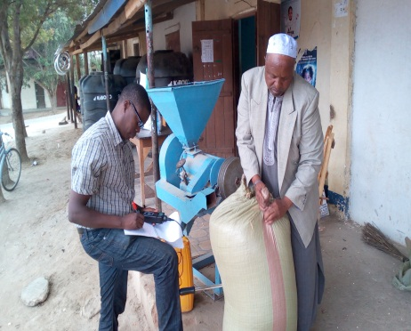 | 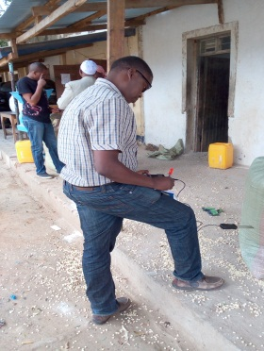 | 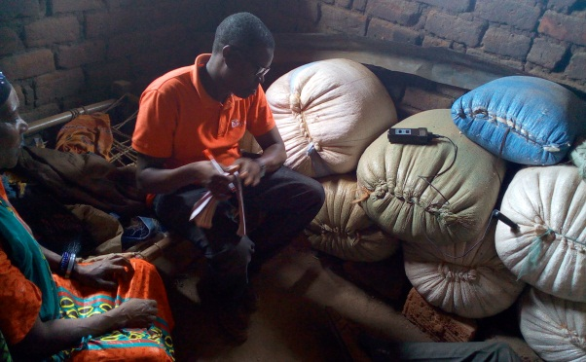
Figure 4: Use of ICTs in Food Losses Assessments (a picture taken in Kiteto district) during Maize losses assessment at storage stage November, 2016.
In the study conducted by FAO on maize losses assessment in Mbozi and Manyara districts one of the observations was inflation of fake inputs like (postharvest pesticides, seeds fertilizers etc.) being sold in the market. Due to ineffective application of pesticides, the losses at storage stage have increased significantly. Also failure of maize seeds to germinate was reported to be obvious.

How ICT Can Solve this?
- All inputs supplied in the market should have identification number/codes (e.g. 10233, 10235, 10237, etc.).
- When a farmer/buyer wants to purchase any agricultural inputs he/she should dial to a specified code e.g. *150*10233#
- After dialing an SMS should display on the phone screen indicating:
  - The manufacturer
  - Date of manufacturing
  - Expiry dates
  - etc.
- If the product is not in the database it should display otherwise
- The farmer will have the right to deny the product

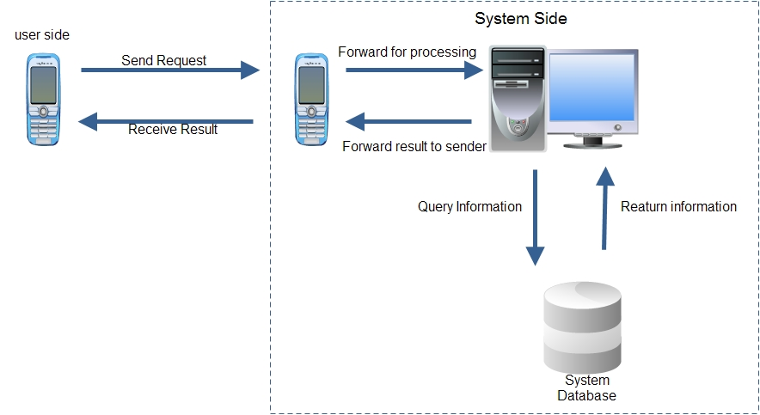
Figure: Syntax of how a mobile phone information system works

FAO Tanzania applying innovative ways to collect agricultural statistics which offer a wide range of solutions to some agricultural challenges. In the future Tanzania Food security and information system plan to use collected information on chronic analysis classification.

In summary information and technology are now being used widely with remarkable positive results to perfume their task in agricultural development.

