WORKING FOR BEES

INTEGRATING BEEKEEPING WITH SUNFLOWER FARMING AT

LANDOS FARM- November 2018

By R Mutisi

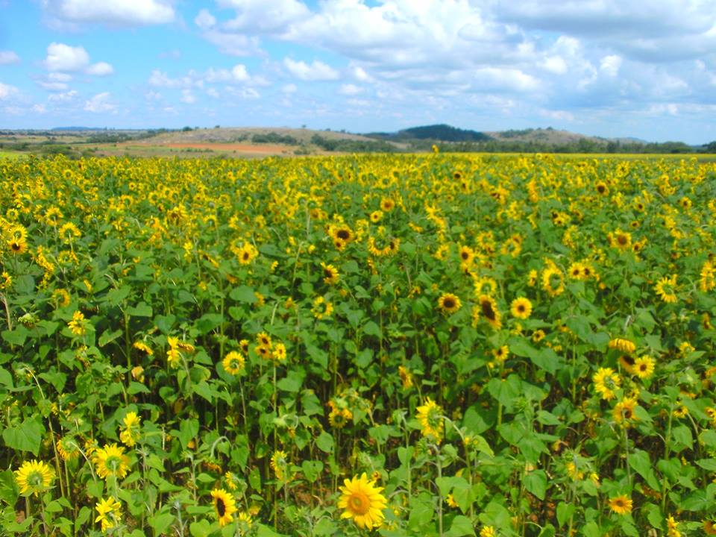

The Helianthus annuus

- Introduction
The sunflower crop is fast growing, heat tolerant (warm weather crop), grows well under dry conditions and can deliver maximum yields with minimum effort from your part. The sunflower crop produces a lot of seeds having each sunflower head producing about 2 000 seeds which can be collected easily. Seed from the sunflower can be used as food, stock feed and for health benefits.
Honey bees are by far the major insect visitors to the sunflower blossoms (McGregor, 1976). Bees collect both nectar and pollen from sunflower blossom and favour the Helianthus species that are very attractive. The sunflower crop needs pollinators for it to bear good quality seeds. Bees play a major role in pollinating sunflowers as they get attracted by the conspicuous yellow colour. DAF (2005) stated that the production quality of sunflower nectar and pollen is poor with regards to the nutritional requirements of honey bees.
A mixture of managed honey bee colonies and other bees produces a very effective pollination service (Greenleaf and Kreman, 2006). A conservation of wild habitat and alternating selected farm management practices has high chances of increasing sunflower production.
Most sunflower cultivars are self-incompatible meaning that to have a successful pollination, pollen must come from another plant. If pollen from a floret is transferred to the receptive stigma of another flower on the same head then the seed will set. When self pollination (within the same head) seed set is usually low, undersized and the amount of oil in the seed and germination rate are reduced (McGregor, 1976). The seed that results from self pollination sprouts more slowly, and production is usually lower than plants obtained from the crossed seed (McGregor, 1976).

- Sunflower crop establishment
The crop was established in December 2017 at Landos Farm in Headlands. The land preparation and seed sowing was done mechanically by Landos staff (See picture below)

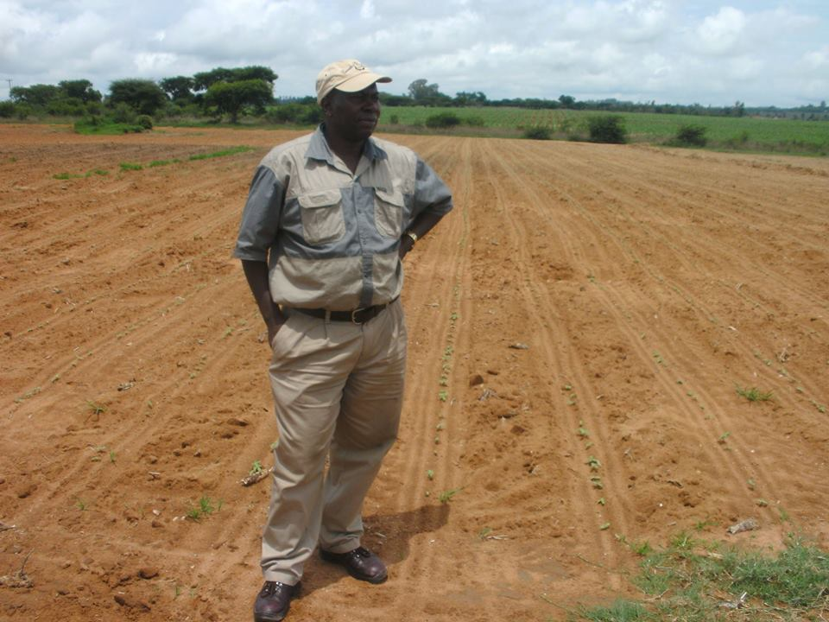

Seeds in this area where Robert is standing sprouted within 10 days after sowing.

The different growing stages of the sunflower crop are shown on pages 4 and 5.
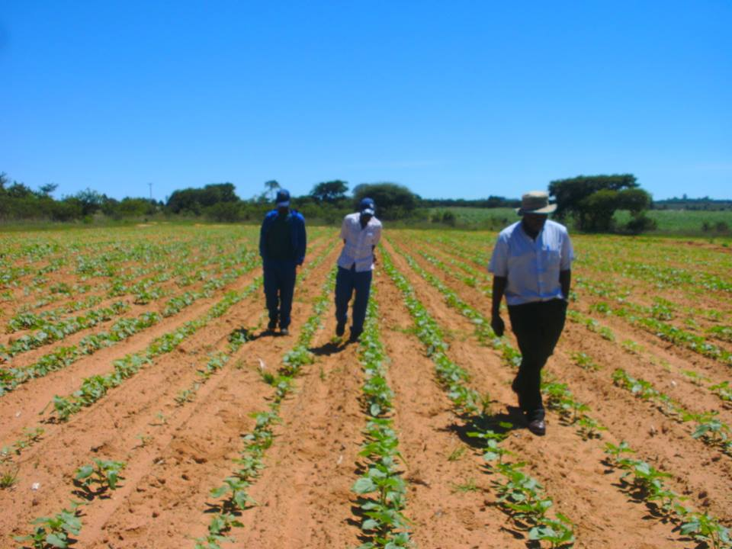
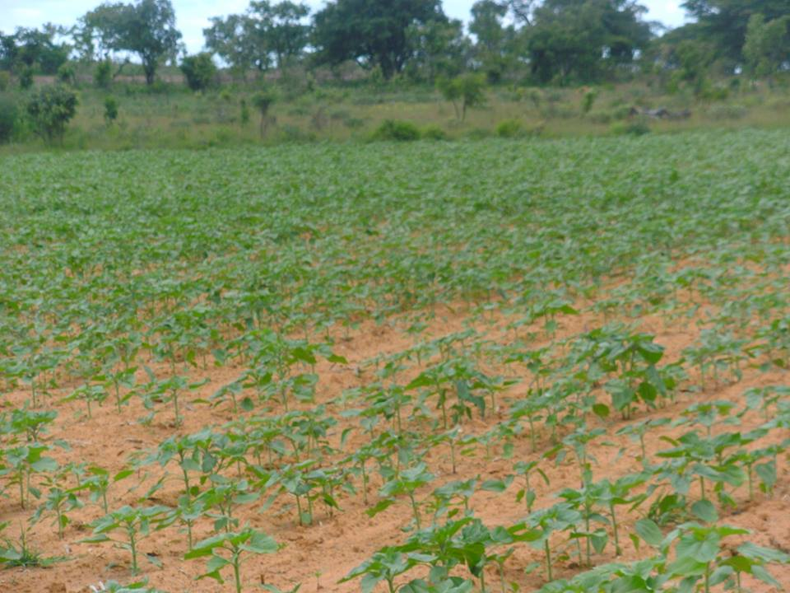
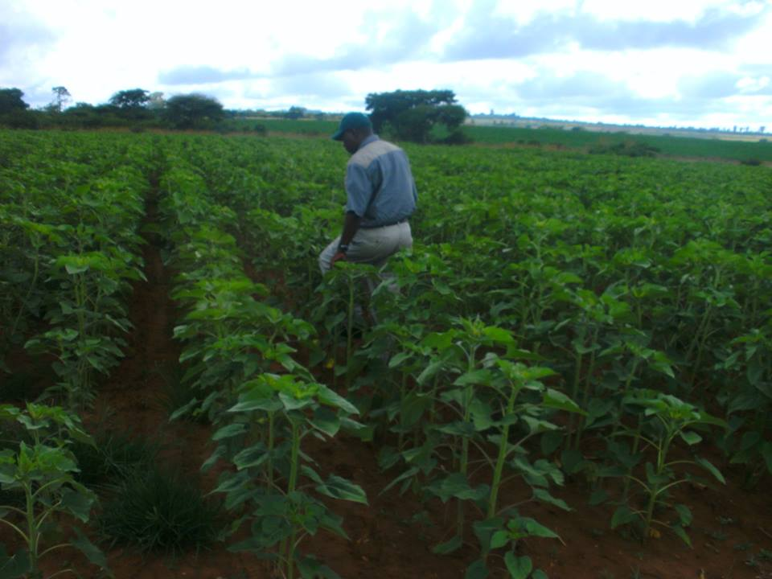
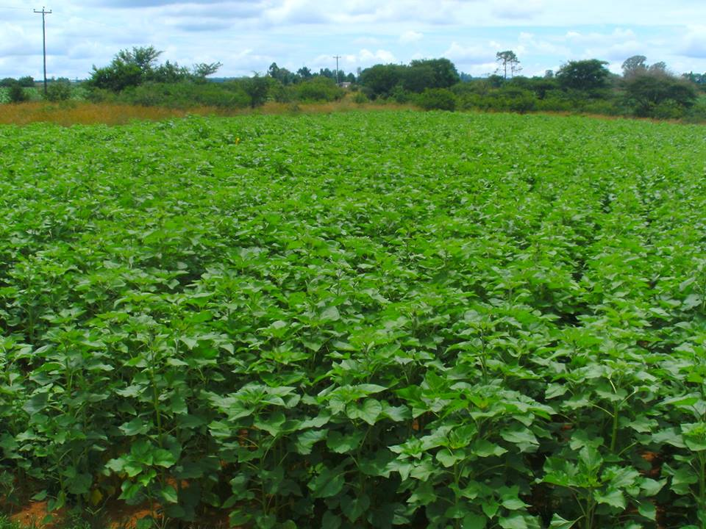
The sunflower crop started flowering after two months from the day of sowing. Flowering started early February 2018. Twenty bee hives with strong colonies were introduced in the sunflower crop when flowering was at 5%. This started with the setting of stands in various areas around the crop field. The bee colonies were brought in the crop field to pollinate the crop flowers after the setting of the stands. Pages 6 and 8 show pictures of sunflower crop starting to flower and stands being set and some bee hives placed on the wooden stands.
Sunflower crop starting to flower
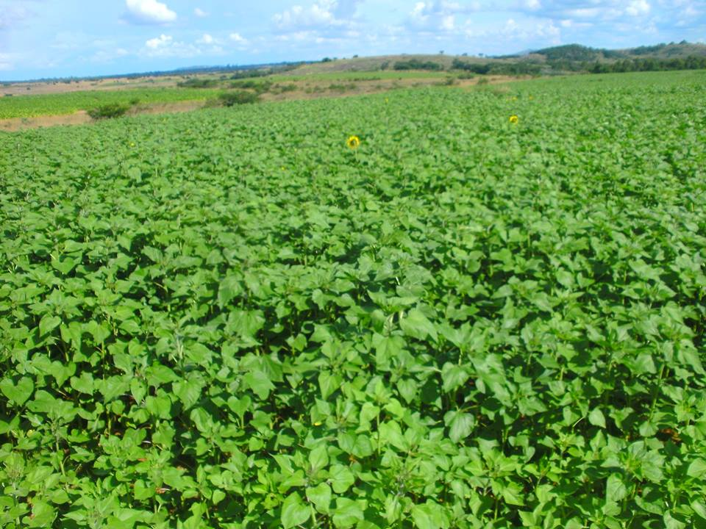

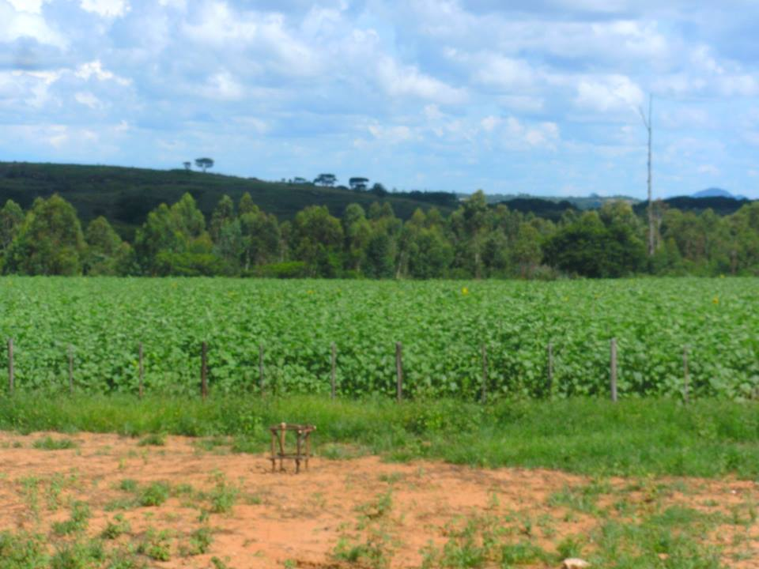
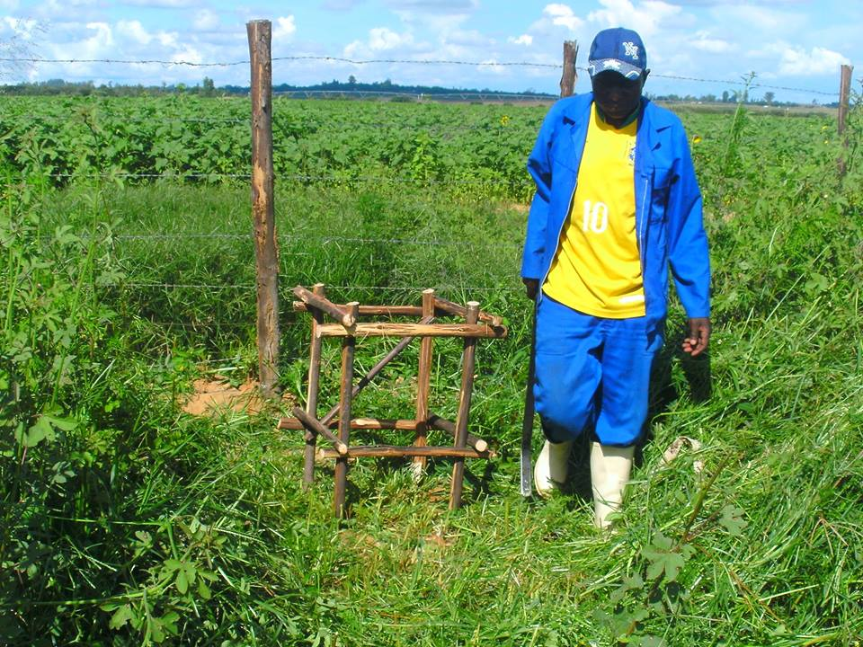
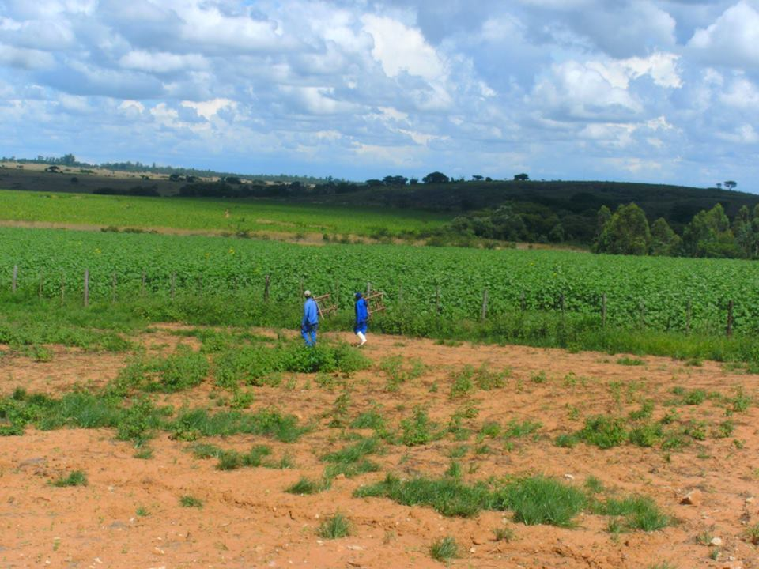
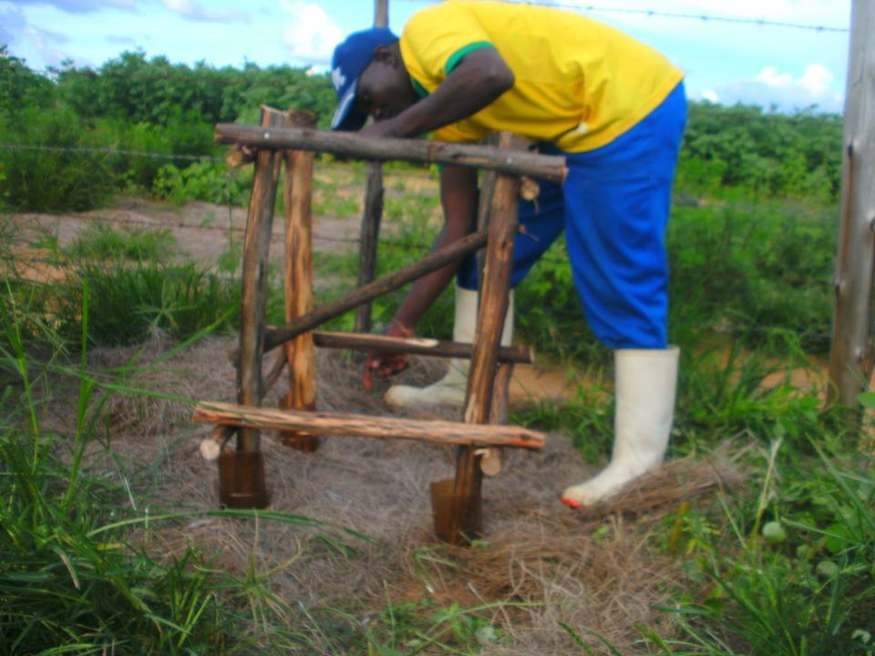
The pictures that are on pages 9 and 10 show the bee hives lined up in the crop field.
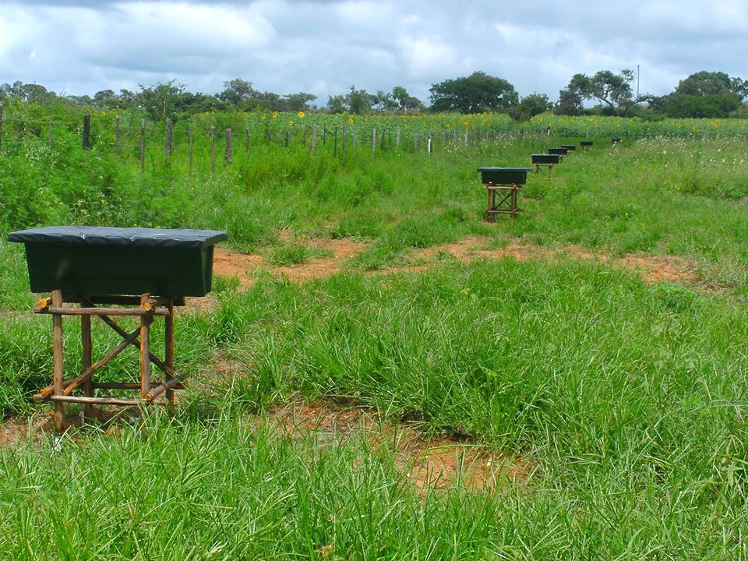
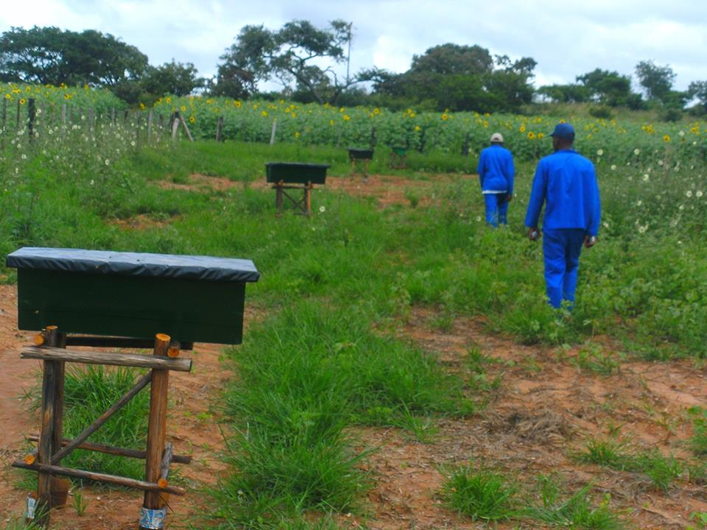
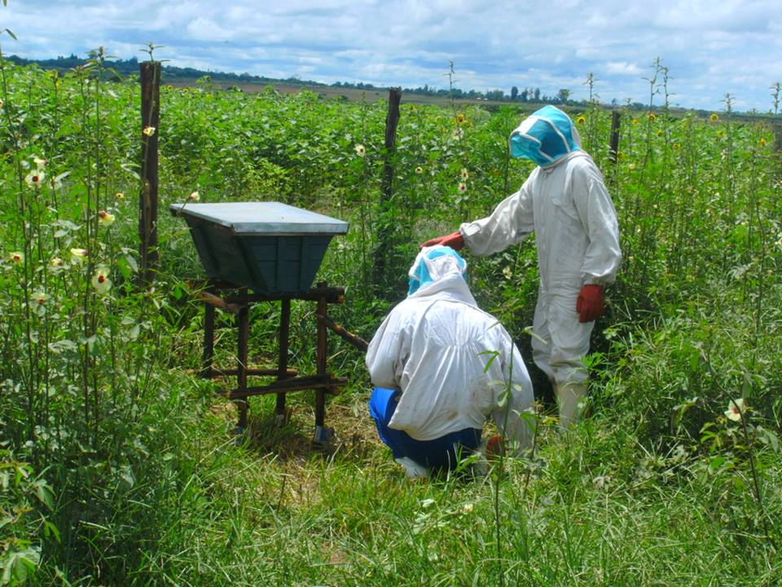
The pictures shown on pages 11 to 12 show different flowering stages of the sunflower crop
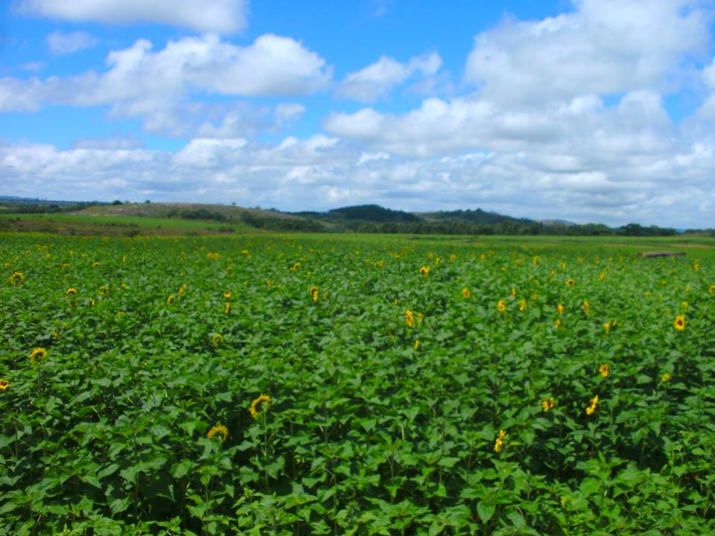

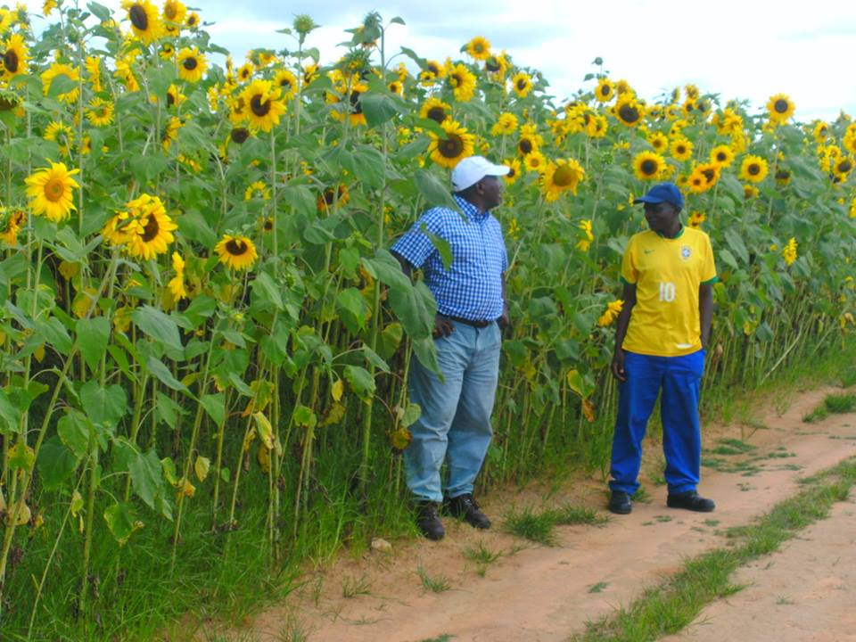
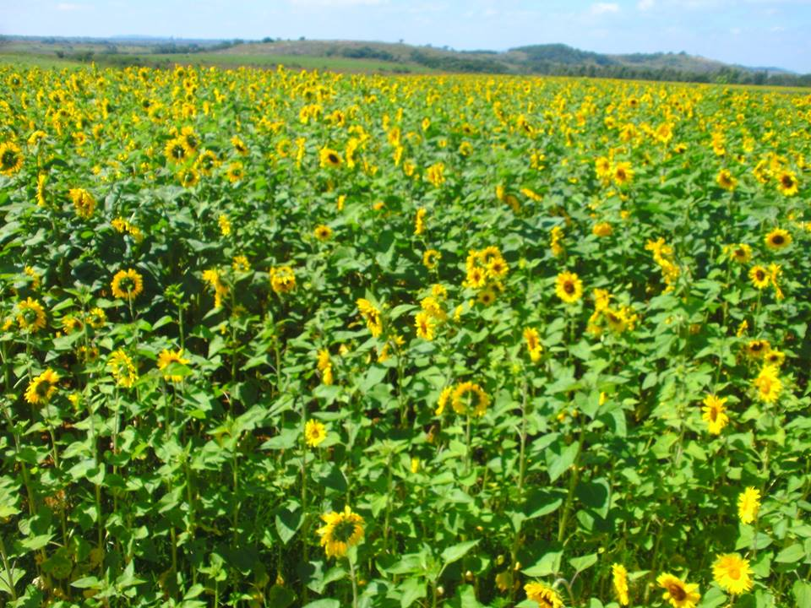
- Pollination activity
The bees were introduced at 5% blossom and this encouraged the bees to start working right away. The opening flowers would stay for 20 days. We observed that a few flowering plants in the area disturbed the sunflower pollination exercise since bees had to visit the other flowering plants. It was observed that 83% of the sunflower heads opened soon after the first head opened.
We introduced 2 beehives per hectare since we used strong colonies for this exercise. The weak colonies are not recommended for pollination. The stocking of 4 beehives can be reached if the objective is that of producing seed.
In the exercise we used those hives with 5-6 frames of brood as we found this to be very ideal for the pollination exercise. We considered that the expansion of the brood nest would demand more pollen to feed the larvae. This resulted in bees being very active in the collection of pollen thereby pollinating the flowers. Bees were even forced to fly out of the beehive during less ideal conditions to collect pollen.
Honey bees are very loyal to one type of blossom when foraging and this make them very useful in pollination. We noted that bees were leaving the beehives to forage on sunflower blossom and they continued to do so.
The proportion of honey bees collecting nectar or pollen from flowers depended on the relative availability of nectar and pollen at the time as well as the food requirement of the colonies around the crop. It was noted that the rate at which bees visited the flowers depended on the amount of nectar and pollen present. This varied with the type of flowers and the stage of the flower development, climatic conditions and the number of foraging insects present in the area.
We noted that bee activity at temperatures below 13 degrees Celsius was very low. Honey bee activities increased with the rise of temperatures from 15.5 degrees Celsius up to 42.2 degrees Celsius. Above 42.2 degrees Celsius bees’ activities were slowed down.

Page 14 has pictures that show honey bees in action. One at the base of the flower is collecting nectar and one at the top is collecting pollen. The nectar gatherers were found quite often foraging at the base of the blossom and these were not as vigorous as the pollen gatherers which were found to be more vigorous on the blossom. The pollen gatherers had more pollen on their body hairs than the nectar gatherers. This enhanced the value of pollen gatherers as effective pollinators.

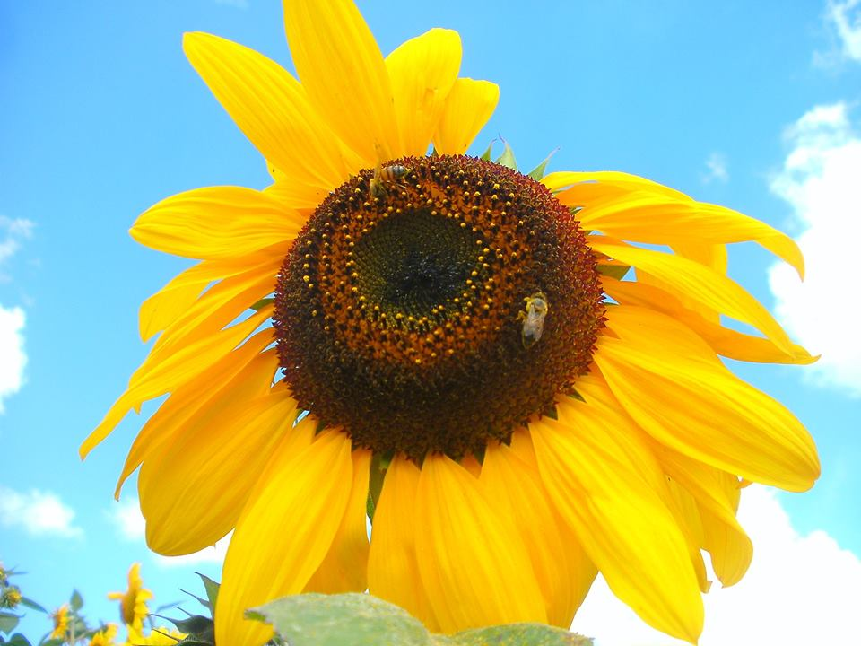
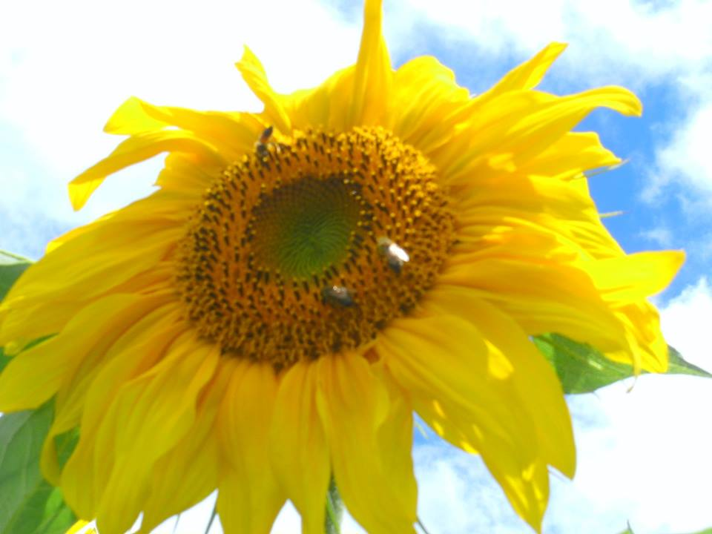
- Factors affecting sunflower pollination
The sunflower relies on pollinators in the form of insects and small birds to reproduce. The pollinators are living organisms, their ability to pollinate is affected by several factors which can be manipulated and planned for giving an opportunity to address the challenges thereby increasing the sunflowers’ yield.
4.1 Weather
Bees are the primary pollinators of sunflowers and while they feature several physical adaptations that make them an ideal pollinator, they are affected by several weather conditions. We found that under excessive cold, heat and wind the activity of bees in their search for food was slowed down and at some point even stopped. Bees worked best under 60-108 degrees Fahrenheit (15.5-42.2 Degrees Celsius). The winds in excess of 15miles (24.14 Km)/hr and incessant rains stopped bee activity (McGregor, 1976; Pomroy, 2009)
4.2 Lack of pollinators
The presence of pollinators (insects and small birds) is necessary for a serious pollination effort (McGregor, 1976; Pomroy, 2009). Where there are no adequate pollinators beekeepers find a very lucrative business of renting out bee colonies for pollination services. Whenever a sunflower crop is established 2.5 Kilometres away from the apiary site bees get encouraged to make daily trips even in bad weather looking for pollen and nectar (Pomroy, 2009).
4.3 Insecticides
The broad spectrum insecticides can also affect the pollination services of pollinators. The insecticides would kill individual bees or pollinators immediately or entire colonies over time depending on the chemical in use (Pomroy, 2009). The sick and dying bee colonies cannot travel as far as often looking for food. The use of insecticidal soaps that are designed with the bee safety and health in mind must be considered when spraying sunflower pests (McGregor, 1976). We noticed that during the exercise there was no chemical application that was done in the area and all our bees were safe.

- Heliotropism
During the exercise we found that sunflowers turned their faces towards the sun as they tracked it across the sky. This process is known as heliotropism or solar tracking. We found during the exercise that once the sunflower is pollinated it ceased solar tracking.
The reason why sunflowers turn their heads towards the sun is to get warmth which attracts pollinating insects. The sunlight also facilitated the development of pollen which is needed by the bees (McGregor, 1976; Pomroy, 2009).
- Hive placement
The beehives were elevated for bees to fly longer than just putting the hives on the ground. This was done to ensure maximum bee activity. Long straight lines were used with hives spaced 20 meters. This was used because we had to put the bee hives in a fenced area that was in the centre of the sunflower crop. This was also done for security reasons. We knew very well that long straight lines could cause drifting and non uniformity of colony strengths ( Pomroy, 2009). Our bee hives within the fenced area were facing same direction since the sunflower crop was outside the fenced area. We knew very well that an irregular layout would be more ideal but the layout of the crop field would not allow us to practice this. We managed to have 20 bee hives in the crop area and this gave the team less management work during the exercise.

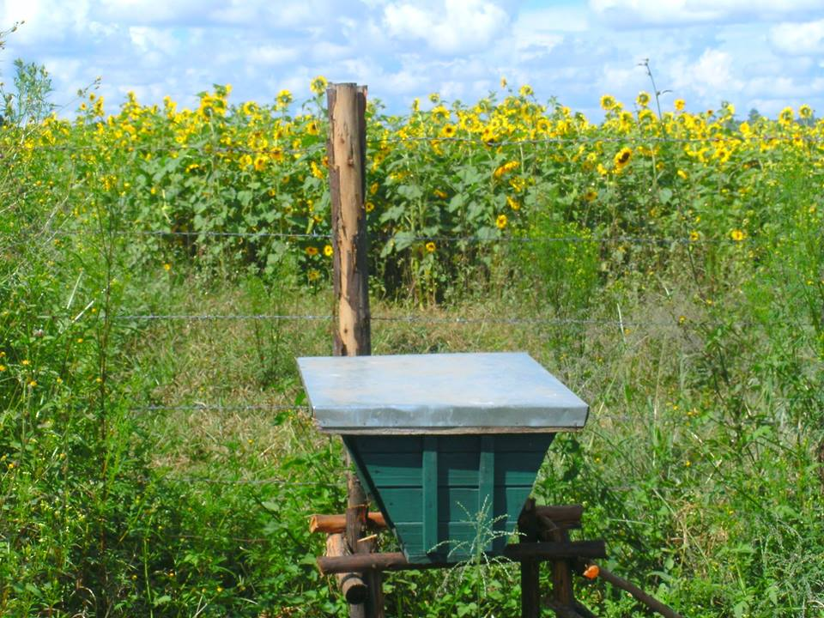
A beehive placed on a stand with the bee entrance facing the crop field.

- Mature sunflower.
During the exercise we found that mature sunflower buds and opened blooms were fixed to the east, with only the leaves continuing to track the sun for photosynthesis. It is at this stage where we realised that the stem stiffens and flowers formed seeds and no longer practiced heliotropism (See picture below)
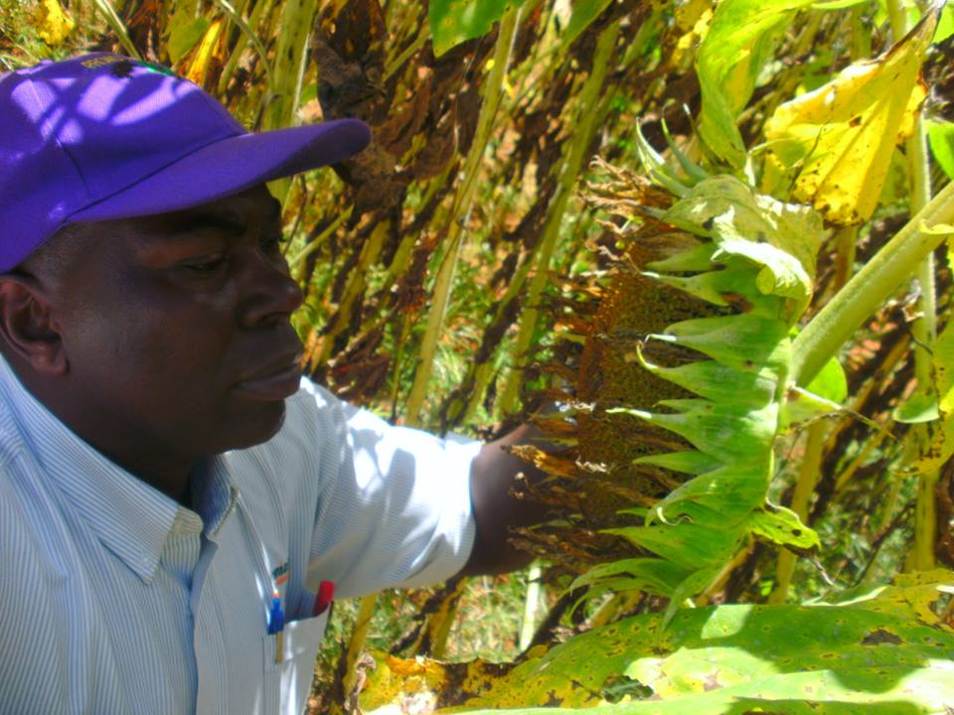
Robert Mutisi inspecting the sunflower head for harvesting readiness.

- Harvesting of sunflower
During the exercise we managed to monitor the flower heads to a point when they showed signs of wilting. This was the right time to harvest the sunflowers. It was also noted that the back sides of the head showed yellow colour that was turning brown (See the picture below).
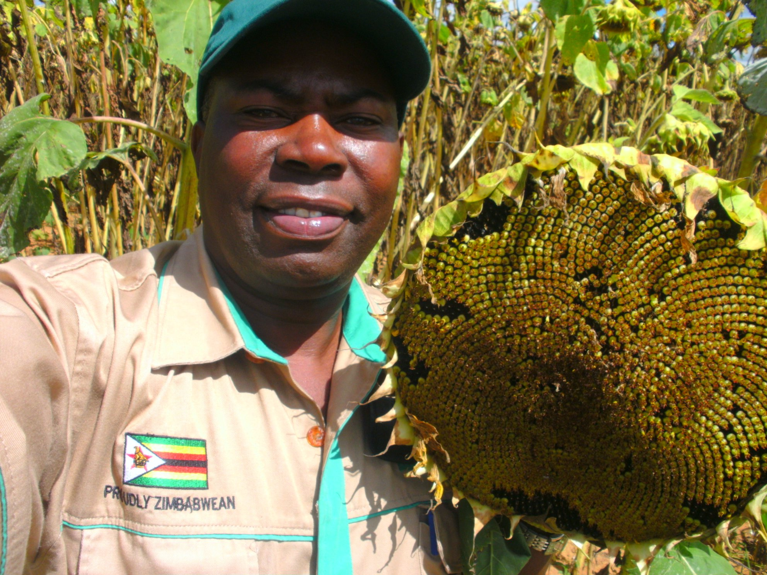
Robert Mutisi holding a sunflower head that is ready for harvesting

- The harvested heads of sunflowers

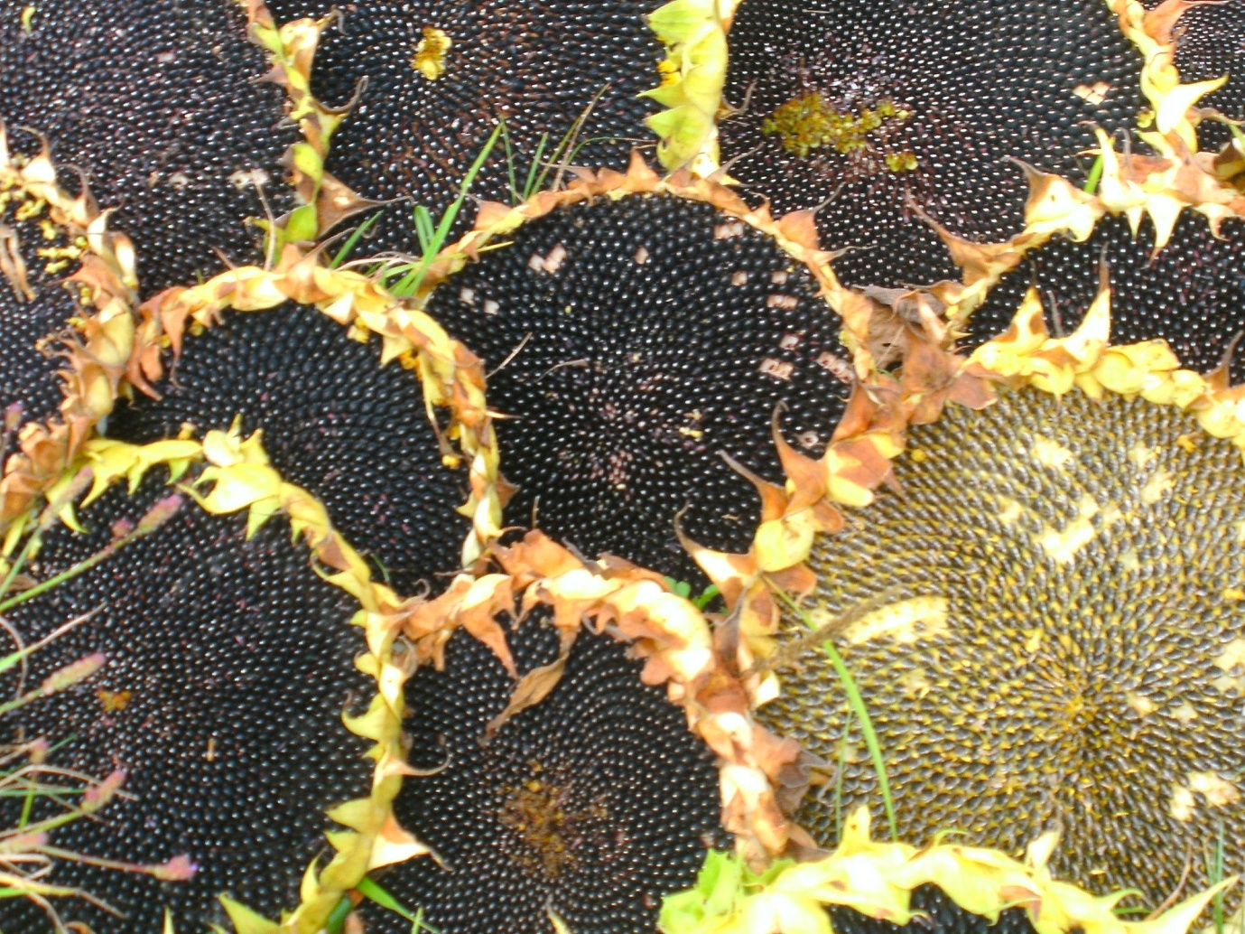
Good quality sunflower heads showing good quality seeds

- Sunflower seed being prepared for oil pressing

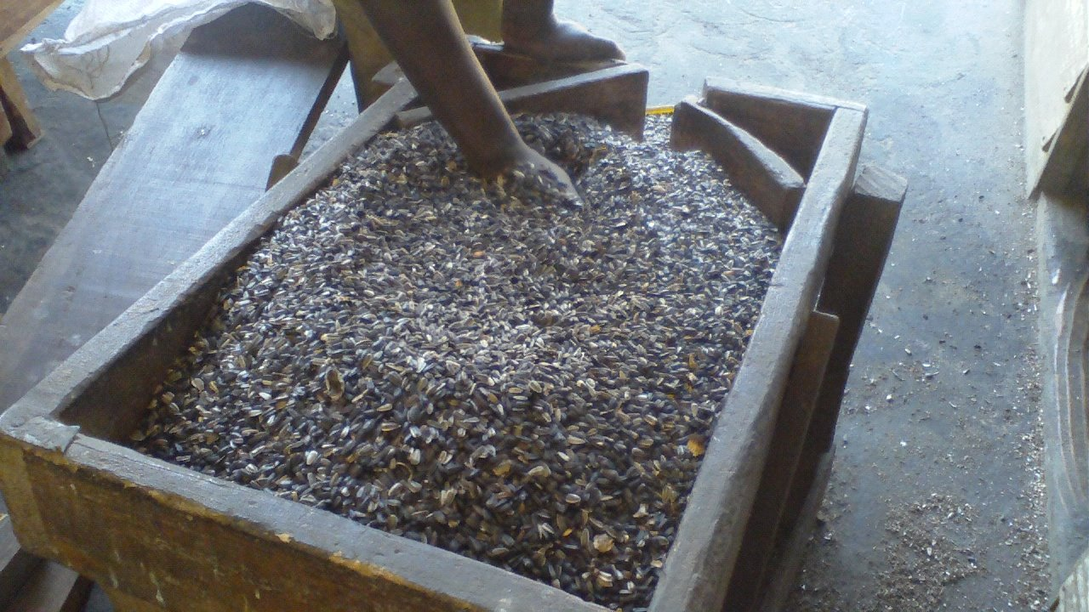

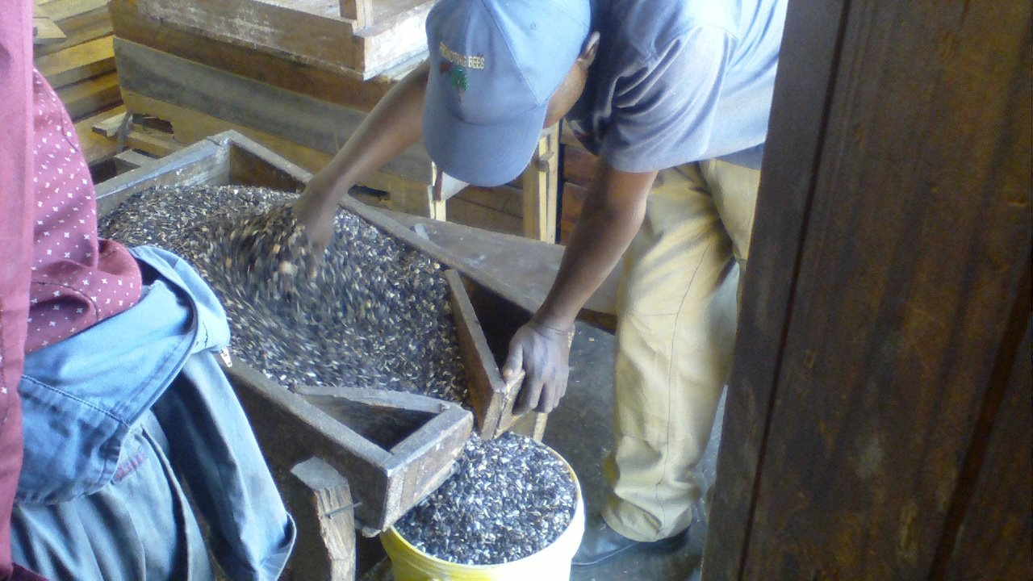

- Sunflower seed being pressed to produce oil and cake

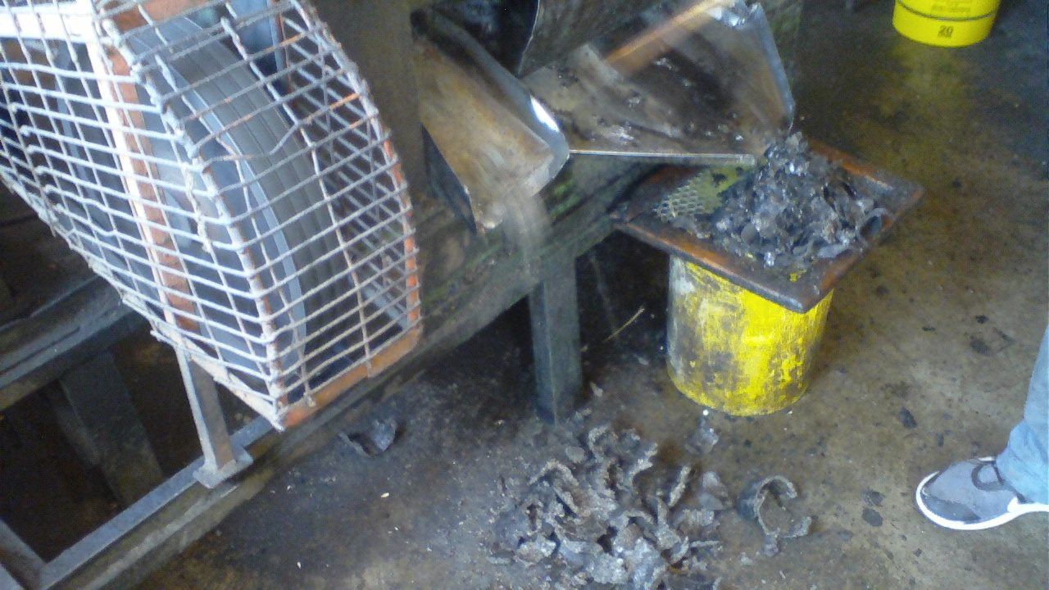

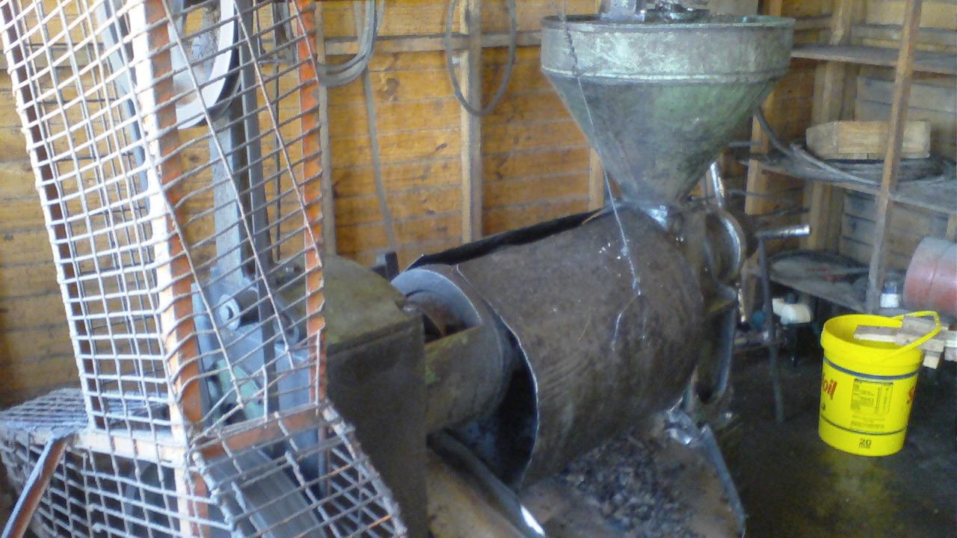

- Bee products harvested from the bee hives
Raw honey harvested from the bee hives.
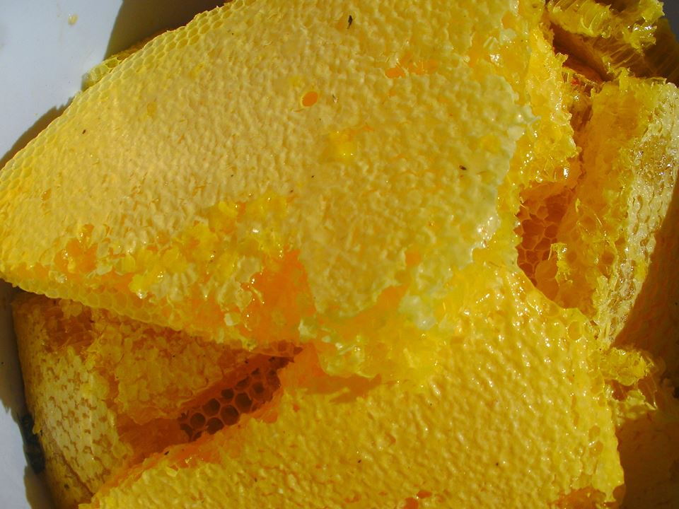
The yellowish colour of the raw honey came from the colour of the flowers where nectar was collected from.

- Processed, packaged and branded honey

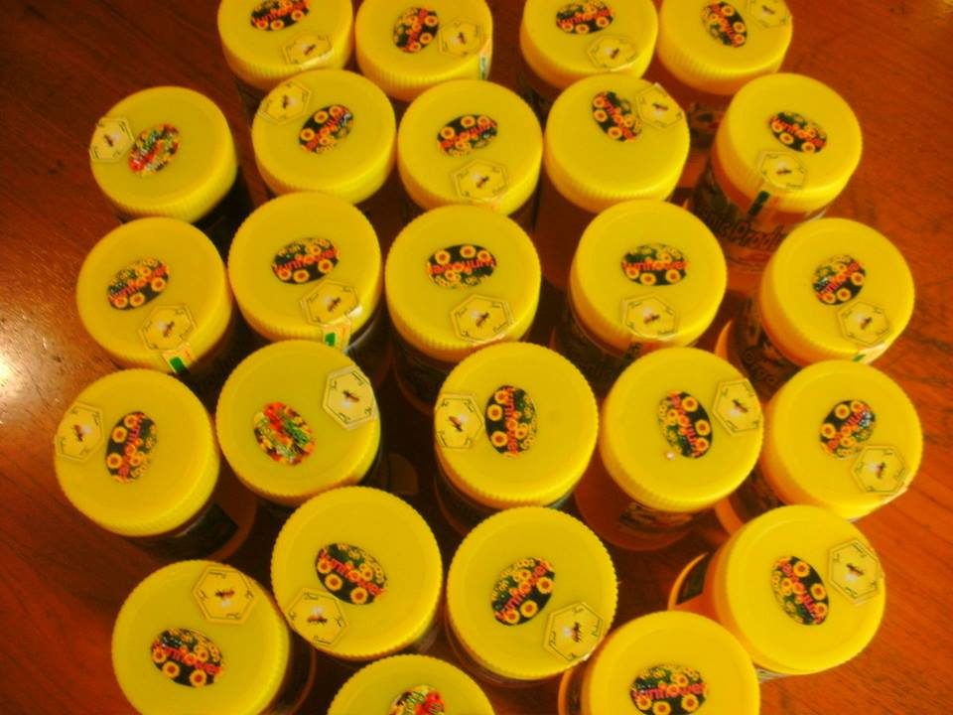
The top of the honey jar has a sticker that shows the flower source of the honey.
- Conclusion
The integrated farming approach where beekeeping was done in a sunflower crop resulted in the production of sunflower seed and bee products. The sunflower seed has several uses that can support human life. Bee products are used as food and medicinal purposes. The integrated farming approach enhances food security, natural resources management and income generation which can improve the local economies. The integrated approach also reduces vulnerability within our farming communities. Sunflower farming needs pollinators for it to be successful. Bees need pollen and nectar from sunflower blossom and the sunflower crop needs bees to pollinate the blossom.

- Recommendation
- Establish a proper plan for the pollination activity
- When pollinating sunflowers make use of irregular patterns with hives facing different directions.
- Make use of very strong colonies for pollination
- Proper timing of pollination activity must be done
- Make use of the proper hive stocking density to suit the intended objectives.
- Address factors that can slow or hinder pollination activities

- References
DAF. (2005). Honey bee pollination benefits for crops and orchards in Western Australia. Australia: Department of Agriculture and Food.
Greenleaf, S. S. and Kreman, C. (2006). Wild bees enhance honey bees’ pollination of hybrid sunflower. Proceeding of the National Academy of Sciences. 103; 13890-13895.
McGregor, S. E. (1976). Insect pollination of cultivated crop plants. USA: USDA, Tucson, Arizona.
Pomroy, R. (2009). RE: Sunflower pollination trial studies in North Australia.

