TOWARDS SUSTAINABLE DEVELOPMENT OF SMALL SCALE FISHERIES IN THE PHILIPPINES: EXPERIENCES AND LESSONS LEARNED FROM EIGHT REGIONAL SITES.

SUMMARY

The focus of this paper is on the governance of small-scale or municipal fisheries in the Philippines in light of the critical role they play in the livelihoods of coastal communities and in the nation as a whole. Annually, some 1.3 million metric tons of fish are harvested from the country’s 17,460 km coastline and 496,000 ha of inland water bodies. This sub-sector contributes significantly to the Philippine economy, supplies the bulk of the dietary fish requirement for over 90 million Filipinos who consume around 38 kg/capita/year, and provides direct employment to 1.4 million fishers. Despite eight national fisheries plans from 1972 to 2010, four major externally funded fisheries programs and thousands of local initiatives, the failures and inadequacies in governance of small-scale fisheries are conspicuous. They are made evident by depleted fishery resources, degraded fish habitats, intensified resource use competition and conflict, post-harvest losses, limited institutional capabilities, inadequate and inconsistent fisheries policies, and weak institutional partnerships. Although there are suitable governance arrangements in place, there needs to be better clarification of management functions between and among the various bodies at different administrative levels. Up-scaling small-scale fisheries management and expanding Institutional partnerships would be beneficial.
Six ‘core’ strategies are proposed to help promote the sustainability of small-scale fisheries: (1) sustain—conservation and rational use of fishery resources; (2) protect—preventive steps to manage threats to habitats and/or ecosystems that support fisheries; (3) develop—development of small-scale fisheries in geographically-appropriate areas, including promotion of livelihoods; (4) capacitate—enhancing the capacity of municipal fishers and relevant stakeholders; (5) institutionalize—organizational integration including scaling-up of fisheries management; and (6) communicate—generation of pertinent information and translation into appropriate formats for practical transmission.
In pursuit of multiple objectives, the governance of small-scale fisheries will continue to be a delicate balancing act. However, it will be the more judicious allocation of administrative resources by local government units to small-scale fisheries, as well as the continuing support of national government agencies and civil society groups, that will be most critical over the longer term.
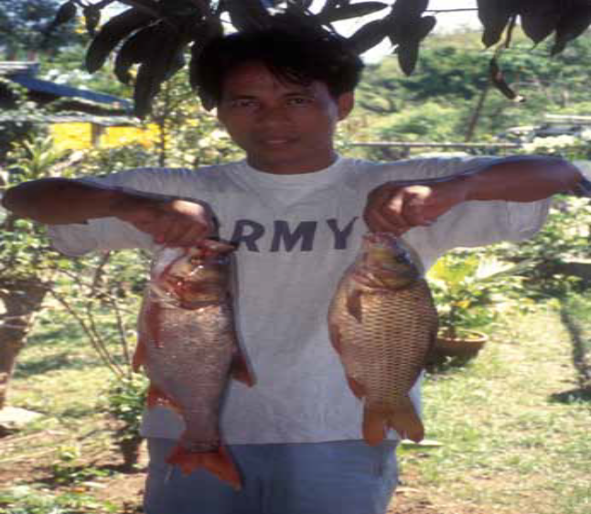
Carp species,Quirino province, region 2

Counterpart contributions were provided by the World Fish Center, DOST regional offices (Regions 1, 2, 5, 6, 8, 11 and 13) and AGHAM Party List. 2 These consist of the following institutions in the eight regional sites: Bureau of Fisheries and Aquatic Resources (BFAR) regional and provincial offices; Department of Environment and Natural Resources (DENR) XI; Bicol University (BU); Davao del Norte State College (DNSC); Davao Oriental State College of Science and Technology (DOSCST); Northern Iloilo Polytechnic State College (NIPSC); Pangasinan State University (PSU); Palawan State University (PSU); Southern Leyte State University (SLSU); Southern Philippines Agri-Business and Marine and Aquatic School of Technology (SPAMAST); Surigao del Sur State University (SDSSU); University of Southeastern Philippines (USP); University of the Philippines in the Visayas (UPV); Cagayan Valley Partners in People Development (CAVAPPED); and various stakeholder representatives from local government units, fishing associations, people’s organizations, other national government agencies, non-governmental organizations, and local communities.

BACKGROUND

The information and insights presented in this lessons learned brief derive from the project entitled Strengthening Governance and Sustainability of Small-Scale Fisheries Management in the Philippines: An Ecosystem Approach. The project was funded1 principally by the Department of Agriculture’s Bureau of
Agricultural Research (DA-BAR), and implemented from 2008 to 2011 by the World Fish Center in collaboration with the Department of Science and Technology (DOST) and selected partners. The underlying project’s goal was to strengthen governance and sustainability of small-scale fisheries management in the Philippines.’
There were a variety of objectives spread across two project phases but the primary objectives relevant to this brief include:

(1) Identifying issues at project sites and assessing potential for an ecosystem based approach to fisheries management.
(2) Assessing current fisheries management practices at different levels of governance and identifying best practices.
The purposes of this paper are twofold. First, it aims to provide brief highlights of the project findings; second, it aims to present the lessons learned in project implementation covering substantive sectoral concerns as well as methodological issues. It wraps up with some strategic directions that need to be undertaken to reverse the deteriorating conditions of small-scale fisheries (SSF) while at the same time promoting their sustainable development.

ANALYTICAL FRAMEWORK AND METHODS

Research frameworks

An institutional analysis research framework was adopted; this was drawn from the theoretical and empirical work of the Institutional Analysis and Development (IAD) framework

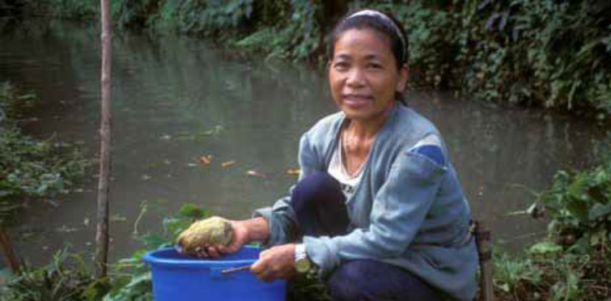
Small scale fish farms provide an extra fish in rural areas, Quirino province, region 2

developed by researchers at the Workshop in Political Theory and Policy Analysis at Indiana University, USA. The IAD relies on methods described by Ostrom and Ostrom (1977), Kiser and Ostrom (1982), Ostrom (1986, 1994) and Oakerson (1992) . The theoretical foundations are based on game theory, neoclassical microeconomic theory, and institutional economics. The institutional analysis research framework has been expanded by Pomeroy (1994) in relation to the fisheries sector. Andrew et al. (2007) provide a general framework for diagnosis and management ofsmall-scale fisheries (Figure 1).
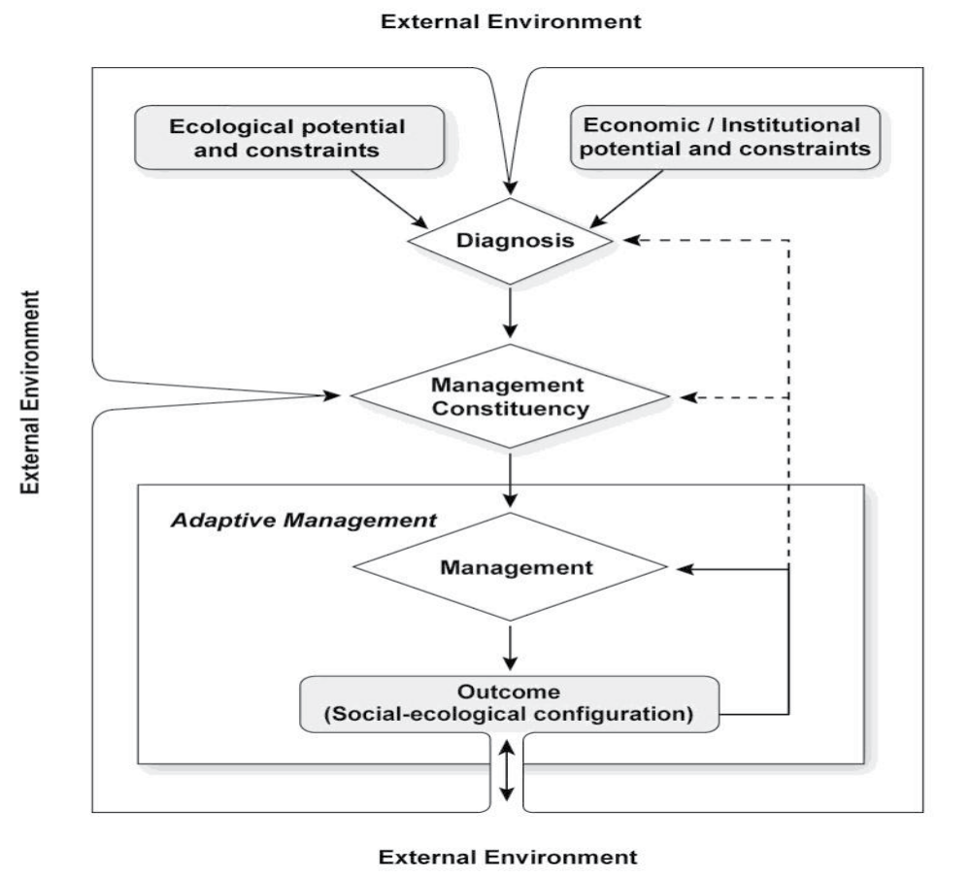
Figure 1. General framework for diagnosis and management of small scale fisheries. (Andrew et al. 2007)

Operationally, the project adopted the Rapid Appraisal of Fisheries Management Systems (RAFMS) approach (Pido 1996, 1997). This consisted of four sequential but overlapping steps: (1) literature review, (2) reconnaissance survey, (3) field data gathering, and (4) community validation (Figure 2). Multi-disciplinary teams were established at each regional site to undertake the research process. The majority of team membership was drawn from faculty members of local academic institutions and government line agencies in the region: DOST, Bureau of Fisheries and Aquatic Resources (BFAR), and Department of Environment and Natural Resources (DENR). The field data gathering (step 3) relied heavily on the use of key informant interviews (KIIs) and focus group discussions (FGDs). The participants included local chief executives, representatives of local government units (LGUs), national government agencies such as BFAR and DENR, consultants, fishing associations, people’s organizations and non-governmental organizations.

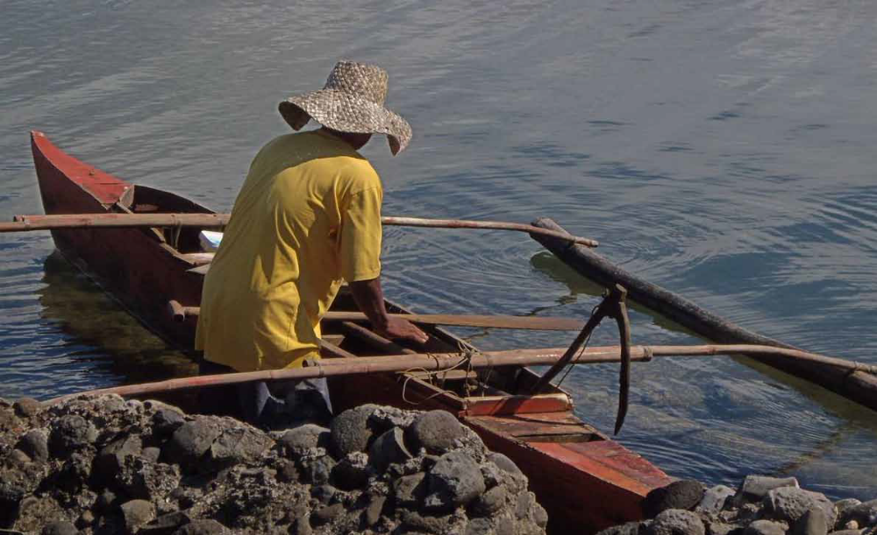
Small size boat, typical of small-scale fisheries in coastal areas in Northern Mindanao,Misamis Occidental,region 10

CASE STUDY SITES

Using these frameworks and the RAFMS, the project explored opportunities for implementing the appropriate measures for an ecosystem approach to fisheries (EAF) and ecosystem approach to aquaculture (EAA), as well as determined how institutional arrangements affect user behavior and incentives. Some aspects of relevant organizations at the local/project site level were examined as their strategies can influence or lead to changes in institutions. Eight study sites were selected by the project (Figure 3); for Phase 1: Region 2 (Babuyan Channel), Region 5 (San Miguel Bay), Region 8 (Sogod Bay) and Region 13 (Lanuza Bay) while for Phase 2: Region 1 (Lingayen Gulf), Region 4B (San Vicente, Palawan), Region 6 (Visayan Sea, Northern Iloilo) and Region 11 (Davao Gulf). These sites were selected using several criteria including: (1) the importance of the bay fishery to the local food security and national food fish requirements; (2) the relative availability of crucial information; (3) the willingness of local communities and governments to participate; and (4) being the recipient of current or previous externally-funded fishery resources management projects. They also provided a representative sample of the various governance approaches used in the Philippines for fisheries and coastal resources management.

HIGHLIGHTS AND FINDINGS

Brief biophysical and socioeconomic characteristics
The coastal habitats in the eight study sides are broadly similar consisting of coral reefs, mangroves and sea grass beds (Table 1). All sites except one employ some form of marine protected area (MPA) or fish sanctuary as a conservation measure. All fisheries are multi-species and multi-gear—gill net, hook and line, beach seine, mini-trawl and spear fishing being the range of methods employed. All the fisheries were reported to be in a state of decline.
Coastal residents are highly dependent on the fisheries for food, livelihoods and income. Pricing of the catch is largely dictated by traders or middlemen; the fishers lack market power. The market chain length varies from local to international. The majority of the fish harvest is marketed for local consumption; the rest is sold in neighboring areas or transported to urban centers, specifically Metro Manila. High value products—such as live groupers, lobsters, processed squids, crabs and sea cucumbers—are exported abroad. Physical infrastructure facilities, such as processing plants and post-harvest equipment that are necessary to support SSF, have remained limited.
Most fishers have low levels of literacy, less than half completing elementary school; generally, they have few economic assets or material possessions. There is low livelihood-diversification as evidenced by the high retention of fishers within the industry. Some alternative livelihood opportunities include rice farming, livestock raising, harvesting of forest products, construction work, transportation or tourism. Small-scale aquaculture plays an important complementary role to SSF in the Philippines. This is due to the generally depleted status of the fishery as shown from the study sites, the need for livelihood diversification, and to ensure dietary protein sufficiency in fishing communities.

Systems view of fisheries problems and issues

The project used four methods to review the data and develop a systems view of fisheries problems and issues. The first two are straightforward and traditional. Initially, a listing of issues was made based on the literature review and stakeholder consultations. In the eight study sites there were 13 common fisheries management issues identified (Table 2). From this generic list, corresponding management measures could be planned to address each particular issue.

Table 1. Some fisheries-related features and characteristics at the eight study sites.
Features | Region 1  (Lingayen  Gulf) | Region 2  (Babuyan  Channel) | Region 4B  (San Vicente,  Palawan | Region 5  (San Miguel  Bay) | Region 6  (Visayan Sea) | Region 8  (Sogod Bay) | Region 11  (Davao Gulf) | Region 13  (Lanuza Bay)
Key coastal  Habitats | Coral reefs,  mangroves,  seagrass beds | Coral reefs,  mangroves,  seagrass beds | Coral reefs,  mangroves,  seagrass beds | Coral reefs,  mangroves,  seagrass beds | Coral reefs,  mangroves,  seagrass beds | Coral reefs,  mangroves,  seagrass beds | Coral reefs,  mangroves,  seagrass beds | Coral reefs,  mangroves,  seagrass beds
Living coral  condition  (percentage  cover) | Poor to fair | Poor to fair  (11 – 51 %) | Fair to good  (25 – 55 %) | Poor to good  (14 – 69 %) | Poor to good | Poor to fair  (< 50 %) | Poor  (15.6 %) | Fair to good  (38 – 68 %)
Habitat  management  measures | Artificial  reefs and fish  aggregating  device;  mangrove  reforestation | MPA,  mangrove  replanting | Network  of MPAs,  mangrove  replanting | Fish sanctuary/  reserves,  mangrove  replanting | MPA, artificial  reefs | Fish sanctuary/  reserves,  mangrove  replanting | Network of  MPAs,  mangrove  replanting | Network of  MPAs,  mangrove  replanting
Fisheries  structure | Multi-species  and multigear  (both  municipal and  commercial) | Multi-species  and multigear  (both  municipal and  commercial) | Multi-species  and multi-gear  (mostly  municipal  sub-sector | Multi-species  and multi-gear  (both municipal  and commercial) | Multi-species  and multi-gear  (both municipal  and commercial) | Multispecies  and multigear  (mostly  municipal  sub-sector) | Multi-species  and multigear  (mostly  municipal) | Multi-species  and multigear  (mostly  municipal)
Major fishing  gear type/  methods | Gillnet | Gillnet, hook  and line | Beach seine,  gillnet | Gillnet,  mini-trawl | Hook and line,  gillnet | Hook and line,  gillnet | Hook and line,  gillnet | Hook and  line, multiple  hand line,  gillnets/drift  gillnets,  spear  fishing
Catch rates  (kg/day-trip) | 1 – 38 kg/  boat/trip | 3 – 6 kg  (gillnets, 2009)  10 kg  (hook and  line, 2009) | 25 – 500 kg/  day-trip (beach  seine)  10 – 60 kg/  haul/day  (gillnet) | 3.1 – 41.6 kg  (gillnets in 2002) | 10.5 – 106  kg/trip | 1 – 6 kg (hook  and line)  3 – 20 kg  (gill nets) | 39 – 85 kg  (gill nets) | 2 – 25 kg  (hook and  line)  5 – 23 kg  (drift gill net)  4 – 20 kg  (spear  fishing)
Trends in  catch rates | Generally  declining | Relatively  declining (i.e.,  gillnets, hook  and line) | Relatively  declining | Generally  declining  (based on FSP/  FRMP reports) | Steadily  declining | Relatively  declining | Relatively  declining

Coastal residents are highly dependent on the fisheries for food, livelihoods and income. Pricing of the catch is largely dictated by traders or middlemen; the fishers lack market power. The market chain length varies from local to international. The majority of the fish harvest is marketed for local consumption; the rest is sold in neighboring areas or transported to urban centers, specifically Metro Manila. High value products—such as live groupers, lobsters, processed squids, crabs and sea cucumbers—are exported abroad. Physical infrastructure facilities, such as processing plants and post-harvest equipment that are necessary to support SSF, have remained limited.
Most fishers have low levels of literacy, less than half completing elementary school; generally, they have few economic assets or material possessions. There is low livelihood-diversification as evidenced by the high retention of fishers within the industry. Some alternative livelihood opportunities include rice farming, livestock raising, harvesting of forest products, construction work, transportation or tourism. Small-scale aquaculture plays an important complementary role to SSF in the Philippines. This is due to the generally depleted status of the fishery as shown from the study sites, the need for livelihood diversification, and to ensure dietary protein sufficiency in fishing communities.

Systems view of fisheries problems and issues

The project used four methods to review the data and develop a systems view of fisheries problems and issues. The first two are straightforward and traditional. Initially, a listing of issues was made based on the literature review and stakeholder consultations. In the eight study sites there were 13 common fisheries management issues identified (Table 2). From this generic list, corresponding management measures could be planned to address each particular issue.

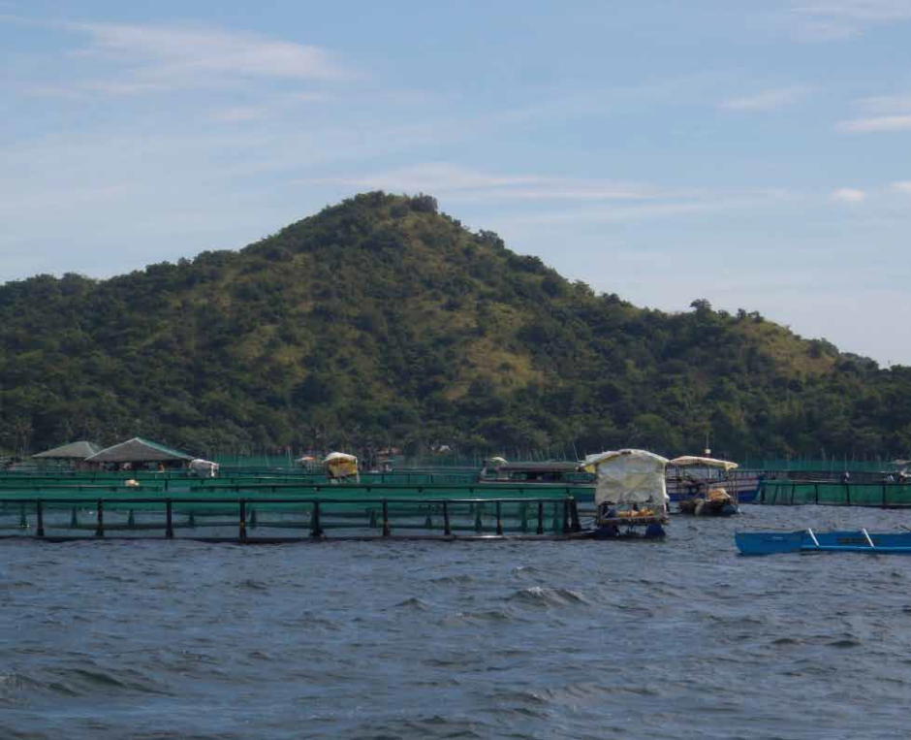
Fish cage aquaculture of milk fish in Sual, Pangasinan, Region 1

Step 1  Secondary data analysis |  | Step 2  Reconnaissance survey

Diagnosis of status/modalities of fisheries government

In the Philippines

Step 3
Field data gathering

Step 4
Community validation
Figure 2. The process of rapid appraisal to assess potential for an ecosystem based approach to fisheries management (modified from Pido et al. 1996, 1997).

Table 2. Summary of key fisheries management issues common to the eight study sites.

Cluster Issues/Problems

1. Depleted fishery resources/Overfishing

1. Bio-physical 2. Habitat destruction

3. Land-based pollution

4. Resource use conflict

5. Lack of alternative livelihood
2. Socio-economic
6. Limited community awareness

7. Limited infrastructure and support services

8. Increasing population and poverty

9. Limited institutional capacity

10. Inadequate/inconsistent policies

3. Governance 11. Limited partnership, coordination and participation

12. Weak law enforcement

4. Others 13. Climate change

In the second method, problem trees were constructed. Such trees depict the problems in a cause-and-effect relationship. For example, in the case of San Miguel Bay, Bicol Region, the core problem identified was ‘declining fish catch’. For this core problem there are 13 associated clusters of problems, which are further broken down into smaller entities. It can be seen that the issues appearing are very similar. Management recommendations are developed based on the identified problems.
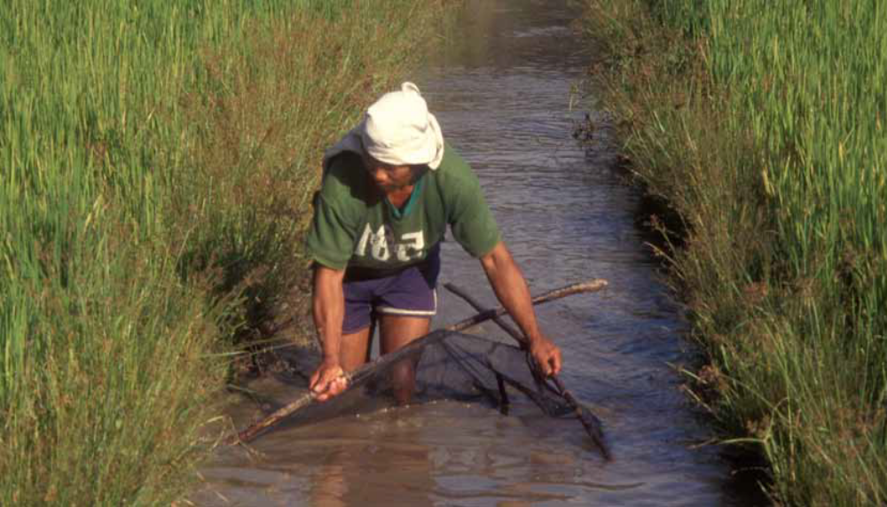
Small-scale fisher using scissor net in freshwater wetland/irrigation in Quirino province, region

The two other methods used were participatory system analysis (PSA) and risk assessment. PSA also views the core problem as a system of cause-and-effect, similar to a problem tree analysis. It reduces the large number of factors to elemental units, examines their interrelationships and identifies “driving factors” for interventions. The process classifies the problems into one of four quadrants: (1) symptom, (2) buffer, (3) critical, or (4) motor/lever.
A ‘symptom’ is an element that is greatly influenced by other elements but may not have much power to change the system itself; a ‘buffer’ refers to an element that is of low importance and expected to have little impact; ‘critical’ pertains to a catalyst that changes many things quickly and may create unexpected and undesired effects; a ‘motor/lever’ is an active element with predictable impacts. This is the most interesting sector for development activities. For example, at the San Vicente (Palawan) site, the motor/lever issue identified was “inadequate/inconsistent fisheries policies” (Figure 5). It implies that the LGU should focus its limited administrative resources on this issue. However, depending on capacity some resources may also be allocated to the critical elements—climate change, weak institutional partnerships and limited institutional capabilities - although with caution.

SYMPTOM  4- Post-harvest Losses | CRITICAL  1- Climate Change  7- Weak Institutional  Partnership  8-Limited Institutional  Capabilities
BUFFER  2- Degraded Fishery Habitats  3- Illegal Fishing Methods  5- Intensified Resource Use  Competion and Conflict  6- Lack of Alternative  Livelihood | MOTOR  9- Inadequate/Inconsistent  Fisheries Policies /LEVER
Figure 5. Result of participatory system analysis in San Vicente, Palawan.

Finally, a risk assessment was conducted on each of the identified issues to determine an appropriate level of response. This is another method of prioritizing issues as it determines how relevant an issue is in terms of the threats it poses. Risk value may be computed by multiplying the consequence (minor to extreme) with the likelihood (remote to likely). The risk values calculated from the 11 issues identified in Lanuza Bay, Surigao del Sur, are given in Table 3. The two issues with the highest values are habitat degradation (16) and low income of fishers (12). Inadequate policies and weak institutional set-up, and post-harvest losses had the lowest risk values of (4) and (2), respectively. Management interventions may then focus on activities related to the conservation of coastal habitats, as well livelihood projects to increase income.

Table 3. Risk assessment results from Lanuza Bay, Surigao del Sur.

Problem/Issue | Impact | Likelihood | Risk value
1. Habitat degradation | 4 | 4 | 16
2. Low income of fishers | 3 | 4 | 12
3. Limited information, awareness, and adaptive capacity | 3 | 3 | 9
4. Increasing human population | 3 | 3 | 9
5. Overfishing | 3 | 3 | 9
6. Weak law enforcement | 3 | 3 | 9
7. Limited LGU funding support | 3 | 3 | 9
8. Climate change | 3 | 3 | 9
9. Limited/inadequate policies | 2 | 2 | 4
10. Weak institutional set-up | 2 | 2 | 4
11. Post-harvest losses | 1 | 2 | 2

Synopsis of the Governance of Small-Scale Fisheries

Governance and management functions are organized at several levels (Table 4). At the village (barangay) level two bodies are typical. The first is the Barangay Fisheries and Aquatic Resources Management Council (BFARMC). This body has multiple functions which include assisting in the arbitration of disputes between fishers over fishery rights, taking active participation in establishing fishing zones and navigation lanes, and gathering data at fish landing points for the preparation of management plans. Second, there is the Bantay Dagat composed of deputized fishery wardens, which has largely law enforcement functions. Members normally go after the illegal fishers, such as cyanide and dynamite fishers, at the village level.

Administrative Level | Fisheries Management Body
Provincial level | • Provincial Agriculture Office
Municipal/City level | • Municipal Agriculture Office  • Municipal Fisheries  and Aquatic Resources  Management Council  (MFARMC)  • Municipal Bantay-Dagat
Village/Barangay level | • Barangay Fisheries  and Aquatic Resources  Management Council  (BFARMC)  • Barangay Bantay-Dagat
Table 4. Major fisheries management bodies at local levels.

At the municipal level the three most common bodies are the Municipal Agriculture Office (MAO), which is the main unit in charge of fisheries operations, the Municipal Fisheries and Aquatic Resources Management Council (MFARMC), and a municipal level Bantay Dagat. Functions of the MFARMC include assisting in the preparation of the Municipal Fishery Development Plan, recommending the enactment of municipal fishery ordinances, and assisting in the enforcement of fishery rules and regulations in municipal waters.
At the provincial level, the Provincial Agriculture Office takes the lead in fisheries-related matters. Its mandate includes the development of provincial agriculture and fisheries plans and their implementation in coordination with relevant partners, and other provisions relating to production, processing, and marketing of agricultural and fishery products. The institutional arrangements for undertaking fisheries management functions across administrative levels may be complex (Table 5). Though some fisheries management functions are quite specific, others are not. For example, fisheries law enforcement is the direct responsibility of the Bantay Dagat, whereas fisheries planning and policy making is normally handled by the FARMCs. Other functions are shared between management bodies. Activities related to information, education, and communication may be shared by the MAOs and local academic institutions. Other functions, such as the role of sustainable financing, appear not to be specific to any management body. The linkage of fisheries management bodies with other institutions is generally not explicit.

Table 5. Institutional arrangements for some fisheries management functions across administrative levels.
Administrative  Level | Institution | Operations | Law  Enforcement | Advisory/  Policy/  Enforcement | Habitat Management | Fishery Resources
National | National | DA-BFAR  Central  Office | PNP Maritime;  PCG | NFARMC | DENR Central Office | Tuna fisheries
Regional | National | DA-BFAR  Regional  offices | PNP Maritime;  PCG | IFARMC | DENR Regional offices | Tuna fisheries
Provincial | National/  LGU- Provinc,,oje | DA-BFAR  provincial  offices, PAO | PNP Maritime;  PCG;  Provincial  Bantay Dagat | PFARMC | DENR-PENRO | Tuna fisheries, Small  pelagic, Demersal
Municipal/City | LGU Municipality/  City | BFAR  municipal  offices, MAO | Municipal  Bantay Dagat | MFARMC |  | Small pelagic, Demersal  Reef fisheries
Village | LGU-Barangay |  | Municipal  Bantay Dagat | BFARMC | DENR-CENRO | Demersal, Reef fisheries

Small-scale fisheries are largely managed by local government units (LGUs) through three organizational entities: (1) village (barangay) on the lowest rung, (2) municipality/city, and (3) province at the highest level. In terms of fisheries, the municipal (and city) governments have the mandate to manage “municipal waters” and resources within the territorial boundaries of these municipalities or cities. The Department of Agriculture (DA) and the Department of Environment and Natural Resources (DENR) are the two main national government agencies (NGAs) that are involved in fisheries management. The Bureau of Fisheries and Aquatic Resources (BFAR), a line agency within the DA, is the primary agency mandated to manage the country’s fisheries sector. In collaboration with other NGAs, BFAR has overall jurisdiction over fisheries and aquatic resources management, except those within municipal waters. The DENR is the primary agency responsible for the conservation, management, development and proper use of the country’s environment and natural resources. The DENR’s areas of responsibilities pertaining to the fisheries sector include the management of foreshore and shoreline areas, as well as protected areas.
This study reviewed four different fisheries governance arrangements. These categories were developed earlier by Pomeroy et al. (2010). The first was the “Clusters and alliances of municipalities to integrate coastal resource management”; included in this category are Lanuza Bay, Lingayen Gulf, Sogod Bay and Visayan Sea (Figure 6).

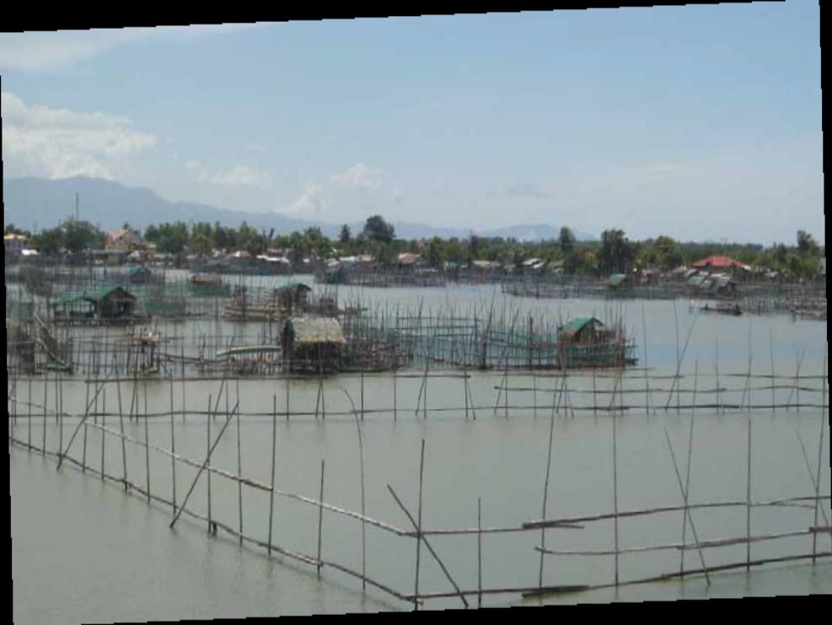
Figure 7. Existing fisheries management bodies and their connections in Davao Gulf, region 11.
Fish pen (stationary gear) are usually establish in river to catch migration and estuarine species, Pangasinan province

NIACDEV

REGIONAL
BFAR
DENR
Province
OPA
Provincial BD
MLGU
MAO
MUNICIPAL BD
MFARMC
SB Committee, Fisheries and Environment
BARANGAY
MFARMC
Baranagay Council
BARANGAY
MFARMC
Barangay Council
Fisher folk

Figure 6. Existing fisheries management bodies and their connections/linkages in Northern Iloilo, region 6

Conclusions and Lessons Learned

Project Methodology

The rapid appraisal methodology used was able to quickly analyze the various features of SSF—from biophysical to socioeconomic to governance. The methodology was cost-effective, relying on a small, elite, multidisciplinary team of local academics and professionals. The data gathering instruments were found to be suitable for the task. Innovations that could be implemented include on site measurements of biophysical characteristics, which would be useful for updating data and validating claims on habitat degradation. Some water quality parameters essential to fisheries, such as dissolved oxygen and turbidity, could be measured using portable instruments. Experimental test fishing could be undertaken by the field researchers.

Innovative project partnership arrangements are feasible

The partnership arrangements, although unconventional, were largely successful. The DOST led project operations in collaboration with various LGU partners. The field research activities were largely undertaken by rapid appraisal team members who were mostly drawn from local academic institutions and government line agencies. The World Fish Center, through its in-house staff and pool of consultants, provided the technical back-stopping.
Overall, the project team received more than adequate support from the LGUs involved. The LGUs and the local communities visited were very receptive to the team. At the outset (during the project scoping stage), the roles and responsibilities of each project partner were clarified. In addition, the partnership arrangements will serve as a mechanism for implementing potential future projects.
Similarly, there is a need to expand partnerships in SSF management. For example, as an NGA, the DOST is a relatively new entrant in SSF and with its various programs of support on capacity building and technology transfer could prove to be a potent partner in SSF development. Linking with ‘non-traditional’ partners, such as civic organizations and local academe, is also becoming a necessity. There should be further engagement offishing organizations and associations, NGOs and civil society groups, particularly when debating crucial issues and engaging in policy dialogues. In this way, diverse perspectives from a range of different stakeholders may be more easily harmonized. More pro-active participation by LGUs would also be beneficial.

Institutional arrangements need to be defined,established and put into practice

It is extremely difficult for an individual LGU to manage the fishery resources within their jurisdiction on their own, due to the trans-boundary nature of these resources. At the end of the Fisheries Resources Management Program, the need was highlighted “to review bay-wide planning, and particularly to revisit the institutional relationships between Bay Management Councils and FARMCs, leading to strengthening bay-wide planning though proper linkages between FARMCs” (ADB, 2007 p. 11). This notion of scaling-up is supported by BFAR through its
spatial approach known as the Integrated Fisheries Management Unit (IFMU). In 2008, BFAR issued Fisheries Office Order No. 217 on the Adoption and Implementation of the IFMU Scheme. This is intended to address the mismatch between governance jurisdiction and the habitats of the fish stocks. This study supports the view that there is no single governance arrangement that can handle all fisheries systems. However, there are a variety of governance arrangements that can be used to manage small-scale fisheries systems in the context of larger coastal ecosystems. These may range from ‘loose’ alliances of FARMCs at all levels to the more rigid organizational structures.
What is further required, though, is the clarification of management functions. The linkage of fisheries management bodies with other institutions and organizations is generally not well defined. Relationships between management bodies must be made more explicit. Many key informants noted that the functions of BFAR and DENR are not clearly delineated in relation to SSF. A key area to improve on is service delivery—from the national government down to the lowest level of local governments.

Management measures need to be streamlined

Many of the fisheries problems and issues that were identified are relatively well known. They have been listed in national fisheries plans over the last 40 years. The management measures that are needed to address these issues are also generally well known. Such management measures or instruments are already contained in the evaluation reports, national plans and even the mandates of fisheries-related organizations. What is needed is for these many management measures to be better structured to maximize their effectiveness. This would provide the political leaders and fisheries managers with a better basis for making decisions on where to allocate their limited administrative and financial resources.

Resource allocation for fisheries management remains minimal

Despite the rhetoric of local political leaders, the actual LGU allocation for fisheries management remains limited. Most of the resource allocation takes place at the municipal or city level, which serves as the main center for the management of SSF. Some resources are allocated at the provincial level; the smallest amount at the village or barangay level. Unfortunately, the actual allocation of administrative resources for SSF is very limited, at times minimal. This project restates that familiar SSF dilemma— although the government could in principle commit resources, it can barely provide for actual operations. In some cases, fisheries related activities were budgeted for but the actual allocation delivered was much less. There is still heavy dependence on externally-funded initiatives. For example, the Fisheries Improved for Sustainable Harvest (FISH) project in Lanuza Bay and the GTZ (German Technical Cooperation) project in Sogod Bay provided guardhouses, motorized boats, masks, snorkels and other equipment. Sustainable financing is needed for effective fisheries management. At the municipal level, more resources must be allocated beyond the 20% Internal Revenue Allotment (IRA). Innovative financing schemes must be instituted, such as a user fee system for MPAs and other fisheries-related habitats that are being used for eco-tourism or marine recreational activities. The financial analysis was constrained by the difficulty in segregating the funds allocated across categories. For example, it was impractical to accurately reflect the personnel costs of an employee in the Municipal Agriculture Office who only uses 20% of his time for fisheries-related work. At times, funding commitments for the fisheries sector were not released at all.

Property rights and regimes remain key concerns

The crucial issue of undefined property rights remains unresolved. The concept of property is central to the current debate on natural resource conservation (Macpherson 1978), including fishery resources. At the heart of any resource management arrangement is the question of ownership, whether implicit or explicit. Bromley (1991 p. 1) argues that “there are few concepts within economics that are more central—yet more confused—than those of property, rights and property rights.”


Fish drying in San Vicente, Palawan, region 4b

Open access to the Philippine fishery resources have been contributory to their severe depletion. Under an open access regime, the fishery resources are practically accessible to anyone. Such unregulated harvesting ensures that overall fishing pressure eventually becomes excessive. Although the 1998 Fisheries Code has advocated a shift from open to limited access through licensing, a nationwide licensing in the municipal fisheries is yet to be implemented. Property rights for other resource-based livelihoods also remain problematic. Many fishers cannot engage fully in agriculture, although they would like to, as they are landless. Most of them can only provide services as hired farm laborers. If agricultural land is really meant to provide an alternative or supplemental livelihood, then problems of land ownership must be resolved first. This reintroduces the issue of agrarian reform. Fishers have very limited alternative livelihood opportunities in forestry, wildlife and mineral resources. Different skill sets are required for mining and quarrying.

Towards Improved Management of Small-scale Fisheries

To improve the management of SSF, six ‘core’ strategies are proposed to reverse the deteriorating conditions: (1) sustain, (2) protect, (3) develop, (4) capacitate, (5) institutionalize, and (6) communicate. In relation to the project, these are synthesized from various sources such as Green et al. (2003), DA-BFAR (2004, 2006), Salayo and Perez (2009) and FISH Project (2010). ‘Sustain’ refers to the conservation and rational use of the fishery resources for the benefit of both present and future generations. Wild stocks must be harvested within their natural regenerative capacity, which means at or below maximum sustainable yield. ‘Protect’ refers to the preventive steps to be undertaken to manage the risks or threats to fisheries and associated ecosystems. This includes efforts to conserve coral reefs, mangroves, sea grass beds and soft-bottom communities, as well as to minimize the negative impacts of pollutants from all sources. ‘Develop’ relates to the development of SSF in geographical areas where it can still be pursued. It also involves developing sustainable livelihoods, as well as improving fisheries products along value chains to raise the standard of living of fishers and their dependents. The need for supplemental and alternative livelihoods was highlighted in all eight project sites. ‘Capacitate’ refers to the capacity-building endeavors that are needed to enhance the capacity of LGUs, municipal fishers and other relevant stakeholders. SSF in particular and fisheries in general require greater integration with other relevant economic sectors and the broader economic system. The efforts of various organizations involved in fisheries management need to be synchronized to achieve maximum benefits. ‘Communicate’ refers to the generation of pertinent information and knowledge, as well as the exchange of ideas and information among coastal stakeholders that is essential for effective fisheries governance. It also includes the use of scientific knowledge for adaptive management.
In pursuit of multiple objectives, the governance of small-scale fisheries will continue to be a delicate balancing act. Biological objectives aim to sustain fish stocks, ecological objectives to protect fisheries habitats, economic objectives to maximize economic efficiency, and social objectives to promote equitable distribution of benefits. Clearly, SSF management is complicated as all of these objectives are difficult to achieve simultaneously.
However, it will be the actual allocation of administrative resources by local government units to small-scale fisheries that will be most critical over the long term.

Acronyms
BAR - Bureau of Agricultural Research
BD - Bantay Dagat
BFAR - Bureau of Fisheries and Aquatic Resources
BFARMC - Barangay Fisheries and Aquatic Resources Management Council
CAO - City Agriculture Office
CENRO - Community Environment and Natural Resources Office
CFARMC - City Fisheries and Aquatic Resources Management Council
DA - Department of Agriculture
DENR - Department of Environment and Natural Resources
DOST - Department of Science and Technology
EAA - Ecosystem Approach to Aquaculture
EAF - Ecosystem Approach to Fisheries
FARMC - Fisheries and Aquatic Resources Management Council
FGD - Focused Group Discussion
FISH - Fisheries Improved for Sustainable Harvest
FLET - Fisheries Law Enforcement Team
GTZ - German Technical Cooperation
KII - Key Informant Interviews
IAD - Institutional Analysis and Development
IFARMC - Integrated Fisheries and Aquatic Resources Management Council
IFMU - Integrated Fisheries Management Unit
IMC - Integrated Municipal Council
IRA - Internal Revenue Allotment
LGU - Local Government Unit
MAFC - Municipal Fisheries and Agriculture Council
MAO - Municipal Agriculture Office
MFARMC - Municipal Fisheries and Aquatic Resources Management Council
MFRB - Municipal Fishery Regulatory Board
MLGU - Municipal Local Government Unit
MPA - Marine Protected Area
NFARMC - National Fisheries and Aquatic Resources Management Council
NGA - National Government Agency
NIACDEV - Northern Iloilo Alliance for Coastal Development
PAFC - Provincial Agriculture and Fisheries Council
PAO - Provincial Agriculture Office
PCG - Philippine Coast Guard
PFARMC - Provincial Fisheries and Aquatic Resources Management Council
PNP - Philippine National Police
PENRO - Provincial Environment and Natural Resources Office
PSA - Participatory System Analysis
RAFC - Regional Agriculture and Fisheries Council
RAFMS - Rapid Appraisal of Fisheries Management Systems
RFARMC - Regional Fisheries and Aquatic Resources Management Council
SAVEMAN - San Vicente Environmental Management Board
SB - Sangguniang Bayan
SSF - Small-Scale Fisheries
Fish drying in San Vicente,

